Effect of Feedrate and Cutting Speed Variation on Surface Roughness in Dry and Wet CNC Turning of SC45 Carbon Steel Using DNMG Inserts
Bagas Imam Abdillah^{a)}, Iis Siti Aisyah^{b)}, Nur Hasanah ^{c)}, Budiono^{d)} and
Jah Romdhony Deril Liozi^{d)}
Department of Mechanical Engineering, University of Muhammadiyah Malang
Jl. Raya Tlogomas No. 246, Malang 65144, Indonesia.

^{a)} bagasimamabdillah12@webmail.umm.ac.id
^{b)} siti@umm.ac.id
^{c)} nurhasanah02@umm.ac.id
^{d)} Corresponding author: budionoft@umm.ac.id
^{e)} derilmlg2@gmail.com

Abstract. This research explores the influence of feedrate and cutting speed variations on surface roughness in dry and wet CNC turning of SC45 carbon steel using DNMG insert tools. Machining trials were conducted under controlled conditions, with feedrates ranging from 0.15 to 0.45 mm/rev and cutting speeds from 250 to 750 m/min. The experiments aimed to analyze the resulting surface quality using a digital surface roughness tester. The results show that higher cutting speeds and lower feedrates significantly improve the surface finish. Furthermore, the application of coolant in wet machining demonstrated a consistent reduction in surface roughness compared to dry conditions. These findings can serve as a reference for optimizing CNC turning parameters to enhance surface integrity in various industrial machining operations.

INTRODUCTION
The development of digital technology is progressing rapidly and impacting all fields, including manufacturing [1]. Competition in the manufacturing industry continues to intensify, both in supporting system technologies and in production. This condition drives all stakeholders to compete in developing more technical and practical equipment [2]. In the past, conventional machines such as lathes, milling machines, laser cutting machines, and others were used for producing equipment, spare parts, components, and finished products. These machines are still used today for specific tasks [3]. In the production of components such as shafts, factory parts, heavy equipment components, automotive parts, aircraft components, and other engineering applications, traditional machines are still partially used [4]. Turning processes require appropriate material to be machined. Steel is a commonly used material due to its ease of forming and relatively low cost [5]. The types of steel vary in terms of strength, hardness, elasticity, toughness, weldability, cold and hot formability, and corrosion resistance [6]. Structural steel accounts for approximately 90% of all steel production and is widely used in construction, such as bridges, towers, and high-rise buildings [7]. SC45 is a carbon steel with approximately 0.45% carbon content, typically used in machine construction applications such as shafts, gears, and other mechanical parts. This steel provides a good balance of strength, hardness, and toughness [8].
In operations demanding high production rates, short machining times, and consistent quality, conventional machines are no longer recommended. CNC (Computer Numerical Control) machines have become the preferred solution over the past decades [9]. The use of CNC lathes offers high-speed machining and excellent dimensional accuracy, while requiring less manual labor. The adoption of CNC machining has increased rapidly with the growth of factory automation [10]. Earlier generations of CNC turning machines had only 2 axes, but modern machines now include 2.5-axis, 3-axis, and 5-axis configurations in both horizontal and vertical setups [11]. Initial design planning must be done by recording the workpiece dimensions before and after machining, material selection, tools, target quality, and the machine specifications [12].
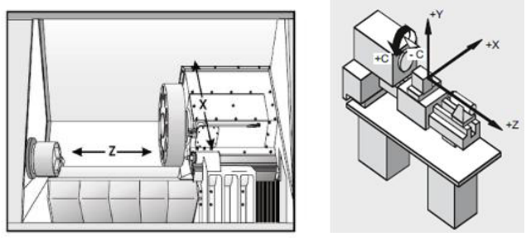
Figure 1. Axis system for turning process

Workpiece design planning for turning operations, including G-code and M-code simulation, can be performed in advance using CAD/CAM software to generate the toolpath and programming code before actual machining is executed [13]. For turning processes without CAD/CAM simulators, X and Z axis planning is done first, followed by CNC program development and toolpath plotting, which simplifies the turning process [14]. This research employs DNMG insert tools in CNC turning of SC45 round bar material, with variations in feedrate, cutting speed, and the use of coolant. These parameters are expected to influence the resulting surface roughness, measured using a surface roughness tester. To ensure accurate testing and focused results, the scope of this study includes: turning of SC45 round bar using a CNC lathe; DNMG insert tools; cutting speeds of 250, 500, and 750 m/min; feedrates of 0.15, 0.25, 0.35, and 0.45 mm/rev; a constant depth of cut of 0.5 mm; no tool angle variation; and wet machining with a coolant mixture ratio of 1:10 between cutting fluid and water. Surface roughness testing was performed using a digital tester model JD360. The machining parameters used in this study were selected to reflect commonly used values in general practice, with results intended to support parameter optimization in CNC turning operations.

Methodology
This research was conducted through an experimental approach to investigate the effect of feedrate and cutting speed on surface roughness in CNC turning of SC45 carbon steel. The specimens were machined under both dry and wet conditions, with systematic parameter variation, followed by surface roughness testing. The material used in this study was SC45 carbon steel round bar with a diameter of 45 mm and a length of 150 mm. The raw material was sectioned into 12 specimens using a cutting grinder with a maximum wheel speed of 3800 m/min and a power output of 2000 W. Fig. 1 shows the cutting machine used in the material preparation phase.

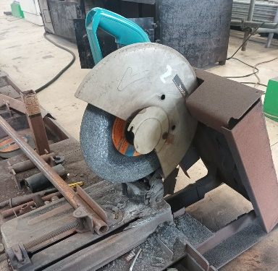
Figure 1. Cutting grinder used to section SC45 round bars
The turning process was carried out using a CNC lathe with specifications including a maximum workpiece diameter of 460 mm, maximum workpiece length of 1255 mm, and bar capacity of 90 mm. The machine featured a three-axis system with X-, Y-, and Z-axis strokes of 260 mm, 100 mm, and 1345 mm, respectively. The experiments were programmed and executed without the use of CAM simulation, based on predefined toolpath and parameter values. Fig. 2 illustrates the CNC turning machine used in this research.

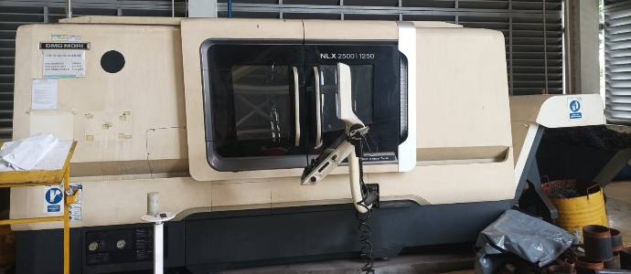
Figure 2. CNC lathe used for the turning experiments

The cutting tool utilized was a DNMG insert mounted on a standard tool holder. The tool angle and depth of cut were kept constant throughout the process. The depth of cut was maintained at 0.5 mm, and no rake or side angle variation was introduced. To evaluate the effect of feedrate and cutting speed, machining was performed with the following parameter settings: The machining was performed using DNMG insert tools mounted on a standard tool holder, without variation in cutting angle. The depth of cut was fixed at 0.5 mm throughout all experiments to maintain consistency. The process parameters were varied using cutting speeds of 250, 500, and 750 meters per minute (m/min), combined with feedrates of 0.15, 0.25, 0.35, and 0.45 millimeters per revolution (mm/rev). Machining trials were conducted in both dry and wet conditions. In the wet condition, a standard water-based coolant was applied in a 1:10 coolant-to-water ratio. No proprietary or internal production coolant formulation was used, and all procedures were designed to follow general industrial practice without referencing any company-specific methods
The turning operations were performed under two different conditions: dry machining and wet machining. In the wet machining condition, a standard industrial coolant was applied at a fixed ratio of 1:10 (coolant to water). No proprietary formulations or internal data were used or disclosed. After machining, surface roughness of each specimen was measured using a JITAIKEYI JD360 digital surface roughness tester. The device has a measurement range of Ra: 0.005–16.000 µm and Rz: 0.02–160.00 µm, with an indication accuracy of 0.001 µm. Each specimen was tested five times to ensure result consistency, and the average Ra values were recorded. Fig. 3 shows the roughness tester used in the experiment.


Figure 3. Surface roughness tester (JD360 model) used for Ra measurements

Dimensional verification before and after machining was conducted using a digital caliper with 200 mm capacity and ±0.02 mm accuracy. This was done to confirm the consistency of the machined length and to identify any deviation during the cutting process.
The experimental design was structured to isolate the influence of each independent variable (cutting speed and feedrate) on the dependent variable (surface roughness). All other machining variables were held constant, including insert type, tool angle, depth of cut, and coolant ratio in wet conditions

Results and Discussion
The experiments were conducted to analyze the surface roughness (Ra) values resulting from CNC turning of SC45 carbon steel under both dry and wet conditions. The roughness of each specimen was measured five times using a digital surface roughness tester, and the average Ra values were used for analysis. The results are organized in two main sections: dry machining and wet machining.

Surface Roughness under Dry Machining Conditions
Table 1 presents the surface roughness values obtained from the dry turning process across various combinations of cutting speeds and feedrates. Each cell in the table represents the average roughness value derived from five measurements on each specimen.

TABLE 1. Surface roughness (Ra) under dry machining conditions.
Cutting Speed (m/min) | 0.15 mm/rev | 0.25 mm/rev | 0.35 mm/rev | 0.45 mm/rev
250 | 2.266 | 2.575 | 3.527 | 3.533
500 | 2.012 | 2.036 | 2.502 | 2.687
750 | 1.321 | 1.413 | 2.066 | 2.207
Average | 2.007 | 2.008 | 2.698 | 2.809

As shown in Table 1, higher cutting speeds tend to produce smoother surfaces. At a cutting speed of 750 m/min and a feedrate of 0.15 mm/rev, the lowest Ra value was recorded at 1.321 µm. In contrast, the highest roughness occurred at the lowest cutting speed (250 m/min) and highest feedrate (0.45 mm/rev), with an Ra of 3.533 µm. These results demonstrate the significant influence of both parameters on surface finish in dry turning. A graphical representation of this trend is shown in Fig. 4, where surface roughness clearly increases with feedrate and decreases with cutting speed.

Figure 4. Surface roughness vs. feedrate and cutting speed under dry machining conditions

Surface Roughness under Wet Machining Conditions
The same experimental parameters were applied under wet machining conditions using a standard water-based coolant with a 1:10 dilution ratio. The results are shown in Table 2, which indicates that the use of coolant leads to generally lower surface roughness values.

TABLE 2. Surface roughness (Ra, µm) under wet machining conditions.
Cutting Speed (m/min) | 0.15 mm/rev | 0.25 mm/rev | 0.35 mm/rev | 0.45 mm/rev
250 | 2.238 | 2.370 | 2.805 | 2.883
500 | 1.845 | 1.895 | 2.362 | 2.398
750 | 1.230 | 1.312 | 1.997 | 2.088
Average | 1.771 | 1.852 | 2.180 | 2.456

Based on Table 2, the surface roughness under wet conditions is consistently lower than that of dry conditions for all parameter combinations. The lowest Ra value was obtained at a cutting speed of 750 m/min and a feedrate of 0.15 mm/rev, measuring 1.230 µm. This indicates the effectiveness of coolant in reducing friction and heat during machining, thus improving surface quality. The data trends are visualized in Fig. 5, which confirms that increasing feedrate results in higher roughness, whereas increasing cutting speed leads to a smoother finish.

Figure 5. Graphs of Roughness Values Against Feedrate and Cutting Speed in Wet Turning

Comparative Analysis
A comparative overview of both conditions indicates that wet machining consistently provides better surface quality than dry machining. For instance, at a cutting speed of 750 m/min and feedrate of 0.45 mm/rev, wet turning produced a surface roughness of 2.088 µm, while dry turning resulted in 2.207 µm. When averaged across all parameters, the mean surface roughness for dry machining was 2.381 µm, whereas wet machining achieved a lower average of 2.118 µm. These findings align with previous studies. Adik and Mahendra [15] emphasized that higher cutting speeds result in better surface finish, while Zubaidi et al. [9] found that lower feedrates contribute significantly to smoother surfaces. Additionally, Rahmi et al. [3] demonstrated the effectiveness of coolant in achieving lower Ra values during turning operations. In summary, this research confirms that both feedrate and cutting speed are critical factors in determining surface finish in CNC turning. Furthermore, the application of coolant can significantly enhance machining quality by reducing tool–workpiece interface temperature and friction.

CONCLUSION
Based on the results of this study, it can be concluded that cutting speed, feedrate, and the use of coolant significantly influence the surface roughness of SC45 carbon steel in CNC turning processes. An increase in cutting speed results in a decrease in surface roughness. This is evident from the lowest roughness values obtained at a cutting speed of 750 m/min, with an average Ra of 1.6571 µm under wet conditions and 1.752 µm under dry conditions. Similarly, feedrate plays a critical role in determining the surface quality. Lower feedrates produce smoother surfaces, as demonstrated by the lowest Ra values recorded at 0.15 mm/rev, which were 1.7713 µm for wet turning and 2.0079 µm for dry turning. Furthermore, the application of coolant was proven to enhance surface finish. Across all parameter combinations, wet machining consistently resulted in lower average roughness (2.1189 µm) compared to dry machining (2.3811 µm). These findings highlight the importance of optimizing machining parameters, particularly cutting speed, feedrate, and coolant usage, to improve surface quality in CNC turning of SC45 carbon steel.

References
- Runtu, R.R., Soukotta, J., and Poeng, R., Analysis of the capability and reliability of Weiler Primus lathe machine through static characteristic testing based on ISO 1708 standard. J. Online Poros Tek. Mesin, 2000. 4(1): p. 63–75.
- Umar, R.B., Munawar, M., and Thamrin, N., Effect of heat treatment on the mechanical properties of SC45 steel welding process with SMAW (Shielded Metal Arc Welding). J. Mechanical Engineering Research, Year unknown: p. –.
- Rahmi, M., Rachmatullah, R., and Umam, K., Effect of coolant and time variation in the turning process on the surface roughness of AISI 4140 steel. J. Mechanical Engineering Research, 2022: p. 13–14.
- Singh, R., et al., Effective use of cutting parameters in turning process to enhance tool life. J. Mechanical and Production Engineering, 2017. 3: p. 1–5.
- Bagus, I., Indra, P., Gde, T., and Nindhia, T., Effect of lathe tool types on surface roughness of machined stainless steel. J. Energi dan Manufaktur, 2013. 6(1): p. 81–86.
- Bayu, N., Effect of spindle speed and feedrate on CNC turning process. J. Mechanical Engineering Research, 2018.
- Golwa, G.V., Romahadi, D., and Arwati, I.G.A., Analysis of characteristics of SC45 steel changes due to the quenching and tempering process. World Chemical Engineering Journal, 2022. 6(2): p. 39.
- Tiwari, R., Das, D., Sahoo, A.K., Kumar, R., Das, R.K., and Routara, B.C., Experimental investigation on surface roughness and tool wear in hard turning of JIS SC45 steel. Materials Today: Proceedings, 2018. 5(11): p. 24535–24540.
- Zubaidi, A., Syafa, I., and Darmanto, A., Effect of cutting parameters on surface roughness. Momentum, 2012. 8(1): p. 40–47.
- Materials, R., and ICT Modules, Reading materials for computer numerical control. Technical Training Manual, 2009. August Issue.
- Çelik, A., et al., Covariance structure analysis of health-related indicators among the elderly in home care focusing on subjective health. J. Mater. Process. Technol., 2018. 1(1): p. 1–8.
- Rahmatullah, R., Amiruddin, A., and Lubis, S., Effectiveness of CNC turning and CNC milling in the machining process. Int. J. Econ. Technol. Soc. Sci., 2021. 2(2): p. 575–583.
- Gao, W., Zhang, C., Hu, T., and Ye, Y., An intelligent CNC controller using cloud knowledge base. Int. J. Adv. Manuf. Technol., 2019. 102(1–4): p. 213–223.
- Kussul, E., et al., CNC machine tools for low-cost micro devices manufacturing. J. Appl. Res. Technol., 2004. 2(01): p. 76–91.
- Adik, M.A., Effect of tool type, spindle speed, and depth of cut on surface flatness and chip formation of ST60 steel during conventional turning. J. Mechanical Engineering Research, Year unknown: p. 311–318.

