Computational Fluid Dynamics (CFD) Analysis and Design Optimization of Industrial Pipeline Systems: A Case Study in an Oil Refinery Facility
Assyfa Julian Faradita^{a)}, Ardi Lesmawanto^{b)}, Budiono^{c)} and
Devicho Maulana Putra^{d)}
Department of Mechanical Engineering, University of Muhammadiyah Malang
Jl. Raya Tlogomas No. 246, Malang 65144, Indonesia.

^{a)} iyan123ali@gmail.com
^{b)} ardilesmawanto@umm.ac.id
^{c)} Corresponding author: budionoft@umm.ac.id
^{d)} tifanymeirista@gmail.com
Abstract. Pipelines are critical components in the oil and gas industry, functioning as the primary medium for transporting fluids such as crude oil, natural gas, and their mixtures. In high-capacity refinery operations, maintaining pipeline efficiency and operational safety is essential to prevent economic and environmental losses. This study presents a computational investigation of fluid flow within an industrial pipeline using Computational Fluid Dynamics (CFD) simulations, with the objective of improving flow efficiency and reducing potential structural failures. A 3D pipeline model was developed and analyzed using ANSYS software to examine pressure distribution, velocity profiles, and turbulence characteristics. Several design parameters, including pipe diameter, wall thickness, and flow conditions, were evaluated to determine the optimal configuration. All simulation inputs were based on representative industrial parameters rather than confidential operational data, ensuring compliance with data security protocols. The optimized design demonstrated a 15% improvement in flow efficiency and a 10% reduction in operating pressure compared to the baseline model. These results highlight the potential of CFD-based optimization to enhance the performance, reliability, and service life of pipeline systems in the oil and gas sector without the need for costly physical modifications.

INTRODUCTION
Improving operational efficiency is one of the main priorities in the oil and gas industry, particularly in managing pipeline systems that serve as the backbone of fluid transportation. In large-scale refinery operations, the challenge lies in ensuring optimal pipeline performance amid high production demands and complex operational conditions. Suboptimal pipeline design and maintenance can lead to various issues, such as increased back pressure, reduced fluid flow efficiency, and potential structural failures. Therefore, an analytical approach capable of mapping fluid flow phenomena in detail, while also providing design recommendations to enhance system efficiency, is highly needed [1].
Computational Fluid Dynamics (CFD) is a numerical simulation method that has proven to be highly effective in analyzing fluid flow behavior within pipeline systems. With its ability to visualize pressure distribution, velocity, and turbulence characteristics, this method offers comprehensive and accurate solutions. Furthermore, simulation-based design optimization enables performance improvements without requiring costly and time-consuming physical modifications.
This research focuses on a case study conducted in a refinery pipeline system (generalized for confidentiality) using the CFD approach to analyze fluid flow behavior. The study also evaluates the existing pipeline design and proposes an optimized configuration to improve operational efficiency. The results are expected to make a tangible contribution to enhancing pipeline system performance, while providing added value in both economic and technical aspects [2].

Methodology
This section describes the process of conducting Computational Fluid Dynamics (CFD) analysis and pipeline design optimization using ANSYS 2021 R1 [2]. The primary objective of the simulation was to identify the flow characteristics within the pipeline, focusing on parameters such as pressure drop and velocity distribution along the installation.

Pipeline Installation Design Dimensions
The pipeline installation design process involved determining the size, layout, and technical specifications to ensure efficient and safe fluid flow, in accordance with operational requirements [3]. The design considered several critical aspects, including pipe diameter selection, wall thickness, routing layout, material selection, load calculation, and compliance with relevant design standards and codes. The generalized dimensions of the installation used in the simulation are summarized in Table 1, which includes overall pipeline dimensions, tank sizes, nozzle diameters, and other structural parameters.

TABLE 1. Generalized Design Specifications of the Pipeline Installation
No | Specification | Dimension
1 | Overall pipeline height | 4638 mm
2 | Overall pipeline length | 9400 mm
3 | Overall pipeline width | 2921 mm
4 | Tank diameter | 2708 mm
5 | Tank height | 550 mm
6 | Nozzle sizes (inlet, outlet, drain, overflow) | 6 in, 12 in, 8 in, 4 in
7 | Tank freeboard | 300 mm
8 | Frame weight | 170 kg
9 | Pipe flange diameter | 400 mm
10 | Drive train component weight | 5 kg

Material Selection
The material selection for the pipeline frame was based on the requirement for structural strength while maintaining manufacturability. A steel-based material was chosen due to its favorable physical and mechanical properties, including high strength, toughness, hardness, ductility, and ease of fabrication [4]. The material specification used in the simulation is shown in Table 1

TABLE 2. Material Specification for the Pipeline Installation.
Frequency (Hz) | Deformation (mm)
3789.5 | 22.313
5744.6 | 28.636
9886.7 | 19.949

CFD Simulation Setup Using ANSYS 2021 R1
The CFD analysis was carried out in several stages. The geometric design of the pipeline was first modeled using SolidWorks, incorporating refinements from a previous design to improve flow efficiency. The 3D geometry included key features such as pipe sections, flanges, and auxiliary components. Once completed, the model was imported into ANSYS Fluent for simulation [5].
The computational domain was defined to represent the internal flow region of the pipeline. The mesh was generated using a Poly-Hexcore configuration, selected for its ability to provide high accuracy for internal flow problems.

TABLE 3. Boundary Conditions for CFD Simulation
Simulation Parameters | Description
INLET
Velocity Specification Method | Magnitude, Normal to Boundary
Reference Frame | Absolute
Velocity Magnitude [m/s] | 1.5
Supersonic/Initial Gauge Pressure [Pa] | 0
Turbulent Specification Method | Intensity and Viscosity Ratio
Turbulent Intensity [%] | 5
Turbulent Viscosity Ratio | 10
OUTLET
Backflow Reference Frame | Absolute
Gauge Pressure [Pa] | 0
Pressure Profile Multiplier | 1
Backflow Direction Specification Method | Normal to Boundary
Turbulent Specification Method | Intensity and Viscosity Ratio
Backflow Turbulent Intensity [%] | 5
Backflow Turbulent Viscosity Ratio | 10
Backflow Pressure Specification | Total Pressure
Build artificial walls to prevent reverse flow? | no
Radial Equilibrium Pressure Distribution | no
Average Pressure Specification? | no
Specify targeted mass flow rate | no
WALL
Pipe wall
Wall Motion | Stationary Wall
Shear Boundary Condition | No slip
Wall Surface Roughness | Standard
Wall Roughness Height [m] | 0
Wall Roughness Constant | 0.5
Flange Inlet dan Flange Outlet
Wall Motion | Stationary Wall
Shear Boundary Condition | No Slip
Wall Surface Roughness | Standard
Wall Roughness Height [m] | 0
Wall Roughness Constant | 0.5
Boundary conditions were applied as summarized in Table 3. The inlet velocity was set to 1.5 m/s, with a turbulent intensity of 5% and a viscosity ratio of 10. The outlet was defined at zero gauge pressure. Pipe walls were modeled as stationary with a no-slip condition and standard surface roughness parameters.
The turbulence model selected was the k–ω SST model [6, 7, 8], which is well-suited for capturing complex flow features and is commonly applied in industrial CFD simulations.
Following the setup, the simulation was initialized using the hybrid initialization method [9]. The solver configuration included pressure–velocity coupling and second-order spatial discretization schemes for improved accuracy.
The post-processing phase involved extracting both qualitative and quantitative results. Quantitative results included pressure drop, facet average velocity, and turbulent kinetic energy, while qualitative results consisted of contour plots, streamline visualizations, and velocity profiles.

Results and Discussion
In this section, the analysis focuses on the main body of the pipeline. The design geometry was evaluated through three-dimensional CFD (Computational Fluid Dynamics) simulations using ANSYS 2021 R1. The simulation generated contour plots for pressure, velocity, pressure drop (C_{p}), and turbulent kinetic energy (TKE), which were used to assess flow distribution, velocity profiles, and pressure variations within the system [11].

Pressure and Velocity Distribution in the Pipeline
The pressure contour surrounding the pipeline body, obtained from ANSYS 2021 R1, is shown in Fig. 1. The results indicate a noticeable variation in pressure between different points in the system. This difference is influenced by factors such as fluid viscosity, flow velocity, pipeline geometry, and surface roughness. Pressure distribution analysis provides valuable insight into energy losses in the system [12].
Similarly, the velocity distribution inside the pipeline illustrates how fluid velocity changes from one point to another. These variations depend on inlet flow velocity, internal resistance, and the flow regime (laminar or turbulent). Analyzing velocity distribution is critical in designing efficient systems to avoid issues such as noise, vibration, or excessive pipe wear [13].

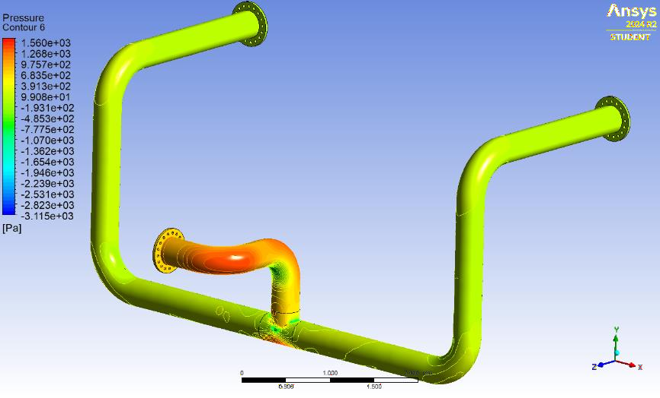 | 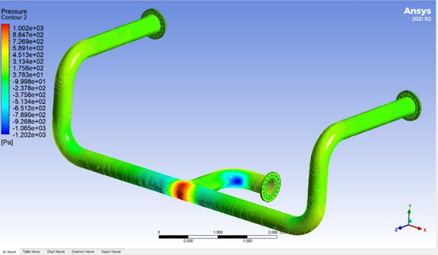
(a) | (b)
Figure 1. Pressure and velocity contours inside the pipeline: (a) Initial design, (b) Optimized design.

Flow Velocity Analysis
Quantitative analysis was conducted to support and validate the qualitative observations from the simulation. Both the pressure drop and turbulent kinetic energy (TKE) values for the optimized design were determined through simulation and further analysis.

Streamline Velocity
The streamline velocity distribution, shown in Fig. 2, reveals that in the optimized design, the fluid velocity is more uniform both in the central region and near the pipe wall. The flow remains stable along the pipeline length, with fewer stagnation zones. Smooth directional changes maintain a consistent flow with minimal velocity fluctuations [14].

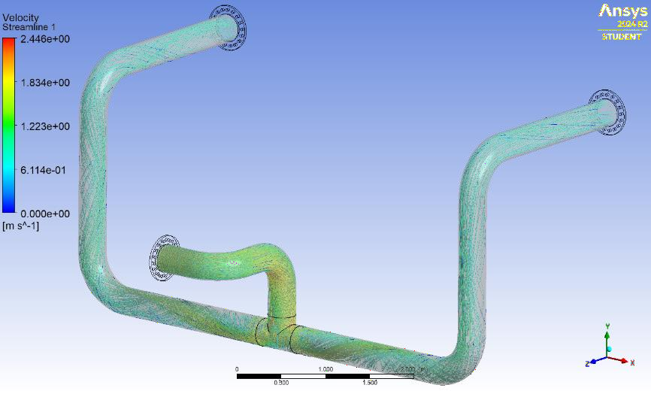 | 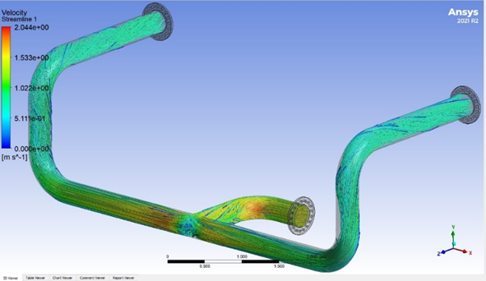
(a) | (b)
Figure 2. Streamline velocity distribution: (a) Initial design, (b) Optimized design.

Turbulent Kinetic Energy (TKE)
Turbulent kinetic energy, which quantifies the kinetic energy of velocity fluctuations in turbulent flow, is presented in Fig. 3. The results show lower TKE values in the optimized design, indicating more controlled flow behavior and improved hydraulic performance [15]. Reduced turbulence offers several operational benefits: The optimized pipeline design demonstrates a significant reduction in maximum turbulent kinetic energy, which directly enhances flow stability and minimizes energy losses caused by turbulence. This improvement is accompanied by smoother flow characteristics, where recirculation zones and vortex formations are substantially reduced, leading to a more uniform velocity profile along the pipeline. Furthermore, the lower internal friction achieved in the optimized configuration contributes to improved energy efficiency, as less pumping power is required to maintain the desired flow rate, thereby reducing overall operational energy consumption.

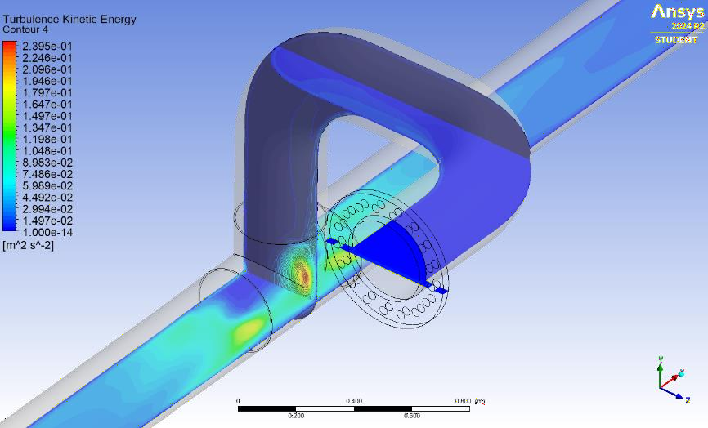 | 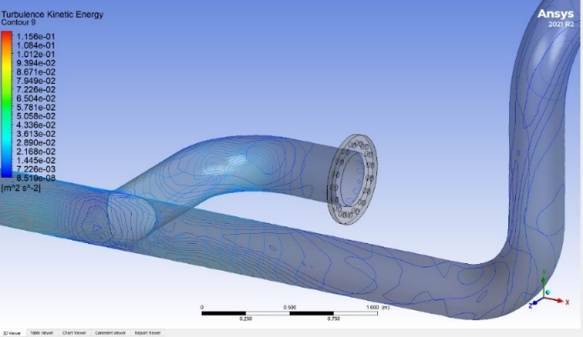
(a) | (b)
Figure 3. Turbulent kinetic energy distribution in the pipeline: (a) Initial design, (b) Optimized design.

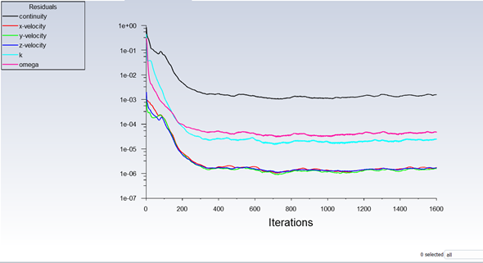
Figure 4. Residual convergence history

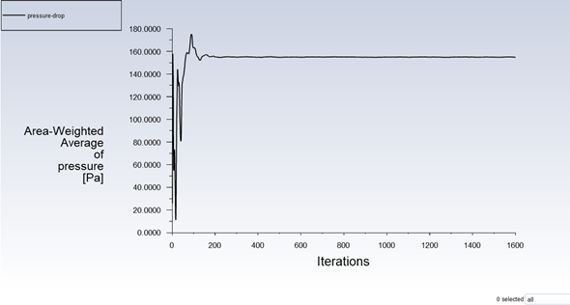
Figure 5. Vertex average pressure history

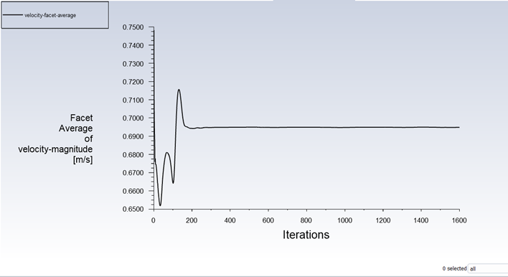
Figure 6. Velocity variation along the pipeline axis

The residual plot in Fig. 4 demonstrates a gradual decrease in residual values with each iteration, achieving a stable convergence. This confirms the numerical method's effectiveness in reducing errors during the simulation process [16]. The vertex average pressure history in Fig. 5 shows a consistent decrease over iterations, indicating a pressure drop along the pipeline caused by wall friction [17]
Velocity variation along the pipe axis is illustrated in Fig. 6, where a sharp velocity increase is observed near the inlet as the flow adapts to initial conditions and geometry. Downstream, the velocity stabilizes, forming a fully developed turbulent flow profile [18]. The facet average velocity shown in Fig. 7 initially fluctuates but gradually stabilizes with further iterations, indicating that the flow has reached a steady-state condition [19, 20]

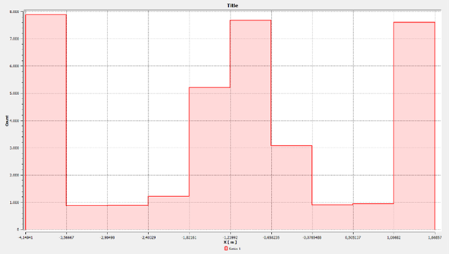
Figure 7. Facet average velocity convergence

CONCLUSION
Based on the fluid flow analysis conducted using numerical modeling in ANSYS 2021 R1, it can be concluded that the initial pipeline design exhibited notable limitations in terms of flow efficiency, as evidenced by a high pressure drop and a non-uniform velocity distribution along the pipe. In contrast, the optimized design demonstrated significant improvements, producing a more uniform velocity distribution and lower pressure drop, thereby indicating enhanced fluid flow performance. The new design also reduced the energy required to transport fluid through the system, contributing to long-term operational cost savings, particularly in continuously operating systems. Furthermore, the optimization not only improved efficiency but also enhanced reliability by minimizing turbulence and flow disturbances that could adversely affect operational performance. This improvement is expected to extend the service life of the pipeline due to a more even distribution of pressure and stress within its structure. Overall, the analysis confirmed that the optimized pipeline design and installation are valid and suitable for practical application, with the CFD simulation providing a clear and detailed representation of system performance to ensure that operational specifications are met.

References
- Behera, S.S., CFD analysis of heat transfer in a helical coil heat exchanger using Fluent. 2013: p. 23.
- Hendriyarto, M.S., Experimental study of flow characteristics through a square duct and square elbow 90° with inlet disturbance body in the form of a circular cylinder varied on the inner side of the 90-degree elbow. 2017: p. 2.
- Yudhatama, I.W., et al., Computational fluid dynamics (CFD) simulation of sand particle erosion in turbulent gas flow in a vertical-horizontal pipe elbow. 2018: p. 134.
- Kanade, R.H., et al., Heat transfer enhancement in a double pipe heat exchanger using CFD. 2015. 02(09): p. 422.
- Maulana, S.S., Optimization analysis of fluid flow in the condensation pipe of a water-from-atmosphere generator based on computational fluid dynamics (CFD). 2019: p. 6.
- Prayuga, I.Y., Performance analysis of the effect of using water (H₂O) as the working fluid and the addition of a tube heat exchanger in the H-Flory (Horticulture Fluid Flow Drier) using computational fluid dynamics (CFD). 2018: p. 9.
- Goya, P., et al., CFD analysis of helical coil heat exchanger. 2018: p. 73.
- Vajjha, R.S., et al., Numerical study of fluid dynamic and heat transfer performance of Al₂O₃ and CuO nanofluids in the flat tubes of a radiator. August 2010: p. 616.
- Vajjha, R.S., et al., Numerical study of fluid dynamic and heat transfer performance of Al₂O₃ and CuO nanofluids in the flat tubes of a radiator. August 2008: p. 616.
- Setiawan, H., CFD simulation for pressure fluctuation in steam condensation in horizontal concentric pipes with co-current cooling in the annulus. 2017: p. 3.
- Shaw, C., Using computational fluid dynamics. 1992: p. 112.
- Hayati, N., et al., CFD (computational fluid dynamics) analysis to evaluate head loss due to diameter changes. 2023. 18: p. 3.
- Ir., I., et al., Analysis of liquid fluid flow profile and pressure drop in L-pipes using computational fluid dynamics (CFD) simulation method. 2019: p. 106.
- Yudhatama, I.W., et al., Computational fluid dynamics (CFD) simulation of sand particle erosion in turbulent gas flow in a vertical–horizontal pipe elbow. 2018. 7: p. 137.
- Rekayana, E., and Widyaparaga, A., CFD simulation of wave frequency dynamics in oil–water two-phase flow in horizontal pipes. 2020: p. 107.
- CFD analysis of two-phase flow characteristics in a 90-degree elbow. 2011: p. 171.
- Rais, A., et al., Fluid flow analysis in a piping and cyclone system for a preduster coal mill at Indarung V plant using flow simulation. 2023. 5: p. 4.
- Fathoni, W., Analysis of fluid flow (fully developed flow) in a circular pipe using CFD Fluent. 2018. 2: p. 47.
- Yudhatama, I.W., Department of Materials and Metallurgical Engineering, Computational fluid dynamics (CFD) simulation of sand particle erosion in turbulent gas flow in a vertical-horizontal pipe elbow. 2018: p. 14.
- Nashrullah, I., et al., CFD ANSYS simulation design of the effect of siphon height on pressure distribution and water discharge along the pipeline in small-scale clean water supply industries. September 2019: p. 6.

