Structural Behavior of a Shell and Tube Heat Exchanger Under Thermal Steady - State Conditions Using Finite Element Analysis
Muhammad Meirza Nurdiansyah^{1,a)}, Muhammad Lutfi Kamal^{1, b)},Achmad Fauzan Hery Soegiharto^{1,c)}, Suwarsono Suwarsono^{1,d)}, Nur Hasanah^{1,e)}
Author Affiliations
¹Universitas Muhammadiyah Malang,
Jl. Raya Tlogomas No. 246, Malang, Jawa Timur, Indonesia.
Author Emails
^{a)} meirzanurdiansyah@webmail.umm.ac.id
^{b)} muhammadlutfi@webmail.umm.ac.id
^{c)} achmadfauzan@umm.ac.id,
^{d)} suwarsono@umm.ac.id
^{e)} Corresponding author: nurhasanah02@umm.ac.id
Abstract. This study examines the structural performance of a Shell and Tube Heat Exchanger (STHE) under thermal steady-state conditions using Finite Element Analysis (FEA). The system geometry was modeled in Autodesk Inventor, and numerical simulations were performed in ANSYS 2025 R1. Stainless Steel 304 was selected as the construction material, with thermo-mechanical properties obtained from the Mat Web database. Thermal analysis indicated that steady state was achieved at 10 seconds, with a maximum temperature of 185.84 °C and a minimum of 112.22 °C, producing a thermal gradient of 73.62 °C. Structural analysis revealed a maximum equivalent stress of 1466.2 MPa, substantially exceeding the material’s yield strength. The observed high stress and strain concentrations indicate a potential risk of localized failure due to thermal expansion. These findings highlight the critical role of numerical simulation in the thermo-mechanical optimization of energy and industrial systems.

INTRODUCTION
A heat exchanger is a device used to transfer heat between two fluids without direct contact between them[1]. This device can serve to either heat or cool the working fluid. The heat transfer process involves conducting through the separating wall and convectionwithin fluid [2]. This phenomenon is known as conjugate heat transfer, which occours simultaneously within the heat transfer system [3]. Heat exchanger are widely applied in power plants, the food industry, HVAC, and other manufacturing sectors [4].
Steady – state thermal and structural analyses can be employed to ensure the efficiency and reliability of a heat exchanger under operational conditions [5]. Steady – state thermal analysis aims to examine the temperature distribution and heat flow in a system whose temperature remains constant over [6]. Meanwhile, structural analysis is required to evaluete the stress, strain, and deformation that occur due to temperature differences and system pressure [7].
Various methods have been developed to improve heat transfer efficiency and structural durability in heat exchangers Beragam metode [8]. Reviews of thermal efficiency enhancement techniques indicate that these strategies play a critical role in overall system performance [9]. Both experimental approaches and numerical simulations are widley used to assess thermal performance. Exergy analysis results indicate that efficiency is significantly influenced by mass flow rate and fluid temperature [10]. These factor must be considered in the design and operation of heat exchangers to achieve optimal efficiency.
Whit technological advancements, approaches based on Finite Element Analysis (FEA) are increasingly utilized in both thermal and structural evaluations. Numerical methods enable the assessment of complex parameters that are difficult to evaluate experimentally [11]. Previous studies have shown that FEA can accurately simulate thermal loads in heat transfer systems. Morever, numerical modeling has proven effective in analyzing stress and deformation resulting from thermal expansion [12]. This approach enhances accuracy in evaluating heat exchanger designs.
The structural durability of a shell and tube heat transfer exchanger under steady thermal loads is analyzed using the FEA approach. This analysis includes evaluating the temprature distribution and the structural response of the shell and tube heat exchanger under thermal steady – state conditions. The main contributions of this study is to reveal the influence of thermal and mechanical loads on the structural performance of the heat exchanger. These finding can serve as a reference for selecting efficient and durable materials and design parameters for industrial applications.
.

METHODOLOGY
The reserch procedure involved geometry modeling, material definitions, boundary conditions applications, meshing, solving, and post – processing of the simulation result. The study was conducted using Finite Element Analysis (FEA) to evaluete the structural response under steady thermal loads for the developed heat exchanger model [13]. The simulation was performed using ANSYS 2025 R1 (Student version).
The geometry modeling of the shell and tube heat exchanger (Figure 2) was carried out using Autodesk Inventor. The geometric details included shell wall thickness, baffle dimensions, and tube length, adjusted according to the actual design (Figure 1). Geometric simplifications were applied to reduce computational complexity Whitout compromising the accuracy of the simulations results.
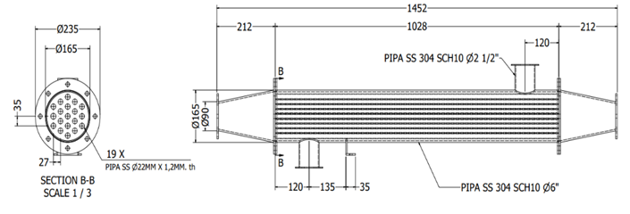
Figure 1. Dimension Shell and Tube Heat Exchanger

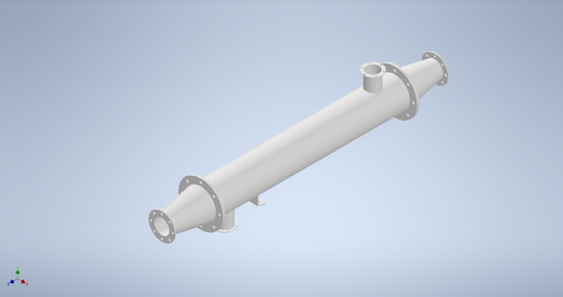
Figure 2. CAD Model of Shell and Tube Heat Exchanger

Material property definitions was conducted to ensure that the simulation accurately represented the actual system conditions. The parameters included elastic modulus, density, and thermal expansion coefficient. The material used in the analysis was Stainless Steel 304 (SS 304). Table 1 presents the mechanical and thermal properties od SS 304 obtained from the Matweb database [14].

Table 1. Material Properties of SS 304
Parameter | Value
Density | 8000 Kg/m³
Ultimate Tensile Strength | 505 MPa
Yield Strenght | 215 MPa
Thermal Expansion Coefficient | 1,8 × 10⁻⁵ C⁻¹
Thermal Conductivity | 16,2 W/m·K
Heat Capacity (cₚ) | 500 J/kg·K

The simulation procces generated 35,983 nodes and 9,084 elements in the simulation model, as shown in figure 3. The methods applied included MultiZone meshing for one components and body Body Sizing for the remaining five components. Mesh control setting used “Elements Order: Program Controlled” for automatic optimization by the software, allowing element selection to match the geometry complexity and numerical analysis requirements [15].
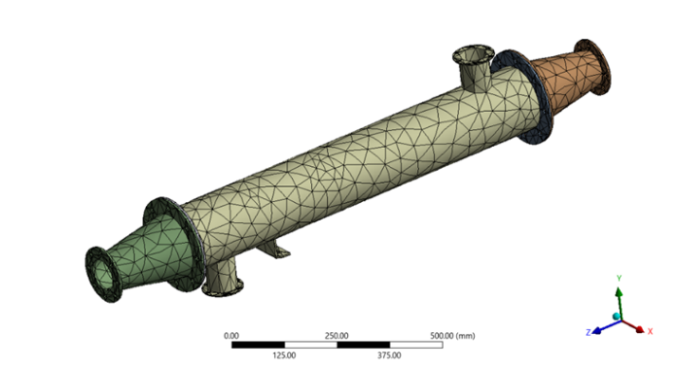
Figure 3. Mesh Generation Result

In the numerical solving stage, the system of equations derived from the finite element modeling (FEM) was solved by applying boundary conditions, loading, and solutions to the global stiffness matrix [16]. The simulation results included stress distribution, strain distribution, and other physical parameters. The accuracy of the results was highly dependent on the precision in defining boundaries and selecting the numerical method.

Table 2.Thermal Conditions
No | Parameter | Value
1 | Initial temperature of shell region | 260 °C
2 | Steady-state temperature of shell region | 180 °C
3 | Initial temperature of tube region | 22 °C
4 | Steady-state temperature of tube region | 120 °C
5 | Convection | Stagnant air - horizontal cyl

Table 3. Mechanical Conditions
No | Parameter | Value
1 | Thermal Load | Imported Body Temperature (Steady State Thermal)
2 | Elastic Support | Applied to bolt areas at 200 N/mm² (elastic modulus of bolts made from stainless steel) to restrict movement due to thermal expansion

The final stage was post-processing, which involved visualization and evaluation of the numerical simulation results. The analyzed data included stress distribution, strain distribution, and safety factor. Evaluation was conducted using graphs, contour plots, and animations to understand the structural response to loading [17]. Visualization helped identify stress concentration areas and potential failure zones in the analyzed components.
The steady-state thermal analysis was carried out to evaluate the operating temperature of the heat exchanger based on the boundary conditions listed in Table 2. The convection boundary condition referred to the "stagnant air – horizontal cylinder" model with a heat transfer coefficient of 1,24 × 10⁻⁶ W/mm²·°C. The simulation was run until 10 seconds, marking the point at which the system reached thermal steady-state (Figure 4).
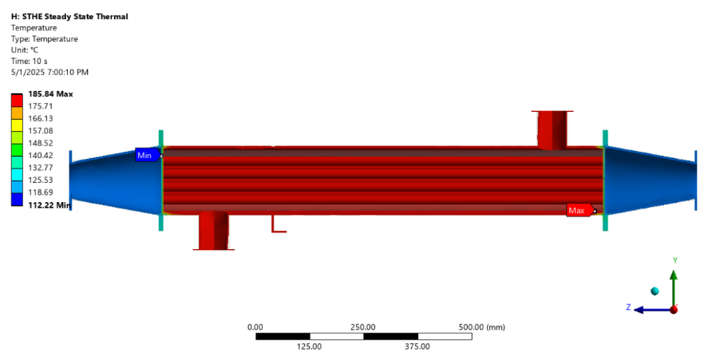
Figure 4. Temperature Distribution

The structural analysis was conducted to evaluate the equivalent (von Mises) stress and thermal strain due to thermal loading imported from the steady-state thermal analysis. The simulation results indicated that the maximum equivalent stress reached 1466,2 MPa, occurring in the STHE structure (Figure 5). This value far exceeded the yield strength of Stainless Steel 304 (215 MPa), indicating a risk of local plastic deformation, particularly in the baffle section.
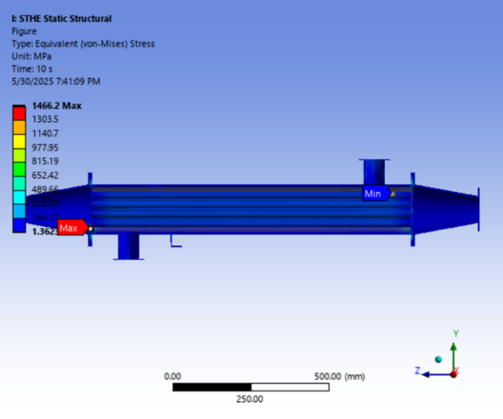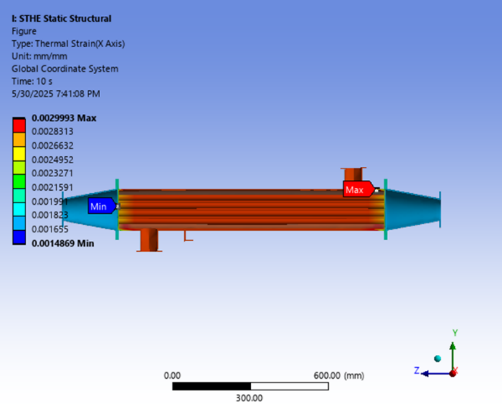
Figure 5. Equivalent (von-Mises) Stress (left), Thermal Strain (right)
Meanwhile, the maximum thermal strain of 2,9993 × 10⁻³ mm/mm was recorded in the convection area at 10 seconds (Figure 5). indicating significant material expansion due to high temperature gradients between components.

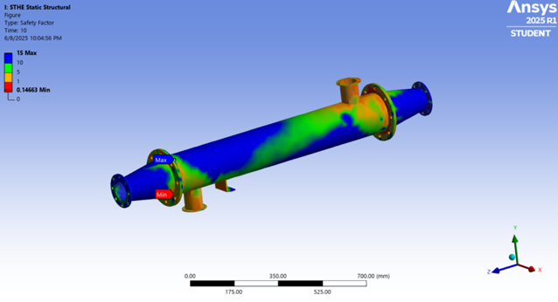
Figure 6. Safety Factor.

The safety factor is defined as the ratio between the material’s yield strength and the maximum stress occurring due to thermal loading. Based on the simulation results (Figure 6), the minimum safety factor was recorded at 0,077 at the beginning of the simulation (t = 1 s), and gradually increased at each time interval.

RESULTS AND DISCUSSION)
The simulation results illustrate the progression of temperature distribution over a 10-second period. At the beginning of the simulation (t = 1 s), the minimum temperature was recorded at -8,86°C and the maximum at 283,17°C. These values indicate that heat distribution was not yet uniform, and the system was still in the process of adjusting the temperature between components. Over time, the system temperature gradually equalized. At the end of the simulation (t = 10 s), the minimum temperature increased to 112,22°C, while the maximum decreased to 185,84°C, with the average system temperature reaching 148,27°C (Table 4).

Table 4. Temperature Changes in Tube Region, Shell Region, and System until Steady-State
Time [s] | Tube Temperature [°C] | Shell Temperature [°C] | Minimum [°C] | Maximum [°C] | Average [°C]
1 | 22 | 260 | -88,624 | 283,17 | 134,15
2 | 32,889 | 251,11 | 4,5911 | 272,36 | 135,72
3 | 43,778 | 242,22 | 18,045 | 261,54 | 137,29
4 | 54,667 | 233,33 | 31,498 | 250,73 | 138,86
5 | 65,556 | 224,44 | 44,952 | 239,91 | 140,43
6 | 76,444 | 215,56 | 58,405 | 229,1 | 141,99
7 | 87,333 | 206,67 | 71,859 | 218,28 | 143,56
8 | 98,222 | 197,78 | 85,312 | 207,47 | 145,13
9 | 109,11 | 188,89 | 98,766 | 196,66 | 146,7
10 | 120 | 180 | 112,22 | 185,84 | 148,27

The difference between the maximum and minimum temperatures at t = 10 s was 73.62°C. This thermal gradient serves as the primary cause of thermal strain and stress within the structure. The increasingly uniform temperature distribution indicates that the system had reached a thermal steady-state condition, where temperature changes over time became negligible.
The temperature distribution in the shell and tube components shows dominant heat transfer from the shell side (hot fluid) to the tube side (cold fluid), as depicted in the simulation visualization (Gambar 4). This confirms that both conductive and convective heat transfer occurred effectively through the tube wall, consistent with the operating principles of a shell-and-tube heat exchanger.
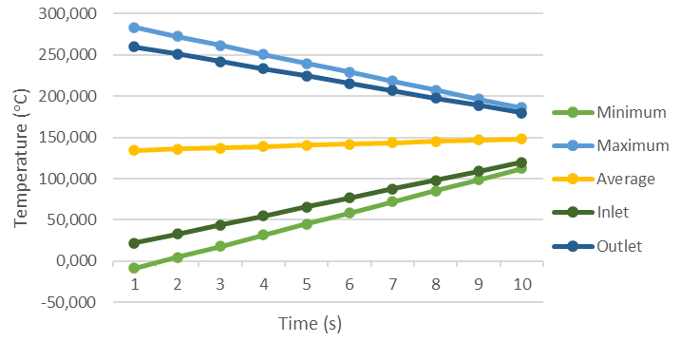
Figure 6. Temperature Result
From Figure 8, it can be concluded that the system functioned according to its design purpose of transferring heat between fluids. The thermal steady-state condition achieved at t = 10 s served as the main reference for subsequent structural analysis, which considered the influence of temperature on the mechanical integrity of the components.
A static structural analysis was performed to evaluate the mechanical response of the shell-and-tube heat exchanger under the final temperature distribution from the steady-state thermal analysis. The thermal load was directly imported as body temperature into the static structural model, accounting for the effects of thermal expansion on stress, strain, and safety factor.
The results of the temperature distribution at the end of the simulation time (t = 10 seconds) are used as thermal load input in the Static Structural analysis. The goal of this stage is to evaluate the mechanical response of the structure due to thermal expansion that occurs during the heat transfer process.
The applied boundary conditions included an elastic support at the bolt areas with a modulus of 200 N/mm² (elastic modulus of bolts made of Stainless Steel) to restrict movement caused by thermal expansion. All components were modeled using Stainless Steel 304, with a modulus of elasticity of 193 GPa and a yield strength of 215 MPa.
The simulation results were analyzed in terms of total deformation, thermal strain, equivalent (von Mises) stress, and safety factor, all of which are summarized in Table 5

Table 5 Changes in Strain, Thermal Stress, and Safety Factor Over Time in Static Structural Simulation
Time [s] | Strain | Stress (MPa) | Safety Factor
1 | 4,9000E-03 | 2780,8 | 0,077
2 | 4,6888E-03 | 2559,7 | 0,084
3 | 4,4777E-03 | 2339 | 0,092
4 | 4,2665E-03 | 2118,6 | 0,101
5 | 4,0553E-03 | 1898,6 | 0,113
6 | 3,8441E-03 | 1679,4 | 0,128
7 | 3,6329E-03 | 1461,1 | 0,147
8 | 3,4217E-03 | 1323,6 | 0,162
9 | 3,2105E-03 | 1380,7 | 0,156
10 | 2,9993E-03 | 1466,2 | 0,147

The simulation results show the development of structural response due to thermal expansion over 10 seconds. The maximum thermal strain decreased from 4,9 × 10⁻³ mm/mm at the beginning of the simulation 2,9993 × 10⁻³ mm/mm at the end of the simulation time. This indicates that even though expansion is still occurring, the increasingly uniform heat distribution causes a decrease in strain intensity within the structure. This value can be calculated using the equation:
$ε=α∙∆T$ (1)

Where $α$ is the coefficient of thermal expansion of$1,8 ×{10}^{-5}°C^{-1}$ for material SS 304. Temperature difference $(∆T)$ between the maximum temperature and the reference temperature is 163,84°C (185,84°C − 22°C). Substituting values into the equation results in:
$$ε=\left(1,8 ×{10}^{-5}°C⁻¹\right)×\left(163,84°C\right)=2,99× {10}^{-3}$$

The maximum equivalent (von Mises) stress decreased significantly from 2780,8 MPa at the start of the simulation to 1466.2 MPa at the 10-second mark. Despite the reduction, this value still far exceeded the yield strength of SS 304 (215 MPa), suggesting a high risk of localized plastic deformation—particularly in the baffle region, which acts as a structural weak point. Minor increases in stress after the minimum point may be due to internal stress redistribution or thermal lag effects, indicating that the system was approaching a new equilibrium state.
The safety factor, as an addition to understand the margin between the actual voltage and the yield strength limit of the material. The trend of increasing safety factors illustrates the enhancement of structural stability along with the flattening of temperature distribution. At the 10th second, the safety factor value reached 0.147, indicating that the system is starting to move towards a safe condition even though it is still below the ideal threshold (>1).

CONCLUSION
Thermal and structural analyses of the Shell-and-Tube Heat Exchanger (STHE) were conducted using the Finite Element Analysis (FEA) approach in ANSYS. The thermal simulation showed that the system reached thermal steady-state at t = 10 seconds with a stable and uniform temperature distribution. The maximum temperature was recorded at 185.84°C and the minimum at 112.22°C, resulting in a thermal gradient of 73.62°C.
The structural analysis revealed that thermal loads from the temperature distribution produced a maximum thermal stress of 1466.2 MPa, which exceeded the yield strength of Stainless Steel 304 (215 MPa), indicating the potential for local plastic deformation in the baffle region. The maximum thermal strain was recorded at 2,9993 × 10⁻³ mm/mm. The system’s safety factor showed a tendency toward stability but remained below the commonly accepted minimum standard (>1).
These results indicate that while the STHE can achieve high heat transfer efficiency, structural reinforcement or design modification is required—particularly in regions with high stress concentrations. Recommendations from this study include optimizing the design and selecting materials with higher structural resistance to thermal expansion. Furthermore, future research is suggested to assess the effects of long-term thermal cycling, alternative material usage, and the influence of dynamic loading on STHE performance.
.

References
[1] P. Rambabu, T. Srikanth, P. Anusha, and B. Jyothi, “Experimental Analysis to Enhance the Performance of Shell and Tube Exchanger With Ribs,” E3S Web Conf., vol. 430, 2023, [Online]. Available: https://doi.org/10.1051/e3sconf/202343001235
[2] E. L. F. Ayuni et al., “The Effect of Insulation Thickness on Heat Transfer Characteristics and Flammability in Tube Mesoscale Combustors,” Journal of Advanced Research in Fluid Mechanics and Thermal Sciences, vol. 116, no. 2, pp. 157–171, 2024, doi: 10.37934/arfmts.116.2.157171.
[3] S. Y. Waware, S. S. Kore, and S. P. Patil, “Heat Transfer Enhancement in Tubular Heat Exchanger with Jet Impingement: A Review,” Journal of Advanced Research in Fluid Mechanics and Thermal Sciences, vol. 101, no. 2, pp. 8–25, 2023, doi: 10.37934/arfmts.101.2.825.
[4] E. Tavousi, N. Perera, D. Flynn, and R. Hasan, “Heat transfer and fluid flow characteristics of the passive method in double tube heat exchangers: A critical review,” International Journal of Thermofluids, vol. 17, p. 100282, Feb. 2023, doi: 10.1016/J.IJFT.2023.100282.
[5] S. Bhattacharyya et al., Thermal performance enhancement in heat exchangers using active and passive techniques: a detailed review, vol. 147, no. 17. Springer International Publishing, 2022. doi: 10.1007/s10973-021-11168-5.
[6] A. Belhocine, D. Shinde, and R. Patil, “Thermo-Mechanical Coupled Analysis-Based Design of Ventilated Brake Disc Using Genetic Algorithm and Particle Swarm Optimization,” SAE International Journal of Passenger Cars - Mechanical Systems, vol. 14, no. 2, pp. 137–150, 2021, doi: 10.4271/06-14-02-0009.
[7] A. Plesca and L. Mihet-Popa, “Thermal analysis of power rectifiers in steady-state conditions,” Energies, vol. 13, no. 8, 2020, doi: 10.3390/en13081942.
[8] V. P. Fahriani, R. Setiawan, F. Hrdlička, and S. Darmanto, “Thermal Design Optimization of No Phase Change Shell-and-Tube Heat Exchanger using Particle Swarm Algorithm,” JEMMME (Journal of Energy, Mechanical, Material, and Manufacturing Engineering), vol. 6, no. 1, pp. 1–14, 2021, doi: 10.22219/jemmme.v6i1.11766.
[9] S. A. Marzouk, M. M. Abou Al-Sood, E. M. S. El-Said, M. M. Younes, and M. K. El-Fakharany, A comprehensive review of methods of heat transfer enhancement in shell and tube heat exchangers, vol. 148, no. 15. Springer International Publishing, 2023. doi: 10.1007/s10973-023-12265-3.
[10] M. M. Rashidi, I. Mahariq, M. Alhuyi Nazari, O. Accouche, and M. M. Bhatti, “Comprehensive review on exergy analysis of shell and tube heat exchangers,” Journal of Thermal Analysis and Calorimetry, vol. 147, no. 22, pp. 12301–12311, 2022, doi: 10.1007/s10973-022-11478-2.
[11] M. Venkateswar Reddy, B. Hemasunder, S. V. Ramana, P. Ramesh Babu, P. Thejasree, and J. Joseph, “State of art on FEM approach in inverse heat transfer problems for different materials,” Materials Today: Proceedings, Jul. 2023, doi: 10.1016/J.MATPR.2023.06.323.
[12] S. Paul, “Finite element analysis in fused deposition modeling research: A literature review,” Measurement, vol. 178, p. 109320, Jun. 2021, doi: 10.1016/J.MEASUREMENT.2021.109320.
[13] M. Peksen, “Thermomechanical Modelling of Materials and Components,” Multiphysics Modelling, pp. 161–180, 2018, doi: 10.1016/B978-0-12-811824-5.00006-7.
[14] Matweb, “MatWeb, Your Source for Materials Information,” MatWeb, pp. 1–2, 2015.
[15] Q. Li and L. Xie, “Analysis and optimization of tooth surface contact stress of gears with tooth profile deviations, meshing errors and lead crowning modifications based on finite element method and taguchi method,” Metals, vol. 10, no. 10, pp. 1–28, 2020, doi: 10.3390/met10101370.
[16] M. Cremonesi, A. Franci, S. Idelsohn, and E. Oñate, “A State of the Art Review of the Particle Finite Element Method (PFEM),” Archives of Computational Methods in Engineering, vol. 27, no. 5, pp. 1709–1735, 2020, doi: 10.1007/s11831-020-09468-4.
[17] R. Anderson et al., “MFEM: A modular finite element methods library,” Computers and Mathematics with Applications, vol. 81, pp. 42–74, 2021, doi: 10.1016/j.camwa.2020.06.009.

