Experimental Study on the Effect of Sacrificial Anodes and Salinity on the Corrosion Rate of SS400 Steel in Marine Environments
Muhammad Rizky Zulfiryansyah^{a)}, Dini Kurniawati^{b)}, Heni Hendaryati^{c)} and Muhammad Hilmi^{d)}
Department of Mechanical Engineering, University of Muhammadiyah Malang
Jl. Raya Tlogomas No. 246, Malang 65144, Indonesia.

^{a)}thecomment.07@gmail.com
^{b)}Corresponding author: dini@umm.ac.id
^{c)}heni@umm.ac.id
^{d)}muhilmi270805@gmail.com
Abstract. The submerged surface of structural steel components in marine environments is highly susceptible to corrosion, leading to a reduction in structural integrity and service life. This experimental study investigates the effectiveness of zinc and magnesium sacrificial anodes in mitigating corrosion on SS400 steel specimens exposed to artificial seawater with varying salinity levels. Corrosion rates were evaluated using the weight loss method, with salinity levels ranging from 3.00% to 4.00%. Three specimen conditions were tested: without anode, with zinc anode, and with magnesium anode protection. The results showed that magnesium sacrificial anodes provided superior protection compared to zinc, significantly reducing corrosion rates. Furthermore, an increase in salinity was found to intensify corrosion. The findings contribute to a better understanding of cost-effective corrosion control methods in simulated marine environments.

INTRODUCTION
Indonesia is recognized as one of the world’s largest maritime nations, with a territorial composition consisting of approximately 71% ocean and 29% land. The country possesses around 17,504 islands, a sea area of 5.8 million km², and a coastline extending over 54,716 kilometers [1]. This geographical advantage, along with its strategic location, positions Indonesia as a crucial pathway for global economic trade, particularly through the utilization of sea routes and marine vessels.
Among the various structural components in marine applications, steel plates—especially those submerged or partially submerged—are constantly exposed to seawater, making them highly vulnerable to corrosion. This form of material degradation may lead to a reduction in structural strength and service life, thus compromising overall system safety. Corrosion can be managed or delayed through both passive protection (e.g., coatings) and active protection methods such as sacrificial anodes.
Corrosion is defined as the degradation of a metal due to electrochemical or chemical reactions between the metal and its environment, often resulting in loss of mechanical properties, roughened surfaces, or even structural failure [2]. It is a natural phenomenon that occurs when materials interact with water and oxygen. As described by researchers, corrosion is as inevitable as taxes and death—unavoidable, yet manageable through understanding and mitigation [2]. Due to its destructive nature, corrosion poses both economic and safety risks [3].
Various methods have been developed to control corrosion rates. One of the most cost-effective and simple methods is the addition of inhibitors to the corrosive medium [4]. However, in marine applications where large structures are involved, galvanic protection through sacrificial anodes is often preferred due to its practicality and long-term effectiveness.
This study investigates the influence of sacrificial anode materials—specifically zinc and magnesium—on the corrosion behavior of SS400 steel in a simulated marine environment. Additionally, it examines how variations in salinity affect the corrosion rate. The experimental approach uses the weight loss method over a controlled 7-day immersion period. The results are expected to support the development of effective and affordable corrosion mitigation strategies in marine settings.

Methodology
This study was conducted through a series of controlled laboratory experiments aimed at evaluating the corrosion rate of SS400 carbon steel in artificial seawater under different salinity levels, with and without sacrificial anode protection. The experimental procedure followed standardized corrosion testing practices, specifically the ASTM G31-72 protocol for immersion corrosion testing.
Three groups of SS400 steel specimens were prepared: Specimen A (unprotected), Specimen B (protected with a zinc sacrificial anode), and Specimen C (protected with a magnesium sacrificial anode). Each specimen was machined to a dimension of 30 mm in length and 8 mm in thickness, while the attached sacrificial anodes had dimensions of 15 mm in length and 7 mm in thickness. Prior to immersion, all specimens were mechanically polished using abrasive paper to remove surface contaminants and ensure uniformity, then weighed using a digital scale to record their initial mass. The specimen dimensions are shown in Fig. 1, and the dimensions of the sacrificial anodes are illustrated in Fig. 2.

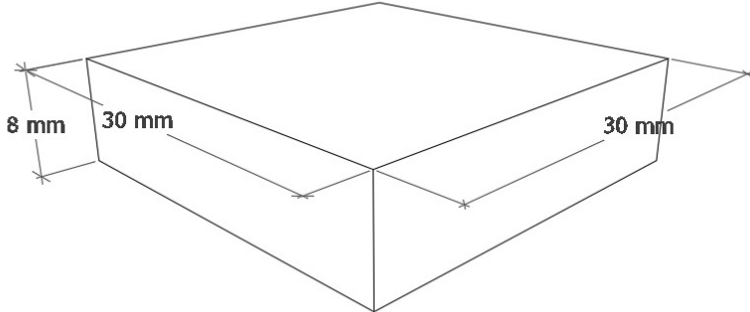
Figure 1. Dimensions of SS400 steel specimen used in testing.

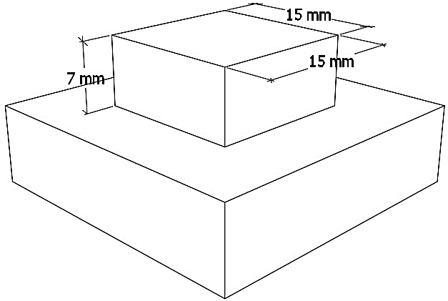
Figure 2. Dimensions of sacrificial anodes (zinc and magnesium).

The corrosive medium was prepared by dissolving analytical-grade sodium chloride (NaCl) powder in distilled water to simulate varying levels of seawater salinity. The salinity concentrations used were 3.00%, 3.25%, 3.50%, 3.75%, and 4.00% by mass. To achieve each concentration, 50 mL of distilled water was initially prepared, followed by the addition of NaCl powder in the amount of 3.00 g, 3.25 g, 3.50 g, 3.75 g, and 4.00 g respectively. The solution was stirred until fully dissolved and then diluted to a final volume of 100 ml. The preparation of the corrosive medium is depicted in Fig. 3.

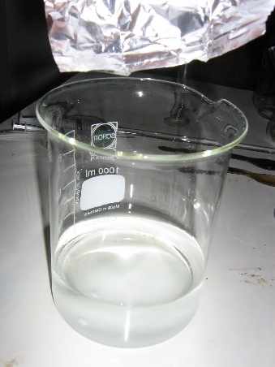
Figure 3. Preparation process of NaCl-based artificial seawater with varying salinity levels.

Fifteen immersion containers were used, each containing a different combination of specimen type and salinity level. The specimens were fully submerged in their respective solutions for a total duration of 168 hours (7 days) at room temperature. After the immersion period, the specimens were removed, rinsed with ethanol and distilled water to remove corrosion products, then dried and weighed again to determine the final mass. The difference between the initial and final weights indicated the mass loss due to corrosion.
The mass loss (W) was calculated using the following equation:

$W=W_{0}-W_{A}$ (1)

Where W is the mass loss (g), W₀ is the initial mass (g), and W_{A} is the final mass (g) after immersion.
The corrosion rate (CR) in millimeters per year was calculated according to the ASTM G31-72 standard using the equation:

$CR= \frac{K × W }{A ×T ×D}$
Where:
• CR is the corrosion rate (mm/year),
• K is a constant (8.76 × 10⁴ for metric units),
• W is the mass loss (g),
• A is the surface area of the specimen (cm²),
• T is the immersion time (hours), and
• D is the density of SS400 steel (7.85 g/cm³).

This methodology enabled accurate quantification of the effect of both sacrificial anode type and salinity level on the corrosion behavior of SS400 steel. By comparing the mass loss and calculated corrosion rates across all test conditions, the relative performance of zinc and magnesium anodes could be evaluated under realistic but controlled conditions.

Results and Discussion
Following the experimental procedures, data analysis was conducted to evaluate weight loss and corrosion rates resulting from the addition of sacrificial anodes (zinc and magnesium), as well as comparison to specimens without any anode. The influence of salinity variation on the corrosion rate of SS400 steel immersed in NaCl solutions of 3%, 3.25%, 3.5%, 3.75%, and 4% over a 7-day period (168 hours) was investigated.

Effect of Sacrificial Anode Addition on Corrosion Rate
Based on the corrosion tests, the addition of sacrificial anodes to SS400 steel specimens immersed in various NaCl concentrations resulted in a significant impact on corrosion behavior. As shown in Fig. 1, corrosion rates generally decreased in the presence of sacrificial anodes.
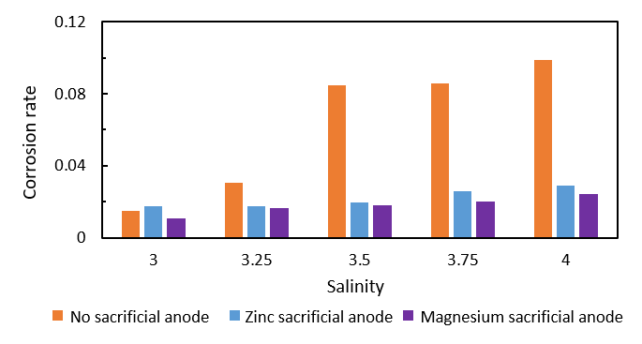
Figure 4. Sacrificial anode test results

In the absence of any anode, the specimen exhibited a corrosion rate of 0.0148 mm/year. As the salinity increased, the corrosion rate also rose significantly—0.0306 at 3.25% salinity, 0.0847 at 3.5%, and 0.0855 at 3.75%. The highest corrosion rate of 0.0987 was observed at 4% salinity. This trend confirms that unprotected steel in saline environments is highly vulnerable to corrosion [6], and specimens without cathodic protection experience accelerated material degradation [7].
When zinc sacrificial anodes were applied, a notable reduction in corrosion rate was observed. At 3% salinity, the rate was 0.0176 and remained unchanged at 3.25%. However, a slight increase occurred at 3.5% salinity (0.0198), followed by a further rise to 0.0257 at 3.75%, and 0.0290 at 4%. These results indicate that zinc offers partial protection, although its effectiveness decreases as salinity increases. A higher concentration of zinc in the anode provides better corrosion protection due to galvanic action [8], while metals lacking any cathodic protection lose mass more rapidly [9].
Magnesium sacrificial anodes demonstrated the most effective corrosion mitigation among all configurations. At 3% salinity, the corrosion rate was only 0.0108, increasing slightly to 0.0165 at 3.25%, and then to 0.0179 at 3.5%. At 3.75%, the rate reached 0.0199, and peaked at 0.0244 at 4% salinity. The superior performance of magnesium is attributed to its lower electrode potential compared to zinc, making it a more suitable material for sacrificial anodes in highly conductive environments [10].

Effect of Salinity on Corrosion Rate in Presence of Sacrificial Anodes
This study also examined how increasing salinity influences the corrosion rate of SS400 steel under various anode protection scenarios. Salinity levels of 3%, 3.25%, 3.5%, 3.75%, and 4% were found to significantly affect corrosion behavior. As salinity increases, corrosion rates escalate accordingly [11]. For instance, the transition from 3% to 3.5% NaCl solution demonstrated a clear rise in corrosion activity [12].

One contributing factor is the presence of aggressive chloride ions (Cl¯), which disrupt passive oxide and hydroxide layers on the steel surface. Furthermore, higher salt content increases the conductivity of the electrolyte, thereby enhancing electrochemical corrosion currents [13]. The test results indicate that increasing salinity consistently lowers the polarization resistance of the specimens, which in turn raises the corrosion rate [14]. This is due to the enhanced oxidation processes experienced by the metal surface under high salt concentrations and external potential exposure [15]. The increased presence of ionic species in the electrolyte solution promotes more rapid chemical reactions, accelerating the corrosion process [16].

CONCLUSION
Based on the experimental results obtained through the 7-day immersion of SS400 steel specimens in NaCl solutions with varying salinity levels of 3%, 3.25%, 3.5%, 3.75%, and 4%, and the addition of zinc and magnesium sacrificial anodes, several conclusions can be drawn. Specimens without any anodic protection exhibited significantly higher corrosion rates, placing them in the hazardous category if left unprotected. The use of sacrificial anodes was proven effective in reducing corrosion rates, with magnesium anodes offering the most optimal protection among the tested materials. Furthermore, an increase in salinity from 3% to 4% led to a corresponding increase in the corrosion rate, confirming the influence of salt concentration on corrosion behavior. An inverse relationship was also observed between salinity and polarization resistance; as salinity increased, the corrosion rate rose, resulting in a noticeable decrease in the polarization resistance of the specimens.

References
- C. Huda and D. H. Sutjahjo, Analysis of Corrosion Rate of Aluminium 5083 as a Hull Material Application, pp. 17–24 (2017). (Translated title)
- R. S. Irianty and D. Khairat, Papaya Leaf Extract as a Corrosion Inhibitor for AISI 4140 Steel in Simulated Seawater, J. Teknobiologi IV, no. 2, 77–82 (2013). (Translated title)
- B. A. Shaw and R. G. Kelly, What Is Corrosion? (2006).
- R. W. Revie and H. H. Uhlig, Corrosion and Corrosion Control: An Introduction to Corrosion Science and Engineering, 4th ed. (John Wiley & Sons, Hoboken, 2008).
- ASTM G31‑72, Standard Practice for Laboratory Immersion Corrosion Testing of Metals, ASTM Spec. Tech. Publ., Reapproved 2004, pp. 534–544.
- ASTM G31-72 (Reapproved 2004), Standard Practice for Laboratory Immersion Corrosion Testing of Metals, ASTM International.
- A. Yanuar, H. Pratikno, and H. S. Titah, Effect of Natural Inhibitor Addition on Corrosion Rate of Pipe Material in Simulated Seawater (2016). (Translated title)
- L. Pongsapan and A. Suhadi, Effectiveness of Zinc Alloy Sacrificial Anode on AISI E 2512 Ship Plate Steel Corrosion Rate in Seawater, J. Mater. Eng. 1, no. 1 (2015). (Translated title)
- C. A. Loto, R. T. Loto, and A. P. Popoola, Performance Evaluation of Zinc Anodes for Cathodic Protection of Mild Steel Corrosion in HCl, Chem. Data Collect. 24, Article 100280 (2019).
- ASTM International, Designation D1141‑98 (Reapproved 2003): Standard Practice for the Preparation of Substitute Ocean Water (2003).
- D. Zakiah, Y. Mariah, D. Fitrial, and A. Ala, Analysis of Sea Water Salinity and Acidity Influence in Jakarta Ports, presented at Seminar Pesisir dan Kelautan, Indonesia, 29 January 2020. (Translated title; venue approx.)
- ASME Boiler and Pressure Vessel Code, Section II, Part A: Ferrous Material Specifications (2010), ASME International.
- ASTM International, Standard Test Method for Conducting Potentiodynamic Polarization Resistance Measurements, ASTM G59‑97 (Reapproved 2014), ASTM International.
- F. Smith, F. Brownlie, T. Hodgkiess, A. Toumpis, A. Pearson, and A. M. Galloway, Effect of Salinity on the Corrosive Wear Behaviour of Engineering Steels in Aqueous Solutions, Wear 462–463, Article 203515 (2020).
- Y. Toshev et al., Protective Coating of Zinc and Zinc Alloys for Industrial Applications, in Proc. 2nd Int. Conf. on Multi‑Material Micro Manufacture (4M 2006), pp. 323–326 (Elsevier, 2006).
- ASM International, Corrosion: Fundamentals, Testing, and Protection, ASM Handbook Volume 13A (ASM International, 2003).

