The Effect of Repair and Modification on the Performance of Heat Exchanger Shell and Tube Unit Secondary Reformer Waste Heat Boiler

Achmad Fauzan Hery Soegihartoª, Fadhil Jamarullah^{b}, Brigas Cahyono^{c}, Mulyono, Anggita Murti Anggraini

ª University of Muhammadiyah Malang
Copyright © 2019 All Rights Reserved. All rights reserved.
Phone. (0341) 464 318-128, fax. (0341) 460782A

fadiljamarullah@webmail.umm.ac.id, achmadfauzan@umm.ac.id,

Abstracts - Shell-and-tube type heat exchangers are widely used in industrial processes, where their operational efficiency is greatly affected by the number of active tubes. Previous research has generally focused on design optimization at the design stage, while studies related to performance degradation due to tube deactivation under actual operating conditions are still limited. This study aims to quantify the effect of reducing the number of active tubes on heat transfer efficiency and pressure loss in waste heat boilers in the secondary reformer unit. The analysis was carried out by combining operational data from industrial factories with calculations using the Log Mean Temperature Difference (LMTD) method. Two scenarios were analyzed, namely all 1,024 active tubes and the condition of 10 tubes deactivatedThe results showed that the deactivation of 10 tubes lowered the heat transfer surface area from 910.7 m² to 901.8 m². In addition, this also reduces the heat transfer rate from 114.31 million kcal/hour to 113.19 million kcal/hour. This decrease is equivalent to a 0.98% reduction in efficiency, which, although relatively small in percentage, can have a significant impact on the achievement of production targets and operating costs on a large industrial scale. These findings provide a practical basis for maintenance planning, repair prioritization, and design optimization of industrial heat exchangers.
Keywords: Shell-and-Tube Heat Exchanger, heat transfer efficiency, tube decommissioning, LMTD method

INTRODUCTION

The shell-and-tube heat exchanger is one of the oldest and most tested heat exchanger technologies. This technology is widely used in various industrial sectors, including petroleum, petrochemicals, power plants, food processing, and the chemical process industry. This technology began to develop since the early 20th century as the need for efficient heat exchange systems increased to optimize large-scale industrial processes. Constructively, this device consists of a tube bundle that is placed in a cylindrical vessel (shell). One fluid flows through the inside of the tube (tube side), while the other fluid flows outside the tube but remains inside the shell (shell side). Heat transfer occurs through the walls of the tube as a physical barrier between the two fluids. This working principle allows for an efficient heat transfer process without direct mixing between fluids, making it suitable for applications that require strict fluid insulation.
The performance of shell-and-tube heat exchangers can be optimized through various design aspects. One is to add baffles to direct fluid flow, increase turbulence, and increase the overall heat transfer coefficient. The development of modern technology has driven significant innovations in the design of these devices. These innovations include the use of metal alloy materials with corrosion resistance and high mechanical strength, as well as the application of an anti-fouling coating to reduce dirt buildup. In addition, design optimization based on Computational Fluid Dynamics (CFD) and the application of heat transfer enhancement techniques such as twisted tubes and helical baffles were also developed. This combination of innovations has been proven to improve thermal efficiency, lower pressure drops, and extend operational life. It also helps reduce maintenance costs, making this technology a top choice for high-temperature and high-pressure applications.
Among the design parameters that affect the performance of shell-and-tube heat exchangers, the length and number of tubes play a crucial role. The length of the tube directly determines the surface area of heat transfer, which affects the maximum heat transfer capacity (heat duty). Increasing the length of the tube tends to increase the surface area and heat exchange effectiveness, but on the other hand it also increases the resistance of fluid flow and pressure drop. Meanwhile, the number of tubes determines the total capacity of the overall heat transfer area. The more active functioning tubes, the greater the heat transfer capacity that can be achieved. However, this also has the potential to increase the pressure drop as well as the energy consumption of the pump or compressor. In industrial practice, long-term operational conditions often cause some tubes to experience fouling, leakage, or structural damage. As a result, operators were forced to deactivate some of the tubes to prevent greater operational disruptions. The deactivation of these tubes directly reduces the area of heat transfer, resulting in a decrease in the capacity and thermal efficiency of the system.
A review of the literature shows that most previous studies have focused on design optimization and improvement of thermal efficiency under ideal or simulation-based operating conditions. Several studies have discussed the influence of variations in the geometry, material, and configuration of baffles. However, studies that use real field data to assess the impact of partial deactivation of tubes are still very limited. This creates a significant research gap, especially in understanding the relationship between the number of active tubes, heat transfer capacity, and system efficiency. This interconnectedness is critical for large-scale industrial operating environments. This gap is important to fill because it is very useful for designers, operators, and maintenance engineers. This information helps them determine operational tolerance limits, prioritize repairs, and plan more efficient redesigns.
Based on this background, this study aims to conduct a quantitative analysis of the effect of reducing the number of active tubes on the performance of shell-and-tube heat exchangers. This study is focused on the Secondary Reformer Waste Heat Boiler unit. The analysis was carried out using the Log Mean Temperature Difference (LMTD) approach to compare the conditions of all active tubes with the conditions in which 10 tubes were deactivated due to technical considerations. By using actual operational data from industrial facilities, this research is expected to make a real contribution in the form of technical recommendations. The recommendations include preventive maintenance, optimization strategies, and planning for the redesign of shell-and-tube heat exchangers. The goal is that thermal performance and energy efficiency can be optimally maintained.

METHODOLOGY
This study uses an engineering physics calculation approach based on actual operational data. The approach was used to analyze the performance of shell-and-tube heat exchangers in Secondary Reformer Waste Heat Boilers. The analysis focused on the effect of the reduction in the number of active tubes on the heat transfer capacity and thermal efficiency of the system.
Descripttion | Shell side | Tube side
Fluid | BFW+Steam (Steam Water) | Secondary Reformer Effluent
Design Press (kg/cm² g) | 139,7 | 44,7
Design Temp (Cº) | 328(in)/328(out) | 894.5 (in)/440.3 (out)
Mass Flow Rate (kg/s) | 1109,57 | 135,7
Pressure (kg/cm² g) | 127 | 39,8
Specific Heat/Cp (kcal/kg°c) | 1,6950 | 0.5260
LMTD (Cº) | 273,83
Q Actual | 110.69 × 10⁶ kcal/h
Heat Transfer Coefficient (U) | 442.2 kcal/m²·h·°C
Tube Material | 13CrMo4-5 (1Cr – 0.5 MB)  Low Alloy Steel
Tube Size | OD 38 x 4.5 THK x 7600L
Number Of Tubes | 1024
Number Of Active Tube | 1014
Surface Area (m2) | 910,7

Based on the available data, the Log Mean Temperature Difference (LMTD) method was chosen as the most effective calculation approach. This method is used to analyze the performance of shell-and-tube heat exchangers [12]. The LMTD method is known as a simple method but has high accuracy. This method is used to calculate the efficiency and heat transfer capacity of this type of heat exchanger [13]. In this study, calculations were made for two different conditions. The first condition is when all tubes are active, while the second condition is performed assuming there are 10 tubes deactivated. A comparison of the two conditions was used to assess the impact of the reduction in the number of active tubes on heat transfer performance. The basic equations used in the LMTD calculation are Q = U × A × ΔTlm [14].
Q = Heat Transfer Rate (kcal/h)
U = Heat Transfer Coefficient
A = Surface Area (m2)
ΔTlm = Log Mean Temperature Diffrence (C°)

RESULTS AND DISCUSSION

Stages of Tube Repair Before Welding
NO | Stages of improvement | Continued repair | Attachment
1 | Removable heat shield plate | After the shield plate is opened, the castable tube sheet is inserted and the ferulle is installed, then the tube to tubesheet is brushed from the rest of the castable | 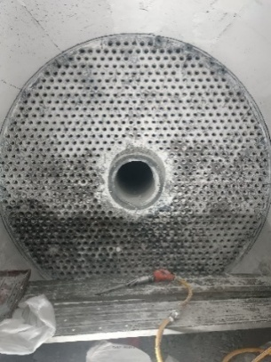
2 | Penetrating test | Penetrant test was carried out on Row 36- Row 41 And the results were not found cracks on the tube, only there was Erosion in Row 38 no 16 – 19 | 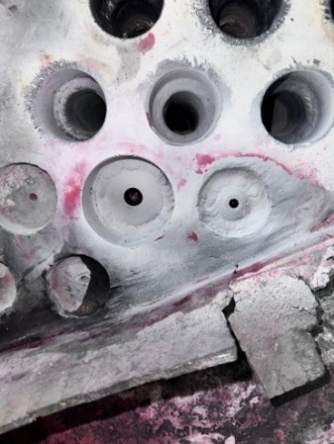
3 | H2 Removal | H2 Removal is carried out in the lower half of the area until the temperature reaches 350ºC Then in the holding for 4 hours | 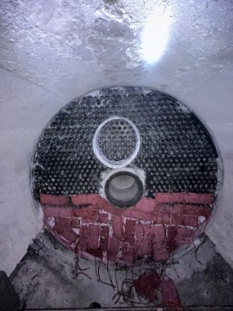

Stages of Welding
Yes | Repair Methods | Explanation | Attachment
1 | Classification of Root pass Row 37 – Row 41 | Penetrant test results of temporary tube scrapping reweld 51 of 71 joint:  Row 37 : 0 of 21 Joints (not yet in penetrant test)  Row 38 : 15 of 20 ACC joints (5 Joints defective shafts and folds)  Row 39 : 9 of 12 ACC joints ( 3 Joint defective folds & Underfill  Row 40 : 11 of 11 Joint ACC  Row 41 : 5 of 7 ACC Joints (2 Shaft Defect Joints) | 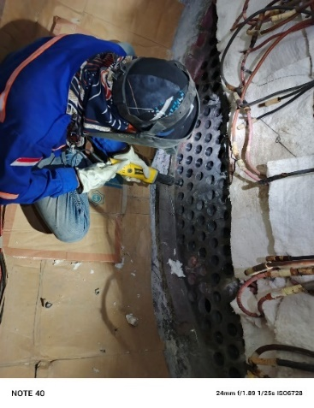
2 | Reweld | From the results of the Root pass, Reweld was carried out on the Joint that was defective.  Row 37 : 21 of 21 Joint ACC  Row 38 : 20 of 20 Joint ACC  Row 39 : 12 of 12 Joint ACC  Row 40 : 11 of 11 joint ACC  Row 41 : 7 of 7 Joint ACC | 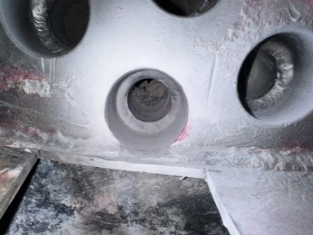
3 | Fullweld Inner Bore Welding tube side inlet | After fullwelding with the IBW method on the inlet side, penetrant tests were carried out on 71 of the 71 joints resulting in no defects (ACC) | 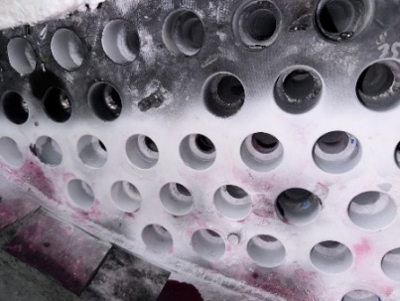

4 | Inlet and Outlet Side Plugs | After the plug is done on the inlet side as many as 2ea and 2ea on the outlet side, the penetrant test is carried out and the result is no defect (ACC) | 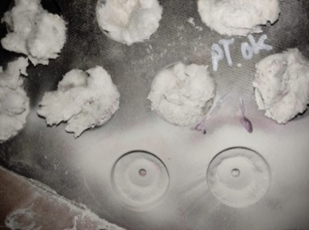
5 | Ultarsonic Test Examination | An ultrasonic test was carried out on the IBW lasa on the entire tube, the result was no damage (no crack) | 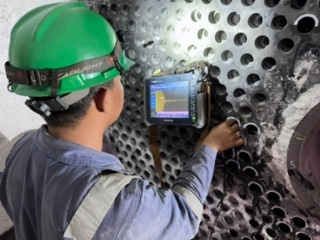
6 | Before Post weld heat treatment (PWHT) | Performed Flatness data retrieval using the pendulum manual | 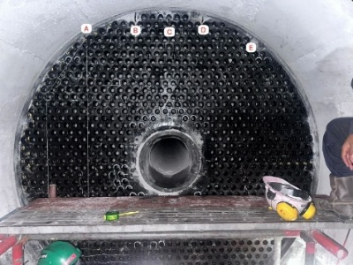
7 | Post weld heat treatment | PWHT on all parts of the tube until the temperature reaches 660º and hold for 60 minutes | 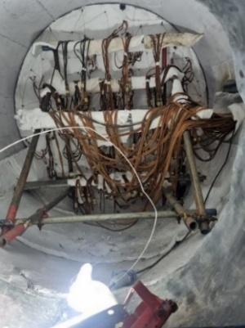
Stages After Hydrotest
After the above repair process, a hydrotest examination was carried out when the pressure was still at 42 kg/cm² and it was found that 2 tubes had leaks. Then the pressure was increased to 120 kg/cm², but the results were still found to be leaks in the Row 20-25 and Row 27-10 tubes. Furthermore, repairs are carried out again with procedures that include the stages of tube repair before welding and the welding stage.

Technical data from the WHB 101-C Secondary Reformer unit with the Shell and Tube Heat Exchanger type were used for the initial efficiency calculation. The assumption is that the entire tube is active, so the surface area of the heat transfer is 910.7 m².
Where: $Q=U ×A × △Tlm$
$Q=442,2 ×910,7$ × 283.95 = 114,308,424 Kcal/h
Then to calculate efficiency using the LMTD method on Shell and tube type heat exchangers, an effectiveness formula is used [15]
ε$=\frac{Q Aktual}{Q Maksimum}x100\%$
ε = 96,84%$=\frac{110,69}{114,31}x100\%$
This means that the efficiency of the WHB 101-C Secondary Reformer Unit with the Shell and tube Heat Exchanger type is 96.84% before the Tube deactivation process is carried out. In this case study, a total of 10 tubes out of 1024 tubes have been deactivated. Where the cross-sectional area of the heat transfer surface is automatically reduced. The heat transfer area greatly affects the heat transfer efficiency of the heat exchanger [16] .
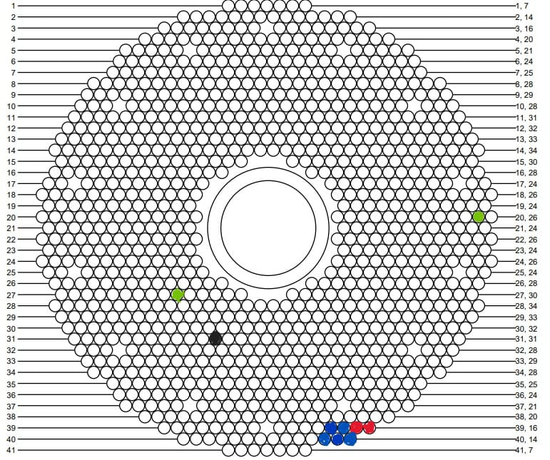
Figure 1. Tube that has been deactivated
With the actual condition now 10 tubes have been deactivated for technical reasons so the active tube is 1014 Tube. This makes the surface area of the heat cross-section (A) reduced to
A$=\frac{Tube Aktif}{Total Tube Keseluruhan}xSurface Area$
$=\frac{1014}{1024}x910,7$A = 901.8 m2

So that its heat transfer rate (Q) changes to Q = U × A × △lm
Q = 442.2 × 901.8 x 283.95 = 113.190.642 kcal/h
Which means that there is a decrease in the value of the heat transfer rate (Q) before 10 tubes are deactivated. The efficiency calculation was carried out with the formula ε = (113.19 / 114.31) × 100% = 99.02%, which means that there was a decrease in efficiency of 0.98% from the condition before the deactivation of the tube. With the initial efficiency value before repair of 96.84%, the actual efficiency that occurs in the field today is 96.84% - 0.98% = 95.86%.

Variable | Total active tube 1024 | Total active tubes 1014 | Decline
Heat Transfer Surface Area (A) | 910.7m2 | 901.8m2 | 8.9m2
Heat transfer rate (Q) | 114,308,424 Kcal/h | 113,190,642 kcal/h | 1,117,782 kcal/h
Efficiency Value (ε) | 96,84% | 95,86% | 0,98%

The graph above shows the efficiency value if some tubes are deactivated

CONCLUSION
The results of this study clearly show that the deactivation of 10 tubes out of a total of 1,024 tubes in the shell-and-tube heat exchanger unit of the Secondary Reformer Waste Heat Boiler unit has a real impact on the decline in system performance. The surface area of heat transfer was reduced from 910.7 m² to 901.8 m². This was followed by a decrease in heat transfer capacity from 114.31 million kcal/hour to 113.19 million kcal/hour, or around 0.98% of optimal conditions. Although this decline appears small in percentage, the impact is significant on the scale of large industrial operations. This mainly affects the achievement of production targets, energy consumption, and long-term operational stability.
These findings prove the initial hypothesis and confirm the gap analysis that has been described in the introduction. The reduction in the number of active tubes—whether due to fouling, leakage, or structural damage—has direct implications for the reduction in the thermal efficiency of the system. This confirms the importance of proper monitoring and maintenance to maintain optimal performance. The cumulative effects of decreased heat transfer capacity can force operational adjustments, increase energy costs, and reduce design safety margins. Therefore, this study emphasizes the importance of implementing routine monitoring programs and preventive care strategies. In addition, predictive inspections are also needed to detect potential damage to the tube early.
In addition, the results of this study can be the basis for technical decision-making for the planning of redesign or replacement of components in heat exchangers. The active tube count optimization approach is essential in the management of shell-and-tube heat exchangers. This approach considers a balance between thermal efficiency, pressure drop, and operational costs. This allows the industry to maintain system performance at an optimal level while extending the life of the equipment. Thus, this research does not only make an academic contribution. The research also has high practical relevance for the industrial sector that relies on the reliability and efficiency of shell-and-tube heat exchangers.

REFERENCES

[1] S. Kakaç, H. Liu, and A. Pramuanjaroenkij, "Heat Exchangers: Selection, Rating, and Thermal Design; Fourth Edition."
[2] P. G. Vicente, A. Garc, and A. Viedma, "Heat transfer and pressure drop for low Reynolds turbulent ̄ow in helically dimpled tubes." [Online]. Available: www.elsevier.com/locate/ijhmt
[3] "s Figure 1. TEMA designations for shell-and-tube heat exchangers."
[4] L. Leal et al., "An overview of heat transfer enhancement methods and new perspectives: Focus on active methods using electroactive materials," Int J Heat Mass TransfPp. 505–524, 2013, doi: 10.1016/j.ijheatmasstransfer.2013.01.083ï.
[5] C. W. Chan, E. Siqueiros, J. Ling-Chin, M. Royapoor, and A. P. Roskilly, "Heat utilisation technologies: A critical review of heat pipes," May 30, 2015, Elsevier Ltd. doi: 10.1016/j.rser.2015.05.028.
[6] M. Ali, A. Ul-Hamid, L. M. Alhems, and A. Saeed, "Review of common failures in heat exchangers – Part I: Mechanical and elevated temperature failures," Jan. 01, 2020, Elsevier Ltd. doi: 10.1016/j.engfailanal.2020.104396.
[7] A. Patel, "Heat Exchanger Materials and Coatings: Innovations for Improved Heat Transfer and Durability," Anand Patel. International Journal of Engineering Research and Applications www.ijera.com, vol. 13, no. 9, pp. 131–142, 2023, doi: 10.9790/9622-1309131142.
[8] T. Ma, H. Yang, Y. Zhang, L. Lu, and X. Wang, "Using phase change materials in photovoltaic systems for thermal regulation and electrical efficiency improvement: A review and outlook," 2015, Elsevier Ltd. doi: 10.1016/j.rser.2014.12.003.
[9] M. R. Saffarian, F. Fazelpour, and M. Sham, "Numerical study of shell and tube heat exchanger with different cross-section tubes and combined tubes," International Journal of Energy and Environmental Engineering, vol. 10, no. 1, pp. 33–46, Mar. 2019, doi: 10.1007/s40095-019-0297-9.
[10] I. Mudawar, "Assessment of High-Heat-Flux Thermal Management Schemes," 2001.
[11] G. P. Sullivan, R. Pugh, A. P. Melendez, and W. D. Hunt, "Operations & Maintenance Best Practices A Guide to Achieving Operational Efficiency," 2002.
[12] D. Shekhar, "OPTIMIZING THE DESIGN AND SELECTION OF HEAT EXCHANGERS THROUGH LMTD CORRECTION FACTOR." [Online]. Available: www.irjmets.com
[13] K. Silaipillayarputhur and H. Khurshid, "The design of shell and tube heat exchangers – A review," Dec. 26, 2019, Transstellar Journal Publications and Research Consultancy Private Limited (TJPRC). doi: 10.24247/IJMPERDFEB201910.
[14] M. Ashraf and N. Khare, "Design and Optimization of Heat Exchanger Systems for Industrial Applications," Radius: Journal of Science and Technology, vol. 2, no. 1, p. 9, 2025, doi: 10.5281/zenodo.15327130.
[15] Y. A. Cengel, "Steady versus Transient Heat Transfer 63 Multidimensional Heat Transfer 64 Heat Generation 66."
[16] A. Fakheri, "Heat exchanger efficiency," J Heat Transfer, vol. 129, no. 9, pp. 1268–1276, Sep. 2007, doi: 10.1115/1.2739620.

