Effect of Interpass Temperature on Flux-Cored Arc Welding of ASTM A36 Steel Using Liquid Penetrant and Tensile Testing Methods
Putra Daffa Indrastata Rakhmadian^{1, a)}, Nur Subeki^{1, b)}, Nur Hasanah^{1, c)},
and Reza Aulia Rahman^{1, 2, d)}
¹Department of Mechanical Engineering, University of Muhammadiyah Malang, Malang, Indonesia
²Department of Mechanical Engineering, The University of Osaka, Osaka, Japan

^{a)}putradaffa776@gmail.com
^{b)} nursubeki@umm.ac.id
^{c)} nurhasanah02@umm.ac.id
^{d)} Corresponding author: rezarahman@umm.ac.id
Abstract. This study investigates the effect of interpass temperature on the mechanical properties and surface defects of welded joints produced by the Flux-Cored Arc Welding (FCAW) process on ASTM A36 steel. The interpass temperature plays a critical role in influencing the microstructure and mechanical performance of welded joints. In this work, three interpass temperature variations were applied: 100 degrees Celsius, 150 degrees Celsius, and 200 degrees Celsius. The welding was carried out under controlled laboratory conditions, followed by Liquid Penetrant Testing (LPT) to detect surface defects and tensile testing to evaluate joint strength. The results showed that no surface defects were detected in any specimen, indicating proper temperature control and welding technique. The highest tensile strength and elongation were obtained at an interpass temperature of 100 degrees Celsius, attributed to the lower heat accumulation and faster cooling rate, which preserved material ductility and minimized residual stresses. Conversely, higher interpass temperatures tended to reduce tensile strength and elongation due to slower cooling rates and greater thermal distortion. These findings provide insights into how interpass temperature optimization can enhance the quality of FCAW-welded ASTM A36 steel joints.

INTRODUCTION
One of the metal joining methods that involves partial melting of the base metal and filler metal under pressure, with or without additional material, and results in a continuous joint, is known as welding [1]. Welding encompasses various methods, and one widely used technique is Flux-Cored Arc Welding (FCAW). The advantages of FCAW include its semi-automatic operation and the absence of the need to replace welding wire during the process, as the electrode is supplied in roll form [2].
FCAW is commonly found in construction work, where materials must be shaped according to design requirements. A material widely used in construction is ASTM A36 steel [3]. The popularity of ASTM A36 steel is due to its good weldability, high ductility, and toughness. However, it has limitations, such as relatively low hardness and wear resistance, making it prone to corrosion when exposed to oxygen, ions, and water [4].
The welding process produces a Heat-Affected Zone (HAZ), where heat from welding causes temperature distribution, distortion, and residual stresses. The formation of the microstructure in welded materials is closely related to the cooling process. The interpass temperature influences the cooling rate and determines the formation of microstructural phases in the material [5].
After welding, inspections are carried out to ensure joint quality. Two general inspection categories are Destructive Testing (DT) and Non-Destructive Testing (NDT). DT involves damaging the welded material to determine failure modes or material behavior under load, as well as to obtain mechanical property values [6]. NDT refers to the physical inspection of materials to identify defects without causing damage [7][8]. A common DT method is the tensile test, which determines tensile strength and the average modulus of elasticity of the tested material [9]. One of the most widely applied NDT methods is the penetrant test (PT), a simple yet fast and relatively accurate method for detecting surface defects [10][11].
A study by Saifudin et al. [12] reported that variations in interpass temperature affect deformation in the base metal and that higher interpass temperatures influence impact strength; however, their study did not include tensile or non-destructive testing. This finding is supported by research from Miftachul et al. [13], which states that interpass temperature influences microstructure and hardness in stainless steel, where higher hardness values correspond to lower decibel levels required to reach 80% Full Screen High (FSH). In addition, a study by Kurniyanto et al. [14] found that increasing interpass temperature reduces hardness and lowers bainite content.
Based on the above background, this study aims to determine the tensile strength and surface defects resulting from variations in interpass temperature. The findings are expected to serve as a reference for similar studies and to contribute to the development of welding technology. Furthermore, this research provides additional knowledge to mechanical engineering students and the academic community regarding the performance of FCAW-welded joints.

Methodology
This research consisted of two main stages: the welding process and the specimen testing process. The study was conducted from September to October 2024. Welding and specimen preparation were carried out under controlled workshop conditions, while the mechanical and non-destructive tests were performed in accredited laboratories to ensure measurement accuracy and repeatability.
The experimental design used in this study was a true experimental method, focusing on the mechanical characteristics of welded joints and the detection of surface defects. The base material was low-carbon ASTM A36 steel, joined using the Flux-Cored Arc Welding (FCAW) method. The study compared the mechanical properties of specimens welded at three different interpass temperatures: 100°C, 150°C, and 200°C. The tensile test was selected as the destructive testing method, while surface defect detection was carried out using the Liquid Penetrant Test (LPT).
The constant variables in this experiment included the type of base material (ASTM A36 steel), welding method (FCAW), and joint configuration (V-groove). The independent variable was the variation in interpass temperature. The welding was performed using an FCAW machine with CHT711 wire electrodes of 1.2 mm diameter. Additional tools included a vernier caliper for dimensional measurement, a cutting torch for specimen preparation, and standard cleaning tools to ensure proper surface conditions before and after welding. The base metal plates had a thickness of 10 mm, a length of 250 mm, and a width of 125 mm, with a total of six specimens prepared for the study.
The research procedure began with a literature review of relevant studies and welding standards. The next step was the preparation of tools and materials, ensuring they met the required specifications. Welding was then performed according to the predetermined interpass temperature variations. Temperature was monitored using a calibrated contact thermometer, and welding was only continued when the measured interpass temperature reached the target value. After welding, each specimen was subjected to visual inspection to ensure conformance with the dimensional and surface finish requirements.
Tensile testing was performed using a universal testing machine (UTM) in accordance with the relevant ASTM standard, with the goal of determining tensile strength and elongation at fracture. Liquid penetrant testing was conducted following the ASTM E165 standard, using red penetrant to detect surface cracks and other discontinuities. For both tests, the data collected included maximum load, tensile strength, percentage elongation, and qualitative defect observations.
Fig. 1 presents the schematic diagram of the experimental workflow, illustrating the sequence from specimen preparation to final testing. The collected data were tabulated and analyzed using Microsoft Excel. Quantitative results from the tensile test were plotted in graphs to observe trends across interpass temperature variations, while LPT results were presented with photographic documentation for visual comparison.

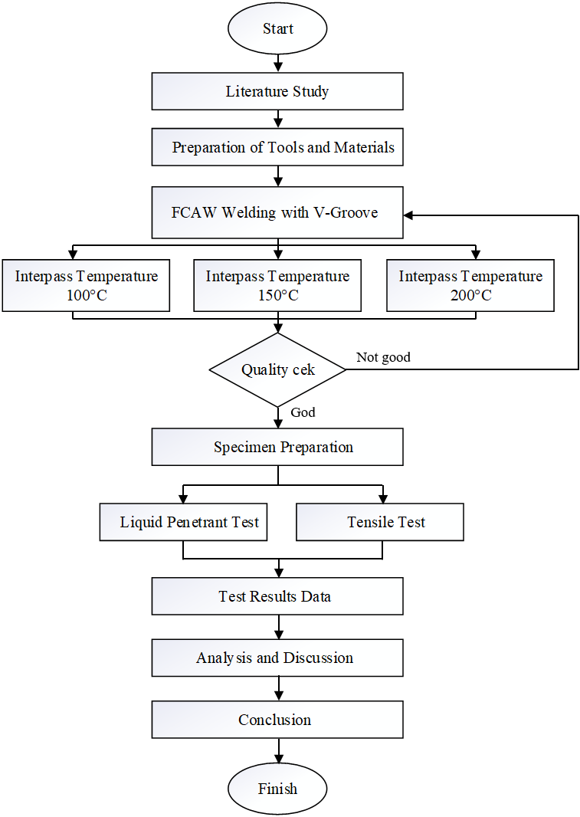
Figure 1. Research Flow Diagram.

Results and Discussion
This section presents the results of the Liquid Penetrant Test (LPT) and tensile testing conducted on welded ASTM A36 steel specimens prepared using the Flux-Cored Arc Welding (FCAW) method with three interpass temperature variations: 100°C, 150°C, and 200°C. The discussion focuses on the relationship between interpass temperature, defect occurrence, tensile strength, and elongation.

Liquid Penetrant Test (LPT) Analysis
The LPT results for the three interpass temperature variations are shown in Fig. 2, which displays the surface condition of the welded specimens after testing. No surface defects were detected in any of the specimens welded at interpass temperatures of 100°C, 150°C, or 200°C. This indicates that maintaining an appropriate interpass temperature is critical in preventing the formation of cold cracks in the Heat-Affected Zone (HAZ).
The absence of defects also demonstrates that the welding process was performed with effective temperature control and proper welding technique. The only visible marks were slight shadow-like stains, caused by incomplete cleaning of the red penetrant during the removal stage, particularly at the side areas. This is consistent with previous findings indicating that proper cleaning after penetrant application is essential for accurate defect visualization [15][16].

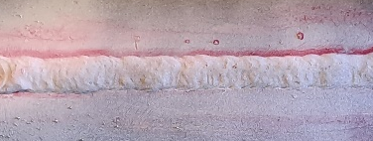 | 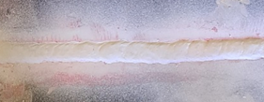 | 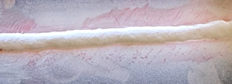
(a) | (b) | (c)
Figure 2. Liquid Penetrant Test results for specimens welded at interpass temperatures of: (a) 100°C, (b)150°C, and (c) 200°C.

Tensile Test Analysis
The tensile test specimens for the three interpass temperature variations are shown in Fig. 3. All specimens exhibited fracture outside the weld metal and HAZ, occurring instead in the base metal region. This suggests that the base metal had a lower tensile strength compared to the HAZ and weld metal, indicating sound weld quality [17][18].

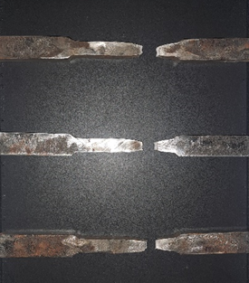 | 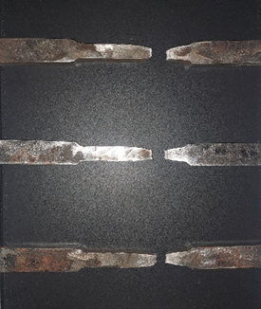 | 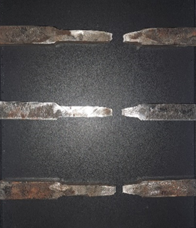
(a) | (b) | (c)
Figure 3. The tensile test specimens for the three interpass temperature variations: (a) 100°C, (b)150°C, and (c) 200°C.

The tensile strength and elongation values for each interpass temperature variation are summarized in Table 1. The results show that the highest tensile strength (425.95 MPa) and elongation (9.16%) were obtained for the 100°C interpass temperature. In comparison, tensile strength decreased to 411.40 MPa at 150°C and further to 410.78 MPa at 200°C. A similar trend was observed for elongation, which declined to 8.74% and 8.15% for 150°C and 200°C, respectively.

TABLE 1. Tensile strength and elongation for different interpass temperatures.
Interpass Temperature (°C) | Tensile Strength (MPa) | Elongation (%)
100 | 425.95 | 9.16
150 | 411.40 | 8.74
200 | 410.78 | 8.15

The tensile strength trend shown in Fig. 4 reveals that lower interpass temperatures led to higher tensile strength values. At 100°C, the relatively lower heat input between welding passes helped maintain the stability of the material temperature, allowing it to return closer to its initial condition before subsequent passes. This reduced excessive heat accumulation, which can weaken the welded joint area.

Figure 4. Variation of tensile strength at different interpass temperatures.

Furthermore, a lower interpass temperature minimized thermal distortion and residual stresses in the weldment, contributing to improved mechanical properties [19]. In contrast, higher interpass temperatures, such as 150°C and 200°C, slowed the cooling rate after welding, leading to a greater degree of residual stress relaxation and potential microstructural coarsening, both of which can reduce tensile strength.

Effect of Interpass Temperature on Elongation
The variation in elongation across interpass temperatures is presented in Fig. 5. The highest elongation value of 9.16% was recorded at 100°C, indicating that this condition was optimal for preserving material ductility. Faster cooling rates at lower interpass temperatures contribute to a more uniform residual stress distribution, enabling the material to sustain greater plastic deformation before fracture [21][22].
At higher interpass temperatures, elongation decreased to 8.74% for 150°C and 8.15% for 200°C. This reduction is attributed to slower cooling rates and higher accumulated heat, which can increase the material's brittleness and reduce its capacity to undergo plastic deformation. Moreover, excessive heat can promote the development of localized thermal stresses or minor surface imperfections that further diminish ductility [23][24].

Figure 5. Variation of elongation at different interpass temperatures.

Summary of Findings
The results indicate that the optimal mechanical properties for FCAW-welded ASTM A36 steel are achieved when the interpass temperature is maintained at 100°C. At this temperature, tensile strength and elongation are both maximized due to the favorable balance between heat input, cooling rate, and residual stress distribution. Higher interpass temperatures lead to a gradual decline in both tensile strength and elongation, underscoring the importance of interpass temperature control in welding practice.

CONCLUSION
This study investigated the influence of interpass temperature on the mechanical properties of welded joints, with particular focus on tensile strength and elongation. Based on the experimental results, the following conclusions can be drawn:
- The highest tensile strength was achieved at an interpass temperature of 100°C, reaching 425.95 MPa, while higher interpass temperatures of 150°C and 200°C resulted in slightly lower tensile strengths of 411.40 MPa and 410.78 MPa, respectively.
- The greatest elongation was also observed at 100°C with a value of 9.16%, indicating better ductility compared to 150°C (8.74%) and 200°C (8.15%).
- Lower interpass temperature (100°C) was more favorable for achieving optimal mechanical performance, likely due to reduced heat accumulation, faster cooling rates, and minimized residual stress relaxation.
- Increasing interpass temperature tended to reduce both tensile strength and ductility, suggesting the importance of temperature control during multi-pass welding to ensure high-quality welds.
- These findings provide a useful reference for optimizing welding parameters in order to achieve better mechanical performance of welded structures.

References
- N. Naharuddin, A. Sam, and C. Nugraha, Tensile strength and bending of welded joints in SM 490 steel using SMAW and SAW methods, J. Mek. 6(1), 550–555 (2017).
- B. H. Pangaribowo and W. H. A. Putra, Effect of preheating on repair welding of ASTM A36 steel on mechanical properties using FCAW process, J. Tek. ITS 7(2), (2019).
- B. M. Parker, Columnar-carbon and graphene-plate lattice composite, (2024).
- J. Arifin, H. Purwanto, and I. Syafa’at, Effect of electrode type on mechanical properties of welded joints, Momentum 13(1), 27–31 (2017).
- Muqsalmina, Syukran, and Hanif, Effect of interpass temperature on the mechanical properties of SMAW welding process for SS400 carbon steel, J. Weld. Technol. 1(1), 17–21 (2019).
- M. J. Abdulloh, B. H. Irawan, and M. Mutiarani, Non-destructive and destructive testing of WPS for tubular lower leg jacket S420 G2+M Z35 product, Proc. Ind. Res. Work. Natl. Semin. 14(1), 88–95 (2023).
- T. Endramawan, E. Haris, F. Dionisius, and Y. Prika, Analysis of SMAW 3G butt joint welding results using non-destructive penetrant testing based on ASME standards, Politeknik Negeri Indramayu, 8–12 (2017).
- D. J. Huggett, On-line phased array ultrasonic testing system for friction stir welding applications, 2, (2022).
- M. Z. Mawahib, S. Jokosisworo, and H. Yudo, Tensile and impact tests on SMAW welding using generator set with different electrode diameters, Kapal J. Mar. Sci. Technol. 14(1), 26–32 (2017).
- T. Endramawan and A. Sifa, Non-destructive dye penetrant and ultrasonic testing on SMAW butt joint welding with ASME acceptance criteria, IOP Conf. Ser. Mater. Sci. Eng. 306(1), (2018).
- G. Cataldo, Method for testing pipeline welds using ultrasonic phased arrays, 2(12), (2021).
- S. T. Saifudin, M. Muhammail, et al., Effect of interpass temperature on SMAW welding deformation and impact strength of ASTM A36 steel, Borobudur Eng. 4(1), 10–24 (2024).
- M. Miftachul Munir et al., Comparative analysis of interpass temperature on stainless steel 304 using FCAW process in DAC curve formation, 1–5 (2023).
- H. B. Kurniyanto et al., Analysis of interpass temperature variation effect on chromium-molybdenum SA 387 grade 12 material with FCAW welding on hardness value, (2023).
- W. Partnerschaft, Flux-cored wire, welding method using flux-cored wire, method for producing welded joint using flux-cored wire, and welded joint, 1(19), 1–8 (2018).
- Z. Cao and H. Xue, Nondestructive inspection method for coatings and ceramic matrix composites, 2(12), 2–7 (2020).
- R. F. Miller, Hardbanding method and apparatus, (2023).
- W. I. Property and R. Art, A canister for a carbonation machine international, (2024).
- I. Norman, D. Nelson, M. A. Us, and M. J. Pistorino, Electron beam additive manufacturing, 2, (2021).
- J. Bradley, J. Lee, and D. Roland, Welding assembly for a welding torch, with two contact tips and a cooling body to cool and conduct current, 1(19), (2022).
- Chovet, Flux-cored wire for welding steel having a high nickel content, (2012).
- R. Cited and S. Rock, Retracting lifeline systems for use in tie-back anchoring, 2, (2019).
- T. Una, O. N. Alla, and C. O. N. Tante, Systems, structures and materials for electrochemical device thermal management, 2, (2019).
- P. Examiner and J. L. Ward, Welded structure having excellent resistance to brittle crack propagation and welding method therefor, 2(12), (2020).

