Improvement of Weld Seam Quality in Spiral Steel Pipe Production Using the DMAIC Approach
Imam Mustofa^{a)}, Dini Kurniawati^{b)} Nur Hasanah^{c)} and Gusti Musta'annubillah^{d)}
Department of Mechanical Engineering, University of Muhammadiyah Malang
Jl. Raya Tlogomas No. 246, Malang 65144, Indonesia.

^{a)} imammustofa3010@gmail.com
^{b)} Corresponding author: dini@umm.ac.id
^{c)} nurhasanah02@umm.ac.id
^{d)} gustimustaannubilah01@gmail.com
Abstract. This study aims to improve the quality of weld seams in the manufacturing process of spiral steel pipes by applying the DMAIC (Define, Measure, Analyze, Improve, Control) methodology. The research was conducted in a pipe manufacturing facility in Indonesia over a three-month observation period. Data were collected through direct observations, interviews with production personnel, and documentation of defect occurrences. Quality indicators such as process capability index (Cp) and sigma level were analyzed to identify performance gaps. The main types of welding defects observed include stop-start marks, off-center welds, porosity, and weld misalignment. Root cause analysis using fishbone diagrams and 5W+1H revealed contributing factors such as inconsistent operator performance, equipment wear, and deviations from standard procedures. A 5S-based improvement strategy was implemented to enhance workplace discipline and reduce welding defects. The post-implementation evaluation indicated an increase in the Cp value and sigma level, demonstrating measurable improvement in process quality. This study highlights the effectiveness of DMAIC as a structured approach to improving welding quality in continuous production environments.

INTRODUCTION
In the era of global competition, manufacturing industries are required to continuously improve product quality while increasing production efficiency. Quality improvement has become a critical aspect that directly impacts customer satisfaction and company competitiveness [1]. In production systems, defects not only cause financial losses but also affect the continuity of operations. To address these issues, organizations adopt various quality control strategies, one of which is the implementation of Six Sigma [2].
Six Sigma is a structured methodology that focuses on reducing process variation and eliminating defects by using statistical tools and structured improvement stages [3]. The most common Six Sigma methodology is DMAIC (Define, Measure, Analyze, Improve, Control), which provides a systematic framework for identifying problems, analyzing root causes, implementing improvements, and sustaining results [4]. DMAIC has been widely applied in manufacturing industries for defect reduction and quality enhancement [5].
One sector that demands high product quality is the pipe manufacturing industry. Spiral welded steel pipes are widely used in infrastructure, water distribution, and oil and gas projects [6]. In this production process, welding quality is a critical parameter that affects the structural integrity and performance of the final product. Welding defects such as porosity, misalignment, or incomplete fusion can compromise safety and durability [7].
Previous studies have shown that applying the DMAIC approach in welding processes can significantly reduce the defect rate and improve overall product quality [8]. In addition to DMAIC, the implementation of 5S in the workplace has been proven to support productivity and discipline by creating a clean, orderly, and safe working environment [9].
This study aims to apply the DMAIC approach to improve weld seam quality in spiral steel pipe production. The research focuses on identifying the most frequent types of defects, analyzing their root causes, and proposing improvement strategies based on quality tools such as Pareto diagrams, cause-effect analysis, and the 5S concept. The objective is to demonstrate how a structured and data-driven approach can effectively enhance production quality without disclosing specific operational or proprietary data from the manufacturing facility.

Methodology
This research was conducted at a spiral steel pipe manufacturing facility in Indonesia over a period of three months. The study applied the Six Sigma DMAIC framework, which consists of five phases: Define, Measure, Analyze, Improve, and Control. Each phase was executed using relevant quality tools to ensure a systematic and data-driven approach to problem-solving.
In the Define stage, the primary quality problem was identified through direct observation of the production line and preliminary interviews with operators and quality control personnel. A SIPOC (Supplier, Input, Process, Output, Customer) diagram was constructed to map the production process of spiral steel pipes. Furthermore, Critical to Quality (CTQ) parameters were established to represent customer expectations regarding weld seam integrity.
The Measure phase involved collecting data on welding defects from daily production reports and quality inspection logs. Data collection focused on the types and frequencies of welding defects recorded during the three-month study period. The process capability index (Cp) and sigma level were calculated to assess the current performance of the welding process.
During the Analyze phase, a Pareto chart was used to identify the most dominant types of welding defects. To determine their root causes, a fishbone (Ishikawa) diagram and the 5W+1H method were applied, supported by discussions with operators, supervisors, and maintenance personnel. This analysis focused on factors related to manpower, machinery, materials, methods, and the work environment.
In the Improve phase, several improvement strategies were proposed based on the analysis results. These included re-standardization of work procedures, periodic operator training, scheduling of maintenance activities, and the implementation of the 5S methodology in the work area. These actions were aimed at reducing the occurrence of welding defects by addressing the root causes identified in the earlier phase.
Finally, the Control phase focused on ensuring the sustainability of the implemented improvements. Monitoring mechanisms were established through updated standard operating procedures (SOPs), visual workplace cues, and routine quality audits. Following the implementation of these improvements, process performance was re-evaluated using the same capability metrics (Cp and sigma level) to verify the effectiveness of the corrective actions.

Results and Discussion

Recapitulation of Welding Defects
A recapitulation of welding defect data from Spiral Welding Machine 1 in the Steel Pipe Industry was conducted from October to December 2024. The processed data, which represents the total output and defect frequency per type, is summarized in Table 1.

TABLE 1. Recapitulation of Welding Defect Types in Spiral Steel Pipes.
CODE | DESCRIPTION | DEFECT FREQUENCY 2024
CODE | DESCRIPTION | Oct | Nov | Dec | Total
SS | Stop Start | 47 | 13 | 20 | 80
OCO | Out Centre, Outside | 34 | 11 | 20 | 65
SC | Scratch | 31 | 2 | 4 | 62
PI | Porosity, Inside | 19 | 4 | 3 | 26
BT | Burn Through | 16 | 7 | 15 | 38
PO | Porosity, Outside | 21 | 3 | 3 | 27
JWO | Jump Weld, Outside | 18 | 19 | 12 | 49
 | Total Production | 2,151 | 1,454 | 1,290 | 4,859

Define Phase
In the Define phase, the initial step involves identifying whether defective products exist [6]. This identification process refers to quality standards set by the client. Several tools were employed in this stage to support problem definition.

SIPOC Diagram
The SIPOC (Suppliers, Inputs, Process, Outputs, Customers) diagram helps recognize issues in the production process. It evaluates inputs and outputs at every stage and helps understand both internal and external customer needs [19]. The SIPOC diagram is presented in Fig. 1.

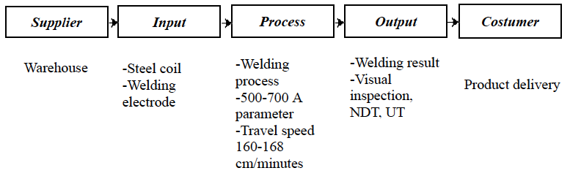
Figure 1. SIPOC Diagram.

Critical to Quality (CTQ)
CTQ analysis aims to identify quality attributes that reflect customer preferences and expectations [20]. It ensures that key quality metrics meet performance standards. The identified CTQ data is presented in Table 2.

TABLE 2. Critical to Quality (CTQ) Identification.
Defect Type | Number of Defects | Percentage | Cumulative Percentage
Stop Start | 80 | 23.05% | 23.05%
Out Centre, outside | 65 | 18.73% | 41.78%
Scratch | 62 | 17.87% | 59.65%
Porosity, inside | 26 | 7.49% | 67.14%
Burn Through | 38 | 10.95% | 78.09%
Porosity, outside | 27 | 7.78% | 85.87%
Jump Weld, outside | 49 | 14.12% | 100.00%
Total | 347

Measure Phase
In this phase, measurements were performed using sampling data collected by the company over a predefined period [21]. The Pareto diagram is used to classify defects from highest to lowest frequency [22]. The results are shown in Figs. 2, 3, and 4.
As shown in Figure 2, the welding defects recorded in October 2024 include Stop Start (SS) with 47 units, Out Centre, Outside (OCO) with 34 units, Scratch (SC) with 31 units, Porosity Inside (PI) with 19 units, Burn Through (BT) with 16 units, Porosity Outside (PO) with 21 units, and Jump Weld Outside (JWO) with 18 units. It can be concluded that the most frequent defect during October 2024 was the Stop Start (SS) defect.
As shown in Figure 3, the welding defects recorded in November 2024 include Stop Start (SS) with 13 units, Out Centre, Outside (OCO) with 11 units, Scratch (SC) with 2 units, Porosity Inside (PI) with 4 units, Burn Through (BT) with 7 units, Porosity Outside (PO) with 3 units, and Jump Weld Outside (JWO) with 19 units. It can be concluded that the most frequent defect during November 2024 was Jump Weld Outside (JWO).

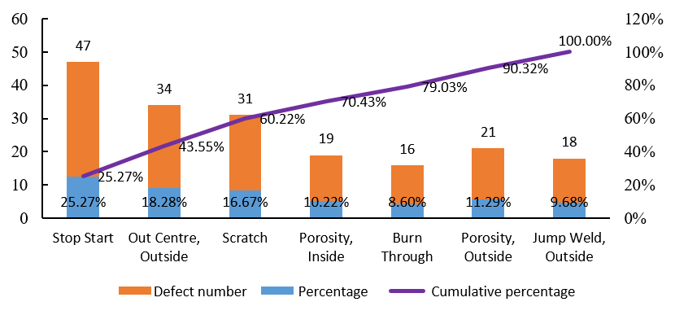
Figure 2. Pareto Diagram for October 2024.

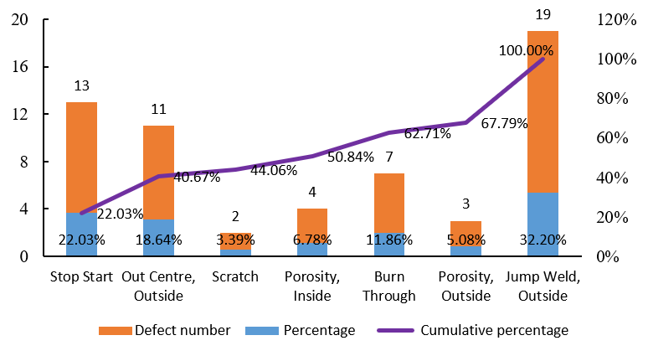
Figure 3. Pareto Diagram for November 2024.

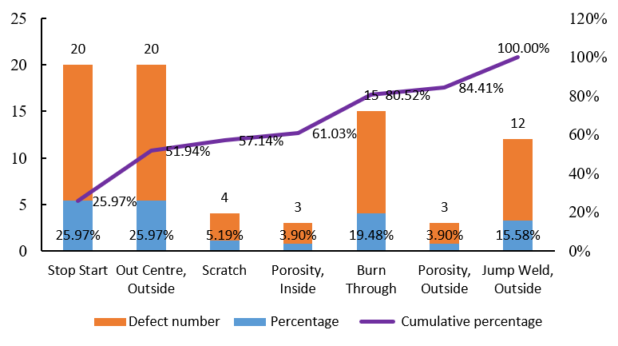
Figure 4. Pareto Diagram for December 2024.
As shown in Figure 4, the welding defects recorded in December 2024 include Stop Start (SS) with 20 units, Out Centre, Outside (OCO) with 20 units, Scratch (SC) with 4 units, Porosity Inside (PI) with 3 units, Burn Through (BT) with 15 units, Porosity Outside (PO) with 3 units, and Jump Weld Outside (JWO) with 12 units. It can be concluded that the most frequent defects during December 2024 were Stop Start (SS) and Out Centre, Outside (OCO), both occurring 20 times.
Further quantitative assessment was conducted through DPU (Defect per Unit), DPMO (Defect per Million Opportunities), Sigma Level, and Cp (Process Capability). The results of this analysis are displayed in Table 3. Stop Start defects had a DPU of 0.0163 and a DPMO of 16,343.21, resulting in a sigma level of 3.64. Meanwhile, Porosity, Inside showed the lowest DPU (0.0053) and a sigma level of 4.05, indicating better process stability. The average process capability (Cp) was calculated at 1.28.

TABLE 3. DPU, DPMO, Sigma Level, and Process Capability (Cp).
Defect Type | Output | Defects | DPU | DPMO | Sigma | Cp
Stop Start | 4895 | 80 | 0.0163 | 16,343.21 | 3.64 | 1.21
Out Centre, Outside | 4895 | 65 | 0.0133 | 13,278.86 | 3.72 | 1.24
Scratch | 4895 | 62 | 0.0127 | 12,665.99 | 3.74 | 1.24
Porosity, Inside | 4895 | 26 | 0.0053 | 5,311.54 | 4.05 | 1.35
Burn Through | 4895 | 38 | 0.0078 | 7,763.02 | 3.92 | 1.30
Porosity, Outside | 4895 | 27 | 0.0055 | 5,515.83 | 4.04 | 1.34
Jump Weld, Outside | 4895 | 49 | 0.0100 | 10,010.21 | 3.83 | 1.27
Average | — | — | 0.0101 | 10,126.95 | 3.85 | 1.28

The process sigma level (3.85) suggests relatively high quality. According to Sudarwati and Wijaya (2015), industries that achieve sigma levels above 3.5 are considered to have surpassed the national industrial average in Indonesia [23].

Analyze Phase
In the Analyze phase, the root causes of defects were explored using a Fishbone Diagram, as illustrated in Fig. 5. The analysis revealed five contributing categories: Man, Machine, Method, Material, and Environment [25–27]. The primary sources of defects were traced to human-related factors such as inconsistent operator skills and fatigue, along with equipment issues such as uncalibrated machines and electrode misuse.

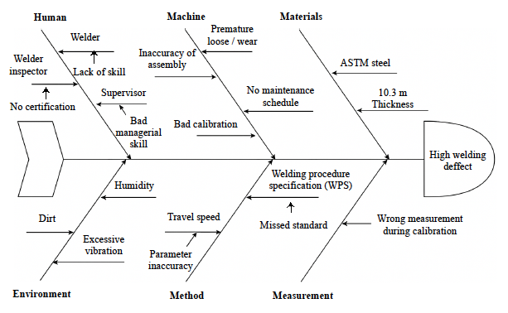
Figure 5. Fishbone Diagram Analysis.

These findings align with prior research by Yuswandi, et al. [27], who observed that human error due to poor training and limited awareness of quality standards plays a major role in defect generation [28].

Improve Phase
Improvement efforts were framed using the 5W+1H method (What, Who, Where, When, Why, How). Based on the analysis, targeted actions were proposed to address each contributing factor. For example, regular technical training was suggested to reduce human error, while preventive maintenance was emphasized to enhance machine reliability. Environmental adjustments, such as regulating temperature and cleanliness in the welding area, were also considered necessary. These improvement strategies are detailed in Table 4.

TABLE 4. Root cause analysis using the 5W+1H method.
Factor | Issue  (What & Why) | Responsible (Who) | Location/Time  (Where & When) | Solution  (How)
Man | Human error due to fatigue and lack of SOP compliance | Welder | Welding area / During welding | Training, discipline, supervision
Machine | Malfunction, unstable current, electrode misuse | Technician, Maintenance Team | Welding area / During welding | Preventive maintenance, regular repair, calibration
Method | Improper welding method or parameters | Production, QC, Operator | Production area / During process | Review method (DMAIC), adjust parameters
Material | Substandard or contaminated materials | Supplier, QC, PPIC | Storage & welding area / Early production | Ensure specs, stricter material inspection
Environment | Poor conditions (temp., humidity, dust) affecting weld quality | Safety (K3), QC | Work & storage area / During welding | Control environment, PPE, cleanliness

Control Phase
The final phase, Control, focused on sustaining improvements through systematic monitoring. The 5S methodology (Seiri, Seiton, Seiso, Seiketsu, Shitsuke) was implemented across the welding area to reduce workplace errors and maintain process discipline. The application of each 5S component is presented in Table 5, which includes standardization of work areas, cleaning protocols, visual cues for safety, and structured training sessions. These initiatives aim to institutionalize best practices and support continuous quality improvement [29].

TABLE 5. Implementation of 5S in welding operations.
5S Element | Key Implementation Activities
Seiri (Sort) | Separate needed and unneeded items; group tools/materials by urgency and function.
Seiton (Set in Order) | Organize tools, materials, workbenches, and spare parts/accessories neatly.
Seiso (Shine) | Clean welding machines, remove spatter from workbench, and clear dust/flux from equipment.
Seiketsu (Standardize) | Mark hazardous areas, provide direction signs, warning colors, and PPE availability.
Shitsuke (Sustain) | Encourage teamwork, allocate training time, and conduct simulations or practical exercises.

By applying the 5S philosophy consistently, the production environment becomes more organized and conducive to error-free operations, thus reinforcing the gains achieved during the Improve phase.

CONCLUSION
Based on the results and data analysis, it can be concluded that quality control of welding defects during the October–December 2024 period recorded a total production of 4,895 steel pipe units with seven identified defect types. The most frequent defects were Stop Start (23.05%), Out Centre Outside (18.73%), Scratch (17.87%), Burn Through (10.95%), Jump Weld Outside (14.12%), Porosity Outside (7.78%), and Porosity Inside (7.49%). Over this three-month period, the average Defect Per Unit (DPU) was 0.0101, with a Defect Per Million Opportunities (DPMO) of 10,126.95. The calculated Sigma Level ranged from 3.64 to 4.04, indicating a moderately good process quality. Additionally, the average process capability index (Cp) was 1.28, suggesting that most of the production met specification limits, although a risk of defects still remains.

References
- A. V. Carvalho, D. V. Enrique, A. Chouchene, F. Charrua‑Santos, “Quality 4.0: An overview,” Procedia Computer Science 181, 341–346 (2021).
- M. Smętkowska, B. Mrugalska, “Using Six Sigma DMAIC to improve the quality of the production process: a case study,” Procedia – Social and Behavioral Sciences 238, 590–596 (2018).
- O. Johnson, “Utilizing Lean Six Sigma model for managing projects in the oil and gas pipeline industry: a case study of selected companies in Lagos State, Nigeria,” (2020). Available online.
- V. Sengupta, D. Havrylov, P. F. Mendez, “Physical phenomena in the weld zone of submerged arc welding – A review,” Welding Journal 98(10), 283S–313S (2019).
- F. Psarommatis, D. Kiritsis, “A hybrid decision‑support system for automating decision making in the event of defects in the era of zero defect manufacturing,” Journal of Industrial Information Integration 26, 100263 (2022).
- S. A. Sazonova, S. D. Nikolenko, A. A. Osipov, T. V. Zyazina, A. A. Venevitin, “Weld defects and automation of methods for their detection,” Journal of Physics: Conference Series 1889(2), 022078 (2021).
- S. Biasuz Block, R. Dutra Da Silva, A. Eugnio Lazzaretti, R. Minetto, “LoHi‑WELD: A novel industrial dataset for weld defect detection and classification, a deep learning study, and future perspectives,” IEEE Access 12, 77442–77453 (2024).
- A. V. Dagmar, Z. J. Husada Tarigan, “The application of the Six Sigma method in reducing the defects of welding on steel material,” IOP Conference Series: Materials Science and Engineering 1010(1), 012044 (2021).
- M. H. Kakaei‑Lafdani, A. Karevan, K. F. Tee, M. Yazdani, “Spiral welded pipe improvement by implementation of Six Sigma,” International Journal of Quality & Reliability Management 39(4), 881–901 (2022).
- M. Terek, “Estimating some metrics in Six Sigma through confidence intervals,” Quality Innovation Prosperity 28(1), 15–25 (2024).
- M. Terek, “How to estimate the Sigma level of the process,” Quality Innovation Prosperity 27(3), 126–140 (2023).
- H. H. Purba, A. Nindiani, A. Trimarjoko, C. Jaqin, S. Hasibuan, S. Tampubolon, “Increasing Sigma levels in productivity improvement and industrial sustainability with Six Sigma methods in manufacturing industry: A systematic literature review,” Advances in Production Engineering & Management 16(3), 307–325 (2021).
- D. Srivastava et al., “Welding processes via Lean Six Sigma framework,” unpublished (year not specified).
- L. M. Monday, “Define, Measure, Analyze, Improve, Control (DMAIC) methodology as a roadmap in quality improvement,” Global Journal of Quality Safety Healthcare 5(2), 44–46 (2022).
- J. De Mast, J. Lokkerbol, “An analysis of the Six Sigma DMAIC method from the perspective of problem solving,” International Journal of Production Economics 139(2), 604–614 (2012).
- I. Beker, M. Lazarević, M. Orošnjak, “mSIPOC‑Work design procedure for complex industrial production process,” Tehnički Vjesnik 32(2), 756–765 (2025).
- M. Toivanen, “Improving new product development through effective Critical‑to‑Quality process and supplier quality activity,” (2022).
- A. Haftimer, “Assessment of shielded metal arc welding defects in five selected small and medium scale enterprises in Addis Ababa City,” (2021).
- W. Wijanarko, “Improvement of MRO material procurement efficiency through the Six Sigma concept at PT Krakatau Steel (Persero) TBK,” journal unspecified 5(10), 4580–4592 (2024).
- A. Cheikhrouhou, “Preface,” IOP Conference Series: Materials Science and Engineering 13(1), 011001 (2010).
- G. H. Yun, S. J. Oh, S. C. Shin, “Image preprocessing method in radiographic inspection for automatic detection of ship welding defects,” Applied Sciences 12(1), Article 123 (2022).
- A. Merjani, I. Kamil, “Application of Seven Tools and PDCA (Plan–Do–Check–Act) to reduce welding defects on pipes,” PROFISIENSI Journal of Industrial Technology Studies 9(1), 124–131 (2021).
- S. Statistik, “Use of Six Sigma method to reduce flow‑out defects to metal finish (Body Welding Dept) at PT Adm Press,” journal unspecified 2(2), 9–18 (2015).
- H. H. Purba, S. Aisyah, “Quality improvement and Lean Six Sigma,” Yogyakarta Expert, p. 376 (2017).
- D. Yang, Y. Cui, Z. Yu, H. Yuan, “Deep learning based steel pipe weld defect detection,” Applied Artificial Intelligence 35(15), 1237–1249 (2021). doi:10.1080/08839514.2021.1975391
- N. Eviyanti, “Fishbone diagram analysis to evaluate aluminum tool manufacturing: a case study at SP Aluminum Yogyakarta,” JAAKFE UNTAN 10(1), Article 10 (2021).
- D. Yuswandi, D. Anindya, R. Dwicahyani, “Product quality control for defective hollow aluminum using Six Sigma DMAIC: case study at PT XYZ Surabaya,” in Seminar Nasional Teknologi Industri Berkelanjutan I (SENASTITAN I), 421–429 (2021).
- H. Zhang et al., “Investigation of weld root defects in high‑power full‑penetration laser welding of high‑strength steel,” Materials 15(3), Article 1095 (2022).
- Y. Xu, M. Wu, X. Nie, Z. Feng, L. Li, F. Yang, “Performance inspection and defect cause analysis of girth weld of high‑steel grade pipeline,” Journal of Physics: Conference Series 2262(1), 012006 (2022).

