Defect Rate Optimization in Carbon Steel Pipe Manufacturing Using Seven Tools and 5W+1H Analysis
Zefano Andra Adamsyah^{a)}, Murjito^{b)}, Budiono^{c)} and Muhamad Reyfan Syah^{d)}
Department of Mechanical Engineering, University of Muhammadiyah Malang
Jl. Raya Tlogomas No. 246, Malang 65144, Indonesia.

^{a)}zefano@webmail.umm.ac.id
^{b)}Corresponding author: murjito@umm.ac.id
^{c)}budiono@umm.ac.id
^{d)}revansyah512@gmail.com
Abstract. A carbon steel pipe manufacturing company in Indonesia was experiencing a defect rate significantly higher than the internal quality standard of 1%. From September to October 2023, the defect rate reached 13% of total production, indicating a serious gap in product quality performance. This study aims to optimize the defect rate using the Seven Tools of quality control and the 5W+1H analytical method. The Seven Tools approach was used to identify the dominant types of defects and analyze root causes, while 5W+1H provided structured guidance for developing improvement strategies. The results showed that the most frequent defect type was the stop-start defect, which was primarily caused by factors related to machine condition and the working environment. Based on the analysis, several corrective and preventive measures are proposed, such as improving routine maintenance schedules and revising the layout of the control room. This integrated approach is expected to reduce defect rates and enhance product quality in future production cycles.

INTRODUCTION
Manufacturing companies must constantly address challenges to improve performance in an increasingly competitive market. Effective production planning is necessary to enhance productivity and achieve improved competitiveness [1]. Quality has become a key indicator for businesses to secure customer loyalty, which significantly impacts overall business performance and the ability to meet customer expectations and needs. To achieve customer satisfaction, quality control processes are designed to attain, maintain, and improve product quality [2].
Various methods are available to implement quality control. This study applies the Seven Tools of Quality Control and the 5W+1H analysis. The Seven Tools method has proven effective in monitoring and controlling production processes, particularly through control charts, while the 5W+1H method is useful in establishing consistent and sustainable quality improvement.
This research was conducted at a carbon steel pipe manufacturing company located in Indonesia, which produces pipes and related products. Data collected from welding processes between September and October 2023 indicated a total of 272 defective products out of 2,169 units. This reflects a defect rate significantly higher than the company’s acceptable threshold of 1%, highlighting the urgency for quality optimization.
Efforts to reduce production costs and cycle times must include strategies to minimize the number of defective products, which often result from waste-generating components [3]. Quality is a critical factor for manufacturing companies to meet predetermined standards and customer requirements, which in turn fosters customer loyalty and positively influences company performance [4].
The Seven Tools consist of fundamental instruments used to resolve production-related issues, particularly those concerning product quality [5]. Each tool in the Seven Tools framework offers a specific function in analyzing and optimizing defect rates:
- Check Sheet: A tool used for initial data collection, often presented in tabular form before further graphical analysis.
- Stratification: Used to break down a complex problem into smaller, categorized components.
- Histogram: A bar chart that displays frequency distributions, indicating how often different values occur in a dataset.
- Control Chart: Visualizes process behavior over time, with control limits to monitor deviations.
- Scatter Diagram: Analyzes relationships between two variables, determining correlation trends.
- Pareto Diagram: A bar chart ranking problems from most to least frequent, based on the Pareto principle.
- Cause-and-Effect Diagram (Fishbone/Ishikawa): Visualizes root causes of problems across categories such as man, machine, method, material, and environment.

In addition, the 5W+1H analysis provides a structured approach to examining problems from multiple perspectives—what, where, who, why, when, and how. The “why” element is often further developed using the 5 Whys technique, which helps trace issues to their root causes [6].
This study also involves Submerged Arc Welding (SAW), a welding process where heat is generated by an electric arc between a bare metal electrode and the workpiece, under a blanket of granular flux. This method allows for automated, high-quality welding with minimal operator exposure [7, 8].

Methodology
This study involves two types of research variables: independent and dependent variables, defined as follows:
Independent Variable: This refers to welding defects, which are considered the cause of variation and the object of control in this research.
Dependent Variable: This is quality control, which is influenced by the frequency and nature of welding defects and reflects the outcome of the control process.
The research was carried out systematically following a defined workflow as shown in Fig. 1. This diagram illustrates the sequence of activities from data collection through defect analysis and recommendation development using the Seven Tools and 5W+1H methods.

Research Time and Location
This study was conducted at a carbon steel pipe manufacturing facility located in Indonesia. The observation period lasted two months, from September to October 2023, during which both primary and secondary data were collected. Primary data were obtained through field observations and interviews with operators and supervisors. Secondary data were collected from existing production documents, quality inspection records, and maintenance logs.

Collected Data
Production data over an eight-week period were compiled to assess defect trends. The data include the total number of produced pipes, accepted (non-defective) pipes, repaired pipes, and calculated defect percentages. These are presented in Table 1.
The data from Table 1 served as the basis for applying the Seven Tools method. Stratification was performed to categorize defects, followed by the use of check sheets, Pareto diagrams, control charts, histograms, scatter diagrams, and fishbone diagrams to identify dominant defect types and analyze their causes. The 5W+1H method was then used to propose corrective actions tailored to each contributing factor.

Research Flow Diagram
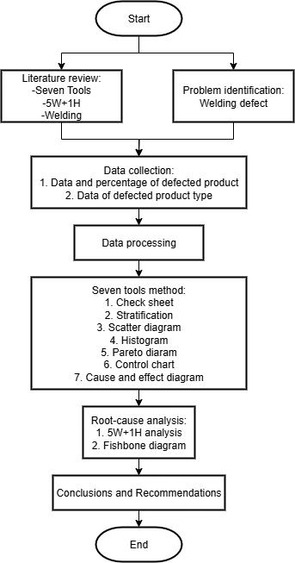
Figure 1. Research Flow Diagram.

TABLE 1. Weekly Production Data and Defect Percentage.
Week | Total Production (Units) | Accepted (Units) | Repaired (Units) | Defect Percentage (%)
1 | 227 | 195 | 32 | 14%
2 | 409 | 379 | 30 | 7%
3 | 266 | 233 | 33 | 12%
4 | 103 | 70 | 33 | 32%
5 | 245 | 215 | 30 | 12%
6 | 205 | 176 | 29 | 14%
7 | 258 | 226 | 32 | 12%
8 | 456 | 403 | 53 | 12%
Total | 2,169 | 1,897 | 272 | 13% (average)

Results and Discussion

Stratification and Check Sheet Analysis
Initial stratification was conducted to classify welding defect types that occurred throughout the eight-week observation period. Based on the check sheet data, five major types of welding defects were recorded: stop-start, porosity, spatter, undercut, and overlap. The frequencies and corresponding proportions are summarized in Table 2.

TABLE 2. Frequency of Welding Defects During the Observation Period.
No | Type of Defect | Frequency (units) | Percentage (%)
1 | Stop-Start | 81 | 29.78%
2 | Porosity | 70 | 25.74%
3 | Spatter | 49 | 18.01%
4 | Undercut | 41 | 15.07%
5 | Overlap | 31 | 11.40%
 | Total | 272 | 100%

From Table 2, it is evident that stop-start defects were the most dominant, comprising 29.78% of all defects, followed by porosity (25.74%) and spatter (18.01%). This classification provided a clear basis for identifying the primary focus in root cause analysis and improvement strategies.

Pareto Diagram
To identify the most critical defect contributing to overall quality problems, a Pareto diagram was constructed using the data from Table 2. As shown in Fig. 2, stop-start, porosity, and spatter collectively account for approximately 75% of all welding defects, highlighting their significance as targets for improvement efforts.

Figure 2. Pareto Diagram of Welding Defects.

Control Chart
A control chart was used to monitor the stability of the defect rate throughout the 8-week observation period. The chart was constructed using weekly defect percentages. As shown in Fig. 3, the defect percentage fluctuated between 11% and 15%, with an average of 13.4%. Although the process remained within control limits, the consistent level of high defects indicates a lack of process capability, necessitating corrective action.

Figure 3. Control Chart.

Histogram and Scatter Diagram
To further illustrate defect distribution, a histogram was created (see Fig. 4), reaffirming that stop-start defects were the most frequently occurring type, followed by porosity and spatter.
In addition, a scatter diagram was developed to examine the relationship between operator work shifts and defect occurrences. As shown in Fig. 5, there is a visible trend indicating that defect rates tend to increase during evening shifts, suggesting that operator fatigue or reduced supervision may contribute to quality issues.

Figure 4. Histogram of Welding Defect Distribution.

Figure 5. Scatter Diagram of Work Shift.

Cause-and-Effect (Fishbone) Diagram
To explore the root causes of the dominant defect (stop-start), a fishbone diagram was constructed and is presented in Fig. 6. The diagram identifies five major categories contributing to the problem:
- Man: Lack of welding experience or inadequate training among operators.
- Machine: Irregular maintenance of welding equipment, causing instability in arc performance.
- Method: Inconsistent welding procedures and absence of a standard operating procedure (SOP) for machine start/stop sequences.
- Material: Pipe surfaces contaminated with oil or rust, causing arc interruption.
- Environment: Poor lighting and cramped welding station layout.

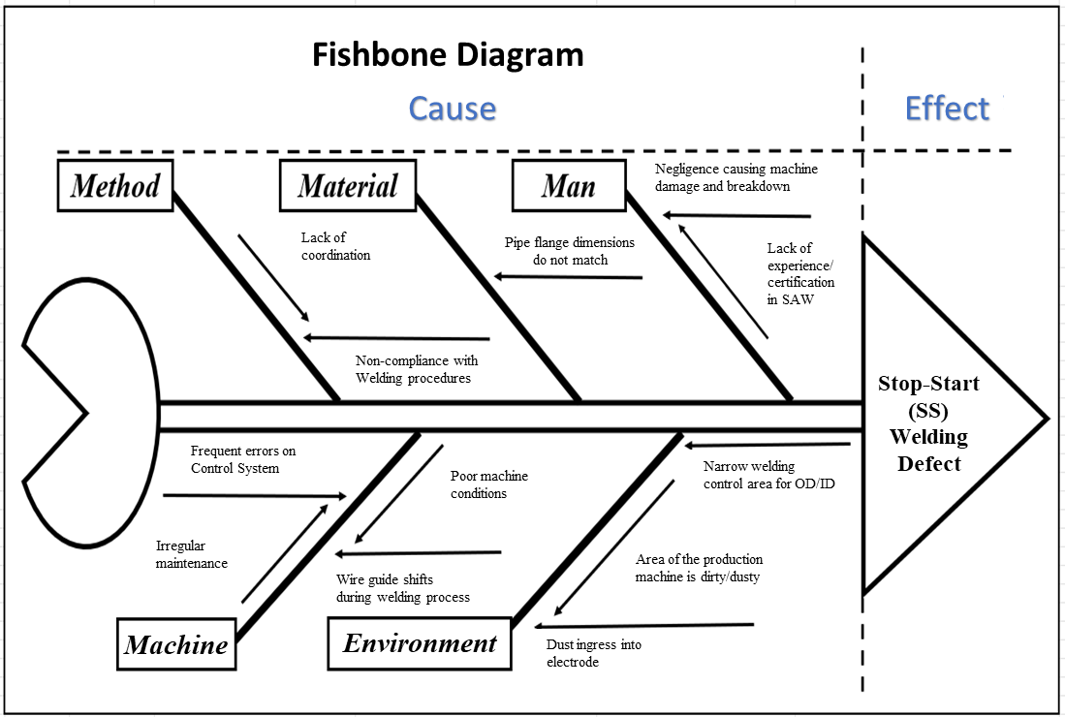
Figure 6. Fishbone Diagram of Stop-Start Defect Causes.

5W+1H Analysis
Based on the root cause identification, a structured analysis using the 5W+1H method was applied to guide the formulation of corrective and preventive actions. The result is shown in Table 3.

TABLE 3. 5W+1H Analysis for Stop-Start Defect Resolution.
Question | Description
What | Stop-start defect, the most frequent welding issue (87 units in 8 weeks).
Where | Predominantly occurs in the main welding area on Line 1.
When | Most frequent during evening and night shifts.
Who | Operators with less than 6 months of experience.
Why | Caused by inadequate SOP, insufficient training, and poor machine condition.
How | Implement SOP updates, schedule regular training, and enhance maintenance.

This integrated analysis provides a clear roadmap for quality improvement initiatives focused on reducing welding defects, particularly those related to human error and equipment condition.

CONCLUSION
This study analyzed the dominant welding defects occurring in the carbon steel pipe production process using a structured quality control approach based on the Seven Tools method. The stratification and check sheet revealed that the stop-start defect was the most prevalent, accounting for 32% of total defects recorded over an 8-week period, followed by porosity (22.8%) and spatter (20.2%).
Through Pareto analysis, these three defect types were identified as the most critical, contributing to approximately 75% of all quality issues. The control chart showed that although the defect rates were within control limits, the overall process stability remained inadequate. Supporting tools such as the histogram, scatter diagram, fishbone diagram, and 5W+1H analysis helped identify key root causes—primarily operator experience, lack of standard procedures, and irregular equipment maintenance.
The results emphasize the need for improved operator training, implementation of standardized work procedures, and scheduled maintenance programs to reduce the frequency of welding defects and enhance overall production quality. Future work may include monitoring the effectiveness of corrective actions through follow-up quality assessments and exploring automation or digital tracking solutions to support continuous improvement.

References
- A. Qwam Alden, “Improving productivity using simulation model: A case study of a steel pipe manufacturing company,” Anbar J. Eng. Sci. 13(1), 35–45 (2022). doi: 10.37649/aengs.2022.175878.
- B. Noori and M. Latifi, “Development of Six Sigma methodology to improve grinding processes: A change management approach,” Int. J. Lean Six Sigma 9(1), 50–63 (2018). doi: 10.1108/IJLSS-11-2016-0074.
- Casban and A. P. Dewi, “Efforts to reduce defect rates in steel pipes using cause-and-effect diagram analysis and the 5W+1H method,” Proc. Natl. Semin. Sci. Technol. 2019, 1–14 (2019). [Online]. Available: jurnal.umj.ac.id/index.php/semnastek.
- D. Tri, A. Rakhmanita, and A. Anggraini, “Implementation of Kaizen to improve performance in a manufacturing company in Tangerang,” J. Ecodemica J. Econ. Manag. Bus. 3(2), 198–206 (2019). doi: 10.31311/jeco.v3i2.6077.
- A. Merjani and I. Kamil, “Application of the Seven Tools and PDCA (Plan-Do-Check-Act) method to reduce welding defects in pipes,” PROFISIENSI J. Ind. Eng. Stud. Program 9(1), 124–131 (2021). doi: 10.33373/profis.v9i1.3313.
- M. H. P. Pratomo and H. S. T. M. T. Prassetiyo, “Proposal for reducing defects in polo shirt products using Failure Mode and Effect Analysis (FMEA) & 5W+1H methods at CV New Bandung Mulia Konveksi,” Proc. FTI Semin., 1–9 (2023).
- Wijayanto, “Study of corrosion and mechanical properties of submerged arc welded joints,” Technol. Technoscintea 6(2), 169–176 (2014).
- K. Kurniawan and S. S. Dahdah, “Quality control of welding in mechanical piping construction using the Seven Tools method,” J. Ind. Eng. J. Res. Sci. Work Ind. Eng. 9(2), 498 (2023). doi: 10.24014/jti.v9i2.23521.

