Quantifying Carbon Emissions in Excavation Operations for Road and Bridge Construction in Indonesia: An Analytical Study
Made Suangga^{a)} and Militia Christy Marchella^{b)}
Civil Engineering, Bina Nusantara University, Jakarta, Indonesia

^{a)} Corresponding author: suangga@binus.edu
^{b)} militia.marchella@binus.ac.id

Abstract. This research investigates the carbon emissions linked to excavation activities in road and bridge construction projects in Indonesia. Using the Ministry of Public Works and Housing’s standard unit price analysis, it quantifies emissions from various excavation types, including ordinary, soft rock, rock, and structural excavation at different depths. The study focuses on two key activities: excavation and loading, and transportation of excavated materials. Findings reveal that rock excavation significantly increases carbon emissions due to the use of rock drilling equipment. Both rock and soft rock excavations also contribute to higher emissions during material transportation, especially with longer haul distances. The analysis provides a detailed view of how equipment and excavation methods affect the overall carbon footprint of construction projects. By categorizing emissions based on activities and equipment, the study identifies key areas for potential efficiency improvements. The research aligns with Indonesia's environmental goals, offering insights for the construction industry to reduce carbon emissions and support the country’s Net Zero Emissions target by 2060. These findings are crucial for policymakers and industry stakeholders aiming to promote more sustainable construction practices.
Keywords: Carbon emissions, Excavation activities, Construction sustainability, Road and bridge projects

INTRODUCTION
Infrastructure development is essential for the progress and economic growth of nations. As countries work to improve their transportation systems, housing, and public facilities, the construction industry expands significantly. However, this rapid development has a significant downside: increased carbon emissions. The construction sector is a major contributor to greenhouse gas emissions, which cause environmental degradation and exacerbate global warming [1]. To combat these issues, countries worldwide are implementing strategies to reduce carbon emissions [2]. In Indonesia, the government has committed to achieving Net Zero Emissions (NZE) by 2060 or sooner [3]. NZE is an ambitious goal where a nation's total greenhouse gas emissions are balanced by the amount of greenhouse gases removed or offset through mechanisms such as reforestation and carbon capture technologies. Additionally, Indonesia's Nationally Determined Contributions (NDC) set specific emission reduction targets to be achieved by 2030 [4].
The construction industry globally is responsible for over 30% of natural resource extraction, 25% of solid waste generation, 40% of global energy consumption, and 25% of greenhouse gas emissions [5] [6]. The building construction and operation sector alone contributes 36% to global energy use and 39% to energy-related CO2 emissions annually [5]. Therefore, reforms and initiatives within the construction industry can have a significant and rapid impact on global climate change, energy consumption, the economy, and society [7]. Earthwork activities in road construction contribute significantly to carbon dioxide emissions and environmental impact [8]. These emissions primarily stem from fuel consumption by heavy-duty diesel equipment used in excavation, loading, and transportation [9]. Researchers have developed various tools and models to estimate fuel use, emissions, and productivity of earthwork operations, including bottom-up approaches [10], productivity-based estimating tools, and frameworks that consider economic, energy, and environmental impacts [11].
Cut and fill work in road and bridge project, also known as earthwork, is a fundamental construction process that involves excavating soil or rock (cut) from one location and depositing the excavated material in another area (fill) [8]. This technique is widely used to level uneven terrains, create building foundations, construct roadways, and develop various infrastructure projects [8]. To meet specific construction requirements, such as achieving the desired elevation and ground stability, cut and fill work frequently relies on heavy machinery and equipment [9]. The operation of this machinery and the associated fuel consumption significantly contribute to the carbon footprint of construction projects [12].
The primary aim of this research is to analyze and estimate the carbon emissions associated with excavation work in construction projects. This study focuses on various types of excavation activities commonly practiced in road and bridge projects in Indonesia. By conducting a detailed analysis, the research seeks to provide insights into the specific contributions of these activities to overall carbon emissions [13] [14].

METHODOLOGY
This research investigates the carbon emissions associated with various types of excavation activities in road and bridge construction projects in Indonesia. The scope of this study includes the following pay items, with the unit of measurement in cubic meters: (1) Ordinary Excavation; (2) Soft Rock Excavation; (3) Rock Excavation; (4) Structural Excavation at depths of 0–2 meters; (5) Structural Excavation at depths of 2–4 meters; and (6) Structural Excavation at depths of 4–6 meters .
The initial step utilizes the standard unit price analysis for civil works, as provided by the Ministry of Public Works and Housing, Government of Indonesia. This analysis is applicable to all pay items in road and bridge projects and includes detailed procedures for calculating the Basic Unit Price of labor, materials, and equipment, which in turn determines the Unit Price of Work. The second step involves a detailed review of the specific stages in excavation that generate CO2 emissions . The primary sources of emissions in this context are the excavation and loading activities, and the material transportation activities. The analysis focuses on the emissions attributable to the operation of heavy equipment during these stages. The methodology progresses with the calculation of coefficients for each piece of heavy equipment used, based on the Unit Price Analysis (AHSP). These coefficients are calculated for each stage of the work, from excavation to material transportation, providing a basis for subsequent emissions calculations. The final step calculates the CO2 emissions specifically generated from excavation activities in road projects. The results from the heavy equipment coefficient calculations are used to quantify the emissions. Since the excavation activities are divided into two main components—excavation/loading and transportation—the emissions are accordingly categorized. For the transportation component, emissions are further analyzed based on the hauling distance, with emissions data provided for every 1 km of material transported.

ACTIVITIS AND HEAVY EQUIPMENTS
For the excavation items considered in this study, the operational scope is divided into two main activities: (1) Excavation and Loading Work and (2) Transportation Work. The carbon emissions associated with these construction activities are primarily determined by the emissions produced by the heavy equipment utilized. The specific pieces of heavy equipment involved in this study are Excavators, Rock Drilling Breakers, and Dump Trucks. Detailed characteristics of these machines, which influence their fuel consumption and subsequent emission outputs, are outlined as follows:
- Horsepower (hp): The horsepower rating is a critical parameter in the emission calculations, serving as a direct indicator of the equipment's energy consumption and operational power.
- Excavator: This equipment has an engine capacity of 133 HP, typically used for various excavation and loading tasks.
- Rock Drill Breaker: With an engine capacity of 138 HP, this equipment is essential for breaking through rock surfaces during excavation.
- Dump Truck: The dump truck used has a capacity of 10 tons and an engine capacity of 254.8 HP, crucial for transporting excavated material.
- Fuel Consumption for Diesel Engines: The fuel consumption rate is a pivotal factor in calculating emissions. For diesel engines, a standardized rate of 0.04 gallons per horsepower-hour (gal/HP.hr) is applied to estimate the fuel usage during equipment operation.
- Emission Factor for Diesel: The emission factor, set at 10.15 kg CO2 per gallon by the Environmental Protection Agency (EPA), is integrated into the analysis to quantify the emissions from diesel consumption.
These specifications form the basis for a robust assessment of the environmental impact associated with the heavy equipment used in excavation and transportation activities. The list of equipment, along with each item's characteristics, is comprehensively detailed in TABLE 1, providing a clear reference for the equipment's role and impact in the overall emissions from the project. This structured presentation of equipment data ensures clarity and facilitates
TABLE 1. The List of Equipment for each excavation work considered in this research and it characteristic
Heavy Equipment | Engine Capacity | Fuel Consp. Rate | Diesel Emission Factor. | Ordinary Soil Excav. | Soft Rock Excav. | Rock Excav. | Structural Excav. (0-2m) | Structural Excav. (2-4m) | Structural Excav. (4-6m)
- Excavating and Loading
Excavator | 133 | 0.04 | 10.15 | Yes | Yes | Yes | Yes | Yes | Yes
Rock Drill Breaker | 138 | 0.04 | 10.15 | No | Yes | Yes | No | No | No
- Transporting
Dump Truck 10 Ton | 254.8 | 0.04 | 10.15 | Yes | Yes | Yes | Yes | Yes | Yes

FORMULA TO CALCULATE CARBOn EMISSION
To accurately quantify carbon emissions from construction activities, a meticulous methodology is applied, focusing on the emissions from each piece of heavy equipment utilized during the construction process. Emissions for each equipment type are calculated by multiplying the specific emission rate (in KgCO2/hour) by the operational or cycle time. The emission rate for each piece of equipment is meticulously derived from a combination of manufacturer specifications and augmented by direct field observations, ensuring an accurate representation of real-world operating conditions.
The formula used to calculate the specific carbon emissions level (Ef) for each equipment is expressed in Eq. 1:
$E_{f}=EC×F×E_{c}×C$ (1)
where 𝐸𝐶 denotes the engine capacity (in HP), 𝐹 signifies the fuel consumption (in gal/HP.hr), 𝐸𝑐 represents the carbon factor (in kgCO2/gal), 𝐶 represents the cycle time of the equipment (hr/m3).
The formula used to calculate the total amount of carbon emissions, Etot is expresses in Eq. 2.
$E_{tot}=E_{f}×V$ (2)
where V represents the volume of work (in this study is 1 m3).
This formulaic approach provides a robust framework for evaluating the environmental impact of various construction practices by quantifying the carbon emissions associated with specific pieces of equipment over the course of their operational activities. This detailed calculation aids in identifying high-emission areas and opportunities for improving environmental efficiency in construction projects.

RESULT AND DISCUSSION
To calculate the amount of carbon emissions, it is necessary to determine the Equipment Coefficient for each piece of heavy equipment used. The assumptions used in calculating the Equipment Coefficient for each type of excavation work considered in this study are presented in TABLE 2.
TABLE 2. Assumption on Soil, Haul distance and Emission Factor
Parameter | Symbol | Unit | Ordinary Soil Excavation | Soft Rock Excavation | Rock Excavation | Structural Excavation (0-2m) | Structural Excavation (2-4m) | Structural Excavation (4-6m)
Soil Conversion Factor | F_{k} | - | 0.7 | 0.6100 | 0.5700 | 0.7000 | 0.7000 | 0.7000
Bulk Density of Material | D | ton/m3 | 1.1 | 0.9370 | 1.2295 | 1.1000 | 1.1000 | 1.1000
Haul Distance | L | km | 1 | 1.0000 | 1.0000 | 1.0000 | 1.0000 | 1.0000
Emission Factor | - | kg CO₂/ TJ | 74100 | 74100 | 74100 | 74100 | 74100 | 74100
Diesel Calorific Value. | - | TJ/liter | 0.000036 | 0.000036 | 0.000036 | 0.000036 | 0.000036 | 0.000036

The Equipment Coefficient of the Excavator for each type of excavation work considered in the analysis is presented in TABLE 3.
TABLE 3. Equipment Coefficient for Excavator
Description | Symbol | Unit | Ordinary Soil Excavation | Soft Rock Excavation | Rock Excavation | Structural Excavation (0-2m) | Structural Excavation (2-4m) | Structural Excavation (4-6m)
Bucket Capacity | V | m³ | 0.93 | 0.93 | 0.93 | 0.93 | 0.93 | 0.93
Bucket Factor | F_{b} | - | 1.15 | 0.95 | 0.85 | 1.15 | 1.15 | 1.15
Equipment Efficiency Factor | F_{a} | - | 0.83 | 0.83 | 0.83 | 0.83 | 0.83 | 0.83
Conversion Factor | F_{v} | Minutes | 1 | 1 | 1 | 0.9 | 1 | 1.1
Time for excavating and loading | T₁ | Minutes | 0.32 | 0.32 | 0.32 | 0.32 | 0.32 | 0.32
Time for others | T₂ | Minutes | 0.10 | 0.1 | 0.1 | 0.1 | 0.1 | 0.1
Cycle Time | T_{s1} | Minutes | 0.42 | 0.42 | 0.42 | 0.42 | 0.42 | 0.42
Production Capacity per Hour | Q₁ | m³/hour | 88.769 | 63.902 | 53.427 | 98.632 | 88.769 | 80.699
Equipment Coefficient | V | Hour | 0.01127 | 0.01565 | 0.01872 | 0.01014 | 0.01127 | 0.01239

The Equipment Coefficient of the Rock Drill Breaker for each type of excavation work considered in the analysis is presented in TABLE 4.
TABLE 4. Equipment Coefficient for Rock Drill Breaker
Description | Symbol | Unit | Ordinary Soil Excavation | Soft Rock Excavation | Rock Excavation | Structural Excavation (0-2m) | Structural Excavation (2-4m) | Structural Excavation (4-6m)
Breaker Diameter |  | cm |  | 0.93 | 0.93
Breaker Capacity | V | m³ |  | 0.95 | 0.85
Breaker Factor | F_{b} |  |  | 0.83 | 0.83
Equipment Efficiency Factor | F_{a} |  |  | 1 | 1
Time for Carving | T₁ | Minutes |  | 0.32 | 0.32
Time for others | T₂ | Minutes |  | 0.1 | 0.1
Cycle Time | T_{s2} | Minutes |  | 0.42 | 0.42
Production Capacity per Hour | Q2 | m³/hour |  | 63.902 | 53.427
Equipment Coefficient | V | Hour |  | 0.01565 | 0.01872

The Equipment Coefficient of the Dump Truck with Capacity of 10 tons for each type of excavation work considered in the analysis is presented in TABLE 5.
TABLE 5. Equipment Coefficient for Dump Truck with Capacity of 10 tons
Description | Symbol | Unit | Ordinary Soil Excavation | Soft Rock Excavation | Rock Excavation | Structural Excavation (0-2m) | Structural Excavation (2-4m) | Structural Excavation (4-6m)
Permissible load in the truck bed | V | m³ | 9.09 | 10.67 | 8.13 | 9.09 | 9.09 | 9.09
Equipment Efficinecy Factor | F_{a} |  | 0.83 | 0.83 | 0.83 | 0.83 | 0.83 | 0.83
Average speed of a loaded truck | V₁ | Km/hour | 20 | 20 | 20 | 20 | 20 | 20
average speed of an unloaded truck | V₂ | Km/hour | 40 | 40 | 40 | 40 | 40 | 40
Time for loading | T₁ | Minutes | 6.145 | 10.021 | 9.134 | 5.530 | 6.145 | 6.759
Travel time for loaded Truck | T₂ | Minutes | 3.000 | 3.000 | 3.000 | 3.000 | 3.000 | 3.000
Travel time for unloaded Truck | T₃ | Minutes | 1.500 | 1.500 | 1.500 | 1.500 | 1.500 | 1.500
Time for others | T₄ | Minutes | 1.000 | 1.000 | 1.000 | 1.000 | 1.000 | 1.000
Cycle Time | T_{s1} | Minutes | 11.645 | 15.521 | 14.634 | 11.030 | 11.645 | 12.259
Production Capacity per Hour | Q₁ | m³/hour | 27.215 | 20.889 | 15.776 | 41.044 | 38.878 | 36.930
Equipment Coefficient | V | Hour | 0.03674 | 0.04787 | 0.06339 | 0.02436 | 0.02572 | 0.02708

The Summary of the Equipment coefficient for each type of excavation work considered in the analysis is presented in TABLE 6.
TABLE 6. Summary of Equipment Coefficient
 | Ordinary Soil Excavation | Soft Rock Excavation | Rock Excavation | Structural Excavation (0-2m) | Structural Excavation (2-4m) | Structural Excavation (4-6m)
 | hour | hour | hour | hour | hour | hour
Excavating and Loading
- Excavator | 0.0113 | 0.0156 | 0.0187 | 0.0101 | 0.0113 | 0.0124
- Rock Drill Breaker | 0.0000 | 0.0156 | 0.0187 | 0.0000 | 0.0000 | 0.0000
Transporting
- Dump Truck 10 Ton | 0.0367 | 0.0479 | 0.0634 | 0.0244 | 0.0257 | 0.0271

The carbon emissions for each type of excavation work considered in the analysis are presented in TABLE 7. The carbon emissions for excavation and loading are separated from the carbon emissions for transportation. The transportation emissions are calculated for every 1 km of haul distance.
TABLE 7. Carbon Emissions for Excavation and Loading, and Transportation per 1 km Haul Distance
 | Ordinary Soil Excavation | Soft Rock Excavation | Rock Excavation | Structural Excavation (0-2m) | Structural Excavation (2-4m) | Structural Excavation (4-6m)
 | (Kg CO₂) | (Kg CO₂) | (Kg CO₂) | (Kg CO₂) | (Kg CO₂) | (Kg CO₂)
Excavating and Loading | 0.61 | 4.38 | 4.55 | 0.55 | 0.61 | 0.67
- Excavator | 0.61 | 0.85 | 1.01 | 0.55 | 0.61 | 0.67
- Rock Drill Breaker | 0.00 | 3.54 | 3.54 | 0.00 | 0.00 | 0.00
Transporting | 3.80 | 4.95 | 6.56 | 2.52 | 2.66 | 2.80
- Dump Truck 10 Ton | 3.80 | 4.95 | 6.56 | 2.52 | 2.66 | 2.80
TOTAL | 4.41 | 9.33 | 11.10 | 3.07 | 3.27 | 3.47

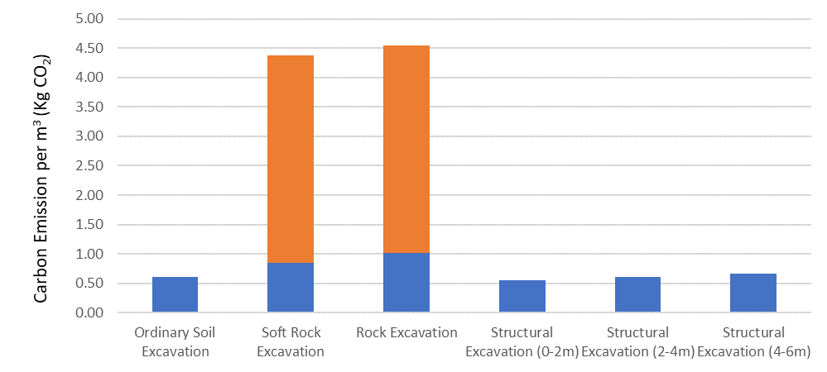
FIGURE 1. Carbon Emission per m³ from Excavating and Loading Activities

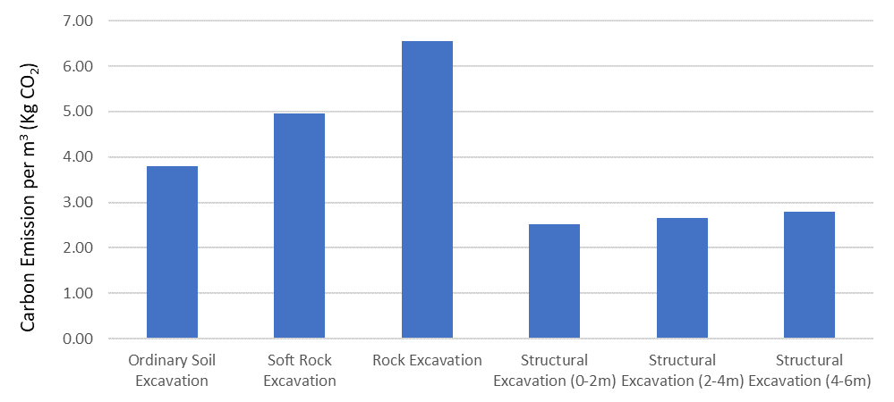
FIGURE 2. Carbon Emission per m³ from Transportation Activities for 1 km hauling distance

The carbon emissions from rock excavation work are significantly higher compared to ordinary excavation and structural excavation. This is primarily due to the rock drilling equipment, which produces substantial carbon emissions and plays a critical role in the total carbon emissions generated. The carbon emissions produced by ordinary excavation and structural excavation are relatively similar, displayed in FIGURE 1.
A similar trend (FIGURE 2) is observed in the carbon emissions from the transportation process. The transportation emissions for rock and soft rock excavation are higher compared to those for soil excavation.

CONCLUSION
This study conducted a comprehensive analysis of carbon emissions from various excavation activities in road and bridge construction projects in Indonesia, using standard unit price analysis guidelines from the Ministry of Public Works and Housing. It highlighted the significant differences in carbon emissions between different excavation activities, notably revealing that rock and soft rock excavation, due to intensive use of rock drilling equipment, generates substantially higher emissions compared to ordinary and structural excavation. Additionally, the transportation of excavated materials, particularly over longer distances, considerably increases the project's total emissions.
The research emphasizes the critical role of integrating carbon emission assessments into both the planning and execution phases of construction projects. By identifying emission hotspots, construction managers and policymakers can deploy targeted strategies to minimize environmental impacts. This study utilizes a rigorous methodology that incorporates equipment specifications, direct field observations, and standardized emission factors, ensuring accurate and reliable emission calculations that adhere to industry standards.
The findings advocate for technological advancements and the implementation of best practices in the construction industry to meet Indonesia's environmental objectives and broader global sustainability targets. This contribution enriches the dialogue on sustainable construction, offering practical insights that can help mitigate the environmental footprint of crucial infrastructure projects, thereby supporting sustainable development initiatives.

ReferenceS
- K. O. Yoro and M. O. Daramola, "CO2 emission sources, greenhouse gases, and the global warming effect," in Advances in carbon capture: Elsevier, 2020, pp. 3-28.
- T. Patrianti, A. Shabana, and R. W. D. Tuti, "Government risk communication on greenhouse gas emission reduction to tackle climate change," Jurnal Penelitian Komunikasi Dan Opini Publik, vol. 24, no. 2, pp. 155-170, 2020.
- A. Capony, B. Muresan, M. Dauvergne, J.-C. Auriol, V. Ferber, and A. Jullien, "Monitoring and environmental modeling of earthwork impacts: A road construction case study," Resources, conservation and recycling, vol. 74, pp. 124-133, 2013.
- Y. Xie, H. Fan, and Z. Huang, "Comparative analysis of subsidy and fee policies for construction equipment emissions reduction," Journal of Cleaner Production, vol. 406, p. 137011, 2023.
- L. Shi et al., "Comparative study of greenhouse gas emission calculations and the environmental impact in the life cycle assessment of buildings in China, Finland, and the United States," Journal of Building Engineering, vol. 70, p. 106396, 2023.
- Y. Zhao, X. Duan, and M. Yu, "Calculating carbon emissions and selecting carbon peak scheme for infrastructure construction in Liaoning Province, China," Journal of Cleaner Production, vol. 420, p. 138396, 2023.
- H. Zhang, D. Zhai, and Y. N. Yang, "Simulation-based estimation of environmental pollutions from construction processes," Journal of cleaner production, vol. 76, pp. 85-94, 2014.
- M. A. Aboelhassan and I. H. Hashim, "ASSESSING CARBON DIOXIDE (CO2) OF EARTHWORKS’OPERATIONS DURING ROAD CONSTRUCTION," ERJ. Engineering Research Journal, vol. 41, no. 3, pp. 205-213, 2018.
- B. Muresan et al., "Key factors controlling the real exhaust emissions from earthwork machines," Transportation research part D: Transport and Environment, vol. 41, pp. 271-287, 2015.
- L. Hughes et al., "Carbon dioxide from earthworks: a bottom-up approach," in Proceedings of the Institution of Civil Engineers-Civil Engineering, 2011, vol. 164, no. 2, pp. 66-72: Thomas Telford Ltd.
- M. Masih-Tehrani, S. Ebrahimi-Nejad, and M. Dahmardeh, "Combined fuel consumption and emission optimization model for heavy construction equipment," Automation in Construction, vol. 110, p. 103007, 2020.
- A. Kong, H. Kang, S. He, N. Li, and W. Wang, "Study on the carbon emissions in the whole construction process of prefabricated floor slab," Applied Sciences, vol. 10, no. 7, p. 2326, 2020.
- I. S. J. Andini Nugrahardani, Mochamad Agung Wibowo, Hari Budieny, "EVALUASI MATERIAL WASTE DAN CARBON FOOTPRINT PADA PENERAPAN GREEN CONSTRUCTION," Jurnal Karya Teknik Sipil, vol. 6, no. 1, pp. 375-384, 2017.
- M. Sparrevik, X. Qiu, R. A. Stokke, I. Borge, and L. de Boer, "Investigating the potential for reduced emissions from non-road mobile machinery in construction activities through disruptive innovation," Environmental Technology & Innovation, vol. 31, p. 103187, 2023.

