Study of maximum deflection of truss bridges using rotation data
Made Suangga^{a)} and Kevin Sapari^{b)}
Civil Engineering, Bina Nusantara University, Jakarta, Indonesia

^{a)} Corresponding author: suangga@binus.edu
^{b)} kevinsapari10@yahoo.com
Abstract. This research paper presents a methodology for estimating the maximum deflection of a Simple Span Truss Bridge using tiltmeter sensors as part of a Structural Health Monitoring System. The study site was a bridge located in Pusat Penelitian Jalan, Kota Bandung, Jawa Barat, Indonesia, chosen for its relevance and representative characteristics. A three-dimensional Finite Element Method (FEM) model was developed to accurately represent the bridge's geometric and mechanical properties. Actual data on maximum deflection, rotation, and strain were acquired by subjecting the FEM model to realistic load conditions. Regression analysis was conducted to derive equations for calculating maximum deflection based on the measured rotation and strain data. The accuracy of the estimated maximum deflection was validated by comparing it with values obtained from 3D structural analysis using FEM software. The study demonstrated that the average difference between the FEM maximum deflection and the regression equation values derived from stress/strain measurements was 4.28% for linear regression. This indicates that linear regression, which produces simpler equations, can be considered a viable option. The analysis also revealed that the level of accuracy is influenced by the magnitude of the maximum deflection. Accurately estimating extremely small deflection values poses challenges due to the inherent limitations of the regression equations and the nature of the load configurations. This research highlights the potential of using rotational data from tiltmeters for effective deflection monitoring in truss bridges, offering a practical, cost-effective solution for maintaining bridge health and ensuring structural integrity.
Keywords: Structural Health Monitoring, Simple Span Truss Bridge, Maximum Deflection Estimation, Tiltmeter Sensors

INTRODUCTION

Bridges are critical infrastructure that experience dynamic and repetitive loads over long periods, leading to deterioration over time. Consequently, it is essential to monitor the condition of bridge structures to ensure they remain in proper condition. This is achieved through a system called the structural health monitoring system (shms), which aims to obtain sustainable information on civilian buildings [1]. Shms can monitor conditions that change gradually or suddenly by evaluating the working load and its mechanical response [1].

To date, an increasing number of structures have been monitored and tested, leading to a greater understanding of structural behavior. Measurements of deflection, strain, and rotation during load tests and long-term monitoring can detect signs of potentially detrimental changes in the structure [2] [3]. The development and successful implementation of long-term structural monitoring systems on bridges have been widely reported by researchers. In recent years, tiltmeters (also called inclinometers) have been widely used for construction monitoring, structural examinations, and long-term performance monitoring of bridges due to their simplicity and affordability.

The method of measuring bridge deflection using rotational data from tiltmeters is considered promising, practical, inexpensive, and simple [1] [3]. It effectively measures static and dynamic deflection of bridge spans under load, even for spans crossing significant heights. This method does not require a fixed viewing position, as the tiltmeter is directly mounted on the bridge, greatly increasing measurement efficiency. Results indicate that the rotation method is a potential technique for measuring bridge deflection, demonstrating significant technical application value and a promising future with accurate results.

This research aims to develop a model to predict deflection values in truss bridges using data from tiltmeters. The model is created using the sap2000 application based on provided bridge dimensions [4]. Regression equations are derived to compare the accuracy of the model with the rotational values obtained, ultimately determining the effectiveness of this method in predicting bridge deflection [5] [6].

A truss bridge is a type of bridge constructed from steel wide flange (wf) beams connected by gusset plates to form triangular units. These triangles distribute stress from tension and compression forces effectively. Despite being categorized as older bridge designs, truss bridges remain popular due to their relatively easy production and installation processes compared to other bridge types [4].

The objective of this research is to evaluate rotational data in predicting deflection values, identifying the most accurate regression results based on these data for predicting deflection in truss bridges. This study directly supports sustainable development goal (sdg) 9 by enhancing bridge resilience, introducing cost-effective monitoring technology for sustainable infrastructure, and fostering innovation for safer and more accessible infrastructure [1]. By developing and implementing structural health monitoring systems for bridges, this study enhances their ability to withstand dynamic and repetitive loads and ensures their structural integrity.

METHODS
The research methodology for this study comprises several critical steps to thoroughly examine the deflection of a Simple Span Truss Bridge using rotation data. The main phases of this methodology include:

a. Study Location Selection
This research focused on a truss bridge located in Pusat Penelitian Jalan, Kota Bandung, West Java, Indonesia. This bridge was selected due to its suitability for the study's goals and its representative characteristics.
b. Development of a Three-Dimensional Finite Element Model
A 3D Finite Element Method (FEM) model of the bridge was created, capturing its geometric and mechanical properties. This model allows for a detailed analysis and simulation of the bridge's structural responses.
c. Collection of Empirical Data
Empirical data on maximum deflection and rotations were gathered by applying various loading conditions to the 3D FEM model, simulating real-world operational scenarios. This process provided essential data for further analysis.
d. Calculation of Maximum Deflection Formulas
Formulas for maximum deflection were derived from rotation data through Multiple Regression analysis, aiming to establish a reliable relationship between measured rotations and the corresponding deflection values.
e. Validation of Maximum Deflection Estimates
To verify the accuracy of the deflection estimates from the regression equations, a comparison was made with deflection values obtained via 3D structural analysis using FEM software. This step confirmed the reliability of the proposed estimation method by comparing it with FEM software outcomes.
f. Sensor Effectiveness Comparative Analysis
A comparative analysis was conducted to evaluate the accuracy of using tiltmeters for monitoring the bridge's structural health. Sensor data was scrutinized to assess their effectiveness in accurately estimating maximum deflection.
By following this structured approach, the study achieved precise maximum deflection estimates for the truss bridge, facilitating efficient monitoring and evaluation of its structural integrity.

CASE STUDY
The study was conducted on a truss bridge in FIGURE 1 that located in Cisaranten Bina Harapan, Kec. Arcamanik, Kota Bandung, in the Province of Jawa Barat, Indonesia. This location was chosen due to its relevance to the research objectives and the representative characteristics of the bridge structure. The site is part of the Pusat Penelitian Jalan in Bandung, making it an ideal subject for detailed structural analysis and monitoring.

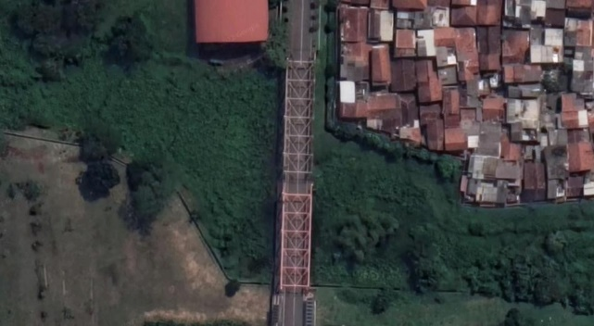 | 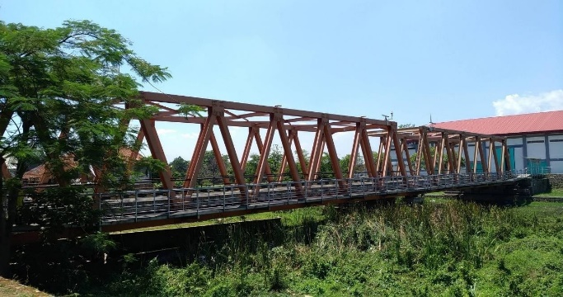
 | 

FIGURE 1. Case Study – Truss Bridge with 35 m span

FINITE ELEMENT MODEL OF the BRIDGE
A detailed three-dimensional Finite Element Model (FEM) was carefully developed to accurately represent the bridge's real-world condition. As shown in FIGURE 2, this FEM was designed to capture the complex details of the bridge's structural components, allowing a realistic simulation of its behavior under varying load conditions.
For accurate deflection measurement, rotations were precisely recorded only at the ends of the bridge span. This targeted approach was chosen to provide essential insights into the bridge's peak deflection, supplying critical data for subsequent analysis and estimation tasks.

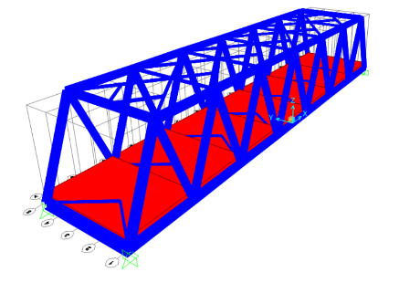 | 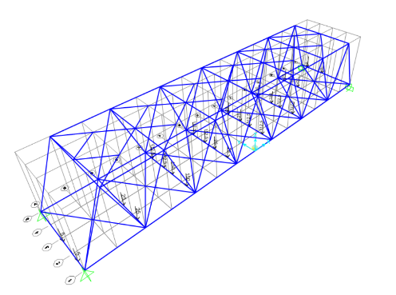

FIGURE 2. Finite Element Model of The Bridge

The Location on the maximum deflection measurement and the location of rotation data drive from tilt meter sensor are presented in FIGURE 3 and FIGURE 4.

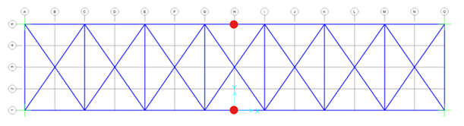
FIGURE 3. The Locations of Maximum Deflection

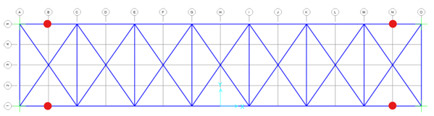
FIGURE 4. The Location fo Rotation data from Tiltmeter

MAXIMUM DEFLECTIOn AND ROTATION DATA
To obtain the maximum deflection, rotation, and stress/strain data, 136 different load configurations were analyzed. These configurations represented a variety of realistic conditions the bridge might experience throughout its service life. FIGURE 5 illustrates a selection of these configurations, showcasing the range of load magnitudes and distributions taken into account during the analysis.

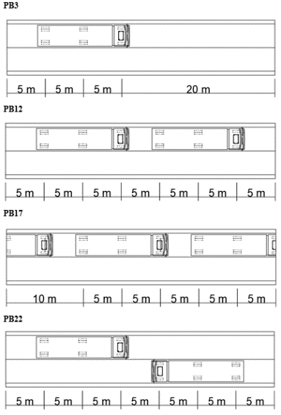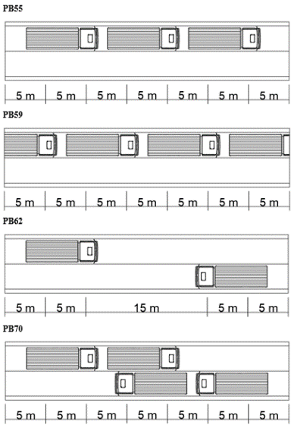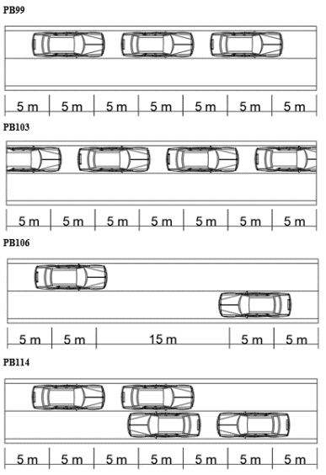
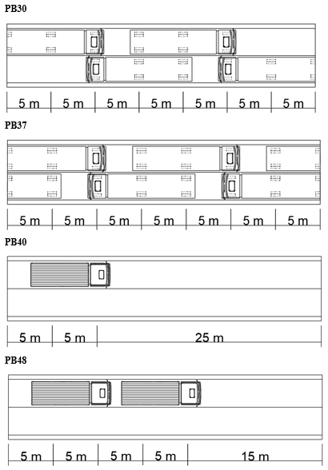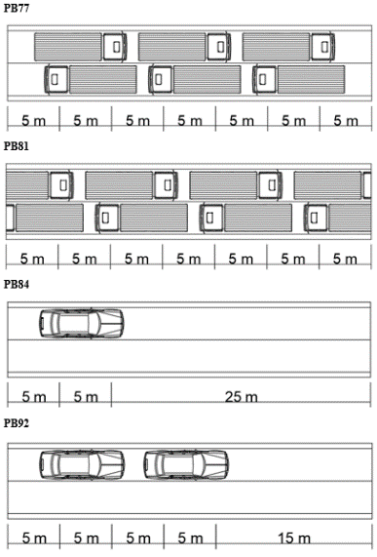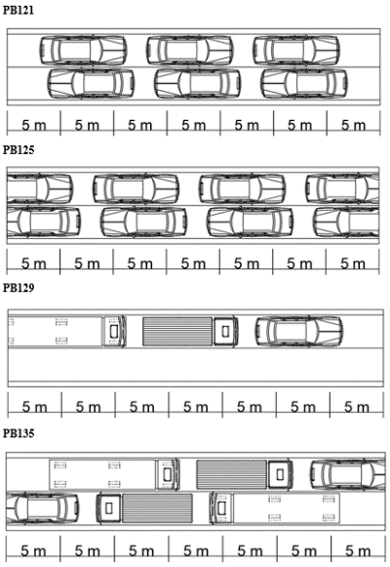
FIGURE 5. Sample of Load Configurations

The maximum deflection values, along with the corresponding rotations, were obtained through the three-dimensional FEM analysis. Based on previous studies, it is known that at low deflection values, the accuracy of the maximum deflection obtained using regression data is low. Therefore, in this research, only load combinations that resulted in deflection values of 10 mm or higher were considered. There were 26 data points with deflections of 10 mm or more, as presented in TABLE 1. These values were analyzed to develop regression equations that predict maximum deflection based on measured rotation and stress data. The accuracy of these predictions was then validated against the deflection values obtained through FEM analysis. This approach ensured that only the most relevant and significant deflection values were considered, thereby enhancing the reliability and precision of the deflection predictions.

TABLE 1. Deflection Values from FEM Model for Load Combinations Resulting in Deflections of 10 mm or More, Sorted by Smallest Deflection Value
Load Conf. | The truss structure located on the right |  |  | Load Conf. | The truss structure located on the Left
Load Conf. | δ (mm) | ϕ₁ (Rad) | Φ₂ (Rad) |  | δ (mm) | ϕ₁ (Rad) | Φ₂ (Rad)
PB23 | -10.078 | 0.000770 | -0.000774 | PB23 | -10.078 | 0.000770 | -0.000773
PB73 | -10.213 | 0.000887 | -0.000866 | PB73 | -10.213 | 0.000861 | -0.000893
PB29 | -10.484 | 0.000821 | -0.000830 | PB29 | -10.484 | 0.000826 | -0.000825
PB134 | -11.015 | 0.000891 | -0.000916 | PB134 | -11.015 | 0.000911 | -0.000896
PB24 | -11.274 | 0.000798 | -0.000802 | PB24 | -11.274 | 0.000798 | -0.000802
PB70 | -11.374 | 0.000941 | -0.000973 | PB70 | -11.374 | 0.000968 | -0.000947
PB75 | -11.375 | 0.000942 | -0.000974 | PB75 | -11.375 | 0.000968 | -0.000947
PB33 | -13.093 | 0.001047 | -0.001032 | PB33 | -13.093 | 0.001027 | -0.001053
PB72 | -13.454 | 0.001056 | -0.001055 | PB72 | -13.454 | 0.001050 | -0.001061
PB79 | -13.457 | 0.001057 | -0.001056 | PB79 | -13.457 | 0.001051 | -0.001062
PB71 | -13.871 | 0.001072 | -0.001078 | PB71 | -13.870 | 0.001073 | -0.001077
PB30 | -13.913 | 0.001100 | -0.001126 | PB30 | -13.913 | 0.001120 | -0.001105
PB76 | -14.277 | 0.001124 | -0.001135 | PB76 | -14.277 | 0.001129 | -0.001129
PB135 | -14.539 | 0.001203 | -0.001229 | PB135 | -14.539 | 0.001223 | -0.001209
PB136 | -15.402 | 0.001261 | -0.001263 | PB136 | -15.402 | 0.001257 | -0.001267
PB32 | -15.586 | 0.001346 | -0.001332 | PB32 | -15.586 | 0.001326 | -0.001353
PB37 | -15.733 | 0.001349 | -0.001357 | PB37 | -15.733 | 0.001349 | -0.001357
PB31 | -15.990 | 0.001381 | -0.001404 | PB31 | -15.990 | 0.001396 | -0.001388
PB35 | -15.990 | 0.001381 | -0.001404 | PB35 | -15.990 | 0.001397 | -0.001388
PB38 | -15.991 | 0.001381 | -0.001404 | PB38 | -15.991 | 0.001397 | -0.001389
PB36 | -15.992 | 0.001397 | -0.001389 | PB36 | -15.992 | 0.001382 | -0.001405
PB78 | -16.294 | 0.001403 | -0.001385 | PB78 | -16.294 | 0.001378 | -0.001411
PB77 | -16.698 | 0.001433 | -0.001462 | PB77 | -16.698 | 0.001454 | -0.001441
PB80 | -16.698 | 0.001433 | -0.001462 | PB80 | -16.698 | 0.001454 | -0.001441
PB82 | -16.700 | 0.001434 | -0.001463 | PB82 | -16.700 | 0.001455 | -0.001442
PB81 | -16.701 | 0.001455 | -0.001442 | PB81 | -16.700 | 0.001434 | -0.001463

Regression Equation to Determine Maximum Deflection
The deflection and stress values presented in Table 1 then processed by multiple regression analysis to obtain a maximum deflection – rotation regression equation. The regression equations to determine the maximum deflection are presented in TABLE 2.
TABLE 2. Regression Equations to Determine Maximum Deflection
No | Case and Equation | Eq. No.
1 | On the truss structure located on the right | (1)
1 | δ_{max} = 0,082692 – 5838,04 ϕ₁ + 6106,542 ϕ₂ | (1)
2 | On the truss structure located on the left | (2)
2 | δ_{max} = 0,10866 - 11843 ϕ₁ + -0,3329 ϕ₂ | (2)

RESULT AND DISCUSSION
The accuracy of the proposed approach was thoroughly evaluated by comparing the maximum deflection values obtained from the Three-dimensional FEM model with those calculated using the regression equation. The Sample of this accuracy check results are presented in TABLE 3, which presents a comparison of the maximum deflection values obtained from both the FEM model and the regression equation. FIGURE 4 presenting the comparison of average accuracy of linear regression and quadratic regression for booth type of sensors.
TABLE 3. Sample of Max Deflection from FEM Analysis vs Deflection based on Rotations Shorted by Smallest Deflection
Load Config. | δ FEM  (mm) | The truss structure located on the right |  |  | The truss structure located on the left
Load Config. | δ FEM  (mm) | δ Equation (mm) | Δ  (mm) | (%) | δ Equation  (mm) | Δ  (mm) | (%)
PB23 | -10.078 | -9.139 | 0.939 | 9.32% | -9.011 | 1.068 | 10.59%
PB73 | -10.213 | -10.384 | -0.171 | 1.67% | -10.088 | 0.125 | 1.22%
PB29 | -10.484 | -9.779 | 0.705 | 6.73% | -9.674 | 0.810 | 7.73%
PB134 | -11.015 | -10.713 | 0.302 | 2.75% | -10.680 | 0.335 | 3.04%
PB24 | -11.274 | -9.474 | 1.800 | 15.97% | -9.342 | 1.932 | 17.13%
PB70 | -11.374 | -11.353 | 0.022 | 0.19% | -11.355 | 0.019 | 0.17%
PB75 | -11.375 | -11.365 | 0.010 | 0.09% | -11.355 | 0.019 | 0.17%
PB33 | -13.093 | -12.332 | 0.762 | 5.82% | -12.054 | 1.039 | 7.94%
PB72 | -13.454 | -12.525 | 0.930 | 6.91% | -12.327 | 1.128 | 8.38%
PB79 | -13.457 | -12.537 | 0.920 | 6.84% | -12.338 | 1.118 | 8.31%
PB71 | -13.871 | -12.759 | 1.112 | 8.02% | -12.599 | 1.271 | 9.17%
PB30 | -13.913 | -13.215 | 0.698 | 5.02% | -13.156 | 0.758 | 5.45%
PB76 | -14.277 | -13.410 | 0.866 | 6.07% | -13.262 | 1.014 | 7.10%
PB135 | -14.539 | -14.445 | 0.094 | 0.64% | -14.375 | 0.164 | 1.13%
PB136 | -15.402 | -14.992 | 0.410 | 2.66% | -14.778 | 0.624 | 4.05%
PB32 | -15.586 | -15.909 | -0.323 | 2.07% | -15.595 | -0.009 | 0.06%
PB37 | -15.733 | -16.079 | -0.347 | 2.20% | -15.868 | -0.135 | 0.86%
PB31 | -15.990 | -16.553 | -0.564 | 3.52% | -16.424 | -0.435 | 2.72%
PB35 | -15.990 | -16.553 | -0.563 | 3.52% | -16.436 | -0.446 | 2.79%
PB38 | -15.991 | -16.553 | -0.562 | 3.51% | -16.436 | -0.445 | 2.78%
PB36 | -15.992 | -16.555 | -0.563 | 3.52% | -16.259 | -0.267 | 1.67%
PB78 | -16.294 | -16.566 | -0.271 | 1.66% | -16.211 | 0.083 | 0.51%
PB77 | -16.698 | -17.211 | -0.513 | 3.07% | -17.111 | -0.413 | 2.47%
PB80 | -16.698 | -17.211 | -0.513 | 3.07% | -17.111 | -0.413 | 2.47%
PB82 | -16.700 | -17.223 | -0.523 | 3.13% | -17.123 | -0.423 | 2.53%
PB81 | -16.701 | -17.217 | -0.517 | 3.09% | -16.874 | -0.174 | 1.04%
Average |  |  |  | 4,27 % |  |  | 4,29 %

TABLE 3 present the average differences between the FEM maximum deflection and the regression equation values derived from stress/strain measurements. The average difference is 4.28% for linear regression. Therefore, the use of linear regression, which produces simpler equations, can be considered as a viable option

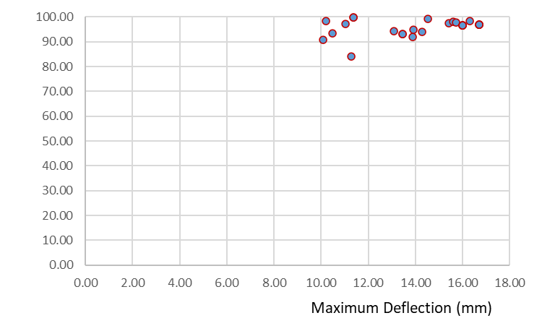 | 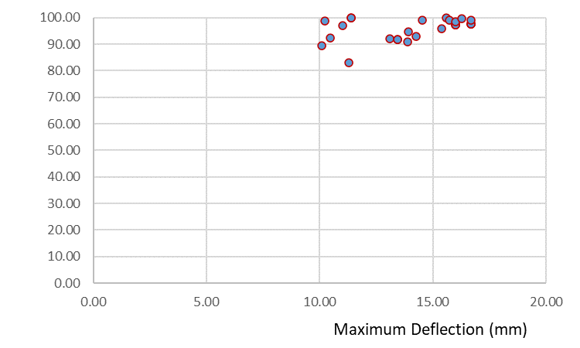
- The truss structure located on the right | - The truss structure located on the left

FIGURE 4. The Effect of Deflection Magnitude to the Level of Accuracy

FIGURE 4 reveal that the level of accuracy is influenced by the magnitude of the maximum deflection. Accurately estimating extremely small deflection values can pose challenges due to the inherent limitations of the regression equation and the nature of the load configurations.

CONCLUSION
Based on the analysis conducted in this research, the following conclusions can be drawn:
- The results indicate that quadratic regression provides a slightly higher level of accuracy in estimating maximum deflection using stress data, although the difference in accuracy between the two regression methods is not significant. Therefore, the use of linear regression can be considered a viable option.
- The average differences between the Finite Element Model (FEM) maximum deflection and the regression equation values derived from stress/strain and rotational measurements were small. These small average differences indicate a high level of agreement between the two methods in estimating the maximum deflection.
- The estimation accuracy was slightly higher when using rotational data compared to stress/strain data
In summary, the research demonstrates the efficacy of the regression-based estimation approach for assessing maximum deflection in a simple span steel girder bridge. Further field tests and real-world applications will help validate and refine the system for broader use.

References
- H. Sousa, F. Cavadas, A. Henriques, J. Bento, and J. Figueiras, "Bridge deflection evaluation using strain and rotation measurements," Smart Struct. Syst, vol. 11, no. 4, pp. 365-386, 2013.
- K. Ozakgul, O. Caglayan, and E. Uzgider, "Load testing of bridges using tiltmeters," 2009, pp. 1-4.
- X. Hou, X. Yang, and Q. Huang, "Using inclinometers to measure bridge deflection," Journal of Bridge Engineering, vol. 10, no. 5, pp. 564-569, 2005.
- O. S. Sutresman and T. Tjandinegara, "Analisis Teoritis dan Eksperimental Defleksi Balok Segiempat Dengan Variasi Posisi Pembebanan," in Proceeding Seminar Nasional Tahunan Teknik Mesin XI (SNTTM XI) & Thermofluid IV Universitas Gadjah Mada (UGM), Yogyakarta, 2012, pp. 16-17.
- D. Surachmat and M. Suangga, "Penentuan nilai defleksi maksimum pada jembatan steel box girder berdasarkan data nilai rotasi," Jurnal Muara Sains, Teknologi, Kedokteran Dan Ilmu Kesehatan, vol. 5, no. 2, pp. 411-420, 2021.
- M. Suangga and D. Surachmat, "Maximum deflection of simple span steel box girder bridge using stress data," in IOP Conference Series: Earth and Environmental Science, 2022, vol. 998, p. 012017: IOP Publishing.

