Study on Vehicle Speed Correlation Phenomenon using Regression Analysis (Case Study: Asrikaton Road, Pakisaji Subdistrict, Malang City, East Java)
Amalia Nur Adibah^{a)}, Muhammad Hajid Mufid^{b)}, and Khoirul Abadi^{c)}
Department of Civil Engineering, University of Muhammadiyah Malang, Malang, Indonesia

^{a)} Correspondence author: amalianuradibah@umm.ac.id
^{b)} hajidkeren28@gmail.com
^{c)} khoirul@umm.ac.id
Abstract. A traffic jam is a situation or circumstance where traffic stops or even stops due to the large number of vehicles. In addition to the high volume of vehicles passing, vehicle speed can also affect the level of congestion that occurs, especially in border areas such as what happens on the road in Asrikaton Village, District, Malang Regency. This study aims to analyze the relationship between saturation level and 3 types of speed, namely spot speed, running speed, and travel speed. The method that will be used in this study is the regression method, there are 6 regression methods that will be used, namely, 3rd order polynomials, 2nd order polynomials, logarithms, linear, exponential, and powers. The results of the analysis of 3 types of speed and degree of saturation are obtained with the value of the equation. y = -1196.9 – 2008.6 + 1095.1x – 234.37 with the result ${ x}^{3}{ x}^{2}{ R}^{2}=$ 0.8867 From this study, it can be concluded that journey speed is the type of speed that is most relevant to the degree of saturation.
Keywords: Congestion, Speed, Regression, Traffic, Transportation

INTRODUCTION
Highways are one of the infrastructures that are urgently needed by humans today. Almost every corner of the place is a highway. Roads are an indispensable means of transportation in carrying out all fields of activity, especially in terms of activities that can support the economy of all levels of society between regions [1]. Highways serve as a link to various places, and also as a means for various transportation, such as buses, cars, motorcycles, etc. The definition of highway according to the regulation of the Ministry of PUPR Number: 03/PRT/M/2012 Article 1, a road is a land transportation infrastructure that covers all parts of the road, including complementary buildings and equipment intended for traffic, which are located on the ground, above the ground, underground and/or on the water surface, as well as above the water surface, except for trains, truck road, cable road. Along with the development of the population, of course, it also increases traffic density and of course also increases the demand for available infrastructure, especially highways [2] .
Traffic jams are one of the most frequent problems on the highway. Vehicle speed is one of the factors that cause congestion. The average speed of the vehicle affects the condition of the highway [3]. Traffic problems have several interrelated aspects. Good traffic is one that can realize a smooth flow, sufficient speed, safe, comfortable and cheap. Traffic is also inseparable from the presence of vehicles running or stopping. For vehicles that stop or park, it can cause very important problems. Immobile vehicles will require parking in a private space but the rest are parked in a parking lot outside of a private parking lot [4].
Regression is a statistical method that formulated mathematical equations or functions that show relationships or influences. Regression is a statistical method the formulates equations. In the world of statistics and data analysis, regression analysis is one of the most commonly used tools to understand the relationships between variables and make predictions based on existing data. Regression analysis provides a robust framework for exploring causal relationships between independent and dependent variables. By understanding these relationships, we can make useful predictions and identify the factors that play an important role in explaining the variation in the variables we observe. In this article, we will explain regression analysis in the context of definitions, objectives, functions, and calculation methods that are often used in analytical or other variable practices. processed data, as quantitative data [5].
According to Hobbs, FD (1995) speed is generally divided into 3 types, namely [6]:
a. Spot speed is the speed of a vehicle at a given time measured from a specific place.
b. Running speed is the average speed of a vehicle in a lane when the vehicle is moving and is obtained by dividing the length of the lane divided by the length of time the vehicle is moving in the lane.
c. Travel speed is the effective speed of the vehicle traveling between two places, and is the distance between the two places divided by the length of time the vehicle takes to complete the journey between the two places, with this length of time including the time to stop due to traffic obstacles (delay).
The objectives of this study are:
- To analyze the relationship between 3 types of speed and degree of saturation with 6 regression methods on the road section of Asrikaton Village, District, Malang Regency.
- Find the most related types of speed between the 3 types of speed and saturation level.

METHODs
Malang Regency is located in the province of East Java, Indonesia, this city is located at the coordinates 7.9797° S 112.6304° E, with an area of about 3,530 Km2, has an altitude of about 440 – 667 m above sea level. Malang Regency consists of 33 sub-districts, has a population of around 2,703,135 people as of 2023. with Kepanjen as the capital. Asrikaton is one of the sub-districts in Malang Regency, has an area of about 495.08 hectares. with 116 hectares of rice fields and 114 hectares of agricultural land, then other land covering an area of 268 hectares. Asrikaton Village is the village with the 3rd largest population in the sub-district after Mangliawan Village with a population of 16,888 people. With a male population of 8,400 people and a female population of 8,488 people.
Traffic characteristics refer to various attributes that define and affect the movement of vehicles on the highway [7]. This research is based on quantitative data obtained from field observations which aims to find out the type of vehicle speed that is most relevant to the saturation degree variable in a predetermined area, and obtain results that can be used for future researchers.

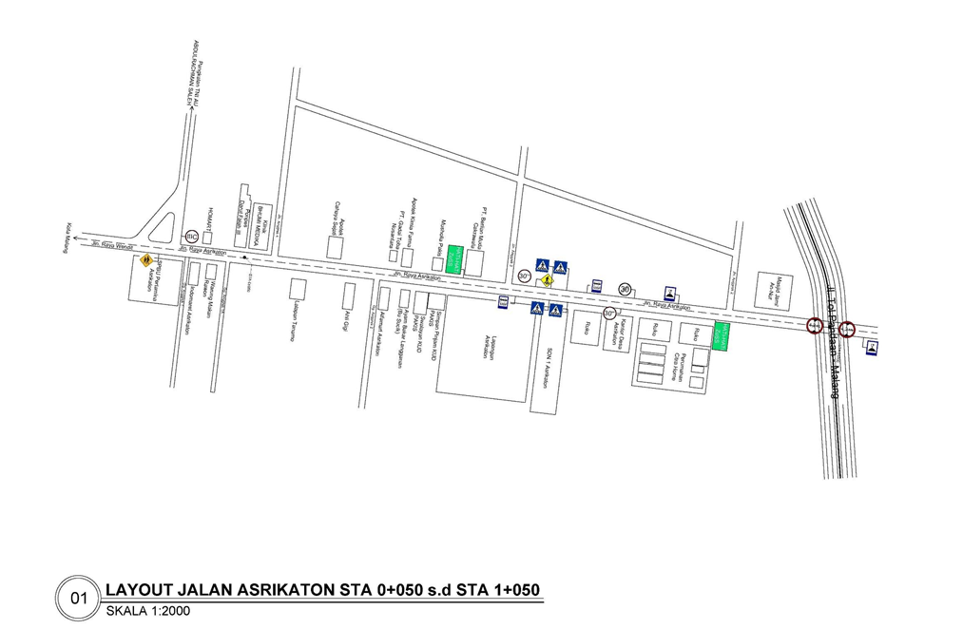
FIGURE 1. Research location

FIGURE 1. The picture above is the location plan to be analyzed, namely in the area of the Asrikaton highway along approximately 100 meters. Where the location selection is based on the area bordering other regions.
To make a connection between the data from the Degree of Saturation and the 3 types of velocity, the regression method is the most suitable method to find the connection between 2 different variables. It can be measured by looking at the results of $R^{2}$ values that are close to 1, the closer to 1 the result, the higher the connection between the 2 variables. Regression is a statistical method by formulating mathematical equations or functions that show the relationship or influence of two or more variables. The adjusted values are small, so the ability of independent variables to account for the variation of dependent variables is very limited. Meanwhile, if the adjusted value is close to one, then the independent variable describes all the information necessary to predict the variation of the dependent variable well [8]. This regression can also be used as a prediction with data processed as quantitative data. There are 6 regression methods that will be used in this discussion, there are:
1. 3rd Orde Polynomial Regression
Polynomial regression is a special type of regression that works on a curvilinear relationship between a dependent value and an independent value [9]. In general, polynomial regression models are written in the form, The difference from the polynomial order 2 is the number of orders.$R^{2}$
Y= ${ax}^{3}$+ cx + d${ bx}^{2}$ (1)
2. 2nd Orde Polynomial Regression
Polynomial regression is a linear regression model formed by summing the influence of each of the predicted variables (X) promoted to the k-th order. In general, polynomial regression models are written in the form of:
Y= + bx + c${ax}^{2}$ (2)
3. Regression Logarithmic
Logarithmic regression is a regression model that incorporates logarithms in its equations. Specifically, in logarithmic regression, the logarithms of independent variables are taken. So the equation of the logarithmic regression model.
$y_{h}at$ = np . log(X) (3)
4. Linear Regression
Simple linear regression analysis is an approach method to model the relationship between one dependent variable and one independent variable [10]. The regression method is a statistical method that makes predictions using the development of mathematical relationships between variables, namely dependent variables (Y) and independent variables (X), with the following formula:
Y = a + bx (4)
5. Exponential Regression
The exponential regression method is used to analyze the relationship between two variables that have an exponential relationship, such as population growth data or company revenue. This model can be used to predict the value of one variable based on the value of another variable calculated by the formula:
Y = ${be}^{ax}$ (5)
6. Power Regression
Y = ${ax}^{b}$ (6)
The regression method above is used to analyze the relationship between 3 types of speed with degree of saturation, after the analysis is carried out, $R^{2}$ the highest value or close to 1 is taken to get the type of speed that is most relevant to the variable degree of saturation.
Saturation level is the determination of the performance level of intersections and road sections. The degree of saturation value indicates whether the road section has capacity problems or not. The saturation level is calculated using the current and capacity expressed in smp/h. The saturation level is used to analyze traffic behavior. The basic equation for calculating the saturation level is as follows [11]:
$DS=\frac{Q}{C}$ (7)
Explanation:
DS = Saturation Level
Q = traffic flow (smp/h)
C = Capacity (smp/h)

RESULTS AND DISCUSSION
This research analyzes the connectivity between the degree of saturation and vehicle traffic speed on Asrikaton roads. This research use the regression method to determine the highest significance of the relation between them.
TABLE 1. Data Degree of Saturation analysis
Time | Total Volume (smp/h) | Free Flow Speed (Km/h) | Road Capacity (smp/h) | Degree of Saturation (DS) | Actual Speed
06.30 – 07.30 | 1923,25 | 45,6 | 3203,05 | 0,60 | 36,2
06.45 – 07.45 | 2039,95 | 45,6 | 3100,825 | 0,66 | 35
07.00 – 08.00 | 1928,1 | 45,6 | 3100,825 | 0,62 | 36
07.15 – 08.15 | 1818,7 | 45,6 | 3203,05 | 0,57 | 36,4
07.30 – 08.30 | 1638,15 | 45,6 | 3203,05 | 0,51 | 37
07.45 – 08.45 | 1516,1 | 45,6 | 3407,5 | 0,44 | 38,2
08.00 – 09.00 | 1471,05 | 45,6 | 3407,5 | 0,43 | 39
08.15 – 09.15 | 1442,1 | 45,6 | 3407,5 | 0,42 | 39,8

TABLE 1. The data above is the data from field observation of vehicle volume, along Asrikaton Road. Which has been analyzed to get a Degree of Saturation value.
TABLE 2. Factual Velocity Data
Time | Spot Speed (Km/h) | Runnng Speed (Km/h) | Journey Speed (Km/h)
06.30 – 07.30 | 37,02 | 39,18 | 42,16
06.45 – 07.45 | 38,21 | 40,66 | 42,47
07.00 – 08.00 | 39,15 | 44,31 | 42,04
07.15 – 08.15 | 39,03 | 45,11 | 41,25
07.30 – 08.30 | 38,98 | 45,46 | 39,03
07.45 – 08.45 | 39,05 | 45,69 | 39,81
08.00 – 09.00 | 38,23 | 44,35 | 40,25
08.15 – 09.15 | 38,68 | 44,18 | 39,90

TABLE 2. The data above is the result of field observations of the average speed of vehicles from 2 directions along the Asrikaton highway.

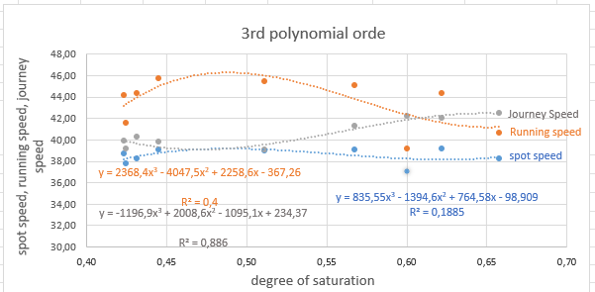
FIGURE 2. The results of the analysis using the 3rd order polynomial method

FIGURE 2. The figure above is the result of correlation analysis of 3 types of velocity and degree of saturation using the 3rd order polynomial regression method, where the results of the equation for each type of velocity are obtained as follows: spot speed with the equation y = 835.55 – 1394.6 + 764.58x - 98.909${ x}^{3}{ x}^{2}$ with a result ${ R}^{2}=$ of 0.1885 where the degree of connection is low, Running speed with the equation y = 2368.4${ x}^{3}$- 4047.5-2258.6x – 367.26 with the result ${ R}^{2}=$ 0.44 where the level of connectivity is quite low, Journey speed with the equation y = -1196.9 – 2008.6 + 1095.1x – 234.37${ x}^{3}{ x}^{2}$ with the result ${ R}^{2}=$ of 0.8867 where the level of connectivity is very high.

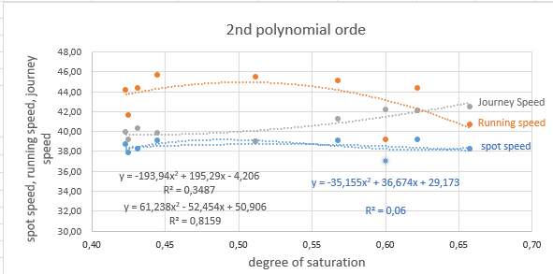
FIGURE 3. Results of Analysis using the 2nd order polynomial method

FIGURE 3. The figure above is the result of correlation analysis of 3 types of velocity and degree of saturation using the 2nd order polynomial regression method, where the results of the equation for each type of velocity are obtained as follows: spot speed with the equation y = -35.155 +36.674 x + 29.173 ${ x}^{2}$with a result ${ R}^{2}=$ of 0.068 where the level of correlation is very low, Running speed with the equation y = -193.94 + 195.29 x – 4.206 with a result of $R^{2}=$ 0.3487 where the level of connectivity is quite low, Journey speed with the equation y = -61,238 – 52,454 x + 50,906 ${ x}^{2}$with a result $R^{2}=$ of 0.8159 where the level of connectivity is very high.

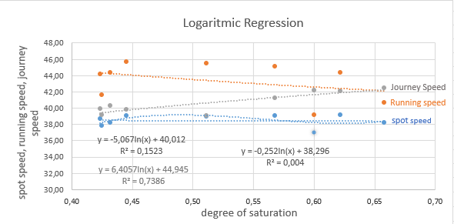
FIGURE 4. Results of Analysis using Logarithmic Method

FIGURE 4. The figure above is the result of correlation analysis of 3 types of velocity and degree of saturation using the Logarithmic Regression method, where the results of the equation for each type of velocity are: spot speed with the equation y = -0.252ln(x) + 38.296 with a result $R^{2}=$ of 0.004 where the level of correlation is very low, Running speed with the equation y = -5.067ln(x) + 40.012 with a result of $R^{2}=$ 0.1523 where the level of connectivity is low, Journey speed with the equation y = 6.4057ln(x) + 44.945 with a result $R^{2}=$ 0.7386 where the level of relevance is high.
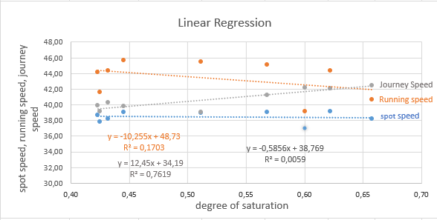
FIGURE 5. Results of Analysis using Linear Regression

FIGURE 5. The figure above is the result of correlation analysis of 3 types of velocity and degree of saturation using the Linear Regression method, where the results of the equation for each type of velocity are: spot speed with the equation y = -0.5856x + 38.769 with a result $R^{2}=$ 0.0059 where the level of correlation is very low, Running speed with the equation y = -10.225x + 48.73 with a result of $R^{2}=$ 0.1703 where the level of connectivity is low, Journey speed with the equation y = 12.45x + 34.19 with a result $R^{2}=$ of 0.7619 where the level of connectivity is high.
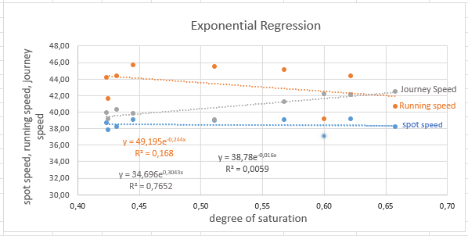
FIGURE 6. Results of Analysis using Exponential Regression Method

FIGURE 6. The figure above is the result of correlation analysis of 3 types of velocity and degree of saturation using the Exponential Regression method, where the results of the equation for each type of velocity are: spot speed with the equation y = ${38,78e}^{-0,016x}$. with a result ${ R}^{2}=$ 0.0059 where the degree of correlation is very low, Running speed with the equation y = $49,195e^{-0,244x}$. with a result $R^{2}=$ 0.168 where the degree of relevance is low, Journey speed with the equation y = ${34,696e}^{0,3043x}$. with a result $R^{2}=$ 0.7652 where the level of relevance is very high.

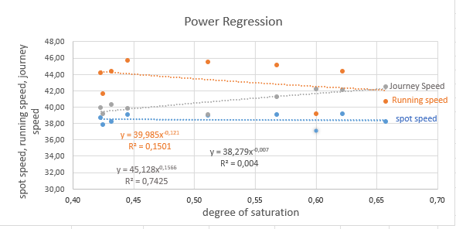
FIGURE 7. Results of Analysis using the Power Regression Methodp

FIGURE 7. The figure above is the result of correlation analysis of 3 types of speed and degree of saturation using the Regression Power method, where the results of the equation for each type of speed are: spot speed with y = ${38,279x}^{0,007}$with a result of $R^{2}=$ 0.004 which is very low, Running speed with equation y = ${39,985x}^{-0,121}$with a result $R^{2}=$ 0.1501 where the level of relevance is quite low, the journey speed with the equation y = ${45,128x}^{0,1566}.$with a result $R^{2}=$ 0.7425 where the level of relevance is high.

CONCLUSION
From the results of the analysis using 6 regression methods, the highest results were obtained in each method. For the 3rd order polynomial method, the highest result was obtained in the type of Journey speed with a result $R^{2}$= 0.8867 which has a very high level of connectivity, for the 2nd order polynomial method the highest result was obtained in the type of journey speed with a result $R^{2}$= 0.8159 which has a very high level of connectivity, the Logarithmic method obtained the highest result in the type of journey speed with the result $R^{2}$= 0.7386 which has a high level of connectivity, for the Linear method the highest result is obtained in the type of journey speed with a result $R^{2}$= 0.7619 which has a high level of connectivity, for the Exponential method the highest result is obtained in the type of journey speed with a result $R^{2}$= 0.7652 which has a high level of connectivity, , for the Power method the highest result is obtained in the type of journey speed with a result $R^{2}$= 0.7425 which has a high level of connectivity. From the results above, it can be concluded that Journey speed is the type of speed that is most relevant to the degree of saturation. Which has a value of $R^{2}=$ 0.8867 which is analyzed using the 3rd order polynomial method, it is explained that it has the closest value to the maximum number, which is 1.

REFERENCEs
1. Feriska, Y., et al., Analisa Kerusakan Jalan Kabupaten Ruas Klampok–PG Banjaratma Kabupaten Brebes. Era Sains: Jurnal Penelitian Sains, Keteknikan Dan Informatika, 2023. 1(1): p. 10-18.
2. Kementerian, P., Peraturan Menteri Pekerjaan Umum Nomor: 03/PRT/M/2012 tentang Pedoman Penetapan Fungsi Jalan dan Status Jalan. Pemerintah Indonesia, 2012: p. 1-12.
3. Sasmita, A., et al., Analisis pengaruh kecepatan dan volume kendaraan terhadap emisi dan konsentrasi karbon monoksida di jalan jenderal sudirman, kota pekanbaru. Jurnal Teknik Sipil, 2022. 16(4): p. 269-279.
4. Novianto, H., Analisis Kemacetan Lalu Lintas Akibat Parkir Di Badan Jalan: Studi Kasus : Sekitar Jalan Ketapang Selatan Depan Pasar Cepu Kabupaten Blora. Jurnal Teknik Sipil, 2020. 5(2): p. 19-29.
5. Hartati, E., R. Indriyani, and I. Trianingsih, Analisis Kepuasan pengguna website SMK Negeri 2 Palembang menggunakan regresi linear berganda. MATRIK: Jurnal Manajemen, Teknik Informatika Dan Rekayasa Komputer, 2020. 20(1): p. 47-58.
6. Adi, A.S., Pengaruh Volume Sepeda Motor Terhadap Kemacetan Lalu Lintas pada Ruas Jalan Pangeran Antasari Samarinda. Kurva S: Jurnal Keilmuan dan Aplikasi Teknik Sipil, 2019. 6(2): p. 86-99.
7. Gunawan, G.R.F., et al., Analisis Pengaruh Parkir Kendaraan dan Pedestrian pada Ruas Jalan terhadap Karakteristik Lalu Lintas (Studi Kasus Ruas Jalan Gajah Mada Brebes). Infratech Building Journal, 2021. 2(2): p. 1-9.
8. Azahra, A.A., Analisis Prediksi Jumlah Penerimaan Mahasiswa Baru Menggunakan Metode Regresi Linier Sederhana. Bulletin of Applied Industrial Engineering Theory, 2022. 3(1): p. 75-78.
9. Malensang, J.S., H. Komalig, and D. Hatidja, PENGEMBANGAN MODEL REGRESI POLINOMIAL BERGANDA PADA KASUS DATA PEMASARAN. Jurnal Ilmiah Sains, 2013. 12(2): p. 149-152.
10. Andika Eka, P. and A. Juarna, Prediksi Pro duksi Daging Sapi Nasional dengan Meto de Regresi Linier dan Regresi Polinomial. Jurnal Ilmiah Komputasi, 2021. 20(2): p. 209-216.
11. Al Faritzie, H., Analisis Pengukuran Derajat Kejenuhan dan Tingkat Pelayanan Ruas Jalan R. Sukamto Kota Palembang. Jurnal Deformasi, 2021. 6(2): p. 131-141.

