The Improvement of Degree of Saturation in Public Service Areas in Commercial Areas (Case Study: Asrikaton Street, Pakisaji Subdistrict, Malang City, East Java)

Khoirul Abadi^{a)}, Hilda Surya Agung Hanafi^{b)}, and Amalia Nur Adibah^{c)},
Department of Civil Engineering, University of Muhammadiyah Malang, Malang, Indonesia

^{a)} Corresponding author: khoirul@umm.ac.id
^{b)} agunghanafi2004@gmail.com
^{c)} amalianuradibah@umm.ac,id

Abstract. Malang City is a city of tourism, education, and places that are often visited, Currently several roads are experiencing a shift in function such as in the area of Jalan Raya Asrikaton Malang City, some roads have become vehicle parking lots or public transportation, causing a decrease in road capacity to cause congestion. The purpose of the study is to determine the capacity of road performance by analyzing the maximum flow volume, type of vehicle, class of side obstacles on the road, and saturation level on the road as an evaluation of road performance capacity, to reduce congestion on the Asrikaton Highway. This study uses the guidelines of MKJI 1987 (Indonesian Road Capacity Manual in 1987) to determine the capacity of road sections and also the saturation level of road sections. Based on the results of the study, the maximum flow volume of vehicles is 2309.5 vehicles, with the largest number of vehicles being motorcycles (MC), with a saturation degree value of 0.657 at the maximum flow volume. The average category of road saturation level "C" before the alternative method was applied, after the alternative method was analyzed, the value of the degree of saturation decreased to 0.562 and the average category of the road saturation level "B".
Keywords: Degree of saturation, side obstacles, Highway Sections, Traffic

INTRODUCTION
Malang City is one of the cities of tourism, education, and places that are often visited by visitors, this makes Malang City can develop rapidly. With population data in 2023 with 8147182 residents according to the Central Statistics Agency of Malang City. So that economic growth develops rapidly, one of which is on Asrikaton Street. In this area, there are educational and health facilities including Islamic boarding schools, health clinics and settlements that are starting to be crowded. The Asrikaton road section becomes congested because it is a link between regions and becomes a road to tourism. In addition, there is economic growth and population growth so that the increase in activities and movements directly affects the need for vehicles as transportation.
Currently, several roads have experienced a shift in function such as in the Asrikaton Highway area, Pakisaji Sub-District, Malang City, some roads become vehicle parking lots or public transportation, this causes a reduction in road capacity so as to cause congestion on the road section. This also affects economic activities in the area and causes accidents caused by the vehicle even though transportation activities are very important in the development of an area.
Roads are land transportation infrastructure that includes all parts of the road, including connecting buildings, complementary buildings and their equipment that intended for traffic, which is located in ground level, above ground level, below ground and or water level, as well as above the surface water, except rail roads, truck roads, and cable roads [1]. In regional development, transportation infrastructure is important in supporting the movement of people or goods [2]. Transportation is the displacement of mass, either people or freight (goods, assets, residues, etc.), from one point to another. This displacement takes place along a route and consumes a given amount of resources, such as time or an amount of energy, while the latter is responsible for the action of the external force (driving force) that causes the displacement [3]. The purpose of transportation is transportation that is used to make it easier for humans to carry out daily activities [4].
The problem faced is congestion on the road. Congestion is the number of public transportation or online motorcycle taxis that often stop carelessly, entering and exiting vehicle parking areas, and the flow of vehicles that cross at intersections without traffic lights [5]. Traffic congestion is a growing problem in many cities around the world. Everything indicates that the matter will continue to get worse, which is an undoubted threat to the quality of urban life where in recent years, there has been a considerable increase in the negative effects of traffic congestion on society, the economy [6].
The purpose of this study is to find out about the road performance capacity on Asrikaton roads by analyzing the maximum flow velocity volume, the type of vehicles passing by, the class of side obstacles on the road, and the saturation level on the road section as a material for evaluating the road performance capacity on Asrikaton Road, to reduce congestion that occurs on the Asrikaton highway section.

METHODS
The degree of saturation is the ratio of traffic volume (V) divided by the capacity (C) of a certain section of the road can give an idea of the condition of the traffic flow, if the value V/C = 1 means that the condition of the traffic flow is not at its capacity [7]. Traffic flow is the number of vehicles that pass through a certain section of a certain road in a certain unit of time [8], and also collect data on the number of vehicles on the road section, until obtaining the results of the degree of saturation for evaluation.
Malang City is one of the tourist cities, the city area of Malang is astronomically located at 12.06° – 112.07° East Longitude and 7.06° – 8.02° South Latitude, Malang City which is located at an altitude between 440 – 667 meters above sea level, is one of the tourist destination cities in East Java because of its natural and climatic potential. On this road section, congestion is not uncommon due to the increasing volume of traffic vehicles and high side obstacles on the road. This causes the vehicle speed to be low.
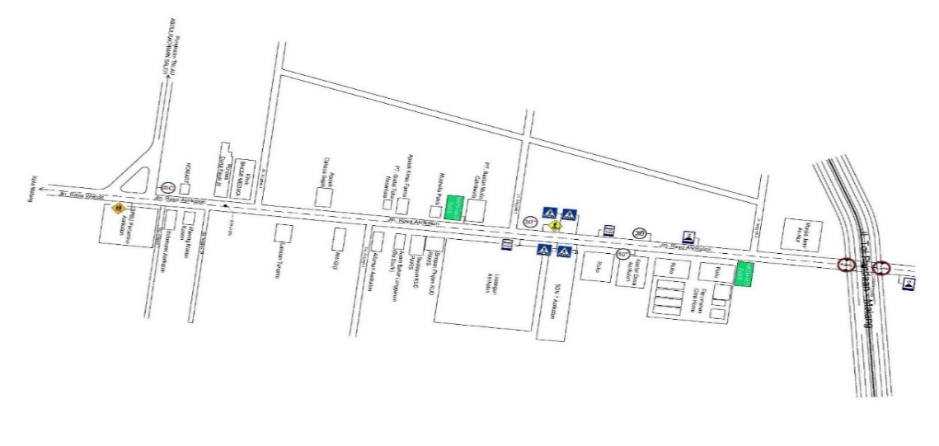
FIGURE 1. Research Location

This research was carried out by conducting a direct survey along the road, using the guidelines of MKJI 1987 (Indonesian Road Capacity Manual in 1987) which aims to determine the capacity of road sections and also the saturation level of road sections. In this problem, what is of concern is Jalan Asrikaton which connects Blimbing District, with Tumpang District. Because Malang City is a tourist city and the Asrikaton road section is one of the congested roads and the main road to tourist areas in Malang City, it is necessary to evaluate the following data. Supported by data conducted by surveys in the area carried out on Asrikaton road with data samples, the length of the analyzed road is 1000 meters, namely a road with two lanes that are not divided into 2/2 TB or 2/2 UD types, with a traffic flow volume at 06.30 - 09.30, Asrikaton road that connects Blimbing district with Tumpang district, On the Asrikaton road section as shown in FIGURE 1. in the STA 0+50 to STA 1+50 segment, there are 2 undivided lanes (2/2 UD). The width of the road at STA 0+50 is 9 meters with the width of the right shoulder of the road is 1.2 meters, the left shoulder of the road is 1 meter. Then at STA 0+500 the road width is 9 meters with the right shoulder 1.2 meters, the left shoulder of the road is 2.3 meters. Meanwhile, at STA 1+050 the road width is 8.1 meters with the right shoulder of 1.3 meters and the left shoulder of the road 0.6 meters. It can be evaluated through the criteria of road saturation level, but it is necessary to study the characteristics of the road, including vehicle volume, vehicle speed, road capacity and the type of vehicle passing through the road section.
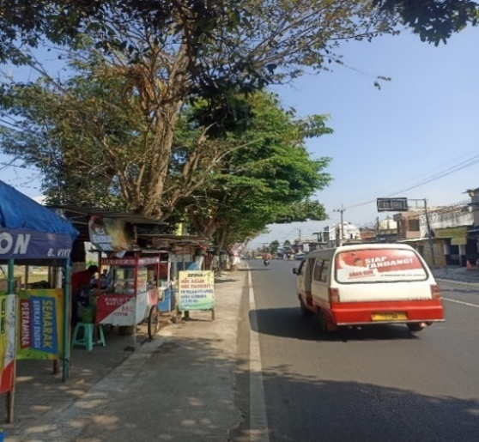
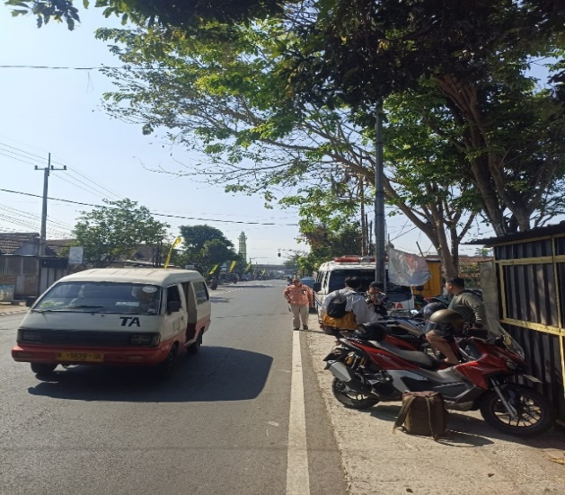

FIGURE 2. condition of Asrikaton Highway

FIGURE 2. Explaining the current condition of the asrikaton road where in accordance with the direct condition that many vehicles are still parked on the shoulder of the road, which will affect the side obstacles and will make the road capacity will be reduced. This needs to be evaluated for road performance in the future so as to make the road performance on the Asrikaton highway section even better.

RESULTS AND DISCUSSION
This research analyzes the performance of road sections on Asrikaton roads by determining the maximum speed, side obstacle class, vehicle volume, and the degree of road saturation, as well as the feasibility level of Asrikaton road sections. Some of the data above is used as supporting data for these studies, but in this study the data that can be used as side obstacles because the factors that affect the traffic flow on Asrikaton roads are the class of side obstacles, and it is easy to apply directly.

MAXIMUM TRAFFIC FLOW VOLUME
Based on the data from the survey results directly on Asrikaton roads, data results are obtained that can beused for road evaluation materials where the data obtained is the volume of traffic flow during peak hours or the maximum volume of traffic, from the survey results, the maximum traffic flow volume is obtaine.
TABLE 1. Maximum Traffic Flow Volume
Hour (AM) | Number of vehicles  (A – H) | Hour (AM) | Number of vehicles  (H – A) | Total (passenger car unit/15 minutes) | Total (passenger car unit/Hour)
06.30-06.45 | 146.05 | 06.30-06.45 | 224,30 | 379,35 | -
06.45-07.00 | 194.6 | 06.45-07.00 | 327,65 | 522,25 | -
07.00-07.15 | 195.15 | 07.00-07.15 | 307,80 | 502,95 | -
07.15-07.30 | 193.6 | 07.15-07.30 | 334,10 | 527,70 | 1923.25
07.30-07.45 | 166.4 | 07.30-07.45 | 320,65 | 487,05 | 2039.95
07.45-08.00 | 163 | 07.45-08.00 | 247,40 | 410,40 | 1928.1
08.00-08.15 | 178.5 | 08.00-08.15 | 215,05 | 395,55 | 1818.7
08.15-08.30 | 179.4 | 08.15-08.30 | 167,75 | 347,15 | 1638.15
08.30-08.45 | 199.35 | 08.30-08.45 | 165,65 | 365,00 | 1516.1
08.45-09.00 | 168.7 | 08.45-09.00 | 196,65 | 365,35 | 1471.05
09.00-09.15 | 187.35 | 09.00-09.15 | 177,25 | 364,60 | 1442.1
09.15-09.30 | 187.8 | 09.15-09.30 | 164,6 | 352,40 | 1447.35
Source : processed data.

From the results of the survey from TABLE 1, the maximum traffic flow volume with a total of 2039.95 passenger car units/hour, was obtained, which was the largest. with the type of two-lane road is not divided and the distance from A - H and also H - A is taken as a reference distance with the reference distance that has been carried out. the maximum traffic volume value is used as the Q value. The value of the vehicle flow volume is also required to determine the Capacity Adjustment Factor for Direction Separator (FCSP), which will also be used to calculate the value of the degree of saturation of the road. Calculation of Capacity Adjustment Factor for Direction Separator (FCSP), using a table that has been made by the Indonesia Road Capacity Manual (MKJI) (1997), with the data in TABLE 2.
TABLE 2. Capacity Adjustment for Directional Separator (FCSP)
SP Direction Separation % |  | 50-50 | 55-45 | 60-40 | 65-35 | 70-30
FCsp | Two Lane 2/2 | 1,00 | 0,97 | 0,94 | 0.91 | 0,88
FCsp | Four Lanes 4/2 | 1,00 | 0,985 | 0,97 | 0,955 | 0,94
Source : Manual Kapasitas jalan Indonesia (MKJI)(1997)

The calculation of the Adjustment Factor for Direction Separation (FCsp) value will also affect the value of the degree of road saturation. The following is the Direction Separation Adjustment Factor (FCsp) calculated at the maximum current that occurred in the study using the comparison of the number of vehicles in the direction of A-H at 06.45 – 07.45 with the number of 749.75 vehicles (36.75%) and the comparison of the number of vehicles in the direction of H-A at 06.45 – 07.45 with the number of 1290.2 vehicles (63.25%) as a result of the calculation of the direction separation adjustment factor (FCsp) formed by percent (%).
Traffic volume is the number of vehicles that pass through a certain section on a certain road section in a certain unit of time [9]. this calculation is used to calculate the degree of saturation in road sections or highway structures as well as general data.

FIGURE 3. Vehicle Volume Classification in A-H direction

FIGURE 4. Vehicle Volume Classification in H-A direction

In the results of the study, data were obtained in the direction of A-H in FIGURE 3. that the vehicles that pass a lot are motorcycles with a percentage of 85%, then followed by light vehicles with a percentage of 14% and the last heavy vehicle 1%, and on the H-A side in FIGURE 4. the percentage of motorcycles is obtained by 91%, then light vehicles 8% and the last heavy vehicle with a percentage of 1%, This data shows that the density that often occurs on the Asrikaton road section is motorcycles. This will also affect the speed of vehicles on the road, This will also affect the speed of vehicles on the road.

SIDE OBSTACLE CLASS
Side obstacles are activities next to road segments that cause problems along the road by hindering traffic performance to function optimally [10]. In determining the value of side obstacles are all guided by the MKJI 1997 (Indonesia Road Capacity Manual in 1997), using the Indonesian National Standard, in determining side obstacles there are several criteria, namely the weight factor of side obstacle events, the weighted frequency of side obstacle events, and the table of weighted frequencies of side obstacle events.
TABLE 3. the weight factor of side obstacle events
Type of Side Collision Event | Symbol | Weight factor | Frequency of occurrence | Weighted frequencies
Pedestrian | PED | 0,5 | 20 | 10
Parking, Vehicle Stop | PSV | 1,0 | 18 | 18
Vehicles in and out | EEV | 0,7 | 213 | 149,1
Slow Driving | SMV | 0,4 | 54 | 21,6
Total |  |  |  | 198,7
Source : Manual Kapasitas Jalan Indonesia (MKJI 1997).

In the calculation of the side obstacle class according to MKJI 1997 (Indonesia Road Capacity Manual of 1997), this calculation comes from the frequency of events which is conventionally multiplied by the weight is the frequency of events for 1 hour at the maximum traffic flow. Based on TABLE 3, the total incidence of side obstacles is 198.7 incidents, in this category the Asrikaton road section is included in the "Low" category where with general conditions including settlements, several public vehicles, etc.

DEGREE OF ROAD SATURATION
The degree of road saturation is an indicator of the high traffic volume at an intersection and determines its handling [11]. The theoretical magnitude is between 0 - 1, which means that if the value is close to 1, the condition of the road is close to saturation. The purpose of this study is the relationship between the degree of saturation to find out the level of service on the road. In determining the degree of saturation, the calculation used is the capacity of the road divided by the maximum traffic flow. The provisions for the degree of saturation value have guidelines in the Indonesia Road Capacity Manual (MKJI) (1997) as shown in TABLE 4.
TABLE 4. Degree of Saturation (Level of Services = LOS)
Service Level | Characteristic | Ratio (V/C)
A | Free flow conditions with low traffic volume and high speed. The driver can choose the desired speed without hindrance. | 0,00 – 0,20
B | In the stable current zone. The driver has enough freedom in choosing his speed. | 0,21 – 0,44
C | In the stable current zone. Speed is controlled by traffic. | 0,45 – 0,75
D | The current starts to be unstable. The speed is low and variable, the volume is close to capacity. | 0,75 – 0,84
E | The current is unstable with frequent stalls. Low speed and traffic volume approaching or at capacity. | 0,85 – 1,00
F | Blocked current. Low speed, volume above capacity, often jams for a long time | >1,00
Source : Manual Kapasitas jalan Indonesia (MKJI)(1997).

The results obtained from the calculation for road capacity on Asrikaton road at the time of maximum flow volume are as follows:
$C=Co x FCw x FCsp x FCsf x FCcs$ = 2900 × 1,25 × 0,91 × 1,00 × 0,94 = 3100,825 pcu/hour (1)
The calculation results for the road capacity (C) on the Asrikaton road section are 3100,825 passenger car units/hour
As for the value of the degree of saturation of traffic flow on Asrikaton Road at that hour is :
DS = Q/C = 2039.95 / 3100,825 = 0,657 (2)
The result of the saturation degree of Asrikaton road with the two-way type is not divided at 06.30 – 09.30 AM is 0.657 which is the largest. In addition to determining the value of the highest degree of saturation (Level of Service = LOS) of the road at the maximum flow volume, the following are also the results of the value of the degree of saturation of the road (Level of Service = LOS), at each hour on the Asrikaton highway section:
TABLE 5. Degree of road saturation (Level of Service = LOS) every hour of research
Hour | Total volume (Pcu/Hour) | FCsp | Road Capacity (C)  (C = Co x FCw x FCsp x FCsf x FCcs) | Level of Service (LOS) | Category Level of Service (LOS)
06.30 - 07.30 | 1923,25 | 0,94 | 3203,05 | 0,600 | C
06.45 - 07.45 | 2309,95 | 0,91 | 3100,83 | 0,657 | C
07.00 - 08.00 | 1928,1 | 0,91 | 3100,83 | 0,622 | C
07.15 - 08.15 | 1818,7 | 0,94 | 3203,05 | 0,568 | C
07.30 - 08.30 | 1638,15 | 0,94 | 3203,05 | 0,511 | C
07.45 - 08.45 | 1516,1 | 1,00 | 3407,50 | 0,445 | B
08.00 - 09.00 | 1471,05 | 1,00 | 3407,50 | 0,432 | B
08.15 - 09.15 | 1442,1 | 1,00 | 3407,50 | 0,423 | B
08.30 - 09.30 | 1447,35 | 1,00 | 3407,50 | 0,425 | B
Source : processed data

From TABLE 5 on saturation levels, Asrikaton roads belong to the "C" average category, this is included in the stable flow zone. Speed is controlled by traffic, with a total of 2309.5 vehicles and the average crossing is motorcycles (MC) which have a road saturation level (Level of Service = LOS) with a value of 0.657 at maximum flow volume. So there needs to be an evaluation, by calculating the level of road saturation (level of Service = LOS), it can also reduce the class of side obstacles by implementing several policies about pedestrians, parking, stopped vehicles, vehicles entering and exiting, and slow vehicles, this also needs to be carried out policies about parking prohibition signs, speed limits, etc. When the side obstacle becomes very low, the result of the calculation of the Asrikaton highway is as follows:
An alternative way to reduce the level of road saturation (Level of Service = LOS) is to analyze several obstacles that make the value of the degree of road saturation increase, especially the class of side obstacles such as pedestrian adjustment, vehicles parked on the shoulder of the road, as well as vehicles that stop, then vehicles that enter and exit, and vehicles with slow speeds. According to the calculation results, the most frequency is vehicles entering and exiting, this can reduce the value of the degree of saturation of the road to the category of "Very Low". From this category, the value of the degree of road saturation (Level of Service = LOS) can be re-analyzed according to the data in TABLE 6:
TABLE 6. Degree of road saturation (Level of Service = LOS) alternative result every hour of research
Hour | Total volume (Pcu/Hour) | FCsp | Road Capacity (C)  (C = Co x FCw x FCsp x FCsf x FCcs) | Level of Service (LOS) | Category Level of Service (LOS)
06.30 - 07.30 | 1923,25 | 0,94 | 3748,25 | 0,513 | C
06.45 - 07.45 | 2309,95 | 0,91 | 3628,63 | 0,562 | C
07.00 - 08.00 | 1928,1 | 0,91 | 3628,63 | 0,531 | C
07.15 - 08.15 | 1818,7 | 0,94 | 3748,25 | 0,485 | C
07.30 - 08.30 | 1638,15 | 0,94 | 3748,25 | 0,437 | B
07.45 - 08.45 | 1516,1 | 1,00 | 3987,50 | 0,380 | B
08.00 - 09.00 | 1471,05 | 1,00 | 3987,50 | 0,369 | B
08.15 - 09.15 | 1442,1 | 1,00 | 3987,50 | 0,362 | B
08.30 - 09.30 | 1447,35 | 1,00 | 3987,50 | 0,363 | B
Source : processed data

From the results of the research carried out, data on the maximum flow volume on the Asrikaton Highway section with a value of 2309.95 vehicles were obtained. The type of vehicle that passes through the road is a motorcycle (MC). And the results were obtained from the side obstacle class with the category "Low", with the highest saturation degree value of 0.657 and for the value of the degree of road saturation (Level of Service = LOS) at 06-30 - 07.30 with the "C" category. Then at 07.45 - 09.30 with category "B".
After analyzing and finding an alternative way of this study, the value of the degree of saturation of the road (Level of Service = LOS) on the Asrikaton highway section can reduce the value of the degree of saturation (Level of Service = LOS) to 0.562 for the maximum traffic flow volume and also reduce some values of the degree of saturation (Level of Service = LOS) at certain hours with the result at 06.30 – 08.15 to category "C" with the explanation In the stable flow zone. The driver has enough freedom in choosing his speed. Meanwhile, at 07.30 – 09.30 it is in the "B" category with an explanation in the stable flow zone. The driver has enough freedom in choosing his speed. This reduces the value of the degree of road saturation (Level of Service = LOS) at 07.30 – 08.30 where the results before the alternative method are included in the category "C" and after the alternative method is carried out becomes "B".

CONCLUSIONS
The results of the research from the Asrikaton highway section, Pakisaji District, Malang City, East Java, were obtained that the maximum volume of traffic flow on Jalan Asrikaton at 06.30 – 09.30 WIB was 2309.95 vehicles, the maximum volume of this volume occurred at 06.45 – 07.45 WIB, this is the largest number of vehicle volumes compared to other hours during the study, This shows that at that hour is the schedule or time of community activities to go to work or carrying out educational activities, etc. Then the volume of vehicles that pass the most on the road is motorcycles (MC) from A-H with a percentage of 85% and light vehicles (LV) with a percentage of 14%, then heavy vehicles (HV) with a percentage of 1%, as well as in the flow of H – A with a percentage of motorcycles (MC), light vehicles (LV) with a percentage, and heavy vehicles (HV) with a percentage, this shows that the most dominant volume of vehicles on the road is motorcycles with a percentage of directions A – H and H – A biggest. In the side obstacle class on the Asrikaton Highway section, there is a "low" side obstacle value or in a category where general conditions include residential areas, residential areas, some public vehicles, etc. This is stated from the results of the research on the frequency of side obstacles on the Asrikaton highway. The saturation level on Asrikaton Highway has an average value of "C" in the Stable flow zone category. Speed is controlled by traffic, with the largest road saturation value (level of Service = LOS) of 0.657, this shows that the road capacity is still relatively dense, this is also evident from the results of the study at 06.30 – 09.30 have an average road saturation value (Level of Service = LOS) with category "C". So there needs to be an evaluation of problems such as the implementation of pedestrian policies, parked vehicles, stopped vehicles, slow speed vehicles or side obstacle class problems. And alternative ways to overcome the problem were obtained such as reducing the class of side obstacles to "Very Low", this affected the value of the degree of road saturation (Level od Service = LOS) to an average of B, this was proven at 07.30 – 08.30 which previously had a category "C" and the average value of the degree of road saturation (Level of service = LOS) became category "B" and the highest value of the saturation level (Level of Service = LOS) became 0.562.

References
1. Indonesia, M.P.R., Pedoman Pelaksanaan Kegiatan Manajemen dan Rekayasa Lalu Lintas. Kementerian Perhubungan, Republik Indonesia, 2015: p. 1-45.
2. Nevisantya, B., et al. The assessment of the pedestrian-ways service level in the Pasuruan economic zone (case study: Pandaan market, Pasuruan, Malang). AIP Publishing.
3. Márcio de Almeida, D.A., Transportation, Energy Use and Environmental Impacts. 2019: Elsevier.
4. Wilton, W. and A. Pruima, Studi Analisis Pemilihan Moda Transportasi Umum Darat di Kota Padang antara Kereta Api dan Bus Damri Bandara Internasional Minangkabau. Jurnal Teknik Sipil Institut Teknologi Padang, 2019. 6(1): p. 30-37.
5. Dewi, T., et al., Simulasi Kemacetan Lalu Lintas Pada Lokasi Bundaran Baltos Bandung. Smart Comp, 2020. 9(2): p. 92-95.
6. Almatar, K.M. and A.I. Almulhim, The Issue of Urban Transport Planning in Saudi Arabia: Concepts and Future Challenges. International Journal of Sustainable Development & Planning, 2021. 16(7): p. 1317–1327.
7. Al Faritzie, H., Analisis Pengukuran Derajat Kejenuhan dan Tingkat Pelayanan Ruas Jalan R. Sukamto Kota Palembang. Jurnal Deformasi, 2021. 6(2): p. 131-141.
8. Amal, A.S., et al., Analisa Kinerja Ruas Jalan Panglima Sudirman Singosari-Malang. Jurnal Ilmiah Universitas Batanghari Jambi, 2023. 23(3): p. 2754-2759.
9. Faritzie, H.A., B. Djohan, and B. Wijaya, Pengaruh Volume Kendaraan Terhadap Tingkat Kerusakan Jalan Pada Perkerasan Lentur (Flexible Pavement). Jurnal Teknik Sipil UNPAL, 2019. 9(2): p. 100-107.
10. Nangaro, M.C., L.I.R. Lefrandt, and J.A. Timboeleng, Pengaruh Hambatan Samping Terhadap Kinerja Jalan (Studi Kasus: Jl. Lembong, Kota Manado). Jurnal Sipil Statik, 2022. 10(1).
11. Suryaningsih, O.F., H. Hermansyah, and E. Kurniati, Analisis Kinerja Simpang Bersinyal (Studi Kasus Jalan Hasanuddin-Jalan Kamboja, Sumbawa Besar). INERSIA lnformasi dan Ekspose Hasil Riset Teknik Sipil dan Arsitektur, 2020. 16(1): p. 74-84.

