Comparative Analysis of the Behaviour of Vertical Links with Hollow Square (HW) Cross-sections in EBF Earthquake Resisting High Rise Steel Structures with Variations in Link Length Dimension
Alfida Rahmawati Wibowo^{a)}, Putra Agil Nasrullah^{b)}, Erwin Rommel^{c)}, and Aulia Indira Kumalasari^{d)}
Department of Civil Engineering, University of Muhammadiyah Malang, Malang, Indonesia

^{d)} Corresponding author: auliaindira@umm.ac.id
^{a)} alfidarahmawatiwibowo@gmail.com
^{b)} putraagilnasrullah@gmail.com
^{c)} erwin_r@umm.ac.id
Abstract Eccentrically Braced Frames (EBF) are earthquake-resistant steel structures that have good shear capacity and ductility. EBF structures make links the element that is damaged first compared to other elements. EBF has 2 types of links, namely vertical links and horizontal links. This study will discuss the comparison of vertical links using the Eccentrically Braced Frames (EBF) short link and Eccentrically Braced Frames (EBF) long link systems in the building to be studied, which is a portal system with eccentric braces. Based on the research that has been carried out, with the ETABS auxiliary program, it is found that the link length configuration is able to affect the behaviour of the EBF portal structure with the HW profile due to earthquake loads, where the behaviour in question is the deviation response, stress ratio, base shear, ductility, and structural stiffness. The structure with the application of short links is able to produce smaller deformation and stiffness when compared to the structure with long links. In ductility, both structures are able to produce ductility values above 4. While in the stress ratio, both structures are able to meet the requirements of not exceeding the value of 1.00 in both EBF structures with short and long links. As for the base shear or pushover using a short link, the first melting results are better than using a long link EBF portal.
Keywords: EBF, earthquake, connection, pushover, ETABS

INTRODUCTION
The rapid development in Indonesia has recently triggered growth and development, coupled with population growth, requiring the development of facilities and infrastructure to support life. However, the development of facilities and infrastructure is often constrained by the lack of available land. To overcome these problems, high-rise buildings are a good solution to expand development land, so planners made high-rise buildings. However, because Indonesia is located between two active world plates, Eurasia and Australia, Indonesia is prone to earthquakes. Even lately, earthquakes often shake Indonesia on a large scale, where in 2018 there have been several major earthquakes that occurred in Indonesia. [1]
The solution to overcome the shortage of land due to population density with vertical development has its own risks, for example due to the influence of earthquakes. It is known that the higher a high-rise building structure is, the more vulnerable it is to lateral forces, especially earthquake forces. This is because, as a rule, the higher a building is, the greater the earthquake-induced load will be. The magnitude of the earthquake force received is also influenced by the mass of each floor, where the mass of the floor plays a significant role in the location of the vertical centre of mass of the high-rise building. [2]
Buildings must be suitable for their purpose and it is not permitted to change the function of the building without prior structural analysis so that structural safety is guaranteed. [3]
Steel is a material that has toughness properties, namely strength and ductility. These properties make steel able to withstand large loads even though it has undergone large deformations. Toughness is the ability of steel to absorb large amounts of energy, so the use of steel structures is recommended in the planning of earthquake-resistant steel building structures.
One alternative in designing earthquake-resistant buildings is to use steel structures with the Eccentrically Braced Frame (EBF) system. The EBF structural system is a system that requires inelastic behaviour to only occur in the link beams during earthquake loading so that the links will experience inelastic rotation, while the other components of the EBF remain in elastic condition. There are three possible link beam criteria in the EBF structural system, namely short link (EBF-S), intermediate link (EBF-I), and long link (EBF-L) which are determined by normalising the link length with the ratio between plastic moment capacity (Mp) and plastic shear capacity (Vp). Structural analyses were conducted on three 10-storey building models using the Split K-Braces type EBF system with varying link lengths.
In general, there are two portals in Eccentrically Braced Frames (EBF), namely EBF with horizontal links (H-EBF) and EBF with vertical links (V- EBF). With the existence of these two types of continuous beams, it is very difficult to repair or change links that are damaged in H-EBF after a large earthquake and disrupt other structural systems. Based on the weaknesses of the H-EBF, the V-EBF is used which allows for the repair or replacement of damaged link elements after a major earthquake, without having to replace or possibly change parts of the beam.
In previous research the authors used link elements in Eccentrically Braced Frames (EBF) are K and V type links with the results of the base shear parameter [4]. In addition, there are also studies that use horizontal EBF with double tubular profiles, because tubular links have better ductility than WF. [5]
From the research that has been done, there has not been much research on vertical links with HW profiles. So in this study, a comparison of vertical links using the Eccentrically Braced Frames (EBF) short link and Eccentrically Braced Frames (EBF) long link systems will be discussed in the building to be studied, which is a portal system with eccentric braces. Eccentric braced portals are subjected to 2 types of loads, namely gravity loads and lateral loads. The analysis in this study uses the ETABS programme.

RESEARCH METHOD
In the structural planning analysis of the building with the building design criteria to be reviewed, which is located in the city of Surabaya, East Java, Indonesia. Has a function as an office building. For a rectangular building with a building length of 20m, a building width of 16m, and a height of each floor of 4m with a total of 10 floors. The material used in this steel building structure uses steel quality in the form of BJ42 with fy 250 Mpa and fu 410 Mpa.
This modelling uses two 10-storey steel building structures with an earthquake resisting system using EBF type vertical braces, using various dimensions and link lengths. The structural link beams composed of HW 200 x 200 x 12 x 12 profiles were selected with a length of 100 cm and HW 200 x 200 x 9 x 9 profiles were selected with a length of 150 cm. These sizes represent the EBF structure with short and intermediate links illustrated in FIGURE 1.
In addition to the HW profiles used in the link beams, the profile types used in other sections are listed in TABLE 1 and 2. However, the WF profile type was used in the main structure. The structure that has been carried out preliminary design is then modelled to be given linear and nonlinear static loads, where for the linear static method is given a load in the form of a spectrum response to find out how the structure behaves after being given an earthquake load, while the nonlinear method is given a load in the form of a pushover to determine the performance of the structure being analysed. Then the modelling results are analysed through the stability, performance, and ductility of the structure. The code EBFV indicates that the structure has an earthquake resisting system in the form of EBF with vertical link type, capital letters S and L stand for short link and long link, for HW indicates the type of profile used which is hollow square.
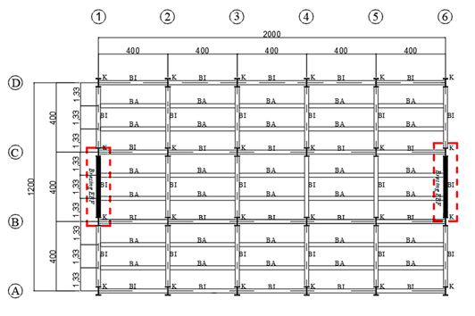 | 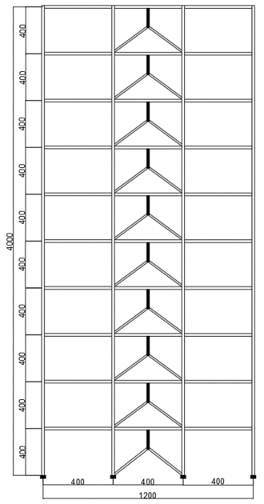
FIGURE 1. a) Building Plans, and b) Side View Plan

TABLE 1. Structure Properties to EBF Short Link and Long Link
No | Part of EBF | Specification
1 | Coloum 1-10 storey | WF 454.7 X 419.1 X 42.2 X 67.6
2 | Struktur beam 1-3 storey | WF 256.5 X 203.7 X 8.9 X 15.7
3 | Strukur beam 4-6 storey | WF 252 X 202.9 X 8 X 13.5
4 | Struktur beam 7-10 storey | WF 247.1 X 202.2 X 7.4 X 11
8 | Bracing 1-3 storey | WF 209.6 X 205 X 9.1 X 14.2
9 | Bracing 4-6 storey | WF 206.2 X 203.7 X 7.9 X 12.6
10 | Bracing 7-10 storey | WF 203.2 X 203.2 X 7.2 X 11
Source: profile of etabs
TABLE 2. Link beam properties
No | Name | Dimension of the Link | Calssification
1 | EBFV-S HW | 100 cm | EBF with short link
2 | EBFV-L HW | 200 cm | EBF with Long link

RESULT AND DISCUSSION

STRUCTURE DRIFT, DRIFT RATIO, AND INTERSTORY DRIFT
In the structural deviation there are lateral loads or horizontal loads that occur due to earthquake loads. To reduce the occurrence of structural deviation in this analysis, it is necessary to use braces and links in the EBF portal steel building structure by using variations in link length as a comparison in the form of EBF-S-HW and EBF-L-HW with each having the largest structural deviation value of 46.500mm and 64.129mm which can be seen in FIGURE 2(a).
After obtaining the results of the structural deviation of the two models. Then the drift ratio control is carried out, in the form of the deviation that occurs at the top of the building divided by the total height of the building. The drift ratio contained in some models must not exceed the drift ratio limit, which is a value of 0.0025 or H/400. Comparison of the drift ratio of the EBF portal with a comparison of link length variations in the form of HW short, HW long gets the largest deviation results of 0.001163mm and 0.001608mm respectively which can be seen in FIGURE 2(b).
The storey drift or inter-storey deviation is the ratio of the deviation that occurs between floors to the height between levels. The value of the deviation between floors is multiplied by Cd and divided by I. The Cd value in accordance with SNI 1726-2019 article 7.2.2 is 4 for eccentric brace frame systems. The storey drift should not be more than the allowable inter-storey deviation. At all levels with earthquake risk category II, the calculated deviation should not exceed 0.020 times the floor height or 80 mm in accordance with SNI 1726-2019 article 7.12.3. Comparison of storey drift to the EBF portal with a comparison of link length variations in the form of HW short, HW long gets the largest deviation results of 24.020mm and 34.184mm with a maximum limit of 61.538mm which can be seen in FIGURE 2(c).

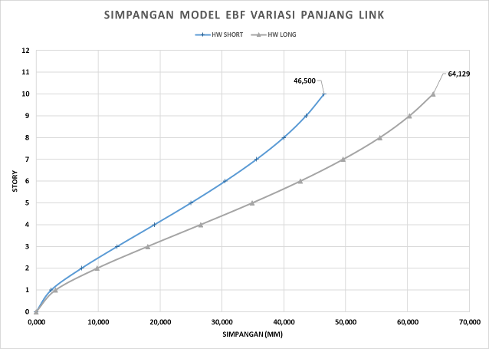 | 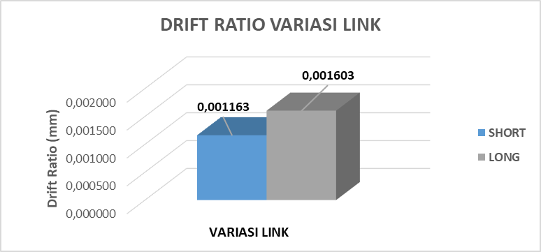

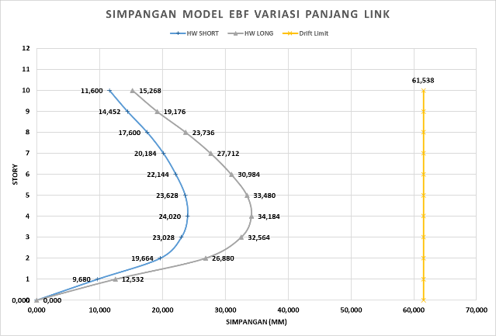
c)
FIGURE 2. a) Drift structure, b) Drift Ratio, and c) Interstorey Drift of the EBF structure

Stress ratio is the ratio between the ultimate load and the cross-sectional capacity of the structural element. Stress ratio explains the effectiveness of the cross section in resisting loads that work either due to moments, axial loads or a combination of both. In the EBFV-S-HW structure type, the ultimate load with the capacity of the structural element cross section occurs on the link beam located on the 3rd floor by getting the maximum stress ratio value of 0.708. Then in the EBFV-L-HW structure type, the ultimate load with the cross-sectional capacity of the structural elements occurs on the link beam on floor 3 by getting the maximum stress ratio value of 0.469 which can be seen in (TABLE 3) and for modelling of the stress ratio can be seen in FIGURE 3.

TABLE 3. Stress Ratio of The Structure
Type of Structure | Maximum Stress Ratio | Element
EBFV-S-WH | 0,708 | Link beam at the 3nd floor
EBFV-L-WH | 0,469 | Link beam at the 3nd floor

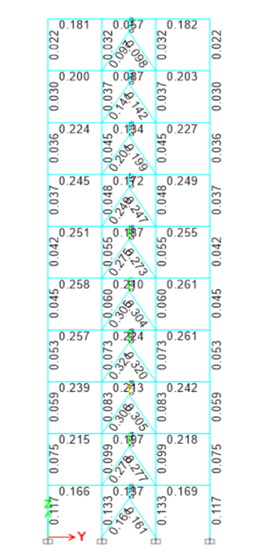 | 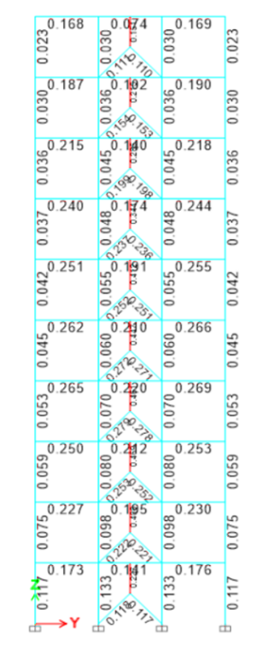
FIGURE 3. Stress Ratio that occurs on EBF with a) short link, b) long link

BASE SHEAR
In the nonlinear pushover static analysis using ETABS, pushover curves are obtained that show the relationship between deviation and base shear for each portal model. The following FIGURE 4 is the value of the base shear with different slopes of the brace in the form of EBF-V-HW using link elements, namely in the form of short links and long links, each experiencing the first melting, namely in the EBF-V-HW short link portal is 320.00 kN and 8079.73 mm, and for the EBF-V-HW long link portal is 415.09 kN and 8965.37mm.

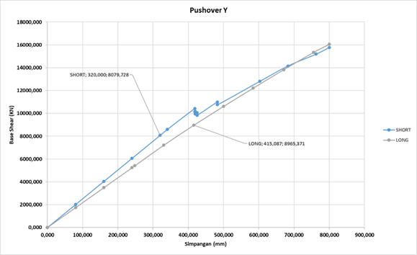
FIGURE 4. Pushover Curve

STRUCTURE DUCTILITY AND STIFFNESS
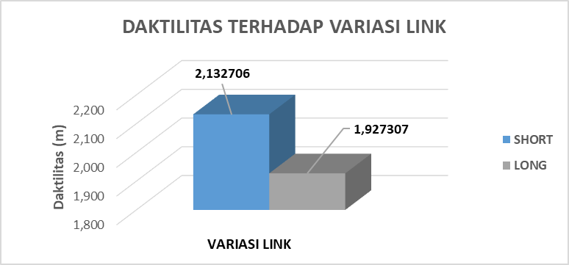 | 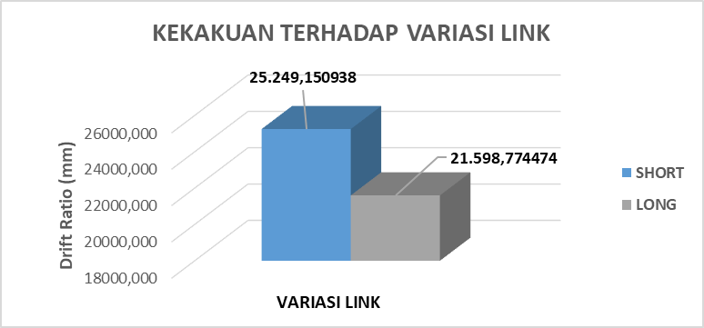

FIGURE 5. a) Structure Ductility, b) Structure Stiffness

Structural ductility, the amount of review of ductility values obtained in each model received due to earthquake loads through comparisons that can be made to each analysis model. And from the pushover curve, it can be seen that the structural ductility of each model. Ductility is the comparison of the first yield point and the ultimate point that occurs on the pushover curve. A comparison of the structural ductility of the EBF portal with a comparison of link length variations in the form of EBF-V-HW short and EBF-V-HW long gets the largest deviation results of 2.133mm and 1.927mm, as shown in FIGURE 5 (a).
Structural stiffness can also be determined from pushover curves. The stiffness of the structure is obtained from the ratio between the shear force and the ratio at the time of the first yield on the building structure. A comparison of the structural stiffness of the EBF portal with a comparison of link length variations in the form of EBF-V-HW short and EBF-V-HW long gets the largest deviation results of 25,249.15mm and 21,598.77mm, as shown in FIGURE 5 (b).

CONCLUSION
Based on the research that has been carried out, with the ETABS auxiliary program, it is found that the link length configuration is able to affect the behaviour of the EBF portal structure with HW profile due to earthquake loads, where the behaviour in question is the response of deviation, stress ratio, base shear, ductility, and structural stiffness. The structure with the application of short links is able to produce smaller deformation and stiffness when compared to the structure with long links. In ductility, both structures are able to produce ductility values above 4. While in the stress ratio, both structures are able to meet the requirements of not exceeding the value of 1.00 in both EBF structures with short and long links. As for the base shear or pushover using a short link, the first melting results are better than using a long link EBF portal.

REFERENCES

- S. Pandaleke, B. D. Handono, and S. O. Dapas, "Perencanaan Ulang Bangunan Struktur Baja Rumah Sakit Umum Ratumbuysang di Kota Manado," Jurnal Sipil Statik, vol. 7, no. 6, 2019.
- M. F. Santur, J. J. S. Pah, and E. E. Hangge, "Hubungan Antara Tinggi Pusat Massa Vertikal Bangunan Tingkat Tinggi Terhadap Simpangan Antar Lantai Akibat Beban Gempa," Jurnal Teknologi, vol. 16, no. 1, pp. 28-34, 2022.
- F. Nugroho, "Penerapan Analisis Pushover Untukmenentukan Kinerja Struktur Padabangunan Eksisting Gedung Beton Bertulang," Jurnal Momentum ISSN 1693-752X, vol. 18, no. 2, 2016.
- R. F. Manope, H. Manalip, and B. M. M. Ointu, "Analisis portal struktur baja berdasarkan konfigurasi tipe Dan variasi panjang link sistem Ebf (Eccentrically Braced Frames)," Jurnal Sipil Statik, vol. 7, no. 9, 2019.
- S. Kaffah, "Analisis Perilaku Vertical Eccentrically Braced Frame Menggunakan Profil Tubular Ganda," Jurnal Aplikasi Teknik Sipil, vol. 19, no. 4, pp. 395-406, 2021.

