Comparative Analysis of Structural Behavior regarding the Strong Axes and Weak Axes using the EBF Portal Bracing System
Geby Alvionita^{a)}, Erwin Rommel^{b)}, Aulia Indira Kumalasari^{c)}, and Lintang Satiti Mahabella^{d)}
University of Muhammadiya Malang, Faculty of Engineering, Civil Engineering

^{c)} Corresponding author: auliaindira@umm.ac.id
^{a)} geby.al01@gmail.com
^{b)} erwin_r@umm.ac.id
^{d)} lintangsmahabella@umm.ac.id
Abstract. Eccentrically Braced Frame (EBF) is an earthquake resistance system using a steel structure that ability to completly resist shear capacity and ductility. This system prioritizes links that are damaged first compared to other elements. Planning an earthquake-resistant building using a vertical link type EBF system are properly alternative to be implemented to education facility buildings as though this case study. Vertical type links make it simply to refinement structure or replace links without changing the primary beam if damage occurs due to an earthquake. Accordingly, eartquake-resistant building planning utilized the EBF portal bracing system, with bracing placement on the waek axis and strong axis based on the length and width of the building. Furthemore, modeling is carried out using ETABS to determine the behavior that occurs due to earthquake loads which are calculated according to the location by method of response spectrum analysis. The planning result are analyzed afterwards according to available rules to comply building safety standards based on their function.
Keywords : EBF, vertical link, response spectrum analysis, earthquake, strong axes, weak axes

INTRODUCTION
Tectonic earthquake are movements within the earth’s core that consequence to fault scrape of tectonic plates. Indonesia is a territory with a fairly complex about tectonic structure and quite active about earthquake waves in the world. Based on statiscal calculations of earthquake that occured in Indonesia, there were 71,628 eartquake that occured that could be analyzed in the 11 (2009-2019) year obeservation period [1] . Earthquake are natural disasters that necessary to be consider
Earthquake resistant building planning is necessary in Indonesia with a purpose of preventing structural failure and minimizing losses and casualties as a result of eartquake. Therefore, especially structures or high-rise buildings must be able to resist vertical forces due to gravity loads and horizontal forces consequence of earthquake. Accordingly, utilizing steel material in this construction planning are exactly choice it is known that steel has high ductility, usage time travel are relatively long time, the duration of work is faster, is effective efor use over long spans and the ratio of structure weight to structure capacity is low [2]. The addition of using a bracing frame system is another alternative to icrease the stiffness of steel structures.
Eccentrically Braced Frame is a braced frame system which has better advantages in terms of ductility and absorption of spatial energy[2]. This is caused by the presence of stiffeners in the parts of the beam that intersect with the braces or what are usually called links. This part is a element that is able to absorb earthquake energy by undergoing inelastic rotation while the other elements remain elastic[3].

METHODS
In the planning analysis of the building structure according to the design criteria to be made, this building is located in Kediri City, East Java, Indonesia. This building functions as an educational facility building. This building has dimensions of 24 meters long, 15 meters wide and 29.1 meters high with a total of 7 floors. This building has a height difference between floors of 6 meters on the 2nd floor, the other floors have a height of 3.85 meters so that loading will be given according to its function. The structural material is planned to use BJ41 quality steel with fy (yield stress) 250 MPa and fu (ultimate stress) 410 MPa[4]. Based on the planning results are ilustrated in FIGURE 1. Futhermore, the planned profile dimensions are presented in TABLE 1. This building plan was then modeled utilizing of ETABS software to apply loads using a linear static analysis method in the form of spectrum response analysis according to the location of this building planned. The results of the modeling are continued analysis to determine the stability of the structure in the weak axis and strong axis areas of the building.
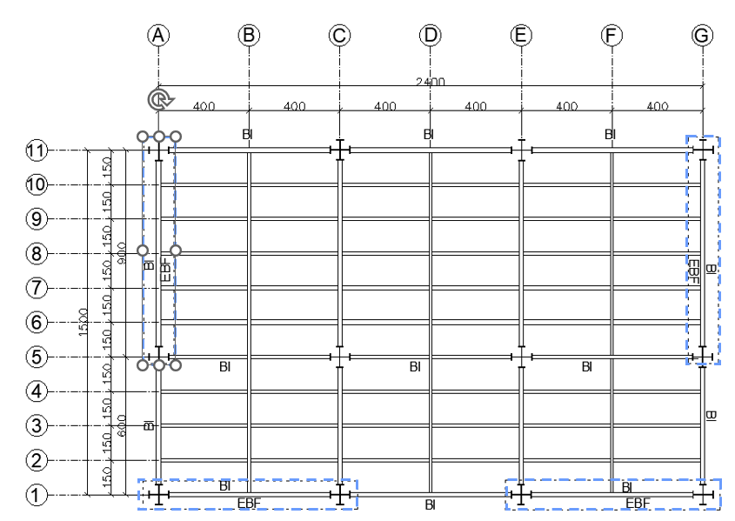
a)
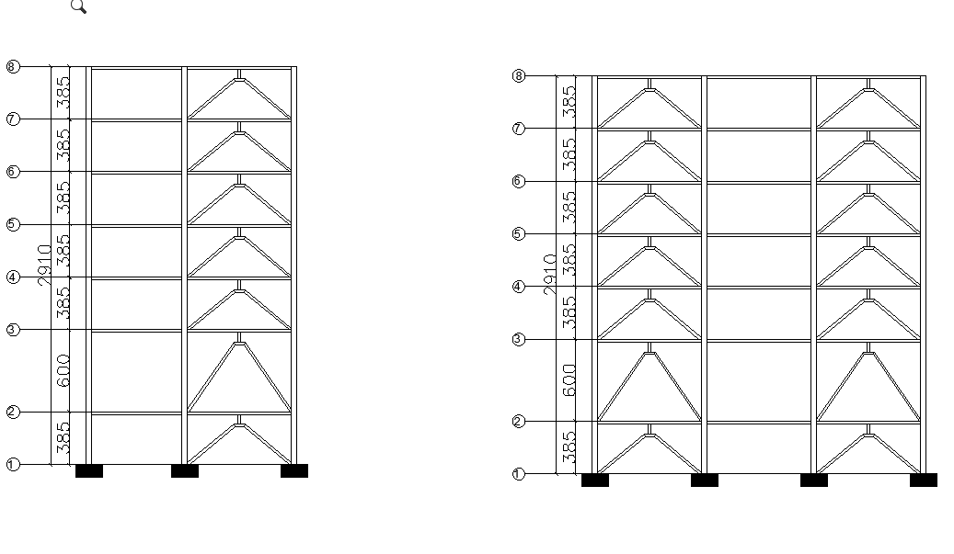
b) c)
FIGURE 1. a) Building Plans, b) Side view (y axis), and c) Rear view (x axis)

TABLE 1. Structure Properties
Numb. | Part of Stucture | Spesifications (mm)
1 | Coloumn | KC 900 × 300 ×18 × 34
2 | Primary Beam | WF 600 × 300 × 12 × 20
3 | Secondary Beam (x axis) | WF 500 × 300 × 11 × 15
4 | Secondary Beam (y axis) | WF 300 × 150 × 6,5 × 9
5 | Bracing 2 storey | WF 300 × 300 × 11 ×17
6 | Bracing 1,3-7 storey | WF 200 × 200 × 12 × 12

RESULTS AND DISCUSSION

PRELIMINARY DESIGN LINKS
The profile dimensions used in this modeling are divided into two, on the floors 1, 3-7 with a height of 3.85 millimeters using a WF profile of 200 × 200 × 12 × 12. Morover on the floor 2 which has the largest floor height using a WF profile of 300 × 300 × 11 ×17. Description of the link profile planning data used is presented in TABLE 2.
TABLE 2. Link Properties
WF 200 × 200 × 12 × 12 |  | WF 300 × 300 × 11 ×17
h = d = | 200 mm | h = d = | 300 mm
tw = | 12 mm | tw = | 11 mm
tf = | 12 mm | tf = | 17 mm
Zx = | 558500 mm³ | Zx = | 1679500 mm³
Furthermore, continued with calculating the plastic moment and plastic shear force before continuing to determine the link height used for the vertical type of link. The results of the calculation of plastic moment and plastic shear force are presented in TABLE 3.
TABLE 3. Result of Plastic Momen and Plastic Shear Force
 | WF 200 × 200 × 12 × 12 |  | WF 300 × 300 × 11 ×17
Mp | 139625000 N.mm |  | 419875000 N.mm
Vp | 3024 N |  | 4389 N
Followed by determining the length of the link used in the vertical configuration this link is a shear link type. The choice of using shear links is that have a short spans that do not exceed the maximum limit permitted according to standards, and are known to has the ability to resist greater shear forces[5]. The results of link calculations in the vertical type of link configuration are presented in TABLE 4.
TABLE 4. Link Planning Data Used
 | Limmit of Permitted Links | WF 200 × 200 × 12 × 12 |  | WF 300 × 300 × 11 ×17
Shear Link | e < 1,6 $\frac{Mp}{Vp}$ | 65 ≤ 73 |  | 65 ≤ 153
Medium Link | 1,6 $\frac{Mp}{Vp}$ < e < 2,6 $\frac{Mp}{Vp}$ | 73 ≤ e ≤ 120 |  | 153 ≤ e ≤ 248
Flexible Link | 2,6 $\frac{Mp}{Vp}$ < e | 120 ≤ e |  | 248 ≤ e
Link used |  | 65 cm |  | 65 cm

STRUCTURE DRIFT, DRIFT STOREY, ANDA DRIFT RATIO
Deviations or structure drift in high-rise buildings are occur due to various factors, one of which is the presence of seismic activity which has an impact on the higher the building. Therefore the lateral displacement becomes more significant[6]. Furthermore, it is necessary to add structural stiffeners in the form of bracing and links to reduce deviations that occur in the building. In this building, it is planned to place EBF braces on two axes, severally which has a difference in the maximum deviation value of the x-axis on the 7th floor of 49.738 millimeters. Moreover, on the y-axis, the maximum deviation is located on the 7th floor at 34.803 millimeters. The comparison result of the deviations on each brace placement axis can be seen in FIGURE 2 (a).
Furthermore , after obtaining the maximum deviation on each axis, it is necessary to calculate the deviation between floors find out that the building has an adequate level of safety against lateral loads and does not exceed the permissible deviation in accordance with SNI 1726:2029[7]. Based on these standards, this building is included in risk category IV therfore the coefficient used is 0.010. The results of the deviation between floors on the x-axis and y-axis are presented in FIGURE 2 (b).
On the other hand, is the drift ratio which is the ratio of the maximum drift value to the total height of the structure. The results of this comparison are required not to exceed the permit limit determined according to the risk category, is that 0.010. The results of this comparison between the x-axis and y-axis are presented in FIGURE 2 (c).

- b)

c)
FIGURE 2. a) Structure Drift, b) Drift Storey, and c) Drift Ratio

STRESS RATIO
The stress ratio is a comparison between the stress that occurs in a structural element and the permitted stress limit or what is called the ultimate condition. This proceed is carried out to control the cross-section of the profile used in accordance with SNI 1726:2019. In this condition, the building shows the effectiveness of the cross-section used in supporting loads acting vertically and horizontally over spans with different variations. In FIGURE 3 (a) and (b), it is shown that the cross-section of the main structural elements has met the requirements, is that not exceeding the ratio limit of 1.00.
However, as presented in TABLE 5 the cross section of the link element located on the y-axis in this building is a weak axis with a maximum stress ratio limit of more than 1.00. Moreover, the x-axis, which is the strong axis of this building, has a stress ratio limit with a safe value of <1.00. The main factor that causes this to happen is the span length of the primary beam which is used as a brace[7]. On the y-axis, the braces are placed at a span of 9 meters, while on the x-axis the braces are placed at a span of 8 meters.
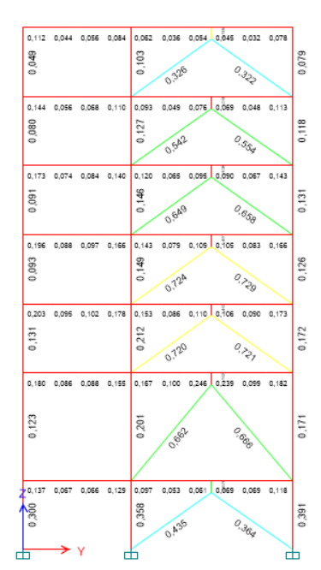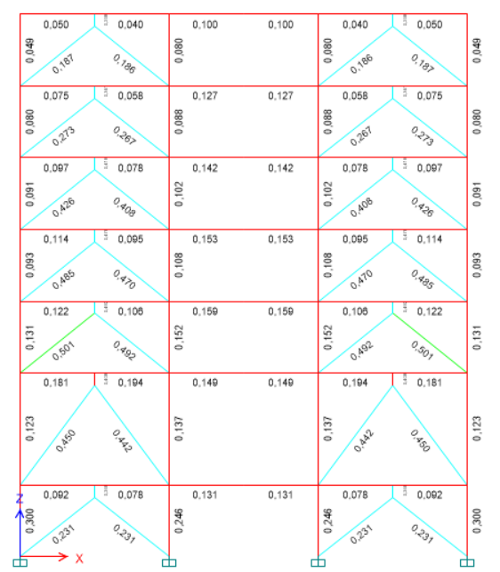
- b)
FIGURE 3. a) Check Design Y-Z Axes, and b) Check Design X-Z Axes
TABLE 5. Strees Ratio of The Link Structure
Global Axes | Maximum Stress Ratio | Element
Y Axes | 1,491 | Link beam at the 4 floor
X Axes | 0,492 | Link beam at the 3 floor

CONCLUSIONS
Overall, based on the analysis carried out with the help of ETABS software, it was found that the placement of links in the strong axis and weak axis areas has a significant difference. Where on the weak axis the deviations in the structure, the drift storey and the drift ratio that occur are relatively smaller compared to the strong axis. Morover, based on the stress ratio value that occurs on the strong axis, the value is relatively smaller compared to the weak axis. This is also influenced by other things, is that the number of braces placed and the span length of the primary beam utilizing as braces. Accordingly, it can be concluded that the placement of braces is more effective in strong axis areas where there are more columns than weak axes. This also needs to consider other factors, such as span length and floor height which will be reviewed for placing the braces

References
- A. Sabtaji, “Tatistik Kejadian Gempa Bumi Tektonik Tiap Provinsi Di Wilayah Indonesia Selama 11 Tahun Pemangat,” Buletin Meteorologi, Klimatologi dan Geofisika, pp. 31-46, 2020.
- P. A. Pangestuti dan B. Suswanto, “Analisis Performa Eccentrically Braced Frames (EBF) Vertikal Link Menggunakan,” Jurnal Aplikasi Teknik Sipil, vol. 19, pp. 247-256, 2021.
- S. Kaffah dan B. Suswanto, “Analisis Perilaku Vertical Eccentrically Braced Frame Mengunakan Profil Tubular,” Jurnal Aplikasi Teknik Sipil, vol. 19, pp. 395-406, 2021.
- Y. Lesmana, Handbook Analisa dan Desain Struktur Baja Berdasarkan SNI 1729:2020, Penerbit Nas Media Pustaka, 2021.
- A. K. Tanuwijaya, F. Tanaya, H. Santoso dan E. Tanojo, “Pengaruh Faktor Kuat Lebih pada Kinerja Struktur Baja Rangka Terbreis Eksentris dengan Tipe Multi-Story X pada Bangunan 12 dan 18 Lantai,” Jurnal Dimensi Pratama teknik Sipil, vol. 12, pp. 9-16, 2023.
- S. Anggraini, E. Septiandini dan I. P. Wangi, “Perencanaan dan Analisis Keefektifan Penempatan Dinding,” Jurnal Talenta Sipil, vol. 7, pp. 238-246, 2024.
- A. Muza'ki dan R. Trimurtiningrum, “Analisis Kinerja Struktur Gedung Perkantoran Pabrik,” Jurnal Teknik Industri Terintegrasi, vol. 7, no. 3, pp. 1539-1550, 2024.

