A Study of Liquefaction and Expansive Soil Risk Based on Atterberg Limits Parameters at RDF Rorotan Project, North Jakarta
Bramantyo Eko Prabowo^{a)} and Gilang Almaghribi Sarkaraputra^{b)}
Engineering of EPCC Division, PT Wijaya Karya (Persero) Tbk., Jakarta, Indonesia

^{a)} Corresponding author: bramantyo@wikamail.id
^{b)} almaghribi@wikamail.id
Abstract. Indonesia has a significant risk of massive soil movement phenomena due to liquefiable soil and expansive soil. The most well-known incident of soil liquefaction was in Palu in 2018 with a 7.4-magnitude earthquake. It is essential to look at potential dangers, especially those relating to site conditions, as this event may result in massive losses. According to previous studies and research from articles on this risk, Jakarta is one of the most vulnerable locations with medium to high degrees of risk. The soil material becomes one of the leading causes of the high risk of liquefaction, expansion, or swelling. So, it is necessary to study the specific soil type at the site location. RDF Rorotan, a project for renewable and clean energy that transforms domestic waste into a fuel energy source, requires research on the risks. The method for evaluation is adopted by the Seed et al. method, which involves using the Atterberg limit to assess value limitation to several groups. The soil data obtained from soil investigations are analyzed and the conclusion is that it has been found that the soil on the project is included in the C-Zone category, i.e. not-liquefiable soil. On the other hand, the majority of the RDF Rorotan project soil is included in the expansive soil type with an S value greater than 5%, which is sensitive to water content and easily swells and shrinks. That expansive soil has the risk of reducing the bearing capacity of the foundation design.
Keywords: Liquefaction, Expansive, Atterberg, Seed, Jakarta

INTRODUCTION
The island nation of Indonesia has a significant risk of earthquakes that directly harm buildings and cause destruction in the surrounding environment. Quakes also cause a massive amount of soil movement called soil liquefaction, swell when getting moisture and shrink or crack when dry called expansive soils [1]. This phenomenon can be estimated using index properties such as plasticity index, liquid limit, and plastic limit called the Atterberg limit and can be correlated with engineering properties [2] [3] [4]. Plasticity characteristics of clay soil are primarily governed by the fine-grained particles on the material [5]. Referring to these studies and evaluations, it is necessary to evaluate the risk with the Atterberg limit.
The engineers of consultants and contractors were not concerned about this risk, particularly before the Palu disaster in September 2018, which had a magnitude of 7.5 M and triggered massive mudflows [6] [7]. The absence of recommendation guidelines for mitigating the risk has led various organizations to conduct studies and investigations in this field. The previous research on liquefaction risk by the Geological Team of the Ministry of Energy and Mineral Resources explains that many areas in Indonesia have a high to medium risk of liquefaction [8]. However, the study's outcomes are still straightforward and do not specifically describe the risk level of the project's location. Therefore, to prevent the impact of significant and massive commercial and social losses, it is necessary to investigate the risks, especially those related to site conditions.
In 2024, PT Wijaya Karya (Persero) Tbk. developed Refuse Derived Fuel (RDF) Rorotan in North Jakarta as an EPCC Contractor. Jakarta is a well-known city with several areas that are subsiding rapidly and consists of fluvial sediment from channels and flood deposits, coastal and shallow sediment, and the Gede and Pangrango volcanoes [9]. Referring to the study using GPS surveys between 1997 and 2005, the estimation of subsidence rates is 1–10 cm/year [10]. The observed subsidence rates in several locations show a positive correlation due to groundwater extraction and the natural consolidation of alluvial soil. This sediment deposit varies from clay, silt, sandstone, and limestone, with more than 290 meters of thickness. On the other hand, the Jakarta groundwater basin is in critical condition due to excessive groundwater exploitation of up to 40%.
Referring to previous studies and research from journals related to liquefaction and expansive soil risk, Jakarta is one of the most vulnerable areas with medium to high levels of risk. The Atlas of Indonesian Liquefaction Vulnerability Zone, 2019 shows that the area of Jakarta is an area with a medium level of liquefaction risk [8], and another study in the Gulf of Jakarta using Kramer's method (2008) found that Jakarta has a susceptibility rating of liquefaction from medium to high [11]. On the contrary, a different study using the Moss et al. method (2006) explains that the probability of Jakarta's liquefaction occurring is low [12]. On the other hand, almost 65% of the soil in Indonesia is expansive soil that has large swelling and shrinking potential [13]. Jakarta's soil conditions, which come from sedimentation, are high in clay concentration. This is an early indicator that the area is also at risk of structural failure due to expanding soils. With these conditions, it is necessary to study the risk of land movement, especially liquefaction and expansive soil risk.

METHODS
The criteria for the potential occurrence of liquefaction and expansive soil based on Atterberg limits parameters with Seed et al. method is widely used for cohesive soil. Soil parameters are determined by various elements, including the distribution of soil particle size, soil strength or density, plasticity characteristics, soil water levels, and the site's risk of earthquakes. There are three main recommended criteria based on Atterberg limit: liquid limit (LL), plastic limit (PL), plasticity index (PI), and water content (Wc) [14] [15] [16]. The liquid limit (LL) is a condition in which the level of soil water in soil conditions starts to change from plastic to liquid or vice versa. The plasticity index (PI) is the difference between a soil's liquid limit and the plastic limit. Moreover, the water content (Wc) is the water-weight ratio and the solid particles' mass in the soil volume.
The process of liquefaction in the soil is based on the velocity at which porous pressure occurs, and soil permeability greatly influences this process. Generally, a condition's liquefaction level will decrease with increasing water soil permeability. High permeability allows porous water to drain quickly, preventing liquefaction conditions. Soil with significant acceptable contents, such as clay or silt, is potentially susceptible to cyclically induced liquefaction. The previous research on the material shows that soils with particles finer than 0.074 mm or passing sieve #200 with a low liquid limit (LL) and plasticity index (PI) easily cause liquefaction.
The study methodology compares the Atlas of Indonesian Liquefaction Vulnerability Zone Atlas results with a simple and quick method that uses specific soil material data of the project. One practical method for this kind of analysis is the one described by Seed et al. (2003). This approach indicates the original soil condition at the project site through classification as either liquefiable or not liquefiable soil. The study results will guide project planning, including the amount of money and time needed to reduce the risk of liquefaction from the proposal phase until engineering design details.
The Seed et al. (2003) method is described by three zones on the Atterberg limit chart for liquefaction risk. A-Zone described as liquefiable soil has limit values at PI ≤ 12% and LL ≤ 37% for low-plasticity silts or silty clay, as well as a high water content relative to their liquid limit of 85%. B-Zone is considered potentially liquefiable soil, with PI = 12%–20% and LL = 37%–47%, with water content greater than 85% of the LL. Due to earthquake events, C-Zone soils with PI > 20% and LL > 47% are generally considered not-liquefiable soils. Liquefaction phenomena are easily possible because the soil will quickly become liquid with only a low water content.
The Seed et al. (1962) method uses the plasticity index to calculate expansive soil potential. Through numerous studies and investigations on soil samples, Seed provided a formula to assess the risk level of expansive soil. This risk is classified into four levels: a value of 0–15 for low risk, 1.5–5 for medium risk, 5–25 for high risk, and more than 25 for very high risk of expansive soil [17] [18]. This formula remains relevant when used alongside other specific formulas to determine the potential for expansive soil. Detail of method for the liquefaction and expansive soil risk are described in FIGURE 1. Flowchart of Risk Analysis Seed et al. Method.

Start

Risk Analysis
Seed at al. Method

Liquefaction Risk
Expansive Risk

S = 60K (PI) ^{2.44}
K = 3.6 x 10⁻⁵
LL > 47%
PI > 20%
LL = 37% - 47%
PI = 12% - 20%
Wc ≥ 0.85 LL
LL ≤ 37%
PI ≤ 12%
Wc ≥ 0.85 LL

A-Zone
Liquefiable Soil
B-Zone
Potentially
Liquefiable Soil
C-Zone
Not-liquefiable Soil
S < 1.5% Low
1.5%≥ S >5% Medium
5%≥ S >25% High
25% ≥ S Very High

Finish

FIGURE 1. Flowchart of Risk Analysis Seed et al. Method

RESULTS AND DISCUSSION

INDONESIAN LIQUEFACTION VULNERABILITY ZONE ATLAS
The Atlas of Indonesian Liquefaction Vulnerability Zone, 2019, concludes that most Jakarta is in a yellow zone [8]. The yellow area indicates that the area is in a zone of moderate liquefaction vulnerability, means there are risks of uneven liquefaction, and the soil structure is generally damaged. The types of soil structural damage are lateral displacement, vertical displacement, and sand boil. Only a few areas in the north—coastal areas—with a high risk of liquefaction are indicated with a red area. A coastal sediment deposit of clay likely causes this. Otherwise, the southern area of Jakarta Province is indicated as not vulnerable to liquefaction events, with a gray area.
The RDF Rorotan Project is located in the yellow liquefaction vulnerability zone. This area is above the Alluvium Plateau, like clay, silt, and a small quantity of grave soil. The condition of the previous project area was swampy, with the current allocation being rice fields. There are several channels that, during the rainy season, bring a considerable amount of water, such as irrigation and natural drainage. These channels increase the soil's water content and may be a risk factor for liquefaction. The RDF Rorotan Liquefaction Vulnerability Zone can be seen in FIGURE 2.
Liquefaction can cause significant and massive damage to the infrastructure of RDF process plants. It would take a lot of cost and time to mitigate and reinforce the soil and the structures. The vulnerability zones on this map are only offered as a general overview and initial data for region planning. Additional studies using primary data are required to predict the liquidation risk level accurately. Therefore, it is necessary to obtain additional confirmation with more accurate and detailed data regarding the amount of liquefaction risk in the area of RDF site Rorotan, North Jakarta, before planning the structural design.
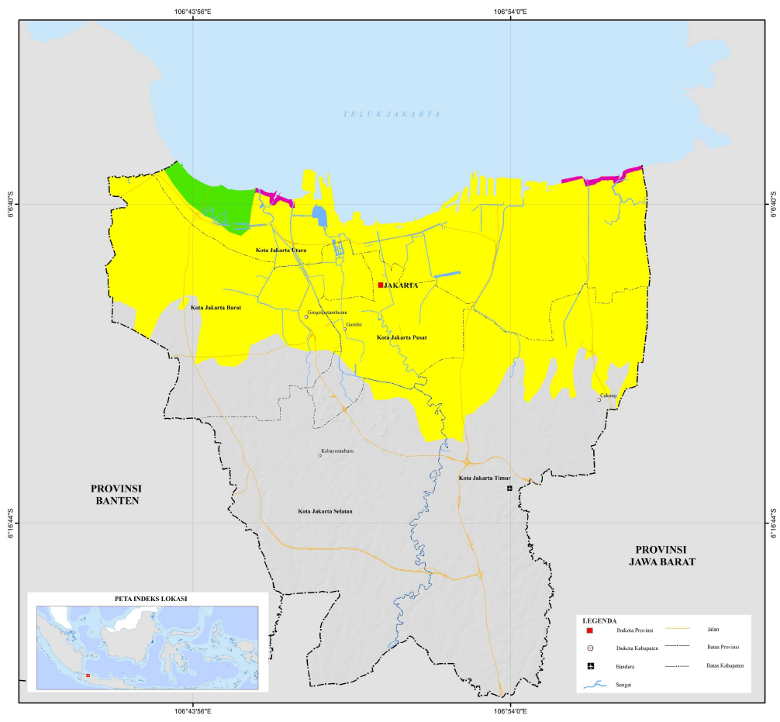
RDF Rorotan Project Location
FIGURE 2. Prov. Jakarta, Atlas of Indonesian Liquefaction Vulnerability Zone (2019)

SOIL MATERIAL ANALYSIS
In May 2024, the RDF Rorotan Project took soil data from the site investigation. The soil investigator performs the investigation before starting the engineering design or construction of the process plant. The soil sample was taken at three different ground depth ranges from each of the 12 borehole points. Later, the soil test, including sieve analysis, soil strength or density, and Atterberg limit test perform in the soil laboratory.
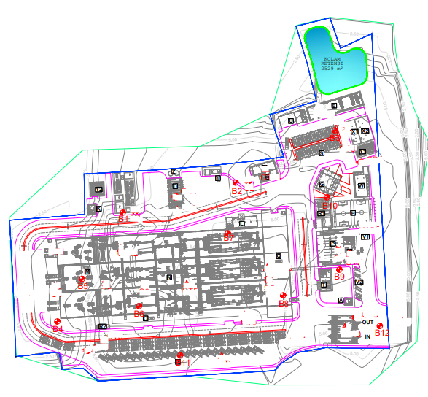
Line of B1-B2-B3 Stratigraphy
FIGURE 3. Soil Borehole Layout of The RDF Rorotan Project Site

The general characteristics of the soil at RDF Rorotan can be divided into four layers, as seen in FIGURE 3. The first layer is soft silt, homogeneous with a moist condition until 10 meters. The second layer is soft clay with high plasticity and homogeneous gray for 5 meters of thickness. The third layer is sandy clay, homogeneous brown with low plasticity for only 5 meters, and the last, fourth layer is silty sand, dark gray with dense condition until 40 meters, the deepest of the soil investigation for this project. The detailed soil layer can be seen in FIGURE 4.
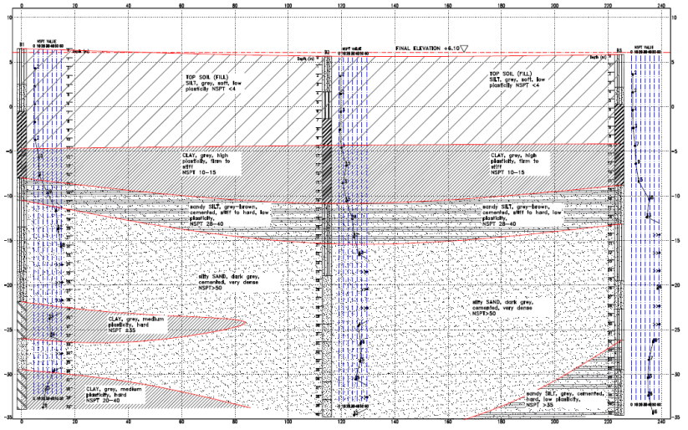
FIGURE 4. Stratigraphy Soil Layer B1-B2-B3 of the RDF Rorotan Project Site

According to laboratory test results, majority soil at depths of up to 10 m is dominant to very soft clay with detail as previous FIGURE 4. The Atterberg limit testing results show that the plasticity limit (PL) varies between 19% and 67%, and the liquid limit (LL) is between 33% and 93%. Calculating from PL and LL, the plasticity index (PI) is between 11% and 45%. Therefore, the data will be analyzed using the Seed et al. method approach.
The soil data is categorized into three criteria and applied to several boundaries to determine the natural soil's liquefaction risk level on RDF Rorotan, North Jakarta. The 36 data indicate that the liquid limit (LL) is above 47%, with the plasticity index over 20%. So, the soil data included the C-Zone category, and there was little chance of liquefaction soil risk or not-liquefiable soil.
The analysis for the risk of expansive soil will use the plasticity index (IP) results from 12 borehole points at each of the 3 depths. The S value, or swelling ratio, of the soil shows a range between 1.58% and 27.00%, indicating a medium to very high risk level. The median of S number is 8.83%, placing it in the high-risk category. It can be concluded that the soil in RDF Rorotan has a high chance of becoming expansive. The detailed results of the analysis can be seen in TABLE 1.
The distribution of soil types indicates that soil belongs to the C-Zone category, not liquefiable soil. The soil material is clay or silt with a high plasticity index. Only a minority of materials, including clay, have low plasticity, but they are still accepted in the C-Zone category. Previous studies show that the fine-grained soils reported as liquefiable soil are CL, CL-ML, and ML, which refer to the Unified Soil Classification System [16]. However, the soil material is classified as a C-Zone category because of the high PI value and the LL of more than 47%. The plotting results of the analysis can be seen in FIGURE 5.
The most critical soil is B10, the closest sample to the B-Zone category. This sample was gathered at a depth of 11.50 to 12.00 meters, with a plasticity index (PI) of 20.46% and a liquid limit (LL) of 42.97%. However, the water content value for this sample is 30.56%, which is less than 85% of LL. Therefore, the material is still acceptable for being described as non-liquefiable.

TABLE 1. Soil Material Analysis of Rorotan Soil, Seed et al Method.
ID | Depth | PI (%) | LL (%) | Liquefaction Soil Risk |  |  | Expansive Soil Risk
 |  |  |  | Zone | Wc (%) | Result | S (%) | Result
B1 | 1.50 - 2.00 | 40,54 | 70,82 | C | 57,55 | Not-Liquefiable | 18,10 | High
B1 | 4.50 - 5.00 | 29,36 | 55,27 | C | 45,71 | Not-Liquefiable | 8,24 | High
B1 | 9.50 -10.00 | 21,53 | 41,06 | C | 37,98 | Not-Liquefiable | 3,86 | Medium
B2 | 7.50 - 8.00 | 23,15 | 47,2 | C | 41,35 | Not-Liquefiable | 4,61 | Medium
B2 | 9.50 - 10.00 | 40,3 | 71,78 | C | 69,28 | Not-Liquefiable | 17,84 | High
B2 | 11.50 - 12.00 | 32,91 | 58,6 | C | 36,50 | Not-Liquefiable | 10,88 | High
B3 | 4.50 - 5.00 | 35,031 | 68,923 | C | 42,65 | Not-Liquefiable | 12,67 | High
B3 | 9.50 - 10.00 | 30,341 | 80,098 | C | 71,67 | Not-Liquefiable | 8,92 | High
B3 | 11.50 - 12.00 | 35,834 | 81,791 | C | 71,5 | Not-Liquefiable | 13,39 | High
B4 | 1.50 - 2.00 | 30,073 | 67,647 | C | 61,76 | Not-Liquefiable | 8,73 | High
B4 | 4.50 - 5.00 | 20,913 | 51,032 | C | 43,93 | Not-Liquefiable | 3,60 | Medium
B4 | 9.50 - 10.00 | 34,76 | 67,753 | C | 43,51 | Not-Liquefiable | 12,44 | High
B5 | 1.50 - 2.00 | 14,92 | 60,6 | C | 54,79 | Not-Liquefiable | 1,58 | Medium
B5 | 4.50 - 5.00 | 19,36 | 57,73 | C | 52,07 | Not-Liquefiable | 2,98 | Medium
B5 | 9.50 - 10.00 | 19,68 | 54,59 | C | 31,4 | Not-Liquefiable | 3,10 | Medium
B6 | 5.50 - 6.00 | 36,27 | 75,89 | C | 67,77 | Not-Liquefiable | 13,80 | High
B6 | 9.50 -10.00 | 24,95 | 52,14 | C | 45,72 | Not-Liquefiable | 5,54 | High
B6 | 13.50 - 14.00 | 33,4 | 66,02 | C | 41,56 | Not-Liquefiable | 11,28 | High
B7 | 1.50 - 2.00 | 25,18 | 62,41 | C | 67,52 | Not-Liquefiable | 5,66 | High
B7 | 4.50 - 5.00 | 28,77 | 52,23 | C | 43,29 | Not-Liquefiable | 7,84 | High
B7 | 9.50 - 10.00 | 43,97 | 74,71 | C | 64,95 | Not-Liquefiable | 22,07 | High
B8 | 3.50 - 4.00 | 15,49 | 56,37 | C | 43,27 | Not-Liquefiable | 1,73 | Medium
B8 | 7.50 - 8.00 | 30,94 | 89,16 | C | 82,22 | Not-Liquefiable | 9,36 | High
B8 | 11.50 - 12.00 | 42,16 | 84,13 | C | 50,66 | Not-Liquefiable | 19,92 | High
B9 | 1.50 - 2.00 | 21,45 | 56,16 | C | 48,18 | Not-Liquefiable | 3,83 | Medium
B9 | 4.50 - 5.00 | 38,04 | 72,45 | C | 58,47 | Not-Liquefiable | 15,50 | High
B9 | 9.50 - 10.00 | 45,57 | 71,7 | C | 73,78 | Not-Liquefiable | 24,08 | High
B10 | 3.50 - 4.00 | 45,56 | 93,51 | C | 105 | Not-Liquefiable | 24,07 | High
B10 | 7.50 - 8.00 | 22,31 | 45,91 | C | 51,87 | Not-Liquefiable | 4,21 | Medium
B10 | 11.50 - 12.00 | 20,46 | 42,97 | C | 30,56 | Not-Liquefiable | 3,41 | Medium
B11 | 3.50 - 4.00 | 27,12 | 66,25 | C | 64,91 | Not-Liquefiable | 6,79 | High
B11 | 7.50 - 8.00 | 47,76 | 77,88 | C | 44,72 | Not-Liquefiable | 27,00 | Very High
B11 | 11.50 - 12.00 | 24,67 | 47,37 | C | 33,97 | Not-Liquefiable | 5,39 | High
B12 | 3.50 - 4.00 | 31,545 | 64,879 | C | 43,09 | Not-Liquefiable | 9,81 | High
B12 | 7.50 - 8.00 | 25,222 | 92,929 | C | 75,67 | Not-Liquefiable | 5,69 | High
B12 | 13.50 - 14.00 | 43,601 | 89,952 | C | 83,05 | Not-Liquefiable | 21,62 | High

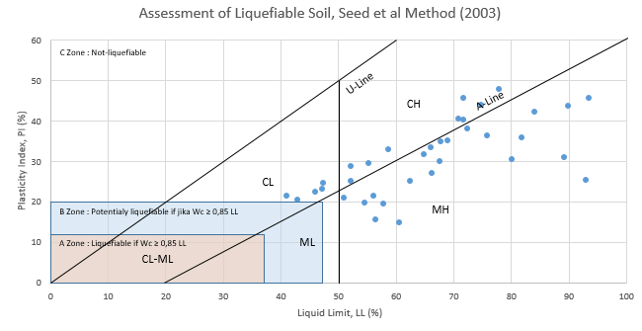
FIGURE 5. Assessment of Rorotan Liquefiable Soil, Seed et al Method (2003)

On the other hand, research concluded that the plasticity index ranges more than 20%, indicating that the soil is an expansive soil type, characteristic of expansive soil that is easy to swell and shrink depending on soil water content [19]. The previous study also concluded that Jakarta and surrounding areas can have expansive soil types [20]. These studies confirm the result of the expansive soil risk at RDF Rorotan. Expansive soil is also dangerous to the stability of the foundations and structures of buildings, as soil is sensitive to changes in water content that can temporarily reduce the soil's bearing capacity. The solution of this condition is optimization of Atterberg limit with additional material such as sawdust, crumb rubber or waste marble powder [2] [21].

CONCLUSIONS
The evaluation results of liquefaction risk based on soil material at RDF Rorotan Project, North Jakarta, show that the soil material is included in the C-Zone category. This C-Zone category has little chance of liquefaction occurring because the soil is not liquefiable. So, it is possible to continue the design work to estimate the cost and schedule of construction without considering the additional mitigation work for liquefaction. Nevertheless, the analysis found that the project site's soil characteristics included to expansive soil, which is extremely sensitive to water content, resulting in soil that easily swells and shrinks and has the risk of reducing the bearing capacity of foundation design. This condition is solved by optimizing the Atterberg limit with additional materials.
Although there are still areas for improvement in Seed et al. method, this method can find the probability of liquefaction and expansive soil more easily and quickly, especially for fine-grained or clay type soils. This method can be beneficial for consultants and contractors to accommodate limited analytical time. However, a deeper analysis of the interaction between soil and earthquake or other load shall be considered if there are any indications of soil being liquefiable or expansive. A better analysis will require more data, including SPT and CPT values and possible earthquake risks at the project site. This analysis will provide a more accurate assessment of the risk and the factors that led to the event.

Acknowledgments
The authors thank PT Wijaya Karya (Persero) Tbk, especially the Engineering EPCC Division and RDF Project Team, for supporting and allowing us to conduct this research.

References
1. Gobena, J.A. and S. Suppiah, Strength characteristics of expansive soil mixed with quarry residue and cement. Int. J. Innov. Technol. Explor. Eng, 2019.
2. Aliy Gobena, J., G. Kumar, and S. Suppiah, Optimization of Atterberg limits of treated expansive soils with Taguchi method. Materials Today: Proceedings, 2021. 43: p. 2127-2133.
3. Kargar, P., A. Osouli, and S. Kumar, Liquefaction behavior evaluation of a multi-layered site with fines-dominated soils. Soil Dynamics and Earthquake Engineering, 2023. 169: p. 107875.
4. Shimobe, S. and G. Spagnoli, Some generic trends on the basic engineering properties of fine-grained soils. Environmental Earth Sciences, 2019. 78(9): p. 281.
5. Gobena, J.A. and S. Suppiah, Strength Characteristics of Tropical Expansive Soil–A Review. Int. J. Sci. Technol. Res., 2019.
6. Jalil, A., et al., Liquefaction in Palu: the cause of massive mudflows. Geoenvironmental Disasters, 2021. 8(1): p. 21.
7. Upomo, T.C., et al. Assessment of Petobo Flowslide Induced by Soil Liquefaction during 2018 Palu–Donggala Indonesian Earthquake. Sustainability, 2023. 15, DOI: 10.3390/su15065371.
8. Geologi, B., Peta Zona Kerentanan Likuefaksi Indonesia. 2019, Bandung.
9. Marwanza, I., et al., Land Subsidence and Geotechnical Impact of Jakarta Kota Area. INDONESIAN JOURNAL OF URBAN AND ENVIRONMENTAL TECHNOLOGY, 2023: p. 145-164.
10. Abidin, H.Z., et al., Land subsidence characteristics of Jakarta between 1997 and 2005, as estimated using GPS surveys. GPS Solutions, 2008. 12(1): p. 23-32.
11. Dinata, I.A., et al. Liquefaction hazard analysis for infrastructure development in gulf of Jakarta. in AIP Conference Proceedings. 2016. AIP Publishing.
12. Agung, P.A.M., et al., Probabilistic of in Situ Seismic Soil Liquefaction Potential Based on CPT-Data in Central Jakarta, Indonesia. International Journal of Sustainable Construction Engineering and Technology, 2023. 14(1): p. 241-248.
13. Sofian, A.C. and A. Prihatiningsih, Effectiveness of adding organic waste on expansive soil using handheld penetrometer and free swell test. IOP Conference Series: Materials Science and Engineering, 2020. 1007(1): p. 012124.
14. Seed, R.B., et al. Recent advances in soil liquefaction engineering: a unified and consistent framework. in Proceedings of the 26th Annual ASCE Los Angeles Geotechnical Spring Seminar: Long Beach, CA. 2003.
15. Seed, R.B., et al., Recent advances in soil liquefaction engineering and seismic site response evaluation, in International Conferences on Recent Advances in Geotechnical Earthquake Engineering and Soil Dynamics. 2001, University of Missouri--Rolla.
16. Boulanger Ross, W. and I.M. Idriss, Liquefaction Susceptibility Criteria for Silts and Clays. Journal of Geotechnical and Geoenvironmental Engineering, 2006. 132(11): p. 1413-1426.
17. Narmandakh, D., et al., The use of feed-forward and cascade-forward neural networks to determine swelling potential of clayey soils. Computers and Geotechnics, 2023. 157: p. 105319.
18. Shrestha, S., Study of effects of coarse grain contents on Atterberg limits and expansiveness of the clay. 2016.
19. Das, B.M. and N. Sivakugan, Fundamentals of geotechnical engineering. 2017: Cengage Learning.
20. Levany, O.S. and G.S. Sentosa, POTENSI TANAH EKSPANSIF DI WILAYAH JAKARTA DAN SEKITARNYA. JMTS: Jurnal Mitra Teknik Sipil, 2024: p. 589-596.
21. Sakr, M.A.H., et al., Geotechnical parameters modelling and the radiation safety of expansive clayey soil treated with waste marble powder: a case study at west Gulf of Suez, Egypt. Environmental Earth Sciences, 2021. 80(7): p. 263.

