Performance Analysis and Development of Type A Passenger Terminal Jombang City
Andi Syaiful Amal^{a)}, Rofikatul Karimah^{b)}, Azhar Adi Darmawan^{c)}, and Ivanya Anindhi Subekti^{d)}
Department of Civil Engineering, University of Muhammadiyah Malang, Malang, Indonesia

^{a)} Corresponding author: andisyaiful@umm.ac.id
^{b)} rofikatul@umm.ac.id
^{c)} azharadidfts@umm.ac.id
^{d)} ivanyaanindhi170805@gmail.com

Abstract. While providing services to service users, the Kepuhsari terminal is still not meeting the expectations of the surrounding community or the standard of type A terminals. Thus, grasping the present situation is crucial condition of the terminals in Jombang City in relation to the terminal assessment. The inspection strategy is a field study technique by distributing questionnaires and meetings with relevant agencies. The Importance Performance Analysis (IPA) method was used to analyze the data. From research information, the Kepuhsari terminal currently has an average arrival rate (λ) = 2 bus/hour, service level (µ) = 9 bus/hour, typical number of vehicles in a frame (n) = 1 bus, average – average queue length inside the system (q) = 1 bus, average normal time in the system (d) = 0.14 hours, average normal system delay period (w) = 0.02 hours, average headway ( h) = 0.4 hours and traffic intensity (ρ ) = 0.2. Area requirements such as the arrival area, departure area, parking area and passenger waiting area are sufficient to accommodate AKDP/AKAP buses and prospective passengers. For service performance using the Importance Performance Analysis (IPA) method, an average level of conformity was obtained of 64.55%, which means that the users of the Kepuhsari terminal are satisfied and there are 3 attributes that need to be developed to make the Kepuhsari terminal service more satisfactory, namely the availability of signs and signs. Discussion of circulation within the terminal, availability of repair facilities and officers checking the suitability of public transport, availability of boards with information on arrival/departure schedules and travel fares for all bus routes at the bus station.
Keywords: Terminal Perfomance, The Standart of Service, Importance Perfomance Analysis.

INTRODUCTION

The development of land transportation aims to improve the ability of transportation to be broader, orderly, orderly, safe, smooth, fast and efficient at a cost that is affordable to the community and able to support people's lives and encourage equitable development with implementation priorities including improving the provision of transportation capabilities and services. path [1] Therefore, road transportation services which include passenger and cargo transportation within cities, between cities and between regions need to be fostered, developed and increased in efficiency. In encouraging and accelerating the achievement of development goals both nationally and regionally, the role of transportation has an important and strategic position in its development and needs to be arranged in a unified, integrated system [2] [3] To ensure smooth and orderly integration between intra and inter modes/vehicles or means of transport, then in certain places it is necessary to build and develop a terminal [4] Jombang City is the center of Islamic boarding schools on the island of Java. Jombang City has a passenger terminal named the Kepuhsari terminal, The location of the Kepuhsari terminal is in Peterongan sub-district, north route, precisely on Jalan Mastrip number 2, on the border between Mojokerto Regency, Jombang City and Kediri Regency. Kepuhsari Terminal is a type A terminal and the main terminal in Jombang district standing on 1.7 hectares of land with a land area of ​​3 hectares, has 15 shelters (bus stops). The development of a passenger terminal in the city of Jombang is in line with the general direction and policies of regional development, namely in the context of improving public services and utilizing and developing regional potential. Based on the Decree of the Minister of Transportation of the Republic of Indonesia Number: 31 of 1995 concerning Road Transportation Terminals, The existence of the Jombang city passenger terminal on the one hand, based on its service function, is included in the Type A Passenger Terminal category, because the Jombang city passenger terminal has organized public vehicle service functions for inter-city and inter-provincial transportation, inter-city transportation within the province, and rural transportation. However, on the other hand, when viewed from other provisions regarding type A passenger terminals in terms of the type of facilities (main and supporting), location requirements and construction criteria (terminal design, traffic and environmental impact analysis) are not yet in accordance with applicable provisions. The construction of the Jombang city passenger terminal so that its function is in accordance with the Decree of the Minister of Transportation, then its existence must be gradually and continuously improved. Therefore, it is necessary for the implementation of development to be in accordance with applicable criteria, Therefore, before the terminal construction is carried out, as an initial step/preparation, an activity is needed in the form of a study or research on the development of the Jombang city passenger terminal in an intensive, planned and integrated manner based on the geographical conditions and road transportation network system as well as the spatial planning of Jombang city by paying attention to short-term interests and long-term developments. So it is necessary to formulate the problems that exist at the Kepuhsari terminal, that is : (1) How is the performance at the Jombang City terminal, (2) What is the level of service at the Jombang City terminal, (3) What are the Jombang City terminal services that need to be developed to meet service performance requirements, and (4) What are the development directions for the Jombang City terminal.

METHODS

Research Location
In this study, the location that will be used is the Jombang city passenger terminal area. The method used is the survey method, namely the researcher directly conducts observations in the field to find the data needed to carry out the survey, as shown in FIGURE 1.

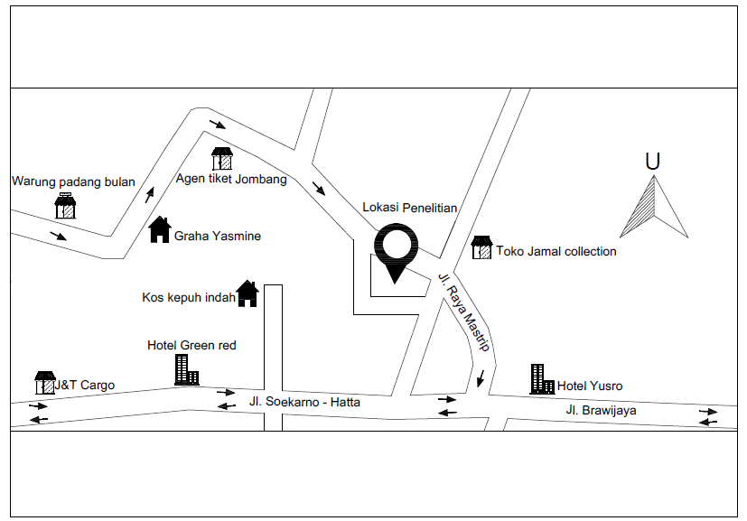
FIGURE 1. Terminal Location Map

Research Flow Framework
The research flowchart is presented in FIGURE 2.

Identification of problems
Data collection
Data Analysis :
- Review the Quality of Technical Services and Terminal Standards
- Analyzing Terminal Service Types with Ministerial Regulation No. 40 of 2015
- Analyzing the Gap Value
- Analyzing Customer Satisfaction Index
- Arrangement of type A terminals in accordance with the regulations of the Republic of Indonesia Law Number 22 of 2009
Results and Discussion
Conclusions and Recommendations
Primary Data :
- Trenggalek Terminal facility data
- Terminal Physical Data
- Questionnaire Data
Secondary Data :
- Trenggalek terminal layout.
- Amount and type of vehicles entering and leaving Trenggalek terminal
- Amount of AKAP & AKDP passengers
FIGURE 2. Flow Diagram

Data collection
To find and solve a problem, data collection is carried out. The supporting data for this analysis serves to assist in compiling research reports. Primary data and secondary data are data that will be used as supporting data for analysis.

Primary Data
Research data comes from original sources or thoughts from individuals or groups (people) or the results of observations and events or test results from an object obtained directly, known as primary data. Including the direct distribution of questionnaires in the field using the direct interview method/filling out of questionnaires containing several statements that have been previously made and then addressed to respondents.

Secondary Data
Other data such as existing books or evidence, or data from related agencies are data sources obtained during research, known as secondary data. The description of secondary data is as follows:
- Layout of the Kepuhsari Jombang terminal
- Number and type of vehicles entering and leaving the Kepuhsari – Jombang terminal.

Data analysis
Analysis of the Kepuhsari Jombang terminal will be processed based on the Regulation of the Minister of Transportation of the Republic of Indonesia Number: 40 of 2015 concerning service standards for organizing road transportation passenger terminals. he importance performance analysis method is used to calculate the performance weight and importance of sub-variables as well as the average value of performance and importance of variables. These service variables and attributes are arranged in the form of a questionnaire and then distributed to respondents.

Discussion
The discussion functions to answer or explain everything in the research accompanied by the data obtained.

Conclusion and Recommendations
After data processing and analysis is carried out, a conclusion will be drawn that answers the objectives of the research.

RESULTS AND DISCUSSION

Population
Population is the initial stage before conducting data collection and analysis. The entire population at the Kepuhsari terminal is 301 people.

Research Sample
A sample is the number and characteristics of a population. [5] The sampling procedure in this final assignment uses the Incidental Sampling technique. So the Slovin formula can be used to determine the number of respondents whose population is already known. According to [6] the following is the sample formula used in the research :

$n=\frac{N}{{Ne}^{2}+1}$
Where:
n = number of samples needed
N = number of population at the terminal
e = tolerable error 10% = 0.1
$$n= \frac{N}{{Ne}^{2}+1}$$
$$n= \frac{301}{{301(0,1)}^{2}+1}$$
$$n= 75,06≈75$$
So the sample required for the research is 75 people.

Terminal Operational Performance Evaluation
The formula used in the analysis to measure the performance of the Kepuhsari Jombang terminal :
- Load factor
$LF= \frac{Vpnp}{TD} X 100$ [7]

Where :
LF = Number of load factors
Vpnp = All passengers
TD = carrying capacity
- Queue time [8]
- The number of intermediate transport values ​​in the system (n).
$n = \frac{ρ}{1 - ρ}$
- The length of the queue is the mean value of transport in the system (q).
$$q = \frac{{ ρ}^{2}}{1 - ρ}$$
- The mean value time of transport in the system (d).
$$d = \frac{1}{µ - λ}$$
- The mean waiting time of a vehicle in the system (w).
$$w = d- \frac{1}{µ }$$
Where :
P = traffic intensity (λ/µ).
µ = average service level
λ = average arrival rate
- Headway
$H= \frac{60.C.Lf}{P}$
Where :
H = Between the bus before and after (minutes).
P = Number of passengers at peak hour
C = Bus volume.
LF = Taken 70% (when conditions are dense).

Load Factor Calculation
TABLE 1. Load Factor Jombang – Malang
No. | Arrival and Departure (hours) | Passengers depart | Capacity | Load Factor
1 | 07:40 | 5 | 37 | 13,5135
1 | 07:45 | 5 | 37 | 13,5135
2 | 08:00 | 5 | 37 | 13,5135
2 | 08:06 | 5 | 37 | 13,5135
3 | 08:24 | 4 | 37 | 10,8108
3 | 08:29 | 4 | 37 | 10,8108
4 | 08:44 | 11 | 37 | 29,7297
4 | 08:49 | 11 | 37 | 29,7297
5 | 09:03 | 3 | 37 | 8,1081
5 | 09:13 | 3 | 37 | 8,1081
6 | 09:22 | 2 | 37 | 5,4054
6 | 09:29 | 2 | 37 | 5,4054
7 | 09:40 | 2 | 37 | 5,4054
7 | 09:45 | 2 | 37 | 5,4054
8 | 10:25 | 0 | 37 | 0
8 | 10:30 | 0 | 37 | 0
9 | 13:26 | 1 | 37 | 2,7027
9 | 13:32 | 1 | 37 | 2,7027
10 | 14:07 | 0 | 37 | 0
10 | 14:12 | 0 | 37 | 0
11 | 14:30 | 1 | 37 | 2,7027
11 | 14:38 | 1 | 37 | 2,7027
12 | 15:20 | 1 | 37 | 2,7027
12 | 15:30 | 1 | 37 | 2,7027

The load factor is presented in TABLE 1.

Arrival Rate Calculation
Calculation of the arrival rate (λ) of buses arriving with an observation time interval of 6 hours.[9]
- Calculation of AKDP buses for the Jombang – Malang route
The number of buses that arrived was 12 bus, as shown in TABLE 2.
λ $=\frac{number of vehicles arriving}{observation time}$
$=\frac{12}{6}$
$=2$ bus/hour

TABLE 2. Bus Arrivals
No. | Route | Arrival rate
No. | Route | bus/hour
1 | Jombang – Malang | 2
2 | Jombang – Tuban | 2
3 | Surabaya – Trenggalek | 1
4 | Surabaya – Tulungagung | 1
5 | Surabaya – Ponorogo | 2
6 | Surabaya – Blitar | 1
7 | Surabaya – Yogyakarta | 2
8 | Surabaya – Semarang | 1
9 | Surabaya – Magelang | 2
10 | Surabaya – Purworejo | 1

Service Level Calculation
The service level is the number of buses that receive service during the observation time at the terminal (µ) with an observation time interval of 6 hours, calculated from 07:30 – 10:30 and 13:00 – 16:00. The SKDP bus service is shown in TABLE 3.
AKDP bus for Jombang – Malang route.

µ $=\frac{number of bus coming}{amount of time in the departure area}$
$=\frac{12}{1,1}$
$=10$ bus/hour
TABLE 3. AKDP Bus Services
No. | Route | Level of service
No. | Route | Bus/hour
1 | Jombang – Malang | 11
2 | Jombang – Tuban | 8
3 | Surabaya – Trenggalek | 17
4 | Surabaya – Tulungagung | 17
5 | Surabaya – Ponorogo | 10
6 | Surabaya – Blitar | 15
7 | Surabaya – Yogyakarta | 10
8 | Surabaya – Semarang | 15
9 | Surabaya – Magelang | 13
10 | Surabaya – Purworejo | 19

Queue Time
Calculation of the queue time for the Jombang – Malang AKDP bus
a. Calculation of traffic intensity (ρ).
ρ $=\frac{λ}{µ}$
ρ $=\frac{2}{10}$
ρ $=0,2$
b. Calculation of the average number of vehicles (n).
n $=\frac{ρ}{1-ρ}$
n $=\frac{0,2}{1-0,2}$
n $=0,25≈1 bus$

- Calculation of the average queue length in the system (q).
q $=\frac{ρ^{2}}{1-ρ}$
q $=\frac{{0,2}^{2}}{1-0,2}$
q $=0,05≈1 bus$

d.. Calculation of the average duration in the system (d).
d $=\frac{1}{µ-λ}$
d $=\frac{1}{10-2}$
d $=0,12 hours≈7,5 minute$

- Calculation of the average waiting duration in the system (w).
w $=d-\frac{1}{µ}$
w $=0,12-\frac{1}{10}$
w $=0,025 hours≈2 minute$

TABLE 4 show the calculation of Time Between Bus
TABLE 3. calculation of Time Between Bus
No | Route | Λ | µ | Ρ | N | Q | D | W
No | Route | Bus/  hour | Bus/  hour | Ρ | Bus | Bus | hour | hour
1 | Jombang – Malang | 2 | 10 | 0,20 | 0,24 | 0,04 | 0,12 | 0,02
2 | Jombang – Tuban | 2 | 8 | 0,25 | 0,33 | 0,08 | 0,17 | 0,04
3 | Surabaya – Trenggalek | 1 | 17 | 0,07 | 0,07 | 0,005 | 0,06 | 0,004
4 | Surabaya – Tulungagung | 1 | 17 | 0,05 | 0,05 | 0,003 | 0,06 | 0,003
5 | Surabaya – Ponorogo | 2 | 10 | 0,20 | 0,25 | 0,05 | 0.13 | 0,02
6 | Surabaya – Blitar | 1 | 15 | 0,07 | 0,07 | 0,005 | 0,07 | 0,005
7 | Surabaya – Yogyakarta | 2 | 10 | 0,20 | 0,25 | 0,05 | 0,13 | 0,02
8 | Surabaya – Semarang | 1 | 15 | 0,07 | 0,07 | 0,005 | 0,07 | 0,005
9 | Surabaya – Magelang | 1 | 13 | 0,08 | 0,08 | 0,006 | 0,08 | 0,006
10 | Surabaya – Purworejo | 2 | 19 | 0,11 | 0,12 | 0,012 | 0,06 | 0,006

Headway
$H= \frac{60.C.Lf}{P}$
H $= \frac{60x37x0,29}{35}$ = 18 minute
Calculation of the headway of the Jombang – Malang AKDP bus is presented in TABLE 5.
- number of passengers (P) = 35 person
- Vehicle capacity (C) = 37 seat
- Load factor (Lf) = 29%

TABLE 5. AKDP Bus Headway Calculation
No. | Trayek | P (person) | C (seat) | LF (%) | H (minute)
1 | Jombang – Malang | 35 | 37 | 29% | 18
2 | Jombang – Tuban | 25 | 37 | 25% | 22
3 | Surabaya – Trenggalek | 27 | 60 | 21% | 28
4 | Surabya – Tulungagung | 19 | 60 | 13% | 24
5 | Surabaya –Ponorogo | 45 | 60 | 28% | 22
6 | Surabaya – Blitar | 25 | 36 | 33% | 28
7 | Surabaya – Yogyakarta | 50 | 55 | 29% | 19
8 | Surabaya – Semarang | 30 | 55 | 25% | 27
9 | Surabaya – Magelang | 27 | 47 | 23% | 24
10 | Surabaya – Purworejo | 18 | 55 | 14% | 25

Terminal Performance Analysis
There are area calculations for the performance of the Kepuhsari Terminal, Jombang City, East Java Province, including: departure area, arrival area, parking area and waiting area for prospective passengers.
Arrival and Departure area
- Arrival
For AKDP buses, there are 9 buses entering the arrival area at the same time, within a period of 1 hour with a maximum of 17 passengers, assuming every 7.5 minutes/vehicle enters 1 lane that serves 2 AKDP buses at the same time, then :
- Number of lines required = 1 line (serves 2 AKDP bus)
- AKDP space requirement = 3.00 m x 5.00 m x 1 lane = 15 m2
- Platform area circulation = 17 people x 1.2 m2 x 1 AKDP lane = 20.4 m2
- So the total arrival area = 15 m2 + 20.4 m2 = 35.4 m2
The required area for the arrival area of ​​AKDP and AKAP buses is 97.1 m2 for the current area of ​​385 m2.

- Departure
For the needs of the AKDP bus departure area, it is assumed that every 7.5 minutes/vehicle 1 route serves 2 AKDP transportation at the same time within a period of 1 hour, then :
- Number of lines required = 1 line (serves 2 AKDP bus)
- AKDP space requirement = 3.00 m x 5.00 m x 1 lane = 15 m2
- Platform area circulation = 17 people x 1.2 m2 x 1 AKDP lane = 20.4 m2
- So the total departure area = 15 m2 + 20.4 m2 = 35.4 m2
The required area for the departure area of ​​AKDP and AKAP buses is 97.1 m2 for the current area of ​​273 m2..

Parking area
For the parking area of ​​the Kepuhsari terminal, Jombang is located south of the arrival area, based on the space requirements in the parking area, it is assumed as follows:

$Z=\frac{Y x D}{T}$
Where :
Z = the amount of stopping space required
Y = vehicle stops for a moment
D = median value of duration (hours)
T = duration of observation (hours)

AKDP Bus
- Z = $\frac{44 x 0,05}{6}$
= 0,3 ≈ 1 plots

AKDP space requirement = 3.00 x 5.00 x 1 plot = 15 m2.
The total area required for AKDP and AKAP bus parking areas is 59 m2 for the current parking area of ​​141 m2.

Waiting Area for Prospective Passengers
The space requirements for the waiting area for prospective passengers are assumed to be as follows:
- Waiting room for prospective AKDP passengers
- The number of AKDP 1 lane with 2 vehicles with a maximum of 17 passengers, so 2 x 17 = 34 people per 5.2 minutes
- The number of assumed introductions is 15%, so 15% x 34 = 5 people
- Seating assuming 39 people, 1/3 using seats with a seating area of ​​(0.24 m^2) and 2/3 standing.
So = (1/3 x 39) x 0,24 $m^{2}$ = 3,12 $m^{2}$ and (2/3 x 39) x 1,12 $m^{2}$ = 29,12 $m^{2}$
The total area required for waiting rooms for prospective AKDP passengers is 3.12 m2 + 29.12 m2 = 32.24 m2
he required area for the arrival area of ​​AKDP and AKAP buses is 97.1 m2 for the current area of ​​186 m2.

Analysis IPA ( Importance Perfomance Analysis )
Importance Performance Analysis has been generally accepted and used in various fields of study because it is then applied and the display of analysis results makes it easier to propose performance improvements [10]. Calculation of the mean value of the satisfaction level using the following formula:

$Xi=\frac{\sum{x}}{n}$
Where:
Xi : mean score on satisfaction
∑x : overall satisfaction score.
n : total respondents.

Attribute 1
- satisfaction level (Xi).
$Xi=\frac{176}{75}$
$Xi=2,3$
- The mean value of the level of satisfaction of all attributes.
$$\overset{̿}{x}= \frac{\sum{xi}}{k}$$
$$\overset{̿}{x}= \frac{47,6}{20}$$
$$\overset{̿}{x}= 2,5$$
Calculation of the mean score of the level of importance using the following formula:
$Yi=\frac{\sum{y}}{n}$
Where :
Yi : middle value of importance score.
∑y : overall importance score.
n : total respondents.

Attribute 1
level of interest (Yi)
$Yi=\frac{350}{75}$
$Yi=4,7$
The mean value of the level of importance of all attributes. While, the satisfaction scores is presented in TABLE 6.
$$\overset{̿}{y}= \frac{\sum{yi}}{k}$$
$$\overset{̿}{y}= \frac{78,7}{20}$$
$\overset{̿}{y}= 4,1$

TABLE 6. Importance and Satisfaction Scores
No. Attribute | Satisfaction Score | Satisfaction Level (Xi) | Importance Score | Level of Interest (Yi)
A1 | 176 | 2,3 | 350 | 4,7
A2 | 210 | 2,8 | 370 | 4,9
A3 | 120 | 1,6 | 347 | 4,6
A4 | 240 | 3,2 | 340 | 4,6
A5 | 177 | 2,4 | 261 | 3,5
A6 | 210 | 2,8 | 348 | 4,6
A7 | 228 | 3,0 | 348 | 4,6
A8 | 226 | 3,0 | 322 | 4,3
A9 | 150 | 2,0 | 324 | 4,3
A10 | 127 | 1,7 | 260 | 3,5
A11 | 155 | 2,1 | 230 | 3,1
A12 | 241 | 3,2 | 275 | 3,7
A13 | 135 | 1,8 | 195 | 2,6
A14 | 195 | 2,6 | 340 | 4,5
A15 | 192 | 2,6 | 294 | 3,9
A16 | 200 | 2,7 | 296 | 3,9
A17 | 138 | 1,8 | 224 | 3,0
A18 | 149 | 2,0 | 250 | 3,3
A19 | 139 | 1,9 | 295 | 3,9
A20 | 160 | 2,1 | 230 | 3,1
Total | 3568 | 47,6 | 5899 | 78,7
Average |  | 2,5 |  | 4,1

The following formula is used [11]:
Tki $= \frac{xi}{yi}x 100\%$
Where :
Tki : Level of conformity .
xi : The mean score of the level of satisfaction for each attribute.
yi : The mean value score of the level of importance of each attribute
The following is an example of manual calculation:
Attribute 1
Tki $= \frac{xi}{yi}x 100\%$
Tki $= \frac{2,3}{4,7}x 100\%$
Tki $= 49,93 \%$

The following TABLE 7 is a conformity level results:
Table 7. Level of Conformity
No. Attribute | Satisfaction Level  ( Xi ) | Level of Interest ( Yi ) | Level of Compliance  ( Tki )%
A1 | 2,3 | 4,7 | 48,94 %
A2 | 2,8 | 4,9 | 57,14 %
A3 | 1,6 | 4,6 | 34,78 %
A4 | 3,2 | 4,5 | 71,11 %
A5 | 2,4 | 3,5 | 68,57 %
A6 | 2,8 | 4,6 | 60,87 %
A7 | 3 | 4,6 | 65,22 %
A8 | 3 | 4,3 | 69,77 %
A9 | 2 | 4,3 | 46,51 %
A10 | 1,7 | 3,5 | 48,57 %
A11 | 2,1 | 3,1 | 67,74 %
A12 | 3,2 | 3,7 | 86,49 %
A13 | 1,8 | 2,6 | 69,23 %
A14 | 2,6 | 4,5 | 57,78 %
A15 | 2,6 | 3,9 | 66,67 %
A16 | 2,7 | 3,9 | 69,23 %
A17 | 1,8 | 3 | 60,00 %
A18 | 2 | 3,3 | 60,61 %
A19 | 1,9 | 3,9 | 48,72 %
A20 | 2,1 | 3,1 | 67,74 %
Average |  |  | 64,55 %
Assessment criteria :
81,26 – 100 = it`s really satisfying
62,51 – 81,25 = quite satisfying
43,76 – 62,50 = less satisfying
25,00 – 43,75 = not satisfying
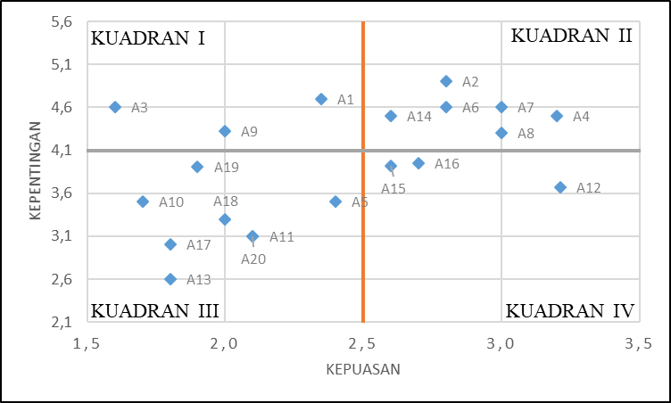
FIGURE 3. Cartesian Diagram

FIGURE 3 shows the cartesian diagram of assessment criteria:
quadrant I (one) has the importance of service at the top with satisfaction at the bottom
quadrant II (two) has the importance of the highest service with the highest level of satisfaction.
quadrant III (three) having the lowest level of service importance and with the lowest level of satisfaction,
quadrant IV (four) has the lowest importance of service with the highest level of satisfaction.

Jombang City Terminal Development Plan
In quadrant I there are indicators that are very important or crucial for development.
- Attribute 1 (Road safety facilities).
At the Kepuhsari terminal in Jombang City, there needs to be signs and directions that are used to provide information on the position of the terminal entrance/exit, drop area, parking area, and no parking signs.
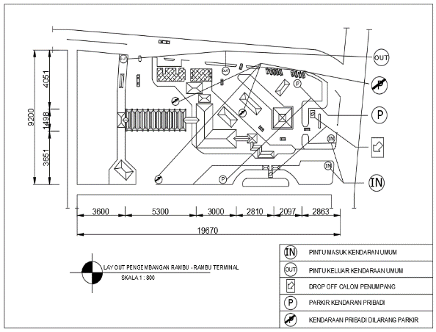
FIGURE 4. Layout of Terminal Sign Development

- Attribute 3 (Facilities and information for roadworthiness inspection and repair of public vehicles).
The terminal needs special facilities to periodically check the roadworthiness of public transportation, so it is necessary to add complete repair facilities in good condition and officers to check the roadworthiness of public transportation.

- Attribute 9 (Bus departure, arrival and fare schedules).
To help make it easier for terminal service users to find out all routes, schedules and bus fares that will enter the terminal. Therefore, it is necessary to add media in the form of digital signage to provide information that can make it easier to convey information.

CONCLUSIONS
From the results of the performance evaluation and development plan, the following conclusions were drawn :
a. The performance of the Kepuhsari bus terminal in Jombang City, East Java Province, based on research results, shows that the load factor of the Kepuhsari terminal is not overloaded, the time with the middle value of the bus in the system is 9 minutes, the waiting time for passengers with the middle value is 2 minutes, headway of each bus with a mean value of 24 minutes and all bus routes have a value of ρ > 1, there will be no bus queue (infinite), The area requirements for the arrival area, departure area, parking area, waiting area for prospective passengers at the Kepuhsari terminal can accommodate AKDP/AKAP buses and prospective public transportation passengers.
b. The service performance at the Kepuhsari terminal obtained a value of 64.55% for all attributes, which means that the current condition, seen from the quality of terminal services, is in the (satisfying) category.
c. Of the 20 attributes in the Cartesian graph, 3 attributes are obtained which are located in quadrant I, namely the availability of signs, road markings, street lighting and fences, facilities and equipment to carry out minor repairs on public vehicles and areas to carry out roadworthiness checks. Availability of transportation schedules upon arrival and departure in general and written acknowledgement.
d. At the terminal there is service performance that needs to be developed to maintain order, security and comfort for users of the Kepuhsari terminal services in Jombang City.

Suggestion
For Terminal Managers
Terminal management needs to evaluate service performance every 10 years to maintain order and comfort. With this evaluation, the management can more easily know what is prioritized in developing services at the Kepuhsari terminal, Jombang. Need to add information boards with schedules for all routes and fares.. Security personnel outside the area around the terminal need to be tightened again in order to regulate public transportation with the aim of maintaining optimal arrival and departure rates and smooth traffic flow.
For the Community
Optimally, Kepuhsari Terminal, Jombang City requires awareness for all people who want to use public transportation for arrival and departure activities to be carried out in the terminal if the initial departure or destination radius is less than 1 kilometer.

Reference
1. D. of the M. of T. of the R. of I. N. K. 31., “Concerning Road Transportation Terminals,” Jakarta, 1995.
2. R. of the M. of T. of the R. of I. N. P. 40, “Service Standards for the Implementation of Road Transportation Passenger Terminals.,” Jakarta, 2015.
3. R. of the M. of T. of the R. of I. N. P. 24, “Implementation of Road Transportation Passenger Terminals,” Jakarta, 2021.
4. A. Y. Abubakar Iskandar, “Towards Orderly Traffic and Road Transportation,. Directorate General of Land Transportation,” Jakarta, 1997.
5. Sugiyono, “Quantitative, Qualitative and RND Research Methods,” Bandung, 2013.
6. Algifari, “Measuring Service Quality with Satisfaction Index, Importance-Performance Analysis (IPA) Method and Kano Model,” Yogyakarta: Bhakti Profesindo Yogyakarta Publisher, Yogyakarta, 2009.
7. T. S. P. Arifin and D. E. Intari, “Analisis Kinerja Operasional Terminal,” J. Fondasi, vol. 6, no. 2, pp. 1–12, 2017.
8. T. Y. Astanto, B. S. Waloejo, and D. M. Utomo, “Evaluasi Kinerja Operasional dan Kinerja Pelayanan Terminal Kertonegoro Kabupaten Ngawi,” Plan. Urban Reg. Environ., vol. 8, no. 1, pp. 65–76, 2019, [Online]. Available: https://purejournal.ub.ac.id/index.php/pure/article/view/369/301
9. J. H. Frans and E. Hunggurami, “Evaluasi Dan Pengembangan Kapasitas Terminal Bus Kota Kupang,” J. Tek. Sipil, vol. 6, no. 2, pp. 129–142, 2017.
10. C. . Martinez, “Evaluation Report: Tools Cluster Networking Meeting,” Arizona, 2003.
11. A. Bakhtiar, “Kajian Efektifitas Operasional Terminal Hamid Rusdi Malang,” J. Rekayasa Sipil, vol. 8, no. 167, pp. 707–715, 2020, [Online]. Available: https://scholar.google.com/scholar?q=related:bx9mF8FFTikJ:scholar.google.com/&scioq=hamid+rusdi&hl=id&as_sdt=0,5&as_ylo=2020

