Arch Bridge Structure Behavior with Tied Arch Models
(Case study on Bridge Model Simulation with 4 meters Span)
Maghfiroh Dwi Rizkayanti^{a)}, Muh. Iqbal Alfi Rohmatik^{b)}, Abdul Malik^{c)},
Moh. Abduh^{d)}, and Faris Rizal Andardi^{e)}
Department of Civil Engineering, Universitas Muhammadiyah Malang, Malang, Indonesia

^{d)} Corresponding author: abduh@umm.ac.id
^{a)} dwirizka2018@gmail.com
^{b)} iqbal.alfi85@gmail.com
^{c)} cayorealme63@gmail.com
^{e)} farisrzl@umm.ac.id
Abstract. The design of a 4-meter span arch bridge requires in-depth analysis to ensure the stability and efficiency of the structure in supporting the applied loads. The main challenge is to determine the optimal design in accordance with technical specifications and safety standards. This study aims to design a 4-meter span arch bridge that meets safety standards and structural efficiency. The methodology includes a literature review and model simulation to determine the most efficient arch profile. Load data and material parameters were collected and tested using structural analysis software. The results were verified by comparing the simulation outcomes with relevant literature and design standards. The study showed that the parabolic arch profile provides a more uniform stress distribution compared to the semi-elliptical profile. High tensile strength steel was proven to be more efficient in reducing maximum deflection in the bridge span. The use of additional supports at specific points also significantly reduced bending. The proposed design successfully meets the safety and efficiency criteria in accordance with bridge design standards. The proposed design of a 4-meter span arch bridge offers an effective and safe solution in line with current bridge design standards.
Keywords: Simulation, bridge, arch, model, behavior

INTRODUCTION
Indonesia is an archipelagic country where two-thirds of its territory consists of the sea, which amounts to approximately 3,25 million km2 [1]. Based on Indonesia's geographical conditions, which are separated by rivers, valleys, straits, and others, this can become an obstacle for the development of certain areas due to limited infrastructure [2]. The need for bridge infrastructure is crucial as a connector between regions, so it is expected to accelerate regional development and improve accessibility. In order to achieve equitable national development, it is necessary to provide national infrastructure in the form of bridges to facilitate mobility from one region to another. Innovation in bridge design that is strong, effective, and easy to implement is required.
A bridge is part of road infrastructure that functions to cross rivers, valleys, or straits, allowing regions to be connected and not isolated. [3]. A bridge must be designed to be robust and optimized in terms of strength, durability, operational costs, and architectural value. An Arch Bridge, or Tied Arch Bridge, is designed with an arch shape to reduce the moment on the bridge, making the use of hot-rolled steel more efficient compared to parallel girders. Bridge infrastructure plays a key role in accelerating the economic and social development of a region, especially in an archipelagic country like Indonesia, which has many rivers, valleys, and straits [4]. A well-designed bridge enables better mobility, reduces isolation, and supports regional economic growth [5].
The arch bridge design offers advantages in reducing bending moments, making it more efficient in using materials such as hot-rolled steel. This design allows for a robust and durable bridge while maintaining a high aesthetic value [6]. Hot-rolled steel is chosen as a construction material due to its strength, durability, and high design flexibility, making it efficient and economical for short spans [7]. Structural analysis and load simulation are crucial steps to ensure the stability and safety of a bridge without excessive deformation [8]. Additionally, integrating local cultural elements into the architectural design is important to make the bridge a symbol of regional identity [9]. The use of Indonesian cultural decorative elements enhances aesthetic value and fosters local pride. Thus, this arch bridge not only meets infrastructure needs but also contributes to the social and cultural development of the region.

METHODS
In this study, several methods were used to plan an arch bridge model that complies with technical requirements and planned specifications. With a literature review as the initial planning step, the data used as references were obtained from various sources, including the 2024 Indonesian Bridge Competition (KJI) guideline book, SNI 1725:2016, and SNI 1729:2020. The data from these sources includes technical information for bridge planning, such as span length, bridge width, bridge height, as well as loading requirements and bridge assembly specifications. This data was then used in numerical model simulations to determine the deflection values for the planned bridge configuration, followed by cross-section analysis that includes internal force analysis such as tension, compression, shear, and moments.
Controlling the tension members in a bridge is crucial to ensure that the structural elements subjected to tension can withstand the applied tensile forces without experiencing deformation or failure. The control for tension members is explained with Equation 1 for slenderness, Equation 2, and Equation 3 for tensile yield and tensile failure.
$\frac{K×L}{r}≤$ 300 (1)
φ$P_{n}$ = φ$F_{y}$Ag ≥ $P_{u}$ (2)
φ$P_{n}$ = φ$F_{u}$Ae ≥ $P_{u}$ (3)
Compression members function to transmit loads from the upper part of the bridge to the supports or foundation. By controlling the compression members, we can verify their strength and stability, preventing structural failures such as buckling, which could threaten the safety of the bridge and its users. This control is explained in Equation 4 and Equation 5.
$\frac{Lc}{r} ≤200$ (4)
φ$P_{n}$ = φ$F_{cr}$Ag ≥ $P_{u}$ (5)
Shear occurs when horizontal forces cause a shift or displacement between structural elements. By performing shear control, potential damage that could affect the strength and integrity of the bridge can be identified and prevented. Shear control is done using Equation 6.
$V_{n}$ = 0.6$F_{y}$ Aw Cv2 ≥ $V_{u}$ (6)
Excessive moments can cause significant deformation and even structural failure. By performing moment control, the safety and stability of the bridge can be maintained in the long term. This control uses Equation 7 and Equation 8.
$\frac{b}{t}≤$ 0,45$\sqrt{\frac{e}{fy}}$ (7)
$M_{n}$ = (1,92-1,17$\sqrt{\frac{My}{Mcr}}$) $M_{y}$) ≥ $M_{u}$ (8)
Steel cables or wire ropes are crucial elements widely used in various lifting and pulling operations. Additionally, these steel cables play a vital role in bridge construction, especially in supporting loads and maintaining structural stability [10]. In the use of wire ropes, it is essential to calculate the safe working load that the wire rope can withstand. This safe working load calculation uses Equation 9.
SWL = $\frac{B}{S}$ : Sin ∅ $F_{p}$ (9)
The selection of wire rope size is generally done by considering the weight of the load it must support [11]. This is important because the diameter of the wire serves as an indicator of the rope's strength, with larger sizes allowing it to support heavier loads. To ensure that the rope size used can handle the required load and its capacity, calculations using Equation 10 are necessary.
WLL = $\left(\frac{d^{2}π}{4}\right)SWL . K$≥ $P_{u}$ (10)

RESULTS AND DISCUSSION

STRUKTURAL SYSTEM
In accordance with the regulations outlined in the 2024 Indonesian Bridge Competition (KJI) Guidelines, Sasirangan Bridge designed using the main structural system of the bridge, which is the arch (tied arch bridge), that functions to reduce bending moments and acts as a member receiving compressive forces. The compressive forces are transmitted to the abutments through hangers, which are sling cables, due to the loads received by the substructure. The configuration of the bridge can be seen in FIGURE 1.

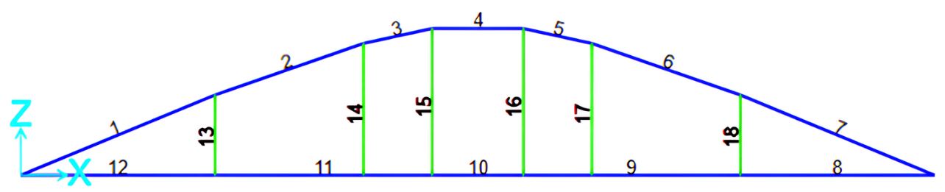
FIGURE 1. Configuration of the “Sasirangan Bridge” Structure

STRUCTURAL MODELING
In structural modeling, the elements of the structural system (such as members and cables) are modeled using software to determine the load-bearing capacity of the designed structural cross-sections. The modeling of the Sasirangan Bridge configuration is represented in three dimensions (3D), as shown in FIGURE 2. The bridge specifications are detailed in TABLE 1.
TABLE 1. Specifications of the “Sasirangan Bridge”
Component | Description
Support | Pinned - Roller
Specifications | Bottom girder | : Double angle profile 45$×22,$5$×$2 mm
Specifications | Arch member | : Double angle profile 45$×22,$5$×$2 mm
Specifications | Cross member | : Hollow 15$×30×$1 mm
Specifications | Wind bracing | : Hollow 15$×30×$1 mm
Specifications | Cable element | : Galvanized wire rope
Floor plate | Multiplex 3 mm

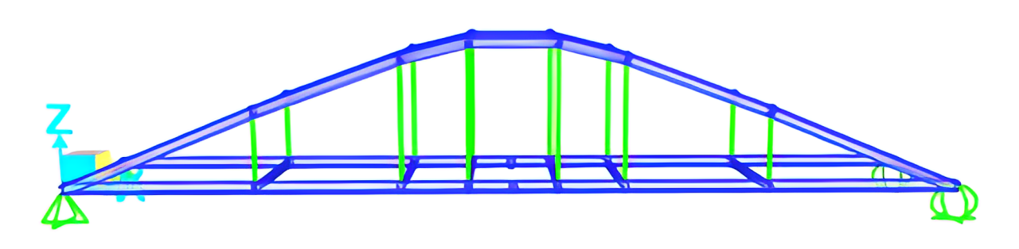
FIGURE 2. 3D Model

LOAD ANALYSIS
In planning a bridge, one of the key considerations is the issue of applied loads. The loads applied to the “Sasirangan Bridge” are based on the 2024 Indonesian Bridge Competition (KJI) guideline book and SNI 1725:2016 [11]. The results of the load analysis are summarized in TABLE 2.
TABLE 2. Load Data for the Arch Bridge Model
Type of Load | Description | Factor | Weight (kg) | Total weight
Dead Load | Structural load | 1,1 | 38,58 | The total weight of the “Sasirangan Bridge” model is 55,53 kg
Dead Load | Bridge connection load | 1,1 | 7,72
Dead Load | Floor plate load | 1,4 | 2,88
Dead Load | Ornamental load | 2,0 | 2,50
Dead Load | Finishing load | 2,0 | 3,86
Live Load | Test load | 1,8 | 250,00 | Total test load of 250,00 kg

DEFLECTION ANALYSIS
Based on the model analysis results, the maximum deflection obtained is 2.48 mm. The allowable maximum deflection or permitted deflection according to the guidelines in the 2024 Indonesian Bridge Competition (KJI) guideline book is 5 mm (L/800), and the target deflection is 3.00 mm. Thus, this bridge model complies with the existing regulations. The deflection of the model is shown in FIGURE 3.

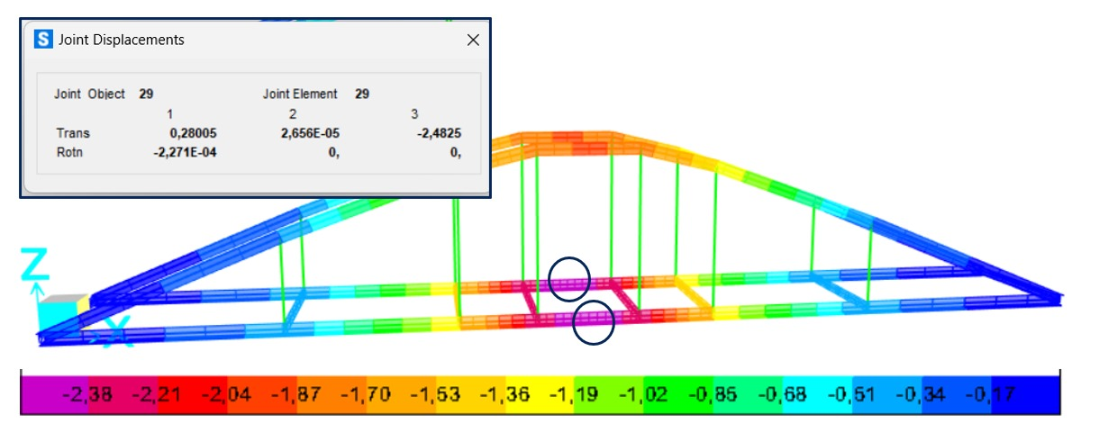
FIGURE 3. Deflection results

From the simulation and analysis results obtained, the bridge structure design has met the applicable requirements for this competition. The deflection produced, based on the analysis and loading, is close to the target deflection value, and the maximum deflection occurs at the midpoint of the bridge span.

ANALYSIS OF STRUCTURE
Based on the predetermined configuration, the next step is to analyze it to determine the strength of the designed bridge. The profile dimensions used in the “Sasirangan Bridge” model are the results of the preliminary design conducted through model analysis with the aid of software. The description of the analysis for the “Sasirangan Bridge” model refers to SNI 1729:2020 [12].
TABLE 3 Tension Member Calculation Results
Item | Description |  | Control
Slenderness | 89,35 ≤ 300 |  | OK
Item | ∅ Pn (kg) | Pu (kg) | ∅ Pn ≥ Pu
Tensile yield | 7752,98 | 411,79 | OK
Tensile failure | 7619,73 | 411,79 | OK

If a tension member fails or is damaged, it can lead to local or even total collapse of the bridge, potentially resulting in accidents and significant losses. The calculation results can be seen in TABLE 3.
The control results from Equation 4 and Equation 5 are explained in TABLE 4.
TABLE 4. Compression Member Calculation Results
Item | Description |  | Control
Slenderness | 86,47 ≤ 200 |  | OK
Item | ∅ Pn (kg) | Pu (kg) | ∅ Pn≥ Pu
Compressive Strength | 5301,14 | 488,08 | OK

Without adequate control, shear can result in serious damage such as cracking or structural failure. The results from the control using Equation 6 are detailed in TABLE 5.
TABLE 5. Shear Force Calculation Results
Item | Vn (kg) | Vu (kg) | Vn ≥ Vu
Nominal shear | 2130,31 | 22,27 | OK

The results of the moment control calculations for the bridge model can be seen in TABLE 6.
TABLE 6. Moment Calculation Results
Item | Description |  | Control
Width ratio-to-thickness | 3 ≤ 12,99 |  | OK
Item | Mn (kg.mm) | Mu (kg.mm) | Mn ≥ Mu
Nominal moment | 67162,05 | 3422,52 | OK

CONNECTION DESIGN
In planning connections, it is important to perform strength control and analyze bolt requirements [13]. The following are the connection strength control and bolt requirements analysis, as explained in TABLE 7 and TABLE 8.
TABLE 7. Connection Calculation Results
Bolt Strength Control
Item | Reference | Requirements | ∅Rn (kg) | Pu (kg) | ∅ Rn ≥ Pu
Tensile capacity | SNI 1729: 2020 J3.6 | ∅Rn = ∅ Fnt Ab ≥ Pu | 2384,35 | 425,90 | OK
Shear capacity | SNI 1729:2020 J3.6 | ∅Rn = ∅ Fnv Ab ≥Pu | 1430,61 | 425,90 | OK
Tear capacity | SNI 1729:2020 J3.10 | ∅Rn= ∅1,2 𝑙c t Fu≥ Pu | 1629,89 | 425,90 | OK
Bearing capacity | SNI 1729:2020 J3.10 | ∅Rn= ∅ 2,4 d t Fu≥ Pu | 1086,59 | 425,90 | OK
TABLE 8. Connection Requirements and Geometry Design
Item | Reference | Requirements | Description
Bolt requirements | SNI 1729:2020 J3 | $$\frac{Pu}{Minimum Capacity}$$ | $\frac{Pu}{Bearing capacity}$ = $\frac{411,79}{1086,59}$ = 0,379  Two bolts are used
Bolt spacing | SNI 1729:2020 J3 | 3db < S < 200  24< 30 mm < 200
Edge distance | SNI 1729:2020 J3 | 1,5db < S < 150  12< 15mm < 150
TABLE 9. Cable calculation results
Item | WLL (kg) | Pu (kg) | WLL ≥ Pu
Cable breaking capacity | 328,11 | 100,08 | OK
According to the analysis results outlined in TABLE 7, the control results in the connection design meet the requirements, where the applied forces are still smaller than the load-bearing capacity of the plate with bolts as shown in TABLE 8, indicating that it is strong and meets the requirements. Similarly, the geometry of the connection design, with a formation that complies with the requirements for bolt spacing, bolt-to-edge distances, and others, also meets the standards as shown in TABLE 9.

CONCLUSIONS
The design of the “Sasirangan Bridge” arch model complies with and refers to the 2024 Indonesian Bridge Competition (KJI) guidelines. The design theme is “Design and Build a Robust and Optimal Bridge Considering Local Wisdom.” For the robust “Sasirangan Bridge” arch model, a double angle profile with dimensions of 22.5×45×2 mm is used for the main structure, and transverse members use a hollow profile of 3×15×1 mm, designed to support an even distribution of loads. Additionally, 4 mm Galvanized Wire Rope is used to provide structural support and safety. Analysis results show that the deflection is 2.48 mm, which is below the allowable deflection, indicating that the structural performance meets safety and stability standards, and the structural members are optimized. The “Sasirangan Bridge” arch model has a weight of 55.534 kg.

Acknowledgments
With deep gratitude, the author wishes to thank all parties who have provided support and facilities in the completion of this work, especially to the university and faculty leaders, the lecturers in the Civil Engineering Program, and all members of the Surya Team at Muhammadiyah University of Malang for their support and cooperation during the research process, as well as the mentors for their guidance, motivation, and invaluable support in completing this work in a better and more meaningful way.

References

1. Hayyin, A., SENTRI: Jurnal Riset Ilmiah. SENTRI: Jurnal Riset Ilmiah, 2023. 2(4).
2. Putri, W. and S. Samadi, ANALISIS HAMBATAN INFRASTRUKTUR DI KEPULAUAN NUSA TENGGARA TIMUR: MENDORONG PEMBANGUNAN WILAYAH YANG BERKELANJUTAN. 2024.
3. Aldillah, D., Fungsi Infrastruktur Jembatan Bagi Perubahan Masyarakat Kelurahan Lempake Kecamatan Samarinda Utara. Journal Sosiatri-Sosiologi, 8 (1), 2020: p. 72-86.
4. Chu, L., et al., Assessing the impact of bridge construction on the land use/cover and socio-economic indicator time series: A case study of Hangzhou Bay Bridge. GIScience & Remote Sensing, 2021. 58(2): p. 199-216.
5. Nugraha, A.T., et al., The Role Of Infrastructure In Economic Gro\Tth And Income Inequality In Indonesia. Economics & Sociology, 2020. 13(1): p. 102-115.
6. Mei, L. and Q. Wang, Structural optimization in civil engineering: a literature review. Buildings, 2021. 11(2): p. 66.
7. Aprianto, M.C., Perlakuan Panas dan Celup Cepat (Quenching) untuk Meningkatkan Sifat Mekanik pada Baja Ringan G550. JURNAL FLYWHEEL, 2022. 13(2): p. 53-62.
8. Bathista, M.D., R.I. Sulasmono, and P. Risdanareni, Optimization of Hanger Spacing of Steel Arch Bridges Using Dynamic Loads. INERSIA lnformasi dan Ekspose Hasil Riset Teknik Sipil dan Arsitektur, 2024. 20(1): p. 86-96.
9. Permatasari, R.C., S.M. Wardhana, and Y.N. Utomo, Local cultural identity representation at the Yogyakarta International Airport gate. Dewa Ruci: Jurnal Pengkajian dan Penciptaan Seni, 2023. 18(2): p. 113-122.
10. Nurdin, I., et al., Analisis Kekuatan Tali Baja (Wire Rope) Dalam Penggunaan Alat Angkat Keranjang (Basket) Peralatan: Tali Baja. Jurnal Rekayasa Mesin dan Inovasi Teknologi, 2023. 4(1): p. 235-245.
11. Indonesia, S.N. and B.S. Nasional, Pembebanan untuk jembatan. SNI, 2016. 1725: p. 2016.
12. Nurjaman, H.N. Beban desain minimum dan kriteria terkait untuk bangunan gedung dan struktur lain. BSN.
13. Paisal, P., Analisis Kekuatan Sambungan Baut Yang Searah Dan Melintang Gaya Batang. Journal Mechanical Engineering, 2023. 1(1): p. 42-47.

