Reservoir Area Arrangement to Reduce Land Erosion with Green Belt Implementation (Case Study: Kesi Dam, NTB)
Dandy Achmad Yani^{1,a)}, Suwignyo^{1,b)}, Azhar Adi Darmawan^{1,c)}, Sulianto^{1,d)}, Ernawan Setiyono^{1,e)}, and Khoirin Nissa^{2,f)}
¹Civil Engineering Department, University of Muhammadiyah Malang, Malang, Indonesia
²Magister Student of Water Resources Engineering Department, Brawijaya University, Malang, Indonesia

^{a)} Corresponding author: dandyachmad@umm.ac.id
^{b)} suwignyo@umm.ac.id
^{c)} azharadidfts@umm.ac.id
^{d)} sulianto@umm.ac.id
^{e)} ernawan_s@umm.ac.id
^{f)} khoirinnissa26@gmail.com
Abstract. Dam area planning is needed to maintain the sustainability of the reservoir function. The problem that often occurs in the dam area is erosion on land that causes shallowing in the reservoir. The easiest technical approach to apply is improving land use cover, such as reforestation and land conservation. Reforestation or agroforestry can be implemented intensively depending on the characteristics of the land to be planted. This is because the type of plant chosen must be by the characteristics of the land, both in terms of soil type and slope. The results of this study explain that plants with deep roots, low evapotranspiration, and are already known by the community can be selected. Implementing planned area planning can reduce erosion on land by up to 75.906%.
Keywords: Green Belt, Kesi Dam, Erosion, Sedimentation

INTRODUCTION
Watershed sustainability (DAS) plays a significant role in maintaining the balance of water quality and quantity [1]. As the population increases and land conversion increases, the distribution of vegetation or plant types that can support water absorption is decreasing[2], so surface runoff will have an erosion impact on the land[3]. Erosion on land can cause sedimentation in reservoirs[4]. The condition of sediment entering the reservoir from upstream due to changes in land cover can threaten the stability of the dam, so it is crucial to monitor the accumulation of the amount of incoming sediment[5].
In Indonesia, reservoir sedimentation has emerged as a prevalent issue, warranting significant attention due to its associated risks, particularly the impact on the reservoir's lifespan and functionality[6]. Addressing sedimentation requires both technical and non-technical strategies, which can generally be categorized into four main activities: reducing upstream erosion, minimizing the sediment load entering the reservoir (preventive measures), minimizing sediment deposition within the reservoir, and removing accumulated sediment (corrective measures)[7]. According to previous studies [8] the application of green belts can protect the upstream area and the area around the reservoir from human activities that can cause erosion. Human activities are vulnerable to land clearing, so one effort to suppress it is by implementing green belts[9].
This study aims to analyze the problems of the dam area and design the arrangement of the area using green belts. The issues of the dam area studied will focus more on restoring protected areas upstream of the dam to prevent erosion and the arrangement of the reservoir boundary area with green belts to reduce sedimentation in the reservoir. The strategy concept applied is through the rehabilitation of forest areas based on conservation[3] and anticipating environmental degradation in the reservoir border zone[8].

METHOD
Geographically, the Kesi Dam is located at 118°11'34" E and 8°31'23" S. Administratively, it is located in the Bonto watershed, specifically in Tolokalo Village, Kempo District, Dompu Regency. The water catchment area spans 1,105 hectares, with an inundation area reaching 9.75 Ha (FIGURE 1). Meanwhile, FIGURE 2a and FIGURE 2b show changes in land use cover from 2011 to 2020 in the Kesi Dam catchment area.

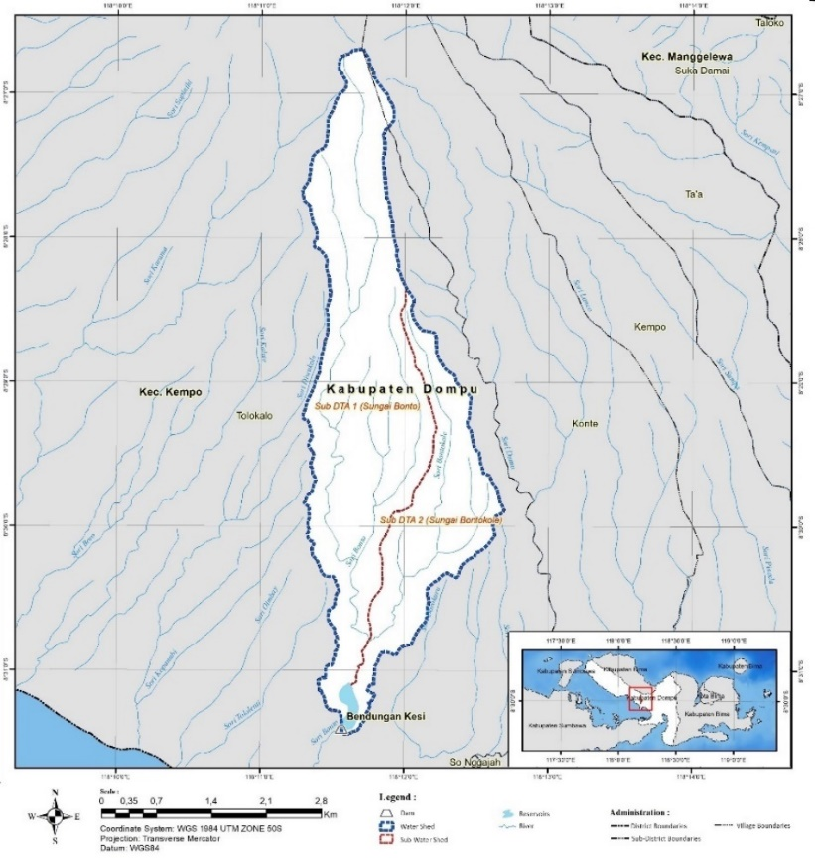
FIGURE 1. Kesi Dam Catchment Area

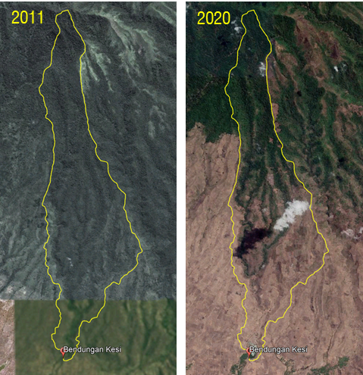
 | (a) | (b)
FIGURE 2. Land use cover conditions in 2011 (a) and 2020 (b)

The data used in this study are secondary data obtained from service provider consultants and the Nusa Tenggara I River Basin Office, consisting of: land use and reservoir area maps, water catchment area maps, site plans, and Kesi Dam sedimentation data. The steps required in this study can be seen in FIGURE 3.

FIGURE 3. Design Steps for Layout of Kesi Dam Area.

In FIGURE 3 data collection activities is aiming to not only inventory, also conducted initial studies and evaluations related to secondary data collected. The data is analyzed to find out the problems of the area in detail in the Kesi Dam. So, the concept and strategy of the area problems can be described and compiled. The design of the area arrangement, of course, still considers the existing landscape conditions of the dam [8].

RESULTS

REGIONAL PROBLEM ANALYSIS
Kesi Dam is a multipurpose dam for irrigation, raw water, and livestock. However, over time, several problems have arisen concerning the conditions in the reservoir and the surrounding area. FIGURE 4 shows the potential and problems of the Kesi Dam area. Changes in land use such as in FIGURE 2a, cause erosivity in the Kesi Dam catchment area with a very heavy category (178.26 tons/ha/year), especially in open land (FIGURE 5). Currently, the reservoir is experiencing shallowing due to quite large sedimentation due to the inflow of water (FIGURE 6a) from the upstream direction and land erosion on the reservoir boundary. The results show that sedimentation that occurs in the Kesi Dam reaches 0.54 mm/year with a concentration distribution as in FIGURE 6b and will continue to experience additional sediment reaching 0.41 meters for the next five years (FIGURE 6c) and an additional 0.78 meters for the next ten years (FIGURE 6d). This results in a decrease in the effective reservoir capacity[5].

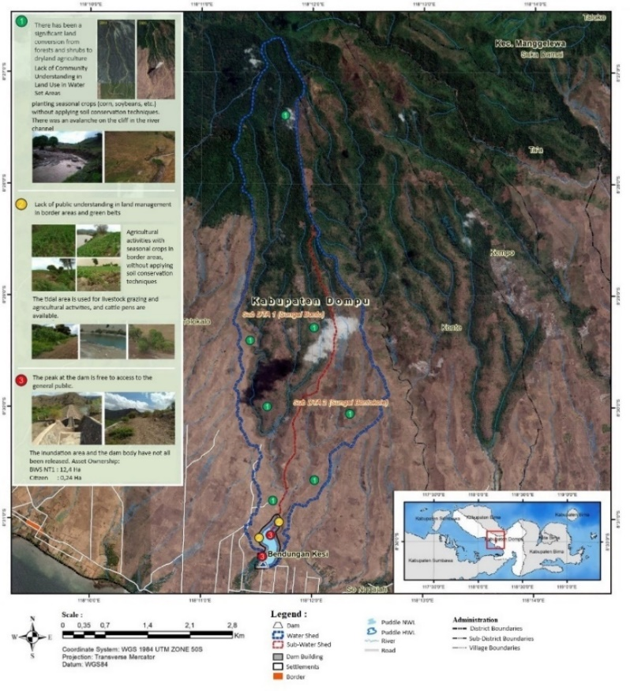
FIGURE 4. Map of Potential and Problems of the Kesi Dam Area

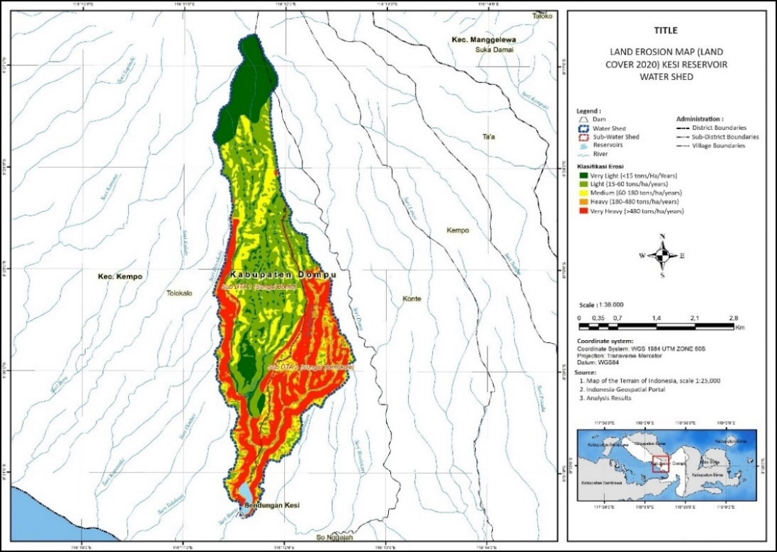
FIGURE 5. Land Erosion Map (Land Cover 2020)

(a)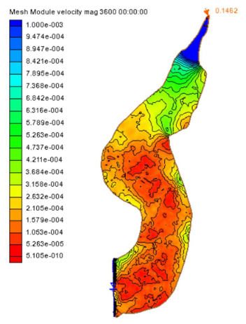 | (b)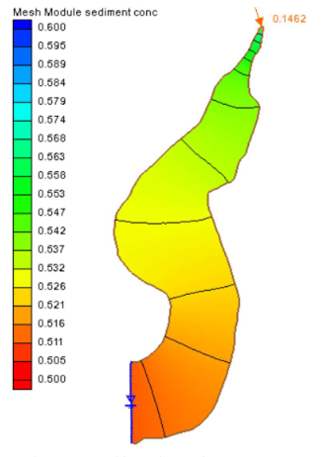
(c)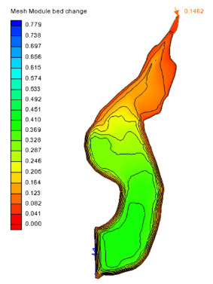 | (d)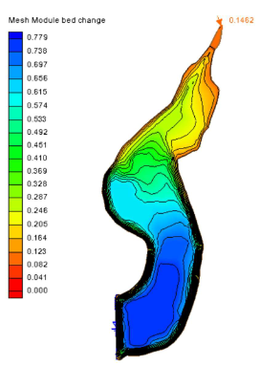
FIGURE 6. Sedimentation Conditions in Kesi Reservoir. Distribution of flow velocity in the last period (a), sedimentation conditions in the last period (b), projection of sedimentation conditions in 5 years (c), and projection of sedimentation conditions in 10 years (d)

Meanwhile, in the problem of the existing boundaries and green belt of the Kesi Dam, the most influential factor is human activity, such as the community's understanding that does not fully understand the boundaries of the boundaries and green belt, planting the green belt area with inappropriate plants, and the use of the reservoir boundaries that are not by applicable regulations. This could be because knowledge about green belt regulations has not fully reached the general public[9].

AREA ARRANGEMENT STRATEGY
Based on the results of the problem analysis, a matrix of regional planning strategies can be proposed in TABLE 1 below:
TABLE 1. Matrix of Proposed Area Arrangement Strategies
Areas | Main Problem | Strategy | Work program
Reservoir Catchment Area | - Conversion of forest areas and significant changes in land use.  - Erosion that occurs on land | - Restore the function of protected forest areas and production forests.  - Land conservation based on slope class | - Intensive reforestation pattern for protected forests and agroforestry pattern for production forests.  - Reforestation with agroforestry patterns, implementation of bench terraces, and application of credit terraces.
Borders and Green Belts | - The use of the green belt of the Kesi reservoir is not in accordance with its intended purpose, such as dry crop farming by the community.  - Border use does not comply with applicable regulations | - Restore the function of the green belt with recommended plants  - Protect the green belt area with appeals.  - Control agricultural activities in border areas.  - Management of agricultural land by applying conservation techniques. | - Intensive pattern reforestation in the green belt area.  - Installation of asset limit boards and information/admonition boards.  - Reforestation of agroforestry patterns and installation of information/admonition boards.  - Formation of community groups and holding reservoir communication forums

Reforestation should be carried out according to the characteristics of the land[3]. Regulations on the types of plants and the number of trees planted are regulated in the "Regulation of the Minister of Environment and Forestry Number 23 of 2021 concerning the Implementation of Forest and Land Rehabilitation". The types of trees and the number of plantings for each reforestation pattern for protected forests, production forests, border areas green belts, and other use areas vary as explained in TABLE 2.

Table 2. Types of Trees and Number of Trees that Need to be Planted Based on Reforestation Patterns
Areas | Region | Reforestation Patterns | Plant Type | Amount | Planting Distance | Wide Application
Water Catchment Area | - Protected forest  - Production Forest  - Community Forest (HKm)  - Other Use Areas | Intensive  Intensive  Agroforestry  Agroforestry | (Tetramales nudiflora), (Duabanga moluccana), (Toona sureni), (Aleurites moluccana)  (Duabanga moluccana), ( Tectona grandis ), ( Dalbergia latifolia ), ( Swietenia macrophylla )  (Ceiba pentandra), (Anacardium occidentale), (Moringa oleifera), (Mangifera indica)  (Ceiba pentandra), (Anacardium occidentale), (Moringa oleifera), (Mangifera indica) | 625 – 1,100 stems/hectare  625 – 1,100 stems/hectare  200 – 400 stems/hectare  In green open areas and public facilities | 3 x 3 meters, minimum seedling height 0.7 – 1.0 meters  4 x 4 meters, minimum seed height 0.7 – 1.0 meters  5 x 5 meters, minimum seed height 0.7 – 1.0 meters  6 x 6 meters, minimum seed height 0.7 – 1.0 meters | 0.51 Hectare  397.15 Hectares  62.89 Hectares  9.56 Hectares
Borders and Green Belts | - Green Belt  - Border | Intensive  Agroforestry | (Cassia fistula), (Casuarina equisetifolia), (Pterocarpus indicius), (Vetiveria zizanioides)  (Ceiba pentandra), (Anacardium occidentale), (Moringa oleifera), (Mangifera indica) | Unlimited, all green belt areas  200 – 400 stems/hectare | 3 x 3 meters, minimum seedling height 0.7 – 1.0 meters  6 x 6 meters, minimum seed height 0.7 – 1.0 meters | 1.72 Hectares  8.55 Hectares

Intensive reforestation for protected forests has the characteristics of deep-rooted trees, low evapotranspiration, and plants that produce fruit/sap/wood. Meanwhile, for production forests, those that have high commercial value characteristics are selected, silviculture techniques have been mastered, easy to procure quality seeds and seedlings, and are by the agro-climate. For community forests, other use areas, and border areas, characteristics are selected that are almost the same as productive forests, the difference is in the selection of types of plants that have economic productive value and adjust to market needs. Meanwhile, for green belt areas, the selected plants are required to meet the conditions by the provisions of the "Regulation of the Minister of Public Works and Public Housing Number 09/PRT/M/2015 of 2015 concerning the Use of Water Resources".
The area arrangement integrated with the local spatial aims to limit urban expansion. The green belt areas can also have a tourism function but need to inform the public that they are in a conservation area so that development in the area can be reduced[10]. For this reason, the boundaries and information/appeal boards must be installed. The installation design of boards can make up to 5 units total, while the asset boundary markers up to 56 units. The distribution of reforestation locations and the installation of information boards and asset markers can be seen in FIGURE 7 and FIGURE 8.

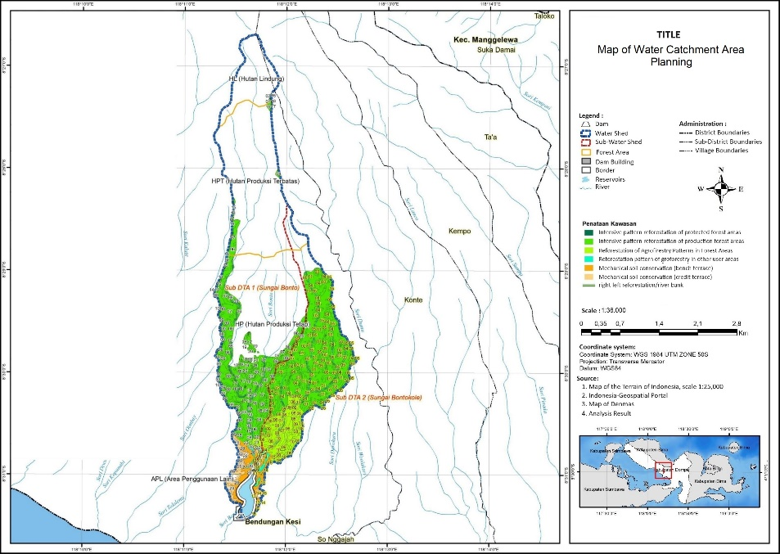
FIGURE 7. Map of Water Catchment Area Planning

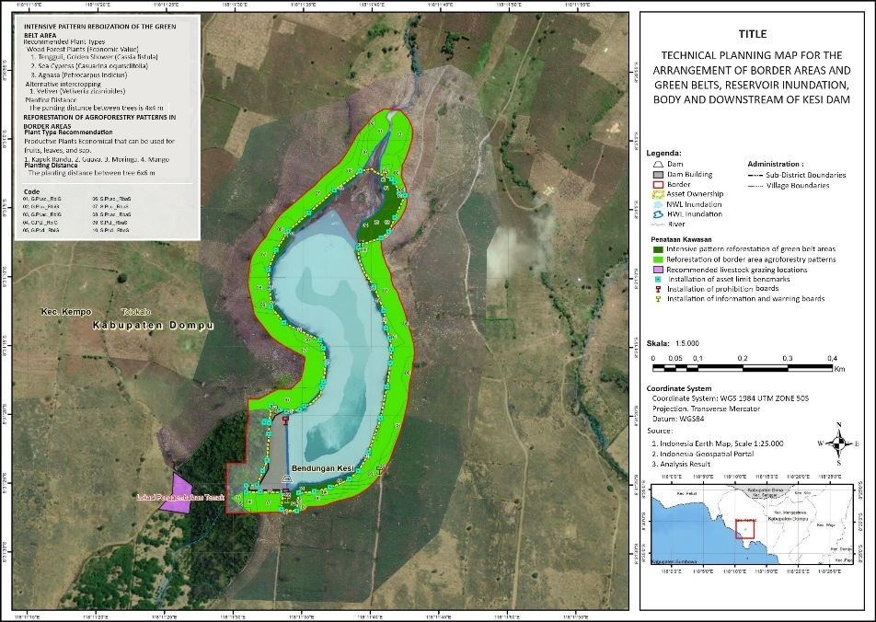
FIGURE 8. Border Area and Green Belt Layout Planning Map

If the target of the arrangement is achieved, the land in the Kesi Dam catchment area will experience a positive change in land cover that can reduce erosion on the land (FIGURE 9). The results of the analysis of the potential for land erosion that occurred in the Kesi Dam catchment area decreased from 178.26 tons/ha/year (FIGURE 3) to 42.95 tons/ha/year (FIGURE 10), which is 75.906%. However, in addition to regular monitoring, stakeholder involvement, and collaboration with environmental experts, and other experts need to be carried out to ensure the sustainability of this area arrangement strategy[9]. This is because local government policies can combine various interests and encourage green belt planning[11]. Overall, this approach can provide positive results and become a solid foundation for sustainable management of sedimentation aspects in the Kesi Dam.

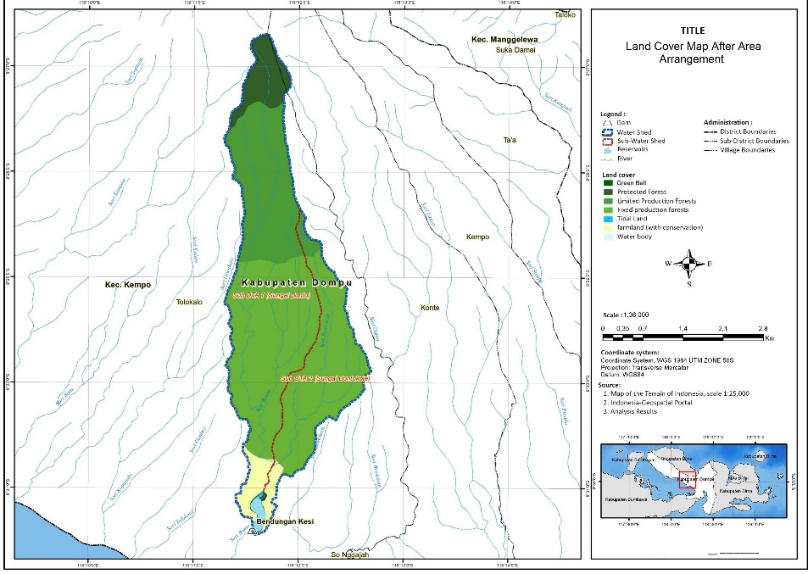
Figure 9. Land Cover Map After Area Arrangement

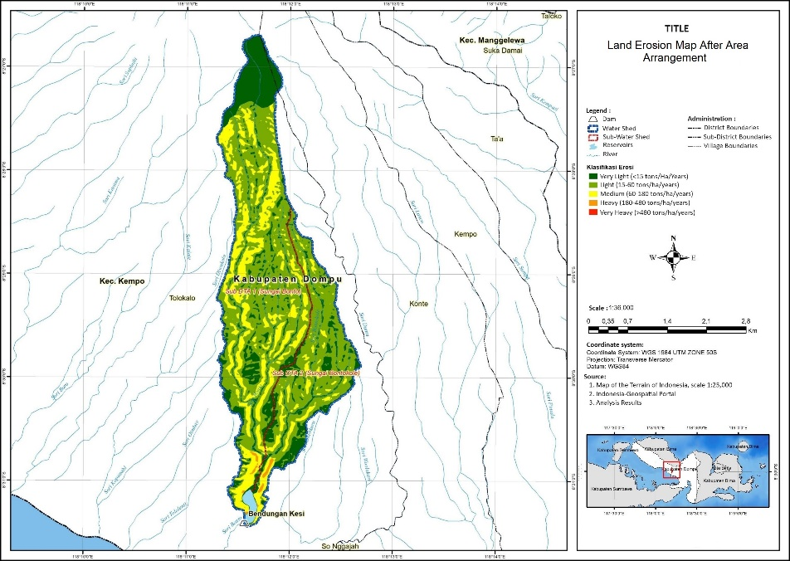
FIGURE 10. Land Erosion Map After Area Arrangement

CONCLUSIONS
This study analyzes the problems and examines strategies for the Kesi Dam arrangement area to reduce land erosion by implementing green belts. The results of the study concluded that the arrangement of the area requires systematic steps in restoring the function of protected forests, production forests, land conservation, and selecting appropriate plant types to reduce land erosion. The types of plants that are appropriate to the characteristics of the land in the Kesi Dam catchment area are deep-rooted, have low evapotranspiration, and are already known by the community. For the successful implementation of border areas and green belts, the installation of information boards and asset markers can be implemented. As a result, the change in erosion potential can reach 75.906%.

ACKNOWLEDGEMENT
All data of this research are supported by the government of BWS Nusa Tenggara I (Nusa Tenggara I River Basin Center) and PT. Aria Jasa Konsultant as a consultant providing services for the Kesi Dam project in 2022.

REFERENCES
1. Narendra, B.H., et al., A review on sustainability of watershed management in Indonesia. Sustainability, 2021. 13(19): p. 11125.
2. Darmawan, A.A., et al. Assessment of spatial changes of LULC dynamics, using multi temporal landsat data (case study: Lesti Sub Watershed, Malang Regency, Indonesia). in IOP Conf. Series: Earth and Environmental Science. 2021. Malang.
3. Wahyuningrum, N. and P.B. Putra, Analisis Lahan Terdegradasi DAS Brantas dan Upaya Penanggulangannya untuk Mendukung Rehabilitasi Lahan. Jurnal Penelitian Kehutanan Wallacea, 2019. 8(2): p. 135-145.
4. Szatten, D. and M. Habel, Effects of Land Cover Changes on Sediment and Nutrient Balance in the Catchment with Cascade-Dammed Waters. remote sensing, 2020. 12: p. 3414.
5. Daramola, J., et al., Impacts of Land-Use Change, Associated Land-Use Area and Runoff on Watershed Sediment Yield: Implications from the Kaduna Watershed. water, 2022. 14: p. 325.
6. Utomo, P. and P. Febriani, Penentuan TIngkat Akurasi Beberapa Metode Prediksi Efisiensi Tangkapan (Trap Efficiency) Sedimen di Waduk Mrica. Jurnal Rekayasa Sipil, 2021. 17: p. 248-258.
7. Castro, P.W. and C.A. Mantilla, Implementation of Strategies for the Management of Dams with Sedimented Reservoirs. Water Resources Management, 2021. 35: p. 4399-4413.
8. Noegroho, N. and Y.M. Ardiani. Utilization of greenbelt zone around the dam Study case: Logung Dam, Kudus Regency, Central Java. in Study case: Logung Dam, Kudus Regency, Central Java. 2018. Tangerang.
9. Kirby, M.G. and A.J. Scott, Multifunctional Green Belts: A planning policy assessment of Green Belts wider functions in England. Land Use Policy, 2023. 132.
10. Zhou, L., et al., A critical role of the capital green belt in constraining urban sprawl and it fragmentation measurement. Land Use Policy, 2024. 141.
11. Kirby, M.G., J. Zawadzka, and A.J. Scott, Ecosystem service multifunctionality and trade-offs in English Green Belt peri-urban planning. ECosystem Services, 2024. 67.

