Study of Trap Efficiency Parameters on Morphological Changes in the Selorejo Reservoir
Azami Mukhlisun Nadwah ^{1, c)} Sulianto ^{2, b)} Lourina Evanale Orfa^{3, a)}
Author Affiliations
^{1,2,3}Universitas Muhammadiyah Malang
Author Emails
^{a)} lourinaorfa@umm.ac.id
^{b)}sulianto@umm.ac.id
Abstract. This study aims to analyze the distribution and volume of sedimentation in the Selorejo Reservoir using the Surface Water Modelling System (SMS) version 8.1. Sedimentation issues in the reservoir reduce its storage capacity and impair its performance, including irrigation and Hydroelectric Power Plant (PLTA) operations. Simulations were conducted to predict sediment distribution patterns over the next five years, utilizing inflow discharge data, reservoir bottom topography, and Total Suspended Solids (TSS). The research methodology involved two subprograms within SMS, namely RMA2 for modeling dynamic flow and SED2D-WES for modeling sediment transport. The simulation results indicated that sedimentation predominantly occurs in the upstream portion of the reservoir and spreads downstream, with significant sediment accumulation at certain points. Validation with Echo Sounding measurements from 2018 and 2022 revealed that SMS has a high accuracy level in predicting sedimentation. This study provides a clear understanding of sediment distribution patterns in the Selorejo Reservoir, which can serve as a reference for planning mitigation measures against the impacts of sedimentation. Furthermore, the results demonstrate that SMS can be effectively utilized for reservoir management and future sedimentation challenges.

INTRODUCTION
Reservoirs are vital infrastructure for water resource management. Their function is not only to store rainwater during the rainy season but also to maintain water availability during the dry season. Beyond their water retention, reservoirs offer numerous benefits, from supporting agriculture through irrigation systems, providing habitat for freshwater fish farming, and generating clean energy through hydroelectric power plants. Furthermore, reservoirs play a role in mitigating potential flooding and developing into natural tourist destinations.
The Selorejo Dam is one such water resource management infrastructure located in East Java, specifically in Pandansari Village, Ngantang District, Malang Regency. Located at the foot of Mount Kelud, the dam was constructed between 1963 and 1972. With a capacity of 1,990,000 m³, the Selorejo Dam plays a vital role in harnessing the potential of river flow in the region.
The dam also supplies water for generating hydroelectric power (PLTA) with an installed capacity of 4.5 MW. Furthermore, this dam plays a role in agricultural irrigation, flood control, and supports the tourism and freshwater fisheries sectors. The Selorejo Dam reflects a multi-use water resource strategy that not only supports technical needs but also contributes to the local economy and environmental conservation.
In reservoir management, particularly the Selorejo Reservoir, common issues frequently encountered include planning, operations, and maintenance. One of the dominant issues in maintenance is sedimentation. Sedimentation occurs as a result of erosion in the catchment area, where soil particles are dislodged from the land surface due to intense rainfall and surface runoff. This eroded material is carried through the natural drainage network to the river system and subsequently accumulates at the bottom of the reservoir. This sediment accumulation gradually reduces the effective reservoir storage volume, decreasing operational efficiency, and increasing the need for dredging. Therefore, a sedimentation management strategy based on land conservation, erosion control, and hydrological monitoring is essential.
High rates of sedimentation in reservoirs directly impact storage capacity, particularly in dead storage zones, which should not be filled with solid material. As a result, the effective storage volume also decreases, impacting the operational efficiency of the reservoir, including the performance of hydroelectric power plants (PLTA). On the other hand, direct sediment measurement requires specialized instruments, is a time-consuming process, and is costly. In contrast, river discharge data tends to be easier to obtain and is continuously available at most observation locations. Therefore, an efficient alternative approach is needed to map sediment distribution spatially and temporally.
In response to this situation, sediment distribution analysis is a strategic step to obtain an initial overview of the distribution of sediment material within the reservoir. This information is crucial for supporting early and effective decision-making related to sediment management planning. In this study, sediment distribution analysis in the Selorejo Reservoir was conducted using hydrodynamic and sediment transport modeling software, the Surface Water Modeling System (SMS). This approach is expected to produce simulations that accurately represent field conditions and support future sedimentation impact mitigation efforts.
The Surface Water Modeling System (SMS) is software developed to model the dynamics of water flow and sediment movement in two horizontal dimensions. This system uses a numerical approach to solve hydrodynamic and sediment transport equations spatially. The reliability of simulation results generated by SMS is greatly influenced by the quality of the input data and the accuracy of the calibration of model parameters, such as boundary conditions, geometric characteristics, and physical flow properties. Therefore, the model validation and verification process is crucial for obtaining an accurate representation of field conditions.
The Surface Water Modeling System (SMS) is a hydraulic and sediment modeling software specifically developed for simulating two-dimensional horizontal surface flow systems. SMS provides a comprehensive graphical interface, enabling users to efficiently build, edit, and analyze water flow and sediment transport models. This system is widely used in civil engineering and water resources studies, particularly those related to the modeling of rivers, reservoirs, estuaries, and coastal areas. In the context of flow and sediment modeling, SMS integrates two main subprograms: RMA2 and SED2D-WES. The RMA2 subprogram is a finite element method-based solver used to solve two-dimensional flow equations under steady and unsteady conditions. RMA2 calculates the distribution of flow velocity and water level based on the boundary conditions and bottom topography input into the system. This program is capable of accounting for the effects of bottom roughness, pressure gradients, turbulent viscosity, and complex geometric conditions, making it highly suitable for modeling in reservoirs and natural channels.
Meanwhile, SED2D-WES is a subprogram used to model sediment transport processes within the water column and its interaction with the bottom. This program accommodates various transport mechanisms, including the transport of suspended sediment and bedload, as well as erosion and deposition processes that occur due to variations in flow velocity and bottom morphology. SED2D-WES operates based on the output from RMA2, ensuring that sediment modeling is dynamic and responsive to changes in flow patterns.
The performance and accuracy of modeling results in SMS are highly dependent on several important aspects, including the quality and resolution of input data, accuracy in determining parameters.

METHODS
Data Collection
The data required to complete this study is the data used as input in running the Surface-Water Modeling System. The following is an overview of the data required for this study:
- Reservoir bottom topography
The reservoir topography was obtained from echosounding measurements conducted by the Public Company (Perum) Jasa Tirta 1. This topography data was later converted into bathymetry. This bathymetry data will form the elements of the SMS 8.1 program.
- Reservoir Inflow Discharge
The inflow discharge data in this study is the Selorejo Reservoir discharge data. In this study, the inflow discharge data was obtained from measurements conducted by the Public Company (Perum) Jasa Tirta 1.
- Total Suspended Solids (TSS)
TSS data is taken as a representation of sediment particles carried by water. In this study, TSS data also came from the public company (Perum) Jasa Tirta 1.

Research Data Analysis
Data analysis was conducted in several stages:
- 1. Data Collection: Topographic data, inflow discharge, and TSS were collected and prepared as input for the simulation.
- 2. Modeling with SMS: The collected data were entered into SMS software version 8.1 to model flow and sediment transport. This modeling was performed using two subprograms: RMA2 for dynamic flow simulation and SED2D-WES for sediment transport simulation.
- 3. Validation: The modeling results were compared with field data to validate and evaluate the modeling accuracy.

Research Stages
The flowchart of the research stages is presented as follows:
  - Data Preparation: Collecting topographic data in the form of bathymetry, inflow discharge, and TSS.
  - Morphological Change Analysis: Analyze changes in reservoir morphology based on bathymetric data from 2018 and 2022.
  - Water Flow Modeling (RMA2): Conduct simulations to model water flow in the reservoir using the collected data.
  - Sediment Transport Modeling (SED2D-WES): Simulations are conducted to model the movement and distribution of sediment in the reservoir.
  - Results Analysis: Analyze simulation results to determine the distribution patterns and volume of sedimentation in the reservoir over the next five years and determine how the analysis results match actual data.

RESULT AND DISCUSSION

Modeling Data
Bathymetry data is information about the topography of the waterbed, including measurements of water depth and the shape of the river or reservoir bed. Bathymetry forms the basis for SMS modeling. In this study, the bathymetry data used were 2018 for modeling and 2022 for model validation.
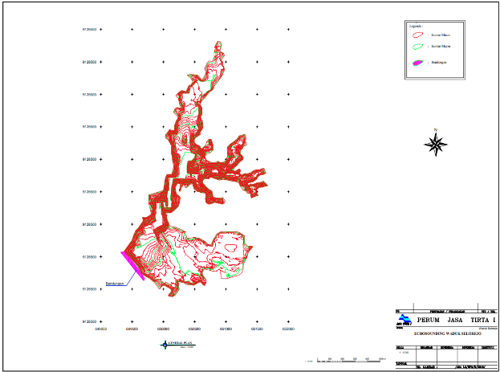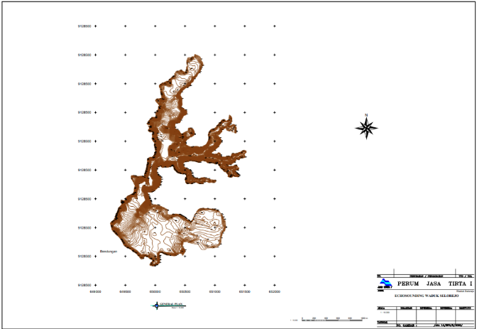
Figure 1. Bathimetry Data

In the RMA2 modeling stage, the data required for water flow modeling are river discharge entering the reservoir in m3/s and water level elevation in meters. The river discharge data obtained is the result of measurements by the Public Company (Perum) Jasa Tirta 1 and has been converted into these units, so no data processing is required.

Figure 2. Average Monthly Inflow Graph for 2018-2022

The average monthly discharge shows significant variation, with the highest values occurring in January and February, typically the rainy season. The lowest discharge occurs from July to October, indicating a dry season pattern.
Figure 2 provides important insight into the hydrological conditions that influence sediment transport to the reservoir. High discharge during the rainy season brings more sediment into the reservoir, which then settles due to the reduced flow velocity. Conversely, low discharge during the dry season allows sufficient time for sediment particles to settle, especially in areas with low turbulence.
TSS includes various types of particles such as sediment, sand, clay, plankton, plant debris, and other organic or inorganic materials that are insoluble in water and remain suspended. The TSS value obtained from the measurement results carried out by the Public Company (Perum) Jasa Tirta 1 and expressed in milligrams per liter (mg/L), but in the SMS 8.1 modeling the unit used is kilograms per cubic meter (kg/m³) so data processing is necessary.

Figure 3. Average TSS Monthly Graph 2018-2022

Figure 3 present TSS data in two units: milligrams per liter (mg/L) and kilograms per cubic meter (kg/m³), with monthly averages shown in Figure 4.4. The TSS pattern exhibits fluctuations consistent with the inflow pattern. The highest concentrations occur during the rainy season (January to March), while lower concentrations occur during the dry season (July to October).
This indicates that the high inflow during the rainy season contributes to an increase in the sediment load carried into the reservoir. High TSS concentrations during this period lead to more rapid sediment accumulation, especially in the upstream part of the reservoir.
The combination of bathymetry, inflow, and TSS data provides a comprehensive understanding of sedimentation dynamics in the Selorejo Reservoir. The data presented demonstrates that sedimentation patterns are strongly influenced by inflow water discharge and suspended sediment concentration. This provides a solid foundation for modeling flow patterns and sediment distribution using SMS 8.1.

Modelling Morphology
Flow modeling using the RMA2 subprogram in SMS 8.1 aims to simulate water flow patterns in the Selorejo Reservoir. After the reservoir modeling has been completed and all baseline data has been prepared, the flow and sediment distribution simulations can be performed. The analysis models used in SMS 8.1 are RMA2 and SED2D-WES, with RMA2 used for flow modeling and SED2D-WES for sediment transport modeling.
In this modeling, RMA2 modeling must be performed before SED2D-WES modeling to analyze sediment transport patterns. The following are the analysis steps in RMA2 modeling:
  - Enter the mesh module in SMS 8.1 software.
  - Then, create a nodestring in the finished mesh model as input for the incoming and outgoing water flow in the model. This nodestring is used to provide flow direction in the model.
  - Once all the nodestrings in the model are present, enter the input for each nodestring using nodestring > RMA2 > assign BC. In this study, the upstream nodestring model uses discharge data input, and the downstream nodestring model uses water level data.
  - Enter the control model in RMA2. This control model contains several parameters used to adjust the simulation. Once the control model parameters have been filled in according to the simulation requirements, the model can be simulated by going to RMA2 > run RMA2.
  - The water flow pattern model can be opened using the command Data > Data Browser > Import > Select Modeling Solution > Open > Done

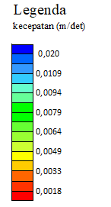
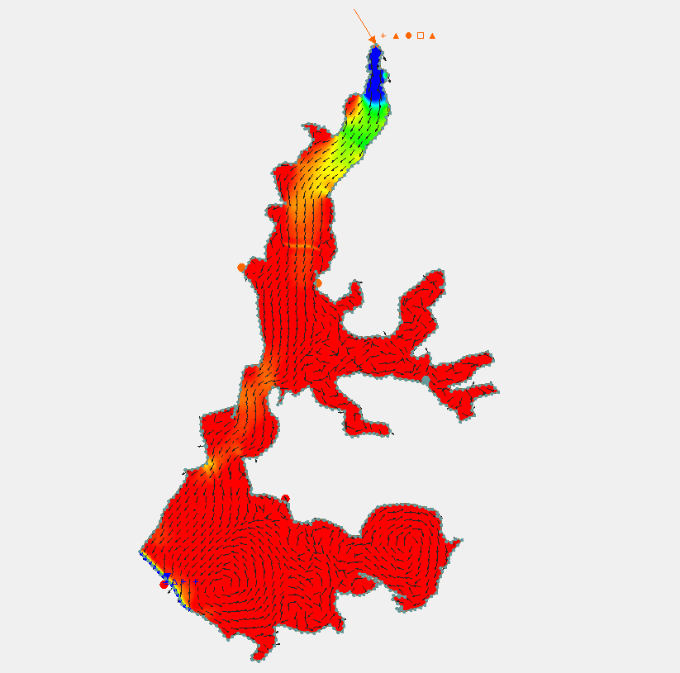
Figure 3. RMA2 Modelling

After successfully modeling the water flow pattern (RMA2), the next step is to model the sediment distribution pattern (SED2D). Here are the steps to model the sediment transport pattern:
  - Enter the mesh module in the SMS 8.1 software.
  - Go to SED2D > Global Parameters. This step contains parameters for the sediment to be simulated. The data entered is sediment data from the study location.
  - Once the global parameters have been filled in according to the simulation requirements, click the node string in the upstream section and enter the sediment inflow data using the SED2D > Assign BC command.
  - Go to SED2D > Model Control. This step aims to configure the sediment modeling simulation, including the simulation that will take place during the modeling process.
  - Then, go to SED2D > Run SED2D. The simulation will run according to the reservoir specified in the model control.
  - The sediment distribution pattern model can be opened using the command Data > Data Browser > Import > Select Modeling Solution > Open > Done.

This study predicts changes in the reservoir bed due to sedimentation using the following assumptions:
  - Predictions of flow, concentration distribution, and sediment distribution in the reservoir are analyzed for the next five years.
  - The reservoir inflow data is the average historical discharge, assumed to be the same from year to year, representing a transient flow over five years with a one-month period.
  - The reservoir water level is assumed to be constant, at the normal reservoir water level.
  - The reservoir analysis is performed using the RMA2 subprogram, using the following parameter values:
- Eddy viscosity coefficient (Exx = Eyy) = 5000
- Reservoir bed roughness coefficient (n-manning) = 0.027
- Water temperature = 23°C
- Water density = 1000 kg/m3
  - The sediment transport analysis in the reservoir using the SED2WES subprogram uses the following assumptions.
- Diffusion Coefficient (Dxx = Dyy) = 1.500
- Initial concentration = 0.0270 kg/m3
- Settling velocity = 0.0100 m/s
- Trap efficiency = 80%
- Acceleration due to gravity (g) = 9.806650 m/s2

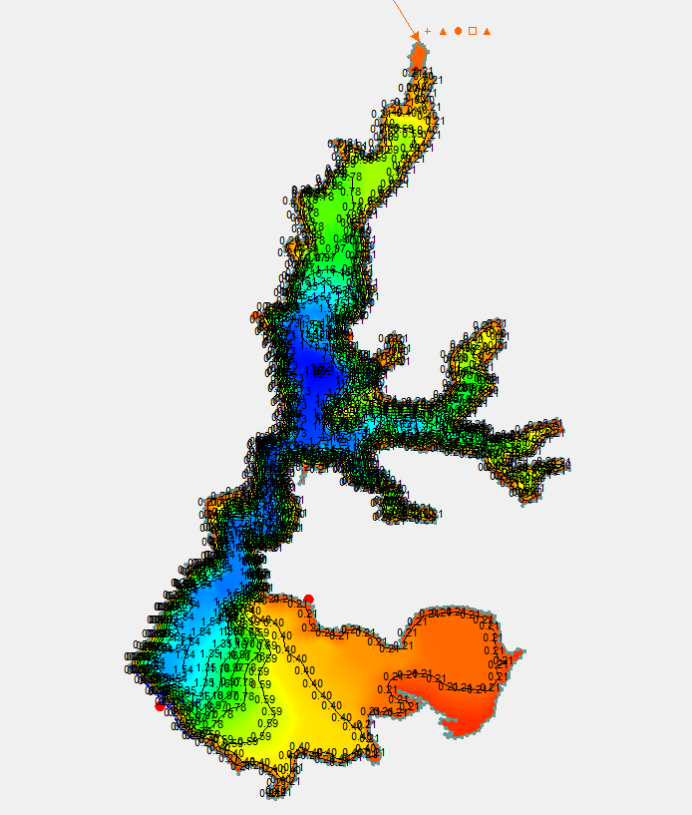
Figure 3. SED2D Modelling

Sediment transport simulation using SED2D-WES produced a sediment distribution map in the Selorejo Reservoir. The simulation results show that sediment particles are deposited more heavily in the upstream and middle sections of the reservoir, with concentrations decreasing downstream. Factors such as flow turbulence and reservoir bottom topography play important roles in this distribution.
The higher sediment distribution in the upstream section may be due to larger sediment particles settling more quickly due to gravity. Conversely, finer sediment with smaller particle sizes is carried further downstream before settling. This pattern reflects the natural behavior of sediment transport, where bedload settles more rapidly than suspended load.After the modeling and analysis process is complete, the next step is to analyze changes in reservoir morphology using bathymetric data obtained from field measurements. This bathymetric data provides a more in-depth picture of the reservoir's depth, bottom topography, and elevation changes over time. This information is crucial for monitoring and understanding morphological dynamics, such as sediment accumulation, which can affect reservoir capacity and function.Bathymetric data is used to analyze how reservoir morphology changes due to sedimentation. For this analysis, three samples, or three cross-sections, were taken: the upstream, midstream, and midstream sections of the reservoir, or the same sections as those used in the previous modeling analysis.
After the simulation and analysis of morphological changes based on modeling and field data, the next crucial step is a comparative analysis. This analysis aims to evaluate the agreement between the modeling results and actual data collected in the field.Modeling provides a theoretical overview of how reservoir morphological changes occur due to sedimentation processes. These modeling results are based on various parameters and assumptions incorporated into the simulation system, including water flow, sediment volume, and the physical characteristics of the reservoir itself. Although modeling can provide fairly accurate predictions, verification through field data is still necessary to ensure the reliability of these results.
In this comparative analysis, each modeling result will be compared with field data obtained from direct measurements. Field data includes information such as actual elevations at various measurement points, accumulated sediment volume, and morphological changes occurring in various parts of the reservoir, both upstream, midstream, and downstream. The purpose of this comparison is to determine the extent to which the modeling results match actual conditions in the field.
If the modeling results and field data show good agreement, it can be concluded that the modeling has a high level of accuracy and can be used to predict future morphological changes. Conversely, if there are significant differences between the modeling results and field data, further evaluation of the parameters and assumptions used in the modeling is necessary. This is essential to improve the model's accuracy and ensure its reliability for use in reservoir management planning.
To improve the accuracy and effectiveness of the model, adjustments were made to several key parameters that influence the simulation results. These adjustments aimed to bring the simulation results closer to the desired conditions or more realistic results. The process began by selecting a single cross-section as the primary representation. This cross-section selection facilitated gradual analysis and parameter testing, allowing for a more in-depth evaluation of each applied change.
The adjustments focused on the efficiency trap, with the initial value of 80% gradually increased until it reached 90%. This step aimed to find the most appropriate parameter values, thus reflecting more accurate simulation results. By using a single cross-section as a test area, the literacy process could be more focused and efficient without requiring direct involvement of the entire model. Once the appropriate parameters were found, these values were applied to the entire model to achieve more consistent and representative results.
The modeling process began with the determination of initial parameters, namely a trap efficiency of 80%, which resulted in simulation results lower than the bathymetric data. Through evaluation and iteration, the efficiency parameter was gradually increased until it reached 87%, where the simulation results showed a better fit with the bathymetric data.

Validation
Sedimentation is a major factor influencing changes in reservoir bottom morphology over time. To understand the accuracy of sedimentation modeling in representing real-world conditions, Nash-Sutcliffe Efficiency (NSE) and Root Mean Square Error (RMSE) analyses were performed on simulation results using several trap efficiency scenarios. Trap efficiency describes the percentage of sediment retained in the reservoir before being carried downstream.
Validation was conducted to test model accuracy by comparing simulation results with 2022 bathymetry data. Validation aims to determine the extent to which the model can represent actual conditions over a specific time period.
The RMSE calculation results show a value indicating that the model has an error rate that is still within the tolerance limit. Based on hydrodynamic modeling validation standards, a model is considered to have good accuracy if the RMSE value is below 10% of the average reservoir elevation. From the calculations performed, the RMSE values obtained for each scenario are seen in Table 1 below:

TABLE 1. RMSE with Efficiency Trap 80%
El. bathimetry | El. Hasil simulasi | Selisih (m) | Selisih kuadrat (m2)
620.40 | 620.28 | -0.1200 | 0.01440
611.97 | 611.79 | -0.1770 | 0.03133
609.31 | 609.11 | -0.2040 | 0.04162
608.48 | 608.22 | -0.2610 | 0.06812
607.94 | 607.65 | -0.2910 | 0.08468
607.43 | 607.11 | -0.3180 | 0.10112
608.18 | 607.83 | -0.3480 | 0.12110
608.58 | 608.21 | -0.3750 | 0.14063
608.58 | 608.21 | -0.3750 | 0.14063
607.98 | 607.66 | -0.3180 | 0.10112
610.03 | 609.74 | -0.2910 | 0.08468
610.22 | 609.96 | -0.2610 | 0.06812
614.95 | 614.75 | -0.2040 | 0.04162
620.26 | 620.11 | -0.1500 | 0.02250
620.40 | 620.28 | -0.1200 | 0.01440
 | Total |  | 1.07607
 | RMSE |  | 0.267839131
 | Persentase |  | 27%

TABLE 2. RMSE with Efficiency Trap 87%
El. bathimetry | El. Hasil simulasi | Selisih (m) | Selisih kuadrat (m2)
620.40 | 620.38 | -0.02 | 0.000400
611.97 | 611.94 | -0.03 | 0.000870
609.31 | 609.28 | -0.03 | 0.001156
608.48 | 608.44 | -0.04 | 0.001892
607.94 | 607.89 | -0.05 | 0.002352
607.43 | 607.38 | -0.05 | 0.002809
608.18 | 608.12 | -0.06 | 0.003364
608.58 | 608.52 | -0.06 | 0.003906
608.58 | 608.52 | -0.06 | 0.003906
607.98 | 607.93 | -0.05 | 0.002809
610.03 | 609.98 | -0.05 | 0.002352
610.22 | 610.18 | -0.04 | 0.001892
614.95 | 614.92 | -0.03 | 0.001156
620.26 | 620.24 | -0.02 | 0.000625
620.40 | 620.38 | -0.02 | 0.000400
 | Total |  | 0.029891
 | RMSE |  | 0.044640
 | Persentase |  | 4%

TABLE 3. RMSE with Efficiency Trap 90%
El. bathimetry | El. Hasil simulasi | Selisih (m) | Selisih kuadrat (m2)
620.40 | 620.48 | 0.08 | 0.00640000
611.97 | 612.09 | 0.12 | 0.01392400
609.31 | 609.45 | 0.14 | 0.01849600
608.48 | 608.65 | 0.17 | 0.03027600
607.94 | 608.13 | 0.19 | 0.03763600
607.43 | 607.64 | 0.21 | 0.04494400
608.18 | 608.41 | 0.23 | 0.05382400
608.58 | 608.83 | 0.25 | 0.06250000
608.58 | 608.83 | 0.25 | 0.06250000
607.98 | 608.19 | 0.21 | 0.04494400
610.03 | 610.22 | 0.19 | 0.03763600
610.22 | 610.39 | 0.17 | 0.03027600
614.95 | 615.09 | 0.14 | 0.01849600
620.26 | 620.36 | 0.10 | 0.01000000
620.40 | 620.48 | 0.08 | 0.00640000
 | Total |  | 0.47825200
 | RMSE |  | 0.17855942
 | Persentase |  | 18%

Based on the results of the RMSE analysis of various trap efficiency scenarios, it can be concluded that a trap efficiency of 87% is the scenario closest to actual conditions. With an RMSE value of only 0.0446 meters and an error rate of 4%, this scenario indicates that the sedimentation modeling is accurate and adequately represents changes in the reservoir bed's morphology.
Based on the calibration and validation results, the SMS 8.1 model can be used to predict reservoir morphological changes with an acceptable level of accuracy. The obtained RMSE values indicate that the model can predict sedimentation with high accuracy, making it a reliable tool for sedimentation mitigation planning in the Selorejo Reservoir.
Parameter adjustments were made incrementally in each section to ensure that the simulation results accurately reflect actual conditions. This process demonstrates the importance of iteration in modeling to produce valid results that are representative of field observations.
Parameters play a significant role in hydrodynamic and sedimentation modeling. Parameters such as trap efficiency, settling velocity, and diffusion coefficient directly determine how software like SMS 8.1 simulates sediment flow and distribution.
If parameters are not adjusted to local conditions (for example, the unique sediment characteristics or inflow discharge in the Selorejo Reservoir), simulation results can differ significantly from reality. This is evident when comparing initial simulation results with field data, where the sediment thickness in the initial simulation was much lower. After parameters such as trap efficiency were calibrated from 80% to 90%, the simulation results more closely matched the field data.
Based on the modeling results, it can be concluded that SMS software is an accurate tool for predicting sedimentation rates in the reservoir. Modeling with parameter adjustments, such as a trap efficiency of 87%, successfully produced simulation values that closely approximated bathymetric data in various sections.
However, to obtain more precise results, accurate input data is required as a basis for the simulation. The quality and accuracy of bathymetric data, sediment material characteristics, and other hydrodynamic parameters significantly influence the final modeling results.
Therefore, utilizing SMS software can be an effective solution for sedimentation analysis, provided it is supported by valid data that represents field conditions.

CONCLUSION
SMS Accuracy Level in Analyzing Reservoir Sedimentation Validation of simulation results against bathymetric data indicates that the model has a fairly high level of accuracy, with a low Root Mean Square Error (RMSE) value. Model accuracy is influenced by parameter adjustments such as trap efficiency, which, with a value of 87%, produces simulation results that most closely align with actual conditions.

Acknowledgments
I would like to express my gratitude to Jasa Tirta for their assistance in providing the data. The Civil Engineering Study Program accommodated this research, ensuring its successful implementation.

References

- Anggrahini, R. (1997). Pemodelan Aliran Sedimen di Sungai Menggunakan Pendekatan Numerik. Tesis, Institut Teknologi Bandung, Indonesia.
- Budiman, S. (2008). Pemodelan Sedimentasi Waduk Menggunakan Software Hidrodinamika. Laporan Penelitian, Universitas Brawijaya, Malang.
- Elder, J.W. (1959). The dispersion of marked fluid in turbulent shear flow. Journal of Fluid Mechanics, 5(4), 544–560.
- Hutabarat, S., & Dewi, C.A. (2011). Pengendalian Sedimentasi pada Waduk: Studi Kasus di Waduk Jatiluhur. Jurnal Teknik Sipil, Universitas Gadjah Mada, Yogyakarta.
- Jansen, P.P., Van Bendegom, L., Van den Berg, J., De Vries, M., & Zanen, A. (1979). Principles of River Engineering. Pitman Publishing Inc.
- Joseph, P., Norton, W.R., & King, I.P. (1979). Two Dimensional Hydrodynamic and Sediment Transport Model. Resources Management Associates
- King, I.P., Norton, W.R., & Orlob, G.T. (1998). Surface Water Modeling System (SMS) Version 8.0. University of California, Waterways Experiment Station (WES).
- Kodoatie, R.J. (2002). Pengelolaan Sumber Daya Air Terpadu. Pustaka Pelajar, Yogyakarta.
- Linsley, R.K., Franzini, J.B., Freyberg, D.L., & Tchobanoglous, G. (1985). Hydrology for Engineers (3rd ed.). McGraw-Hill Book Company.
- Perusahaan Umum (PERUM) Jasa Tirta 1. (2018-2022). Data Debit Inflow dan Total Suspended Solids (TSS) Waduk Selorejo. Malang, Indonesia.
- Raudkivi, A.J. (1990). Loose Boundary Hydraulics (3rd ed.). Pergamon Press.
- Sharma, H.D. (1979). Hydrology and Water Resources Engineering. Nem Chand & Bros.
- Sosrodarsono, S., & Takeda, K. (1983). Bendungan dan Bangunan Air. Pradnya Paramita, Jakarta.
- Sunjoto, S. (2004). Teknik Bendungan dan Waduk: Perencanaan dan Pengelolaan Sumber Daya Air. Gadjah Mada University Press, Yogyakarta.
- Soemarto, C.D. (1999). Hidrologi Teknik. Usaha Nasional, Surabaya.
- Tirtomihardjo, H. (1997). Erosi dan Sedimentasi di Daerah Aliran Sungai (DAS). Lembaga Penelitian Universitas Padjadjaran, Bandung.
- Varshney, R.S. (1979). Engineering Hydrology. Nem Chand & Bros.
- Ven Te Chow. (1992). Open-Channel Hydraulics. McGraw-Hill Book Company.
- Wibowo, P. (2002). Pemeliharaan Waduk dengan Metode Pengendalian Sedimentasi. Jurnal Teknik Pengairan, Institut Teknologi Sepuluh Nopember (ITS), Surabaya.

