Effectiveness Hec-ResSim 3.5 program for Optimal Operation of Tugu Dam Reservoir East Java of Indonesian
Ahmad Zhulfikar Akbar^{1, a)}, Lourina Evanale Orfa^{2, b)}, and Sulianto^{3, c)}
^{1,2,3} Civil Engineering Department, Universitas Muhammadiyah Malang, 65144, Indonesia
^{a)} ahmadzhulfikar@gmail.com
^{b)} lourinaorfa@umm.ac.id
^{c)} sulianto@umm.ac.id
Abstract. This study evaluates the effectiveness of the HEC‑ResSim 3.5 software in optimizing the operation of the Tugu Dam Reservoir, located in Trenggalek Regency, East Java, Indonesia, with an effective capacity of 9.50 million m³. The reservoir serves multiple purposes, including irrigation, raw water supply, and flood control. Input data consisted of historical inflow records (1987–2019) expanded using synthetic series generated by the Thomas–Fiering method, water release decisions based on the Standard Operating Procedure (SOP) of the Brantas River Basin Authority (BBWS), and irrigation water demand for 2022. The HEC‑ResSim model was calibrated and validated against 2021 operational data, achieving a Root Mean Square Error (RMSE) of less than 10%, indicating high accuracy. Two operation scenarios were tested: (1) releases following the 2022 RTOW pattern, achieving 92% reliability with minimal spill; and (2) releases matching actual irrigation demands, achieving 100% reliability but increasing annual spill by 18%. The results demonstrate that integrating HEC‑ResSim with inflow, offers an effective, computationally efficient approach for dam operation in Indonesia. Nevertheless, for long-term operational optimization, adaptive cropping patterns and climate change projections should be incorporated to minimize water losses.
Keywords: HEC‑ResSim 3.5; reservoir; simulation; operation.
INTRODUCTION
The constitutional Indonesian has been mandatory to utilize water for the benefit of the Indonesian people. They called earth, water, and natural resources contained therein are controlled by the state and used for the greatest prosperity of the people. As stated in Article 33 paragraph 3 of the 1945 Constitution, it is the duty of all Indonesian citizens (Undang-Undang Dasar Negara Republik Indonesia 1945, 1945). Indonesian ranks fourth among the world's most populous countries with 278 million people (BPS Indonesia, 2023), with a population growth rate of 1.17%. Rapid population growth and a secure future for water in many regions require guaranteed certainty. As a country crossed by the equator, Indonesia is blessed with abundant water resources. (Badan Pusat Statistik Indonesaia, 2024)
Data compiled by the Directorate General of Water Resources of the Ministry of Public Works and Public Housing (PUPR Indonesian) in 2023 shows that the average annual surface water availability in Indonesia reaches 2.78 trillion m³/year. This water availability is distributed across 128 river basins. Of this abundant supply, 80 percent is used for agricultural sustainability (PUPR Indonesia, 2024). Through this government program, the world of higher education is obliged to participate in research and development that supports sustainable energy and water development (Abduh et al., 2024). Nowadays, due to increasing population and water shortage and competition for its consumption, proper and suitable utilization and optimal use of water resources is essential (Mansouri et al., 2015). Optimization would be an alternative solution for an existing project based on qualitative procedures. (Ehteram et al., 2017) including distribution networks are an essential part of all water supply systems.(Abduh et al., 2024). A water distribution network is a system containing pipes, reservoirs, pumps, and valves of different types, which are connected to each other to provide water to consumers (Kumar & Yadav, 2020). Reservoir operations are complex engineering problem, With the growth in population, the demand for water in both consumptive and non-consumptive use has been increased drastically in last decade (Torabi Pudeh et al., 2016).
Operation rules provide explicit instructions for making decisions in specific situations, such as defining minimum and maximum reservoir outflows for flood control, water resources conservation, and water demands. A guide curve is a real-time threshold to operate reservoirs depending on time, season, and storage capacity as well as provide a reference line of reservoir elevation that meets the requirement of storage by time (Kim et al., 2020a). The completion or formulation of reservoir operation policies cannot be separated from optimization to determine maximum profits and/or minimum losses for optimal utilization of reservoir water (Anggraheni et al., 2017). Optimization techniques that are often used in reservoir operations include calculus methods, linear programming, non-linear programming, dynamic programming, real-time operations, and simulation techniques. The simplest of the reservoir operation policies is the standard linear operation policy in which release values are a function of water availability. Climate change, limited water resources, and population growth, result in unbalance between the release of water and the demand (Abdulateef et al., 2021).
HEC‑ResSim (Hydrologic Engineering Center’s Reservoir System Simulation) is a computer program developed by the U.S. Army Corps of Engineers’ Hydrologic Engineering Center to simulate and model the operations of single or multiple reservoirs under various operational objectives and constraints (John D. Klipsch et al., 2021). It enables water managers to conduct detailed simulations of reservoir operations based on rule‑driven decisions that closely replicate those made by human operators, while representing reservoirs and river systems as georeferenced networks consisting of reservoirs, routing reaches, stream junctions, and diversions (John D. Klipsch et al., 2021). The software manages and stores time‑series input and output data through the Hydrologic Engineering Center’s Data Storage System (HEC‑DSS) and supports the modeling of complex outlet structures and operational controls to accurately depict reservoir release mechanisms. It is capable of analyzing both single event scenarios and simulations over full periods of record, thereby supporting comprehensive reservoir planning studies as well as real‑time operational management. HEC‑ResSim assists decision‑makers in optimizing reservoir operations for multiple objectives, including flood risk reduction, water supply management, hydropower generation, and environmental protection, providing a flexible and powerful framework for integrated water resources management (John D. Klipsch et al., 2021).
In Indonesia, real-time reservoir operations particularly those supported by decision-making software remain uncommon, and modeling-based research using HEC-ResSim is limited. Developed by the U.S. Army Corps of Engineers, HEC-ResSim provides rule based, real-time simulation and has been applied worldwide to both single- and multi reservoir systems, yet Indonesian applications are still scarce. Existing studies include an operational optimization analysis of the Marga Tiga Reservoir in Lampung Province, representing flood, normal, and minimum water levels as well as dam outflow (Roni Wibowo, 2022), and an assessment of the Leuwikeris Reservoir in West Java Province, modeling water resource availability under three alternative supply schemes.
The Tugu Dam, located in East Java within the Brantas River Basin, holds significant potential for effective and efficient water resource management. Under ideal conditions, the dam is expected to optimally regulate river flows, mitigate the risks of flooding and drought, and maintain adequate water quality for irrigation, industrial use, and public consumption (Balai Besar Wilayah Sungai Brantas, 2022). Water resource management at the Tugu Dam must therefore be conducted in an integrated and sustainable manner, taking into account technical, social, and economic considerations. Based on available data, the dam’s technical specifications include a catchment area of 43.06 km², an irrigated area of 1,250 ha, and a main dam height of 89.85 m. However, to fully realize this potential, a well-planned and integrated operational framework is required to ensure optimal (Balai Besar Wilayah Sungai Brantas, 2022). Water resource management at the Tugu Dam faces several challenges, one of which is the inefficiency of its irrigation system. Despite its large water storage capacity, water distribution to agricultural land is often uneven and suboptimal, resulting in agricultural productivity around the dam falling short of expectations. In response to this issue, the present study aims to develop an operational pattern for the Tugu Dam that can adequately meet the irrigation water demands of the Prenguk, Bubuk, Darungan, Cupuk, and Prambon irrigation areas on the left bank, as well as the Ngepeh, Jabung, Nglongah, and Outlet irrigation areas on the right bank.
One potential solution for optimizing reservoir operation patterns is the use of the HEC-ResSim software. According to the User’s Manual developed by the U.S. Army Corps of Engineers, HEC-ResSim is designed to facilitate the testing of various reservoir operation rules and to support the selection of the most effective operational patterns. The program can accommodate multiple water resource management objectives, including irrigation, flood control, raw water supply, and hydropower generation, making it highly relevant for the management of multipurpose reservoirs such as the Tugu Dam. HEC-ResSim has proven effective through its application in various previous studies, including the Abay River in Ethiopia (Wondye, 2009), the Tucui Dam in Brazil (Lara et al., 2014), and the Eastern Nile River (Belachew Azeb, 2014). The successful use of this software in diverse geographical and hydrological contexts demonstrates its flexibility for adaptation to local conditions in Indonesia. By employing rule-based simulation modeling, HEC-ResSim can provide insight into reservoir performance under different hydrological scenarios, thereby supporting data-driven decision-making processes.
HEC-ResSim has been proven to possess broad applicability and effectiveness in addressing a wide range of challenges in reservoir and water resources management. Its modular architecture, map-based schematic interface, and network representation capabilities enable realistic modeling of complex river–reservoir systems, while its status as public-domain software facilitates the sharing of knowledge and data (Dash et al., 2023). Operationally, HEC-ResSim supports multi-objective management—including irrigation, flood control, hydropower generation, navigation, and environmental flow maintenance through rule-based decision-making and robust scripting capabilities for managing complex systems (Meshkat & Klipsch, 2018).
The model’s accuracy has been consistently demonstrated, with performance metrics showing a correlation coefficient ≥ 0.97 and Nash–Sutcliffe efficiency ≥ 0.85 in most studies, alongside excellent calibration results for monthly discharge simulation, water allocation assessment, and operations at various storage elevation levels (Sulaiman et al., 2021). Furthermore, its integration with other models, such as SWAT and Genetic Algorithms, enhances its ability to optimize operations under uncertainty, adapt to climate variability, and evaluate future scenarios (Kim et al., 2020b). Collectively, these advantages position HEC-ResSim as a comprehensive, adaptive, and data-driven solution for meeting diverse operational and planning needs in both single and multi-reservoir systems worldwide.
In the study “Effectiveness Hec-ResSim 3.5 program for Optimal Operation of Tugu Dam Reservoir East Java of Indonesian”, using HEC-ResSim is expected to generate a comprehensive analysis of reservoir storage capacity and its responsiveness to water supply demands. The results of analysis can be used to design an operational pattern that not only optimizes dam functions but also ensures a more equitable distribution of water across all supplementary irrigation areas. Thus, the application of HEC-ResSim represents a strategic approach to improving water resource management efficiency while supporting the sustainability of agricultural production within the Tugu Dam service area.

MATERIALS AND METHODS

This research is a development of previous decision by dam Tugu operators and applied at Tugu dam after impounding 2021. The data that has been obtained from the government release decision, inflow series 1987-2019 from AWLR Keser River (33 years, 10-day aggregation), Evapotranspiration 2022, Irrigation demand.

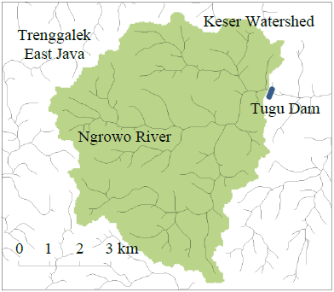
FIGURE 1. Tugu Reservoir and Keser River

Data Collection in order to model the reservoir operation of Tugu, data were collected from the Balai Besar Wilayah Sungai (BBWS) Brantas and from previously carried out studies as shown in TABLE 1. The data includes storages capacities of reservoir at different elevations, time series flow data, intake, spillway, and demand water irrigation, and evaporation data of the reservoir in years.

TABLE 1. Tugu Dam and Reservoir Data Collection Sources
Data | Years | Sources
Storages capacities of reservoir | 2021 | Hydrology reports Tugu Dam (BBWS) Brantas
Time series flow data | 2021 | Hydrology reports Tugu Dam (BBWS) Brantas
Intake | 2021 | Detail design of Tugu Dam
Spillway | 2021 | Detail design of Tugu Dam
Demand water irrigation | 2021 | Hydrology reports Tugu Dam (BBWS) Brantas
Release water decision | 2021 | Hydrology reports Tugu Dam (BBWS) Brantas
Evaporation data of the reservoir | 2021 | Hydrology reports Tugu Dam (BBWS) Brantas

Rainfall data from 1987-2019 were collected to analyses for inflow and automatic water level recorder from 2019 – 2021. The Input screen of reservoir system modelling using the Hec- ResSim model of the Tugu Reservoir and Keser River as shown in FIGURE 1

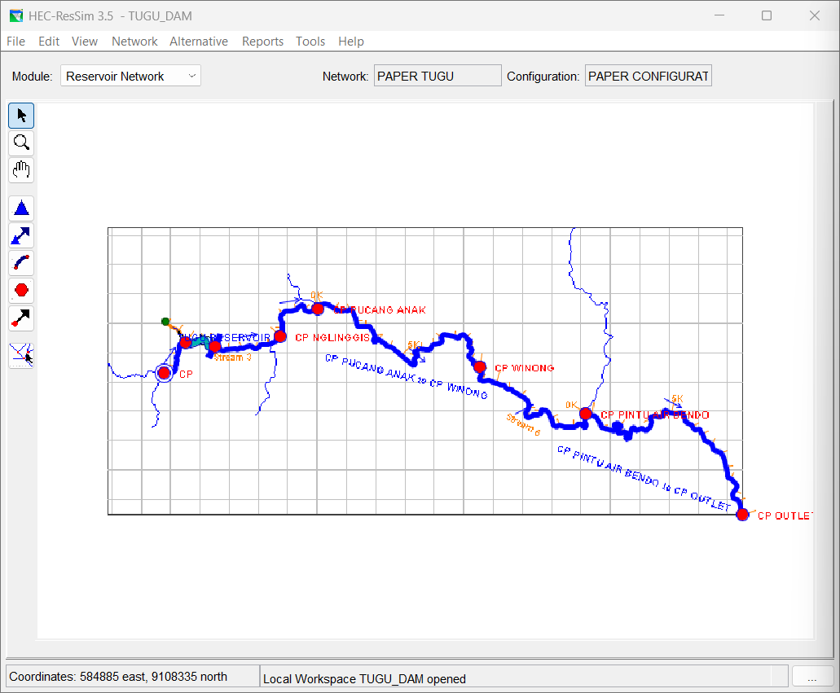
Figure 2. Input Screen of Hec-Ressim for Modelling Tugu Reservoir

The main objective of the Watershed Setup module was to give a setup to create the watershed. The watershed setup module is the part of other HEC generations like HEC-RAS, HEC-ResSim, HEC-FIA and HEC-HMS. The Tugu Reservoir watershed is related to the alignment of upstream and downstream reaches of the Keser River and the Tugu Reservoir in the watershed. The watershed setup module includes all the streams, projects (reservoirs), time-series locations, impact areas, computation points and hydraulic and hydrologic data points for the watershed area. The final configuration of all these elements is used to generate the watershed framework.
The Reservoir Network is the second step and is the most complicated module of the software. In the Reservoir Network module, the river and reservoir schematic diagram shows the operational elements and the physical parts of model, and the new alternatives can be developed so that they can analyze in the simulation. Then the river reaches and the remaining network elements were connected to accomplish the network scheme. The operational and physical data for each element of the network were incorporated on finishing of the schematic figure. Alternatives were developed that describe the operation sets, initial conditions, reservoir network and DSS time series files.
The network parts that are demonstrated by HEC-ResSim may have four types, for example, junctions, routing reaches, reservoirs, and diversions. Different modules of the HEC-ResSim model are shown in Figure 2. The Physical data tab and the Observed data tab of the Reservoir Editor of the Model are shown in FIGURE 3 and FIGURE 4, respectively.

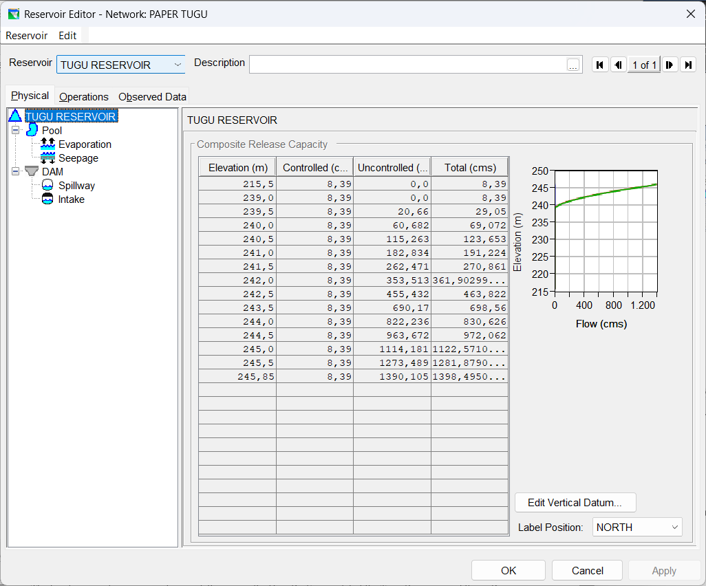
FIGURE 3. Physical Input Data of Tugu Dam and Reservoir.

The simulation module was used to separate the output results from the development of the model. After the definition of the alternatives and completion of model, the module was used to run the simulation. It was required to define the simulation time window, alternatives to be assessed and simulation run interval. The DSS file consisted of all the DSS records that shows the input and output time series data for the considered alternatives. Besides this, elements may be saved and edited for further simulations.
The main concepts of the theoretical development of the reservoir network consists of two parts: A physical part that includes the Tugu dam and reservoir, spillways, dam structure, tail waters information and correct information of all these is very important for an adequate result. The second part of the reservoir network is the provision of operation rules for the Tugu Reservoir—that is a basic step in the model development. The description of this portion is really complicated and require a lot of information and hydrological and hydraulics equations are used for calculation. Conditional portrays like if, or, then, and rules are used for the better development of the Tugu Reservoir simulation model.
The physical part is a very important part in the HEC-ResSim model as even minor changes affect the behavior of the reservoir system. The physical part input consists of dam parts and reservoir details that consist of the Tugu spillways, reservoirs storage and pool surface area, dam crest, length of crest of dam was included. The mathematical water flow models for large areas include water inflow in reservoir, flow in open streams, and release from the outlet.
Spillways are the controlled/uncontrolled outlets of a dam to pass the flood safely to d/s stretches of river safely. During the high flow season, the reservoir level increases and results in overflowing of the dam crest. In such condition, the turbine or spillway will cater to pass this surplus discharge to restrain towards the guide curve. In the case of the Tugu dam, Auxiliary and Service spillways are used to spill the extra water from the reservoir in the flood season, and spillways are put into operation when the reservoir level reaches 239.06 m.
The releases from spillways were estimated by Equation below that. These calculations were crucial in determination of the operational rules and physical considerations. The maximum increase in reservoir level depends on the discharge capacity of both spillways at different reservoir elevations. The operation rules in operation sets for the discharge capacity of both spillways were used to spill excess water at different elevations. Spill from the Auxiliary
and Service spillways were calculated with Equation:

$$Q=C . B. a .\sqrt{2.g.Do}$$

where ‘Q’ is discharge (m³/s), ‘C’ is discharge coefficient (0.75 for streamlined and 0.6 at the sharp edge), ‘B’ is spillway width, ‘a’ is spillway gate above the threshold, ‘g’ is acceleration and ‘Do’ is water depth over spillway. Pan evaporation of Tugu lake was used to determine the change in pool storage due to evaporation. End pool storage after seepage, evapotranspiration and releases from spillways, power and irrigation tunnels was determined by the HEC-ResSim model from continuity Equation:

$$S_{2}=S_{1}-E_{VAP}+\left(INFLOW-OUTFLOW\right). CQS$$

where ‘S1’ is end of period storage, ‘E_{vap}’ is evaporation during time interval, ‘Outflow’ is power release and leakage, ‘CQS’ is discharge to storage conversation. Tugu Reservoir standard operation procedures were used in this study defined by BBWS rule curves of dam that specify the Tugu pool storage or required releases based on the time of year and the current reservoir storage in the reservoir.

results and discussion
The HEC-ResSim Model was calibrated and validated for the release irrigation from the Tugu Reservoir according to BBWS standard operation procedures for the year 2021. Results of the model simulation of Hec-ResSim are indicated in figures 21 and 22. The various simulations of the HEC-ResSim model indicates that the model was highly sensitive to the irrigation release efficiency. This model according to the BBWS standard operations and by trial and error, the model generates the releases irrigation from Tugu, and the patterns were approximately similar to the actual observed data throughout the year for the calibrated and validated years 2021

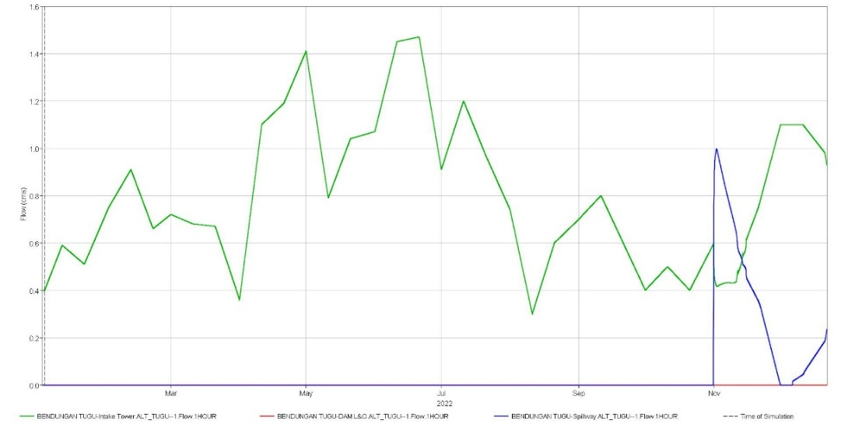
FIGURE 4. Result of Simulation in Hec-Ressim

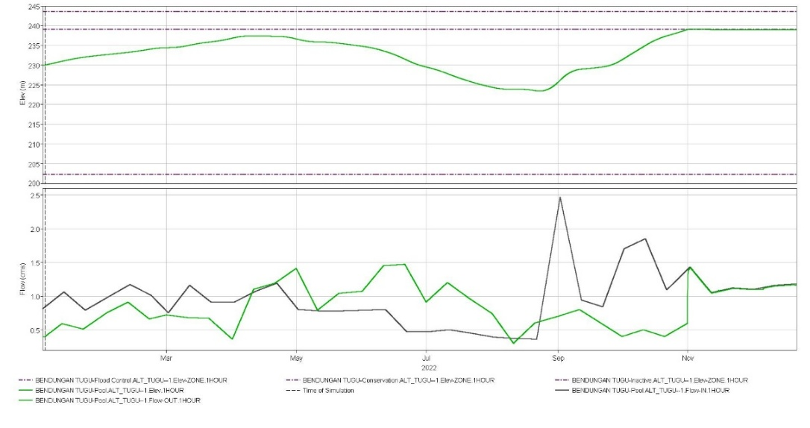
FIGURE 5. Simulation Result

The coefficient of efficiency, RMSE and NRMSE indicate the satisfactory values for accuracy of the model as shown in TABLE 2.
TABLE 2. RMSE Result
Coefficients | Results between elevation observation and  elevation simulation
RMSE | 4,853
NRMSE | 2,080

The results of Root Mean Square Errors check after the validation of the model for the years 2021 and simulated model using Hec-ResSim, its validation was carried, see Figures 6 and 7 for irrigation releases and power generation, respectively. The results of validation coincide with the observed value within the satisfactory limits. The resemblance of the simulated values of the model were very closer to the observed values for irrigation releases and power generation, as shown by the RMSE in TABLE 2
FIGURE 6. Release and Simulation Graphic

FIGURE 7 Observation and Simulation Result Comparison

CONCLUSION
In this study, the HEC-ResSim model for Tugu Reservoir was developed for analyzing reservoir operations in 2021 considering simulation using the Hec-ResSim model. The constraint of the SOPs implemented by BBWS are also outlined and modelled in the HEC-ResSim. The new developed methodology was simulated for the Tugu reservoir. After successful calibration and validation, modeling using Hec-ResSim is effective, with root mean square error (RMSE) check the results is 2,080% it means under 10% the control of RMSE is strong. Simulation results show that the use of Hec-Ressim is highly effective.

Acknowledgments
The authors are grateful to the University of Muhammadiyah Malang and the supervising lecturer.

REFERENCES

- Abduh, M., Orfa, L. E., Sulianto, S., & Iqbal, K. (2024). Pressure Drop Analysis of Turbine Housing Model with Circular Sliced Pipe for Micro Hydropower Generation. Aceh International Journal of Science and Technology, 13(2), 92–102. https://doi.org/10.13170/aijst.13.2.37998
- Abdulateef, T., Irzooki, R., & Abbas, A. (2021). Operation of Mosul – Dokan Reservoirs and Samarra Barrage Using HEC – ResSim Model During Dry Period. Engineering and Technology Journal, 39(8), 1273–1280. https://doi.org/10.30684/etj.v39i8.1991
- Anggraheni, D., Jayadi, R., & Istiarto, D. (2017). EVALUASI KINERJA POLA OPERASI WADUK (POW) WONOGIRI 2014. Jurnal Teknisia, XXII(1).
- Badan Pusat Statistik Indonesaia. (2024). 2. statistik-indonesia-2024. 52.
- Belachew Azeb, Z. M. (2014). Eastern Nile Basin Water System Simulation Using Hec-ResSim Model How does access to this work benefit you ? Let us know !
- Dash, S. S., Sahoo, B., & Raghuwanshi, N. S. (2023). An integrated reservoir operation framework for enhanced water resources planning. Scientific Reports, 13(1). https://doi.org/10.1038/s41598-023-49107-z
- Ehteram, M., Karami, H., Mousavi, S. F., El-Shafie, A., & Amini, Z. (2017). Optimizing dam and reservoirs operation based model utilizing shark algorithm approach. Knowledge-Based Systems, 122, 26–38. https://doi.org/10.1016/j.knosys.2017.01.026
- Balai Besar Wilayah Sungai Brantas. (2022). Laporan Hidrologi Pekerjaan: Monitoring dan Evaluasi Bendungan Tugu Pasca Impounding di Kabupaten Trenggalek.
- John D. Klipsch, George C. Modini, Sara M. O’Connell, Marilyn B. Hurst, & Daniel L. Black. (2021). HEC-ResSim User’s Manual (3.3).
- Kim, J., Read, L., Johnson, L. E., Gochis, D., Cifelli, R., & Han, H. (2020a). An experiment on reservoir representation schemes to improve hydrologic prediction: coupling the national water model with the HEC-ResSim. Hydrological Sciences Journal, 65(10), 1652–1666. https://doi.org/10.1080/02626667.2020.1757677
- Kim, J., Read, L., Johnson, L. E., Gochis, D., Cifelli, R., & Han, H. (2020b). An experiment on reservoir representation schemes to improve hydrologic prediction: coupling the national water model with the HEC-ResSim. Hydrological Sciences Journal, 65(10), 1652–1666. https://doi.org/10.1080/02626667.2020.1757677
- Kumar, V., & Yadav, S. M. (2020). Optimization of Water Releases from Ukai Reservoir Using Jaya Algorithm. Advances in Intelligent Systems and Computing, 949, 323–336. https://doi.org/10.1007/978-981-13-8196-6_29
- Lara, P. G., Lopes, J. D., Luz, G. M., & Bonumá, N. B. (2014). Reservoir operation employing HEC-ResSim: Case study of Tucuruí dam, Brazil. 6th International Conference on Flood Management, September 2014, 1–12.
- Mansouri, R., Torabi, H., Hoseini, M., & Morshedzadeh, H. (2015). Optimization of the Water Distribution Networks with Differential Evolution (DE) and Mixed Integer Linear Programming (MILP). Journal of Water Resource and Protection, 07(09), 715–729. https://doi.org/10.4236/jwarp.2015.79059
- Meshkat, M., & Klipsch, J. D. (2018). World Environmental and Water Resources Congress.
- PUPR Indonesia. (2024). Booklet Air Untuk Negeri edisi 1 2024. 01.
- Roni Wibowo. (2022). Sistem Pengoperasian Waduk Margatiga Menggunakan Software HEC-ResSim.
- Sulaiman, S. O., Abdullah, H. H., Al-Ansari, N., Laue, J., & Yaseen, Z. M. (2021). Simulation model for optimal operation of Dokan Dam reservoir northern of Iraq. International Journal of Design and Nature and Ecodynamics, 16(3), 301–306. https://doi.org/10.18280/IJDNE.160308
- Torabi Pudeh, H., Mansouri, R., Haghiabi, A. H., & Yonesi, H. A. (2016). Optimization of Hydraulic-Hydrologic Complex System of Reservoirs and Connecting Tunnel. Water Resources Management, 30(14), 5177–5191. https://doi.org/10.1007/s11269-016-1477-5
- Undang-Unndang Dasar Negara Republik Indonesia 1945, Pub. L. No. 75 (1945).
- Wondye, F. (2009). Abay Basin Water Allocation Modelling Using Hec – Ressim.

