Optimization of CBF Bracing Configuration for High-Rise Buildings in Earthquake-Prone Areas
Moh. Abduh^{1, a)} and Aulia Indira Kumalasari^{2, b)}
Author Affiliations
¹Civil Engineering Department, Faculty of Engineering, University of Muhammadiyah Malang
² Civil Engineering Department, Faculty of Engineering, University of Muhammadiyah Malang
Author Emails
^{a)} Corresponding author: abduh@umm.ac.id
^{b)} auliaindira@umm.ac.id
Abstract. Indonesia is one of the countries with high seismic activity. Therefore, it is necessary to design earthquake-resistant building structures, especially in steel structures. Apart from the frequency of earthquakes that occur, earthquake resistant building design must also meet the needs of high-rise buildings. One of the earthquake resistant systems in steel structures is the CBF system. CBF (Concentrically Braced Frame) is a steel frame structural system that uses braces that are placed concentrically to the connection of column and beam members. CBF has several types of configurations including Diagonal Braced, Inverted V-Braced, and X-Braced. With these different types of configurations, it is necessary to study and analyze the performance of these types of configurations in both high-rise and low-rise buildings in seismic areas. The high-rise building consisted of 12 floors with a total height of 48 m. The analysis was performed using responses spectrum and pushover analysis in numerical modeling with Diagonal Braced, Inverted V-Braced, X-Braced, and MRF configuration. The results of the analysis show that the Diagonal Braced high-rise building has better performance such as drift, drift ratio, floor drift compared to other configurations and MRF. In the results of stress ratio of high-rise buildings, Inverted V-Braced has a more optimal value than other configurations. In addition, Diagonal Braced has the highest ductility value for both high-rise as well as the highest stiffness value. For all structures analyzed, the resulting performance level is still in the Immediate Occupancy (IO) category. Each type of configuration has a different collapse mechanism, and finally for the highest energy dissipation value in the X-Braced configuration in high-rise buildings, but outside of the type of configuration the MRF system has a greater energy dissipation value than the CBF system

Introduction
An earthquake is a vibration caused by the sudden movement of tectonic plates on the Earth's surface. Indonesia is one of the countries with a high frequency of earthquake activity. This is due to the geodynamic activity occurring in Indonesia. This condition is caused by the subduction zone located south of Java Island, formed by the activity of the Indo-Australian Plate against the Sunda Block. The Indo-Australian Plate extends from the Australian continent to India, with part of it subducting beneath Java and Sumatra Islands, which mark the southernmost boundary of the Sunda Block. Earthquakes can cause significant damage to building structures, so it is important for buildings to be designed and constructed with consideration for earthquake resistance [1], [2] .
Earthquake-resistant building design is an integral part of structural design. The purpose of such design is to prevent structural failure, economic losses, and even loss of life in the event of an earthquake. Low-rise to high-rise buildings must be able to withstand both vertical and horizontal forces [3], [4]. In earthquake-resistant building design, several aspects must be considered, including structural systems and materials. Generally, building structures in Indonesia use concrete and steel as materials. One material suitable for earthquake-resistant buildings is steel. This is because steel is a material with sufficient strength and stiffness and is lighter in weight. One effective way to improve a building's resistance to earthquakes is to increase the vertical stiffness of its structure. This can be achieved by adding more elements that can withstand shear forces. Examples include the addition of diagonal structures, shear walls, or modifications to the connections between structural elements. These measures will automatically reduce the lateral forces caused by earthquakes. Additionally, one effective way to strengthen the structure is by using bracing, which can reduce horizontal deflection and enhance shear resistance between floors. As a result, the risk of cracks forming at the joints between beams and columns can be minimized, thereby avoiding potential structural failure [5], [6].
Bracing is a brace used to reinforce a building structure. The function of the brace is to strengthen the structure and ensure stability. Some types of steel frame structures used to withstand earthquakes include Special Moment-Resisting Frame Structures, Ordinary Matter-Resisting Frame Structures, Limited Moment-Resisting Frame Structures, Special Moment-Resisting Beam Frame Structures, Special Concentric Bracing Frame Structures, Ordinary Concentric Braced Frame Structures, and Eccentric Braced Frame Structures. In this study, the focus is on Special Concentric Braced Frames (SCBF). Currently, there are increasingly diverse types of bracing in steel structures, and these variations can produce different behaviors, as shown by previous studies. Therefore, this study will analyse steel structures with several types of bracing, including Diagonal Braced CBF, Inverted V-Braced CBF, and X-Braced CBF, with bracing placed on the exterior center. This analysis will help in understanding the differences in building behavior for each type of bracing.
Regardless of the frequency of earthquakes in Indonesia and the use of earthquake resistance systems and bracing configurations, building construction is still necessary to meet the need for earthquake-resistant buildings, both high-rise and low-rise. High-rise buildings and low-rise buildings have different characteristics in terms of height, proportions, and lateral loads acting on the structure. Therefore, it is important to understand how the performance of each type of bracing configuration can impact the earthquake resistance of buildings of various heights [7].
Previous studies include a Comparative Analysis of Horizontal Deviation in Earthquake-Resistant Building Structures Using Lateral Braces, which found that adding lateral braces can significantly reduce inter-storey drift compared to buildings without lateral braces. Another study, Analysis of Steel Portal Structures with Concentric Braced Frame Systems Using the 2017 Earthquake Map, found that the X-Braced CBF model is the most effective type of braced frame in reducing inter-storey displacement and deflection according to the results of the 2017 design spectrum response analysis. It also compared the analysis results between the Diagonal Braced CBF, Inverted V -Braced CBF, and X-Braced CBF types showed no significant differences, as all three types of bracing had relatively similar performance [8], [9], [10], [11]. Further research on High-Rise Building Design Using Concentric Braces shows that the deflection values in high-rise buildings are greater than those in low-rise buildings, and that the higher the number of floors, the greater the deflection between floors. A comparative study encompassing both types of buildings will provide a more comprehensive understanding of the effectiveness of bracing configurations in enhancing seismic resistance across various building scales. The findings of this research can offer practical guidance to engineers and structural designers in selecting the most suitable bracing configuration for specific applications and can contribute to the development of more efficient and safe seismic design guidelines for buildings.

Literature Study

Seismic-Resistant Building Design

Indonesia is one of the most earthquake-prone regions in the world. Therefore, identifying and analyzing earthquake-prone areas is very important for mitigation and preparedness in dealing with such disasters. One way to achieve this is by designing earthquake-resistant buildings. The purpose of earthquake-resistant building design is to prevent structural failure and minimize the risk of loss of life [12], [13], [14], [15]. In earthquake-resistant building design, there are key concepts and principles. First, during small earthquakes that occur frequently, the main structural elements of the building must remain intact and function properly. Minor damage to non-structural elements that can still be tolerated is permitted. Secondly, in rare moderate earthquakes, damage to the main structure may occur, but it can still be repaired. Non-structural elements may be damaged, but they can be replaced with new ones. Thirdly, in rare strong earthquakes, buildings may suffer structural and non-structural damage, but they must not collapse completely. The primary objective is to maximize the protection of occupants or people inside the building. The designed structure is expected to withstand repeated loads until it enters inelastic behaviour without experiencing a significant loss of strength. Therefore, the energy generated by earthquake loads must be absorbed and distributed by the structure through inelastic deformation. This capability is known as structural ductility [16].
In earthquake-resistant building design, building height is also a matter of concern because it has a significant impact on structural response during an earthquake. Taller buildings tend to have lower natural vibration frequencies, making them more vulnerable to earthquakes with lower vibration frequencies. If the natural frequency of a building is close to the frequency of an earthquake, resonance can occur, and if the vibrations are amplified, this can increase the potential for damage. Taller buildings have greater mass and are farther from the centre of gravity, resulting in larger inertial forces during an earthquake. These inertial forces exert greater pressure on the building structure, particularly at upper levels. Building height also influences the extent of deflection during an earthquake. The taller the building, the greater the potential for deflection, which can cause damage to both structural and non-structural elements.
Concentrically Braced Frames

One type of structure in multi-storey buildings that can withstand lateral forces caused by earthquakes is to add lateral bracing to the structural frame elements. This type of structural system is often referred to as a bracing frame system, and the common configuration used in this system is CBF (Concentrically Braced Frame). The CBF (Concentrically Braced Frame) structural system is an evolution of the unbraced portal frame system, commonly known as MRF (Moment Resisting Frames). CBF has a higher stiffness level compared to MRF, due to the role of bracing as a stiffening member with good stiffness and as an effective earthquake energy absorber, which together enhance the CBF's capability as an earthquake-resistant steel structure [5], [8], [9].
The inelastic behaviour of CBF is influenced by three main factors, namely the slenderness ratio of the bracing, the number of storeys, and the configuration of the bracing. The first factor, the slenderness ratio, has a significant impact when the bracing is subjected to compressive loads. The number of building storeys also affects the inelastic behaviour of CBF, as taller buildings are more prone to soft storey effects. To prevent this, capacity design is required, where the bracing is designed as the primary seismic-resistant element with overstrength factors in the columns based on the axial forces acting on the bracing.
The shape of the structure or configuration of the bracing also greatly influences the behaviour of CBF. The configuration determines how lateral forces are distributed and absorbed by the structure during an earthquake or other dynamic loads. Certain configurations may be more susceptible to stress concentration or deformation, which can lead to soft storey effects or other structural failures. Therefore, selecting the appropriate configuration is crucial to ensure that the inelastic behaviour of CBF can support the safety and stability of the building.

METHOD

This research began with a literature study that was used as a reference for planning in the Concentrically Braced Frame (CBF) Structural System. The references used were standards, regulations, related books, and relevant journal references. The next stage is the preliminary design phase. The preliminary design is the initial stage of this research, where several components required for steel structure planning are determined to achieve effective results. These components include material quality, profile dimensions, and others in accordance with the literature used. In this modelling, the building is planned to be constructed in the city of Malang and will function as an office building. The soil type is classified as medium soil. The material used is steel with a Fy of 250 MPa, Fu 410 MPa, E 200,000 MPa, and a Poisson's ratio of 0.3. The seismic restraint system used is a bracing type with a configuration as shown in Figure 1. This study also models an MRF building structure as a modelling validator. Additionally, the dimensions used in the modelling are listed in Table 1. Structural modelling was performed using ETABS analysis software. This modelling aims to provide a realistic representation of the building's conditions and should be as detailed as possible to ensure the results closely approximate or represent the behaviour of the planned structure. After modelling with ETABS, a Response Spectrum Analysis was conducted using the collected data to determine the behaviour of the structure.
The seismic load used in this building structure refers to SNI 1726:2019, and the parameters used in the spectrum response analysis were obtained from the website https://rsa.ciptakarya.pu.go.id/2021 in accordance with the building coordinates, namely in Malang, East Java. After the structure was subjected to seismic loads, the next step was to analyse the behaviour of the modelled structure. The analysis conducted includes stress ratio control and structural stability analysis, pushover analysis, and a comparison of structural performance. During the stress ratio control and structural stability analysis phase, each model is analysed, and a design is developed to evaluate the stress ratio up to the specified limit, which is ≤ 1.00. In addition, structural stability is also controlled by checking the Drift Ratio and drift storey to ensure that the permissible deflection has been met. If the stress ratio, Drift Ratio, or drift storey does not meet the requirements, then it will return to the initial design stage. If it meets the requirements, the process can proceed to the next stage. If the Spectrum Response Analysis meets the requirements or is deemed safe, it can proceed to the Nonlinear Static Pushover Analysis. The Spectrum Response Analysis is used to compare structural behaviour, while the Nonlinear Pushover Analysis is used to evaluate the performance of each structural model. To perform Pushover Analysis, at least three types of analysis are required on the structural model: analysis of gravitational loads and other loads acting on the structure, then the structure is subjected to gravitational loads multiplied by a specific load factor, and finally the structure is subjected to lateral loads increased gradually by a specific scale factor. Once the pushover analysis has been performed, the next step is to compare the stability, behaviour, and performance results of the structure obtained from each structural model with the variables determined at the outset, after undergoing the established analysis procedures.
Figure 1. Konfiguration of: a) MRF, b) Diagonal Braced, c) Inverted V braced, d) X Braced

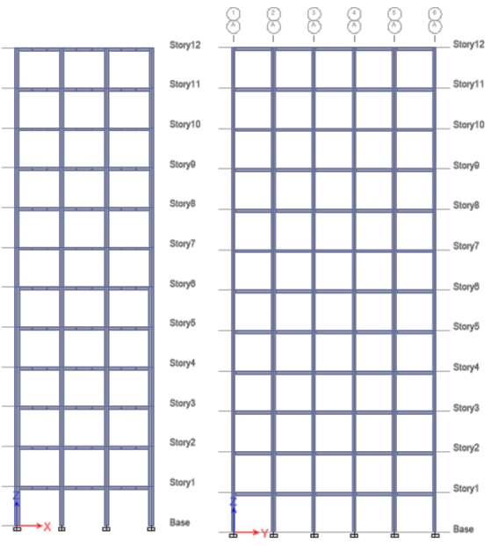  (a) | 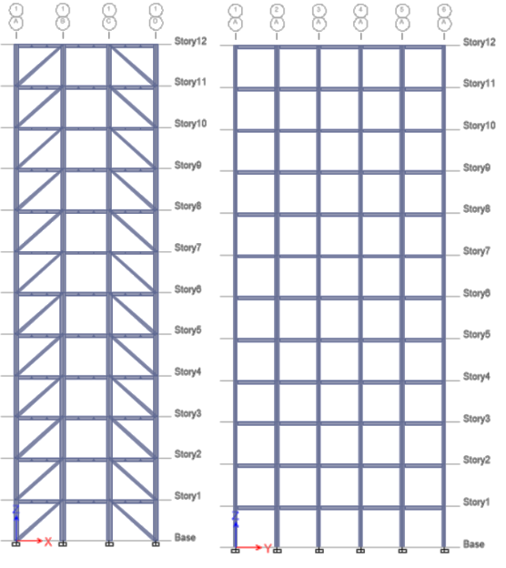  (b) | 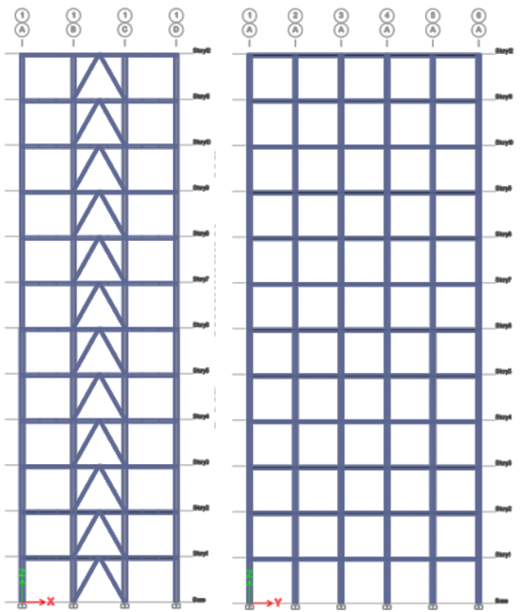  (c) | 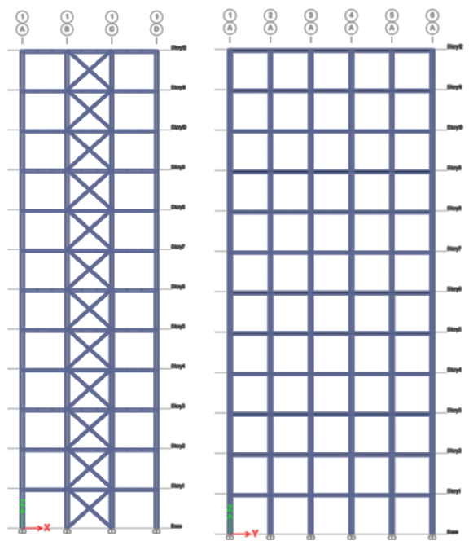  (d)
Figure 1. Modelled structure configurations: a) MRF, b) Diagonal Braced, c) Inverted V Braced, and d) X Braced

Table 1. Profile dimension
No | Element of Structure | Profile Dimension
1 | Column at 1st -6th floor | WF 454.7 X 419.1 X 42.2 X 67.6
2 | Column at 7th -12th floor | WF 386.1 X 398.8 X 21.1 X 33.3
2 | Beam at 1st -6th floor | WF 289.6 X 264.2 X 19.2 X 31.8
3 | Beam at 7th -12th floor | WF 264.2 X 256.5 X 11.9 X 19.6
4 | Secondary beam at 1st -12th floor | WF 203.2 X 203.2 X 7.2 X 11
5 | Braces at 1st -12th floor | WF 206.2 X 203.7 X 7.9 X 12.6

RESULT AND DISSCUSSION

Structure Displacement

Lateral or horizontal loads that occur in structural deflection are caused by seismic loads. To reduce this structural displacement, bracing is required in steel building structures. The function of bracing is to reinforce and absorb seismic energy. To assess the comparative performance of structural deflections, different modelling approaches were examined. The first modelling approach involved using various bracing configurations, while the second modelling approach did not use bracing. Modelling using variations of CBF bracing, including Diagonal Braced CBF, Inverted V-Braced CBF, and X-Braced CBF. The following are the values of structural deflection for CBF and MRF portal frames in a 48-metre-tall building, as shown in Figure 2. When examining the use of several variations of CBF and MRF bracing, the largest structural deflection was found in the MRF portal at 104.867 mm, and for the CBF portal, the largest deflection occurred in the Inverted V-Braced CBF portal at 81.578 mm. Meanwhile, when examining the use of CBF bracing variations in the form of Diagonal Braced CBF, Inverted V -Braced CBF, and X-Braced CBF, the largest structural deflection was found in the Inverted V-Braced CBF portal at 81.578 mm, followed by the X-Braced CBF at 80.25 mm, and the smallest was the Diagonal Braced CBF at 74.819 mm. A summary of the structural deflections with CBF bracing variations of Diagonal Braced CBF, Inverted V-Braced CBF, and X-Braced CBF, along with the MRF for the 48-metre building, is presented in Table 2.
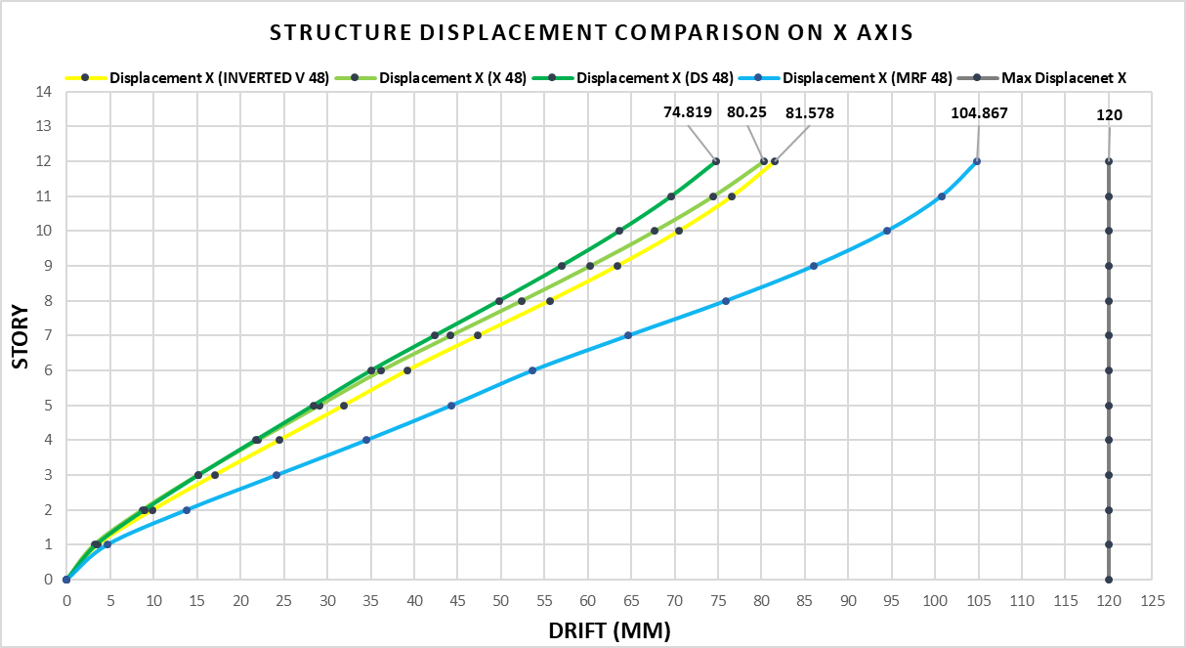
Figure 2. Structure Displacement Comparison on X Axis
Table 2. Summarizing Top Displacement in Each Structure
Diagonal (48 m) |  | Inverted V (48 m) |  | X (48 m) |  | MRF (48 m)
floor | Displacement | floor | Displacement | floor | Displacement | floor | Displacement
12 | 74,819 | 12 | 81,578 | 12 | 80,25 | 12 | 104,867
11 | 69,637 | 11 | 76,636 | 11 | 74,44 | 11 | 100,733
10 | 63,631 | 10 | 70,489 | 10 | 67,683 | 10 | 94,456
9 | 56,958 | 9 | 63,401 | 9 | 60,263 | 9 | 86,059
8 | 49,802 | 8 | 55,596 | 8 | 52,352 | 8 | 75,912
7 | 42,373 | 7 | 47,343 | 7 | 44,181 | 7 | 64,649
6 | 35,043 | 6 | 39,203 | 6 | 36,218 | 6 | 53,668
5 | 28,391 | 5 | 31,901 | 5 | 29,086 | 5 | 44,326
4 | 21,728 | 4 | 24,452 | 4 | 21,971 | 4 | 34,498
3 | 15,177 | 3 | 17,021 | 3 | 15,089 | 3 | 24,173
2 | 8,945 | 2 | 9,868 | 2 | 8,677 | 2 | 13,808
1 | 3,395 | 1 | 3,557 | 1 | 3,161 | 1 | 4,667
Base | 0,000 | Base | 0,000 | Base | 0,000 | Base | 0,000

Based on the deflection values in Table 2, the structure with CBF variations of Diagonal Braced CBF, Inverted V-Braced CBF, and X-Braced CBF as well as MRF in a 48 m building, the structure with a Diagonal Braced configuration produced the smallest deflection among the other configurations, with a value of 74.814 mm. This value indicates that the Diagonal Braced configuration has the best performance in resisting structural deflection compared to the other options. The Inverted V-Braced structure has a deflection of 81.578 mm, slightly larger than the Diagonal Braced and X-Braced configurations, but still demonstrates good performance and flexibility. The X-Braced structure shows a deflection of 80.25 mm. The X-Braced configuration can provide satisfactory performance in resisting structural deflection, with a deflection value smaller than the Inverted V-Braced but larger than the Diagonal Braced. Meanwhile, the structure without bracing (MRF) showed the largest deflection, namely 104.867 mm, which is significantly greater than that of the CBF structure. This value indicates that the addition of bracing elements can improve performance in reducing structural deflection. When considering deflection performance in high-rise buildings, all structures have deflections below the allowable limit. Diagonal Braced structures can be considered the optimal choice for high-rise buildings requiring performance to reduce deflection. X-Braced and Inverted V-Braced structures can serve as alternative options with larger deflection values but still provide adequate performance. Meanwhile, MRF can still be used but with larger deflections. Other factors considered in selecting bracing include the effectiveness and ease of implementation, use of materials, and non-structural requirements such as architectural, mechanical, and other needs.
Drift Ratio

To determine the comparison of the drift ratio of the structure, it is reviewed using different modelling approaches, namely modelling using several variations of bracing configurations, and for the second modelling approach, no bracing is used. Modelling using variations of CBF bracing with types Diagonal Braced CBF, Inverted V-Braced CBF, and X-Braced CBF. The following are the values of the Drift Ratio of CBF and MRF portal structures in a 48 m building, as shown in Figure 3. When examining the use of several variations of CBF and MRF bracing, the largest Drift Ratio value for the MRF portal was 0.002185, and for the CBF portal, the largest Drift Ratio occurred in the Inverted V-Braced CBF portal at 0.001700. When examining the use of CBF bracing variations such as Diagonal Braced CBF, Inverted V -Braced CBF, and X-Braced CBF, the largest structural Drift Ratio value was found in the Inverted V-Braced CBF portal at 0.001700, followed by the X-Braced CBF at 0.001672, and the smallest was the Diagonal Braced CBF at 0.001559. A summary of the structural drift ratios with variations in CBF bracing types (Diagonal Braced CBF, Inverted V-Braced CBF, and X-Braced CBF) and MRF for the 48-metre building is presented in Table 3.
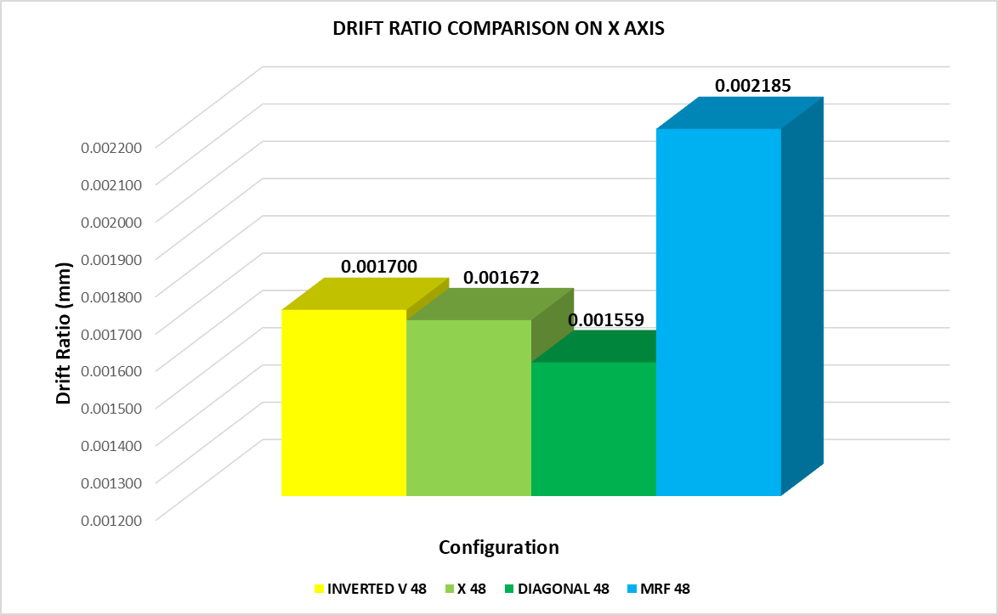
Figure 3. Drift Ratio Comparison of The Structure
Table 3. Summarizing Top Displacement and Drift Ratio in Each Structure
Specimen | Top Displacement | H | Drift Ratio | Δa
 | mm | mm
Diagonal (48 m) | 74,819 | 48000 | 0,001559 | 0,0025
Inverted V (48 m) | 81,578 | 48000 | 0,001700 | 0,0025
X (48 m) | 80,250 | 48000 | 0,001672 | 0,0025
MRF (48 m) | 104,87 | 48000 | 0,002185 | 0,0025

The Diagonal Braced configuration structure exhibits the smallest Drift Ratio value of 0.001559. This value indicates that the Diagonal Braced structure experiences the smallest deviation relative to the building height compared to other configurations. In the second structure, the Inverted V-Braced configuration has a Drift Ratio of 0.001700. Although slightly larger than the Diagonal Braced and X-Braced structures, the Inverted V-Braced structure still demonstrates good deflection resistance performance and greater flexibility. The third structure, the X-Braced structure, has a Drift Ratio of 0.001672. This value is slightly larger than the Diagonal Braced structure but smaller than the Inverted V-Braced structure. The X-Braced structure also demonstrates good performance and the ability to reduce drift effectively. Meanwhile, the MRF structure shows the highest Drift Ratio of 0.002185. This value indicates that MRF has lower drift resistance performance compared to all CBF configurations, with greater drift relative to building height. These values indicate that the addition of bracing elements can improve performance in reducing structural deflection. In the context of Drift Ratio in high-rise buildings, Diagonal Braced is the optimal choice for providing good performance in reducing Drift Ratio. X-Braced and Inverted V-Braced also provide good performance, making them suitable alternatives. As for MRF, although it has the largest Drift Ratio, it can still be used in conditions where flexibility is prioritized over the deflection that occurs.

Drift Storey

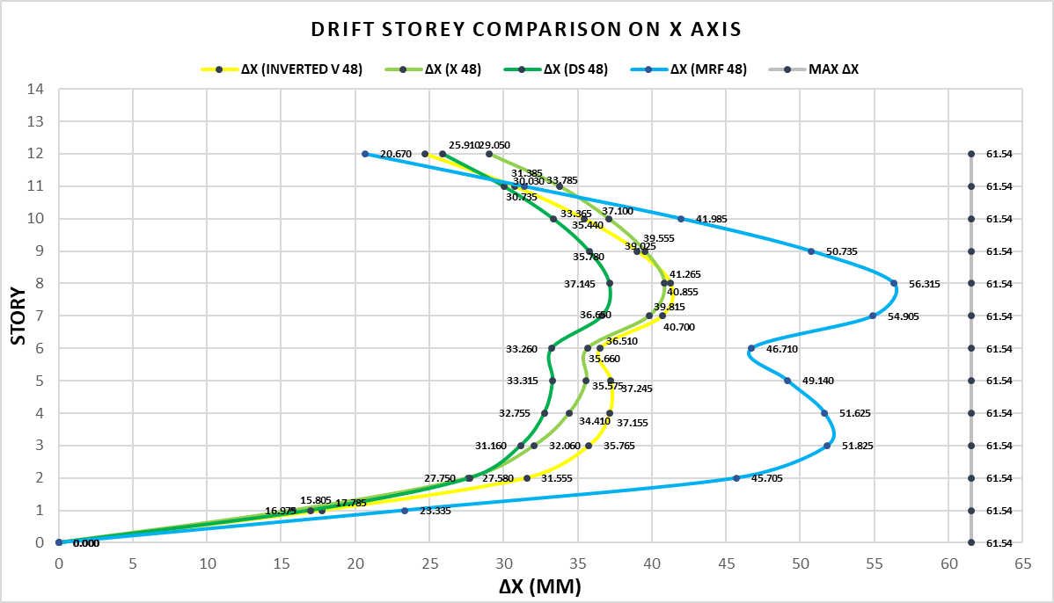
Figure 4. Drift Storey Comparison on X Axis
Table 4. Summary of the structural drift storey with CBF bracing variations
Diagonal (48 m) |  | Inverted V (48 m) |  | X (48 m) |  | MRF (48)
Floor | Δy | Floor | Δy | Floor | Δy | Floor | Δy
12 | 25,910 | 12 | 24,710 | 12 | 29,050 | 12 | 20,670
11 | 30,030 | 11 | 30,735 | 11 | 33,785 | 11 | 31,385
10 | 33,365 | 10 | 35,440 | 10 | 37,100 | 10 | 41,985
9 | 35,780 | 9 | 39,025 | 9 | 39,555 | 9 | 50,735
8 | 37,145 | 8 | 41,265 | 8 | 40,855 | 8 | 56,315
7 | 36,650 | 7 | 40,700 | 7 | 39,815 | 7 | 54,905
6 | 33,260 | 6 | 36,510 | 6 | 35,660 | 6 | 46,710
5 | 33,315 | 5 | 37,245 | 5 | 35,575 | 5 | 49,140
4 | 32,755 | 4 | 37,155 | 4 | 34,410 | 4 | 51,625
3 | 31,160 | 3 | 35,765 | 3 | 32,060 | 3 | 51,825
2 | 27,750 | 2 | 31,555 | 2 | 27,580 | 2 | 45,705
1 | 16,975 | 1 | 17,785 | 1 | 15,805 | 1 | 23,335
Base | 0,000 | Base | 0,000 | Base | 0,000 | Base | 0,000
Drift storey or inter-storey drift is the ratio of the drift occurring between storeys to the inter-storey height. The inter-storey drift value is multiplied by Cd and divided by I. The Cd value, in accordance with SNI 1726:2020 section 7.2.2, is 5 for a concentric bracing frame system. The drift storey must not exceed the permitted floor-to-floor deflection. For all levels classified as seismic risk category II, the deflection must not exceed 0.020 times the floor height or 80 mm, in accordance with SNI 1726:2020 Section 7.12.3. To compare the performance of the drift storey of the structure, different modelling approaches were examined, namely modelling using several variations of bracing configurations, and for the second modelling, no bracing was used. Modelling using variations of CBF bracing with types Diagonal Braced CBF, Inverted V-Braced CBF, and X-Braced CBF. The following are the values of the structural drift storey of CBF and MRF portal frames in a 48-metre building, as shown in Figure 4. When examining the use of several variations of CBF and MRF bracing, the largest structural storey drift value was found in the MRF portal at 56.315 mm, and for the CBF portal, the largest storey drift occurred in the Inverted V-Braced CBF portal at 41.625 mm, with a maximum storey drift limit of 61.54 mm. When examining the use of CBF bracing variations such as Diagonal Braced CBF, Inverted V-Braced CBF, and X-Braced CBF, the largest structural drift ratio was found in the Inverted V -Braced CBF portal at 41.625 mm, followed by the X-Braced CBF at 40.855 mm, and the smallest being the Diagonal Braced CBF at 31.145 mm. A summary of the structural drift storey with CBF bracing variations of Diagonal Braced CBF, Inverted V-Braced CBF, and X-Braced CBF, as well as MRF in a 48 m building, is presented in Table 4.
Correlated with structural deviation and drift ratio, it can be concluded that the addition of CBF portal bracing can significantly reduce structural storey drift compared to structures using only MRF portal bracing. In Diagonal Braced, storey drift shows an increase from the ground floor to the 8th floor, then begins to decrease with the highest value on the 8th floor (37.145 mm). The Diagonal Braced structure exhibits relatively consistent performance, with moderate variations in storey drift. The relatively good performance of the Diagonal Braced structure in the middle section (floors 4 to 8) indicates that the structure is effective in reducing deflection. In the Inverted V-Braced structure, the drift storey also increases from the ground floor to the 8th floor, reaching its highest value on the 8th floor (41,265 mm), then decreases. The Inverted V-Braced structure exhibits good deflection performance but is slightly more flexible than the Diagonal Braced structure. It has performance similar to the X-Braced structure but with slightly lower and higher drift storey values on some floors. In the X-Braced structure, the storey drift increases significantly up to the 8th floor (40,855 mm) and then decreases. The X-Braced structure shows fairly good storey drift performance values, similar to the Inverted V-Braced structure but with higher values than the Diagonal Braced structure. These values indicate fairly good performance but slightly more flexibility. In the MRF structure, the highest storey drift is observed on all floors, indicating the most flexible performance among all CBF configurations. The high storey drift indicates that the MRF structure experiences greater inter-floor deflection, which may impact stability and occupant comfort. In the context of storey drift in high-rise buildings, the Diagonal Braced structure shows the best performance with the smallest storey drift, indicating good performance and excellent stability. X-Braced and Inverted V-Braced also show fairly good performance, with slightly higher deflection values but still effective. MRF has the lowest performance with the highest floor drift, indicating that MRF is less optimal in terms of floor drift performance.

Structural Performance Level
Table 5. Recapitulation of Performance Level Values for Target Deviation of Building 48 m
Model | Disp of Performance Point | H | Drift Ratio
Model | mm | mm | Drift Ratio
Diagonal Braced 48 | 218,297 | 48000 | 0,0045479
Inverted V-Braced 48 | 228,363 | 48000 | 0,0047576
X-Braced 48 | 232,001 | 48000 | 0,0048334
MRF 48 | 309,068 | 48000 | 0,0064389

Table 6. Performance Level at 48 m Building
Model | IO | DC | LS | CP
Model | 0,01 | 0,01-0,02 | 0,02 | 0,33
Diagonal Braced 48 | V
Inverted V-Braced 48 | V
X-Braced 48 | V
MRF 48 | V

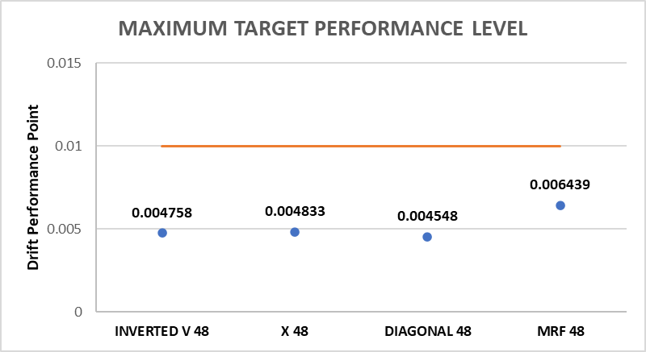
Figure 5. Performance Point on each structure
To determine the comparison of structural performance levels, the difference in modelling is examined, namely modelling using several variations of bracing configurations, and for the second modelling, bracing is not used. Modelling using CBF bracing variations with Diagonal Braced CBF, Inverted V-Braced CBF, and X-Braced CBF types. The following are the performance levels of the CBF and MRF portal structures in the 48-metre building, as detailed in Tables 5 and 6. From the comparative analysis conducted, with the target performance level being life safety (LS). Tables 5 and 6, along with Figure 5, show that at the Performance Point, the plastic hinges formed are still at the Immediate Occupancy (IO) level. Therefore, the structures of each modelling can be classified as having very good performance, even better than the desired target. Diagonal Braced excels in stiffness and has the lowest potential for non-structural damage. Inverted V-Braced and X-Braced also perform well, with slightly more deformation compared to Diagonal Braced. MRF is more flexible but still meets the Immediate Occupancy (IO) category, though with a slightly higher risk of non-structural damage.
Table 7. Performance Point Recapitulation of Inelastic Building 48 m
Model | Displacement of Performance Point (mm) | H (mm) | Drift Ratio
Diagonal Braced 48 | 158,297 | 48000 | 0,0032979
Inverted V-Braced 48 | 182,649 | 48000 | 0,0038052
X-Braced 48 | 152,001 | 48000 | 0,0031667
MRF 48 | 209,068 | 48000 | 0,0043556

Table 8. Performance Level Recapitulation of Inelastic Building 48 m
Model | IO | DC | LS | CP
Model | 0,005 | 0,005-0,015 | No Limit | No Limit
Diagonal Braced 48 | V
Inverted V-Braced 48 | V
X-Braced 48 | V
MRF 48 | V
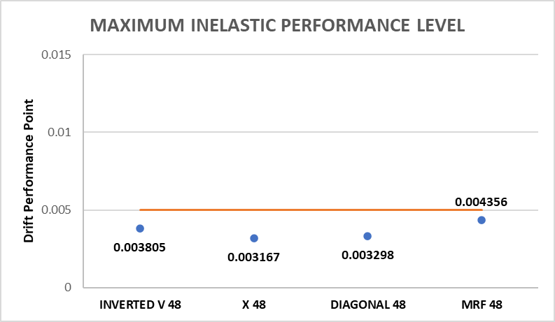
Figure 6. Maximum inelastic performance level of each structure
When we look at the inelastic deflection, from the comparative analysis that has been done, with the target performance level being life safety (LS), Tables 7 and 8, along with Figure 6, show that at the Performance Point, the plastic hinges formed are still within the Immediate Occupancy (IO) level for the Diagonal Braced CBF, Inverted V-Braced CBF, and X-Braced CBF portals. In Figure 6, the MRF structure has the highest drift performance point value of 0.004356, followed by diagonal, x braced, and inverted V, which are 0.003298, 0.003167, and 0.003805, respectively. This value is obtained from the ratio between the displacement of the performance point divided by the height of the building, as shown in Table 7. For the MRF portal, the plastic hinges formed are very close to the Damage Control (DC) level. As shown in Table 8, a structure is considered to have a performance level in the DC category if the calculated ratio has a value of 0.005-0.015. Meanwhile, if the ratio value is below 0.005, the structure collapse mechanism falls into the immediate occupancy classification. Therefore, the addition of braced portals can provide a better structural performance level compared to the MRF portal. Additionally, the structures of each model can be classified as having very good performance, even better than the required target. X-Braced provides the best performance in inelastic conditions with the smallest deflection, making it very rigid and ideal for direct post-earthquake functionality. Inverted V-Braced and Diagonal Braced are alternative options, with slightly more inelastic deformation, but still within the safe IO category. MRF is very close to the Damage Control (DC) category, showing the greatest deformation and requiring repairs after an earthquake before it can be used again.

CONCLUSION
Based on the results of the analysis from the research conducted, including spectrum response and pushover analyses of the eight models analyzed, the conclusion of this study is that for high-rise buildings, Diagonal Braced and X-Braced are the best choices for reducing lateral displacement and improving stability. Inverted V-Braced is also quite good, while MRF is suitable for buildings that require high flexibility even though the displacement is greater. On the other hand, for low-rise buildings, Inverted V-Braced is the primary choice for efficiency, while X-Braced and Diagonal Braced can serve as adequate alternatives. MRF can also be used for high flexibility but with larger deflections. In terms of drift ratio, Diagonal Braced is most effective for high-rise buildings, followed by X-Braced and Inverted V-Braced, while MRF has the largest drift ratio. For low-rise buildings, Inverted V-Braced is the most efficient primary choice. For drift storeys, Diagonal Braced shows the best performance, with X-Braced and Inverted V-Braced also effective, while MRF shows the lowest performance. In terms of stress ratio and internal forces, for high-rise buildings, Inverted V-Braced is recommended for long-term efficiency and the best distribution of internal forces, while Diagonal Braced is suitable for high loads with good internal force distribution, and X-Braced offers a balance between capacity and load, though with less-than-optimal load distribution, resulting in less-than-optimal bracing performance. In low-rise buildings, Diagonal Braced is best for efficiency and safety, Inverted V-Braced is suitable for high workloads, and X-Braced balances capacity and load. In terms of structural performance, the entire structure still falls under the Immediate Occupancy (IO) category, meaning the structure performs better than the initial target of Life Safety (LS). Diagonal Braced excels in stiffness and minimizes non-structural damage, while Inverted V-Braced and X-Braced are also good. MRF is more flexible but has a higher risk of non-structural damage. In high-rise buildings, if high energy dissipation is required, MRF or X-Braced are the best choices, while Diagonal Braced is suitable for stability and deflection control. Inverted V-Braced strikes a balance between energy dissipation and stiffness. This also applies to low-rise buildings.
REFERENCES
[1] D. Kurniati, M. Z. Fauzi, R. Ripangi, A. Falegas, and I. Indria, “Klasterisasi Daerah Rawan Gempa Bumi di Indonesia Menggunakan Algoritma K-Medoids,” MALCOM: Indonesian Journal of Machine Learning and Computer Science, vol. 1, no. 1, 2021, doi: 10.57152/malcom.v1i1.61.
[2] I. N. Setiawan, D. Krismawati, S. Pramana, and E. Tanur, “Klasterisasi Wilayah Rentan Bencana Alam Berupa Gerakan Tanah Dan Gempa Bumi Di Indonesia,” Seminar Nasional Official Statistics, vol. 2022, no. 1, 2022, doi: 10.34123/semnasoffstat.v2022i1.1538.
[3] N. Rochmah, M. Beatrix, and B. Sutriono, “STUDI PERENCANAAN GEDUNG TINGKAT TINGGI DAN GEDUNG TINGKAT RENDAH DENGAN MENGGUNAKAN BRESING KONSENTRIK,” EXTRAPOLASI, vol. 18, no. 2, 2021, doi: 10.30996/extrapolasi.v18i2.6019.
[4] Imad Shakir, Mohammed Ahmed Jasim, and Sardasht S. Weli, “High Rise Buildings: Design, Analysis, and Safety,” International Journal of Architectural Engineering Technology, vol. 8, 2021, doi: 10.15377/2409-9821.2021.08.1.
[5] A. D. Sen, C. W. Roeder, D. E. Lehman, and J. W. Berman, “Nonlinear modeling of concentrically braced frames,” J Constr Steel Res, vol. 157, 2019, doi: 10.1016/j.jcsr.2019.02.007.
[6] C. R. Bradley, L. A. Fahnestock, and E. M. Hines, “Dual system design for a low-ductility concentrically braced frame with a reserve moment frame,” Structures, vol. 34, 2021, doi: 10.1016/j.istruc.2021.09.009.
[7] B. Rangaraj, K. Nalinaa, M. Ashokkumar, P. Deepalakshmi, S. Rishika, and M. S. Vaishnavi Devi, “Comparative analysis of unbraced and chevron braced steel buildings of different storeys,” Mater Today Proc, 2023, doi: 10.1016/j.matpr.2023.05.378.
[8] T. Y. Yang, H. Sheikh, and L. Tobber, “Influence of the brace configurations on the seismic performance of steel concentrically braced frames,” Front Built Environ, vol. 5, 2019, doi: 10.3389/fbuil.2019.00027.
[9] O. Seker, “Seismic response of dual concentrically braced steel frames with various bracing configurations,” J Constr Steel Res, vol. 188, 2022, doi: 10.1016/j.jcsr.2021.107057.
[10] F. Barbagallo, M. Bosco, E. M. Marino, and P. P. Rossi, “Proposal and validation of a design procedure for concentrically braced frames in the chevron configuration,” Earthq Eng Struct Dyn, vol. 50, no. 11, 2021, doi: 10.1002/eqe.3499.
[11] A. Panjaitan et al., “The Performance of Concentrically Braced Frames (CBF) in Chevron V Brace and Diagonal Configuration by Considering Various Frame Heights,” Aceh International Journal of Science and Technology, vol. 12, no. 2, 2023, doi: 10.13170/aijst.12.2.30848.
[12] A. Jufriansah, Y. Pramudya, A. Khusnani, and S. Saputra, “Analysis of Earthquake Activity in Indonesia by Clustering Method,” Journal of Physics: Theories and Applications, vol. 5, no. 2, 2021, doi: 10.20961/jphystheor-appl.v5i2.59133.
[13] I. Bali, “On-Site Earthquake Early Warning System as an Alternative Earthquake Mitigation Solution in Indonesia,” PRESUNIVE CIVIL ENGINEERING JOURNAL, vol. 1, no. 1, 2023, doi: 10.33021/pcej.v1i1.4245.
[14] K. Satake et al., “Tsunami Source of the 2010 Mentawai, Indonesia Earthquake Inferred from Tsunami Field Survey and Waveform Modeling,” Pure Appl Geophys, vol. 170, no. 9–10, 2013, doi: 10.1007/s00024-012-0536-y.
[15] S. Widiyantoro et al., “Implications for megathrust earthquakes and tsunamis from seismic gaps south of Java Indonesia,” Sci Rep, vol. 10, no. 1, 2020, doi: 10.1038/s41598-020-72142-z.
[16] J. H. Ling, Y. T. Lim, and E. Jusli, “Methods to Determine Ductility of Structural Members: A Review,” Journal of the Civil Engineering Forum, 2023, doi: 10.22146/jcef.6631.

