Enhancing Service Quality of Trans Jatim BRT Bus Stops Based on User Preferences: A Case Study of Corridor 1 Gresik–Surabaya–Sidoarjo
Hairil Fausan Lutfi Anwar ^{1, b)}, Amalia Nur Adibah ^{2, a)}, Khoirul Abadi ^{3,c)}
¹²³ Department of Civil Engineering, Engineering Faculty, University of Muhammadiyah Malang, Malang, Indonesia
^{(a)}Corresponding author : amalianuradibah@umm.ac.id
^{(b)}hairilfausanlutfi@gmail.com
^{(b)}khoirul@gmail.com

Abstract. Well-designed bus stops are vital to the efficiency of Bus Rapid Transit (BRT) systems, which aim to reduce congestion, decrease reliance on private vehicles, and improve public service quality. In the fast-growing Gerbangkertosusila metropolitan area (Gresik–Surabaya–Sidoarjo), the Trans East Java Corridor 1 BRT was introduced to address increasing mobility needs. However, inconsistencies in bus stop quality, limited accessibility for persons with disabilities, and insufficient fleet capacity during peak hours hinder service performance.
This study assesses bus stop service quality based on user perceptions and preferences, with the aim of formulating improvement strategies. A mixed-methods approach was applied, combining field observations with surveys of 100 respondents. Data were analyzed using the Kano Model, Refined Kano Model, and Importance–Satisfaction Model to classify and prioritize service attributes.
Ten attributes were identified for optimization, most falling into the “must-be” or “one-dimensional” categories, highlighting their significance in shaping user satisfaction. While some achieved surplus or excellent satisfaction ratings, notable gaps were found in security facilities, real-time information provision, waiting area comfort, and accessibility for disabled passengers. Recommended measures include upgrading safety infrastructure, enhancing information systems, improving waiting facilities, and ensuring inclusive design. These actions are expected to boost service quality, encourage public transport use, and support sustainable BRT operations.

Keyword: BRT, bus stop, user perception, service quality, design

INTRODUCTION
In a modern and integrated transportation system, bus stops (stops) not only function as designated stopping points for public vehicles but also function as service centers that support the comfort, safety, and efficiency of public travel [1]. Well-designed bus stops are an important component in ensuring the smooth operation of the public transportation system, especially for Bus Rapid Transit (BRT) services. which is intended as a solution to traffic congestion and efforts to improve the quality of public transportation. Bus stops or shelters are places to pick up and drop off bus passengers, usually placed on the bus transportation service network [2]. The Gresik, Surabaya, and Sidoarjo areas are part of the Kertosusila Gate metropolitan area that have experienced rapid population growth and economic activity. With a vast and diverse area ranging from coastal areas to densely populated industrial and residential zones, the demand for efficient and affordable public transportation is becoming increasingly urgent. In this context, the Trans East Java BRT service operating in the Gresik–Surabaya–Sidoarjo corridor was introduced as an initiative of the provincial government to provide an accessible, integrated, and reliable mode of mass transportation [3][4].
Since its initial launch, Trans Jatim has seen a significant increase in daily passengers, from around 2,800 – 3,000 passengers in the first week to around 3,500 – 4,000 passengers per day in the following period [5]. This upward trend reflects the increasing reliance of people on mass transportation services and highlights the importance of adequate supporting infrastructure, such as bus stops, in ensuring service quality.
However, real-world conditions reveal that the quality of bus stops in Corridor 1 of the Trans East Java BRT system has not met the expectations of the community. Complaints have arisen regarding the inconsistency of the facilities, while some stops are equipped with adequate seating and lighting, others do not even have basic facilities. In addition, only a handful of bus stops are equipped with additional features such as wifi, CCTV, and route information that are clearly displayed, resulting in a difference in the quality of service across the network [6]. Another important issue is the limited number of operational buses, which leads to overcapacity during peak hours [7]. In addition, many bus stops lack accessibility features for people with disabilities, posing significant challenges to inclusive mobility. This problem shows that although Trans East Java services have succeeded in attracting users, the quality of its supporting infrastructure, especially bus stops, has not developed in parallel to meet the increasing demand.
These issues show the urgent need for a comprehensive evaluation of the design and condition of the existing Trans Jatim bus stops. This study is important to identify problems that arise regarding bus stops during the operation of the Trans East Java BRT that need to be considered and reviewed in the form of updating or improving the design of the bus stop. The renewal or improvement of the bus stop design aims to improve the quality of service so that it can compete in an increasingly competitive industry and maintain community satisfaction [8].

METHODS
This study uses a combined approach between qualitative and quantitative methods (mixed methods) to analyze the influence of bus stop facility design on the satisfaction of BRT Trans Jatim Corridor 1 users. A qualitative approach is used to describe the existing conditions of the bus stop design through user observation and perception, while a quantitative approach is applied to test the relationships between variables using simple linear regression analysis.
The study was conducted along Corridor 1 of Trans East Java which serves the Gresik-Surabaya-Sidoarjo route, with data collection carried out during July-August 2025. Data was collected through field observation and the distribution of questionnaires to active BRT users, especially during peak hours both weekdays and weekends to ensure a valid representation. The study population included all daily users of BRT Trans East Java Corridor 1, with sample determination using the Slovin formula and a margin of error of 10%, resulting in 100 respondents from 6,978 users who were considered sufficiently representative of user characteristics [9].
The research variables were determined based on terminal service standards in the Ministry of Transportation regulations, which include aspects of safety, security, order, comfort, convenience, and equality. Each variable reflects the attributes of the bus stop service that affect user satisfaction. The analysis technique used is the canoe method, which classifies service attributes based on the user's perception of the presence and absence of certain features. The incorporation of Kano's analysis with a 7-point likert scale to measure interest and satisfaction levels results in a service priority matrix. This allows researchers to map attributes that are top priorities for improvement as well as maintain attributes that have met user expectations.

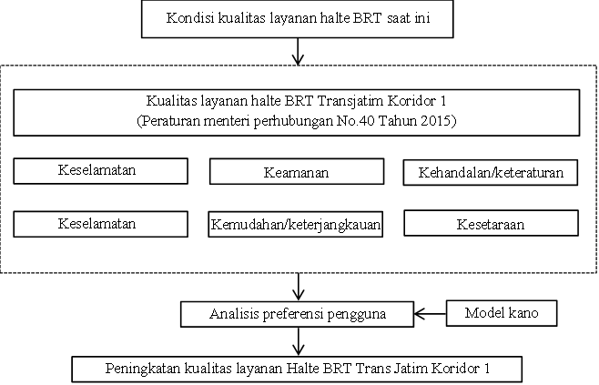
Figure 1. Flowchart

In the analysis of the canoe model, the attributes in the service are classified into four main categories. First, the must be attribute is a basic requirement that if not available will cause user dissatisfaction, but its presence does not contribute significantly to increased satisfaction. Second, the one-dimensional attribute shows a linear relationship between service performance and user satisfaction, where the higher the level of service provided, the higher the level of satisfaction felt. Third, the atrractive attribute is able to significantly increase satisfaction when given, but its absence does not necessarily decrease user satisfaction. Fourth, the indifferent attribute is an element whose existence does not significantly affect the level of user satisfaction [10]. This classification serves as the basis for evaluating service development priorities based on user perceptions and preferences.

RESULT and DISCUSSION
This research aims to evaluate and assess the quality of Trans Jatim Corridor 1 Bus Rapid Transit (BRT) bus stop services based on user perceptions and preferences. The focus of the research is directed at various aspects of bus stop services, such as safety, security, order, comfort, ease of access, and equality of facilities. This research also aims to identify the most influential service attributes in terms of satisfaction and map the priorities for improving bus stop services in a structured and data-based manner

Safety

The safety variables in this study include two main indicators, namely the availability of information and the existence of health facilities. Safety information includes clear evacuation route and gathering point instructions that are easily accessible to hlate users. Meanwhile, health facilities include health posts with first equipment, and medical workers who are ready to provide assistance when needed. These two aspects illustrate the efforts of the bus stop in ensuring physical safety and preparedness for the situation for all users.
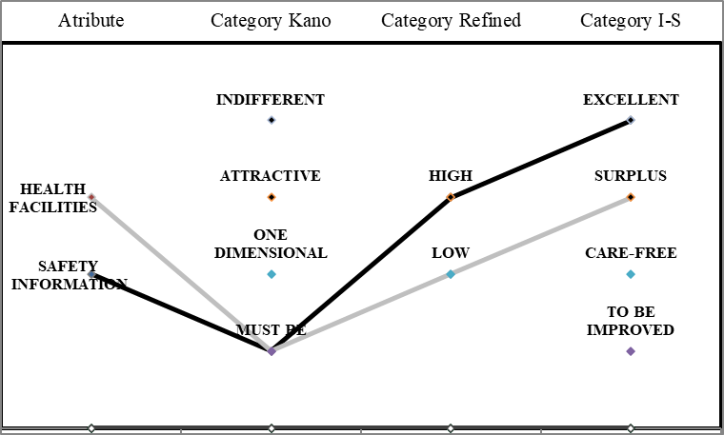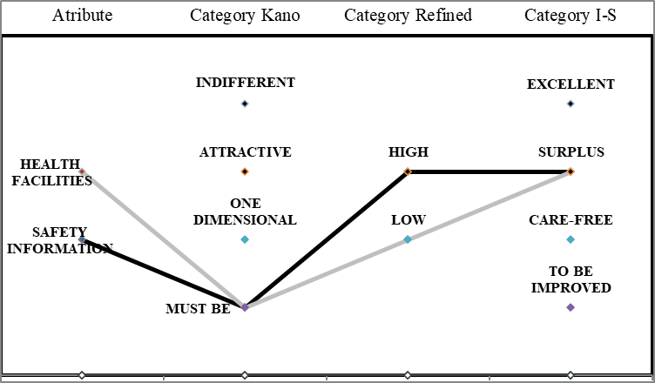
- (b)
Figure 2. Quality of Trans East Java BRT Bus Stop Facility Safety Variables

FIGURE 2, shows the safety information and health facilities that these two attributes are categorized as must be in the Canoe Model on weekdays (a) and weekends (b). This shows that users value the safety aspect as fundamental. In refined canoe models, these attributes are classified as high (safety information attributes) and low (health facilities attributes), emphasizing the importance of the role of safety information and health posts in increasing a sense of security. In the Importance-Satisfaction model, the safety information attribute is in the category of excellent (weekday) and surplus (weekend), while the attribute of healt facilities is also in the surplus category, indicating that although healthcare facilities are considered important, the level of user satisfaction has exceeded their expectations

Security

The security variable focuses on the efforts of service providers in maintaining the condition of the bus stop from potential disturbances that threaten the order and comfort of users. The indicators used include the existence of media for complaints of security disturbances in the form of stickers containing complaint contacts, the existence of a surveillance system through cameras.
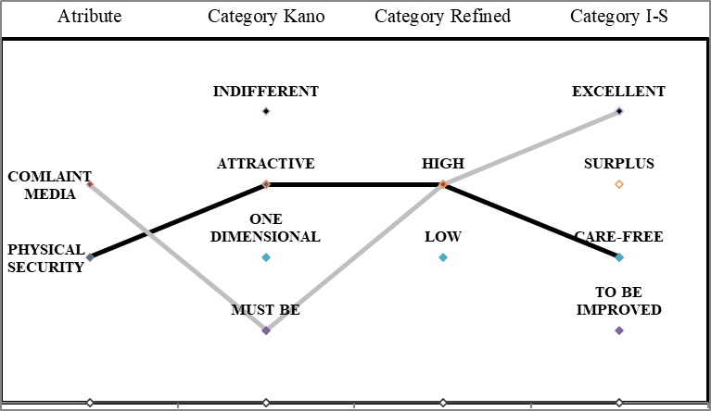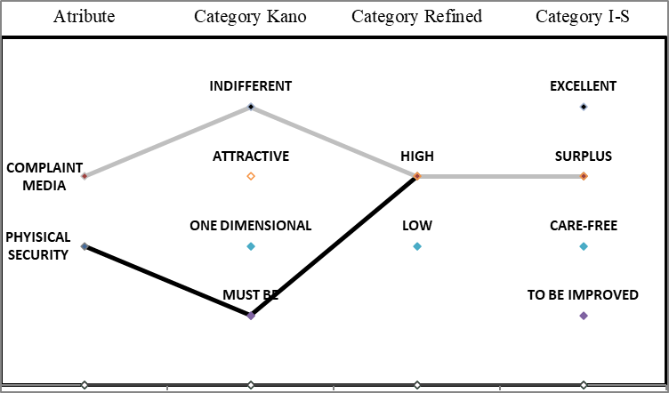
- (b)
Figure 3. the quality of Trans East Java BRT Bus Stop facilities safety variables

FIGURE 3, shows safety information and health facilities that physical security attributes include attractive on weekday (a) and must be on weekend (b). Despite these differences in perception, both are categorized as high in refined canoes as well as surplus and care-free in the Importance-Satisfaction model. This shows that good physical security is highly valued by users, even if it is not always expressed as an explicit need. The media complaint attribute is in the category of must be on weekdays, but becomes indifferent on weekends. However, in both times, these attributes are in the surplus and excellent categories, which indicates that the provision of good schedule information has exceeded the expectations of users.

Reliability/Regularity

The variable of reliability or regularity relates to the consistency, certainty, and regularity of the services offered by the transportation system. In this study, the indicators of this variable include the availability of information on the arrival and departure schedule of vehicles, as well as the existence of information on routes or public transportation routes.
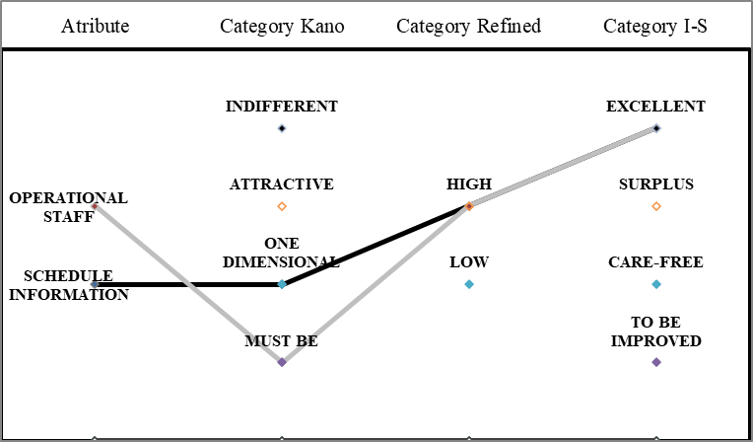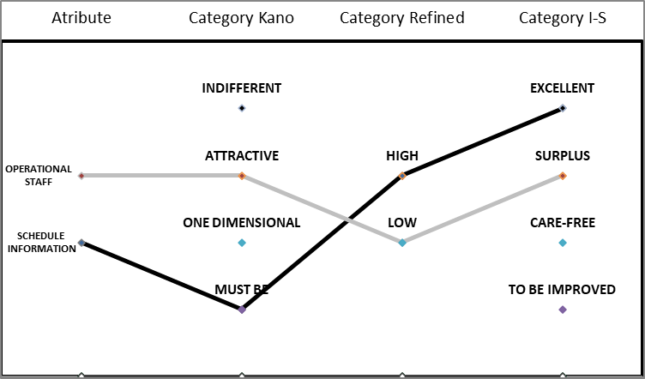
- (b)
Figure 4. quality of Trans East Java BRT Bus Stop facilities reliability variable

Figure 4, shows that the schedule information attribute is categorized as one dimensional on weekday (a) and must be on weekend (b) in the canoe model, as well as included high in the refined canoe model for both times. These findings suggest that schedule availability is an important element that directly affects user satisfaction, especially as a baseline expectation on weekends. In the Importance-Satisfaction model, this attribute is consistently in the excellent category, indicating that the delivery of schedule information has run optimally and exceeded user expectations. Meanwhile, the attributes of the existence of operational officers show differences in perception between times. On weekdays, this attribute is a must be in model canoes and high in refined model canoes, reflecting the importance of the officer's role as a basic element of service directly influencing satisfaction. On the contrary, on weekends these attributes include attractive in canoe models and low in rifened canoe models, indicating that the presence of officers is more considered a plus. In the Importance-Satisfaction model, this attribute is classified as excellent on weekdays and surplus on weekends, indicating that the service quality of the officer has exceeded the user's expectations.

Comfort

The comfort variable refers to the physical and environmental aspects of the bus stop that support the user experience while in the place. The comfort assessment includes indicators in the form of good conditions of the waiting room, maximum lighting at night, and the existence of network facilities that support applications from BRT Trans Jatim, in this case wifi.
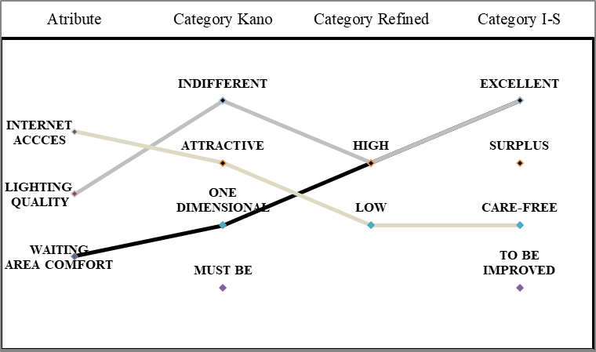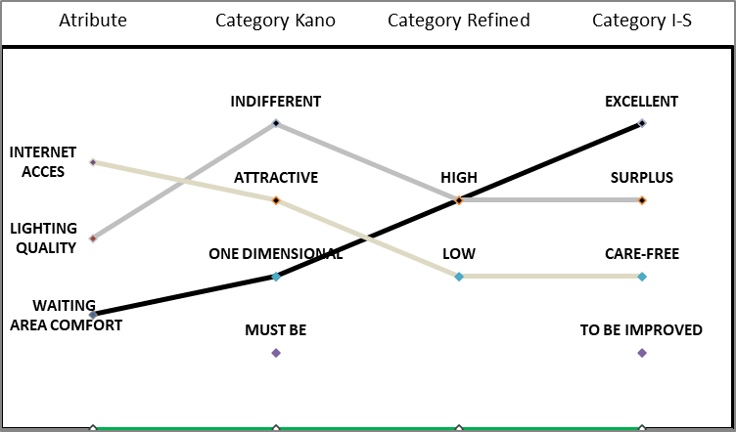
- (b)
Figure 5. quality of facilities at the Trans East Java BRT Bus Stop is a comfort variable

Figure 5, shows that the attributes of space comfort are classified as one dimensional in the canoe's model and high in refined canoe models are equally excellent in the Importance-Satisfaction model on weekdays (a) and weekends (b), indicating a direct contribution to user satisfaction. The attributes of space lighting, classified as indifferent in the canoe's model and high in refined canoe models, as well as in the category of excellent on weekdays and surplus on weekends in the Importance-Satisfaction model, indicate that lighting plays an important role even though it is not always aware of the user. Meanwhile, the internet access attribute was categorized as attractive in the canoe's model and low in the refined canoe model, as well as being in the care-free category in the Importance-Satisfaction model at both times, indicating that although it was an added value, its presence was not a priority in the assessment of user satisfaction.

Convenience/Affordability

The convenience or affordability variable in this study assesses the extent to which bus stops provide access and information that supports the smooth travel of users. There are six subvariables or attributes in this aspect, namely: the location of different passenger boarding lines; availability of service information such as schedules, tariffs, and network maps; clear advanced transportation information; battery charging facilities; a bus stop platform parallel to the bus floor; as well as a private vehicle parking area. All of these indicators show a physical and information integration that aims to facilitate the mobility of users from various backgrounds of needs.

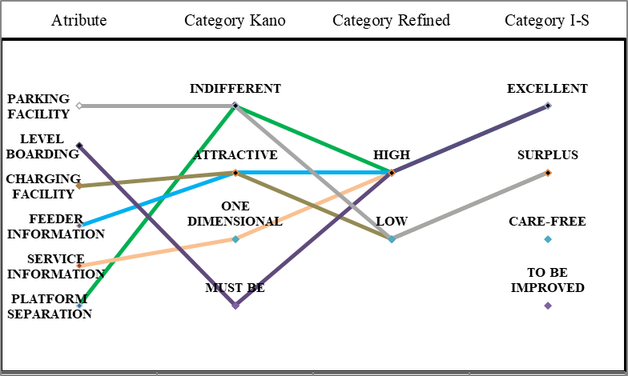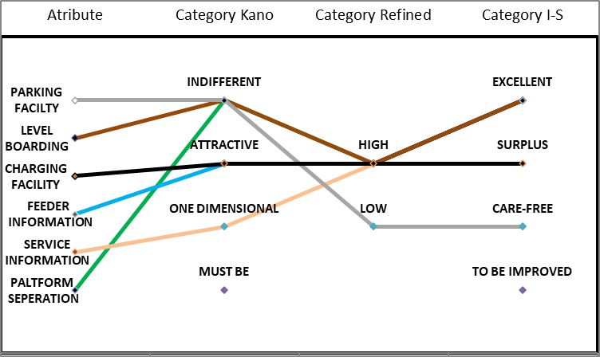
- (b)
Figure 6. quality of facilities for Trans East Java BRT Bus Stop variables convenience/affordability

FIGURE 6, shows information that the path separation attribute was classified as one dimensional on weekday (a) and indifferent on weekend (b), with high in the refined canoe model, and excellent in the Importance–Satisfaction model at both times. The attributes of service information and advanced transportation information show consistency as one dimensional and attractive in the canoe model, as well as high in the refined canoe model, and simultaneously obtain the excellent category in the Importance–Satisfaction model, which confirms the importance of service information and intermodal connectivity for users. The charging facility attributes are classified as attractive on weekends and one-dimensional on weekdays, with high values on weekends but low on weekdays in refined canoes, and are categorized as excellent and surplus in the Importance–Satisfaction model. The attributes of floor equality, categorized as must be and indifferent in model canoes, high in refined canoes, and obtaining excellent ratings at both times, signify the importance of inclusive physical accessibility. Meanwhile, the attributes of parking facilities, included in the indistinct and low-value categories in refined canoes, as well as care-free in the Importance-Satisfaction model, show that this aspect is not a priority in the perception of user satisfaction with the bus stop service.

Equality

The equality variable emphasizes the importance of fair and equal access for all users of the Trans East Java BRT corridor 1, including people with disabilities. In this study, the equality variable was measured through one main subvariable, namely the presence of a ramp (landau plane) with a maximum slope of 20%. The presence of a standard ramp allows wheelchair users, the elderly, as well as individuals with other special needs to access the bus stop without hindrance. This indicator reflects the application of universal design principles in the provision of public transport facilities, which are not only convenient and convenient, but also inclusive.
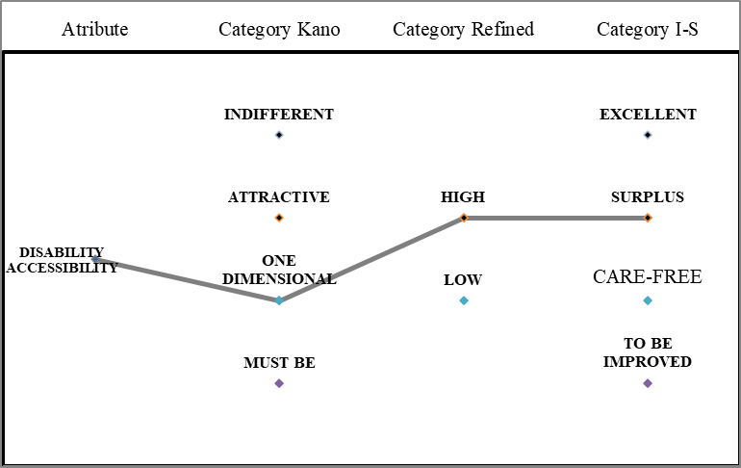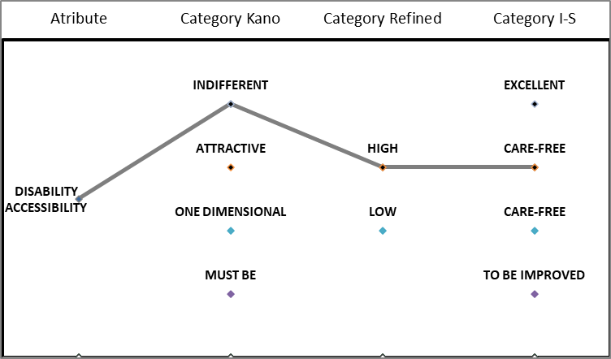
Figure 7. quality of Trans East Java BRT Bus Stop facilities equality variable

FIGURE 7, shows information that the accessibility attributes of the bus stop for the disabled through a 20% ramp slope, are classified as one dimensional on weekdays (a) and indifferent on weekends (b) in model canoes. In refined canoe models, these attributes fall into the category of high value added for both times, which indicates that the improvement of these facilities contributes significantly to user satisfaction, although on holidays it is not considered a major need. Based on the Importance-Satisfaction model, this attribute is included in the surplus category on both weekdays and weekends, indicating that the provision of accessibility has exceeded user expectations and reflects a commitment to the principle of inclusivity

Infrastructure Optimization

Based on the analysis of the canoe model, refined canoe model, and Importance-Satisfaction model, there are ten attributes that require optimization in the BRT Trans East Java Corridor 1 service, namely the physical security attribute, complaint information attribute, schedule information, operational staff, witing area comfort, service information, level boarding, and disability accessibility. Optimization is necessary because these attributes are in the category of must be or one dimensional on model canoes, which indicates that their presence greatly affects user satisfaction. In addition, the results of the Importance-Satisfaction model show that some attributes are in the surplus and excellent categories, indicating that even if the level of satisfaction is quite high, continuous improvement is still needed to maintain competitiveness and meet evolving expectations.
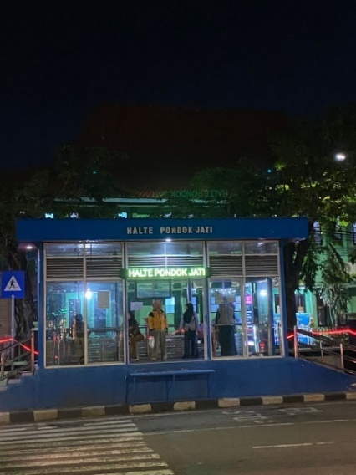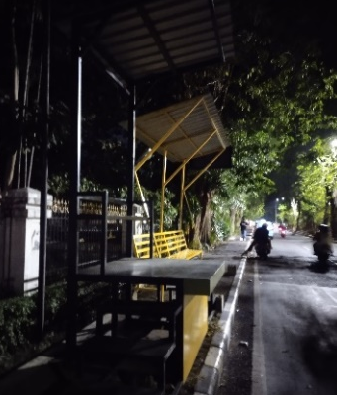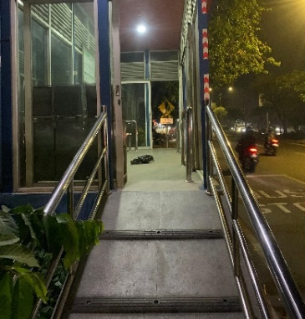
- (b) (c)
Figure 8. Existing condition of the Trans East Java BRT Bus Stop Corridor 1

FIGURE 8, the existing condition of the facilities at the Trans East Java BRT Corridor 1 bus stop which is used as a reference based on the results of the author's data analysis to allocate service attributes that need to be optimized or added. This documentation serves to map development priorities to improve convenience, security, and ease of access for users. In general, the facilities at all bus stops in corridor 1 are not uniform as shown in figures (a), (b), and (c). Some bus stops have ramps for disabled access as shown in figures (a) and (b), but the slope does not meet the maximum standard of 20% as shown in figure (c). Some bus stops are equipped with weather protection walls (a) and (c), while others do not, as in figure (b). Mobile phone charging facilities are also only available at some bus stops. In addition, there are stops that separate the passenger boarding and disembarkation areas from the seating area, as shown in figure (b), which leads to different standards of comfort and accessibility in each location.

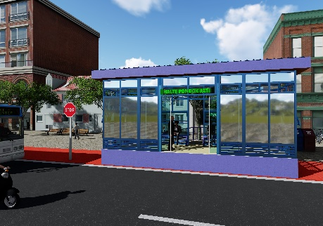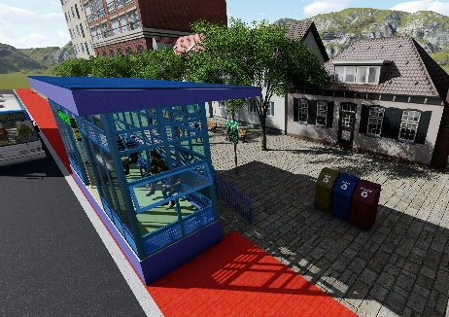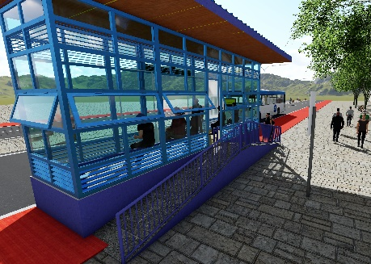
- (b) (c)
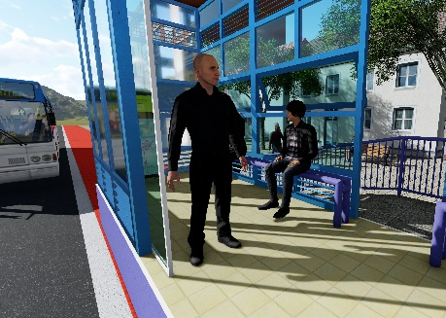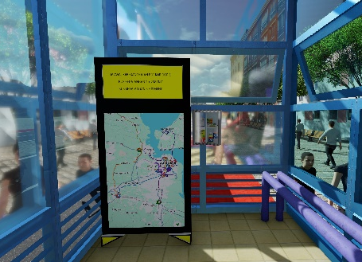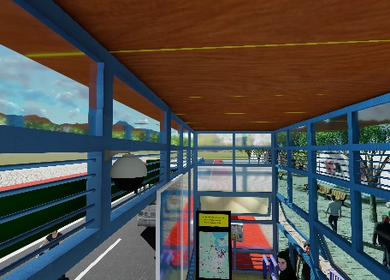
(d) (e) (f)
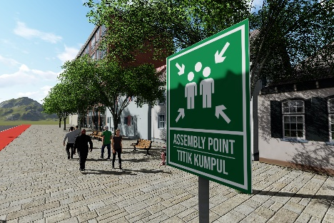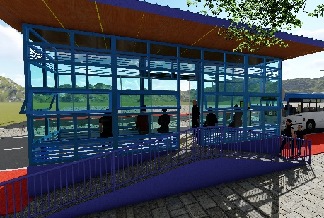
(g) (h)
Figure 9. The results of the design of optimizing the attributes of the Trans East Java BRT Bus Stop corridor 1
FIGURE 9, the results of the design of optimizing the attributes of the Trans East Java BRT Corridor 1 stop are based on the priority of improvement from the results of the research analysis. Figures (a), (b), and (c) show the physical condition of the bus stop's exterior after design optimization. Figure (d) shows the placement of personnel who function as operational officers. Figure (e) shows an LED display containing media complaints about security disturbances, bus arrival and departure schedules, as well as service information including schedules, tariffs, network maps, with a P3K box on the side of the device. Figure (f) shows the installation of CCTV surveillance cameras for security control. Figure (g) illustrates safety facilities in the form of evacuation routes and assembly points. Figure (h) shows a ramp facility with a 20% slope to facilitate access for people with disabilities and users with reduced mobility.

CONCLUSION
This study reveals that the quality of the Trans East Java BRT Corridor 1 bus stop service still requires optimization on several key attributes that affect user satisfaction. Based on the analysis of the Kano Model, Refined Kano Model, and Importance-Satisfaction Model, the ten priority attributes that need to be improved include physical security, complaint information, schedule information, operational staff, waiting area comfort, service information, level
boarding, and disability accessibility. This optimization is important considering that these attributes are mostly a must be or have a direct relationship with user satisfaction (one dimensional). The optimization design produced in this study recommends the addition and improvement of security facilities, the provision of comprehensive information, the improvement of waiting room comfort, and the provision of adequate accessibility for persons with disabilities. The implementation of this recommendation is expected to improve the quality of bus stop services, maintain user satisfaction, and support the goal of the Trans East Java BRT as an efficient, integrated, and inclusive mode of public transportation.

Reference
[1] M. V. Corazza and N. Favaretto, “A methodology to evaluate accessibility to bus stops as a contribution to improve sustainability in urban mobility,” Sustainability (Switzerland), vol. 11, no. 3, Feb. 2019, doi: 10.3390/su11030803.
[2] I. W. I. R. Arnaya, “Keefektifan Halte Terhadap Kemacetan,” J. Teknol. Transp. dan Logistik, vol. 1, no. 1, 2020.
[3] gresikkab, “Resmi Beroperasi, Bupati Gresik Hadiri Launching Bus Trans Jatim,” gresikkab. Accessed: Jul. 25, 2025. [Online]. Available: https://gresikkab.go.id/index.php/detail_news/resmi-beroperasi-bupati-gresik-hadiri-launching-bus-trans-jatim-koridor-i?utm_source=chatgpt.com
[4] R. A. Firmansyah and K. H. Putra, “ANALISIS TINGKAT KEPUASAN PENGGUNA TRANSPORTASI UMUM ‘SUROBOYO BUS’ RUTE HALTE RAJAWALI-TERMINAL PURABAYA DENGAN METODE IMPORTANCE PERFORMANCE ANALYSIS (IPA).”
[5] F. Lailatul Fitri and Y. Cikusin, “KUALITAS LAYANAN TRANSPORTASI PUBLIK DI JAWA TIMUR (Studi Kasus: Pelayanan Transportasi Publik Bus Trans Jatim Koridor I Rute Gresik-Surabaya-Sidoarjo),” 2023.
[6] P. Alifiah and J. Widodo, “EVALUASI KINERJA PENGOPERASIAN BUS TRANS JATIM DI KABUPATEN SIDOARJO JATIM,” Journal of Governance and Public Administration (JoGaPA), vol. 1, no. 4, 2024.
[7] Radar Gresik, “Banyaknya Peminat Trans Jatim tidak Diiring dengan Jumlah Armada,” https://radargresik.jawapos.com/pendidikan/83940495/banyaknya-peminat-trans-jatim-tidak-diiringi-dengan-jumlah-armada?utm_source=chatgpt.com. Accessed: Jul. 29, 2025. [Online]. Available: https://radargresik.jawapos.com/pendidikan/83940495/banyaknya-peminat-trans-jatim-tidak-diiringi-dengan-jumlah-armada?utm_source=chatgpt.com
[8] C. Mokoginta et al., “PENINGKATAN KUALITAS PELAYANAN UNTUK KEPUASAN PUBLIK PADA PENGADILAN TATA USAHA NEGARA MANADO,” 2023.
[9] JPPN, “Hari Angkutan Nasional, Gubernur Khofifah Gratiskan Bus Trans Jatim Sehari Penuh.” Accessed: Jul. 17, 2025. [Online]. Available: https://jatim.jpnn.com/jatim-terkini/36900/hari-angkutan-nasional-gubernur-khofifah-gratiskan-bus-trans-jatim-sehari-penuh#:~:text=Data%20Dinas%20Perhubungan%20Jawa%20Timur%20menunjukkan%20tingkat%20okupansi,Koridor%201%20menjadi%20rute%20tersibuk%2C%20yakni%20627.946%20penumpang
[10] A. N. Adibah and O. R. Manullang, “The Assessment of BRT Trans Semarang Service Quality,” in IOP Conference Series: Materials Science and Engineering, Institute of Physics Publishing, Mar. 2020. doi: 10.1088/1757-899X/771/1/012045.

