Advancing Service Quality in Bus Rapid Transit: Evaluation and Enhancement of Trans Jatim Corridor 1 (Gresik–Surabaya–Sidoarjo)
Muhammad Hajid Mufid^{1,a)}, Amalia Nur Adibah^{2,b)}, Sunarto ^{3,c)}
¹²³Department of Civil Engineering, Engineering Faculty, University of Muhammadiyah Malang, Malang, Indonesia

^{(c)}Corresponding author : narto@umm.ac.id
^{(a)} hajidkeren28@gmail.com
^{(b)} amalianuradibah@umm.ac.id
Abstract. The rapid growth of urban areas has heightened the demand for safe, comfortable, and efficient public transportation. The Trans East Java Bus Rapid Transit (BRT) Corridor 1, serving the Gresik–Surabaya–Sidoarjo route, was introduced to help reduce congestion and dependence on private vehicles. This study evaluates the condition of the Trans East Java BRT Corridor 1 fleet based on five aspects of the Minimum Service Standards (SPM) stipulated in the Regulation of the Minister of Transportation No. 27 of 2015: security, safety, comfort, affordability, and equality.
A descriptive quantitative method was applied through direct observation of 31 buses, assessing factors such as the completeness of security facilities, the feasibility and safety equipment, passenger comfort during peak and non-peak hours, route network integration, and accessibility for persons with disabilities.
The results show that security and affordability achieved perfect scores (100%), indicating that related facilities are complete and functional. Safety scored 94.7%, with the main shortcoming being the absence of seat belts on all buses. Comfort reached only 75% due to insufficient bus capacity during both peak and off-peak hours. Equality scored lowest at 50%, reflecting the lack of dedicated spaces for passengers with disabilities.
Overall, the five aspects yielded an average score of 84%, suggesting that Trans East Java BRT services generally meet the standards but require targeted improvements in comfort and equality. Key recommendations include increasing fleet capacity, installing seat belts system-wide, and providing designated wheelchair spaces to enhance service quality and inclusivity.
Keywords: Public transportation, Minimum Service Standards, Bus Rapid Transit, Performance, Design

INTRODUCTION
The rapid development of urban areas and the increasing need for mobility encourage the importance of an efficient, safe, and comfortable public transportation system. In responding to the challenges of congestion and pollution due to the dominance of private vehicles, one of the efforts to reduce congestion and dependence on private vehicles is to present a mass transportation system such as Bus Rapid Transit (BRT)[1], as only 20% of the population uses public transportation, while the remaining 80% use private vehicles.[2] The East Java Provincial Government presents the Trans East Java Bus Rapid Transit (BRT) service, especially Corridor 1 which serves the Gresik – Surabaya – Sidoarjo route.
Bus Rapid Transit (BRT) is a bus-based mass transportation system designed to provide fast, convenient, and cost-effective services in congested urban corridors[3], Generally, the BRT trans East Java has 20 seats and also 20 handgrips for standing passengers. Bus Rapid Transit is also a bus-based mass transportation that provides fast, comfortable, and cost-effective urban mobility on a separate lane infrastructure, has fast operational characteristics with a certain frequency and excellent marketing and customer service system[4]. One of the important elements of the BRT system is the provision of adequate supporting facilities to ensure comfort, safety, and operational efficiency. Good BRT facilities must be able to support comfort, safety, and accessibility for all levels of society, including people with disabilities[5].

As a modern mode of mass transportation, the Trans East Java BRT is designed with facilities that support user comfort and safety. However, in the field, there are still a number of obstacles such as the lack of route information, limited accessibility for people with disabilities, and bus stop and bus facilities that are not optimal[6]. According to the Regulation of the Minister of Transportation No. 27 of 2015, the movement space for users of public facilities during peak hours is 4 people/m2, and at non-peak hours is 2 people/m2, this needs to be evaluated to increase comfort for Trans East Java BRT users. From the many problems above, this has the potential to reduce public interest in using BRT service facilities. Because the quality of bus stop facilities greatly affects user satisfaction.[7]
Based on these problems, this study aims to evaluate the condition and availability of the Trans East Java BRT Corridor 1 facility, as well as assess its level of conformity with the Minimum Service Standards (SPM) in accordance with PM No. 27 of 2015. The results of the evaluation are expected to be the basis for recommendations for improvement to improve the quality of public transportation services.

METHOD
This study uses a descriptive quantitative approach to evaluate the condition of facilities on the Trans Jatim Corridor 1 Bus Rapid Transit (BRT) service, which serves along the Gresik-Surabaya-Sidoarjo route. Quantitative descriptive research is research that only describes the content of a variable in the research, not intended to test a particular hypothesis [8]In this study, an evaluation was carried out on three main aspects, namely comfort, safety, and accessibility which will be analyzed on 31 fleets operating along the corridor 1 route[9], by referring to the Minimum Service Standards (SPM) based on the Regulation of the Minister of Transportation No. 27 of 2015.

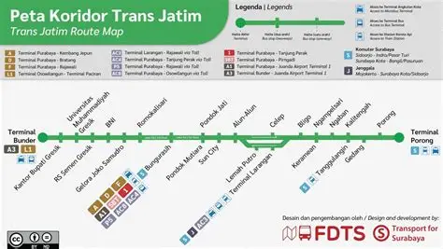
Figure 1. Trans East Java Route Corridor 1

To obtain the required data, the method of direct observation of bus stop facilities and fleets, to assess the physical condition and supporting elements of the service. Observation is a data collection technique by observing and recording phenomena directly in the natural environment without the intervention of researchers[10]. This method allows for accurate and contextual data collection There are several effective methods such as documentation in the form of photographs, field notes, and facility check sheets, such as seating, hygiene, and safety information[11]
There are several main variables and subvariables that will be evaluated to be observed in this study, namely:
1. Convenience: Smoking ban, peak and non-peak hours conditions
2. Safety : Vehicle feasibility, Safety equipment, Health facilities, Emergency response information, Standing passenger grip facilities, Passenger entry and exit, Tires, Speed limiting devices, Driver entry and exit, Electrical for audio visual, Safety belt
3. Security: Hazard sign signal light, Illumination light, Security officer, Window film
4. Affordability: Availability of Route Network Integration
5. Equality: Priority Seats in the Bus, Wheelchair Reserved Space.
In this study, the data was analyzed descriptively by comparing field conditions to SPM indicators. The results of the analysis are used to identify service shortcomings and provide recommendations for improving service facilities at the Trans East Java BRT in the form of image design or bus image layout.
RESULTS AND DISCUSSION

This research refers to the regulation of the Minister of Transportation of the Republic of Indonesia Number PM 27 of 2015 concerning minimum service standards for the transportation of people with public motor vehicles on the route. The data analyzed is data from observations from the Trans East Java BRT which operates along the corridor 1 route, namely the Sidoarjo – Surabaya – Gresik route which totals 31 fleets. Observation data will be analyzed as follows:

Table. 1. Results of Data Analysis
Yes | Type of Service |  | Survey Results | Value
Security
1 | Bus | Hazard signal lights | 31/31 | 100
2 | Bus | Lighting | 31/31 | 100
3 | Bus | Security guard | 31/31 | 100
4 | Bus | Window Film | 31/31 | 100
 |  |  | Sum | 100
Salvation
1 | Bus | Vehicle feasibility | 31/31 | 100
2 | Bus | Safety equipment | 31/31 | 100
3 | Bus | Healthcare facilities | 31/31 | 100
4 | Bus | Emergency response information | 31/31 | 100
5 | Bus | Standing passenger grip facility | 31/31 | 100
6 | Bus | Passenger entry and exit | 31/31 | 100
7 | Bus | Tire | 31/31 | 100
8 | Bus | Speed limiting tools | 31/31 | 100
9 | Bus | Driver's entry and exit | 31/31 | 100
10 | Bus | Electrical for audio visual | 31/31 | 100
11 | Bus | Seat belts | 13/31 | 42
 |  |  | Sum | 94,7
Comfort
1 | Bus | Peak Hours Conditions | 15/31 | 48
2 | Bus | Non-peak hours conditions | 24/31 | 77
3 | Bus | No Smoking | 31/31 | 100
 |  |  | Sum | 75
Affordability
1 | Bus | Route Network Integration Readiness | Available | 100
 |  |  | Sum | 100
Equality
2 | Bus | Priority Seats on the Bus | Available | 100
3 | Bus | Wheelchair-only space | None | 0
 |  |  | Sum | 50
Final Score |  |  |  | 84

The above data is the result of observations that have been analyzed with the Regulation of the Minister of Transportation No. 27 of 2015. From the data in Table .1 In the aspect of safety, it can be categorized as good and there is no need for additional facilities, in the aspect of safety it can be categorized as good but there needs to be an addition of safety belt facilities in the entire fleet to increase security, in the aspect of comfort, it is better to add bus capacity, in the aspect of affordability it can be categorized as good and there is no need for additional facilities, and in the aspect of equality there needs to be additional facilities, namely Add a dedicated space for people with disabilities or wheelchair users.

Security Aspects
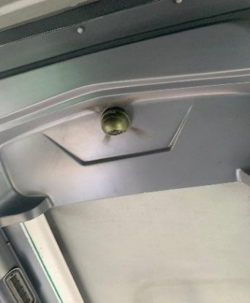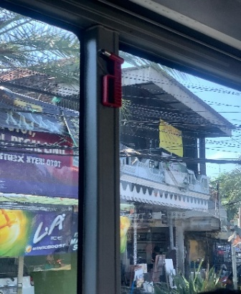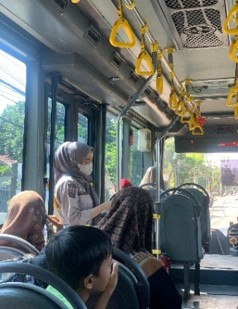

Figure 2. Safety Facilities on the Trans East Java BRT

Graph. 1. Results of security aspect analysis

In the security aspect, an average value of 100% was obtained, where the value was obtained from several variables, namely, hazard signal lights, lighting lights, security officers, window film. From the results of the analysis in GRAPH 1. All safety indicators are in accordance with existing standards and there is no need for additional facilities.
Safety Aspects
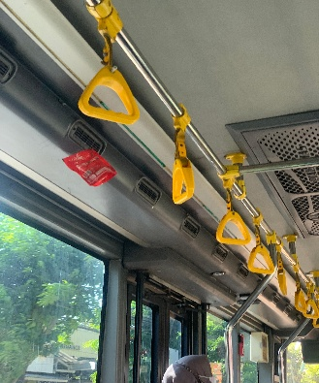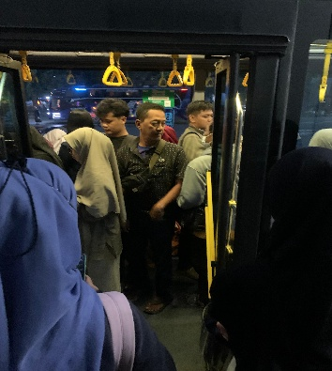

Figure 3. Safety Facilities on the Trans East Java BRT

Graph. 2 Results of the analysis of safety aspects

In the safety aspect, an average score of 94.7% was obtained, from which the value was obtained from the value of vehicle feasibility, safety equipment, Health facilities, Emergency response information, Standing passenger grip facilities, Passenger entry and exit, Tires, Speed limiting devices, Driver's entrance and exit, Electricity for audio visual, Safety belts. From these results, it can be categorized as good, but the seat belt variable needs to be added to the entire fleet to increase safety for East Java trans BRT users.
Comfort Aspect
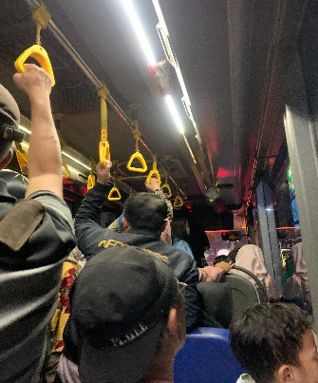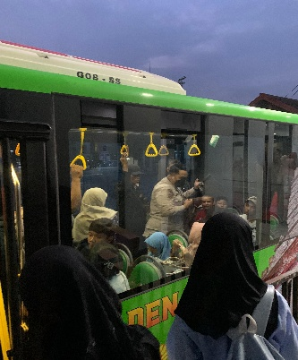
Figure 4. Comfort aspects on the Trans East Java BRT

Graph. 3 Results of the analysis of the comfort aspect

In the aspect of comfort, an average score of 75% was obtained. In GRAPH 3. This value is obtained from the average value of the smoking ban appeal points, peak and non-peak hours conditions, from 2 points have a low value so that it can be interpreted that buses often experience overload during peak and non-peak hours.

Affordability Aspect

Graph. 4 Results of the analysis of the affordability aspect

In the aspect of affordability, it has an average value of 100%, where the value is obtained from the variable of Network Integration Compatibility of the route. From Graph 4. It can be interpreted that the affordability aspect is in accordance with the standard and there is no need for additional facilities.
Equality Aspect
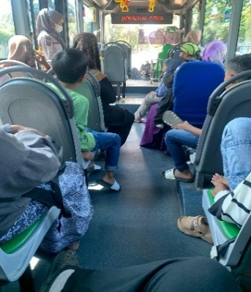
Figure 5. Equality aspects in the Trans East Java BRT

Graph. 5 Results of the analysis of the equality aspect

In Graph 5. the equality aspect has an average value of 50%. Where this value is obtained from the value of Priority Seats in the Bus and also the Special Wheelchair Room, it can be interpreted that the bus still does not have a special room for people with disabilities or wheelchair users, so it is better to add a special space for people with disabilities and wheelchair users in the Trans East Java BRT

Value of the Final Result

Graph. 6 Final score results

Graph 6 shows the results of the evaluation with a total value of 84%, which is the result of the calculation of five aspects of the assessment. Although this achievement is relatively high, further analysis indicates that the aspects of equality and comfort still require special attention. Both aspects show a relatively lower score than the other aspect, so it is concluded that it is necessary to improve facilities to support the achievement of equal and comfortable services for all users, including vulnerable groups such as people with disabilities. This effort is in line with the principle of implementing inclusive and service-oriented public transportation.

The results of the above analysis can be used as an output of the Trans East Java BRT design as a form of evaluation to improve public transportation infrastructure facilities.
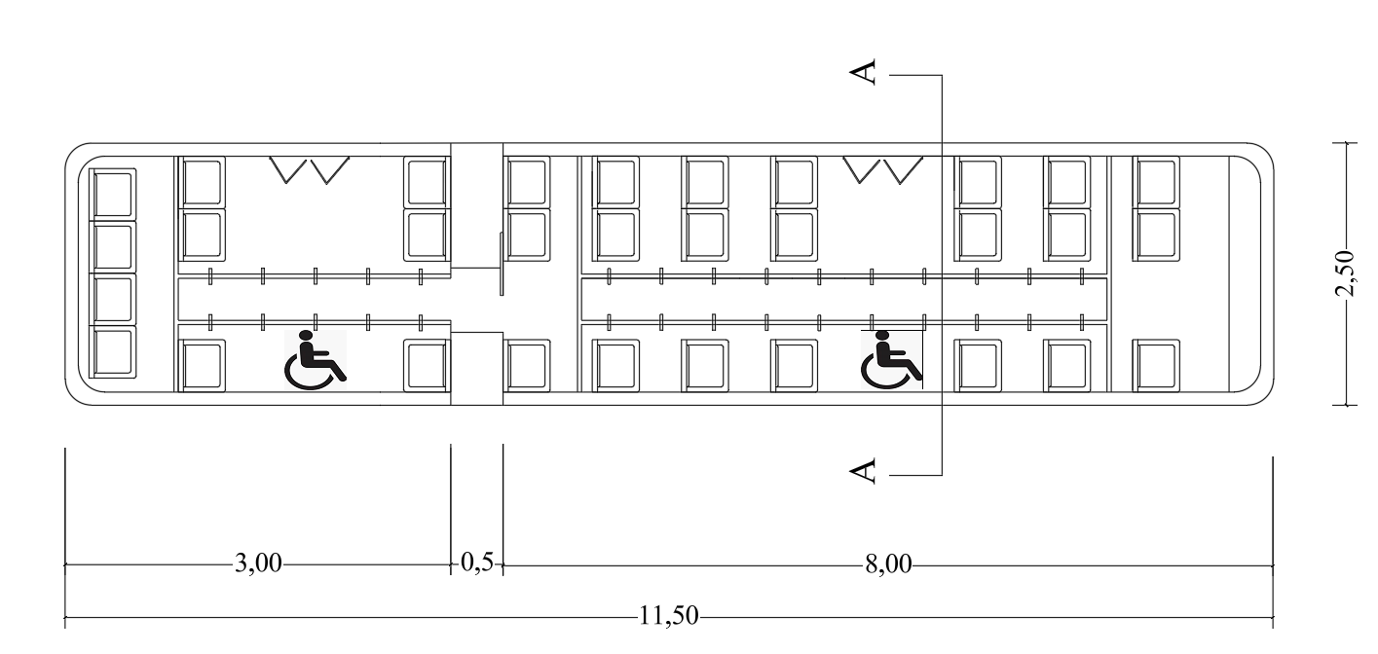
Figure 6. Layout Brt Trans jatim

Figure 6. the results of the evaluation of the Trans East Java BRT facility which refers to the Minimum Service Standards (SPM). In the evaluation, the interior layout of the bus was optimized through the addition of 10 units of seats and handgrips to increase carrying capacity and passenger comfort during the trip. In addition, two special areas designed for wheelchair users or people with disabilities are provided, as a form of applying the principle of inclusivity in the implementation of public transportation.

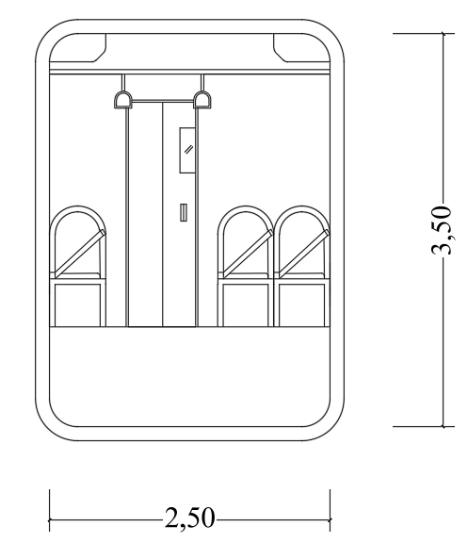
Figure 7. Seen in the Trans jatim Brt

Figure 7. showing the interior condition of the Trans Trans east java BRT fleet after improving safety facilities. All passenger seats have been equipped with seatbelts as part of efforts to meet the safety aspects of public transportation. The implementation of seat belts on each seat aims to minimize the risk of passenger injury due to slowdowns or accidents, and is in line with the principles of public transportation that prioritize user safety

CONCLUSION
Based on the results of the analysis above, the Trans East Java BRT Corridor 1 facility (Gresik – Surabaya – Sidoarjo) has generally met most of the Minimum Service Standards (SPM) with a final score of 84%. The security and affordability aspects are considered very good because all the necessary facilities are available. In terms of safety, the condition of the bus fleet is also good, but it is still necessary to add seat belts on all buses so that passenger protection is more optimal. Meanwhile, the comfort aspect has not been maximized because the bus capacity is inadequate, so it is better to increase capacity, especially during peak hours, so that passengers often experience congestion. In addition, the equality aspect is a major concern because buses do not provide special spaces for wheelchair users or people with disabilities. Therefore, the most needed facility improvements are the addition of seat belts, the addition of bus capacity, and the provision of special spaces for the disabled.
REFERENCES
[1] H. Y. Saputra dan I. F. Radam, "Jurnal Internasional Transportasi Aksesibilitas model lokasi pemberhentian BRT menggunakan Geographically Weighted regression (GWR): Studi kasus di Banjarmasin, Indonesia", Int. J. Transp. Sci. Technol., Köt. 12, sz. 3, hlm. 779–792, 2023, doi: 10.1016/j.ijtst.2022.07.002.
[2] P. Covid, "KADIKMA : Jurnal Matematika dan Pendidikan Matematika", köt. 13, sz. 1, hlm. 67–72, 2022.
[3] A. Sedayu, W. A. Salsabilla, F. Economics, P. Management, és U. Dian, "Analisis Kualitas Pelayanan dan Kepercayaan Konsumen Bus Trans Semarang Cepat di Masa Pandemi Covid-19", 2020.
[4] C. Ayu, N. Sari, és B. Afriandini, "Evaluasi Kinerja Koridor Bus Rapid Transit Purwokerto-Purbalingga", köt. 17, sz. 1, hlm. 53–60, 2020.
[5] E. Kusnadi, Y. Praja, U. A. Saleh, U. A. Saleh, és U. A. Saleh, "ANALISIS FAKTOR-FAKTOR YANG MEMPENGARUHI KUNJUNGAN SEBAGAI VARIABEL INTERVENSI PADA", hlm. 2, sz. 2, 2023.
[6] I. N. Ismiaji, A. O. S. D. Araujo, D. Setijowarno, és B. Setiadi, "Karakteristik dan Persepsi Penumpang Layanan Bus Rapid Transit (BRT) Trans Semarang Corridor III", köt. 7, hlm. 133–141, 2023.
[7] A. M. Affif, "Pengaruh Desain Fasilitas Halte Bus pada Kepuasan Pengguna Bus Trans SPACE", sz. Desember, 2021, doi: 10.24843/JRS.2021.v08.i02.p05.
[8] Kuesioner W. D. A. N., "Teknik pengumpulan data: pengamatan", köt. 3, sz. 1, hlm. 39–47.
[9] N. Ikromah, "Information on Stop Routes, Tariffs and Bus Stops for Transjatim Corridor I Latest August 2024", Mind of the East Java people. [Online]. Elérhető: https://jatim.pikiran-rakyat.com/jawa-timur/pr-3748417738/informasi-rute-pemberhentian-tarif-dan-halte-bus-transjatim-koridor-i-terbaru-agustus-2024?page=all
[10] Z. Jaya, "Evaluasi Kinerja Halte Bus Trans Koetaradja", köt. 16, sz. 3, hlm. 174–178, 2024.
[11] A. Pujianto, A. A. Radisya, és A. S. Chandra, "Evaluasi Efektivitas Operasional BRT: Studi Kasus Kota Bandung", köt. 20, sz. 1, s. 14–22, 2025.

