Trans East Java BRT Service Quality Corridor 1: SERVQUAL Analysis and Kano Model as the Basis of Improvement Strategies
Andrian Eka Nugraha^{1,a)}, Amalia Nur Adibah^{2,b)}, Abdul Samad ^{3,c)}
¹²³Department of Civil Engineering, Engineering Faculty, University of Muhammadiyah Malang, Malang, Indonesia

^{c)}Corresponding author: abdulsamad@umm.ac.id
^{a)} andrianekanugraha97@gmail.com
^{b)}amalianuradibah@umm.ac.id

Abstract. The Bus Rapid Transit (BRT) Transjatim Corridor 1 (Gresik–Surabaya–Sidoarjo–Porong) is designed to reduce congestion while providing safe, comfortable, and affordable public transportation. However, field observations reveal several challenges, including suboptimal fleet conditions, unclear schedule information, and limited facilities for passengers with disabilities. This study aims to assess the service quality of Transjatim BRT from the perspective of its users, referencing six dimensions of the Minimum Service Standards (SPM): safety, security, reliability/order, comfort, convenience/affordability, and equality.
A mixed-methods approach was adopted, combining questionnaire surveys—based on the Kano Model and a Likert scale—with field observations and documentation. A total of 100 respondents participated in the survey, allowing for an analysis of the importance and satisfaction levels of various service attributes.
Findings indicate that on weekdays, service quality is rated as very satisfactory, with most attributes classified in the “excellent” category. Punctuality emerges as the most critical factor to maintain, while consistency of service information strongly influences user satisfaction. On weekends, increased passenger volumes heighten the importance of safety and security, although expectations for convenience and ease of information slightly decline.
Overall, the service meets the required standards, yet improvements are needed in schedule consistency, fleet maintenance, provision of real-time information, and accessibility facilities. Recommended optimization measures include routine fleet servicing, integration of GPS-based tracking, deployment of additional buses during peak periods, and staff training to ensure more inclusive service delivery.

Keywords: BRT, service quality, Kano Model, passengers, design

INTRODUCTION
Bus Rapid Transit (BRT) is one of the popular transportation systems as a more affordable alternative to travel to trains. BRT is a medium mode of transportation between conventional buses and trains, so BRT has the speed and flexibility of trains that are affordable like conventional buses[1]. This bus carries the concept of Bus Rapid Transit (BRT) and is part of the implementation of Presidential Regulation No. 80 of 2019, which supports economic development in the Gerbangkertosusila, BTS, Selingkar Wilis, and South Lintas areas [2].
The development of major cities in Indonesia is driving the need for fast, safe, and affordable public transportation. One of the efforts made by the East Java Provincial Government is to launch the Transjatim Bus Rapid Transit (BRT) service[3]. Corridor 1, which serves the Gresik – Surabaya – Sidoarjo – Porong route, is an important route that connects the buffer area to the city center.
Although this service is designed to provide comfort and convenience for the community, there are still some obstacles in the field. Some of them are suboptimal fleet conditions, unclear schedule information, and limited facilities for people with disabilities. These problems can affect the level of satisfaction and interest of the public in using BRT services[4].
This study aims to evaluate the quality of Transjatim Corridor 1 BRT services based on user perception. The assessment is carried out using the Service Quality (SERVQUAL) approach and the Kano Model to find out which service attributes are considered important by users, and how the quality of the service affects their satisfaction. The results of this research are expected to be input for the improvement and development of BRT services in the future [5].
Assessments by involving the community will be used as input to improve the quality of services in order to attract more users. More and more public transport users, in this case BRT, can reduce congestion[1]. With dedicated lines, strict time management, and larger transport capacity than regular public transport, BRT is becoming an increasingly relevant choice amid population growth and increasingly complex urban mobility.
Therefore, this study aims to evaluate the quality of Transjatim Corridor 1 BRT services based on user perception by integrating the Service Quality (SERVQUAL) method and the Kano Model. The evaluation included six key aspects—safety, security, reliability/orderliness, comfort, convenience/affordability, and equity—to identify the attributes that most affected passenger satisfaction. The results of the research are expected to be strategic inputs for managers in improving service quality, optimizing infrastructure, and expanding the attractiveness of Transjatim BRT as an inclusive, efficient, and sustainable mode of public transportation in the future[3].

METHODS
This research is a mixed methods research that combines 2 approaches, namely a qualitative approach and a quantitative approach. "Mixed Methods focuses on data collection and analysis and combines quantitative data and qualitative data both in single study and series study"[6].

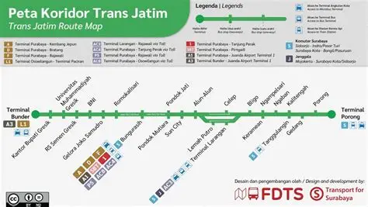
Figure 1. Route Location of BRT Trans Jatim Corridor 1

A quantitative approach was used to measure the level of user satisfaction with Transjatim BRT services through a questionnaire survey based on the Kano model and the Likert scale[7]. Meanwhile, a qualitative approach is used to evaluate the existing condition of bus facilities and infrastructure directly in the field. The location of the research was carried out in Corridor 1 of the Transjatim BRT service which includes the Gresik-Surabaya-Sidoarjo-Porong line. The survey is carried out during peak hours, namely in the morning at 06.30-08.30 and in the afternoon at 16.00-17.30 for weekdays, and at 07.00-09.00 and 15.00-17.00 for weekends.
Stating "population can be defined as the whole of elements in research including subjects and objects with certain characteristics and characteristics"[8]. The population in this study is all active users of the Transjatim BRT service in the corridor. Based on data in 2025, the number of Trans East Java BRT users will reach around 627,946 people from January to March 2025, so if calculated, the number of daily passengers will be 6977 people per day. The sampling technique was carried out by accidental sampling method. "Accidental sampling is a sampling technique where subjects are selected based on ease of access or availability"[9]. The number of samples was determined using the Slovin formula with a margin of error of 10%. Based on Slovin's formula[10], the required number of samples will be 100 samples
The research variable used is the Minimum Service Standard (SPM) stipulated in the Regulation of the Minister of Transportation Number PM 29 of 2015. The main focus of the variables studied was the quality of intercity bus transportation services (AKAP and AKDP)[11]. The variables studied are: safety, security, reliability/order, convenience, convenience/affordability, and equality.
The data collection techniques used in this study are questionnaires, observation and documentation. The questionnaire was designed using two types of questions, namely: functional and dysfunctional questions, to find out how customer satisfaction is if service attributes are available or unavailable. Observations were carried out to observe real conditions in the field, while documentation was carried out to obtain secondary data in the form of location maps and bus stop distribution along the Gresik-Surabaya-Siodarjo-Porong corridor, bus service standards that have been set by the Transportation Agency, and other supporting documents related to the management and operation of buses in the Trans East Java system.
Data analysis in the study used the canoe method. "This model provides a deeper understanding of customer needs and preferences, enabling companies to make targeted and effective decisions in meeting their target audience"[12]. This study also integrates an assessment of the level of satisfaction and interest of users with each of the attributes studied.

RESULTS AND DISCUSSION
This study evaluates the quality of BRT Trans East Java Corridor 1 SBY-SDA-Gresik-Porong services using the Kano and Customer Satisfaction (CS) methods. Observations were made of 100 respondents on weekdays and weekends, focusing on attributes such as safety, security, comfort, affordability, convenience, and equality. with the guidelines of the minimum Service Standards (SPM) using Ministerial Regulation No.29 of 2015.

Safety
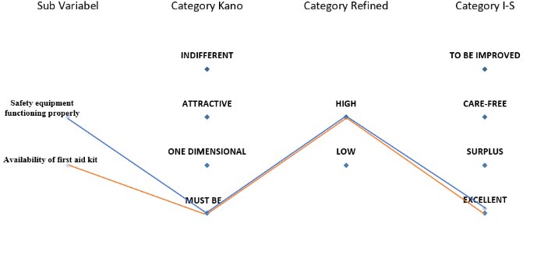
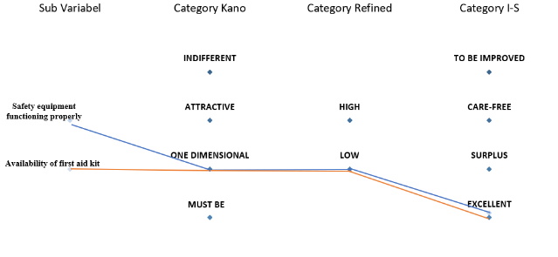
This safety variable attribute compares the results of safety analysis between weekdays (a) and weekends (b) for the two sub-variables: Safety equipment functioning properly and Availability of first aid kit. Whether the safety and health tools are functioning properly and are in their proper place, these two aspects are interrelated for the safety of the users.
(a) (b)
Figure 2. Analysis Data Results

Figure 2, shows the response of the user of the (a) model attribute on weekdays the availability of emergency equipment and the availability of health facilities are in the One Dimensional category with low importance, meaning that good quality will increase satisfaction even though it is not the main priority. On Importance–Satisfaction, both are in excellent, showing excellent performance. In model (b) the weekend shifts to a must be with high importance, indicating that it is considered a basic necessity that must exist. This increase in priority is likely to be influenced by a larger number of passengers on weekends. Its performance remained excellent, meeting expectations despite increased operating expenses.

Security
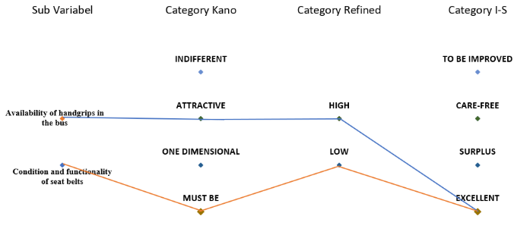
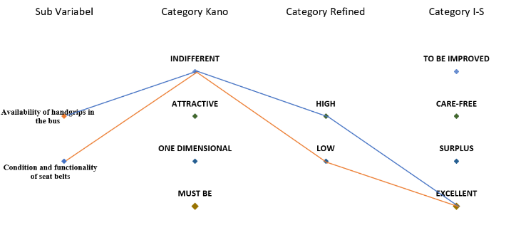
Variable safety attributes are deployed on the passenger's sense of safety, the availability of handgrips and seat belts that function properly, indicators used such as handgrips that are still strong and not damaged to assist the user to stand and seat belts that are still in the passenger seat and function.
(a) (b)
Figure 3. Analysis Data Results

Figure 3, on weekdays (a) handgrips are classified as indifferent (high, Excellent) and seat belts indifferent (low, excellent), showing good condition even though the effect on satisfaction is different. On the weekend (b), handgrips shifted to attractive (high, excelellent) so that it was very satisfying, while seat belts became a must be (low, excellent) which remained satisfactory. This shows the need to focus on improving handgrips on weekends to maintain the comfort and safety of passengers. These findings indicate that safety attributes tend to be rated fairly well on weekdays, but on weekends there is an increased focus on handgrips, so this aspect needs to be a focus of improvement to support user comfort and security.

Reliability/Regularity
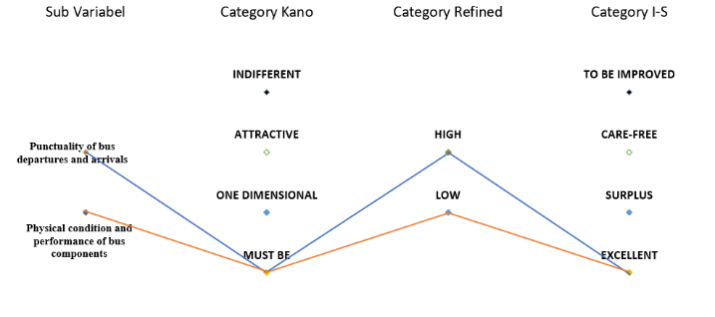
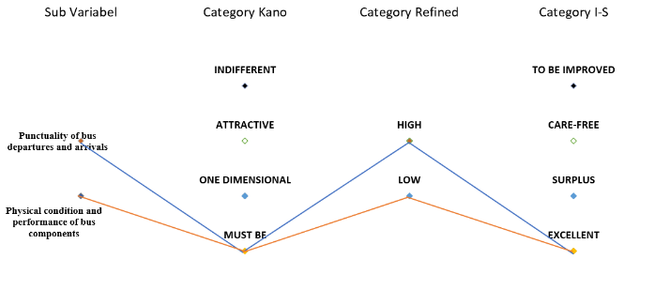
Based on the analysis of the Reliability/Regularity dimension, the two sub-variables analyzed are the timeliness of bus departure and arrival as well as the physical condition and performance of bus components, on weekdays and weekends.
(a) (b)
Figure 4. Hasil Data Analisis

Figure 4, Based on the analysis of the Reliability/Regularity dimension, the two subvariables analyzed are the punctuality of bus departure and arrival as well as the physical condition and performance of bus components, on weekdays (a) and weekends (b). In the weekdays period, punctuality is in the Kano Must Be, Refined Category High, and Category I-S Excellent, indicating that these attributes are basic needs with a high level of expectation and contribute greatly to satisfaction if met. The physical condition and performance of bus components are also in the Kano Must Be, Refined Category Low, and Category I-S Excellent, indicating that although the level of importance in the eyes of users is lower than punctuality, these attributes are still able to have a strong positive impact on satisfaction when met. The same pattern is seen on weekends, where the punctuality and physical condition of the bus are both in the category (Must Be–High/Low–Excellent). These results confirm that these two attributes are crucial factors in building the perception of the reliability of Transjatim's BRT services, with punctuality as the top priority and the physical condition of the bus as an important support for travel comfort and safety.

Comfort
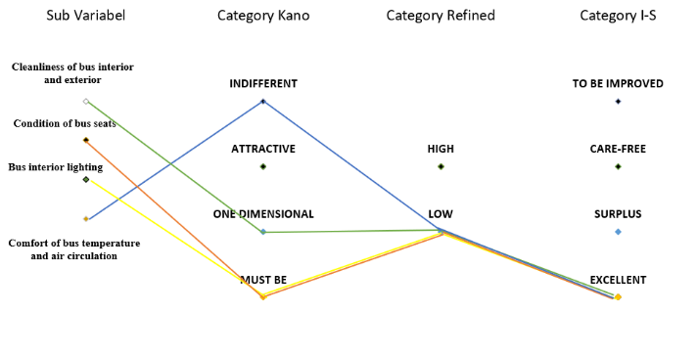
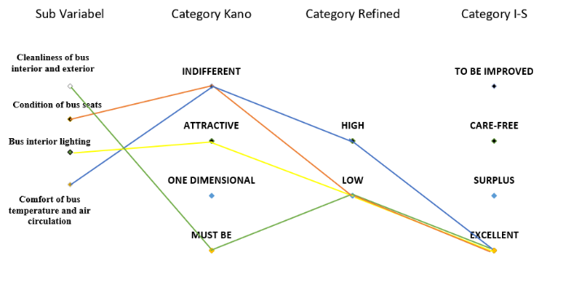
Based on the analysis on the comfort dimension, the four sub-variables were compared between weekdays and weekends, referring to and focusing on the important aspects of the facilities on the bus, whether all facilities were functioning properly even on weekdays and holidays.
(a) (b)
Figure 5. Analysis Data Results

Figure 5, On weekdays (a), bus cleanliness is categorized as must be (canoe), low (refined), and excellent (I-S), while on weekends (b) it changes to one-Dimensional, but remains low and excellent, indicating that expectations for cleanliness remain high but with slightly different perception of function. The condition of the seats on weekdays is classified as indifferent, while on weekends it is a must be, but both remain low and excellent, showing the increasing importance of this attribute on weekends. Lighting on the bus on weekdays is categorized as attractive, while on weekends it is a must-be, but it is still low and excellent, indicating that the perception of lighting becomes more basic on weekends. Air circulation and temperature on weekdays have the categories of indifferent, high, and excellent, but on weekends they remain indifferent, but with the low and excellent categories, showing a decrease in the level of expectation. In general, on weekends there are no sub-variables that are categorized as High, indicating a decrease in user expectations for the comfort aspect on weekends compared to weekdays.

Convenience/Affordability
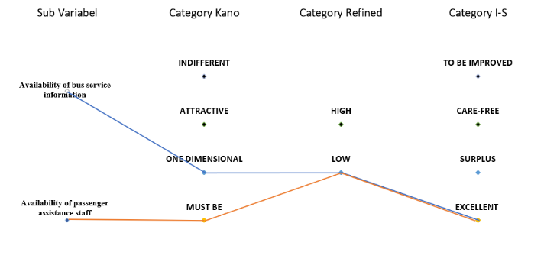
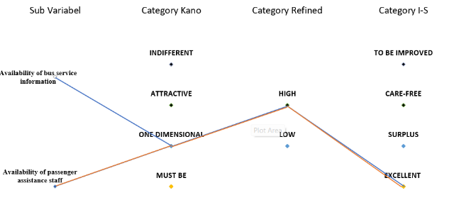
This variable attribute assesses how good the information is in the Trans East Java BRT, assessing the attitude of the officers, information services such as routes or maps, and schedules, and tariffs. The analysis of the convenience/affordability dimension includes two sub-variables, namely the availability of bus service information and the availability of passenger assistance officers
(a) (b)
Figure 6. Analysis Data Results

Figure 6, On weekdays (a), both sub-variables were categorized as one-dimensional (canoe), with a high expectation level, and the I-S score was in the excellent category, indicating that both greatly affected user satisfaction and were met very well. However, on weekends (b) there was a decrease in perception: bus service information remained in the one-dimensional category, but only with low expectations, and the availability of assistance officers dropped to the must be category, also with low expectations, although both still achieved excellent scores in the I-S category. This indicates that although user expectations for the convenience aspect tend to be lower on weekends, existing services still meet or even exceed user expectations.

Equality
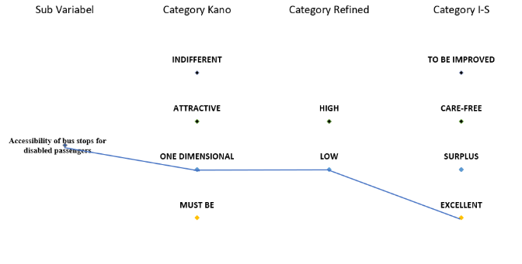
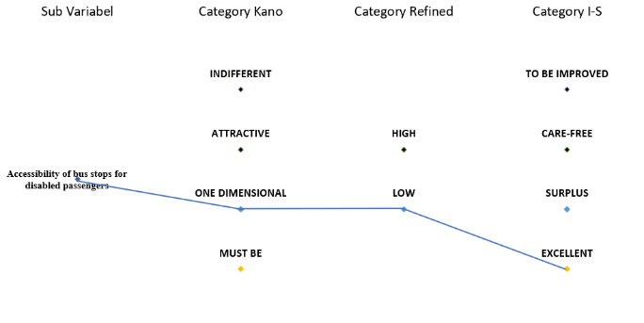
This variable sees and emphasizes access for people with disabilities also needs to be prioritized, equality emphasizes the importance of access for people with disabilities, such as ramps at bus stops, wheelchair spaces, and assistance for officers. User feedback shows that the facility is good and meets expectations, but it needs to be maintained and improved to keep the service inclusive for all passengers.
(a) (b)
Figure 7. Analysis Data Results

In both periods, weekdays and weekends, these attributes are categorized as One-Dimensional in the Kano model, with a Low expectation level and an I-S score indicating Excellent. This indicates that the accessibility of the bus stop for passengers with disabilities is seen as an important factor that affects satisfaction pengguna dan telah Very well fulfilled. There is no significant difference between weekdays (a) and weekends (b), which shows the consistency of user perception of the equality aspect of the Trans East Java BRT service.

Value of the Final Result
Based on the results of surveys and observations in Corridor 1 of the Transjatim BRT (Gresik-Surabaya-Sidoarjo-Porong), the quality of service on weekdays is already at a very satisfactory level with the attributes of safety, security, punctuality, ease of information, and accessibility which are considered excellent. Nonetheless, on weekends higher passenger density levels make safety and security a top priority, while expectations for convenience and ease of information tend to decline. In general, services have met existing standards, with timeliness as a key factor that must be maintained and the consistency of service information as an important element that affects user satisfaction.

Infrastructure Optimization
To maintain and improve service quality, it is recommended that managers carry out routine maintenance of the fleet including checking safety equipment, handgrips, seat belts, seats, lighting, and air circulation. Increased punctuality can be supported by GPS tracking technology and the addition of backup buses during peak hours, while service information needs to be reinforced through digital boards and real-time applications. Accessibility facilities such as ramps and wheelchair spaces must always be maintained, accompanied by training of officers to assist passengers with special needs. Bus cleanliness and lighting optimization also need to be a special concern, especially on weekends, so that passenger comfort and safety are maintained.

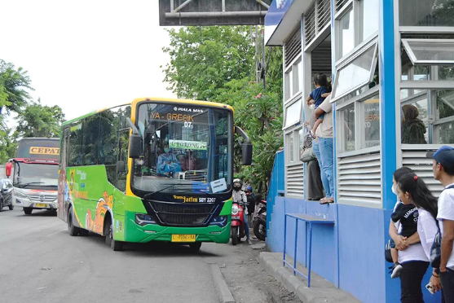
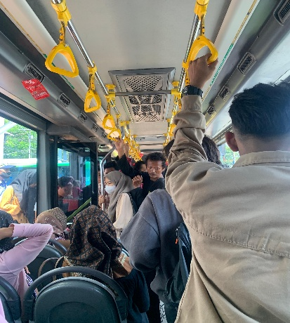
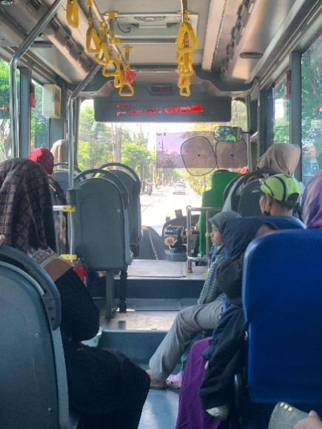

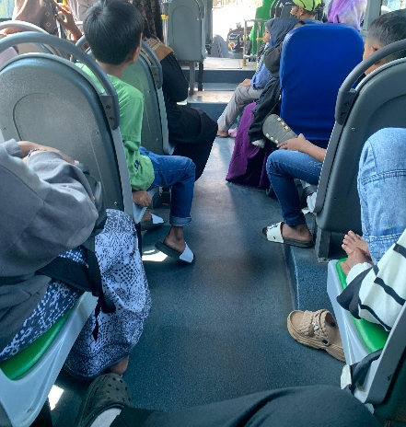
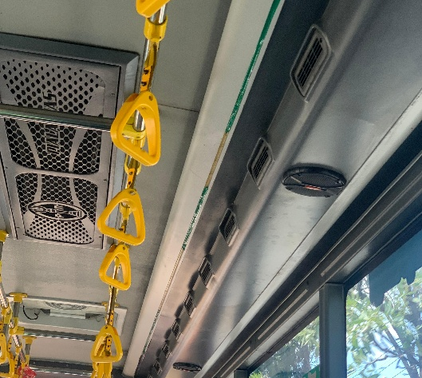
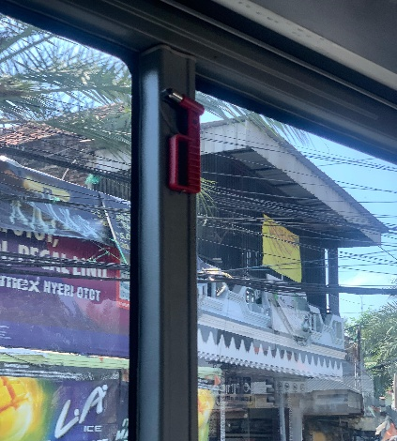
(a) (b) (c)
(d) (e) (f)
Figure 8. Status of BRT Trans East Java Corridor 1

Figure 8, that these attributes describe the state of observation including the Trans East Java BRT facility, and things that need to be maintained and improved. This documentation helps prioritize facilities and placement anywhere so that they become a facility that can make users satisfied. Namely there are safety variables (glass breakers) (d), safety (handgrip) (c), reliability (fleet condition) (b), comfort (bus cleanliness and circulation on the bus) (f) and (e), convenience (bus service information) (a), equality (priority seats) (a).

Final design of the Trans Java East Java bus stop route 1 corridor

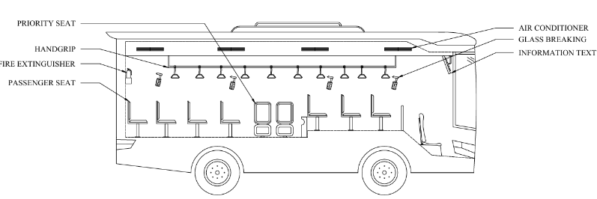
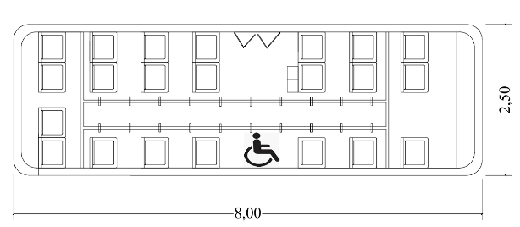
(a) (b)
Figure 9. Final design in bus planning

CONCLUSIONS
This study shows that the quality of Transjatim Corridor 1 BRT services on weekdays is already at a very satisfactory level, with almost all aspects of service—including safety, security, punctuality, ease of information, and accessibility—in the excellent category. Timeliness is a key factor that must always be maintained, while consistency in providing service information plays an important role in maintaining user satisfaction. On weekends, the increase in passenger numbers made safety and security a higher priority, although overall satisfaction levels remained good. In general, Transjatim's BRT service has met the applicable Minimum Service Standards (SPM). However, there are opportunities for improvement, especially in schedule consistency, fleet maintenance, and strengthening accessibility facilities. Managers are advised to carry out regular maintenance of the fleet, utilize GPS tracking technology to monitor punctuality, add a reserve fleet during peak hours, and improve officer training. The implementation of these measures is expected to maintain good service quality while increasing the attractiveness of Transjatim BRT as an efficient, inclusive, and sustainable mode of public transportation.

References
[1] A. N. Adibah and O. R. Manullang, “The Assessment of BRT Trans Semarang Service Quality,” IOP Conf. Ser. Mater. Sci. Eng., vol. 771, no. 1, 2020, doi: 10.1088/1757-899X/771/1/012045.
[2] S. N. Rukmana, “( SIDOARJO-SURABAYA-GRESIK ),” vol. 23, no. 02, pp. 59–66, 2025.
[3] C. Mutiawati, F. M. Suryani, and R. Anggraini, “Importance-Performance Analysis in Public Transport Level of Service: A Case Study of The Trans Koetaradja Bus in Banda Aceh,” Aceh Int. J. Sci. Technol., vol. 11, no. 1, pp. 70–84, 2022, doi: 10.13170/aijst.11.1.23146.
[4] T. Arisandi, K. Ayunaning, U. M. Gresik, and G. Indonesia, “ANALISA TINGKAT KEPUASAN PENGGUNA JASA TRASPORTASI UMUM BUS TRANS JATIM KORIDOR 3 TERHADAP KINERJA OPERASIONAL DAN PELAYANAN ( Studi Kasus : Rute Mojokerto-Gresik ) ANALYSIS OF THE LEVEL OF SATISFACTION WITH THE USE OF TRANS JATIM CORRIDOR 3 PUBLIC TRANSP,” vol. 02, no. 01, pp. 61–66, 2025.
[5] A. Mustakim, S. K. Anggraeni, and ..., “Analisis Kualitas Layanan Dengan Metode KANO Berdasarkan Dimensi SERVQUAL Pada PT. AKR,” J. Tek. Ind. …, 2017, [Online]. Available: https://jurnal.untirta.ac.id/index.php/jti/article/view/1402%0Ahttps://jurnal.untirta.ac.id/index.php/jti/article/download/1402/1113
[6] R. Justan, M. Margiono, A. Aziz, and S. Sumiati, “Penelitian Kombinasi (Mixed Methods),” ULIL ALBAB J. Ilm. Multidisiplin, vol. 3, no. 2, pp. 253–263, 2024, doi: 10.56799/jim.v3i2.2772.
[7] S. M. Fajriyati and N. N. K. Moeliono, “Analisis Kualitas Pelayanan Mengunakan Model Kano (Studi Kasus Pada Ptrans Tahun 2018),” e-Proceeding Manag., vol. 6, no. 1, pp. 904–911, 2019.
[8] W. Sulistiyowati, “Buku Ajar Statistika Dasar,” Buku Ajar Stat. Dasar, vol. 14, no. 1, pp. 15–31, 2017, doi: 10.21070/2017/978-979-3401-73-7.
[9] P. G. Subhaktiyasa, “Menentukan Populasi dan Sampel: Pendekatan Metodologi Penelitian Kuantitatif dan Kualitatif,” J. Ilm. Profesi Pendidik., vol. 9, no. 4, pp. 2721–2731, 2024, doi: 10.29303/jipp.v9i4.2657.
[10] B. Antoro, “Analisis Penerapan Formula Slovin Dalam Penelitian Ilmiah: Kelebihan, Kelemahan, Dan Kesalahan Dalam Perspektif Statistik,” J. Multidisiplin Sos. dan Hum., vol. 1, no. 2, pp. 53–63, 2024, doi: 10.70585/jmsh.v1i2.38.
[11] T. Lembaran, T. Dan, F. Kementerian, N. Serta, F. Eselon, and I. K. Negara, “Perubahan Atas Peraturan Menteri Perhubungan Nomor PM 98 Tahun 2013 Tentang Standar Pelayanan Minimal Angkutan Orang Dengan Kendaraan Bermotor Umum Dalam Trayek,” vol. 2011, pp. 1–17, 2010.
[12] M. Löfgren, L. Witell, and A. Gustafsson, “Theory of attractive quality and life cycles of quality attributes,” TQM J., vol. 23, no. 2, pp. 235–246, 2011, doi: 10.1108/17542731111110267.\

