Evaluating Project Feasibility and Financial Performance Through the Return on Investment (ROI) Method: A Life-Cycle Cost and Revenue Case Study of the Cardova Edupartment Building in Semarang, Indonesia

Rini Pebri Utari ^{a)}, Fitriani ^{b)}, and Sandi Wahyudiono ^{c)}

Department of Civil Engineering, University of Muhammadiyah Malang, Malang, Indonesia

^{a)} Corresponding author: rinipebriutari@umm.ac.id
^{b)} fitriynikarman@webmail.umm.ac.id
^{c)} sandi@umm.ac.id

Abstract. Return on Investment (ROI) is one of the most popular performance measurement and evaluation metrics. ROI analysis (when applied correctly) is a powerful tool in comparing solutions and making informed decisions on the acquisitions of information systems. Over the past several decades, the use of ROI analysis has expanded to include a broader array of social and environmental benefits; this is termed social return on investment, or SROI. This paper examines the use of SROI analysis to evaluate investments in disaster preparedness. Maintenance and replacement costs include annual maintenance expenses and replacement of building components during the specified building life plan. As in Cordova Edupartment Semarang has a building life plan of 50 years. From this analysis, the Life Cycle Cost of the Cordova Edupartment Building for 50 years is Rp1,446,963,144,027 consisting of direct costs of Rp222,881,901,903 (16%), operational costs of Rp363,196,544,319 (25%), maintenance costs of Rp595,702,742,387 (41%), placement costs of Rp98,028,032,247 (7%), Change Costs of Rp78,001,162,410 (5%) and bank loan interest of Rp89,152,760,761 (5%) with a rental price of Rp155,000/m2 and an initial occupancy of 85%, a Net Present Value> 0 of Rp220,819,600,100 is obtained, the Break Even Point value is located at 25.64 years and the Internal Rate of Return obtained a positive result of 9.35% > MARR = 6.78% which means the investment is feasible and profitable.
Keywords: Return on Investment, Investment, Cost estimation, Financial Performance, Construction

INTRODUCTION
Due to the rapid growth of the population, new challenges have emerged, particularly in housing, where the demand for residential units continues to increase. According to 2021 data from the Regional Development Planning Agency (Bappeda) of Semarang City, the number of existing residential buildings was recorded at 92,965 units, while the projected housing demand reached 101,526 units, resulting in a deficit of 8,561 units. To address this issue, one of the most appropriate alternative solutions to meet the high demand for adequate and space-efficient housing is the development of vertical residential buildings. At present, the concept of housing is no longer limited to providing shelter but has also expanded to function as a center for education and entertainment. This concept is embodied in the development project of the Cordova Edupark Apartment.
In the implementation of this apartment development, it is essential to consider not only the construction cost planning during the building phase but also a comprehensive cost planning that includes operational, maintenance, and repair expenses to ensure the expected service life of the structure. The appropriate method for construction cost analysis is the Return on Investment (ROI) method. In this approach, the assessment should not be limited to the initial construction cost alone but should also take into account maintenance and repair costs, design service life, performance, and other factors that may influence the overall value as a consequence of the available alternatives.
Furthermore, through Return on Investment (ROI) analysis, it is possible to evaluate the extent of costs incurred by a building with a green building concept over a specified period. ROI is defined as the total expenditure throughout the life cycle, which includes preparation, design, acquisition, and other costs directly associated with the ownership or utilization of the asset.
The Cordova Edupark Apartment is planned to be constructed as a 19-story building in 2024, with a total floor area of 39,423 m². The current planning, however, is limited only to construction costs and has not yet considered operational and maintenance expenses once the building becomes functional. In addition, the Cordova Edupark Apartment project has not conducted a comprehensive investment feasibility analysis that takes into account maintenance and repair costs. Investment activities are crucial undertakings that require substantial capital and have long-term implications for the sustainability of a project. Therefore, it is essential to evaluate whether such investments will generate long-term benefits or not, as an investment essentially represents a long-term capital commitment.
In addition to the initial investment, it should also be recognized from the outset that such investment will be followed by a number of periodic expenditures that must be anticipated. These expenditures include operational costs, maintenance costs, and other unavoidable expenses. On the other hand, the investment will also generate a range of benefits or returns, either in the form of product sales, services, or facility rentals. Based on previous studies and research, the novelty of this study lies in the inclusion of maintenance and replacement costs within the Return on Investment (ROI) method, using the approach of the Ministry of Public Works Regulation (PERMEN PU) No. 24/PRT/M/2008, as well as the attempt to synergize the ROI method with investment feasibility analysis through the Future Value method.
The objective of this research is to examine and validate the application of the ROI method in order to determine the total investment cost of a building, covering the stages of planning, construction implementation, maintenance, and replacement. By applying PERMEN PU No. 24/PRT/M/2008, it is expected that the building’s service life can be achieved up to 30 years.

METHODOLOGY
A flowchart can be defined as a sequence of stages that represent the core agenda of each planning step, presented in a concise manner. The research planning flowchart is shown in figure 2.

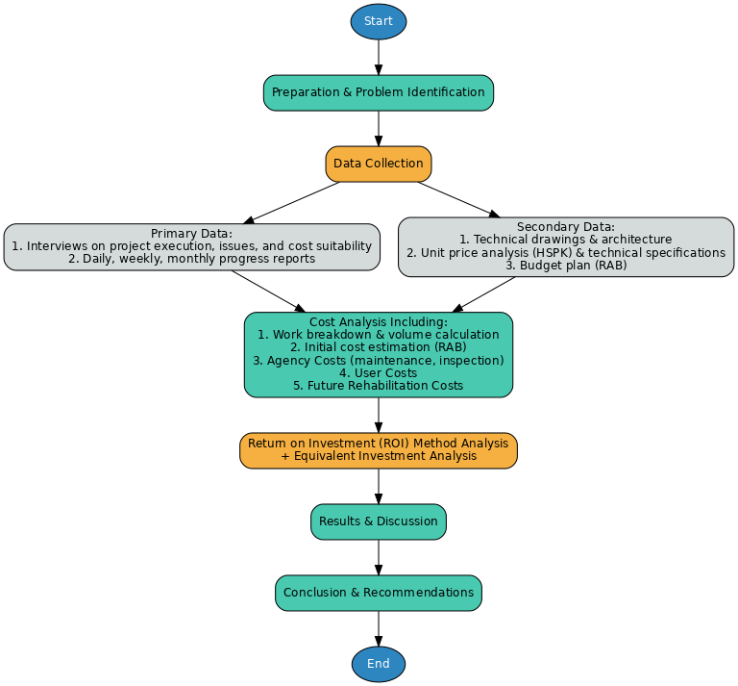
Figure 2. 1 Flow-diagram

RESULTS AND DISCUSSION

Data Collection Results and Existing Project Conditions
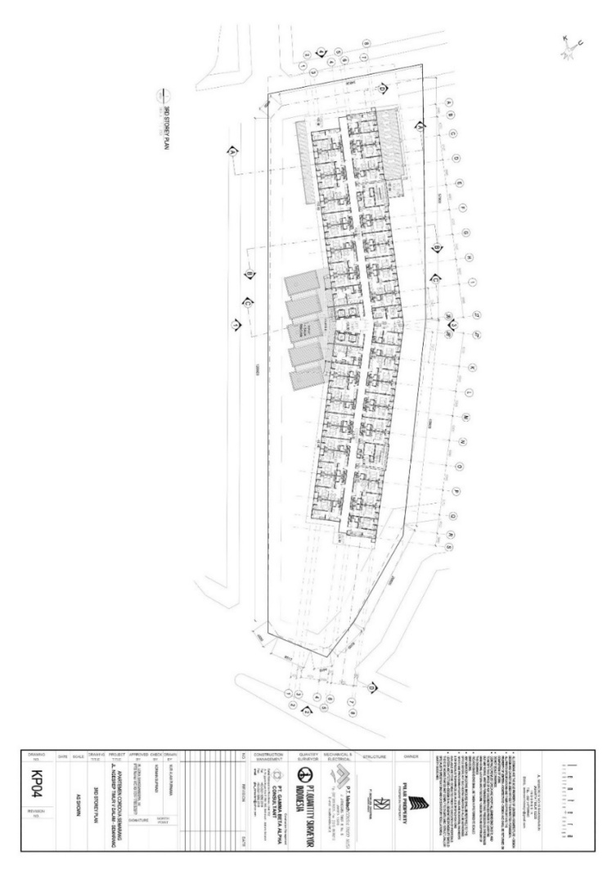
The project site area of Cordova Edupartment Semarang is 4,697 m². The building floor area on each level is 2,074 m². Cordova Edupartment consists of 19 floors including the basement, with a total height of 71.55 meters. The total number of units in Cordova Edupartment is 655 units within a single tower. Public facilities are located from the basement up to the 2nd floor, while the 3rd to the 19th floors consist of residential units of Cordova Edupartment.

Figure 3. Existing Condition of Cordova Edupartment Semarang

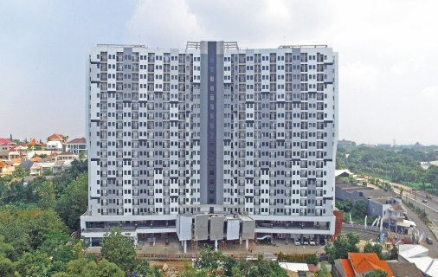

Figure 4. Front Elevation of the Cordova Edupark Apartment

Calculating Direct Costs
The total direct construction cost is presented in the table below:

No | Type of Work | Amount (IDR)
1 | Land Preparation Cost | Rp10.554.189.499
2 | Pre-construction Cost | Rp15.609.275.136
3 | Construction Cost | Rp196.718.437.268
Total |  | Rp222.881.901.903
Tabel 1. Direct Costs

Calculating Operational Costs
The total operational cost is presented in the table 3.2 below:
No | Operational Cost Item | Amount (IDR)
1 | Employee Salaries | Rp396.101.351.453
2 | Water and Electricity | Rp9.211.659.336
3 | Land and Building Tax (PBB P2) | Rp3.684.663.734
4 | Insurance | Rp50.664.126.349
Total |  | Rp460.582.966.806

Tabel 2. Operational Costs
Calculating Maintenance and Replacement Costs
The total maintenance and replacement cost is presented in the table below.

Type of Work | Cost (IDR)
Maintenance | Rp595.702.742.387
Replacement | Rp89.152.760.761
Total | Rp684.855.503.148
Table 3. Maintenance and Replacement Costs
Total Life Cycle Cost
The total life cycle cost is presented in the table below:
Cost Component | Amount (IDR)
Direct Cost | Rp222.881.901.903
Operational Cost | Rp363.196.544.319
Maintenance Cost | Rp595.702.742.387
Replacement Cost | Rp98.028.032.247
Demolition Cost | Rp78.001.162.410
Bank Interest  8.05% x 10 Years | Rp89.152.760.761
Total | Rp1.446.963.144.027

Table 4. Total Life Cycle Cost (LCC)
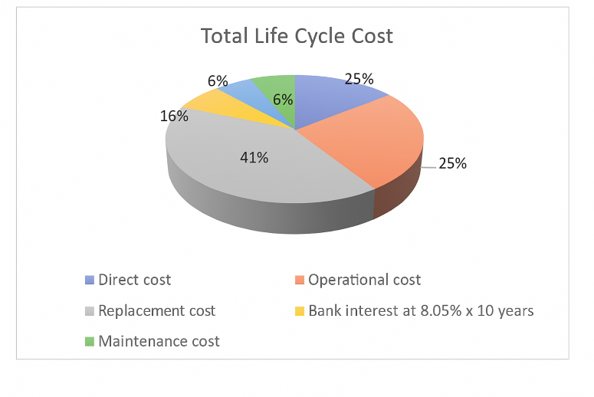
Figure 5. Total Life Cycle Cost

Estimation of the Average Inflation Rate

Inflation Rate of Semarang City (2017-2021)
 | Rate Inflation
Year | National | Central Java | Semarang, City
2017 | 3.75% | 3.62% | 0.29%
2018 | 3.19% | 3.02% | 0.23%
2019 | 2.78% | 2.44% | 0.24%
2020 | 2.03% | 2.26% | 0.13%
2021 | 1.56% | 1.46% | 0.13%
Rata-rata | 2.66% | 2.56% | 1.02%
 |  | Average Inflation Rate | 2.08%
Tabel 5. Average Inflation Rate

Investment Feasibility Analysis
The feasibility of an investment can be determined based on the analysis of benefits and costs. A project, construction equipment, or any form of investment is considered feasible if the benefits obtained are greater than the costs incurred.
In this analysis, several assumptions and limitations are applied as follows:
- Optimistic scenario: Occupancy rate is assumed to be less than 100% from year 1 to year 10, and 100% from year 11 to year 50, with a price of Rp155,000,000/m².
- Normal scenario: Occupancy rate is assumed to be less than 100% throughout year 1 to year 50, with a price of Rp160,000,000/m².
- Pessimistic scenario: Occupancy rate is assumed to be less than 100% throughout year 1 to year 50, with a price of Rp140,000,000/m².
- Interest rate used is 2.08%, which is derived from the inflation rate in Semarang City during the period of 2017–2021.

Cash In
Cash in, or revenue, at Cordova Edupartment is derived from two main components:
IPL (Environmental Management Fee)
IPL is a mandatory fee that must be paid by apartment residents. The amount of IPL is regulated in the Apartment Law Article 57 paragraph (1). Based on PPJB (Sale and Purchase Agreement), the IPL charged is Rp20,000/m²/year, in accordance with the basic tariff of P3SRS (Association of Owners and Residents of Condominium Units).
a) The optimistic scenario of cash in from IPL can be seen in the following table:

Calculation of Revenue Over a 50-Year Period
 | Cash in | Cumulative Value
  Year
1 | Rp30.519.967.000 | Rp30.519.967.000
2 | Rp30.519.967.000 | Rp61.039.934.000
3 | Rp30.519.967.000 | Rp91.559.901.000
4 | Rp30.519.967.000 | Rp122.079.868.000
5 | Rp33.136.399.000 | Rp155.216.267.000
6 | Rp33.344.399.000 | Rp188.560.666.000
7 | Rp33.344.399.000 | Rp221.905.065.000
8 | Rp33.344.399.000 | Rp255.249.464.000
9 | Rp33.344.399.000 | Rp288.593.863.000
10 | Rp36.232.939.928 | Rp324.826.802.928
11 | Rp33.574.031.000 | Rp358.400.833.928
12 | Rp33.574.031.000 | Rp391.974.864.928
13 | Rp33.574.031.000 | Rp425.548.895.928
14 | Rp33.574.031.000 | Rp459.122.926.928
15 | Rp36.462.571.928 | Rp495.585.498.856
16 | Rp36.716.085.656 | Rp532.301.584.512
17 | Rp36.716.085.656 | Rp569.017.670.168
18 | Rp36.716.085.656 | Rp605.733.755.824
19 | Rp36.716.085.656 | Rp642.449.841.480
20 | Rp39.905.034.841 | Rp682.354.876.321
21 | Rp40.184.913.996 | Rp722.539.790.317
22 | Rp40.184.913.996 | Rp762.724.704.313
23 | Rp40.184.913.996 | Rp802.909.618.309
24 | Rp40.184.913.996 | Rp843.094.532.305
25 | Rp43.705.513.896 | Rp886.800.046.201
26 | Rp44.014.500.484 | Rp930.814.546.685
27 | Rp44.014.500.484 | Rp974.829.047.169
28 | Rp44.014.500.484 | Rp1.018.843.547.653
29 | Rp44.014.500.484 | Rp1.062.858.048.137
30 | Rp47.901.242.773 | Rp1.110.759.290.910
31 | Rp48.242.363.966 | Rp1.159.001.654.876
32 | Rp48.242.363.966 | Rp1.207.244.018.842
33 | Rp48.242.363.966 | Rp1.255.486.382.808
34 | Rp48.242.363.966 | Rp1.303.728.746.774
35 | Rp52.533.327.454 | Rp1.356.262.074.228
36 | Rp52.909.925.251 | Rp1.409.171.999.478
37 | Rp52.909.925.251 | Rp1.462.081.924.729
38 | Rp52.909.925.251 | Rp1.514.991.849.980
39 | Rp52.909.925.251 | Rp1.567.901.775.230
40 | Rp57.647.148.941 | Rp1.625.548.924.171
41 | Rp58.062.912.909 | Rp1.683.611.837.080
42 | Rp58.062.912.909 | Rp1.741.674.749.988
43 | Rp58.062.912.909 | Rp1.799.737.662.897
44 | Rp58.062.912.909 | Rp1.857.800.575.806
45 | Rp63.292.807.862 | Rp1.921.093.383.668
46 | Rp63.751.811.283 | Rp1.984.845.194.952
47 | Rp63.751.811.283 | Rp2.048.597.006.235
48 | Rp63.751.811.283 | Rp2.112.348.817.518
49 | Rp63.751.811.283 | Rp2.176.100.628.801
50 | Rp69.525.615.312 | Rp2.245.626.244.113
Tabel.6. Revenue Projection Over a 50-Year Period
Calculation of Net Present Value (NPV)
The NPV for a rental price increase of 10.4% every five years with an initial rental price of Rp155,000/m² is calculated as follows:

NPV = $\sum_{t=1}^{n}{[\left(c\right)t:\left(1+i)^{t}\right]- \sum_{t=1}^{n}{[\left(c\right)t:\left(1+i)^{t}\right] }}$
= Rp1.292.563.860.445 – Rp1.071.744.260.346
= Rp220.819.600.100
The apartment unit rental price with an increase of 10.4% every five years at an initial rental price of Rp130,000/m² yields NPV > 0 (a positive value), which indicates that the investment is feasible and profitable.

Calculation of Break-Even Point (BEP)
For an apartment unit rental price that increases by 10.4% every five years, with an initial rental rate of Rp130,000/m², the break-even point (BEP) occurs in the 25th–26th year, as illustrated in the diagram below.

Annual BEP Calculation:
Difference in years = 25–26 = 1 year
Remaining Different
= (-Rp16.595.316.753) – Rp9.176.117.068
= -Rp25.771.433.821
= 25+((-Rp16.595.316.753):(-Rp25.771.433.821))x1
= 25 + (0,64) x 1 = 25,64 Years

Figure 6. BEP Diagram

Calculation of Internal Rate of Return (IRR)

For I = 5% The following result is obtained:
NPV= Rp589.650.596.478 – Rp622.554.297.663
= -Rp32.903.701.185
Sine at i = 5% The NPV < 0, The IRR can be calculated as follows:
IRR = i${NPV}_{+}+\frac{{NPV}_{+}}{| {NPV}_{+}+ {NPV}_{-}}({NPV}_{+}+ {NPV}_{+})$
Where:
NPV+ = 6,78%
NPV- = 5%
NPV+ = Rp9.176.117.068
NPV- = -Rp32.903.701.185
IRR = 6,78%$+\frac{Rp9.176.117.068}{\left| Rp9.176.117.068+(-Rp32.903.701.185) \right|}(5\%+ 6,78\%)$ = 9,35%

By applying the trial-and-error method, it is found that when the discount rate is 5%, the IRR value obtained is 9.35%. Since IRR (9.35%) > MARR (6.78%), the project can be considered feasible and financially viable. With a rental rate of Rp130,000/m² and an increase of 10.4% every five years, the investment is declared acceptable according to the IRR criterion.

CONCLUSIONS
Based on the discussion in the previous chapter, it can be concluded that this research has successfully addressed the research questions and achieved its objectives. The conclusions derived from the analysis are as follows:
- The analysis indicates that the components of the Life Cycle Cost (LCC) consist of:
a. Direct costs, including land preparation costs, pre-construction costs, and construction costs.
b. Operational costs, including employee salaries, water and electricity expenses, land and building taxes, as well as insurance costs.
c. Maintenance and replacement costs, which cover annual maintenance expenses and the replacement of building components throughout the predetermined design life of the building. In the case of the Cordova Edupartment Semarang, the building is planned to have a design life of 50 years.
- Additional cost components include demolition costs and bank loan interest.
- Based on the analysis, the total Life Cycle Cost (LCC) of the Cordova Edupartment Building over a 50-year period amounts to Rp1,446,963,114,4027. This cost comprises direct costs of Rp222,881,901,903 (16%), operational costs of Rp363,196,544,319 (25%), maintenance costs of Rp595,702,742,387 (41%), replacement costs of Rp98,028,032,247 (7%), demolition costs of Rp78,001,162,410 (5%), and bank loan interest of Rp89,152,760,761 (6%).
- Based on the optimistic scenario analysis, with a rental rate of Rp155,000/m² and an initial occupancy of 85%, the results show a Net Present Value (NPV) greater than zero, amounting to Rp863,392,832,379. The Break Even Point (BEP) is achieved at 12.17 years, while the Internal Rate of Return (IRR) yields a positive value of 19.31%, which is greater than the Minimum Attractive Rate of Return (MARR) of 6.78%. This indicates that the investment is both feasible and profitable, with a relatively high rate of return within a shorter period compared to the normal and pessimistic scenarios. Therefore, the appropriate rental rate is Rp155,000/m² with an initial occupancy of 85%.

Acknowledgments
Based on the results of the analysis, the following recommendations are suggested for future research:
- This study was conducted on the Cordova Edupartment in Semarang, which is located in a strategic area, thereby resulting in relatively high unit values and rental prices compared to other cities. It is recommended that future research should adjust the unit values and rental prices according to the specific location and city where the study is conducted.

- The planned building lifespan in this study is 50 years. It is suggested that future research should align the life cycle cost calculations with the planned lifespan of the building being studied.
- The costs analyzed in this study include direct costs, operational costs, maintenance costs, replacement costs, and demolition costs. For future research, it is recommended that demolition costs be calculated in more detail and in accordance with actual field conditions. In this study, demolition costs were estimated at 10% of construction costs.

References
- Barringer, H. & Weber, D., 1996. Life Cycle Cost Tutorial. In Fifth International Conference on Process Plant Reliability. Houston, Texas, pp. 1–58.
- Cleland, D.I. & King, W.R., 1983. System Analysis and Project Management, New York: Mc Graw-Hill
- Firsani, T. & Utomo, C., 2012. Analisa Life Cycle Cost pada Green Building Diamond Building Malaysia. teknik ITS, 1(September (2012)), pp.D34–D38
- Janitra,Kevin.,Widyanugraha,Khrisna.,Alifin,Setiawardani. 2018. Perhitungan Life Cycle Cost Sistem Pendingin Ruangan Pada Gedung Hotel Goldvitel Surabaya. Jurnal Dimensi Pratama Teknik Sipil Volume 7, No 1
- Kamagi, Grace Priscillia. 2013. Analisis Life Cycle Cost Pada Pembangunan Gedung (Studi Kasus : Proyek Bangunan Rukan Bahu Mall Manado). Jurnal Sipil Statik Vol.1 No.8, Juli 2013 (549-556) ISSN: 2337-673254
- Susilo, Eko. 2018. Analisis Life Cycle Cost Pada Bangunan Rumah Susun Sederhana Sewa Di Daerah Istimewa Yogyakartalife Cycle Cost Analisys On Low Cost Apartmen In Yogyakarta. Tugas Akhir Jurusan Teknik Sipilfakultas Teknik Sipil Dan Perencanaan Universitas Islam Indonesia .Yogyakarta
- Wongkar, Kristti, Yellih. 2016. Analisis Life Cycle Cost Pada Pembangunan Gedung. Jurnal Sipil Statik Vol.4 No.4 (253-262) ISSN: 2337-6732
- Utari, Rini Pebri. 2018. Permodelan Proporsi SDM, Material Dan Alat Pada Proyek Konstruksi Gedung Sederhana & Non Sederhana Studi Kasus : Beberapa Proyek Konstruksi Di Wilayah Jawa Timur. Jurnal Hexagon Volume 3 no 1 2018
- Utari, Rini Pebri. 2019. Pengendalian Biaya dan Waktu dengan Pendekatan Metode Earnead Value Concept (EVM). Jurnal Media Teknik Sipil Volume 17 No 2 Tahun 2019

