The Implementation of Full-Autonomous Driving System in Taxi Enterprises: A Systematic Literature Review
Kevin Kevin^{a)}, Kevin Stenly Liustanto^{b)}, and Sidharta Sidharta^{c)}
Computer Science Department, School of Computer Science, Bina Nusantara University, Jakarta, Indonesia
^{a)} Corresponding author: kevin096@binus.ac.id
^{b)} kevin.liustanto@binus.ac.id
^{c)} sidharta@binus.ac.id
Abstract. The development of technology in cars is very rapid because it’s assisted by extraordinary technological developments. Artificial Intelligence is a sophisticated system that really helps our lives, including the development of car technology. With AI, many things that previously had to be done manually can now be automated. Including vehicles for public transportation like taxis. Usually, a taxi must have a driver who picks us up and takes us. However, technological developments starts to take us towards full-autonomous taxis or driver-less taxis. For this reason, this research paper conduct a Systematic Literature Review (SLR) which discusses the implementation of a full-autonomous driving system in taxis. In this SLR, we will answer three research questions. Those are, What kind of AI algorithms that are most widely used in full-autonomous driving systems; What is the impact of autonomous taxis on the security and safety of other road users; and What is the impact of the use of autonomous taxis on urban transportation. These research questions will be answered using the PRISMA method. As a result, we found that the AI algorithms most frequently used in full-autonomous driving systems are Machine Learning and Deep Neural Networks. Meanwhile for autonomous taxis with the safety of other road users, safety features, prevention, and cooperation of the system with sensors have produced good results by maintaining the safety of pedestrians and other road users. For conclusion in this paper, we conclude that the use of autonomous taxis could bring efficiency in the public transportation sector.
Keywords: autonomous taxi, autonomous vehicle, self-driving taxi, robo taxi, full-autonomous driving

INTRODUCTION
In the past few years, the emergence of autonomous driving technology has become a transformative era in the field of transportation, which has made quite a lot of changes to the structure of mobility and logistics. From the many applications of this innovative technology, its integration into taxi companies is a beacon of modernization and efficiency. This systematic literature review will look at the effects and impact of emerging full-autonomous driving technologies in the taxi industry, exploring the diverse implications and technological advances that are steering this evolution.
Autonomous Vehicles or often abbreviated as AVs, which have the characteristic of being able to operate without human intervention, utilize a combination of Artificial Intelligence, Machine Learning, and many sophisticated sensors to carry out complex navigation of real world traffic conditions. The implementation of technology like this to taxis often referred to as 'Robo-Taxi', is like a stepping stone towards the future. This can also improve safety, reduce congestion and reduce emissions. Apart from that, the impact of autonomous taxis on the social and economic sectors is also quite huge. It has the potential to also change the urban landscape and labor market [1].
This research paper aims to provide an overview of the implementation of autonomous systems in taxi companies. Study the technology used in autonomous vehicle systems and the impact of its use. Based on various papers and journals, we attempt to present a balanced and critical analysis of the autonomous taxi ecosystem. The main goal is to find out how this system is implemented and what impact it has on our daily lives.

LITERATURE REVIEW

AUTONOMOUS TAXI
Autonomous taxis, also referred to as robotaxi, Robotaxis are autonomous vehicles used for driverless ridesharing services, included in SAE level 4 or 5 automation, that can operate without human intervention in most situations. Robotaxis have the potential to improve road safety, reduce congestion, and pollution in cities, but raise concerns about job losses, operator liability, and high costs due to the need for specialized sensors. In 2023, robotaxi trials have been conducted in several cities such as San Francisco, Phoenix, and Singapore, with several services starting to operate to the public. However, there are challenges such as congestion due to network disruptions and access issues for emergency vehicles. Until 2023, one death related to robotaxi was reported, namely a pedestrian who was hit by an Uber test vehicle. In Los Angeles, the driverless Waymo fleet has been approved to operate and begin offering free service, but there are concerns that robotaxis could hamper emergency vehicles.

AUTONOMOUS VEHICLE
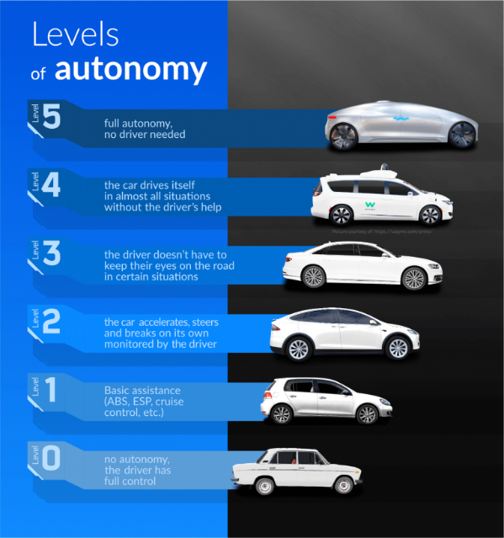
An autonomous vehicle is a vehicle that is able to detect its environment. It can operate without human involvement. It is equipped with technology that can detect conditions around it, including traffic, pedestrians and physical dangers, and can adjust its path and speed without needing a human to control it [2]. We often hear the terms "autonomous car" and "self-driving car". However, the Society of Automotive Engineers (SAE) defines six levels of automated driving, ranging from full human control of the vehicle, to driving assisted by advanced safety technologies such as ADAS, to vehicles that can operate without human intervention in them. Only the top tier represents driverless or fully autonomous vehicles.
FIGURE 1. Levels of autonomous driving

The level of autonomous vehicles consists of six levels that describe the development of the vehicle's ability to drive automatically, as seen in FIGURE 1. At Level 0, the vehicle has no automation features and is fully controlled by the driver without an advanced driver assistance system (ADAS). At Level 1, vehicles begin to have assistive technologies such as Lane Keeping Assist or regular Cruise Control, but the main control remains with the driver. Level 2 allows the use of two or more assistive technologies simultaneously, providing a little more automation in driving. Level 3 introduces capabilities where the driver does not need to drive when the auto feature is active, but should be ready to take over if needed, especially in situations such as on expressways with Adaptive Cruise Control and Lane Keep Assist active. Level 4 provides full automation capabilities in most conditions, but in certain situations such as remote roads or extreme weather, human supervision is still necessary. An example of a vehicle with Level 4 is the BMW i7. At Level 5, the vehicle has full automation without the need for human intervention at all, allowing the car to drive in a variety of conditions without a steering wheel, gas pedal, or brakes. These autonomous vehicles use sensing technologies such as radar, GPS, cameras, and lidar to monitor the surrounding environment and create 3D maps, although this technology is only effective in countries with infrastructure that supports autonomous vehicles. In some countries, such as Indonesia, autonomous systems like Tesla's have not been able to function fully. In addition, these vehicles are also capable of detecting other vehicles and pedestrians, as well as processing data in real-time to control steering, speed, acceleration, and braking [3].

ARTIFICIAL INTELLIGENCE
Artificial Intelligence (AI) is key in autonomous vehicles, enabling detection and decision-making based on the environment [4]. Machine Learning (ML) enhances this capability by supporting the vehicle's Electronic Control Unit (ECU), and continues to be developed to make autonomous vehicle designs more sophisticated. One of the main functions of ML is to monitor the surrounding environment and predict changes that may occur [5]. With the help of AI, Autonomous Vehicle Perception (AVP) technology can detect pedestrians, other road users, or obstacles around the vehicle. Moreover, the semantic segmentation process enables the analysis of each image pixel to determine its class or label, helping the vehicle understand its environment [6].

SENSORS
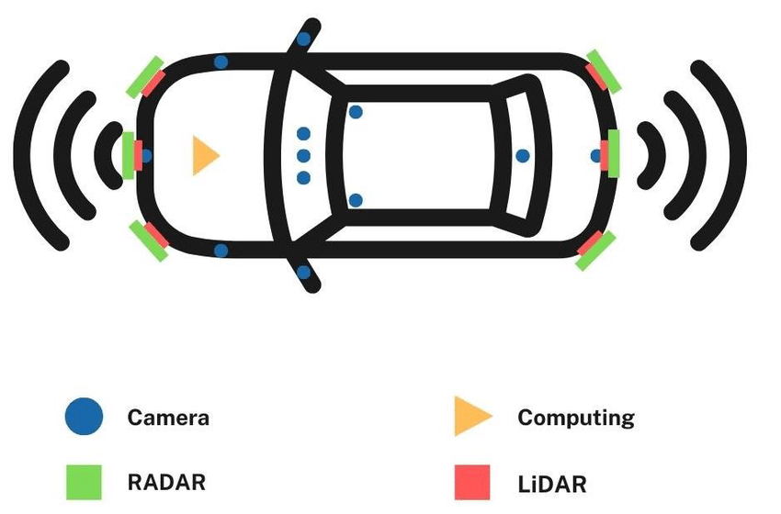
Autonomous vehicles utilize a variety of sensors to collect environmental data, such as cameras that detect objects and transmit data to AI algorithms. However, the camera is less than optimal in bad conditions such as night or fog. Therefore, radar is used in high-end cars because it can measure distance, speed, and angles with high accuracy in a variety of conditions [7]. LiDAR, which is similar to radar but uses laser light, offers high precision despite its high price. Cheaper and more commonly used ultrasonic sensors for parking, work by reflecting ultrasonic waves to avoid collisions at close range [7]. In addition, GPS is an important component in the navigation and route planning of autonomous vehicles, see FIGURE 2.
FIGURE 2. Types of sensors in Avs

METHODS
The purpose of this research is a systematic literature review (SLR). Systematic Literature Review is a research methodology used to understand, identify, evaluate, and use or rework existing literature reviews related to the topic. The purpose of using a Systematic Literature Review is to use existing literature reviews as a basis for creating something new or continuing something that already exists. In this paper, we use the PRISMA approach or its abbreviation Preferred Reporting Items for Systematic Reviews and Meta-Analyses, as shown in FIGURE 3.

RESEARCH QUESTIONS
RQ1: What are the most frequently used AI algorithms for Full-Autonomous driving system?
RQ2: How does the use of self-driving taxis impact the safety of other road users?
RQ3: What is the impact of the use of autonomous taxis on the efficiency of urban transportation?

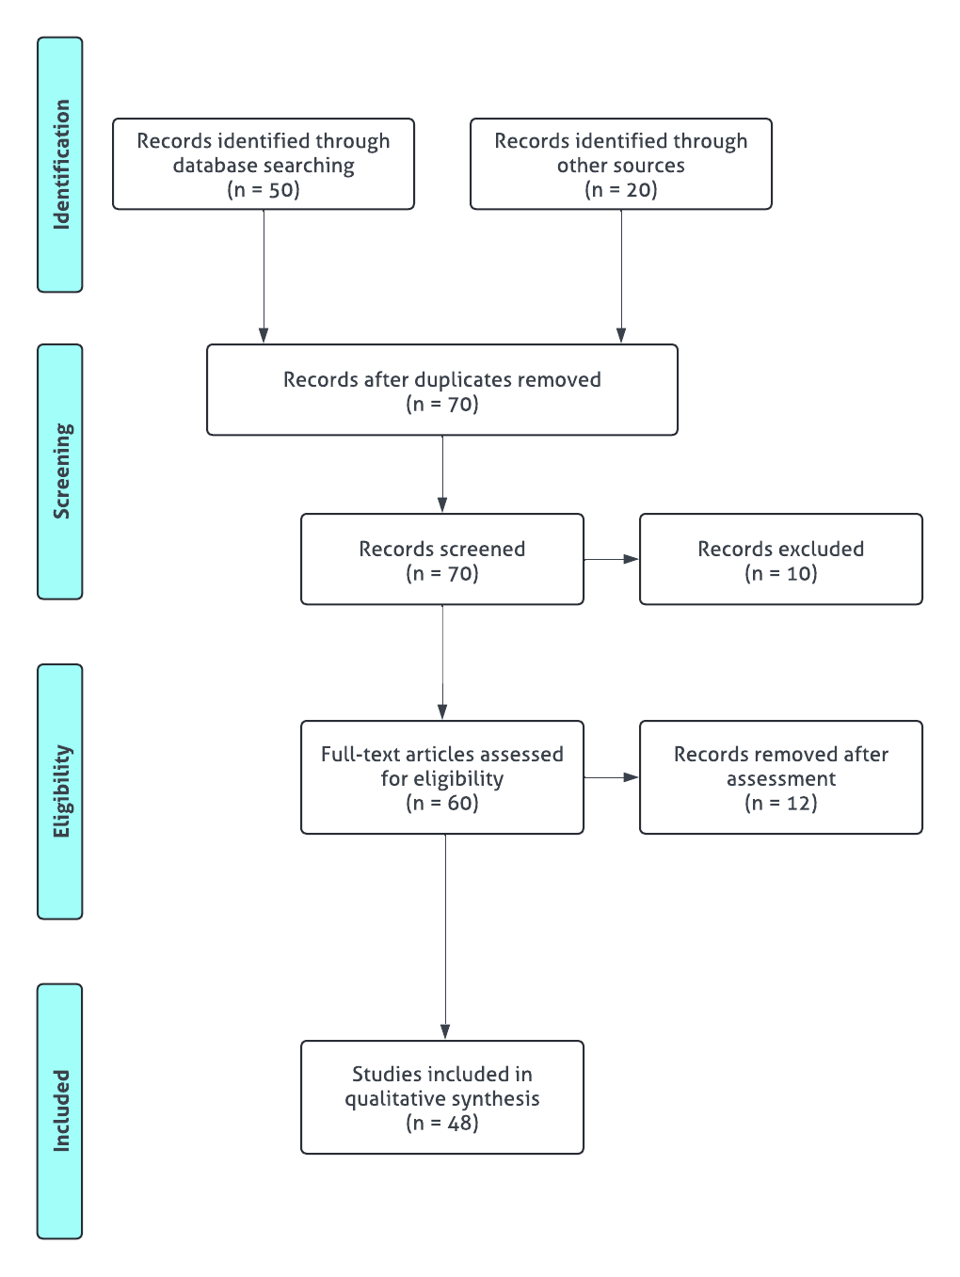
FIGURE 3. Prisma method diagram

SEARCH PROCESS
To create the Systematic Literature Review, we searched the literature from databases such as Mendeley/Elsevier, IEEE, MDPI, Springer, ResearchGate, and Scopus. We limited the search to journals and conference proceedings from 2019 to 2024 to keep the information current, and chose the free access option. We used keywords such as ‘Autonomous Vehicle’, ‘Autonomous Taxi’, ‘Robo taxi’, ‘Artificial Intelligence in Autonomous Vehicle’, ‘Self-driving taxi’, and ‘driver-less taxi’ to obtain all relevant literature. In addition, we also searched for information from various personal non-blog websites, keeping in mind the quality of the articles.

STUDY SELECTION
In selecting journals and proceedings, we checked the title to ensure relevance to the topic, and then read the abstract for an overview of the content. We only selected Open Access articles that were scientific journals, conference proceedings, or from non-blog websites, and published between 2019 and 2024. Studies that did not fulfil these criteria, such as books or older publications, were excluded.

ELIGIBILITY ASSESSMENT
At this stage, the articles that have been selected will be read completely and then we will get the main points. The purpose is to assess and determine the quality of all of the articles. The criteria for this assessment section include:
- Journals must have a clear description of research methods.
- Research method part has a clear dataset and architecture.
- Must have precise and clear research objectives.
- The Results section should be clear and on topic.
- Journals and conference proceedings are expected to include supporting images or illustrations.
- In online articles or websites, must describes the topic in clear language and according to facts.

QUALITATIVE DATA SYNTHESIS
In the data synthesis, we extracted and summarised the key points from the selected articles in a table. This table contains information such as title, year of publication, content, and topics covered, making it easier to write and answer research questions. We also evaluated the quality of the studies by examining the entire content, from the abstract, research questions, to the discussion and results related to autonomous driving systems.

RESULTS AND DISCUSSION

RQ1: MOST FREQUENTLY USED AI ALGORITHMS
To answer this question, we read about AI algorithms which are discussed in various articles that we have collected. The data that we have classified can be seen in TABLE 1.
TABLE 1. Most frequently used AI algorithms
Algorithm | Number of Articles
ML | 5
DNN | 3
CNN | 1
RCNN | 1
K-Means | 1
SLAM | 1
YOLO | 1

From Table 1, we can see that Machine Learning (ML) most often used for Autonomous Vehicles because of the ability to learn from many or large datasets and improve over time. Machine Learning used to analyze data that are gained from various sensors to detect and then respond to their environment. As the name suggests, this algorithm can learn patterns, make predictions, and then take the most appropriate action. For a simple example, ML can learn to differentiate various objects in the real world, such as pedestrians and other vehicles, then ML will learn how to respond, and then it will have different responses between pedestrians and vehicles.
Meanwhile, DNN or Deep Neural Networks is a type of algorithm that are particularly well-suited to tasks that require image or video analysis. DNNs are composed of multiple layers of artificial neurons that proccess and transform the input data, they can learn complex patterns and relationships in the data.The following is an example of Machine Learning working on an Autonomous Vehicle. In FIGURE 4, Machine Learning will analyze the object first. Then, based on the speed and surrounding conditions, it will determine what to do, whether to make an emergency stop, reduce speed gradually, or perhaps make a lane change.
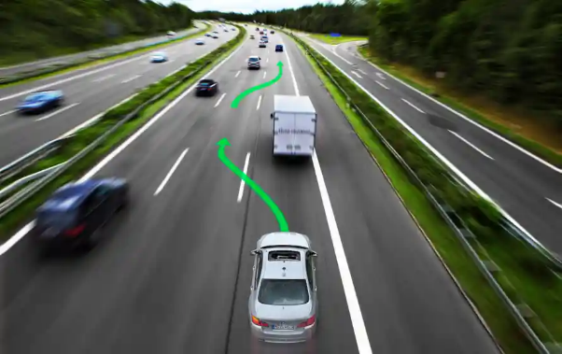
FIGURE 4. Machine Learning Analysis

RQ2: AUTONOMOUS TAXI AND THE SAFETY OF OTHER ROAD USERS
Autonomous taxis have special mechanisms to ensure the safety of other road users. According to article [8], autonomous taxis are equipped with advanced sensors such as cameras, radar, and LiDAR that enable high-accuracy detection of road users, as illustrated in FIGURE 5. Advanced algorithms ensure safety by maintaining a safe distance, giving the right of way, and taking evasive action when necessary [9, 10].
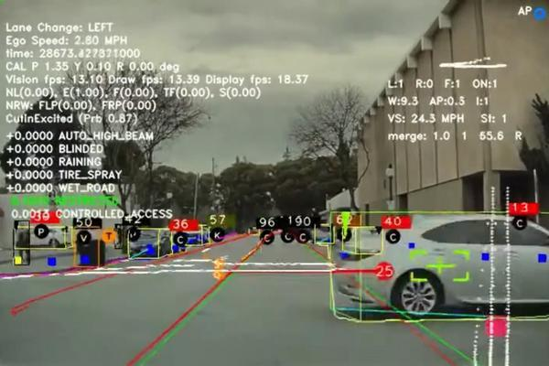
However, there are drawbacks that can affect safety. Reliance on technology makes autonomous taxis vulnerable to extreme weather disturbances that reduce sensor performance [11]. In addition, software errors, such as bugs resulting from incorrect inputs or logic, can interfere with decision-making [12]. Autonomous taxis are also vulnerable to cyberattacks that can cause damage to the system, endangering other road users [13].
FIGURE 5. Autopilot system detecting surroundings

RQ3: IMPACT OF AUTONOMOUS TAXI
- Impact of Autonomous Taxi in Traditional Taxi Business
Autonomous taxis have a huge impact on the traditional taxi business. Traditional taxis will have to compete on price as autonomous taxis have lower operating costs without the need for drivers, so they can offer cheaper fares. This could attract consumers, especially the younger generation, who tend to favour more economical options [14, 15]. The presence of autonomous taxis also reduces the need for drivers, resulting in decreased employment for taxi drivers [16]. However, it also opens up new job opportunities in the fields of technology development, maintenance, data management, cybersecurity, and customer service and technical support for autonomous taxis [17].
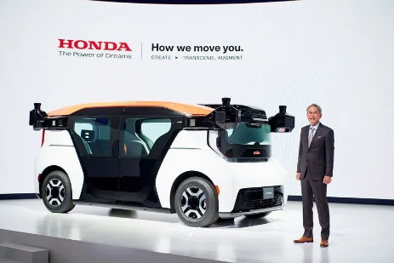
FIGURE 6. Honda Cruise Origin in Japan Mobility Show 2023

- Impact of Autonomous Taxi in Urban Transportation
Autonomous taxis have great potential to improve urban transport efficiency. With advanced algorithms, autonomous taxis can optimise routes, shorten travel time, and increase vehicle speed, thereby improving overall mobility efficiency [18, 19]. In addition, autonomous taxis can speed up switching between transport modes, reduce waiting time, and improve the travelling experience [19].
In addition to efficiency, autonomous taxis also improve accessibility and mobility, especially for the elderly and people with disabilities, by providing shuttle services without manual assistance, making transport more inclusive [20]. Autonomous taxis can also expand transport options in remote areas underserved by public transport, thereby improving mobility for residents in those regions, the example has shown in FIGURE 6.
Autonomous taxis also play a role in reducing emissions and energy consumption in cities. By optimising driving patterns through sensors and predictive algorithms, autonomous taxis can reduce fuel consumption and greenhouse gas emissions [21]. The adoption of electric autonomous taxis can even further reduce air pollution and dependence on fossil fuels, supporting sustainable transport practices [22]. Nonetheless, there are challenges such as safety, legal liability, and large funding requirements that need to be overcome to realise the full potential of autonomous taxis [23, 24].

CONCLUSIONS
In conclusion, this study reviews the literature on the use of Fully Autonomous Driving Systems in taxi companies. We found that Machine Learning algorithms are the most commonly used in the development of autonomous taxis. Autonomous taxis show great potential when it comes to safety, thanks to advanced sensor technology and algorithms that can anticipate hazards. However, these systems are still vulnerable to technical errors and cyberattacks, especially in bad weather conditions.
In the business world, autonomous taxis can reduce operational costs and change consumer preferences, although this can threaten the jobs of traditional taxi drivers. In addition, autonomous taxis can also improve the efficiency of urban transportation and reduce emissions, but there are still challenges in terms of safety, legal, and cost to overcome. Overall, the use of Full Autonomous Driving Systems in taxi companies has the potential to create a safer, more efficient, and sustainable transportation ecosystem, although there are still challenges that need to be faced.

REFERENCES
1. Alanazi, F., A systematic literature review of autonomous and connected vehicles in traffic management. Applied Sciences, 2023. 13(3): p. 1789.
2. Garsten, E., What are self-driving cars? The technology explained. Forbes Innovation. 2024.
3. Cole, M., et al., Exploration of robust and intelligent navigation algorithms to ensure off-road autonomous vehicle mobility. International Journal of Vehicle Performance, 2024. 10(3): p. 239-267.
4. Yadav, S.K., The Development of AI & Self Driving Technology. Interantional J. Sci. Res. Eng. Manag, 2023. 7: p. 1-9.
5. Kumari, D. and S. Bha, Accelerating the Race to Autonomous Cars–A Case Study. International Journal of Applied Engineering and Management Letters (IJAEML), 2021. 5(2): p. 219-231.
6. Jebamikyous, H.-H. and R. Kashef, Autonomous vehicles perception (avp) using deep learning: Modeling, assessment, and challenges. IEEE Access, 2022. 10: p. 10523-10535.
7. Parekh, D., et al., A review on autonomous vehicles: Progress, methods and challenges. Electronics, 2022. 11(14): p. 2162.
8. Ahmed, S., et al., Pedestrian and cyclist detection and intent estimation for autonomous vehicles: A survey. Applied Sciences, 2019. 9(11): p. 2335.
9. Ignatious, H.A. and M. Khan, An overview of sensors in Autonomous Vehicles. Procedia Computer Science, 2022. 198: p. 736-741.
10. He, X. and C. Lv, Toward personalized decision making for autonomous vehicles: a constrained multi-objective reinforcement learning technique. Transportation research part C: emerging technologies, 2023. 156: p. 104352.
11. Vargas, J., et al., An overview of autonomous vehicles sensors and their vulnerability to weather conditions. Sensors, 2021. 21(16): p. 5397.
12. Garcia, J., et al. A comprehensive study of autonomous vehicle bugs.
13. Malik, S. and W. Sun. Analysis and simulation of cyber attacks against connected and autonomous vehicles. IEEE.
14. Abe, R., Introducing autonomous buses and taxis: Quantifying the potential benefits in Japanese transportation systems. Transportation Research Part A: Policy and Practice, 2019. 126: p. 94-113.
15. Pakusch, C., et al., Traditional taxis vs automated taxis–Does the driver matter for Millennials? Travel Behaviour and Society, 2020. 21: p. 214-225.
16. Groshen, E.L., et al., Preparing US workers and employers for an autonomous vehicle future. 2018.
17. Nikitas, A., A.-E. Vitel, and C. Cotet, Autonomous vehicles and employment: An urban futures revolution or catastrophe? Cities, 2021. 114: p. 103203.
18. Zambrano-Martinez, J.L., et al., A centralized route-management solution for autonomous vehicles in urban areas. Electronics, 2019. 8(7): p. 722.
19. Hu, L. and J. Dong, An artificial-neural-network-based model for real-time dispatching of electric autonomous taxis. IEEE Transactions on Intelligent Transportation Systems, 2020. 23(2): p. 1519-1528.
20. Hassan, H.M., et al., Factors that influence older Canadians’ preferences for using autonomous vehicle technology: A structural equation analysis. Transportation research record, 2019. 2673(1): p. 469-480.
21. Khavarian-Garmsir, A.R., A. Sharifi, and M. Hajian Hossein Abadi, The social, economic, and environmental impacts of ridesourcing services: A literature review. Future transportation, 2021. 1(2): p. 268-289.
22. Nunes, A., et al., Estimating the energy impact of electric, autonomous taxis: evidence from a select market. Environmental Research Letters, 2021. 16(9): p. 094036.
23. Carr, N.K., As the Role of the Driver Changes with Autonomous Vehicle Technology, so, Too, Must the Law Change. . Mary's LJ, 2019. 51: p. 817.
24. Nunes, A. and K.D. Hernandez, Autonomous taxis & public health: High cost or high opportunity cost? Transportation Research Part A: Policy and Practice, 2020. 138: p. 28-36.

