Analysis Lighting of TKIT Muadz Bin Jabal Yasmin Sleman Using Dialux Evo to support Green Design
Muhamad Julfan Firnandi^{a)} and Ida Bagus Ananta Wijaya^{b)}
Interior Design Departement, School of Design, Bina Nusantara University, Jakarta, Indonesia

^{a)} Corresponding author: muhamad.firnandi@binus.ac.id
^{b)} ida.wijaya@binus.ac.id
Abstract. Global warming is a phenomenon that can endanger life and the environment because of the negative impacts it causes that are sustainable, such as rising temperatures and wasting electricity, which has other negative impacts. Therefore, there are several forms of solutions that can be done to reduce it. One of them is the Green Design concept that will be applied to the building, the green design concept aims to provide positive things to the environment, such as the utilization of natural energy natural lighting and adding material recyling. The object taken as research is TKIT Muadz Bin Jabal, which has problems in the lighting aspect. So, the author aims to provide a solution by adding a canopy with skylights for lighting and will be simulated with dialux evo software and design with the application of recycled materials. Qualitative research methods to collect data from the objectives. The author gets the conclusion that using natural lighting with openings that are directly exposed to the sun has an impact that is not good for the room.
Keywords: Global Warming, Green Design,Natural Light, Kindergarten

INTRODUCTION
In recent decades, the growth of the population has resulted in a notable rise in the utilization of artificial energy sources, particularly in major urban centers in Indonesia, such as Yogyakarta. As the fourth most densely populated city in Indonesia and a city with numerous tourist attractions and educational centers, the air temperature is exceedingly hot and humid, largely due to the rising temperatures resulting from the high population density and erratic climate patterns. Climate change has emerged as a significant issue in the early 21st century. A study conducted by the NASA Goddard Institute for Space Studies revealed that global surface temperatures over the past decade have increased by 0.8˚C compared to the early 20th century, with two-thirds of this warming occurring since 1975 [1]. Based on statistical data from the Central Bureau of Statistics of Yogyakarta Province (2016) and the Meteorology, Climatology, and Geophysics Agency (2023), the average temperature is 23°C, with the highest temperature reaching 32°C. It should be noted that these figures are subject to variation according to the environment and population density in a particular area.
Kindergarten is the designation for the level of early childhood education that focuses on children aged 4-6 years. The primary objective of kindergarten is to facilitate the development of fundamental abilities across a range of cognitive, emotional, social, and physical domains. Given the large number of children typically enrolled in a kindergarten class, it is essential to ensure that the classroom environment is conducive to learning and well-maintained. One design concept that can positively impact the environment is sustainable design in the interior. The term "sustainable" is not merely an indicator of the potential for future use of a material; it also signifies a commitment to environmental stewardship. The term "sustainable design" is used to describe the creation and operation of a healthy environment that relies on the efficient use of resources and environmentally friendly design principles [2].

In addition to the detrimental impact on the environment, the use of non-durable materials can also have adverse effects on human health. This is due to the influence of unfavorable weather patterns and the accumulation of residues that gradually damage the environment [3]. Moreover, the concept of green design provides a framework for minimizing adverse effects on human health. This concept is defined as a planning method that aims to reduce the impact on humans and the surrounding environment [4].
Therefore, the object taken is a kindergarten called TKIT Muad Bin Jabal which is located in Triharjo, Sleman District, Sleman Regency, Yogyakarta Special Region, by applying the concept of Green Design in designing kindergartens with the help of Dialux Evo software as a tool to simulate the light needed properly.
Green design is an architectural design approach that aims to minimize various harmful impacts on human health and the environment.[4]. The concept of green design is an architectural design that emphasizes the sustainability of the ecosystem between humans and the environment. In understanding green design, the inside or interior of the building must apply an interior landscape that must have unity with the architecture, with the most ideal ratio being 60: 40 for application as a house building and land [4].
The implementation of green design principles within interior spaces entails the utilisation of sustainable materials and the incorporation of increased natural light and ventilation. This approach not only reduces energy consumption but also mitigates the adverse effects of excessive heat. Furthermore, the incorporation of recycled materials in select applications can extend the environmental benefits of green design principles to the built environment.
Natural lighting is defined as illumination obtained from direct sunlight that enters a room through a window or other opening in the building envelope. In general, the level of illumination from natural light is optimal between 7 a.m. and 4 p.m., with a sufficient division of light within the room. The measurement of light intensity is subject to variation. The discrepancy in solar intensity at 12:00 p.m. is more pronounced than at 8:00 a.m. and 4:00 p.m. Consequently, this may result in fluctuations in the level of sunlight intensity. [5] The process of metering can influence the intensity of light. The contrast in solar intensity at 12:00 p.m. is more pronounced in comparison to 8:00 a.m. and 4:00 p.m. Consequently, this may result in fluctuations in the intensity of sunlight. In accordance with the following: [6] The utilization of light that enters through openings can originate from a multitude of disparate sources, encompassing not only quantitative variations but also qualitative nuances such as color, distribution, contrast, glare, and brightness.
A workplace or a place of learning requires an adequate level of natural lighting comfort, [7], in order to perform activities smoothly and have high work productivity. Design compliance with recommended light standards and placement of room layouts in accordance with lighting distribution are some of the ways in which visual comfort can be achieved. However, relying on recommended standards to evaluate comfort is not enough as the behavior of different building users affects their perception of lighting comfort in a space.
In the room contained in TKIT MBJ Yasmin has a lux that is higher than the applicable SNI, the author observes data using an android application to take measurements in the TKIT MBJ Yasmin study room. The following TABLE 1 is the average data obtained when measuring light intensity:

TABLE 1. Average lux obtained by observation on the object

Room Function | Lighting Level  Lux (lx) | Color Rendering Group
Classroom 1 | 500-3500 | 1 or 2
Classroom 2 | 500-3250 | 1 or 2
Classroom 3 | 500-3250 | 1 or 2
Teaher Room | 470-1500 | 1 or 2
Pantry Area and Toilet | 700-1340 | 1 or 2

If there is a match between the light emitted and the size of the space, the visual comfort assessment of the lighting will be appropriate. The level of light brightness in a room is a significant factor that affects the ability of individuals in the room to move properly. One of the most effective light sources is direct sunlight entering the room.
From previous research, research on lighting is more changing the shape of the window that has more work efficiency. with the addition of a canopy that has skylights as the entry of light can provide optimal design efficiency without demolition of the building.

METHODS
In this research, the author employs the principles of scientific inquiry to address the research questions in a systematic and rigorous manner. The research process will be conducted in a step-by-step manner, with each stage contributing to the overall understanding of the phenomenon under study. This includes data summarization, data processing, and data presentation. Qualitative research is an approach that is employed with the objective of attaining a comprehensive and contextual understanding of phenomena. In this method, researchers endeavor to comprehend the meaning, interpretation, and context of a situation or event. Qualitative research data may be collected through a variety of means, including interviews, observation, and data analysis.
In this study, data sources were obtained through scientific articles and journals, as well as books that provide similar explanations to those presented in the research conducted by other researchers. Literature studies were conducted on a range of topics, including kindergarten education, green design, natural lighting, and furniture. By using literature studies, it is hoped that the author can gain a broader insight into the problems and problem-solving approaches based on the topics studied. The following FIGURE 1 is a graphical representation of the stages of research.

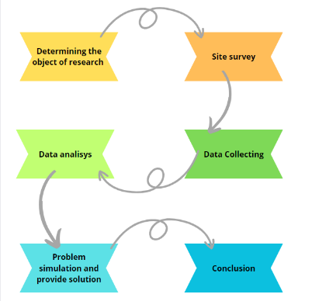
FIGURE.1. Research Step

RESULTS AND DISCUSSION

LOCATION ANALYSIS AND CASE STUDY
This research project is focused on the TKIT Muadz Bin Jabal Yasmin, which is situated in Triharjo, Sleman, Yogyakarta. The edifice comprises a single floor, with rooms extending to the rear. The front room contains a teacher's room and a principal's office. The next room is a living room. The remaining rooms are classrooms, beginning with those designated for classes A, B, and C. These are followed by a pantry, a toilet, and a play area. The last room is a nursery. The primary issue observed at TKIT Muadz Bin Jabal pertains to the main activity room, specifically the classroom and nursery room. The activity room is exposed to direct sunlight, which results in the room becoming uncomfortably hot and humid. This has the effect of reducing the amount of light reaching classrooms A, B, C, and the nursery room. Accordingly, the objective of this study is to implement a solution that entails the installation of a canopy with skylight glass as an intermediary for the entry of light in the hallway area, thereby ensuring that the light remains bright and enters the classroom, see FIGURE 2. The Dialux Evo application will be employed to simulate optimal incoming light.
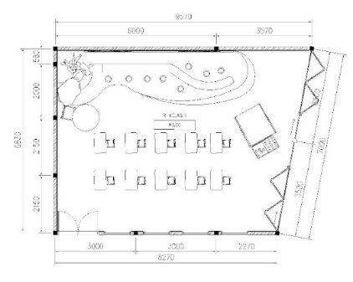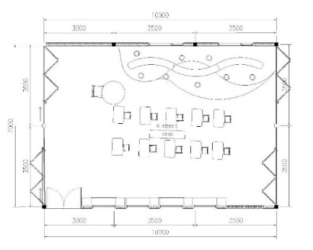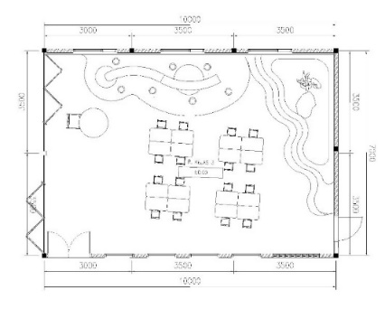
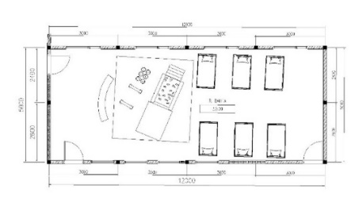
FIGURE 2. Classroom A,B,C dan baby care

EXISTING SIMULATION OF NATURAL LIGHTING
The Dialux Evo software was utilized to conduct simulations, which revealed that certain areas were overexposed, see FIGURE 3.

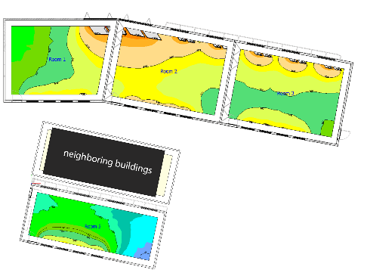
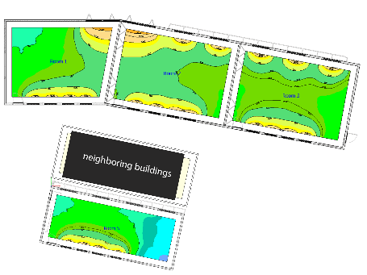
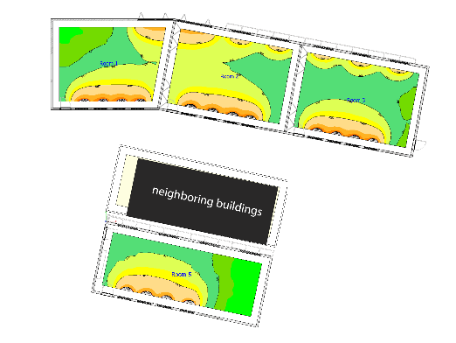
FIGURE 3. Dialux Existing Simulation at 09.00, 12.00 and 15.00

Simulation results obtained using Dialux Evo software show that the window areas receive direct sunlight, resulting in the perception of high temperatures in classrooms A, B, and C, as well as the nursery room. This observation highlights the need for a secondary skin or canopy to improve the distribution of incoming light, given that the light intensity in these areas exceeds 1000-40000 lux. As a result, the light intensity in classrooms A, B and C exceeds the recommended standard for indoor lighting. Such conditions can be distracting and uncomfortable for children who are doing activities indoors. Therefore, the author will provide a solution by adding a canopy for the hallway area to maximize the entry of light and optimize the light entering the room.

PLANNING LAYOUT
In the redesign, the author incorporates a canopy into the front area, specifically the hallway, utilizing a skylight situated at the center of the canopy to permit indirect light to enter.
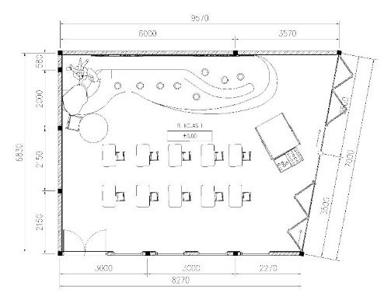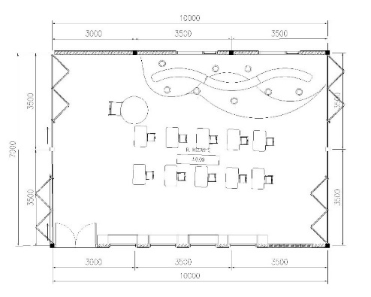
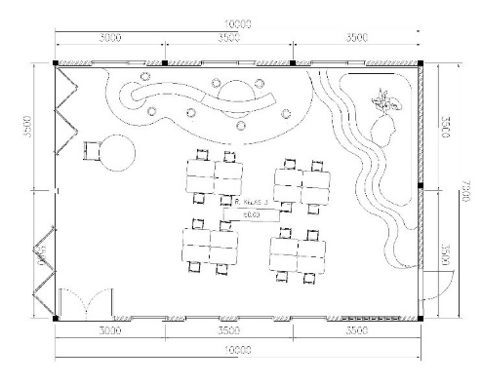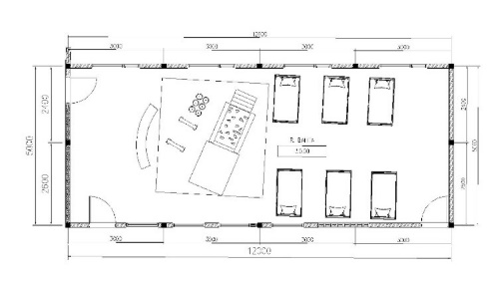
FIGURE 4. Floor Plan A,B,C dan Baby care

In the simulation area, additions have been made to the designed interior. with a forest theme, there are some furniture made for reading in classrooms A, B, C and the nursery room which is given some games for baby learning, some furniture can be seen from the planning plan, as illustrated in FIGURE 4.

SIMULATION OF DAYLIGHTING PLANNING AND SOLUTION

TABLE 2. Information about average lux on Kindergarten
Time | Withot hallway canopy | With hallway canopy | Conclusion
09.00 | 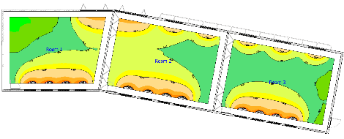  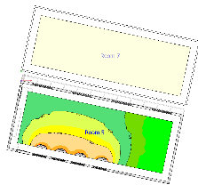  300lux-30000lux | 300lux-2000lux  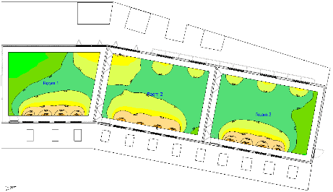  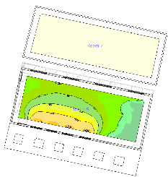 | Using canopy in outdoor area, light comes in  quite evenly inside  display area  excess light only on  the edge of the room
12.00 | 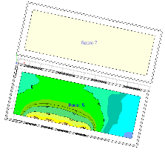  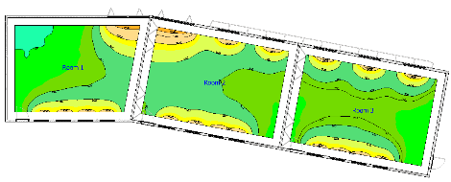  300lux-2000lux | 250lux-500lux  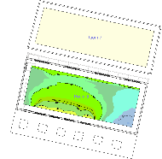  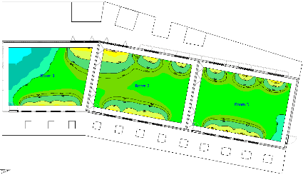 | Using canopy in outdoor area, light comes in  quite evenly inside  display area  excess light only on  the edge of the room
15.00 | 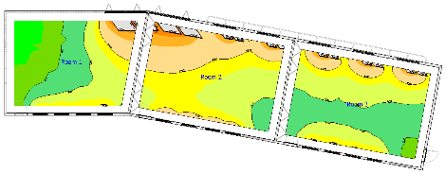  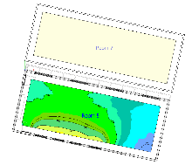  300lux-20000lux | 250lux-5000lux  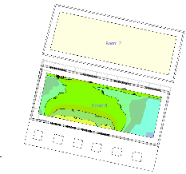  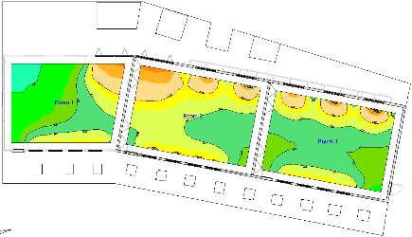 | Using canopy in outdoor area, light comes in  quite evenly inside  display area  excess light only on  the edge of the room

In an effort to save energy, the author provides a solution by utilizing natural lighting with many window openings and the application of cross ventilation as the optimal circulation direction. Therefore, the author simulates the lighting using the Dialux Evo application to provide an overview of the light contained in the selected object.
Therefore, to support natural light, the arrangement of the canopy in the hallway of the room that follows along the classroom building to reduce direct sunlight, but with the addition of several sky lights in the canopy for optimal light distribution to the room. The information about average lux is shown in TABLE 2.

Each room has window openings with the same model, there are openings in the glass that can be opened to utilize air circulation, as shown in TABLE 3.

TABLE 3. Information about average lux on Kindergarten
Floor | Time | Without Canopy | With Canopy
1 | 09.00 | 300-30000 lux with large levels in the area nearest the window | 300-2000 lux with large levels in the area nearest the window
1 | 12.00 | 300-2000 lux with large levels in the area nearest the window | 250-500 lux with large levels in the area nearest the window
1 | 15.00 | 300-20000 lux with large levels on the area nearest the window | 250-5000 lux with large levels in the area nearest the window

The floor plan, which has been simulated, indicates that the data provided in the Dialux Evo settings at 09.00, 12.00, and 15.00, which have been set in the Jakarta area of Indonesia, reveal that the incoming light does not directly enter the room. Rather, it only reaches the edge near the window, as observed in the simulation at 15.00. This observation coincides with the time when children typically return home. Therefore, the room is already excessively stimulating for learning.

APPLICATION GREEN DESIGN
The application of green design in buildings can also help provide effects such as minimizing the use of electrical energy, [8] The establishment offers a refreshing ambience.The design at TKIT Muadz Bin Jabal Yasmin incorporates many openings, and canopies that have the role of shading as well as spreading light to classrooms which serves to reduce dependence on electrical energy during the day. In addition, the utilization of recycled materials, such as cork and wood materials, is also a form of green design implementation, which depicted in FIGURE 6.

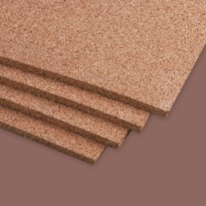
FIGURE 6. Cork Wood Press Material

From what has been simulated and designed, here are the results of 3D rendering of the interior design of TKIT MBJ Yasmin with the application of green design and optimizing the light that can enter the interior of the building, as the 3D rendering is shown in FIGURE 7.

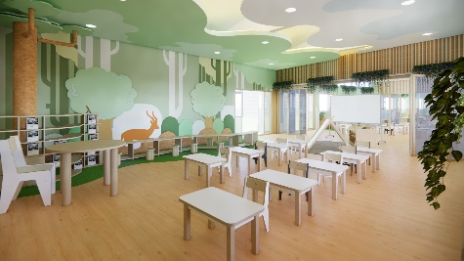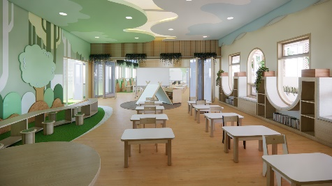
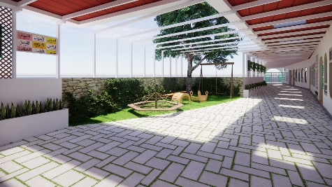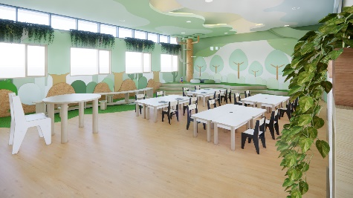
FIGURE 7. 3D Rendering

CONCLUSIONS
Green's design role in addressing environmental issues is critical given the alarming rate of global warming. This concept has the potential to provide benefits to the environment and humans. In this research, the author uses TKIT Muadz Bin Jabal Yasmin, which can be concluded that wide openings do not necessarily have comfort in space, this provides challenges related to the application of sustainable materials and lighting systems in particular. To overcome this problem, the author designed an additional design to facilitate the absorption of sunlight, namely the application of a canopy with the aim of increasing comfort during learning activities. The author used the Dialux Evo application to simulate the room, so as to identify light points with different light intensities. This allows the light requirements for building objects to be determined.

Acknowledgments
The researcher would like to thank God for letting the researcher go through all the difficulties that have been experienced with it being able to complete this research, hence the researcher would like to acknowledge and give the warmest thanks to all the people who helped the researcher complete the research, this with their guidance and suggestions made through all the stages of writing this research.

References
- T. D. Putri, S. Sunarsih, and F. Muhammad, "Analisis Kerentanan Sosial Masyarakat dan Adaptasi Perubahan Iklim di Kampung Gemblakan Atas, Kota Yogyakarta," 2019, vol. 16, 1 ed., pp. 256-264.
- M. R. A. Oktavia and I. Sulistyanto, "Solo Kondominium, Hotel, And Shoping Mall Berpendekatan Architecture Sustainable Design," Jurnal Teknik Sipil dan Arsitektur, vol. 24, no. 2, pp. 38-45, 2019.
- S. Susilawati, "Dampak perubahan iklim terhadap kesehatan," Electronic Journal Scientific of Environmental Health And Disease, vol. 2, no. 1, pp. 25-31, 2021.
- S. Rachmayanti and C. Roesli, "Green design dalam desain interior dan arsitektur," Humaniora, vol. 5, no. 2, pp. 930-939, 2014.
- S. I. Putri and S. Sudarti, "Analisis Intensitas Cahaya di Dalam Ruangan dengan Menggunakan Aplikasi Smart Luxmeter Berbasis Android," Jurnal Materi Dan Pembelajaran Fisika, vol. 12, no. 2, pp. 51-55, 2022.
- M. D. Pangestu, "Pencahayaan alami dalam bangunan," ed: Pencahayaan alami dalam bangunan, 2019.
- A. F. E. Wiyanto, "Analisis pencahayaan alami dan buatan pada ruang kantor terhadap kenyamanan visual pengguna," Jurnal Patra, vol. 3, no. 1, pp. 33-42, 2021.
- I. Ramadhani, "Tinjauan konsep green design pada interior fore coffee Medan. PROPORSI: Jurnal Desain, Multimedia dan Industri Kreatif, 5 (2), 138-147," ed, 2020.

