Challenges in Applying Reinforcement Learning for EV Charging Station Optimization: A Comparative Case Study
Tikno Tikno^{a)}, Brina Miftahurrohmah^{b)}, Grandys F. Prassida^{c)}, Putri Amelia^{d)}, Ardhi Dwi Firmansyah ^{e)} and Catur Wulandari ^{f)}
Universitas Internasional Semen Indonesia, Jl. Veteran – Gresik 61119, Indonesia
^{a)} tikno@uisi.ac.id
^{b)} brina.miftahurrohmah@uisi.ac.id
^{c)} grandys.prassida@uisi.ac.id
^{d)} Corresponding author: putri.amelia@uisi.ac.id
^{e)} ardhi.firmansyah@uisi.ac.id
^{f)} catur.wulandari@uisi.ac.id
Abstract. The proliferation of Electric Vehicle (EV) charging stations is critical for supporting Indonesia's national agenda on battery electric vehicles, as mandated by Presidential Regulation No. 79 of 2023, and for achieving broader sustainability targets. Reinforcement Learning (RL) has emerged as a theoretically promising Artificial Intelligence (AI) approach for the dynamic operational optimization of these stations. This paper investigates the practical challenges of applying standard RL methods to this problem. We developed a discrete-event simulation environment (a digital twin) of a charging station and systematically evaluated two canonical RL approaches: tabular Q-learning and a Deep Q-Network (DQN), proceeding through multiple iterations of reward function design and methodological refinement. Our key finding is that despite these extensive efforts, both RL approaches exhibited significant difficulties in learning effective control policies and consistently failed to outperform a simple First-Come-First-Served (FCFS) baseline in key operational metrics such as average waiting time. Consequently, the primary contribution of this paper is not a superior algorithm, but rather: (1) a critical analysis of the fundamental challenges, including deceptive reward landscapes and the difficulty of credit assignment, that hinder the application of standard RL in this domain, and (2) the provision of a valuable and realistic performance benchmark for future research.

INTRODUCTION
The global transition towards electric mobility represents a critical strategy in mitigating climate change and reducing dependency on fossil fuels. In emerging economies such as Indonesia, this transition is not merely an environmental goal but a national priority, formally accelerated by policies like the Presidential Regulation No. 79 of 2023, which aims to foster a domestic battery electric vehicle (BEV) ecosystem[1]. As the adoption of EVs grows, the focus inevitably shifts to the development of a robust and efficient public charging infrastructure, known as SPKLU (Stasiun Pengisian Kendaraan Listrik Umum) in the local context. The availability and reliability of these charging stations are paramount; studies have consistently shown that the density of charging infrastructure is a primary determinant influencing consumer purchase intentions and alleviating range anxiety[2,3].
However, the proliferation of EV charging stations introduces significant operational and infrastructural challenges. Uncoordinated charging activities can lead to long queues, suboptimal user experiences, and, more critically, impose severe strain on the electrical grid, causing undesirable demand peaks and potential instability[4]. Effective management of these stations is therefore not an option but a necessity. The core problem is one of dynamic optimization: balancing the stochastic arrivals of EVs with varying states-of-charge, fluctuating electricity prices from the grid, and the physical constraints of the charging hardware, potentially integrated with renewable energy sources like solar photovoltaics[5,6].
In response to this complexity, Reinforcement Learning (RL) has emerged in the literature as a particularly promising solution framework. Theoretically, RL is ideally suited for this problem domain. Its model-free nature allows it to learn optimal control policies directly from interaction with a dynamic and uncertain environment, without requiring an explicit mathematical model of user behavior or energy markets[7]. An RL agent could, in principle, learn to intelligently schedule charging sessions to minimize operational costs for the provider, reduce electricity bills for the consumer, and alleviate peak loads on the power grid, adapting its strategy in real-time.
Despite this theoretical appeal, a significant gap exists between the algorithmic promise of RL and its practical, robust implementation in real-world energy systems. The journey from a simulated proof-of-concept to a reliable operational tool is fraught with challenges related to reward function design, state-space representation, sample efficiency, and the stability of the learning process[8]. While numerous studies have proposed novel RL-based scheduling algorithms, there is a comparative lack of investigation into the practical hurdles that arise when standard, well-established RL methods are applied to this task. This paper aims to address this gap by systematically evaluating these challenges. We therefore pose the following research question: “To what extent can standard reinforcement learning algorithms effectively navigate the operational complexities of EV charging station optimization, and what are the primary, practical challenges that emerge during their application in a realistic, simulated case study?”.
To answer this question, this paper conducts a comparative study focused on algorithmic approaches within a single, representative case study of an EV charging station. We analyze and contrast the performance of prominent RL algorithms when applied to a unified optimization problem, aiming to provide a clear-eyed assessment of their practical viability. The primary contributions of this work are: (1) a detailed formulation of the multi-objective EV charging optimization problem tailored for RL; (2) a comparative performance analysis of standard RL algorithms within a realistic case study; and (3) a qualitative and quantitative discussion of the fundamental challenges—such as reward shaping and hyperparameter sensitivity—that are critical for future research and deployment.
The remainder of this paper is organized as follows. Section II provides a review of related work in EV charging optimization and the application of RL. Section III details the methodology, including the case study design, the MDP formulation, and the metrics for comparison. Section IV presents the results of our comparative analysis. Section V discusses these results, interpreting the underlying causes for the observed performance. Finally, Section VI concludes the paper and suggests directions for future work.

LITERATURE REVIEW AND RELATED WORK
This chapter provides a comprehensive review of the research landscape for Electric Vehicle (EV) charging optimization. We begin by examining conventional optimization strategies to establish a baseline, then explore the emergence of Reinforcement Learning (RL) as a more adaptive paradigm. Critically, we then synthesize the literature to identify the persistent challenges and research gaps in applying RL, thereby positioning our comparative study as a necessary contribution to the field.

Conventional Optimization Strategies for EV Charging
Prior to the widespread adoption of learning-based methods, the optimization of EV charging was primarily addressed through mathematical programming and heuristic strategies. The central objectives of these methods have consistently been to minimize operational costs, mitigate stress on the power grid by shaving peak loads, and reduce waiting times for users[9]. Mathematical programming, particularly Mixed-Integer Linear Programming (MILP), has been a popular approach for its ability to find provably optimal solutions under a given model. Researchers have employed these techniques to plan charging station capacity[10] and develop proactive charging strategies based on electricity price predictions[11]. Another significant line of inquiry involves queuing theory, which provides a mathematical framework for modeling EV arrivals and service times to optimize the allocation of chargers and minimize wait times[12]. While powerful, these conventional methods share fundamental limitations. They rely on accurate, explicit models of the environment and struggle to adapt in real-time to the high degree of uncertainty and stochasticity inherent in real-world charging operations.

The Emergence of Reinforcement Learning for Smart Charging
To overcome the rigidity of conventional methods, Reinforcement Learning (RL) has emerged as a leading paradigm for intelligent EV charging management. The appeal of RL lies in its model-free nature and its capacity for adaptive, sequential decision-making in dynamic environments[13]. The literature showcases a breadth of RL applications in this domain. A significant area of focus is dynamic pricing, where RL agents learn to set charging prices to manage demand without prior knowledge of arrival patterns[14]. Deep Reinforcement Learning (DRL), which combines RL with deep neural networks, has been particularly effective for developing decentralized charging scheduling systems[15] and maintaining voltage stability across the distribution network[16]. Various RL algorithms, from Q-learning to advanced actor-critic methods, have been explored, collectively demonstrating, primarily in simulation, that RL can successfully develop sophisticated policies that outperform traditional static approaches[17,18].

Identified Challenges and Research Gaps in Applying RL
Despite promising results, a closer examination reveals that the practical application of RL for EV charging is fraught with significant challenges. The transition from simulation to robust, real-world deployment is hindered by several issues. First is the challenge of Markov Decision Process (MDP) formulation, particularly the difficulty of reward shaping—crafting a reward function that properly balances conflicting objectives without leading to unexpected agent behavior[13]. Second, there are inherent algorithmic hurdles like sample inefficiency and the well-known training instability of many DRL algorithms[8]. Finally, a significant sim-to-real gap persists, as the vast majority of studies are purely simulation-based, with a lack of research on the challenges of deploying these agents in the real world[19].

Positioning the Current Study
Our review reveals a clear trajectory from rigid optimization methods to flexible RL-based solutions. However, the vast majority of the literature focuses on proposing novel algorithms and demonstrating their success in simulation. A distinct gap remains: there is a lack of systematic, comparative studies that benchmark the performance and, more importantly, critically analyze the practical implementation barriers of foundational, standard RL algorithms.
This paper aims to fill this gap by providing a crucial counterpoint to the prevailing success-focused narrative. We shift the focus from proposing a new, superior algorithm to providing a much-needed, clear-eyed analysis of why and how standard methods can fail. By documenting a "negative result" in a structured, evidence-based manner, our contribution is not an algorithm, but a valuable and realistic performance benchmark and a roadmap of practical challenges. We argue that such failure-focused evaluations are rare but essential for the scientific community to avoid costly dead-ends and guide more robust future research.

METHODOLOGY
This chapter details the systematic methodology employed to develop and evaluate an intelligent agent for the optimization of an EV charging station. The overall research workflow, from environment design to comparative analysis, is depicted in Figure 1. Our research adopts an iterative approach, beginning with a fundamental RL algorithm and progressing to a more sophisticated DRL architecture.

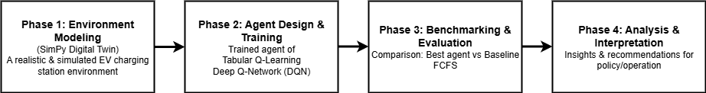
Figure 1. Conceptual Framework

Simulation Environment Design
To facilitate controlled and repeatable experiments, a high-fidelity digital twin of an EV charging station was developed using the SimPy discrete-event simulation library in Python. The environment was designed to emulate the key operational dynamics and stochasticities of a real-world station.
- Station Capacity: The station is configured with 10 charging ports.
- Dynamic Arrival Patterns: EV arrivals are modeled as a Poisson process. The baseline arrival rate is 20 vehicles/hour, scaled by 1.5 during peak periods (07:00-09:00 and 17:00-19:00).
- Charging Duration: Charging session time is drawn from a normal distribution with a mean of 30 minutes and a standard deviation of 5 minutes.
- Decision Interval: The agent decides at discrete 15-minute intervals.

Formal Problem Definition
Before detailing the specific algorithms, we formally define the environment's state and action spaces shared by both agents.
- State Space (S): The state observed by the agent at each timestep t is a vector $S_{t}$ designed to provide a comprehensive snapshot of the station. It is defined as (1):
$S_{t}=\left[q_{t},u_{t}, \sin\left(\frac{2πT_{t}}{T_{day}}\right),\cos\left(\frac{2πT_{t}}{T_{day}}\right) \right]$ (1)

where $q_{t}∈[0,1]$ is the queue length normalized by the maximum expected capacity, $u_{t}∈[0,1]$ is the station utilization (occupied chargers / total chargers), and the sine/cosine pair represents the time-of-day feature, with $T_{t}$ being the minute of the day and $T_{day}$ ​=1440.

- Action Space (A): The agent's action space is discrete and binary, controlling the admission of a newly arriving vehicle. The action at is defined as (2):

$a_{t}∈[0,1]$ (2)

Where $a_{t}$ ​= 1 corresponds to accepting the new vehicle (if a charger is available), and $a_{t}$ = 0 corresponds to deferring the vehicle (i.e., turning it away).

Approach 1: Tabular Q-Learning and the Evolution of Reward Design
Our initial approach utilized tabular Q-learning. The success of this agent is critically dependent on the design of its reward function, which evolved across three distinct iterations:
- Iteration 1: Simple Linear Penalty (reward = -queue_length). This provided an insufficient signal to prevent queue buildup.
- Iteration 2: Quadratic Penalty (reward = -queue_length²). This led to an unexpected "lazy agent" behavior, where the agent avoided penalties by minimizing service.
- Iteration 3: Pivot to Throughput-Based Reward (reward = (C * completed_charges) - (P * queue_length)). This aimed to align the agent's objective with the business goal of maximizing service.

Despite this logical progression, the tabular Q-learning agent consistently failed to outperform a simple baseline, highlighting its inability to generalize across a complex state space.

Approach 2: Deep Q-Network (DQN)
The limitations of the tabular method necessitated a transition to a Deep Q-Network (DQN), which replaces the Q-table with a neural network as a function approximator. Our DQN agent was implemented in PyTorch, incorporating several state-of-the-art optimizations:
- Network Architecture: A Multi-Layer Perceptron (MLP) with two hidden layers of 128 neurons (ReLU activation).
- State Normalization: All state vector components were normalized to a uniform range.
- Cyclical Time Features: As defined in the state space, to provide the network with a continuous, cyclical representation of time.
- Fixed Q-Targets: A separate Target Network was employed to provide stable targets for calculating temporal difference errors, reducing training oscillations.
- Experience Replay: Experiences were stored in a replay buffer and sampled randomly for training to break temporal correlations.

Sensitivity Analysis
To assess the robustness of our findings, we conducted a sensitivity analysis by varying key parameters of both the environment and the DQN agent. We evaluated the DQN agent's performance relative to the FCFS baseline under three environmental conditions: low traffic (arrival rate of 15 vehicles/hour), baseline traffic (20 vehicles/hour), and high traffic (25 vehicles/hour). Furthermore, to test the influence of a critical hyperparameter, we also trained and evaluated the agent with a different learning rate (1e-5, compared to the baseline of 1e-4). The results of this analysis are presented in the next section.

RESULTS
This chapter presents the experimental results from our simulation studies, focusing on agent training performance and a comparative analysis against a baseline scenario.

Analysis of Training Performance
The challenges in applying RL were immediately apparent during training. Figure 2 shows the learning curves of our two primary approaches.
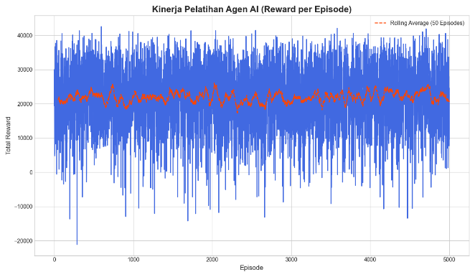 | 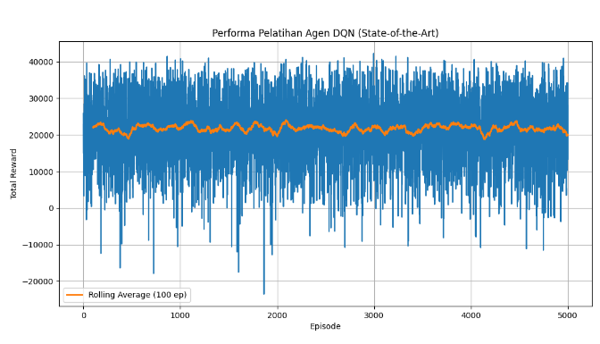
(a) | (b)

Figure 2. (a) Learning Curve of Tabular Q-learning Agent; (b) Learning Curve of DQN Agent

As depicted in Figure 2(a), the tabular Q-learning agent failed to achieve stable learning, with its reward per episode fluctuating erratically. This confirms its inadequacy for this complex environment. In contrast, the DQN agent (Figure 2(b)) showed initial signs of learning, achieving a positive reward level. However, its performance stagnated after approximately 500 episodes, failing to improve despite extended training. This suggests the agent became trapped in a local optimum.

Comparative Performance Analysis
To evaluate the practical impact of the best-performing agent (DQN), we conducted 50 independent 24-hour simulation runs and compared the aggregated results against a First-Come-First-Served (FCFS) baseline. The results for key performance indicators (KPIs) are presented in Table 1.
TABLE 1. Statistical Performance Comparison Between Baseline (FCFS) and DQN Agent.

Performance Metric (KPI) | Baseline (FCFS) (Mean ± Std Dev) | DQN Agent (Mean ± Std Dev) | Change (%) | p-value
Average Waiting Time (minutes) | 64.10 ± 27.59 | 65.13 ± 22.51 | +1.61% | 0.785
Maximum Queue Length | 52.30 ± 18.57 | 51.38 ± 15.02 | -1.76% | 0.812
Total Vehicles Served | 461.48 ± 8.79 | 462.50 ± 5.38 | +0.22% | 0.530
Station Utilization (%) | 96.01 ± 1.78 | 96.40 ± 1.22 | +0.41% | 0.241

The results starkly illustrate a disconnect between the agent's optimization of its reward function and tangible improvements in operational performance. As shown in Table 1, the DQN agent's policy resulted in a slightly worse Average Waiting Time (+1.61%) and showed no statistically significant improvement in any other key metric. To formally validate this observation, we conducted independent two-sample t-tests for each KPI. The resulting p-values, all of which are well above the conventional significance threshold of 0.05, confirm that the observed differences between the DQN agent and the simple FCFS baseline are not statistically significant. This reinforces the finding that the agent, despite learning to optimize its internal reward, failed to produce a practically superior control policy.

Reward Landscape Analysis
To quantitatively investigate the hypothesis that the DQN agent was trapped in a local optimum, we conducted a supplementary analysis by mapping the reward landscape in the vicinity of its learned policy. We systematically perturbed the final policy and evaluated the resulting performance, as shown in Figure 3.
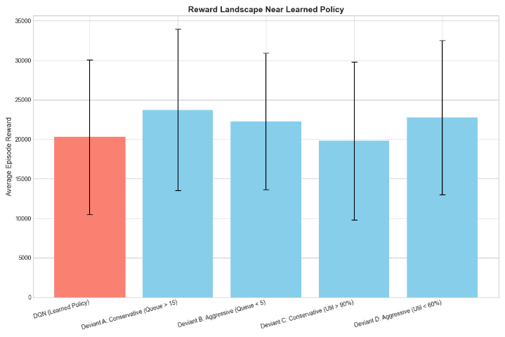

Figure 3. Reward Landscape Analysis in the Vicinity of the Learned DQN Policy

The analysis clearly shows that any small deviation from the agent's final policy—whether becoming more conservative or more aggressive—results in a lower average episode reward. This provides strong quantitative evidence that the agent successfully converged to a sharp local optimum within the reward landscape.

DISCUSSION
The experimental results, while demonstrating no performance improvement, offer critical insights into the practical challenges of applying standard RL algorithms to real-world operational problems.

Interpretation of Learning Challenges
Before delving into the specific challenges, it is useful to summarize the trade-offs between the two methods we tested. Tabular Q-learning, while simple to implement and conceptually interpretable, proved fundamentally incapable of handling the continuous and large state space of this problem, failing to generalize from its experiences. In contrast, the Deep Q-Network (DQN) successfully overcame this limitation through function approximation. However, this power came at the cost of increased complexity, training instability, and a susceptibility to converging on suboptimal policies, as our results demonstrate. The failure of both a simple and a more complex standard algorithm to outperform a basic heuristic is an illustration of complexities often abstracted away in theoretical work. We identify three primary factors:
- Deceptive Reward Landscapes and Generalizability: The stagnation of the DQN agent, supported by the evidence in Figure 3, confirms it became trapped in a local optimum. The agent discovered a policy that was "good enough" at maximizing its reward signal but did not correspond to a globally optimal operational strategy. This challenge of deceptive, non-convex reward landscapes is not unique to our specific setup; it is a fundamental problem in applied RL. This phenomenon has been well-documented in other complex domains such as robotics, where agents may learn to exploit simulation physics in unrealistic ways, and in finance, where strategies may optimize for short-term indicators while missing long-term trends. Therefore, we argue that this finding is generalizable: any attempt to apply standard RL to similar dynamic scheduling problems is likely to face this same core issue, regardless of minor variations in station size or arrival patterns.
- The Long-Term Credit Assignment Problem: In a dynamic environment, the outcome of an action is often delayed. The agent struggled to attribute a distant outcome (a long queue) to a specific, earlier decision. Standard methods like experience replay proved insufficient to resolve the long-term temporal dependencies in this problem domain.
- Imperfections in Reward Function Design: Our results reveal a critical take-home message: designing a reward function that perfectly captures all desired operational nuances (e.g., efficiency, fairness, user satisfaction) is exceptionally challenging. The agent learned to "game" the metric it was given, but not to solve the underlying operational problem.

Implications for Researchers and Practitioners
Our findings, while revealing performance limitations, provide valuable, cost-saving insights for researchers and practitioners exploring AI-driven operational management. Reinforcement learning (RL) is not a "plug-and-play" solution; successful deployment requires a rigorous, iterative process akin to scientific experimentation rather than simple software integration.
First, researchers and practitioners must benchmark complex RL approaches against simple, robust heuristics like FCFS, any proposed algorithm must demonstrate both statistical and practical superiority over these baselines to justify its complexity. Second, reward engineering is paramount; a poorly designed reward function can lead to misaligned incentives, where agents optimize metrics at the expense of real business objectives, such as sacrificing user wait times for throughput. This demands deep domain knowledge and extensive testing. Third, the tendency of RL algorithms to converge to suboptimal policies must be proactively addressed through careful selection of architectures, algorithms, and hyperparameter tuning. Rather than prioritizing novelty, the field should emphasize robustness and systematic analysis of failure modes.
Understanding why and when RL fails in realistic settings is critical for advancing both theory and practice. By adopting this disciplined approach, organizations can avoid costly missteps and ensure that AI investments translate into tangible, real-world value.

Limitations and Future Work
Our simulation, while controlled and informative, reveals a substantial gap between experimental results and real-world deployment, highlighting key limitations that shape the path forward. First, we assume static user behavior, users always wait, ignoring realistic behaviors like balking or reneging, which significantly impact queue dynamics. Second, demand is modeled as stationary, whereas real-world arrivals are influenced by unpredictable factors such as weather, events, and shifting demographics, making generalization across environments challenging. Third, we assume ideal hardware and instantaneous communication, neglecting real-world disruptions like charger failures, maintenance, and network latency, all of which introduce noise that can degrade performance.
These simplifications underscore a critical insight: success in a clean simulation is only the first step; true efficacy lies in robustness to real-world unpredictability. Our findings, showing failure even in this idealized setting, suggest that current RL approaches may be ill-prepared for practical deployment. Future work should focus on more advanced architectures, such as hierarchical or curiosity-driven RL to escape local optima, multi-agent systems for decentralized coordination, and hybrid approaches that integrate RL with forecasting or model-based planning. Together, these directions can enhance adaptability, resilience, and long-term decision-making in dynamic, real-world environments.

CONCLUSION
This paper presented a comparative case study on the challenges of applying standard Reinforcement Learning algorithms for the optimization of Electric Vehicle charging stations. By systematically developing and evaluating both tabular Q-learning and a state-of-the-art Deep Q-Network (DQN) agent within a realistic, stochastic simulation, we demonstrated a significant gap between the agents' ability to optimize a numerical reward function and their ability to produce tangible improvements in operational key performance indicators. Our findings reveal that despite their theoretical promise, standard RL methods struggle with deceptive reward landscapes, long-term credit assignment, and the inherent complexities of reward shaping in this domain. The primary contribution of this work is not a new solution, but rather a critical and evidence-based analysis of the practical barriers that must be understood and overcome. We conclude that the successful application of RL in real-world energy systems requires moving beyond a "plug-and-play" mindset towards a more nuanced approach that involves sophisticated reward engineering, robust benchmarking, and the exploration of more advanced agent architectures.

References
1. M. Muslimin, P.P. Dhyani, D. Luqyana, and D.J.K. Kristianto, “Perancangan dan Pembuatan Prototipe Motor Listrik BLDC 350 dan 3000 Watt,” J.Mek.Ter. 4(2), 78–83 (2023).
2. R. Permana, E. Yuliati, and P. Wulandari, “Analisis Faktor-Faktor Yang Mempengaruhi Konsumen Terhadap Purchase Intention Kendaraan Listrik di Indonesia,” Inobis 6(2), 217–232 (2023).
3. S. Purwasih, and A. Sadad, “Strategi Pengembangan Bisnis Unit PT. PLN Kota Pekanbaru,” Jurnal Multidisiplin Teknologi Dan Arsitektur 2(1), 212–226 (2024).
4. R. Leo, R.S. Milton, and S. Sibi, “Reinforcement learning for optimal energy management of a solar microgrid,” in 2014 IEEE Global Humanitarian Technology Conference - South Asia Satellite (GHTC-SAS), (IEEE, Trivandrum, India, 2014), pp. 183–188.
5. A.D. Danang Luthfiansyah, H. Oktavia, D.C. Pamungkas, M.R. Haq, A.S. Habibie, and R.E. Rachmanita, “PERANCANGAN ECO SMART CHARGING AREA DI POLITEKNIK NEGERI JEMBER: DESIGN OF ECO SMART CHARGING AREA AT JEMBER STATE POLYTECHNIC,” Jesty 1(2), 53–64 (2023).
6. D.D. Suranto, S. Anwar, M. Nuruddin, A. Rofi’i, and A.T. Zain, “Analisa Perancangan dan Pengujian Kendaraan Listrik Roda Dua dengan Variasi Pembebanan,” J-Proteksion. j. Kaji. Ilm. Dan. Teknologi. Teknik. Mesin. 7(2), 47–53 (2023).
7. A.C. Erüst, and F. Yildiz Tascikaraoglu, “Deep Reinforcement Learning for Electric Vehicle Charging Navigation: A Price-Aware Strategy,” (2023).
8. V. Francois-Lavet, P. Henderson, R. Islam, M.G. Bellemare, and J. Pineau, “An Introduction to Deep Reinforcement Learning,” (2018).
9. J.-Y. Shi, H.-M. Ke, C. Li, and J.-J. Shao, “A Coordinated Charging Strategy for Electric Vehicles Based on Hierarchical Optimization,” in Proceedings of the 2018 International Conference on Energy Development and Environmental Protection (EDEP 2018), (Atlantis Press, Nanjing, China, 2018).
10. M. Zeng, X. Zhan, and Y. Li, “Optimal Planning for Electric Vehicle Charging Station Considering the Constraint of Battery Capacity,” in Proceedings of the 2016 International Conference on Artificial Intelligence: Technologies and Applications, (Atlantis Press, Bangkok, Thailand, 2016).
11. J. Lu, S. Liu, J. Zhang, S. Han, X. Zhou, and Y. Liu, “Charging and Discharging Optimization of Vehicle Battery Efficiency for Minimizing Company Expenses Considering Regular User Travel Habits,” Processes 12(3), 435 (2024).
12. G.B. Qiu, W.X. Liu, and J.H. Zhang, “Equipment Optimization Method of Electric Vehicle Fast Charging Station Based on Queuing Theory,” AMM 291–294, 872–877 (2013).
13. H.M. Abdullah, A. Gastli, and L. Ben-Brahim, “Reinforcement Learning Based EV Charging Management Systems–A Review,” IEEE Access 9, 41506–41531 (2021).
14. V. Moghaddam, A. Yazdani, H. Wang, D. Parlevliet, and F. Shahnia, “An Online Reinforcement Learning Approach for Dynamic Pricing of Electric Vehicle Charging Stations,” IEEE Access 8, 130305–130313 (2020).
15. I. Azzouz, and W. Fekih Hassen, “Optimization of Electric Vehicles Charging Scheduling Based on Deep Reinforcement Learning: A Decentralized Approach,” Energies 16(24), 8102 (2023).
16. D. Liu, P. Zeng, S. Cui, and C. Song, “Deep Reinforcement Learning for Charging Scheduling of Electric Vehicles Considering Distribution Network Voltage Stability,” Sensors 23(3), 1618 (2023).
17. A. Viziteu, D. Furtună, A. Robu, S. Senocico, P. Cioată, M. Remus Baltariu, C. Filote, and M.S. Răboacă, “Smart Scheduling of Electric Vehicles Based on Reinforcement Learning,” Sensors 22(10), 3718 (2022).
18. S. Yalçın, and M.S. Herdem, “Optimizing EV Battery Management: Advanced Hybrid Reinforcement Learning Models for Efficient Charging and Discharging,” Energies 17(12), 2883 (2024).
19. K. Mason, and S. Grijalva, “A review of reinforcement learning for autonomous building energy management,” Computers & Electrical Engineering 78, 300–312 (2019).

