Leveraging Service Information System Patents for Entrepreneurial Advantage: Enhancing Intellectual Property-Based Technology and Business Innovation
Dhiafairuz Athallah^{1,a)}, Agung Purnomo^{1,b)}, Mulyani Karmagatri^{1,c)}, Fairuz Iqbal Maulana^{2,d)}, and Meiryani^{3,e)}
¹Entrepreneurship Department, Bina Nusantara University, Jakarta, Indonesia
²Computer Science Department, Bina Nusantara University, Jakarta, Indonesia
³Accounting Department, Bina Nusantara University, Jakarta, Indonesia

^{b)} Corresponding author: agung.purnomo@binus.ac.id
^{a)} dhiafairuz.athallah@binus.ac.id
^{c)} mulyani@binus.edu
^{d)} fairuz.maulana@binus.edu
^{e)} meiryani@binus.edu
Abstract. Leveraging Service Information Systems (SIS) in the information engineering and entrepreneurial scene constitutes a significant catalyst for business innovation and competitive advantage. This research aims to explore the mapping and trends of the global patent landscape regarding SIS integration in the entrepreneurship scene. This research utilizes a comprehensive patent analysis of patent growth trends, CPC classification, inventors, legal status, and main areas of innovations in SIS through the Lens.org database. The researchers gathered 260 patent documents and 141 simple families published from 1995 to 2023 from the Lens database. The study reveals that technological advancements, particularly the digitalization wave in the late 90s, have signified the integral role of SIS in facilitating data-driven decision-making intellectual assets in the business context. There is an entrepreneurial-based opportunity in using SIS patents from the expired and discontinued patents found in this research, totaling 48 discontinued and 26 expired patent documents. The main areas of SIS in entrepreneurship patents were categorized into six main groups: software and application customization, user data and contextual service, financial service, customer service, process management, and marketing. The research pinpoints the United States as the country with the most inventor affiliation in the SIS in entrepreneurship patents through inventor analysis. The research also reveals that the electronic (H) and physics (G) sections dominate the SIS patents. This study proposes a categorization of the main areas of SIS in entrepreneurship-based technology patents into six main groups: software and application customization, user data and contextual services, financial services, customer service, process management, and marketing. This research contributes a novel perspective in enhancing SIS innovation for information engineering and entrepreneurial advantage.
Keywords: Entrepreneurship, Information Engineering, Innovation, Patent, Service Information System

INTRODUCTION
Service information systems (SIS) in information engineering have emerged as a study field that garnered attention from other industries in recent years. As the shifting dynamics of the contemporary entrepreneurship and business industry grow, the urgency of integrating advanced technology into place is considered indispensable. SIS is a tool that collects, manages, and processes data to summarize information {Hilman, 2012 #265}[1]. SIS offers their end users scalable and efficient services by harnessing the power of data analytics and digital technology. The end users in this study's context here would be entrepreneurs, businesses, startups, and SMEs. Companies must adapt and innovate to gain a competitive advantage. SIS is relevant in the business industry as it drives the development of new products, business models, services, business operations, and activities that can improve the efficiency and effectiveness of entrepreneurial ventures [2].
Leveraging SIS in the entrepreneurial scene is a step towards leveraging technological advancement to enhance business operations, decision-making processes, and customer-engagement strategies [1]. SIS helps entrepreneurs and businesses perform time-consuming, routine, repetitive service-related tasks and has evolved to more complex data distribution. Moreover, integrating SIS can lead to streamlining of operations, which saves business costs. Technological advancements and SIS have opened new opportunities for entrepreneurs to grow their businesses [3].
Previous studies have shown how SIS appears to have some potential to be utilized in the entrepreneurial sector. The earlier studies on SIS provided valuable insights using a literature review discussing IS as a service and its role in supporting business management decisions through implications of Platform as a Service (PaaS), Software as a Service (SaaS), and Data as a Service (DaaS) [1]. Another study discusses the implementation, challenges, and conceptual framework of information systems at a multi-national cooperation level through a literature review and interviews with industry practitioners [4]. Another previous research developed an Automated Information System (AIS) to help automate business processes in an enterprise's supply chain, resulting in better management performance [5]. There was a lack of research on SIS from the perspective of patented documents with annual growth analysis, CPC classification, inventors, and legal status. Using patent landscape methodology and conducting analysis would reveal just how progressive the innovation of SIS has come.
The patent landscape analysis is a systematic approach used to comprehend and interpret existing patent documents to identify the state-of-the-art of a specific topic. Patent landscape analysis helps innovators comprehend the contours of existing innovation trends and develop more in-tune inventions. Initiating a search for existing innovation on the subject within the patent database is the initial step in conducting a patent landscape study. After analyzing the search results, the findings were presented visually to facilitate a better understanding and to reach conclusions and recommendations according to the results [6]. The research question is how to map trends in the global patent landscape regarding SIS integration in the entrepreneurship scene. Therefore, this research aims to explore the mapping and trends of the worldwide patent landscape regarding SIS integration in the entrepreneurship scene. This research contributes a novel perspective in enhancing SIS innovation for information engineering and entrepreneurial advantage.

Research METHODS
Lens.org
Patent Database –
543 patent documents
Inclusion criteria
- Relevance of SIS topic in entrepreneurship – ("service information system*" OR "services information system*") AND (entrepreneur* OR startup OR business OR firm OR venture OR SMEs OR corporate)
- Time span –
A whole year before 2024

Patent Landscape Analysis
Annual Patent Growth
Top CPC Classification
Top Inventors
Legal Status
Top Main Areas

Patents selected for the study –
260 patent documents
141 simple family

Generate data visualization for the analysis –
Lens Visual Analyzer

FIGURE 1. Patent Landscape Workflow of SIS in Entrepreneurship

The research was done using a methodology for analyzing and researching patented IP. This study uses a service information system in entrepreneurship as the substance of the study topic. Researchers used several workflow stages as shown in FIGURE 1 for patent landscape analysis. First, researchers found around 543 patent documents related to service information systems from the Lens.org database (https://www.lens.org/) [7]. Lens.org was used as this research's source of document database platform that provides access to global patents [8]. The patent documents data was gathered through an online database search conducted in March 2024 [9].
The researchers used search query ("service information system*" OR "services information system*") AND (entrepreneur* OR startup OR business OR firm OR venture OR SMEs OR corporate), Filters: Published Date = (- 2023-12-31) [9] to search for patents in Lens.org as first inclusion criteria. The researcher used 260 patent document records and 141 simple family IP patents related to SIS in entrepreneurship. The analysis of this study was conducted with data from a complete year, restricting database searches up to the cutoff date of December 31 as the second inclusion criteria [10]. Patent documents published from 1995 to 2023 are used in this study.
Annual patent growth, top CPC classification, top inventors, legal status, and top main areas topics covered by the patent documents were analyzed for this study [11]. The researchers utilized the Lens.org visual analyzer tool to generate the patents' charts, bars, and mappings. The researchers then processed the data to understand what factors play a part in the SIS. Consequently, the landscape of SIS patents presents unexplored areas that offer opportunities for further research or could affect the submission of intellectual property patents [8].

RESULTS AND DISCUSSION
This subject matter explores and analyzes the development of a patented document on SIS in entrepreneurship using annual growth analysis, legal status analysis, inventor analysis, CPC classification analysis, and main areas analysis.

Annual Growth
The over-time growth analysis of the SIS patent development in entrepreneurship through a visualization line chart of granted, filed, and published patents. Annual growth analysis aims to understand the evolution of trends and how many patents have been documented over the years. The line chart in Figure 1 below shows the dynamics and trends in the number of SIS innovation developments and patents. Granted patents are given to those who have completed the patent examination and evaluation process by governments. Published patents are the patents that are still in the early phase of the patent application process assessment. Expired and discontinued patents are the sweet spot for business practitioner to explore the patents that are no longer tied to any entities and therefore use them for their business innovation. Meanwhile, filed patents are patents that haven't been published and granted but have been submitted to the government[12].
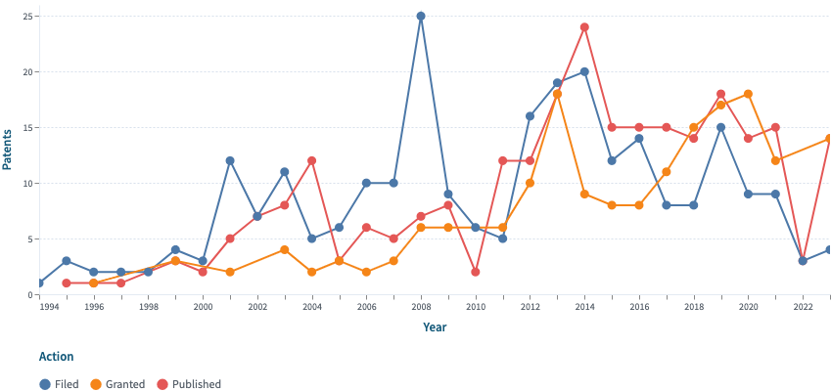
FIGURE 2. Service Information System Document Annual Growth

The SIS in entrepreneurship topic came into view in the Lens database when it was first registered as a filed patent in 1994 (n=1), published as a patent in 1995 (n=1), and granted a patent in 1996 (n=1). Based on Figure 1, filed patents showed an increased trend in 1999 (n=4) until it peaked in 2008 (n=25). In the following years, filed patents experienced a sharp decline from 2009 until 2011 (n=9, n=6, n=5) before it rose again in 2012 (n=16). The number of filed patents then experienced a series of ups and downs. Published patents have a similar trend curve with filed patents but sharply declined from 2005 to 2010 (n=2). After the sharp decline, published patents experienced growth in 2014, with 24 published patents. Granted patents slowly crawled before they experienced a surge in 2013 (n=18), which dropped in the year after that (n=9) and saw a slow rise from 2016 to 2020. The growth of patents related to SIS in entrepreneurship has varied over the years, with several factors that come into play. The factors that have influenced SIS in entrepreneurship are the rapid pace of technological advancement that came with the wave of digitalization and innovations in the late 90s[13]. Research in SIS in entrepreneurship has flourished in recent years, mainly driven by the increasing demand for data-driven decision-making in businesses to gain competitive advantage. Companies seek protection for innovations in SIS in entrepreneurship through patents as safety nets for their tangible and intangible assets [14].

Legal Status
Legal status analysis of patent documents involves examining and interpreting the various stages and conditions under which a patent exists throughout its lifecycle. This analysis is crucial for inventors, companies, legal professionals, and researchers who wish to understand patents' enforceability, scope, and commercial potential. The legality status of patent documents surrounding the subject of SIS in entrepreneurship is noticed below in FIGURE 2.
Active patents are still in place after the patent owner has filed for its rights, giving them patent protection over the innovation. Unlike active patents, discontinued patents are no longer protected but are still granted and valid. Inactive patents are patents that are still listed in the government system but are no longer valid. Patents still in the evaluation process are called pending patents, and it can't be said to be sure if the patent will be approved. Past the specified periods of a patent's validity are considered expired patents [15].

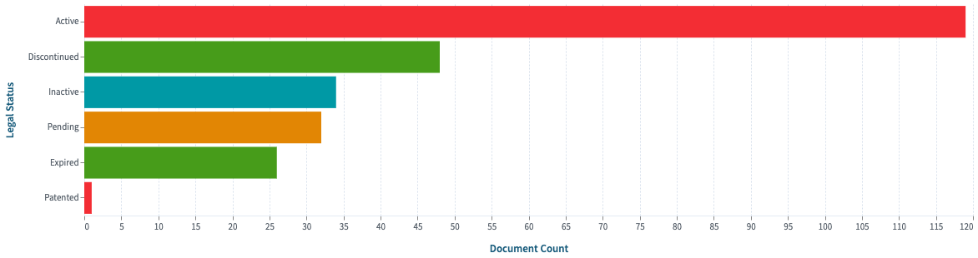
FIGURE 3. Service Information System Patent Legal Status

One hundred eighteen patents of SIS in entrepreneurship were recorded as active patent documents and 48 discontinued patent documents as their legal status. Meanwhile, 34 patent documents are inactive, 26 are expired, and 32 are pending legal status patent documents. Entrepreneurs can use expired patents that have entered the public domain to their advantage. This would lead to better integration of SIS innovations and technology into their entrepreneurial operations, organizational learning, and strategy formulation without the obligation to pay patent royalties. Conversely, patent protection for patent owners is concerning as they have lost their way of gaining incentives and protection over patent rights [15].

Inventors
The individual inventor with the most patent document count for SIS in entrepreneurship can be seen in FIGURE 3. Higgins Christopher William (the USA, n=23); Davis Marc Eliot; Martinez Ronald (the USA, n=20); Jung Edward K. Y.; Levien Royce A.; Malamun Mark A. (USA, n=15); Inoue Shigemitsu; Ishii Yoshuke; Nakamura Koichi (Japan, n=12); Ambrose Jesse; O'Sullivan Joseph James; Rothwein Thomas M (USA, n=12); Wang Jun (China, n=10); Davis Marc; Paretti Christopher T; Redmond Timothy St. John; Shear Victor Henry; Rho Jaisook (USA, n=8); and Tran Bao (China, n=8).

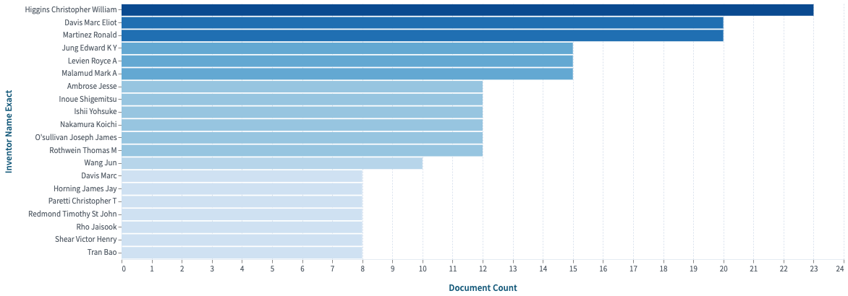
FIGURE 4. Service Information System Patent Inventors

Inventors affiliated with the United States currently have the reign of SIS patent documents with SIS in entrepreneurship, as seen in FIGURE 4. United States-affiliated inventors have been the experts over the years in SIS due to the well-established intellectual property (IP) infrastructure in the United States [16]. This encourages inventors to create inventions without worrying about others using them commercially. The United States has pioneered technological breakthroughs, also reflected in the SIS and entrepreneur patents. The amount of patents from inventors affiliated with the United States shows that the country has invested heavily in this study field, and with a hefty investment, it creates an environment that enables inventors to develop new inventions and register invention patents [17] [18].

CPC Classification
The classification of patents related to SIS in entrepreneurship from various countries can be effectively organized using Cooperative Patent Classification (CPC) in FIGURE 5. The CPC classification evolved from the International Patent Classification (IPC) and is co-managed by the European Patent Office (EPO) and the United States Patent and Trademark Office (USPTO). It organizes patent information into a structured system of nine sections, which are further divided into classes, sub-classes, groups, and sub-groups, facilitating detailed classification of patents [19].

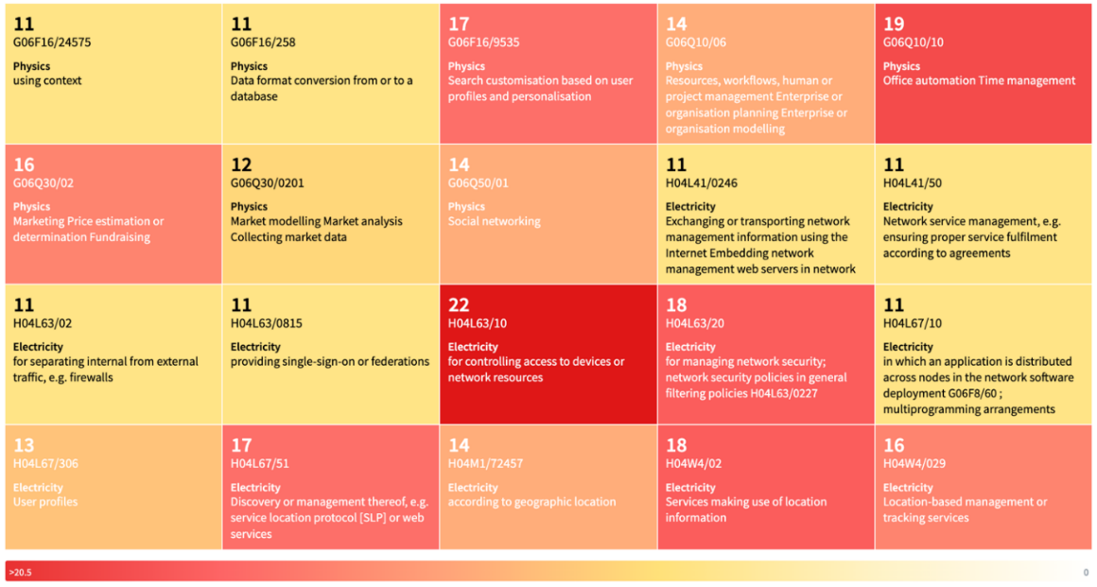
FIGURE 5. Service Information System Patent Classification

Electricity (H) and physics (G) were the patent sections dominating the SIS in entrepreneurship study fields. The patent being protected the most was in the Electricity (H) section, H04L63/10 (n=22), concerning access control to device or network resources. The physics (G) section comprises group G06F16/9535 (n=17) concerning user profiles and personalization for search customization, G06Q10/10 (n=19) about efficiently managing time using office automation., G06Q30/0201 (n=12) on market modeling analysis and G06Q50/01 (n=14) on social networking, G06Q30/02 (n=16) about estimating or determining the marketing price for fundraising.. The electricity (H) section group consists of H04L41/50 (n=11) about network service management, H04L63/20 (n=18) concerning network security management, policies in general filtering, and H04L67/306 (n=13) about user profiles and H04L67/51(n=17) on discovery or management thereof, and H04M1/72457 (n=14) concerning geographic location, and H04W4/02 (n=18) on service by using geographical data and H04W4/029 about geolocation-based administration or tracking service.
SIS in entrepreneurship patents was dominated by electrical (H) and physics (G) patent sections, with H04L63/10 (n=22) being the most prominent section of the group. The prominence of a CPC group section helps illustrate the technological priorities and innovation trends within the field. This prominent electrical section (H) patent, H04L63/10, focuses on managing the authorization of devices or network resources. This indicates the focus on network security and access management within the SIS domain, which also shows the potential for innovation in the subclass.

Main Areas
The main areas section summarizes the most patented categories of areas in SIS in entrepreneurship, as shown in FIGURE 6 and TABLE 1. This study proposes a categorization of the main areas of SIS in entrepreneurship-based technology patents into six main groups: software and application customization, user data and contextual service, financial service, customer service, process management, and marketing. Each main area category is given two example patent numbers.

FIGURE 6. Categorization of Main Areas Patents of Service Information Systems in Entrepreneurship

The main areas section summarizes the most patented categories of areas in SIS in entrepreneurship, as shown in Table 1.

TABLE 1. Main Areas Patents of Service Information Systems in Entrepreneurship

No | Patent Areas |  | Patent Number Example
1 |  | Software and Application Customization | US 2007/0277153 A1 (Jesse et al., n.d.) & US 2017/0026510 A1 (Jun, n.d.)
2 |  | User Data and Contextual Services | US 8108778 B2 (Athellina et al., n.d.) & US 5978841 A (Louis, n.d.)
3 |  | Financial Service | US 5590038 A(G, n.d.) & US 2014/0222671 A1 [25]
4 |  | Customer Service | EP 2523395 B1 [26] & US 2001/0047270 A1 [27]
5 |  | Process Management | US 2020/0027096 A1 [28] & WO 2012/075442 A1 [29]
6 |  | Marketing | US 8554623 B2 [30] & US 2009/0030817 A1 [31]
Software and Application Customization
In the entrepreneurial domain, the customization of software and applications through SIS is one of the main factors for creating tailored solutions that meet the unique demands of entrepreneurs. Software and application customization patents address integration's significance in improving benefits through innovative systems. The patent document US 2007/0277153 A1 emphasizes that efficiently customizing and maintaining business applications was particularly valuable for startups and SMEs as it reduces the total lifecycle cost and supports the dynamic nature of entrepreneurial ventures through fulfilling customer SIS deployments. The patent exemplifies the benefit of SIS in the entrepreneurial scene and plays a role in achieving competitive differentiation from the crowded marketplace and the company's operational excellence.

User Data and Contextual Service
SIS in entrepreneurship is instrumental in garnering user data to deliver contextual services, directly enriching the customer experience. The inventor of US 8108788 B2, Atsani et al., states the importance of leveraging user data within SIS. It is described in the patent that prioritizing data inclusion based on the user and the context of the request helps the system deliver personalized service tailored to each customer. The patent shows that a system that resonates with its target audience will result in a more satisfied customer experience through the example of enhanced user interface mapping. By leveraging such a system, entrepreneurs can gain insights into their customer behavior, tailor their service to each customer's preferences, and ultimately drive customer loyalty, boosting business growth[20]. The main areas of patents of service information systems in entrepreneurship are visible in Figure 5.

Financial Services
The integration of SIS in financial and electrical transaction services secures an efficient operation from a monetary point of view. The patent document US 2014/022671 A1 introduces an automated computerized system and customer-facing digitalized interfaced, namely the iATM system, which allows customers to access financial and transactional services virtually. The system benefits entrepreneurs by enabling the automation of financial services on electronic, unmodified terminal devices. The patent highlights the importance of SIS in providing entrepreneurs with advanced tools to manage financial transactions efficiently.

Customer Services
A strategy that uses both customer service and SIS in entrepreneurship can be considered the cheat key to positive customer satisfaction. Customer service is a crucial part of the customer retention activity that entrepreneurs must constantly engage in and improve [21]. The patent document US 2001/0047270 A1 showcases a system that enhances how organizations and entrepreneurs manage and share their customer service information, where the system forwards the customers' needs addressed with the best resources the business offers. This system approaches the customer service operation system to improve the efficiency of query resolution and deepen the collective knowledge base for customer service experience in the company [22].

Process Management
Process management and service rules ensure that businesses and entrepreneurs abide by the regulatory standard, an aspect of entrepreneurship that some overlook. The patent document WO 2012/075442 A1 explains a system innovation that embodies the principles by providing a comprehensive architecture for processing insurance claims through a computer-implemented system. The system is designed to manage logical rules for segmenting insurance claims that enable efficient processing. The patent demonstrates the potential of SIS for entrepreneurs to exploit to their advantage by streamlining complex business processes [21].

Marketing
Marketing strategies are one of the business efforts in making their products and services be seen by the public eye. The integration of SIS can significantly enhance marketing strategies, as evidenced by the patent document US 8554623 B2. This patent breaks down the method for social network marketing that utilizes consumer referrals. These referrals are used to boost the consumption of goods and services with the help of algorithms and consumer characterizations based on their behaviors and preferences. This approach captures the value of personalized advocacy, which is crucial for entrepreneurs seeking to maximize the impact of their marketing campaigns and foster organic growth of social brand awarenes [23].

Future Research Directions
From a micro perspective, future research should focus on the individual entrepreneur's utilization of Service Information Systems (SIS) patents within their business strategies. Examining how entrepreneurs leverage expired and discontinued SIS patents to develop innovative products and services can provide insights into effective IP management at the startup level. Investigating the role of SIS patents in protecting unique business models and operational processes will highlight the importance of IP in gaining a competitive edge. Entrepreneurs can implement expired and discontinued SIS patents into their business to foster business innovation and create a new value that they could offer to their market and gain a competitive advantage.
At the meso level, research should explore how SIS patents impact the collaborative dynamics within entrepreneurial ecosystems. Analyzing the interaction between startups, established businesses, and academic institutions in the context of SIS IP sharing and co-development of SIS technologies can reveal patterns of innovation diffusion. The identification of patterns can then lead business practitioners to a better understanding of how integration of SIS can elevate their innovation edge. Investigating the role of regional patent offices and IP support services in fostering a culture of SIS innovation and entrepreneurship will provide valuable insights into ecosystem development.
From a macro perspective, future research should investigate the broader economic and policy implications of SIS patents on national and global scales. Assessing the impact of IP laws and patent systems on entrepreneurial activity and SIS innovation rates can inform policy adjustments to foster a more conducive environment for business growth. Examining cross-country comparisons of SIS IP management practices and their effects on technology transfer and commercialization will provide a global perspective on best practices.

CONCLUSIONS
Patents related to SIS in entrepreneurship have shown significant potential in innovation growth of computing and data management, helping business simplify their business activities and generate new products and service value. The number of SIS patents gathered from 1995 to 2023 totaled 260 patent documents and 141 simple families, with the first wave of the surge in SIS patents being in the early 2000s. There were 48 discontinued patent documents and 26 expired documents that entrepreneurs can use as an opportunity window to make new SIS innovations without worrying about paying royalties. United States is seen to be the country with the most inventors of SIS patent documents, with Higgins Christopher William as the most prominent inventor. SIS in entrepreneurship patents were dominated by electricity (H) and physics (G) patent sections, with the H04L63/10 (n=22) subgroup of electricity (controlling access to device or network resources) having the most patents under its group. This study proposes a categorization of the main areas of SIS in entrepreneurship-based technology patents into six main groups: software and application customization, user data and contextual service, financial service, customer service, process management, and marketing.
There are limitations as this study only covered the data through one primer database of patent documents, Lens. This study only discusses the overview of the patent analysis of SIS and its relevance to the entrepreneurial scene. This research implication enhances the body of knowledge by demonstrating the significance of patents in mapping global trends and innovations within Service Information Systems for entrepreneurship. For practical entrepreneurship and industry, this study highlights the strategic advantage of leveraging expired and discontinued patents to drive innovation and reduce costs. The findings suggest that governments should streamline patent regulations and support mechanisms to encourage the utilization of intellectual property to foster entrepreneurial growth and technological advancement.

Acknowledgments
The author would like to thank the Entrepreneurship Department and Research and Technology Transfer Office, Bina Nusantara University, for supporting the research ecosystem, facilities, and publication funding. The author also appreciates Lens.org for granting permission to review global patent data.

Author Contributorship
Dhiafairuz Athallah: Data Curation, Formal Analysis, Investigation, Methodology, Resources, Software, Visualization, Writing–Original Draft Preparation, Writing–Review and Editing; Agung Purnomo: Conceptualization, Data Curation, Formal Analysis, Investigation, Methodology, Resources, Validation, Funding Acquisition, Project Administration, Supervision, Writing–Review and Editing; Mulyani Karmagatri: Data Curation, Formal Analysis, Validation; Fairuz Iqbal Maulana: Data Curation, Validation; Meiryani: Data Curation, Validation.

Data Availability
Harvard Dataverse: ‘Patent Dataset of Service Information System in Entrepreneurship (1995-2023)’. https://dataverse.harvard.edu/dataset.xhtml?persistentId=doi:10.7910/DVN/ZVTBDV (D. Athallah & A. Purnomo, 2024).

References
1. Hilman, M.H., Information system as a service: issues and challenges. Jurnal Sistem Informasi, 2012. 8(2): p. 71-77.
2. Abubakre, M., Y. Zhou, and Z. Zhou, The impact of information technology culture and personal innovativeness in information technology on digital entrepreneurship success. Information Technology & People, 2022. 35(1): p. 204-231.
3. Chen, M., et al., Influence of information technology capability on service innovation in manufacturing firms. Industrial Management & Data Systems, 2020. 121(2): p. 173-191.
4. Wynn, M. and C. Weber, Information Systems Strategy for Multi-National Corporations: Towards an Operational Model and Action List. Information, 2024. 15(2): p. 119.
5. Orlov, V., et al. Designing an information system to automate service management at the enterprise. EDP Sciences.
6. Purnomo, A., et al. Data science publication: thirty-six years lesson of scientometric review. IEEE.
7. Irawan, M.C.S., et al. Global Patent Landscape of Decision Support System in The Business: An Overview. IEEE.
8. Putri, S.I.E., et al. Knowledge Management in Business using Patent Landscape Analysis. IEEE.
9. Barnes, M., J. Carrithers, and J. Sugarman, Ethical and practical concerns about IRB restrictions on the use of research data. Ethics & human research, 2020. 42(6): p. 29-34.
10. Kalleya, C., et al., Smart City Applications: A Patent Landscape Exploration. Procedia Computer Science, 2023. 227: p. 981-989.
11. Agrawal, A. and R. Henderson, Putting patents in context: Exploring knowledge transfer from MIT. Management science, 2002. 48(1): p. 44-60.
12. Buenstorf, G. and D. Fornahl, B2C—bubble to cluster: the dot-com boom, spin-off entrepreneurship, and regional agglomeration. Journal of evolutionary Economics, 2009. 19(3): p. 349-378.
13. Brem, A., P.A. Nylund, and E.L. Hitchen, Open innovation and intellectual property rights: how do SMEs benefit from patents, industrial designs, trademarks and copyrights? Management Decision, 2017. 55(6): p. 1285-1306.
14. Mafu, M., Expired patents: An opportunity for higher education institutions. Frontiers in Research Metrics and Analytics, 2023. 8: p. 1115457.
15. Hsu, D.H. and R.H. Ziedonis, Resources as dual sources of advantage: Implications for valuing entrepreneurial‐firm patents. Strategic Management Journal, 2013. 34(7): p. 761-781.
16. Akcigit, U., J. Grigsby, and T. Nicholas, The rise of american ingenuity: Innovation and inventors of the golden age. 2017, National Bureau of Economic Research.
17. Bell, A., et al., Who becomes an inventor in America? The importance of exposure to innovation. The Quarterly Journal of Economics, 2019. 134(2): p. 647-713.
18. Leten, B., R. Belderbos, and B. Van Looy, Technological diversification, coherence, and performance of firms. Journal of Product Innovation Management, 2007. 24(6): p. 567-579.
19. Ambrose, J., T.M. Rothwein, and K.W. Strobel, Development tool, method, and system for client server applications. 2003, Google Patents.
20. Berger, L., Look ahead caching process for improved information retrieval response time by caching bodies of information before they are requested by the user. 1999, Google Patents.
21. Beyda, P., et al., Systems, Methods, and Computer Program Products for Processing Insurance Claims. 2012, Google Patents.
22. Cooner, J.R., System, business and technical methods, and article of manufacture for utilizing internet of things technology in energy management systems designed to automate the process of generating and/or monetizing carbon credits. 2020, Google Patents.
23. Ying, G., Method and system of bidirectional marketing with feedback. 2012, Google Patents.

