Load Balancing on Three-Phase Distribution Lines Using Photovoltaic Generators Based on the ANFIS Method
Machmud Effendy^{a)}, Muhammad Ridho Dwi Ramadhan^{b)}, Amrul Faruq^{c)}
Department of Electrical Engineering, Universitas Muhammadiyah Malang, Malang, Indonesia

^{a)} Corresponding author: machmud@umm.ac.id
^{b)} ridhodo310@gmail.com
^{c)} faruq@umm.ac.id
Abstract. The electricity distribution system is responsible for connecting the central generation substation with the load. In a three-phase electrical system, one of the main problems is load imbalance, which has an impact on reducing the quality of electrical power. The main cause of load imbalance is that the electrical load power in the R-S-T phase exceeds the imbalance limit. This research presents the development of a photovoltaic (PV) generator as a compensator to overcome load imbalance when dynamic loads are active on the electricity distribution network. PV generation with an inverter controlled using the Adaptive Neuro Fuzzy Inference System (ANFIS) method is able to compensate for load imbalances by injecting PV generated power into the electricity distribution network. The simulation results show that the percentage of unbalance before compensation between the R, S, T phases is 16.47%, 1.49%, and 14.97%, respectively. After PV generation is injected, the percentage of imbalance between phases is 0.3%, 0.7% and 0.3%. These results meet the load imbalance standards permitted by The National Electrical Manufacturers Association (NEMA).
Keywords: PV, ANFIS, Load Balancing

INTRODUCTION
The electricity distribution system regulates electrical energy from the substation to consumer loads. However, load imbalance between R-S-T phases in the electricity distribution system often occurs. This condition will reduce the quality of electrical power in the distribution system so that consumer loads will be disrupted [1, 2]. This load imbalance occurs due to several factors, including unbalanced electrical loads between phases, unequal load operating times for each phase and the length of the line from the generating center to the load. Based on the standard allowable power imbalance percentage of 3%, this refers to The National Electrical Manufacturers Association (NEMA) regulations [3, 4]. Therefore, this research aims to compensate for load imbalances to maintain power quality in distribution lines. There are various methods to overcome this problem, one of which is by utilizing PV generators.
PV is a technological device that can produce DC electrical energy by utilizing sunlight irradiation [5, 6]. Utilization of PV can contribute to reducing dependence on the use of fossil fuels for electricity, and can reduce air pollution levels [7, 8]. On distribution lines, PV generation can help improve the voltage profile, reduce load imbalance, reduce losses, and increase the power factor [9]. The PV generated power that is injected into the AC voltage distribution line needs to be controlled via an inverter device. This aims to ensure that the PV generation system can produce electrical power optimally and be able to compensate for load power imbalances [10].
Several previous studies have developed PV systems to overcome load imbalance. PV systems with a combination of two Proportional Integrator Differentiator (PID) control loops on the inverter are able to compensate for unbalanced loads [2].The inner control loop is useful for controlling current and is responsible for overcoming Total Harmonic Distortion (THD), while the outer control loop is useful for controlling DC link voltage and power flow in the system. However, when the number of PV modules increases, the PID value must be tuned again to match the Pulse Width Modulation (PWM) signal requirements. Other research proposes a PV system combined with a four-legged inverter using a hysteresis controller based on a space vector DC/DC converter which is controlled using Maximum Power Point Tracking (MPPT) with the Perturb & Observ algorithm [11, 12]. The simulation results show the effectiveness of the system in compensating for unbalanced loads. However, the fluctuating 3-phase electrical load power has not been considered.
Restrepo [13] also proposed inverter control for power injection from PV sources in microgrids with a combination of two controls, namely direct power control (DPC) on the L-filter and PI control in d/q coordinates with the LCL-filter. Simulation results show that the DPC controller is able to compensate for load imbalance in various conditions, but still requires large filter inductance, while the PI controller with LCL filter requires special compensation to reduce inherent oscillations due to the LCL filter.
In the research described above, it can be seen that the proposed PV system control has succeeded in overcoming load imbalances on distribution lines. However, the inverter control only relies on conventional PI control. So the inability to track the sinusoidal reference current still appears and there is a poor fault rejection ratio [14]. Therefore, this research proposes an inverter control scheme using the ANFIS algorithm. This algorithm is able to regulate the amount of PV generated power that is injected into the distribution channel when a load imbalance occurs.

METHODS

SYSTEM DESIGN

FIGURE 1. Block Diagram of Distribution Line Connected PV System

FIGURE 1 shows a schematic of a PV system connected to a distribution channel consisting of 3 main devices including PV modules, boost converters (booster) and inverters. The booster operates with MPPT control to maximize power output. The output DC voltage from the boost converter is converted into AC voltage using an inverter device. The ANFIS algorithm generates a PWM signal to control inverter switching. The inverter output voltage is fed via an inductor filter (L) to reduce high frequency harmonic ripples, then the filter output is injected into the distribution network.

DESIGN OF AC VOLTAGE SOURCES AND LOADS
The 3 phase AC grid voltage source is connected to a step down transformer with a power capacity of 1MVA. Meanwhile, the resistor - inductor (RL) is used as a load and dynamic load which will operate at a certain time. TABLE 1 shows the complete parameters of the power source and load. Meanwhile, FIGURE 2 illustrates the modeling of a 3 phase source connected to a transformer to reduce the AC voltage from 11kV to 380V. The output from the transformer is directly connected to the PV generation system

TABLE 1. Source and Load Parameters
Parameter | Value
Source AC | 11kV/30MVA
Frequency | 50 Hz
Transformator | 1MVA, 11kV/380V
Load capacity | 1,5kW

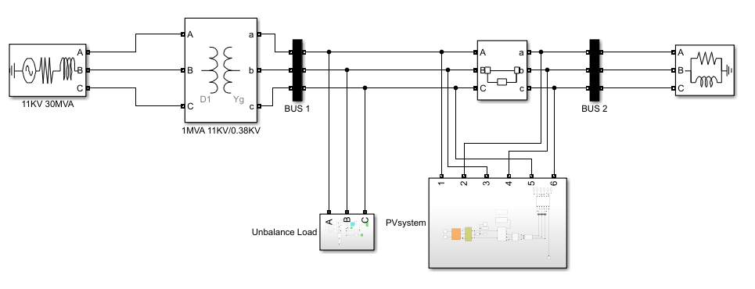
FIGURE 2. Modeling of 3 Phase Distribution Line

PV GENERATION DESIGN
Each PV module has specifications including Pm=250 W, Vmp=30.7 V, Voc=37.3 V, Imp=8.15 A, and Isc=8.66 A. The PV modules are connected in 15 series and 2 in parallel, so that complete electrical parameters are shown. in Table 2.
TABLE 2. Parameter of PV System
Parameter | Value
Maximal power | 7500 W
Open circui voltage | 559,5 V
Short circuit current | 17,32 A
Maximum voltage | 460,5 V
Maximum current | 16,3 A
Set Point of DC Voltage | 540 V
Switching frequency | 25000 Hz

BOOST CONVERTER DESIGN
The boost converter circuit is responsible for increasing the output voltage of the PV generation system. This circuit is designed with continuous mode. To determine the values ​​of components L and C using equations (1) and (2), as follows:
$L_{min}=\frac{{D(1-D)}^{2}×R}{2×f_{sw}}=25e^{-6} H$ (1)

$C=\frac{D}{{R(∆V}_{o}/V_{o})×f_{sw}}=400e^{-6} F$ (2)

D represents the duty cycle =0,5; R is load resistance, f_{sw} and ΔV_{o}/V_{o} are frequency switching and ripple voltage.
The boost converter circuit design is shown in FIGURE 3.

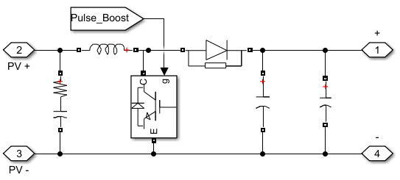
FIGURE 3. Circuit of boost converter

INVERTER CONTROL DESIGN
The inverter is designed using a two level converter with a switching devices model using a 6 IGBT/Diode H-Bridge scheme. Each IGBT is controlled by a Pulse Width Modulation (PWM) signal produced by the PWM generator. FIGURE 4 illustrates the inverter model.

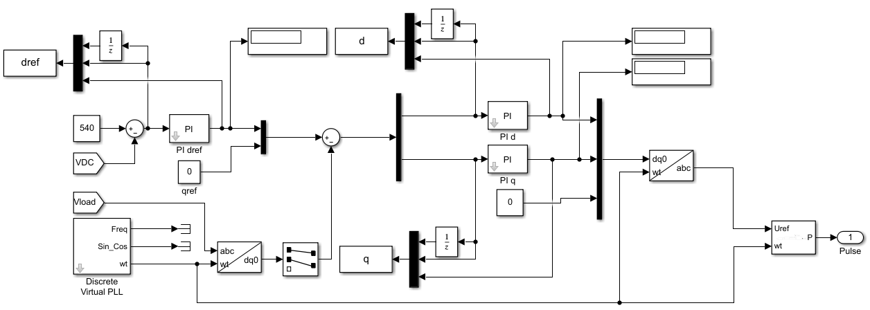

FIGURE 4. Circuit of boost converter

FIGURE 4 explains that control is divided into 2 axes, namely the direct axis (d) and the qudrature axis (q). On the d axis, the DC set point voltage (VDC*) of 540 V is compared with the actual DC voltage (VDC) from the boost converter output and produces a DC voltage error (eVDC). Next, eVDC value is fed to the PI control and produces a direct reference value (d*). The output value from the PI control will then be converted into three phase (abc) form and become a PWM signal. The phase locked loop (PLL) in this control system is responsible for producing the synchronization angle (wt), where this angle is needed for the process of changing the ABC to DQ0 frame and vice versa.

ANFIS ALGORITHM DESIGN
ANFIS control consists of 3 parameters. The first parameter is dref and the others are used on each of the d and q axes. Each ANFIS control has 2 inputs including error and deltaerror with each input consisting of 3 membership functions. This membership function produces a total of 9 rules to produce 1 output. FIGURE 5 shows the ANFIS structure model.

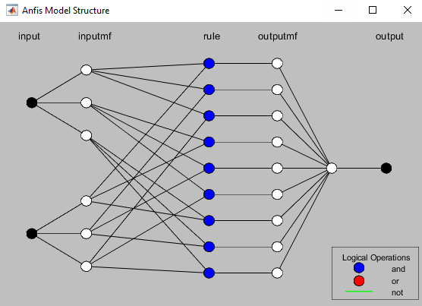
FIGURE 5. ANFIS Structural Model

FIGURE 5 shows that the error and deltaerror data which are the ANFIS input values ​​are obtained from the PI controller input/output (I/O) data on the inverter control. Next, the data obtained is trained to obtain the most effective value according to the inverter control requirements so that it can produce the desired signal form.

RESULTS AND DISCUSSION
This section discusses the simulation of a PV system as a load imbalance compensator on a 3 phase distribution line. Discussion analysis is presented in units per unit (PU) over a period of time (t).

VOLTAGE IN DISTRIBUTION LINES WHEN LOAD CHANGES
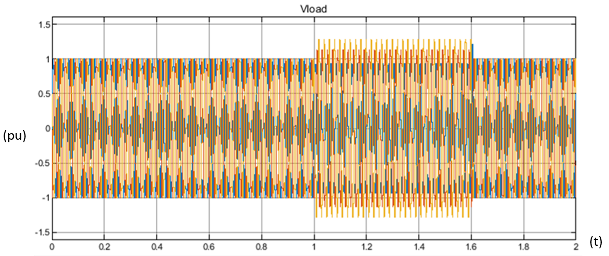

FIGURE 6. Load Voltage Before PV System Connected

The simulation results in FIGURE 6 show that the voltage on the distribution line in the time range (t) 0 to 1 is in a stable state (1 pu) in each phase. However, when t=1-6, the dynamic load is active and makes the voltage unstable between each phase. Based on the simulation results, the AC voltage values ​​respectively between the R, S and T phases are 0.93 pu, 1.13 pu and 1.28 pu during active dynamic loads. Then, FIGURE 7 shows the simulation results when the PV system is connected to the distribution channel. When (t)=0 to 0.74, the load voltage continues to increase until it reaches a normal voltage of 1 pu.

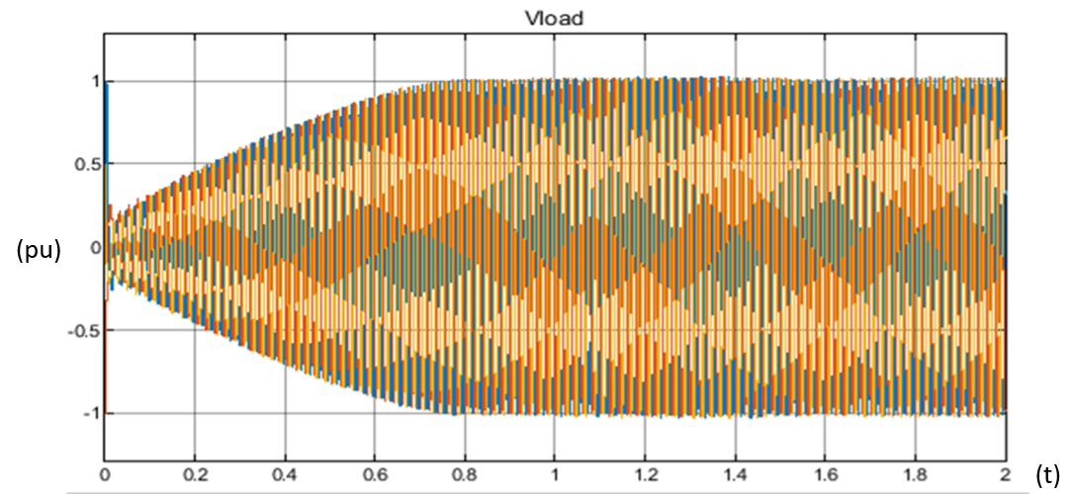

FIGURE 7. Load Voltage After PV System Connected

UNBALANCE FACTOR (UF) AND TOTAL HARMONIC DISTORTION (THD)
From the AC voltage on the distribution line when it is connected to the PV system and when it is not connected to the PV system, the imbalance factor between the phases can be calculated using equations (3) and (4).

$V_{avr}=\frac{V_{R}+V_{S}+V_{T}}{3}=1.113 pu$ (3)
$\% UF Phasa R=\frac{\left|V_{R}-V_{avr}\right|}{V_{avr}}×100\%=16.47\%$ (4)
From Equation (4), it can also be obtained that the unbalance factors for the S and T phases are 1.49% and 14.97%, respectively. The results of these calculations show that the imbalance factor exceeds its normal value. Meanwhile, when the PV system is injected, the unbalance factor for each phase R, S and T respectively becomes 0.3%, 0.7% and 0.3% using the same equation. These results have met the standard 3% limit permitted according to NEMA regulations.
Unbalanced loads on distribution lines can also increase THD during this time period. Based on testing the THD value using Fast Fourier Transform (FFT), the THD value for each phase R, S and T is respectively 5.34%, 4.15% and 2.52% when load imbalance occurs. However, after being compensated by the PV system, the THD value decreased in each with an average value of 2.84%. TABLE 3 shows the complete results of load imbalance percentage and THD.
TABLE 3. Percentage of load imbalance and THD
Phasa | Without PV |  |  | PV Injected
Phasa | Voltage (PU) | THD (%) | UF (%) | Voltage (PU) | THD (%) | UF (%)
R | 0.93 | 6.44 | 16.47 | 1 | 2.68 | 0.3
S | 1.13 | 2.03 | 1.49 | 0.99 | 2.87 | 0.7
T | 1.28 | 5.88 | 14.97 | 1 | 2.98 | 0.3

CONCLUSIONS
The ANFIS control algorithm for inverters in PV generation systems has been presented. PV generation is responsible as a compensator when the electricity distribution line has a load imbalance between its phases. When the dynamic load is active on a 3-phase distribution network, the percentage of imbalance between the R, S, T phases is 16.47%, 1.49%, and 14.97%, respectively. However, after the PV system was injected, the percentage of imbalance between phases was reduced to 0.3%, 0.7% and 0.3% respectively. Even the average THD is 2.84%. The proposed ANFIS Inverter control has been verified with matlab simulink.

References
1. Liu, S., et al., Practical Method for Mitigating Three-Phase Unbalance Based on Data-Driven User Phase Identification. IEEE Transactions on Power Systems, 2020. 35(2): p. 1653-1656.
2. Sinha, A.K., et al. Design of controller for power quality management in presence of unbalanced load integrated with solar PV. in 2014 International Conference on Green Computing Communication and Electrical Engineering (ICGCCEE). 2014.
3. Arghavani, H. and M. Peyravi. Unbalanced Current Based Tarrif. in In: 24th International Conference on Electricity Distribution. 2017.
4. Tsai, T.W., et al., Per-Phase Active Power Distribution Strategy for Three-Phase Grid-Tied Inverters Under Unbalanced Conditions Without DC Sources. IEEE Journal of Emerging and Selected Topics in Power Electronics, 2021. 9(6): p. 6624-6636.
5. Effendy, M., M. Ashari, and H. Suryoatmojo, PV Generation-Energy Storage Coordination with Adaptive Droop Control in Isolated DC Microgrid. International Journal of Innovative Computing, Information and Control, 2023. 19(3): p. 655-669.
6. Quan, X., et al., Photovoltaic Synchronous Generator: Architecture and Control Strategy for a Grid-Forming PV Energy System. IEEE Journal of Emerging and Selected Topics in Power Electronics, 2020. 8(2): p. 936-948.
7. Effendy, M., M. Ashari, and H. Suryoatmojo, Load Sharing and Voltage Restoration Improvement in DC Microgrids with Adaptive Droop Control Strategy. International Journal on Engineering Applications (IREA); Vol 10, No 4 (2022), 2022. 10(4): p. 233-240.
8. Yaqoob, S.J., et al. Flyback Photovoltaic Micro-Inverter with a Low Cost and Simple Digital-Analog Control Scheme. Energies, 2021. 14, DOI: 10.3390/en14144239.
9. Zainuddin, M. and H. Annur, Optimasi Penempatan dan Kapasitas PLTS on grid pada Sistem Distribusi Radial Menggunakan Metode Algoritma Genetika Multi Konstrain. Jurnal Rekayasa Elektrika, 2019. 15(1): p. 1-6.
10. Kamil, H.S., et al. Control Strategy for a Three-Phase Four-leg Grid Connected PV Inverter under Unbalanced Faults. in 2018 IEEE 7th International Conference on Power and Energy (PECon). 2018.
11. Pires, V.F., et al. A control strategy for a grid-connected PV system with unbalanced loads compensation. in 2015 9th International Conference on Compatibility and Power Electronics (CPE). 2015.
12. Motahhir, S., A. El Hammoumi, and A. El Ghzizal, The most used MPPT algorithms: Review and the suitable low-cost embedded board for each algorithm. Journal of Cleaner Production, 2020. 246: p. 118983.
13. Restrepo, J., et al. Inverter Control for Power Injection from PV Sources in Microgrids Under Unbalanced Power Grid and Load Conditions. in 2018 IEEE Third Ecuador Technical Chapters Meeting (ETCM). 2018.
14. Asok, S.K., et al. Proportional Resonant Based Current Control Of Three-Phase Single Stage Grid Connected PV System. in 2018 International Conference on Control, Power, Communication and Computing Technologies (ICCPCCT). 2018.

