Scenario Development of Solar Power Plant
to Support Electricity Needs in Nusantara Capital
Muhammad Syamil Fadlillah^{1,a)}, Erma Suryani^{1,b)}, and Alifia Az-Zahra^{2,c)}
¹Department of Information Systems, Institut Teknologi Sepuluh Nopember, Surabaya, Indonesia
²Department of Civil Engineering, Institut Teknologi Sepuluh Nopember, Surabaya, Indonesia

^{b)} Corresponding author: erma.suryani@gmail.com
^{a)} muhammadsyamil0924@gmail.com
^{c)} alifia.ce.its@gmail.com
Abstract. This study presents a system dynamics model for the economic analysis of solar energy in Nusantara Capital, East Kalimantan, Indonesia. The model evaluates the viability of solar energy as a power source for Nusantara Capital. The model focuses on the economic feasibility of implementing solar energy, considering factors such as cost-effectiveness through strategic policy enforcement, land optimization, and the impact of population growth. The model construction involved defining key variables and their interactions using causal loop diagrams (CLDs) and stock-and-flow diagrams (SFDs). CLDs depict how factors and variables within the system influence each other. Based on these interactions, the model can be translated into a format that accepts data and equations for simulation. Model validation involved comparing its behaviour with real-world data. The model achieved an error rate of less than or equal to 5% and an error variance of less than or equal to 30%, confirming its accuracy. Scenario simulations (most likely, pessimistic, and optimistic) were conducted to forecast varying returns on investment (ROI), demonstrating solar energy's profitability under different conditions. The optimistic scenario predicted the highest ROI of 42% by 2045, with a break-even point reached by 2026. This comprehensive approach provides a robust economic analysis, enabling stakeholders to clearly understand the potential of investing in solar energy for Nusantara Capital.
Keywords: Solar energy; nusantara capital (IKN); simulation model; system dynamics; economic analysis.

INTRODUCTION
The Nusantara Capital, IKN, which will be the new capital of Indonesia is built in East Kalimantan. It is expected that the capital will be relocated in 2024, referring to the enactment of new laws related to the national capital itself. The new capital serves as a symbol of national identity, a sustainable city in the world, and a driver of Indonesia’s future economy. In its development, IKN aims to ensure that it is a green and environmentally friendly city.
Thus, using clean renewable energy is a necessity.
The development of IKN began in 2022 and will be carried out in stages until its completion in 2045. The city is expected to be inhabited starting in late 2024. As IKN is designed to be a green and sustainable city, solar energy is deemed suitable and optimal for several reasons. Solar energy is abundant and renewable, aligning with the region’s geographical and climatic advantages [1]{Gong, 2019 #1}{Gong, 2019 #1}. Additionally, it reduces reliance on fossil fuels, lowers carbon emissions, and supports Indonesia’s commitment and IKN development goals as capital to environmental sustainability and energy security [2].
This research aims to observe the economic value and investment feasibility analysis of solar energy investment in IKN. The model is designed and developed to assess the viability of implementing solar energy as an electricity source in IKN. The new capital will encompass Kutai Kartanegara and Penajam Paser Utara, which will also affect nearby cities like Balikpapan and Samarinda. However, there are diverse perceptions regarding the cost-effectiveness of solar energy. Some believe it to be prohibitively expensive, while others consider it a more affordable alternative [3]. To address these concerns, a simulation model was developed to provide stakeholders, including the IKN Authority and potential investors, with a comprehensive understanding of the feasibility and profitability of solar energy investment.
A dynamic system is used as the method to provide a holistic representation of a real-world system. This system can then be simulated to predict future outcomes, allowing for thorough analysis and the development of recommendations [4]. These recommendations help optimize the real-world system to achieve the best possible results, ensuring informed decision-making for stakeholders involved in the development of IKN.
The model integrates several strategic approaches to ensure the successful implementation of solar energy. These strategies include policy enforcement to promote solar energy use, optimizing available land for strategic solar panel installation, and managing population growth through planned migration. The increasing population in IKN is anticipated to drive up electricity demand, making efficient and sustainable energy solutions crucial. However, uncontrolled population growth could also pose economic challenges, underscoring the need for careful planning and policy implementation [5].
The simulation model developed in this research is divided into five sub-models, which cover the electricity need, population within the capital cities and around them, and economic analysis for solar energy. These sub-models collectively provide a detailed analysis of solar energy’s economic viability. By evaluating the potential outcomes, the model aims to ensure that solar energy can effectively meet the region’s growing electricity needs while providing economic benefits over time.
This research provides a comprehensive review of renewable energy literature, with a focus on solar power and its urban applications. Based on this review, the study outlines the methodology for developing a simulation model, including data collection, model parameters, and a dynamic systems approach. The research presents the simulation results, highlighting key findings and insights into the economic feasibility of solar energy in IKN. These findings inform policy and investment decisions while also addressing potential challenges and limitations. Finally, the paper concludes by summarizing key contributions, recommending directions for future research, and emphasizing the study's significance for developing sustainable energy solutions in the new capital. The remainder of the paper is structured as follows. Section 2 outlines the methodology, explaining the system dynamics modeling process. Section 3 details model development, including the creation of Causal Loop Diagrams and Stock and Flow Diagrams. Model validation is presented in Section 4, while Section 5 explores scenario development. Finally, Section 6 offers conclusions and recommendations for future research.

METHODS
The method used in this research is system dynamic. System dynamics is a robust approach to understanding the behavior of complex systems over time. This method can model, simulate, and analyze the interactions and feedback loops within the system under study. This methodology allows us to capture the dynamic interrelationships and temporal changes that occur within the system, providing valuable insights into its structure and behavior. The following sections will detail the specific steps and processes undertaken in applying system dynamics to our research, including model construction, validation, and simulation, as seen in FIGURE 1.

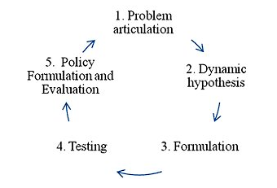
FIGURE 1. System dynamic methodology

PROBLEM ARTICULATION
This initial stage involves clearly defining and articulating the problem to be addressed. It includes identifying the key issues, setting the system boundaries, and determining the main variables and stakeholders involved. The goal is to clearly understand the problem’s context and objectives.

DYNAMIC HYPOTHESIS
In this stage, a dynamic hypothesis is formulated to explain the causes of the problem behavior. The CLD components can be seen in TABLE 1. This hypothesis is based on an understanding of the system’s structure and feedback loops. It involves identifying the relationships between variables and hypothesizing how these relationships drive the system’s behavior over time. This stage is where the causal loop diagram (CLD) starts to develop. CLD is a mapping form to understand cause-and-effect relationships between variables [6].
TABLE 1. Causal Loop Diagram Components
Variable | Symbol | Description
Positive Links | 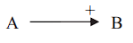 | There is a positive/causal relationship from variable A to variable B.
Negative Links | 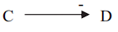 | There is a negative/causal relationship from variable C to variable D.
Delay Links | 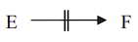 | There is a time delay in the interaction between variable E and variable F.
Positive Loop | 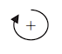 | The effect of a positive/increasing influence among variables where its loop is named reinforcing. This loop occurs when the relationships among variables are the same (both + positive or both - negative).
Negative Loop |  | The effect of a negative/decreasing influence among variables where its loop is named balancing. This loop occurs when the relationships among variables are balancing (There is an odd number of variables with a - negative relationship).

Once all the variables were found, their characteristics were developed in the model. Then, all the variables were modelled into a causal-loop diagram (CLD). The CLD model can determine the cause-and-effect relationship between each variable in the system [7].

FORMULATION
During formulation, the dynamic hypothesis is translated into a formal model. This involves constructing stock-and-flow diagrams, defining equations, and specifying parameters. The model should capture the essential features of the system and allow for simulation and analysis. This step is where the stock and flow diagram (SFD) being developed. In an SFD, stocks represent accumulations that can increase or decrease, while flows represent the processes that cause these stock changes [4] as seen in TABLE 2. This structured classification enhances clarity and facilitates the stock and flow diagram creation. Following this, each variable is intricately linked based on their intrinsic relationships, ensuring that the final diagram provides a thorough and detailed depiction of the system’s behavior over time [2, 8].
Subsequently, dynamic systems utilize simulation processes to construct models that reflect real-world conditions. These models are rigorously tested to gain insights into the system’s behavior [9]. Following testing, evaluations are performed to formulate operational strategies for the system. Simulations are invaluable for decision-making and designing solutions for intricate system issues, ultimately resulting in a framework that is free from assumptions [10].

TABLE 2. Stock and Flow Diagram Symbols
Variable | Symbol | Description
Stock (Level) |  | A variable that accumulates value over time based on rate changes.
Flow (rate) |  | A variable that influences the change in value of a stock.
Auxiliary |  | A variable that is influenced by other variables and contains calculation formulas.

TESTING
The model is tested to ensure its validity and reliability. This involves comparing the model’s behavior with real-world data, checking for consistency and plausibility, and performing sensitivity analysis. Testing helps refine the model and improve its accuracy in representing the actual system. In this research, testing is held in two ways. Firstly, verification ensures the model does not have bugs and errors [11]. Secondly, validation ensures that the model’s behavior outputs accurately represent current conditions. If the model does not function correctly or the results do not represent the current conditions, then the model is considered invalid [12]. In validation, mean comparison (E1) compares the average of real-historical data and simulation results from the model as shown in equation 1; while an error variance (E2) is the same but compares the standard deviation (equation 2).
$E1=\left(\frac{S-A}{A}\right)$ (1)
Where:
S = Average of simulation results
A = Average of real-historical data
The result will be considered valid if E1 < 5%
.
$E2=\left(\frac{Ss-Sa}{Sa}\right)$ (2)
Where:
Ss = Standard Deviation of simulation results
As = Standard Deviation of real-historical data
The result will be considered valid if E2 < 30%.

POLICY FORMULATION AND EVALUATION
In this final stage, the validated model is used to design and evaluate potential policies or interventions. The goal is to identify strategies to effectively address the problem and achieve desired outcomes. Different scenarios and policy options are simulated to assess their impacts and to support decision-making. The scenarios are separated into Most likely, Optimistic, and Pessimistic. The scenarios implemented will use the following strategies:
- Implementing policies to meet electricity needs using solar energy will thereby increase the number of installed solar panels.
- Optimizing the amount of available or existing land through the strategic installation of solar panels will increase the number of installed solar panels.
Increasing the population in the IKN area through planned migration will have potential positive and negative impacts. The positive impact is an increased demand for electricity, which drives the fulfillment of electricity needs in the community. On the other hand, the negative impact is that uncontrolled population growth can lead to economic disparity and slow down economic development.

DATA COLLECTION
The data used in this study were meticulously gathered from various sources to ensure comprehensive coverage and reliability. This section outlines the data collection techniques employed, including the types of data collected, the sources from which the data were obtained, and the procedures followed to ensure data accuracy and integrity. By systematically collecting and analyzing relevant data, this research aims to create a robust model that accurately represents the system under study and supports effective policy formulation and evaluation. The data used were obtained from reports by the Central Statistics Agency and PLN statistical reports.

RESULTS AND DISCUSSION

MODEL DEVELOPMENT
The causal loop diagram was developed after finding all the variables within the problem to get a solution from this research. The variables are separated into endogenous and exogenous, as described in TABLE 3 and TABLE 4. By establishing these variables, the groundwork for the subsequent development of the system dynamics model was laid, ensuring a comprehensive understanding of the intricate relationships and feedback loops that drive the system’s behavior. This foundational step is crucial for accurately modeling the system and deriving meaningful insights into its operation and potential interventions. It is found that all the variables are categorized as below:
TABLE 3. Endogenous Variables
Variables Name
Population | PV Absorption Power
Job Availability | PV Cost Production
Industry | Capacity Charge
GDP | Total Dam
Total PV Investment | Land Availability
Return On Investment | Installation Area
Possible PV Installation | Full Time Jobs
Total PV Production Revenue | Desired Number Employment
New Electricity Budget Investment | Trainees
O&M Jobs | Governmental Subsidies
PV Installation Jobs | Technology Innovation
Total Electricity Produced | PV Conversion Loss
Electricity Demand | PV Absorption Power
TABLE 4. Exogenous Variables
Variables Name
Death Rate | Projected Demand
Immigration | Work Transferred
Emigration | Local
Government Agency

Causal Loop Diagram
Having categorized the key variables influencing our system into endogenous and exogenous types, the Causal Loop Diagram (CLD) can be developed, as seen in FIGURE 2. This step is critical as the CLD visually represents the complex interrelationships and feedback loops among the variables. The CLD will help elucidate how these variables interact over time, highlighting the reinforcing and balancing loops that drive system behavior. Constructing the CLD aims to capture the essence of the system’s structure, providing a clear and detailed map of the causal relationships that will inform subsequent modeling and analysis stages.
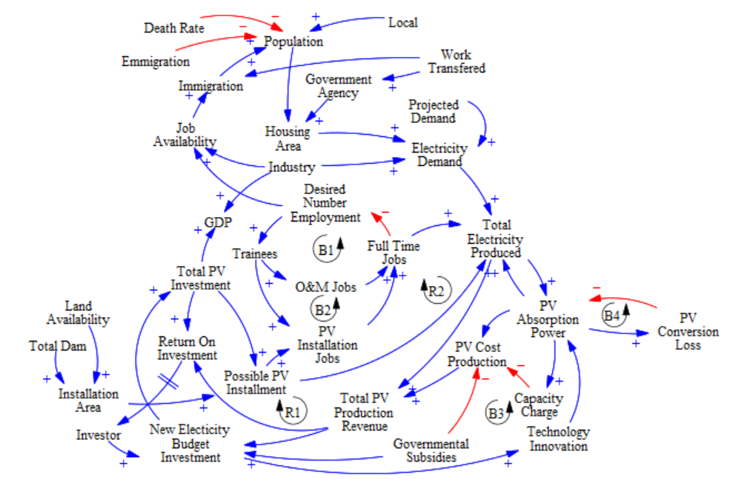
FIGURE 2. Causal loop diagram

Stock and Flow Diagram
The model is divided into five sub-models, including Sub-model Electricity, Sub-model PPU & KK Population, Sub-model Samarinda Population, Sub-model Balikpapan Population, and Sub-model Solar ROI. From the Causal Loop Diagram (CLD) of the CLD Model for Solar Energy Investment Feasibility Analysis, a Stock and Flow Diagram (SFD) will be developed. The SFD’s purpose is to observe the relationships and interactions between variables, providing new information about the system’s state. This knowledge offers insights into the system and influence final decision-making. The developed SFD can be used for scenario testing simulations as seen in FIGURES 3-6. The scenario testing is conducted after the model has been validated and verified.
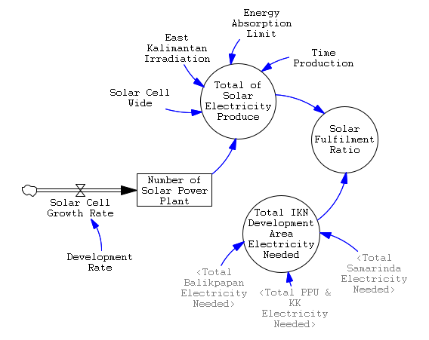
FIGURE 3. SFD sub-model electricity production
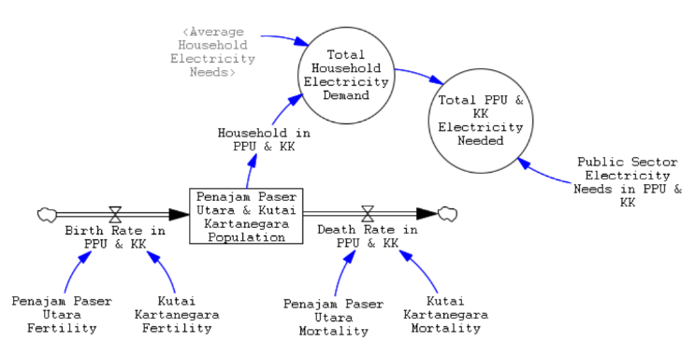
FIGURE 4. SFD sub-model capital area electricity needs
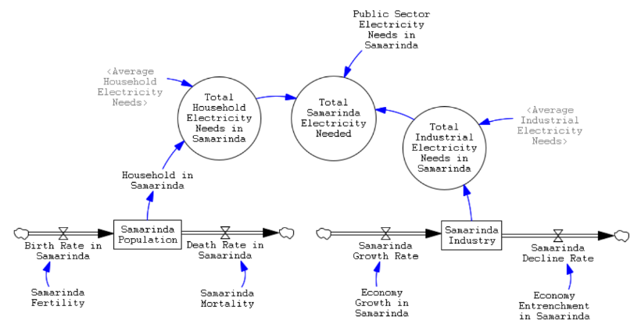
FIGURE 5. SFD sub-model samarinda electricity needs
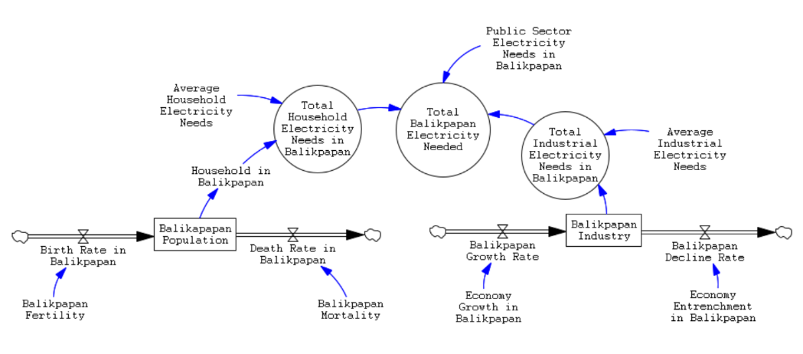
FIGURE 6. SFD sub-model balikpapan electricity needs

MODEL VALIDATION
Model validation is conducted by comparing the average error rate and error variance. A model is considered valid if the error rate is ≤ 5% and the error variance is ≤ 30%. The results for the validation are shown in TABLE 5.

TABLE 5. Validation results
Variables | Type of Validation | Results
Total of Solar Power Plant | Mean Comparison (E1) | 2 %
Total of Solar Power Plant | Error Variance (E2) | 28 %
Population in Kutai and Penajam Paser | Mean Comparison (E1) | 1 %
Population in Kutai and Penajam Paser | Error Variance (E2) | 13 %
Population in Balikpapan | Mean Comparison (E1) | 1 %
Population in Balikpapan | Error Variance (E2) | 9 %
Population in Samarinda | Mean Comparison (E1) | 1 %
Population in Samarinda | Error Variance (E2) | 29 %
Industrial Population | Mean Comparison (E1) | 1 %
Industrial Population | Error Variance (E2) | 14 %

SCENARIO DEVELOPMENT
In the dynamic system simulation model for the feasibility analysis of solar energy investment in the Nusantara Capital, scenarios were also implemented to understand the potential outcomes for the system. Three types of scenarios were applied:

- Most Likely Scenario: A scenario where the system or model operates under normal conditions without any additional factors altering the system.
- Pessimistic Scenario: A scenario where the system or model operates under poor to very poor conditions.
- Optimistic Scenario: A scenario where the system or model operates well under fairly good to excellent conditions.
The results from the scenarios can be seen in FIGURES 7-9.
Based on the dynamic system simulation model results for the feasibility analysis of solar energy investment in the Nusantara Capital, with simulations spanning from 2015 to 2045, each scenario strategy is applied starting from 2023 and continuing for 22 years. The findings indicate that in the optimistic scenario, the solar fulfillment ratio increases sharply, reaching about 9% by 2045, while in the most likely scenario, it gradually increases to around 3%; while in the pessimistic scenario, it remains low, approaching 1%. The total solar electricity production also shows significant growth in the optimistic scenario, reaching approximately 60 million kWh/year by 2045, compared to 20 million kWh/year in the most likely scenario and about 5 million kWh/year in the pessimistic scenario. The total electricity needed for the IKN development area increases significantly in all scenarios, with the highest demand in the optimistic scenario reaching around 900 GWh/year by 2045.
These results suggest that the adoption of solar energy in Nusantara Capital holds promising potential, especially in the optimistic scenario. However, to achieve faster and more substantial profitability, more aggressive changes in the system and policies supporting solar energy implementation are needed. This includes investments in more efficient technologies and enhanced infrastructure support to ensure that solar energy implementation yields quicker and greater profits, thereby further legitimizing the solar energy industry in the future.
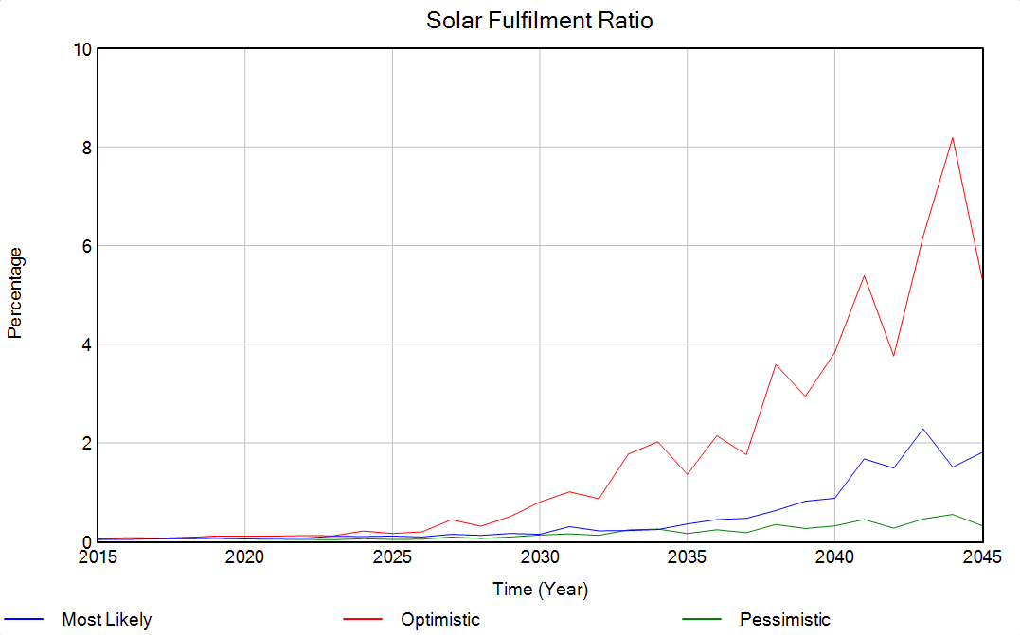
FIGURE 7. Scenarios results for solar fulfillment ratio

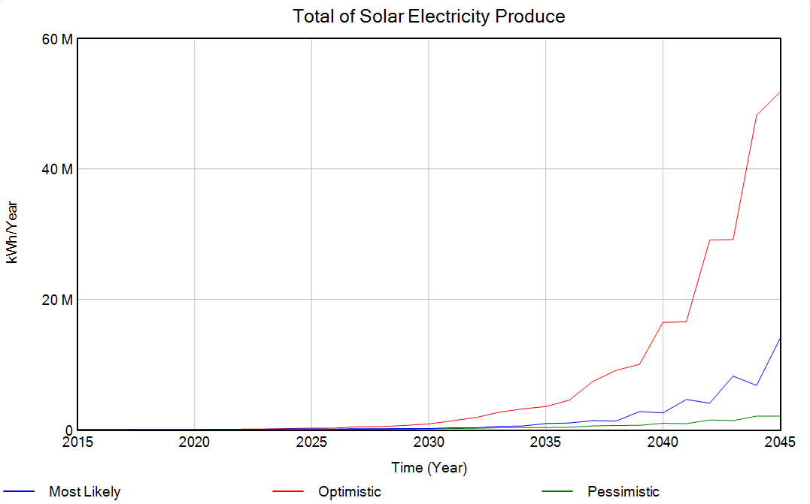
FIGURE 8. Scenarios results for total of solar electricity production

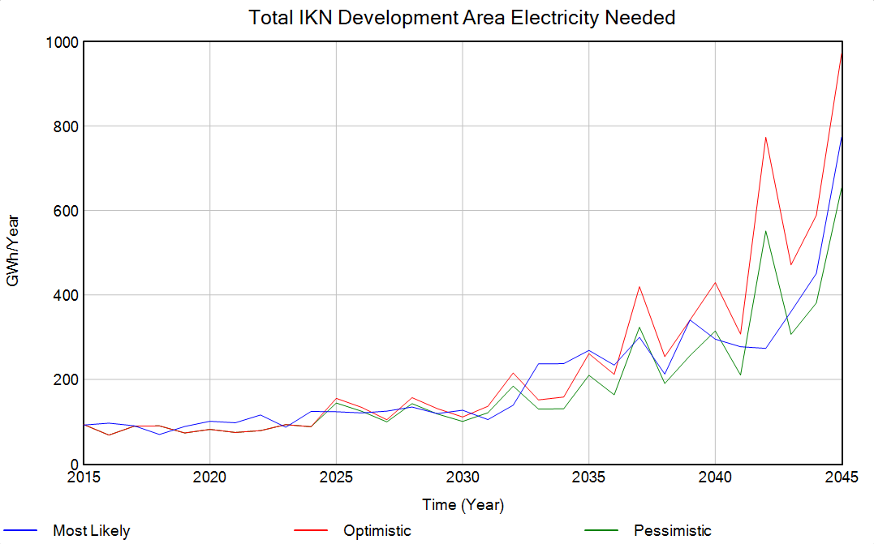
FIGURE 9. Scenarios results for total electricity demand in nusantara capital

Conclusions
The dynamic system simulation model for the economic analysis of solar energy investment in the Nusantara Capital City (IKN) indicates that solar energy is a viable and profitable energy source for the new capital. The model, validated with an average error rate of ≤ 5% and an error variance of ≤ 30%, accurately represents the system’s behavior under different scenarios. The optimistic scenario yields the highest return on investment (ROI) at 42% by 2045, with a break-even point in 2026. Even under the pessimistic scenario, solar energy will become profitable by 2029. These results underscore the economic benefits of adopting solar energy in IKN and highlight the importance of strategic policy implementation and land optimization to enhance profitability.
Moreover, the study confirms that solar energy investment is a sustainable and economically sound decision for supporting the development of IKN. To achieve faster and more substantial profitability, aggressive changes in the system and policies supporting solar energy implementation need to be made. This includes investments in more efficient technologies and enhanced infrastructure support to ensure quicker and greater profits, further legitimizing the solar energy industry in the future.

AcknowledgEments
The authors gratefully acknowledge ﬁnancial support from the Institut Teknologi Sepuluh Nopember for this work under the project scheme of the Publication Writing and IPR Incentive Program (PPHKI) 2024.

References

1. Gong, J., C. Li, and M.R. Wasielewski, Advances in solar energy conversion. Chemical Society Reviews, 2019. 48(7): p. 1862-1864.
2. Zhang, L., et al., How does the photovoltaic industry contribute to China's carbon neutrality goal? Analysis of a system dynamics simulation. Science of The Total Environment, 2022. 808: p. 151868.
3. Hsu, C.-W., Using a system dynamics model to assess the effects of capital subsidies and feed-in tariffs on solar PV installations. Applied Energy, 2012. 100: p. 205-217.
4. Suryani, E., et al., A Model to Improve Workability of Transport Systems. Environment, Development and Sustainability, 2023.
5. Hsiao, C.-T., et al., Dynamic modeling of the policy effect and development of electric power systems: A case in Taiwan. Energy Policy, 2018. 122: p. 377-387.
6. Sterman, J., Business Dynamics, System Thinking and Modeling for a Complex World. http://lst-iiep.iiep-unesco.org/cgi-bin/wwwi32.exe/[in=epidoc1.in]/?t2000=013598/(100), 2000. 19.
7. Arishinta, A. and E. Suryani, Dynamic System Modeling of Renewable Energy Diversification at ITS Surabaya as a Sustainable University Management Effort. IPTEK Journal of Proceedings Series, 2021(6): p. 195-202.
8. Chi, Y.-y., et al., The impact of allocation methods on carbon emission trading under electricity marketization reform in China: A system dynamics analysis. Energy, 2022. 259: p. 125034.
9. Shannon, R.E. Introduction to the art and science of simulation. in 1998 Winter Simulation Conference. Proceedings (Cat. No.98CH36274). 1998.
10. Chaharbaghi, K., Using Simulation to Solve Design and Operational Problems. International Journal of Operations & Production Management, 1990. 10(9): p. 89-105.
11. Mudjahidin, et al., Testing Methods on System Dynamics: A Model of Reliability, Average Reliability, and Demand of Service. Procedia Computer Science, 2019. 161: p. 968-975.
12. Barlas, Y., Formal aspects of model validity and validation in system dynamics. System Dynamics Review, 1996. 12(3): p. 183-210.

