Development of Miniature Near Infrared Spectroscopy Sparkfun AS7265X to analyze the freshness of chicken meat
Basri Noor Cahyadi^{a)}, Zulfatman^{b)}, M. Chasrun Hasani^{c)}, Andika Tegar Pamungkas^{d)}, and Muhammad Fikri Yusuf^{e)}
Electrical Engineering Department, Universitas of Muhammadiyah Malang, Malang, Indonesia

^{a)} Corresponding author: basrinoorc@umm.ac.id
^{b)} zulfatman@umm.ac.id
^{c)} chasrun@umm.ac.id
^{d)} andikategar@gmail.com
^{e)} mfikriyusuf@gmail.com

Abstract. The current evaluation of chicken meat freshness is typically conducted through traditional methods, such as laboratory testing or sensory analysis, including smell and water content examination. While previous studies have shown that near-infrared spectroscopy (NIRS) can evaluate meat freshness quickly and accurately, the technology remains costly and limited to major cities. To address this, a simple and affordable NIRS technology is necessary for broader use in maintaining food quality. This study proposes the development of a miniature NIRS device for measuring chicken meat freshness. The device emits visible, infrared, and UV waves, analyzing the reflected signals. The system is built using the Sparkfun AS7265X sensor, which operates within a spectral range of 410-940 nm. It detects key components such as fat, water, protein, and myoglobin. Tests were conducted on five fresh meat samples and five samples from traditional markets. Results showed fresh chicken meat had a spectrum density of 1.67-1.81 for myoglobin, 0.46 for metmyoglobin, 3.32 for deoxy myoglobin, 11.56 for sulmyoglobin, and fat levels ranging from 1.49 to 17.45. Among the five market samples, one was identified as not fresh. These findings indicate that the miniature NIRS can effectively detect chicken meat freshness. However, further testing in food laboratories is required to verify its accuracy.
Keywords: spectroscopy, infrared, miniature, chromosomes.

INTRODUCTION
Every part of an organization or business system that aims to produce products or services that satisfy customers must implement quality control. This quality control aims to ensure customers that the product comes from a company with high quality and can meet their needs [1]. The Food and Drug Supervisory Agency or abbreviated as BPOM is fully responsible for controlling the quality of a food product in Indonesia. Good raw materials, if handled, processed, and distributed properly, will create a good product. In addition, the results of laboratory testing of the final product can not only guarantee the quality and safety of food. Therefore, it is important to know the freshness and safety of the raw materials used to make animal or vegetable products, especially in terms of freshness [2], [3]. This is related to efforts to minimize product damage during production. This study will focus on the analysis of chicken meat quality. Meat is one of the animal commodities that is a mainstay for the Indonesian people because chicken meat has a good taste, is cheap, and has abundant protein content. In addition, the frequent emergence of the issue of "Ayam Tiren" (chickens that die without being slaughtered) is the main factor for the author to carry out this study.
Currently, meat freshness testing is still carried out conventionally by checking in the laboratory. In recent years, research on meat freshness has been proposed using a classification method based on water content, physical form, color and smell of the meat. Based on the results of previous analysis, it was concluded that the Convolutional Neural Network (CNN) classification method has an excellent ability to identify the freshness of beef based on physical form and color images [4] [5] [6] . In 2023, Andryan Syahfitri said that meat freshness could be classified using the Hue, Intensity, and Saturation (HIS) color space transformation method with an accuracy of 88.9% [7]. Apart from the color and changes in physical form, meat freshness can be seen from the water content, pH, cooking loss and Water Holding Capacity (WHC) as stated by Isye J. Liur [8]. From the methods carried out, there are still several shortcomings such as the classification of meat freshness based on physical form, color and smell. These three components can still be manipulated by adding formalin or preservatives. Meanwhile, classification based on water content and pH can be manipulated by injecting water into the meat.
To cover the shortcomings of previous research, near-infrared spectroscopy technology is used where this technology works by emitting infrared, UV, and visible light waves. By applying this method, the freshness and quality of meat can be analyzed quickly and accurately where this method can detect moisture, protein, and fat content contained in meat, as shown in TABLE 1.
TABLE 1. Chromophores in various types of meat observed at different wavelengths
Chromophores | Type of meat | Wavelength (nm) | Method
Water(O–H bonds) | Chicken | 970 | Near Infrared Reflectance Spectroscopy (NIRS)
Water(O–H bonds) | Lamb | 890 | NIRS
Water(O–H bonds) | Ham | 980 | NIRS using a fiber optic
Water(O–H bonds) | beef | 970, 980 | NIRS
Water(O–H bonds) | pork | 960, 1440, 1450 | NIRS
Fat (C-H bonds) | Chicken | 880, 902, 930 | NIRS
Fat (C-H bonds) | beef | 1200, 1400 | NIRS
Protein (N-H bonds) | beef | 1500 | NIRS
Protein (N-H bonds) | lamb | 540, 580 | Visible Spectroscopy
Myoglobin | Chicken | 425-550 | NIRS
Deoxy myoglobin | beef | 430 | Visible/ NIR Spectroscopy
Deoxy myoglobin | beef | 530 | Visible Spectroscopy
Deoxy myoglobin | Chicken | 540, 580 | Visible Spectroscopy
Metmyoglobin | beef | 475 | NIR Spectroscopy
Metmyoglobin | beef | 780 | Visible Spectroscopy
Metmyoglobin | Chicken | 440-445, 485-500, 560 | Visible/ NIR Spectroscopy
Oxymyoglobin | lamb | 424, 550 | Visible/ NIR Spectroscopy
Oxymyoglobin | lamb | 580 | Visible Spectroscopy
Oxymyoglobin | Pork | 540, 580 | Visible Spectroscopy
Sulf myoglobin | Chicken | 635 | Visible/ NIR Spectroscopy

Previous studies have shown that NIR Spectroscopy has a fairly good ability to assess meat quality and monitor relative absorbance alternation of oxymyoglobin and myoglobin in visible, fat, water, and collagen in NIR spectral ranges [9]. In the field of food research, this method is very popular so that many previous studies have used it to determine the damage to fresh beef, freshness, meat counterfeiting, formalin content in meat, freshness of sea fish, and the quality of rice bran [10] [11] [12] [13] [14]. So based on the results of previous studies, researchers proposed the development of miniature Near Infrared Spectroscopy using the Sparkfun AS7265X sensor.

METHODS
The development of miniature near-infrared spectroscopy consists of three stages, the first is designing miniature spectroscopy, the second is taking data sheets and the third is testing and analysis. The following FIGURE 1 is a block diagram of the development flow of miniature near-infrared spectroscopy. This study will focus on measuring the quality of chicken meat found in traditional markets in the Malang area.
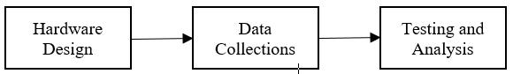
FIGURE 1 Block diagram of the development flow of miniature near-infrared spectroscopy

Miniature near infrared spectroscopy consists of two hardware systems and software or desktop app. The proposed hardware system consists of an ESP-32 microcontroller and a Sparkfun AS7265X near infrared spectroscopy sensor. ESP-32 functions to send data from the spectroscopy sensor to the desktop app. Near infrared spectroscopy works by emitting visible, UV, and infrared light waves where this sensor is able to detect the presence of fat and protein [9]. The protein measured in this tool is myoglobin, where myoglobin is a respiratory protein that functions as a model system in various fields of biology [15], [16]. The wavelength used to measure the molecules contained in chicken meat is shown in TABLE 2.

TABLE 2. list of Chromophores or molecules and wavelengths in chicken meat
Wavelengths (mm) | Chromophores
880, 902, 930 | Fat (C-H bonds)
425-550 | Myoglobin
540, 580 | Deoxy myoglobin
485 | Metmyoglobin
635 | Sulf myoglobin

The desktop app functions to process and display data sent by the ESP-32. The data processing method used in this system still uses a comparison of measurement data with reference data. The following is the flow of the miniature spectroscopy system.

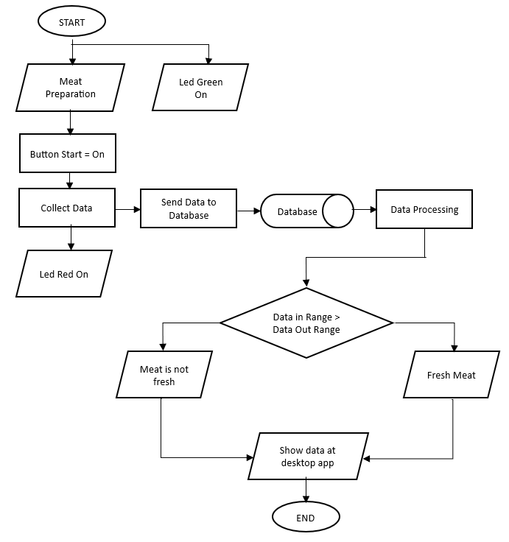
FIGURE 2. System flow diagram

Data collection was carried out in 24 sessions with a time interval of 1 hour and in each session data collection was carried out 20 times. In this test there were 5 samples of chicken meat obtained from the chicken slaughterhouse, so that the meat obtained was confirmed to be fresh meat. These data will later be used as a datasheet for the implementation of chicken meat freshness measurements. Evaluation proposed system, will take five samples of chicken meat from traditional market by randomly in the morning at 09:00 AM.

RESULTS AND DISCUSSION

HARDWARE DESIGN
The following is the result of the miniature near infrared spectroscopy hardware design where this system consists of hardware and software. FIGURE 3 is the result of the miniature near infrared spectroscopy design where this miniature consists of one place for meat to be tested, one button as a start button, and three lights as indicators. This miniature is equipped with a Wi-Fi module to send data from the hardware system to the desktop app.

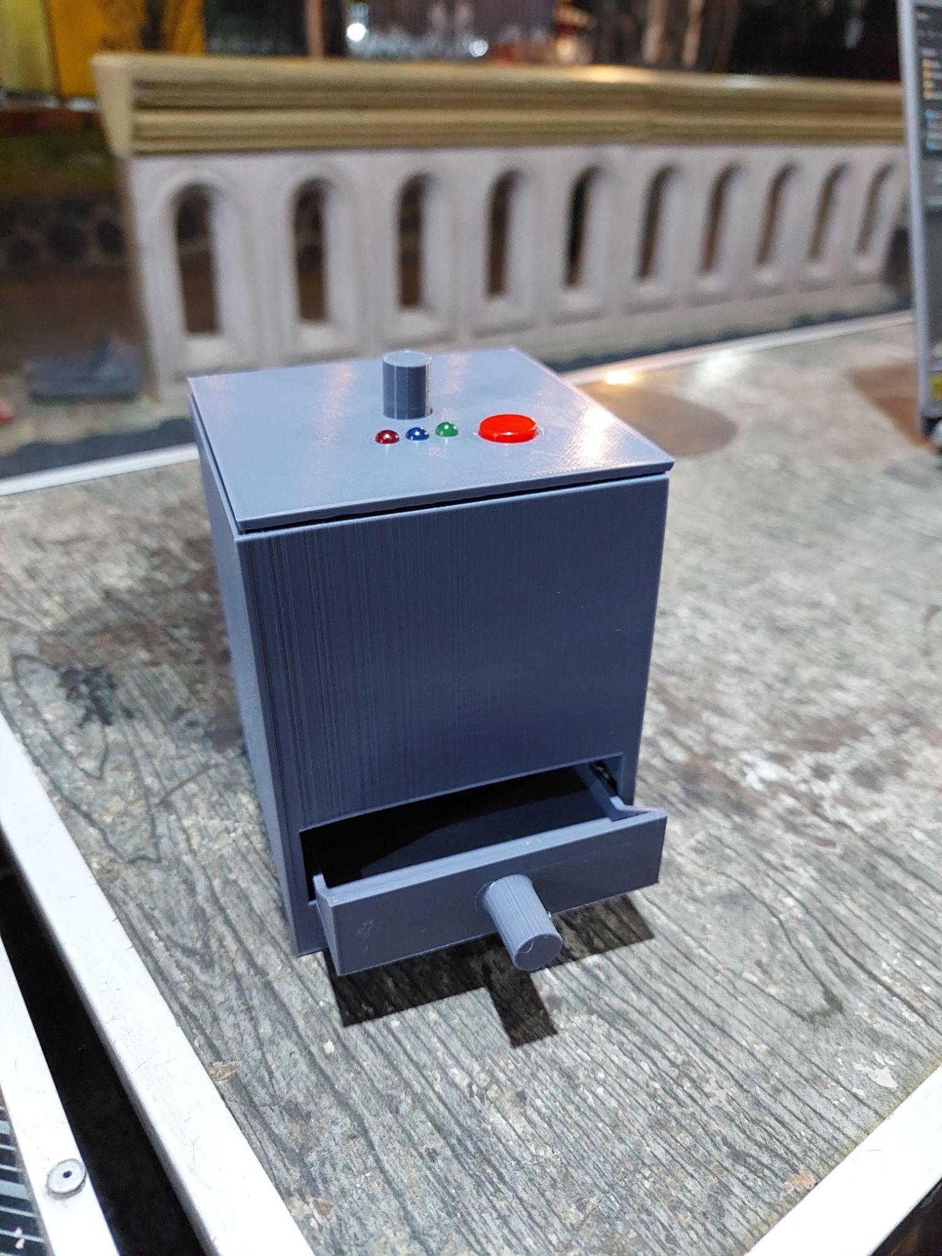
FIGURE 3. Miniature Near Infrared Spectroscopy

FIGURE 4 shows the results of the design of the desktop application to display the measurement data. In this desktop application we can see the spectrum values ​​of chicken meat Chromophores such as water, fat, and myogoblin as well as the results of the meat freshness classification. In the ESP-32 system test, it was able to send data well to the desktop application, as seen in the Wavelength recording data in TABLE 2.

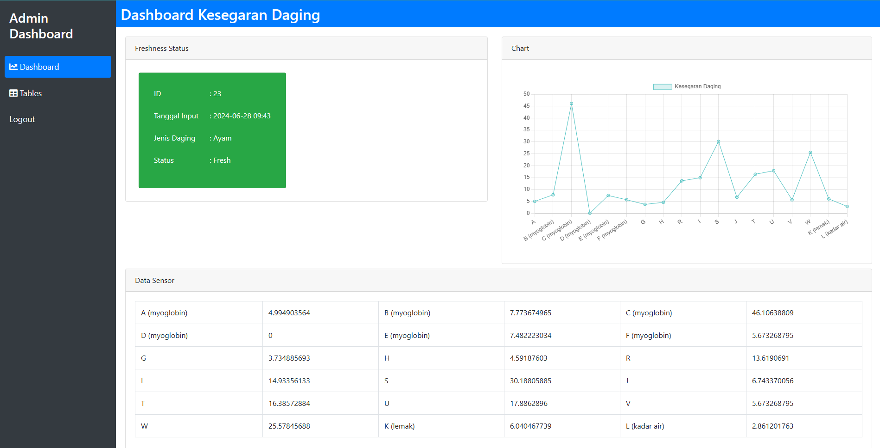
FIGURE 4 Desktop app user interface

DATA COLLECTIONS
FIGURE 5 shows the optical density spectrum of chromophores in chicken meat tissue in sample 1 where the Chromophores components taken are fat, myoglobin, Deoxy myoglobin, Metmyoglobin, Sulf myoglobin. It can be seen in the first measurement that the optical density value for fat is 13 and in the second measurement it increases to 23. In the next measurement which was measured at the third hour and so on, it produced a high optical density value and continued to increase and fell again after the 15th hour. This proves that there is a change in the chromophore structure in chicken meat after the second hour which is caused by bacterial growth. As stated by previous researchers, meat stored at room temperature will only last for 2 hours. While the myoglobin chromophore and other compounds do not experience very significant changes. However, we should not ignore it because this chromophore is very important in binding nutrients and iron.

FIGURE 5. Optical density spectrum of chromophores in chicken meat tissue

From the data in FIGURE 5, we will then make a baseline where the measurement data for 2 hours will be used as a reference to determine the level of freshness of the meat. FIGURE 6 shows a baseline graph for fresh meat obtained from 5 samples tested. From the graph, it can be seen that fresh chicken has a myoglobin protein value of 1.67 and 1.81 while the supporting chromophore values ​​such as metmyoglobin are 0.46, deoxymyoglobin 2.32, and sulfmyoglobin 11.56. while the fat content has a spectrum density value between 1.49 and 17.45. The chromophore spectrum density value will be used as a reference to determine the freshness of chicken meat.

FIGURE 6.Baseline optical density spectrum of chromophores in fresh chicken meat

DATA COLLECTIONS
From the results shown, it can be seen that four chicken meats were declared fresh and 1 chicken meat showed indications of not being fresh. From FIGURE 7, it can be seen that sample 4 has a fairly high value, especially in the fat chromosome and myoglobin, and other samples have values ​​close to the baseline. In sample 5, there is a fairly large decrease in value from the baseline in the fat chromosome (860), but in other chromosomes it is still close to the baseline chromosome value.

FIGURE 7 Comparison of spectrum density values ​​for each sample

The measurement of chicken meat freshness is determined by finding the deviation value in the spectrum density value with the reference spectrum density value at the baseline, where the deviation determined is 30% of the baseline. Moreover, from this it can be concluded that sample 4 can be indicated as not fresh meat. The percentage of spectrum density deviation for each chromosome is shown in TABLE 3.

TABLE 3 Deviation value of density spectrum from each sample

Sample | Myoglobin (410) | Myoglobin (435) | Metmyoglobin (485) | Deoxy myoglobin (585) | Sulmyoglobin (645) | Fat (860) | Fat (900) | Fat (940)
1 | 17% | 34% | 13% | 3% | 6% | 7% | 2% | 1%
2 | 10% | 14% | 13% | 19% | 6% | 16% | 32% | 27%
3 | 33% | 26% | 13% | 22% | 12% | 27% | 15% | 29%
4 | 137% | 92% | 20% | 117% | 77% | 110% | 176% | 337%
5 | 56% | 28% | 39% | 15% | 9% | 35% | 28% | 25%

CONCLUSIONS
Based on the tests that have been carried out, miniature near infrared spectroscopy can be said to be successful, where the hardware test in the form of a sparkfun AS7265x sensor can work well by reading the meat content seen based on the emitted wavelength. From the test results for each sample, it was found that fresh chicken meat has a spectrum density value on the myoglobin chromosome of 1.67 to 1.81, Metmyoglobin 0.46, Deoxy myoglobin 3.32, Sulmyoglobin 11.56, and fat between 1.49 to 17.45. From the testing of chicken meat taken randomly, it was found that there was 1 sample indicated as not fresh where there was a deviation in the average spectrum density value of 163%.

Acknowledgments
This research is supported by Direktorat Penelitian dan Pengabdian Masyarakat (DPPM) of Universitas Muhammadiyah Malang through Engineering Faculty Internal Research Grant. The authors are grateful for supporting the present work.

References
- F. Z. Muttaqin, A. Adinda, F. G. Fahreza, and R. S. Nurlaela, "Kajian Literatur: Keefektifan Analisis Kesegaran Daging Menggunakan Spektroskopi," Karimah Tauhid, vol. 3, no. 7, pp. 7249-7256, 2024.
- A. Ainezzahira et al., "Evaluasi sanitasi pangan pada industri rumah tangga pengolahan tahu di Kelurahan Bojong Nangka, Kabupaten Tangerang," VITKA Jurnal Manajemen Pariwisata, vol. 1, no. 1, pp. 5-12, 2019.
- W. Barragán-Hernández, L. Mahecha-Ledesma, J. Angulo-Arizala, and M. Olivera-Angel, "Near-infrared spectroscopy as a beef quality tool to predict consumer acceptance," Foods, vol. 9, no. 8, p. 984, 2020.
- T. Ekamila, F. Rahayu, A. Zuchriadi, and A. O. Indarso, "Penerapan Deep Learning Untuk Klasifikasi Kesegaran Daging Sapi Berbasis Mobile Apps," Edu Komputika Journal, vol. 10, no. 1, pp. 10-16, 2023.
- F. I. Zulfi, "Identifikasi Tingkat Kesegaran Daging Sapi Lokal Menggunakan Ekstraksi Fitur Warna Berbasis Gui Matlab," 2017.
- J. A. Firdaus, E. Setiawan, and D. Syauqy, "Sistem Pengukur Kesegaran Daging Sapi menggunakan Metode K-Nearest Neighbor (K-NN) dengan Fitur Penambahan Data Latih berbasis EEPROM," Jurnal Pengembangan Teknologi Informasi Dan Ilmu Komputer, vol. 4, no. 5, pp. 1555-1562, 2020.
- A. Syahfitri, K. Ibnutama, and D. Suherdi, "Mendeteksi Tingkat Kesegaran Daging Sapi Menggunakan Metode Transformasi Ruang Warna HIS (Hue, Intensity, dan Saturation)," Jurnal Sistem Informasi Triguna Dharma (JURSI TGD), vol. 2, no. 6, pp. 923-934, 2023.
- I. J. Liur, D. F. Souhoka, and B. J. Papilaya, "Analisis kadar air dan kualitas fisik daging sapi yang dijual di pasar tradisional Kota Ambon," Agrinimal Jurnal Ilmu Ternak dan Tanaman, vol. 10, no. 1, pp. 45-50, 2022.
- M. Peyvasteh, A. Popov, A. Bykov, and I. Meglinski, "Meat freshness revealed by visible to near-infrared spectroscopy and principal component analysis," Journal of Physics Communications, vol. 4, no. 9, p. 095011, 2020.
- A. C. Njume, Y. A. Purwanto, D. A. Astuti, and S. Widodo, "Rapid Assessment of Fresh Beef Spoilage Using Portable Near-Infrared Spectroscopy," Jurnal Keteknikan Pertanian, vol. 9, no. 3, pp. 79-86, 2021.
- L.-C. Fengou, A. Lianou, P. Tsakanikas, F. Mohareb, and G.-J. E. Nychas, "Detection of meat adulteration using spectroscopy-based sensors," Foods, vol. 10, no. 4, p. 861, 2021.
- N. Lestari, Y. Yuwana, and Z. Efendi, "LEVELS OF FRESHNESS AND PHYSICAL DAMAGE IDENTIFICATION OF FISH AVAILABLE FOR COMSUMERS AT PASAR MINGGU MARKET BENGKULU," Jurnal Agroindustri, vol. 5, no. 1, pp. 44-56, 2015.
- A. Rakhmawati, Y. A. Purwanto, S. Widodo, and D. A. Astuti, "Detection of Formalin Content in Chicken Meat Using Portable Near Infrared Spectrometer," Jurnal Teknik Pertanian Lampung (Journal of Agricultural Engineering), vol. 12, no. 4, pp. 831-839, 2023.
- S. Wulandari, M. Adhyatma, D. Pantaya, A. Jayanegara, and R. A. Nurfitriani, "Near infrared spectroscopy for the quality control of rice bran," Livestock and Animal Research, vol. 20, no. 2, pp. 210-219, 2022.
- A. N. Izzah et al., "Effect of Beef Treatment at Different Temperatures on Myoglobin Changes: A Brief Review," Journal of Tropical Food and Agroindustrial Technology, vol. 5, no. 01, pp. 1-8, 2024.
- J. Koch, J. Lüdemann, R. Spies, M. Last, C. T. Amemiya, and T. Burmester, "Unusual diversity of myoglobin genes in the lungfish," Molecular biology and evolution, vol. 33, no. 12, pp. 3033-3041, 2016.

