Identification of EEG Patterns to Detect Emotions of Stress and Anxiety in Adolescents
La Febry Andira Rose Cynthia^{1,a)}, Lailis Syafaah^{1,b)}, Sri Rahayu Dwi Purnaningtyas^{2,c)}, and Mohammad Chasrun Hasani^{1,d)}
¹Department of Electrical Engineering, Universitas Muhammadiyah Malang, Malang, Indonesia
²Department of Pharmacy, Universitas Strada Indonesia, Kediri, Indonesia

^{a)} Corresponding author: lafebryarc@umm.ac.id
^{b)} lailis@umm.ac.id
^{c)} chichirahayu72@gmail.com
^{d)} chasrun@umm.ac.id
Abstract. Stress and anxiety are critical mental health issues among adolescents, with their prevalence steadily increasing. According to the Indonesian Ministry of Health (2022), 20% of teenagers in Indonesia experience anxiety disorders, and the incidence of stress has also risen in recent years. Electroencephalography (EEG) is a promising tool for detecting emotions by recording the brain's electrical activity. EEG can identify specific brain wave patterns associated with emotional states such as stress and anxiety. This study aims to characterize EEG patterns in adolescents experiencing stress and anxiety. The research involved a cohort of teenagers divided into a high stress and anxiety group and a control group. Stress and anxiety levels were assessed using the DASS-21 questionnaire. EEG data were recorded using a 14-channel EEG device during resting states and in response to stress and anxiety stimuli. The EEG data were processed using quantitative analysis to derive parameters such as dominant power, dominant frequency, and dominant frequency duration, which were used to identify EEG patterns correlating with stress and anxiety. The findings indicate that subjects with high anxiety predominantly exhibit beta wave activity, while those with high stress show dominant beta and theta wave activity. These results suggest that EEG can be a valuable tool for identifying neural correlates of stress and anxiety in adolescents. Future research should aim to expand the sample size and involve collaboration with psychologists or psychiatrists to enhance the robustness of these findings.
Keywords: EEG, Stress, Anxiety, Adolescents

INTRODUCTION
Stress and anxiety are significant mental health problems among adolescents, with prevalence continuing to increase. According to data from the Indonesian Ministry of Health (2022), around 20% of teenagers in Indonesia experience anxiety disorders, and the prevalence of stress has also increased in recent years. This condition can have a negative impact on a teenager's psychological development, academic performance, and overall well-being. Therefore, effective methods are needed to detect and understand this condition. Adolescence is a pivotal period of emotional and neurological development, characterized by significant changes in brain structure and function. During this time, individuals are particularly vulnerable to the effects of emotional stress, which can result in long-term mental health issues such as anxiety, depression, and other mood disorders. Recent research has emphasized the importance of understanding how stress impacts the developing adolescent brain, particularly given the heightened emotional sensitivity observed during this stage [1] [2].
According to data from the World Health Organization (WHO), the prevalence of mental health problems, including stress and anxiety, in adolescents has increased significantly. WHO reports that around 10-20% of adolescents worldwide experience mental disorders, with anxiety and depression being the most common problems. Anxiety disorders in particular have a prevalence of around 6-7% among adolescents aged 10-19 years. The COVID-19 pandemic exacerbated this situation, with the prevalence of anxiety and depression increasing by 25% worldwide in the first year of the pandemic. Teenagers are one of the most affected groups, especially due to school closures, social isolation and uncertainty about the future. Risk factors that contribute to increased stress and anxiety in teens include academic pressure, family problems, social media use, and worry about the future. Adolescent girls and those with pre-existing physical health conditions show a higher prevalence of anxiety disorders. Despite the increased need, mental health services for youth are often inadequate, with many countries experiencing significant disruptions in mental health services during the pandemic, leaving many youth without necessary care. If left untreated, stress and anxiety in teenagers can have long-term impacts on their psychological and emotional development.
Electroencephalography (EEG) is a potential tool for detecting emotions through recording the brain's electrical activity. EEG can identify brain wave patterns associated with emotional conditions such as stress and anxiety. This study aims to identify typical EEG patterns that appear in adolescents who experience stress and anxiety. With a better understanding of these patterns, it is hoped that more effective and personalized interventions can be developed to treat mental health problems in adolescents. Quantitative Electroencephalography (QEEG) is a non-invasive neuroimaging technique that measures electrical activity in the brain, offering valuable insights into underlying neural processes. QEEG has been increasingly utilized to explore the neurophysiological correlates of various psychological conditions, making it a promising tool for investigating the effects of emotional stress on brain activity. In another study, it was mentioned that EEG signals using stimuli looked different in alpha/beta and theta/beta ratios [3]. Another study showed that stress and anxiety would increase due to the presence of test stimuli measured using the Indonesian DASS-42 [4]. EEG used in neurofeedback for Anxiety and Post Traumatic Stress Disorder (PTSD) showed that EEG and neurofeedback can be used for brain therapy [5] and using EEGlab and SPSS analysis [6].
However, despite its potential, the application of QEEG to understand stress-induced neural changes in adolescents remains underexplored.
Studies have shown that stress can significantly alter brain function, particularly in regions associated with emotion regulation, such as the prefrontal cortex and amygdala. These stress-related changes in brain activity are of particular concern during adolescence, a period marked by ongoing brain maturation and heightened sensitivity to emotional experiences [7] [8]. Another study showed that QEEG in people with Mild Cognitive Impairment can be used as a parameter for abnormal conditions in brain signals [9] [10]. The use of QEEG to examine these changes could provide crucial insights into the neural mechanisms underlying emotional dysregulation in adolescents.
This research has several specific objectives: first, to identify specific brain wave (EEG) patterns in adolescents who experience stress and anxiety; second, comparing EEG patterns between adolescents with high levels of stress and anxiety and those with normal levels; third, developing a predictive model using machine learning algorithms to predict stress and anxiety levels based on EEG data; fourth, evaluate the effectiveness and accuracy of the EEG method in detecting stress and anxiety in adolescents. This study aims to investigate the impact of emotional stress on adolescent brain activity using QEEG. By analyzing brain wave patterns in response to stress, this research seeks to identify specific neural markers associated with emotional dysregulation. These findings could contribute to a deeper understanding of how stress influences adolescent brain function and inform the development of targeted interventions to support mental health during this critical period.

METHODS
This research involved 11 students from one of University in Kediri with an age range of 19-22 years. The gender of the 11 students was mostly female with a total of 7 students. This research consists of several stages including data collection, signal processing and analysis, as presented in FIGURE 1.

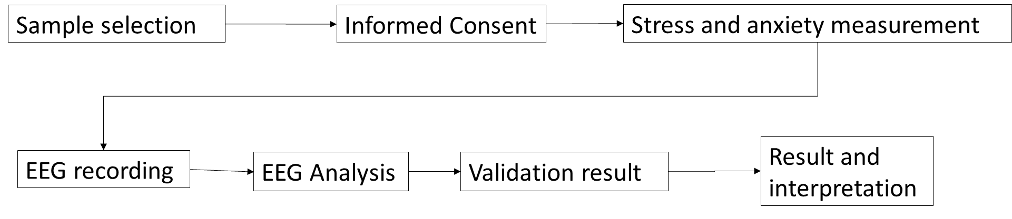
FIGURE 1. research method
Subjects divided into two groups: a group with high levels of stress and anxiety and a control group with normal levels of stress and anxiety. Subject selection will consider factors such as sociodemographic background, mental health history, and use of certain medications. Participants provided with information about the purpose of the study and provide written consent before they are included in the study.
To measure the level of stress and anxiety, the use of the verified DASS-42 (Depression Anxiety Stress Scales) scale be carried out, an instrument widely used in psychological research. Each subject asked to complete the DASS-42 questionnaire to determine their stress and anxiety levels. Completing this questionnaire carried out independently by the subject, perhaps with the help of researchers or research staff.
The DASS-42 questionnaire has 3 main results, namely depression, anxiety, and stress scores [4]. Each condition has its own range of values ​​to be included in the normal, mild, moderate, and severe criteria. This can be seen in TABLE 1 below.
TABLE 1. DASS assessment scale
Level | Depression | Anxiety | Stress
Normal | 0 - 9 | 0 - 7 | 0 - 14
Mild | 10 – 13 | 8 – 9 | 15 – 18
Moderate | 14 – 20 | 10 – 14 | 19 – 25
Severe | 21 – 27 | 15 – 19 | 26 – 33
Very Severe | >28 | >20 | >34

EEG data was taken using a 14-channel EEG device that will be attached to the subject's scalp. The data collection process carried out in two conditions: when the subject is resting and when the subject is given a task that can trigger stress and anxiety, such as a math test or a simulated public speaking situation. During data collection, subjects was asked to remain calm and relaxed, and follow the instructions given by the researcher. Each data collection session will last approximately 30-45 minutes.
The EEG data processed by removing artifacts using signal processing techniques such as quantitative of EEG. Features such as power spectrum, frequency dominant, and dominant time frequency value extracted from the EEG signal as the next step in data analysis. The processed data was used to identify EEG patterns that correlate with stress and anxiety levels in adolescents. Thus, this methodology was designed to identify EEG patterns that correlate with levels of stress and anxiety in adolescents, with the hope of providing new insights into the understanding and management of emotions in this population.

Quantitative Electroencephalograph (QEEG)
Before the EEG signal was segmented, it was filtered by using bandpass filter of 0.5-49 Hz. The segmentation process was employed to standardize the EEG signal lengths across all participants. From the raw EEG data, a one-minute segment free of artifacts was manually selected. This segment was divided into 5-second windows, and each windowed signal was processed through a filter bank to separate the EEG into different frequency bands: delta (0.1–4 Hz), theta (4–8 Hz), alpha (8–13 Hz), beta (13–30 Hz), and gamma (30–50 Hz) [11]. The peak power of each EEG signal within each frequency band was then computed. The computed of the peak power use welch power spectral density.
Quantitative parameter calculation involves measuring the power and frequency for each EEG band across all channels, determining duration parameters, and calculating the percentage of waves within each frequency band. Three power parameters are computed: absolute power, relative power, and power ratios. Absolute power measures EEG signal strength in µV²/Hz, calculated using Welch's method.

RESULTS AND DISCUSSION

EEG RECORDING DATA
This research involved 11 students in one of University in Kediri with an age range of 19-22 years. The gender of the 11 students was mostly female with a total of 7 students. The ethical review approval process was conducted by the Ethics Committee of IIK STRADA Indonesia. Ethical approval was obtained on November 8, 2023, with the ethics number 000514/EC/KEPK/I/11/2023. The measurement results of DASS-42 obtained 3 main parameters, stress, depression and anxiety. From these three aspects, it was found that the anxiety level of 5 subjects was at a moderate value, 1 was severe and the rest were normal. Furthermore, in the depression parameter, 2 subjects experienced moderate depression, 1 mild depression and the rest were normal. In the stress parameter, 3 out of 11 subjects experienced mild stress, see TABLE 2.
TABLE 2. Subject Demography
No | Parameter | Quantity
1 | Number of subject | 11
2 | Age  19-20  21-22 | 7  4
3 | Gender  Man  Woman | 5  6
4 | Depression  Normal  Mild  Moderate  Severe | 8  1  2  0
5 | Anxiety  Normal  Mild  Moderate  Severe | 5  0  5  1
 | Stress  Normal  Mild  Moderate  Severe | 8  3  0  0

TABLE 3 reveals that Subject 3 exhibits severe anxiety accompanied by mild stress. In addition to Subject 3, several other subjects—specifically Subjects 1, 5, 6, and 10—also display notably high scores across the three measured aspects. These elevated scores suggest that these subjects are experiencing significant psychological distress. Given the severity of their symptoms, these subjects are classified as abnormal data points for the purposes of this study.
The identification of these subjects as abnormal is critical for the analysis, as it allows for a focused examination of the relationship between high levels of anxiety and stress and their corresponding physiological and neurological markers. By isolating subjects with pronounced symptoms, the study can more accurately assess the impact of severe anxiety and stress on EEG patterns, particularly in terms of Beta wave activity and other relevant neural indicators.

TABLE 3. DASS-42 Result of 11 subject
ID | DASS 42 Result
ID | Depression | Anxiety | Stress
Sub-1 | 18 | 13 | 17
Sub-2 | 3 | 1 | 4
Sub-3 | 4 | 15 | 15
Sub-4 | 3 | 4 | 10
Sub-5 | 14 | 13 | 13
Sub-6 | 10 | 12 | 16
Sub-7 | 6 | 7 | 5
Sub-8 | 3 | 6 | 9
Sub-9 | 1 | 3 | 9
Sub-10 | 4 | 13 | 13
Sub-11 | 4 | 10 | 4

Furthermore, the inclusion of multiple subjects with high scores across different aspects of the DASS-42 questionnaire enhances the robustness of the analysis. It provides a more comprehensive understanding of how severe anxiety and mild stress manifest across individuals with varying psychological profiles. This approach also facilitates the identification of common EEG patterns that may be indicative of specific mental health conditions, thus contributing to the development of more precise diagnostic tools.
In summary, the identification of Subject 3, along with Subjects 1, 5, 6, and 10, as abnormal data is a crucial step in this research. It enables a deeper exploration of the neural correlates of severe anxiety and mild stress, offering valuable insights that could inform future studies and clinical practices.

EEG ANALYSIS
The image provides a clear representation of the differences in power spectral density (PSD) values between subjects with abnormal conditions and those considered normal. Specifically, it can be observed that individuals with abnormal conditions, such as anxiety and depression, exhibit significantly higher PSD values compared to their normal counterparts. This observation aligns with existing research that has focused on PSD measurements within the beta wave frequency band. In such studies, it has been consistently found that subjects suffering from anxiety and depression tend to have elevated PSD values in this frequency range when compared to individuals without these mental health conditions [12].
This increase in PSD values within the beta frequency band suggests that the brains of individuals with anxiety and depression are functioning at a heightened level of activity. This heightened activity is likely due to excessive cognitive processes such as overthinking, persistent worry, and other mental states that are frequently associated with anxiety and depression. The brain's tendency to operate at this elevated level of activity indicates that it is constantly in a state of heightened alertness. Such a state is typically a physiological response to stress or the continuous experience of anxiety, signaling that these individuals are unable to achieve a relaxed state easily.
Furthermore, this increased beta activity can be interpreted as a marker of the brain's difficulty in transitioning to a state of relaxation or calmness. Individuals with anxiety and depression may find it challenging to downregulate this heightened state of alertness, which contributes to their ongoing stress and anxiety. In contrast, individuals who do not suffer from anxiety or depression usually exhibit lower beta activity during normal or resting conditions. This lower beta activity reflects a more balanced and stable mental state, where the brain is not over-engaged in excessive cognitive or emotional processing. The FIGURE 2 is a picture of the results of the PSD of normal and abnormal subjects in 5 frequency bands.
Furthermore, in subjects with high anxiety scores on the DASS-42 questionnaire, a noticeable increase in the dominant percentage of Beta wave activity was observed. This slight elevation is particularly noteworthy as it suggests that anxiety is not just episodic but rather a pervasive condition in these individuals, manifesting almost continuously. The persistent nature of anxiety likely contributes to the sustained high levels of Beta wave activity, reflecting the ongoing cognitive and emotional engagement associated with anxiety.
This finding is in line with existing literature, which highlights that individuals diagnosed with generalized anxiety disorder (GAD) frequently exhibit increased Beta wave activity, especially within the prefrontal cortex. The prefrontal cortex is critically involved in higher-order cognitive functions, including decision-making and the regulation of emotions. Excessive Beta activity in this area is often associated with chronic worry, heightened arousal, and a general sense of discomfort. These symptoms are hallmark features of GAD, indicating that the brain is in a state of hyper-vigilance, continuously processing and responding to perceived threats or stressors.
In the context of depression, while Beta wave activity can also be elevated, the pattern of this elevation differs from that seen in anxiety. Depression may lead to increased Beta activity, but it is typically characterized by a different distribution and intensity, possibly reflecting distinct underlying neural mechanisms [5]. This differentiation between anxiety and depression in terms of Beta wave patterns underscores the importance of EEG as a tool for distinguishing between various mental health conditions based on their neural signatures.

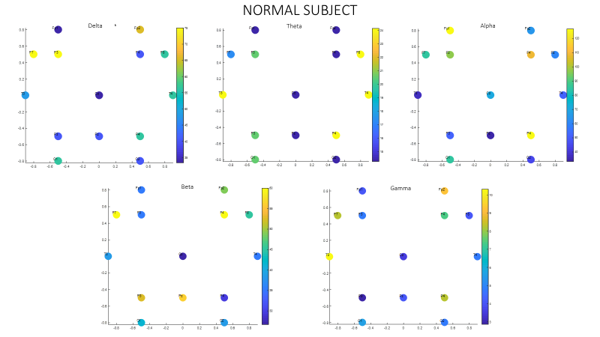
(a)
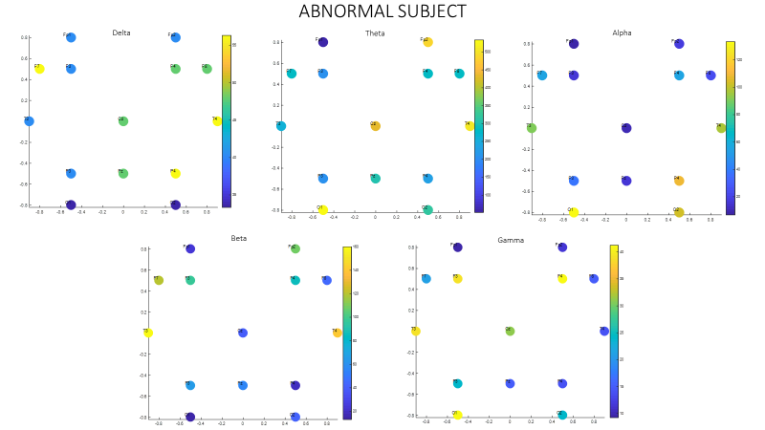
(b)
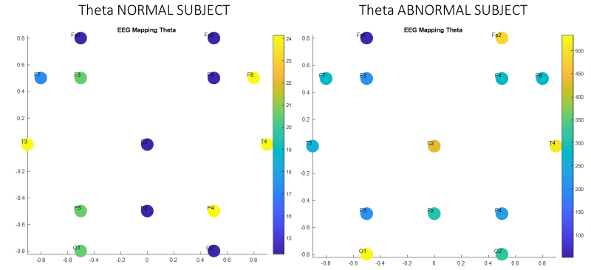
(c)
FIGURE 2. QEEG Mapping on (a) normal DASS result and (b) abnormal DASS result. (c) difference theta normal and abnormal subject

Additionally, this study identified a significant increase in wave activity in abnormal subjects, particularly in the temporal and frontal regions of the brain. This observation supports earlier research findings that link anxiety and stress to heightened activity in the hippocampus and amygdala—two regions of the brain that play crucial roles in the regulation of emotions and the stress response [13] [14] [15]. The hippocampus is involved in memory formation and the contextualization of emotional experiences, while the amygdala is central to the processing of fear and other emotions.
When these regions exhibit increased activity, it is often reflected in EEG recordings as heightened activity in the Temporal and Frontal channels. Specifically, the EEG channels corresponding to these areas include 'F7', 'F8', 'F3', 'F4', 'T3', and 'T4', with potential extensions into adjacent regions, such as FP1 and FP2. The increased activity in these channels is indicative of the brain's ongoing response to anxiety and stress, further reinforcing the connection between these mental health conditions and specific patterns of neural activity.
This enhanced understanding of the neural correlates of anxiety and stress has significant implications for both diagnosis and treatment. By identifying specific EEG patterns associated with these conditions, clinicians can develop more targeted interventions aimed at modulating brain activity in the affected regions. Moreover, this research paves the way for future studies to explore the potential of EEG as a biomarker for anxiety and stress, which could lead to earlier detection and more effective management of these widespread mental health issues.

CONCLUSIONS
This study concludes that subjects experiencing anxiety and stress exhibit a significant increase in the power spectrum within the Theta and Beta wave bands. This enhancement is particularly pronounced in specific brain regions, notably the temporal and frontal areas. The observed increase in power spectrum in these regions can be attributed to heightened activity in the hippocampus and amygdala—two critical structures within the brain that are intimately involved in the processing of stress and emotional responses.
The hippocampus plays a central role in memory formation and the contextualization of emotional experiences, while the amygdala is pivotal in the regulation of emotions, particularly fear and anxiety. When these brain regions become hyperactive due to stress and anxiety, the resulting neural activity is reflected in the EEG recordings as increased power in the Theta and Beta wave frequencies, specifically in the temporal and frontal channels.
This localization of increased activity in the temporal and frontal regions is consistent with the known neuroanatomy of the hippocampus and amygdala, which are situated in these areas. The temporal lobe, associated with processing sensory input and encoding memory, and the frontal lobe, involved in executive functions and emotional regulation, are thus critical regions where the impact of stress and anxiety can be detected through EEG analysis.
These findings underscore the importance of targeting the temporal and frontal regions in EEG studies of anxiety and stress. By focusing on these specific areas, researchers can gain deeper insights into the neural mechanisms underlying these conditions. Additionally, the study's results have potential implications for clinical practice, suggesting that EEG could be a valuable tool for identifying individuals at risk of anxiety and stress-related disorders by monitoring changes in Theta and Beta wave activity in these key brain regions.
In conclusion, the increase in the power spectrum of Theta and Beta waves in the temporal and frontal regions, as observed in this study, provides compelling evidence of the neural impact of anxiety and stress. These findings contribute to the growing body of research that seeks to map the neural correlates of mental health disorders and highlight the utility of EEG as a non-invasive method for assessing brain activity associated with emotional and psychological states.

Acknowledgments
This research was supported by grant funding from the Faculty of Engineering at the University of Muhammadiyah Malang. Additionally, this study was conducted in collaboration with the Pharmacy Study Program, Faculty of Public Health, Pharmacy, and Hospital Administration at STRADA Indonesia University.

References
1. Romeo, R.D., The impact of stress on the structure of the adolescent brain: Implications for adolescent mental health. Brain Research, 2017. 1654: p. 185-191.
2. Pfeifer, J.H. and N.B. Allen, The audacity of specificity: Moving adolescent developmental neuroscience towards more powerful scientific paradigms and translatable models. Developmental Cognitive Neuroscience, 2016. 17: p. 131-137.
3. Tee, Y.W. and S.A. Mohd Aris, Electroencephalogram (EEG) stress analysis on alpha/beta ratio and theta/beta ratio. Indonesian Journal of Electrical Engineering and Computer Science, 2020. 17: p. 175.
4. Marsidi, S.R., IDENTIFICATION OF STRESS, ANXIETY, AND DEPRESSION LEVELS OF STUDENTS IN PREPARATION FOR THE EXIT EXAM COMPETENCY TEST. Journal of Vocational Health Studies, 2021. 5(2): p. 87-93.
5. Micoulaud Franchi, J.-A., et al., EEG Neurofeedback for Anxiety Disorders and Post-Traumatic Stress Disorders: A Blueprint for a Promising Brain-Based Therapy. Current Psychiatry Reports, 2021. 23.
6. Glazebrook, A.A.-O., et al., Posttraumatic growth EEG neuromarkers: translational neural comparisons with resilience and PTSD in trauma-exposed healthy adults. Eur. J. Psychotraumatol, 2023. 14(2000-8066 (Electronic)).
7. Tottenham, N., Early Adversity and the Neotenous Human Brain. Biol. Psychiatry, 2020. 87(1873-2402 (Electronic)).
8. Hanson, J.L., A.R. Hariri, and D.E. Williamson, Blunted Ventral Striatum Development in Adolescence Reflects Emotional Neglect and Predicts Depressive Symptoms. Biol. Psychiatry, 2015. 78(1873-2402 (Electronic)): p. 598-605.
9. Hadiyoso, S., et al., Early Detection of Mild Cognitive Impairment Using Quantitative Analysis of EEG Signals. 2019. 1-5.
10. Martina Wiwie S. Nasrun, L.F.A.R.C., Nurhadi Ibrahim, Zenik Kusrini, Khamelia Malik, Wanarani Alwin, QEEG as a Novel Parameter of Neuroplasticity in Elderly with Mild Cognitive Impairment. Indonesian Journal of Electrical Engineering and Informatics (IJEEI), 2022. 10: p. 573-583.
11. Plucińska, R., et al., Impact of EEG Frequency Bands and Data Separation on the Performance of Person Verification Employing Neural Networks. LID - 10.3390/s22155529 [doi] LID - 5529. Sensors, 2022. 22(1424-8220 (Electronic)).
12. Chen, C.A.-O., et al., EEG-Based Anxious States Classification Using Affective BCI-Based Closed Neurofeedback System. J. Med. Biol. Eng. 41(1609-0985 (Print)).
13. McEwen, B.S., Brain on stress: how the social environment gets under the skin. Proc. Natl. Acad. Sci. U, 2012. 109(1091-6490 (Electronic)).
14. Hou, J., S. Liu, and G. van Wingen, Increased subcortical brain activity in anxious but not depressed individuals. J. Psychiatr. Res, 2023. 160(1879-1379 (Electronic)).
15. Ghasemi, M., et al., Anxiety and hippocampal neuronal activity: Relationship and potential mechanisms. Cogn. Affect. Behav. Neurosci, 2021. 22(1531-135X (Electronic)).

