Optimization of Reheat Turbine Frequency Control Using Moth Flame Optimization - PID and Derivative Error: ITAE Evaluation
Rio Irawan^{a)}, Ermanu Azizul Hakim^{b)}, and Haneef Nouval Alannibras Humaidi^{c)}
Electrical Engineering Department, University of Muhammadiyah Malang, Malang, Indonesia

^{b)} Corresponding author: ermanu@umm.ac.id
^{a)} rioirawan@webmail.umm.ac.id
^{c)} haneefnouval@umm.ac.id
Abstract. This study focuses on load frequency control in reheat turbine systems integrated with governor droop characteristics, faced with sudden load changes in generators that result in frequency deviations from the 50 Hz reference value. Significant frequency deviations that fail to return to the reference value can cause collapse or blackout in interconnected power systems. To address these frequency deviations, the use of a governor as a key component in Load Frequency Control (LFC) is crucial for maintaining frequency stability at set values. The implementation of a Proportional, Integral, and Derivative (PID) controller, optimized using the Moth Flame Optimization (MFO) method with an added derivative function, aims to accelerate the system’s response. This optimization results in an Integral Time Absolute Error (ITAE) of 0.00080, with a rise time of 0 seconds, overshoot of only 0.015%, undershoot of 1%, peak time of 0.15 seconds, and settling time of 2.95 seconds. Compared to methods without the derivative function, which have an ITAE of 0.0010, the addition of the derivative function has proven to enhance accuracy and efficiency in frequency control of reheat turbines.
Keywords: Reheat Turbine, Load Frequency Control, Moth Flame Optimization, PID, Governor, Integral Time Absolute Error.

INTRODUCTION
Electrical energy is an essential element in everyday life. The rapid development of technology and the economy encourages people's need for electrical energy. Therefore, the volume of power generation capacity needs to be increased to meet these needs [1]. Maintaining a balance between the power generated by the generator and the power demand at the load is crucial for the safe and sustainable operation of the power system [2],[3], [4], [5]. A significant power imbalance between the load demand power and the amount of power generated by the power plant is one of the causes of frequency instability. A sudden increase in load can decrease the frequency, while a sudden decrease in load will increase the frequency or where a power surplus will increase the frequency, while a power shortage will decrease the frequency [6], [7].
Large frequency deviations can lead to system instability, collapse, and blackouts [8]. For example, on August 9, 2019, a frequency disturbance in the UK caused power cuts for around 1.1 million customers [9]. Meanwhile, on August 15, 2017, the failure of six gas generating units at the Datan power plant in Taiwan resulted in the worst frequency drop in the last 20 years, affecting 17 cities and about 5.92 million customers [10] . Load Frequency Control (LFC) takes an important role in maintaining frequency stability at a predetermined value in each power system [11]. The governor is one of the power system's Load Frequency Control (LFC) components [12][13][14]. In the context of Load Frequency Control (LFC), the governor balances the turbine speed according to changes in the load [15]. The governor controls the position of a control valve or gate, which regulates the steam electric power plant [16]. The governor will respond to changes in frequency and keep the speed deviation at a reasonable level or a specified value [17]. The use of a governor as LFC without a controller has a slower response to errors than in some previous studies [18], [19], [20].
Proportional, Integral, and Derivative (PID) controllers significantly enhance system responsiveness. However, conventional PID control systems often fall short of optimal performance due to the high sensitivity of PID parameters affecting signal responses in complex situations. Additionally, conventional PID controllers lack flexibility as the parameters used cannot be altered in real-time, making it challenging to adjust to changes in operational conditions. In response, many researchers have developed modern variations of the classic PID algorithm to improve its adaptability [21].
Research by Amallynda and Hutama has proven the efficacy of Moth Flame Optimization (MFO) in solving Workflow Scheduling Problems with Travel Time [22]. Further, a study by Srimannarayana, Bhattacharya, and Sharma shows that MFO is more effective than the Crow Search Algorithm (CSA) and Whale Optimization Algorithm (WOA) in optimizing PID controller settings for managing microgrid frequency, considering the uncertainties of renewable energy sources[23].
Although Moth Flame Optimization (MFO) has proven effective in addressing complex issues, there remains significant room for enhancement, particularly in contexts that require high sensitivity to PID parameters. One proposed improvement is the integration of a derivative function into MFO, aimed at reducing error values before the objective function is calculated in each iteration. The implementation of the derivative function, as evidenced by Hakim and Setyawan in "Hybrid Fuzzy-PID Design Based on Flower Pollination Algorithm for Frequency Control of Micro-Hydro Power Plant," uses the derivative function to refine inputs at each iteration of the fuzzy algorithm, which has been shown to enhance control effectiveness [24]. Given the substantial impact of PID parameters on signal response in turbine load frequency control, this research aims to implement the derivative function that will reduce error values in the circuit output before evaluation by the objective function, namely Integral Time Absolute Error (ITAE), in each iteration process. With this approach, it is expected that the PID Load Frequency Control system for reheat turbines can operate with faster and more efficient responses.

METHODS

MODELING ISOCHRONOUS GOVERNOR SYSTEM
In FIGURE 1, the scheme of the isynchronous governor system is shown, where the measured rotor speed 𝜔𝑟 is compared with the reference speed 𝜔0. The error signal (speed deviation) is amplified and integrated to produce the control signal ∆𝑌, which will control the steam supply valve on the steam turbine. The reset action of the integral controller, ∆𝑌, will reach a new steady state only when the speed error Δ𝜔𝑟 is zero [25].

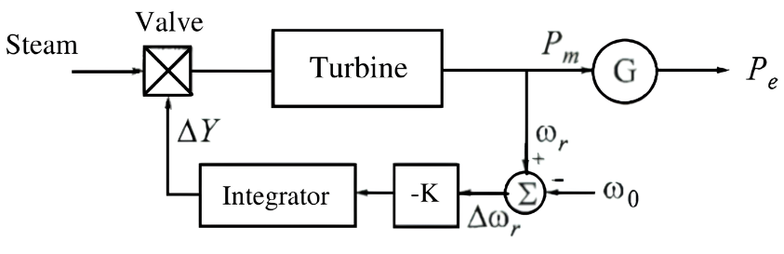
FIGURE 1. Schematic of Governor System

However, for situations where more than one generator is connected to the same grid, an isochronous governor is inadequate as each unit tends to operate at different frequencies. Thus, this triggers the development of steady-state feedback governors that introduce governor systems with speed-drop characteristics to manage load differences more effectively, as shown in FIGURE 2.

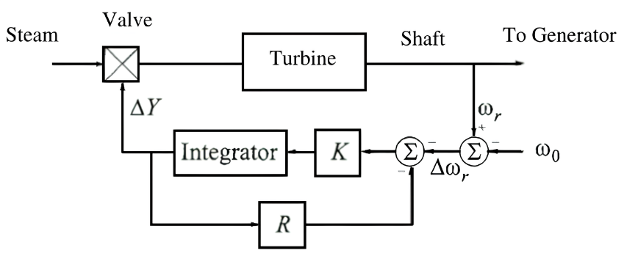
FIGURE 2. Governor System with Steady State Feedback

FIGURE 2 shows a governor with speed-drop characteristics. The system can be simplified into the diagrams in Figures 3 and 4 using a proportional controller with a gain of 1/R [25].
The researcher will implement this governor system model on the reheat turbine model, as shown in FIGURE 5.
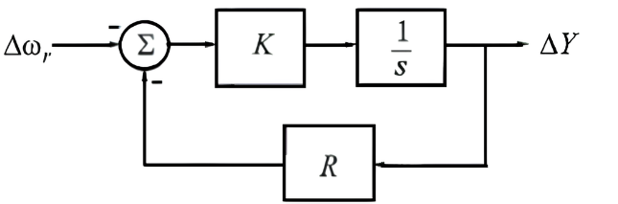
FIGURE 3. Schematic Diagram with Steady State Feedback

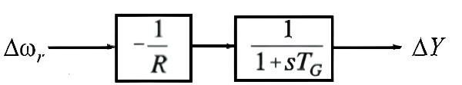
FIGURE 4. Simplified Schematic Diagram

MODELING OF A REHEAT TURBINE SYSTEM WITH GOVERNOR DROOP CHARACTERISTICS

In FIGURE 5, researchers display the modeling of a reheat turbine equipped with a droop characteristic governor system model as designed in FIGURE 4. FIGURE 5 includes representations of the governor with droop characteristics, reheat turbine, rotating mass, and load, which are ideal for analysis in the context of load-frequency. The transfer function for this turbine has been simplified based on the reheat turbine model, assuming that the boiler pressure remains constant. Researchers also provide a turbine power value of 100 MW. Knowing the frequency value at steady state in Hz can be represented in equation (1).

$$f_{actual}=f_{original}+ Δf_{actual}$$ | (1)

Meanwhile, the frequency deviation value can be calculated using equation (2).

$${Δf}_{actual}={Δf}_{pu} × f_{base}$$ | (2)

From equations (1) and (2), the modelling is then connected to the reheat turbine system modelling, which determines the frequency value at steady state in Hz units, as seen in FIGURE 5.

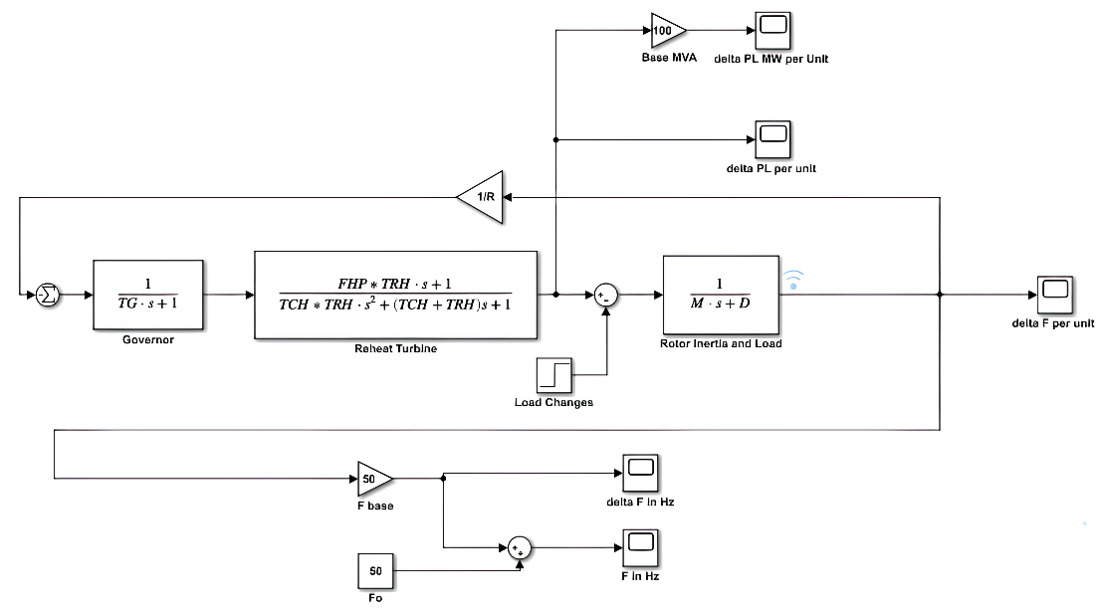
FIGURE 5. Turbine Reheat System

The reheat turbine system in FIGURE 5 is developed with the addition of a PID controller. The PID controller has 3 main parameters, namely proportional control (KP), integral control (KI), and derivative control (KD), as shown in FIGURE 6.

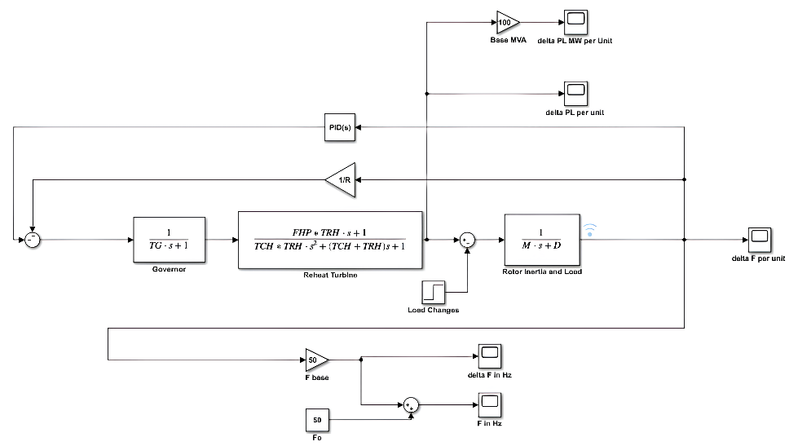

FIGURE 6. Turbine Reheat System Integrated Governor Droop Characteristics with PID Controller

The parameters Kp, Ki, and Kd for the PID controller will be determined using the moth flame optimization method with the addition of a derivative function to the objective function ITAE, which will then be compared with a reheat turbine system without PID, with PID (parameter values for Kp, Ki, Kd determined by trial and error), and PID with MFO (Moth Flame Optimization) without the derivative function. The scheme for implementing the optimization method on the PID controller in the reheat turbine system integrated with droop characteristic governor can be seen in FIGURE 7.
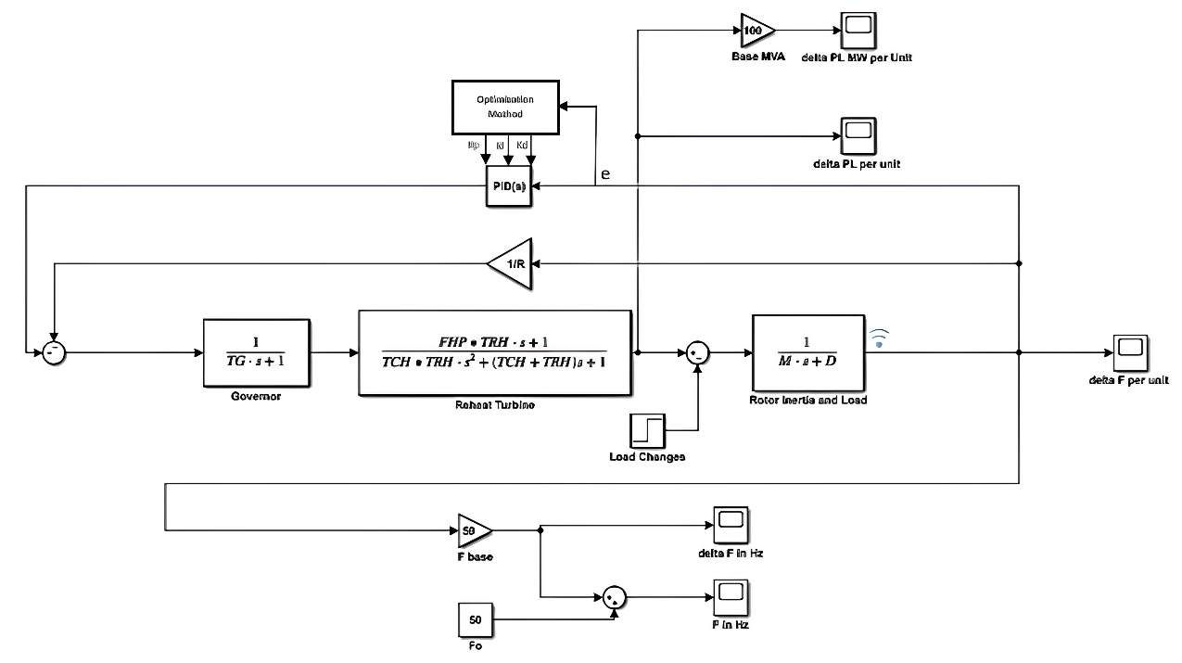
FIGURE 7. Reheat Turbine System Integrated Governor Droop Characteristics with Optimisation Method on PID

The researcher set the speed regulation constant R set at 0.05. The governor time constant TG is set at 0.2. Then, in the turbine reheat system with the Fraction parameter, the total power generated by Section High-Pressure FHP is 0.3, while for Section Low-Pressure FLP is 0.7, and the reheater time constant TRH is set at 7. In addition, in the Simulink system simulation in the rotor and load inertia system block, the inertia constant M is given a value of 10, the damping coefficient D is 1, the power on the turbine is 100 megawatts with a sudden load change ΔPL, which is 0.2 of the power on the turbine, and the frequency is 50 Hz. All these parameters can be seen in TABLE 1.

TABLE 1. Parameters of Reheat Turbine System with Governor
Parameter | Unit | Value
R | Speed Regulation Constant | 0.05
TG | Time Constant Governor (s) | 0.2
FHP | Fraction of turbine torque | 0.3
TRH | Time Constant Reheater (s) | 7
TCH | Time Constant Steam Chest Time (s) | 0.3
FLP | Fraction of Total Power from LP Section | 0.7
M | Rotational Inertia Constant (s) | 10
D | Damping Coefficient | 1
ΔPL | Load Change (pu) | 0.2
f | Frequency (Hz) | 50
 | Turbine Rate Power (MW) | 100

The researcher integrated a derivative function at the output of the induction generator to reduce the resulting error signal. As seen in FIGURE 8, the goal is to optimize the reduction of error changes over time by applying derivative functions.
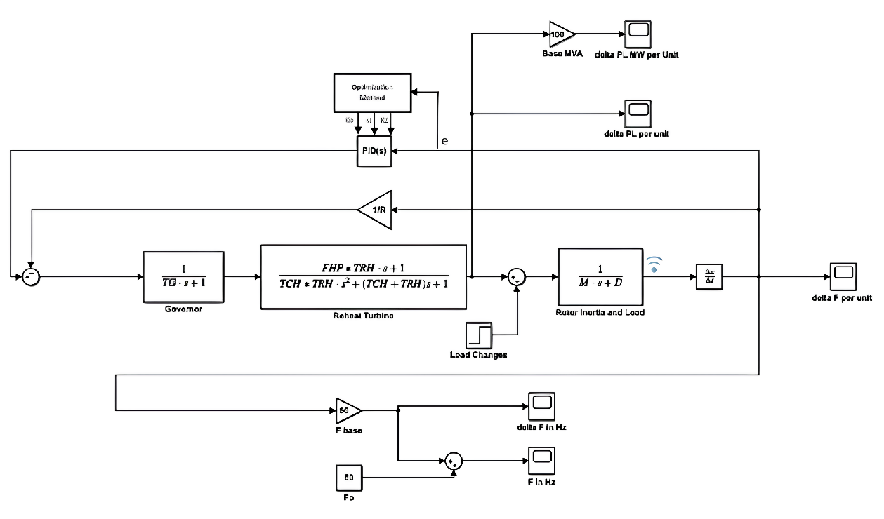
FIGURE 8. Derivative Function Addition of Reheat Turbine System Integrated Governor Droop Characteristics

MOTH FLAME OPTIMIZATION (MFO)
The Moth-Flame Optimization (MFO) method, inspired by the moth's navigation method known as transverse orientation, where moths fly straight at night by maintaining a constant angle relative to the moon. Although effective, moths often fall into pointless and dangerous spiral trajectories near artificial lights. This algorithm, developed by Seyedali Mirjalili, has been tested through 29 benchmark functions and 7 real engineering problems, demonstrating promising and competitive results [26]. Based on its effectiveness, this study will adopt the Moth-Flame Optimization (MFO) technique to optimize the parameter search process for the PID controller in the LFC system of a reheat turbine with a Governor.
The Moth-Flame Optimization (MFO) algorithm treats moths as candidate solutions and their positions in space as problem variables [26]. Based on this adapted model, moths can change their positions in one-dimensional (1-D), two-dimensional (2-D), three-dimensional (3-D), or even in hyperdimensional spaces. This group of moths is then represented in a matrix format as follows.

$$M=\left[\begin{matrix}m_{1,1} & m_{1,2} & \begin{matrix}… & m_{1,d}\end{matrix} \\ m_{2,1} & m_{2,2} & \begin{matrix}… & m_{2,d}\end{matrix} \\ \begin{matrix}\begin{matrix}… \\ …\end{matrix} \\ m_{n,1}\end{matrix} & \begin{matrix}\begin{matrix}… \\ …\end{matrix} \\ m_{n,2}\end{matrix} & \begin{matrix}\begin{matrix}… \\ … \\ …\end{matrix} & \begin{matrix}\begin{matrix}… \\ …\end{matrix} \\ m_{n,d}\end{matrix}\end{matrix}\end{matrix}\right]$$ | (4)

Then, for each moth, it is assumed that there is an array used to store the corresponding fitness value for each moth which can be seen in the equation (5).

$$OM= \left[\begin{matrix}{OM}_{1} \\ {OM}_{2} \\ \begin{matrix}⋯ \\ \begin{matrix}⋯ \\ {OM}_{n}\end{matrix}\end{matrix}\end{matrix}\right]$$ | (5)

The fitness value of the moths is calculated from the fitness function based on their position, which is represented in the matrix M. The result of the fitness function, such as OM1 in the matrix OM, indicates the fitness of the moths. Another critical component in this algorithm is flames, represented in a matrix in equation (6).

$$F=\left[\begin{matrix}f_{1,1} & f_{1,2} & \begin{matrix}… & f_{1,d}\end{matrix} \\ f_{2,1} & f_{2,2} & \begin{matrix}… & f_{2,d}\end{matrix} \\ \begin{matrix}\begin{matrix}… \\ …\end{matrix} \\ f_{n,1}\end{matrix} & \begin{matrix}\begin{matrix}… \\ …\end{matrix} \\ f_{n,2}\end{matrix} & \begin{matrix}\begin{matrix}… \\ … \\ …\end{matrix} & \begin{matrix}\begin{matrix}… \\ …\end{matrix} \\ f_{n,d}\end{matrix}\end{matrix}\end{matrix}\right]$$ | (6)

The dimensions of the M and F arrays are similar, as can be seen between equations (3) and (5). Thus, in flame, it is assumed that there is an array to store the fitness value, which can be seen in equation (7).

$$OF= \left[\begin{matrix}{OF}_{1} \\ {OF}_{2} \\ \begin{matrix}⋯ \\ \begin{matrix}⋯ \\ {OF}_{n}\end{matrix}\end{matrix}\end{matrix}\right]$$ | (7)

Moth and flame have the same goal, which is a solution. The difference between the two is how to treat and update each iteration. The moth is used as an agent that moves around the search space, while the flame is the best position of the best acquisition generated by the moth when searching the search space. Therefore, each moth will search around the flag (flame) and update its position if it finds a better solution. With this process, the moth will always take advantage of the best solution [26].
The MFO algorithm is formulated as a triple-tuple, which means it consists of three main components or functions that work together to approximate the global optimal solution of the optimization problem. In general form, this triple can be seen in Equation (8).

$$MFO=(I,P,T)$$ | (8)

The I function generates a random population of moths and corresponding fitness values. This model can be seen in equation (9).

$$I : ∅ →\{M , OM\}$$ | (9)

P is the primary function that moves the moth in the search space. It takes a matrix M (which contains the moth's position) as input and returns an updated matrix with the new position. The function can be modelled as in equation (10).

$$P : M→M$$ | (10)

The T function will return a true value if the termination criteria have been reached and a false value if the termination criteria have not been reached, as in equation (11).

$$T : M→\{ true,false\}$$ | (11)

In the MFO algorithm, there are two other arrays called upper bound (ub) and lower bound (lb). These matrices define a variable's upper and lower bounds, which can be defined in equations (12) and (13).

$$ub=( {ub}_{1},{ub}_{2},{ub}_{3}⋯,⋯, ⋯, {ub}_{n-1},{ub}_{n}$$ | (12)

$$lb=( {lb}_{1},{lb}_{2},{lb}_{3}⋯,⋯, ⋯, {lb}_{n-1},{lb}_{n}$$ | (13)

After the initialization process, the moth's position is updated through interaction with an entity called "flame", which can be considered a representation of the optimal local solution that the moth needs to pursue. Function P governs this process and is executed repeatedly until function T indicates a stopping criterion has been reached. The inspiration for this update mechanism is taken from transverse orientation, a navigation method used by moths to fly towards light sources, which is adapted to direct movement in this algorithm.
Each moth position update can be represented by the equation (13).

$$M_{i}=S ( M_{i}, F_{j })$$ | (13)

The moth position update in the Moth-Flame Optimization (MFO) algorithm is governed by a logarithmic spiral equation. This equation simulates the flight pattern of moths circling the "flame" (considered as the optimal local solution) in an attempt to reach the optimal global solution, which can be represented in equation (14).

$$S\left(M_{i}, F_{j }\right)=D_{i} . e^{bt} . \cos\left(2πt\right)+F_{j}$$ | (14)

The distance $D_{i}$between the moth and the flame is calculated using the equation (15).

$$D_{i}=| F_{j }- M_{i}|$$ | (15)

The number of flames available in the search is reset via equation (16) at the beginning of each iteration of the Moth-Flame Optimization (MFO) algorithm.

$$flame no=round \left(N-l*\frac{N-1}{T}\right)$$ | (16)

Reducing the number of flames in the Moth-Flame Optimization (MFO) algorithm is necessary because gradually reducing the number of flames allows the algorithm to focus more on high-potential search areas, which in turn speeds up convergence and reduces computation time. This reduction is carried out at the beginning of each iteration to ensure that the focus on the most high-potential solutions is continuously updated as the algorithm progresses. This improves efficiency in finding the optimal solution by reducing the impact of less effective solutions.
The final stage of optimisation with the MFO algorithm in this study involves updating and reporting the best solution found. This stage involves recording the score and the best achieved "flame" position, which is identified through the objective function as the primary performance index. Next, updates are made to the PID control parameters, namely kp, ki, and kd, based on the optimal position obtained. The parameters used by the researcher can be seen in TABLE 2.

TABLE 2. MFO Method Parameters
Parameter | Value
Number of Agents | 100
Maximum Iterations | 20
Lower Bound | [0, 0, 0]
Upper Bound | [600, 600, 600]
Dimensions | 3
Objective Function | ITAE
Spiral Coefficient a | -1 to -2
Spiral Coefficient b | 1
Random Coefficient t | (a - 1) * rand + 1

DESIGN OF THE OBJECTIVE FUNCTION
Objective function selection is an important aspect in optimization problems. It serves as the initial stage to perform synthesis in the spiral system approach and has a significant role as a tool for system analysis and modelling [27]. The quality and speed of each optimization also depend on each objective function used as a working index [28]. Researcher use the Integral of Time-Absolute Error (ITAE) as in equation (17).

$$ITAE=\int_{0}^{∞}{t|e\left(t\right)dt}$$ | (17)

RESULTS AND DISCUSSION
FIGURE 9 shows the frequency response of the reheat turbine system when given a load change of 10% or 0.1 of the generator's power capacity.

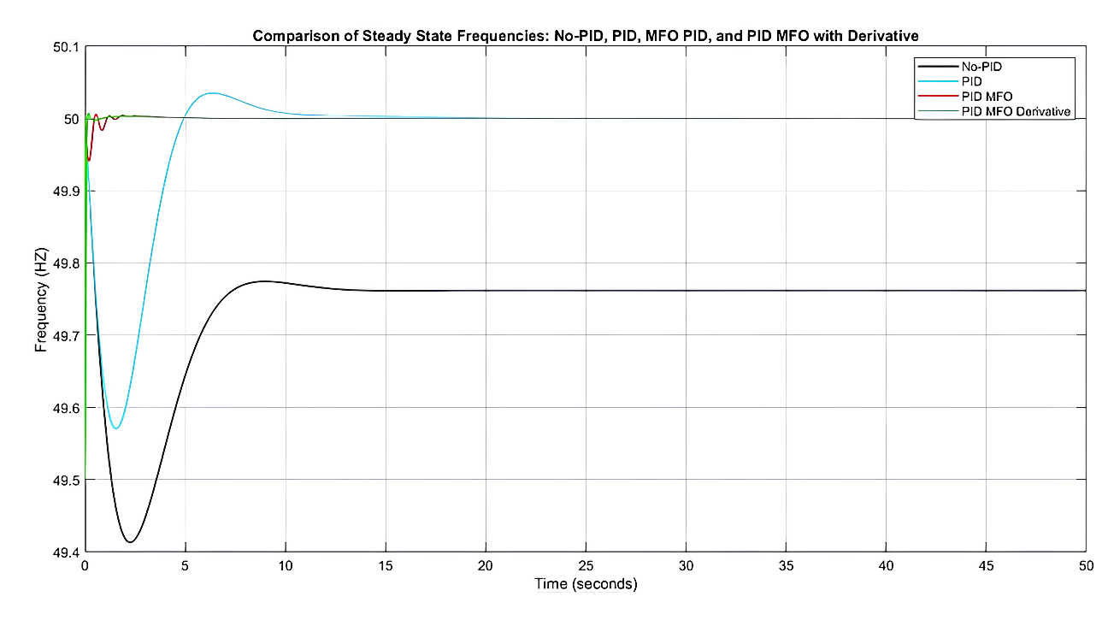
FIGURE 9. Comparison of Frequency Response of Reheat Turbine

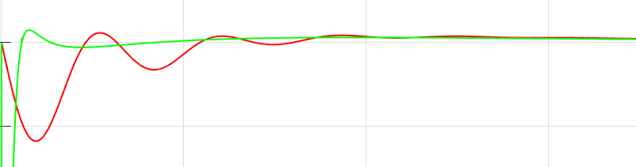
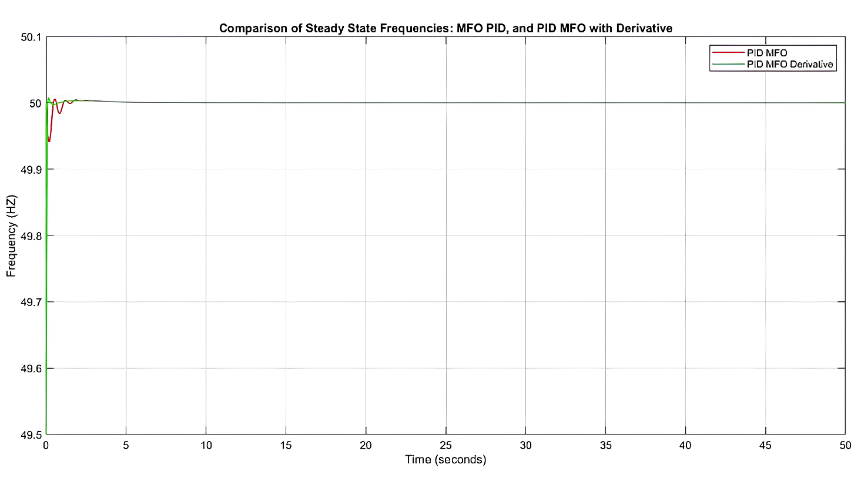
FIGURE 10. Comparison of Frequency Response of Reheat Turbine between PID MFO and Derivative PID MFO

TABLE 3. Experimental Results of Frequency Response of Reheat Turbine
Controler | Rise Time (s) | Over Shoot (%) | Under Shoot (%) | Peak Time (s) | Settling Time (s) | ITAE
Without PID | 0.38 | - | 1.17 | 2.16 | - | 6.016
PID (trial error) | 1.22 | 0.07 | 0.85 | 6.36 | 17.43 | 0.074
PID MFO | 3.9 | 0.011 | 0.11 | 0.54 | 7.80 | 0.0010
PID MFO Derivatives | 0 | 0.015 | 1 | 0.15 | 2.95 | 0.00080

It can be seen in TABLE 3 and FIGURE 9 that the PID MFO integrated derivative function has a higher undershoot than other methods that have controllers, which is 1%, but the PID MFO integrated derivative function can reduce the rise time very quickly with a value of almost 0 (s). The overshoot value reaches 0.015% with a settling time of 2.95 (s). Furthermore, the Integral Time Absolute Error (ITAE) value is the lowest among all tested methods at 0.00080, indicating the high efficiency of this method. ITAE is used as a performance index for reheat turbine system evaluation, indicating that with the integration of derivative functions, the system has a deficient error during operation.
FIGURE 10 shows the difference between the PID MFO with and without a derivative function in more detail. The figure shows that integrating the derivative function in the PID MFO can improve the frequency response of the reheat turbine system better than the PID MFO without the derivative function.

ΔPL Response to Load Change on Generator
FIGURE 11 shows the response of the load change signal, measured in megawatts (MW). Meanwhile, FIGURE 12 illustrates the results of the load change signal per unit (pu) on the generator, with a change of 10% or 0.1 pu of the 100 MW turbine system. This analysis includes the condition without a controller, with a PID controller whose optimization parameters are obtained through the trial error method, PID MFO, and PID MFO integrated derivative function.
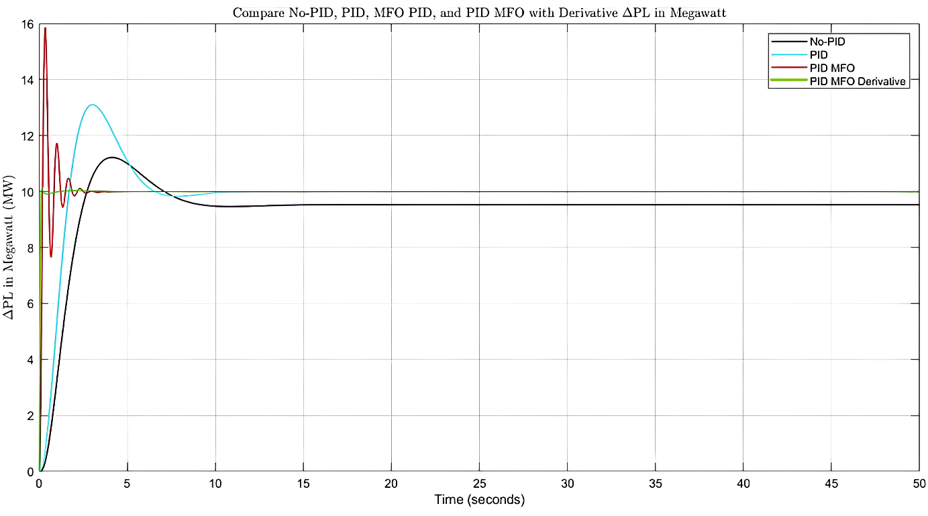
FIGURE 11. Comparison of Load Change Response in MW for Various Controller Configurations

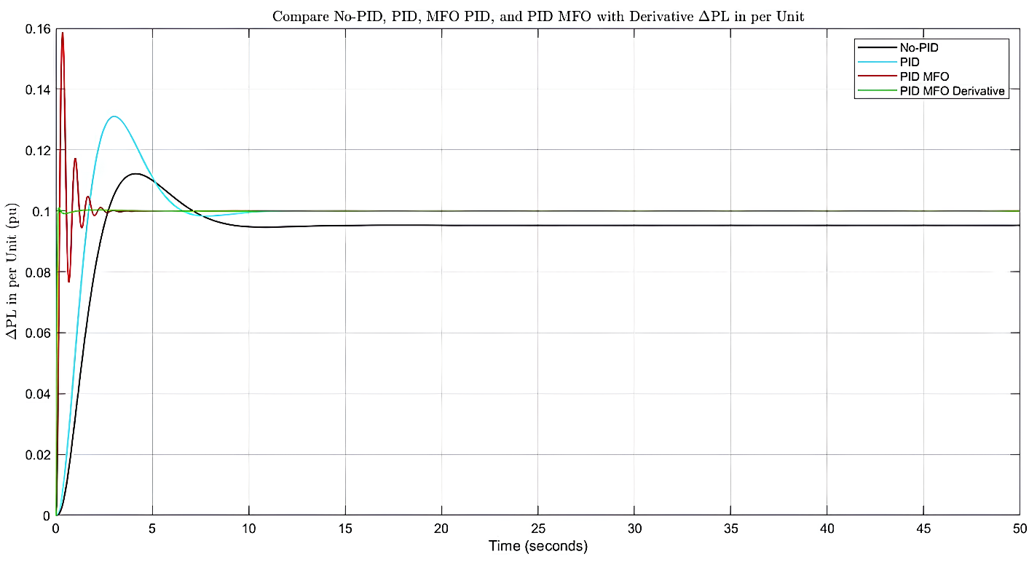
FIGURE 12. Comparison of Load Change Signal Responses per Unit for Various Controller Configurations

TABLE 4. Experimental Results of Load Change Signal Response on Generator
Controler | Rise Time (s) | Over Shoot (%) | Under Shoot (%) | Peak Time (s) | Settling Time (s)
Without PID | 1.76 | 12.18 | 0 | 4.13 | nan
PID (trial eror) | 1.12 | 30.99 | 0 | 3.02 | 17.43
PID MFO | 0.12 | 58.62 | 0 | 0.34 | 1.799
PID MFO Derivative | 0.062 | 1.139 | 0 | 0.15 | 0.099

FIGURE 11, FIGURE 12, and TABLE 4 show that the PID MFO integrated with the derivative function shows excellent performance, with a rise time of only 0.062 seconds, an overshoot of 1.139%, an undershoot of 0%, and a very fast settling time of 0.099 seconds. This configuration shows superior results compared to other controller methods.
Frequency changes have a direct effect on the load change value. If the frequency cannot recover to the reference value, the load change, which should reach 10% or 0.1 of the generator's nominal power, will not be achieved. With the PID MFO controller integrated with the derivative function, the generator system can quickly stabilize at the targeted load change value, which is 10% of the nominal power of 100 MW, or about 10 MW.

CONCLUSIONS
Testing and simulation have been conducted using Moth Flame Optimization (MFO) integrated with a derivative function to control frequency in the reheat turbine system. The results demonstrate that the integration of the derivative function, used to reduce output error before calculating the Integral Time Absolute Error (ITAE) as the objective function, provides excellent frequency response. This optimization achieved an ITAE value of 0.00080, with a rise time of 0 seconds, overshoot of only 0.015%, undershoot of 1%, peak time of 0.15 seconds, and settling time of 2.95 seconds.
Further observations indicate that if the frequency can recover quickly and efficiently, the expected load change target can be achieved. Conversely, a failure in frequency recovery, as in this case with a target load change of 10 MW, will result in a load change that does not reach the expected value. The MFO PID optimization integrated with a derivative function shows significant performance improvements in accelerating rise time, peak time, and settling time in frequency response, as well as in load change signals, better than other control methods. This performance is also reflected in the lowest ITAE value compared to other control methods.

Acknowledgments
Our deepest gratitude goes to Mr. Ermanu Azizul Hakim for his valuable guidance and support during this research process. We would also like to thank Universitas Muhammadiyah Malang for the facilities and support provided, which immensely helped develop this research. We hope that the results of this research can contribute significantly to the advancement of technology in Indonesia, especially in power systems.

References
1. M. Shewarega and A. Ismail, “Digital load frequency control,” 6th IEEE International Energy Conference, ENERGYCon 2020, pp. 939–944, 2020.
2. I. B. Sulistiawati, A. D. Priasmoro, A. Lomi, and A. Priyadi, “Study of static under frequency load shedding on IEEE 3 generators 9 bus system caused of transient condition,” Journal of Telecommunication, Electronic and Computer Engineering, vol. 10, no. 2–3, pp. 37–42, 2018.
3. S. Javaid, M. Kaneko, and Y. Tan, “System Condition for Power Balancing between Fluctuating and Controllable Devices and Optimizing Storage Sizes,” Energies, vol. 15, no. 3, 2022.
4. A. B. Kunya, M. Argin, and S. Kucuksari, “Optimal Load Frequency Control of Multi-Area Power System Considering Incremental Control Action,” in 2019 IEEE Texas Power and Energy Conference (TPEC), pp. 1–6, 2019.
5. C. Power and P. Generators, “Safe Operation Conditions of Electrical Power System,” pp. 1–27, 2021.
6. S. M. Younus, A. Ghani, A. Razzaq, A. Ghafour, and O. S. Al-deen, “Exploring the Impact of Frequency Deviation Due to Generation Loss or Overload Situation on the Standard Electrical Power System,” International Journal of Advanced Natural Sciences and Engineering Researches, pp. 593–600, 2023.
7. B. Anderson, J. Reilly, V. Krishnan, B. Anderson, J. Reilly, and V. Krishnan, “Load Control for Frequency Response – A Literature Review,” no. NREL/TP-5000-77780, 2022.
8. T. Kerdphol, F. S. Rahman, M. Watanabe, and Y. Mitani, “Fundamental Concepts of Inertia Power Compensation and Frequency Control BT - Virtual Inertia Synthesis and Control,” T. Kerdphol, F. S. Rahman, M. Watanabe, and Y. Mitani, Eds., Cham: Springer International Publishing, pp. 13–59, 2021.
9. C. MacIver, K. Bell, and M. Nedd, “An analysis of the August 9th 2019 GB transmission system frequency incident,” Electric Power Systems Research, vol. 199, p. 107444, 2021.
10. H. Hui, Y. Ding, K. Luan, and D. Xu, “Analysis of ‘8•15’ Blackout in Taiwan and the Improvement Method of Contingency Reserve Capacity Through Direct Load Control,” in 2018 IEEE Power & Energy Society General Meeting (PESGM), 2018, pp. 1–5.
11. A. Gupta and A. Sikander, “Performance Evaluation of Controller for Load Frequency Control in Power System,” Apr. 2018.
12. D. M. Andrade, S. Gamboa, and J. A. Torres, “Distributed Load-Frequency Control in Power Systems,” in 2020 IEEE ANDESCON, pp. 1–6, 2020.
13. G. Made, N. Christy, I. N. Suweden, and I. M. Mataram, “Studi Analisis Governor sebagai Load Frequency Control pada PLTG menggunakan Fuzzy Logic Controller,” vol. 17, no. 1, 2018.
14. D. Lastomo, Widodo, H. Setiadi, and M. R. Djalal, “Enabling PID and SSSC for load frequency control using Particle Swarm Optimization,” in 2017 3rd International Conference on Science in Information Technology (ICSITech), pp. 182–187, 2017.
15. D. F. Uman Putra, A. Akbar Firdaus, H. Arof, N. P. Uman Putra, and V. Andria Kusuma, “Improved load frequency control performance by tuning parameters of PID controller and BESS using Bat algorithm,” Bulletin of Electrical Engineering and Informatics, vol. 12, no. 5, pp. 2624–2634, 2023.
16. B. P. Ayyappan and R. Kanimozhi, “An Investigative Study of Generator-Load Tie-Line Model of Speed Governing System and Overview of Design of Conventional Controllers for LFC of Electrical Power Systems,” no. June, pp. 1470–1476, 2019.
17. R. Khalili, H. Rabieyan, A. Khodadadi, B. Zaker, M. Karrari, and S. Karrari, “Mathematical Modelling and Parameter Estimation of an Industrial Steam Turbine-Generator Based on Operational Data,” IFAC-PapersOnLine, vol. 51, pp. 214–219, Jan. 2018.
18. B. B. Wicaksono and T. Wati, “Load Frequency Control in Single-Area Power System Using Integral Control and Proportional Integral,” vol. 2, no. 1, pp. 7–10, 2020.
19. N. A. Karim, “Analisis Pengoperasian Governor Sebagai Pengatur Kestabilan Frekuensi Pada PLTU Mamuju 2 x 25 MW,” no. September, pp. 147–151, 2021.
20. S. Rupatharani and S. Selvakumari, “Load Frequency Control of Multi-Area Power Systems using Genetic Algorithm,” pp. 1–7, 2015.
21. J. Li, W. Li, H. Liang, and L. Kong, “Review of Research on Improved PID Control in Electro-hydraulic Servo System,” 2024.
22. I. Amallynda and B. Hutama, “The Moth-Flame Optimization Algorithm for Flow Shop Scheduling Problem with Travel Time,” Jurnal Teknik Industri, vol. 22, no. 2, pp. 224–235, 2021.
23. P. Srimannarayana, A. Bhattacharya, and S. Sharma, “Load Frequency Control of Microgrid Considering Renewable Source Uncertainties,” 7th IEEE International Conference on Computation of Power, Energy, Information and Communication, ICCPEIC 2018, pp. 419–423, 2018.
24. E. A. Hakim and N. Setyawan, “Hybrid fuzzy-PID design based on flower pollination algorithm for frequency control of micro-hydro power plant,” vol. 4, no. 2, 2024.
25. P. S. Kundur and O. P. Malik, “Chapter Preliminaries,” in Power System Stability and Control, 2nd Editio., New York: McGraw-Hill Education, 2022.
26. S. Mirjalili, “Moth-Flame Optimization Algorithm : A Novel Nature-inspired Heuristic Paradigm,” KNOWLEDGE-BASED SYSTEMS, no. July, 2015.
27. R. Funaki and J. Murata, “Estimation of Objective Functions: Modeling of Problems and Understanding of Decision-Making Processes Towards the Spiral-up Systems Approach BT - Innovative Systems Approach for Facilitating Smarter World,” T. Kaihara, H. Kita, S. Takahashi, and M. Funabashi, Eds., Singapore: Springer Nature Singapore, pp. 101–109, 2023.
28. S. M. H. Mousakazemi, “Comparison of the error-integral performance indexes in a GA-tuned PID controlling system of a PWR-type nuclear reactor point-kinetics model,” Progress in Nuclear Energy, vol. 132, p. 103604, 2021.

