Design and Development of a Boost Converter Using Pulse Frequency Modulation in Wheeled Soccer Robots
Adhitya Ramadhani^{a)}, Khusnul Hidayat^{b)}, and Nur Alif Mardiyah^{c)}
Department of Electrical Engineering, University of Muhammadiyah Malang, Malang, Indonesia.

^{b)} Corresponding author: khusnulhidayat@umm.ac.id
^{a)} ramateumm@gmail.com
^{c)} nuralif@umm.ac.id
Abstract. The development of technology, particularly in the realm of power electronics, has led to the innovation of high-efficiency DC-DC boost converters. This study presents the design and implementation of a boost converter using Pulse Frequency Modulation (PFM) methodology, tailored specifically for wheeled soccer robots. The converter is engineered to efficiently elevate the voltage from a low-level input to a higher, stable output, crucial for the performance of the robot's electrical components, particularly in powering the solenoid actuators used for kicking. The experimental results demonstrate the converter's capability to achieve rapid voltage increments, accompanied by a noticeable reduction in the time required to reach higher output voltages. The study underscores the importance of the PFM technique in optimizing the energy use in soccer robots, thereby enhancing their operational efficiency and responsiveness in competitive settings.
Keywords: DC-DC Boost Converter, Pulse Frequency Modulation (PFM), Wheeled Soccer Robots, Power Electronics

INTRODUCTION
The development of technology, components, and electronic circuits has led to the creation of direct current (DC) power supply systems that convert input DC voltage into another form of DC voltage. Classical isolated power converter topologies, such as flyback or push-pull converters, can easily achieve the high gain required by adjusting the transformer winding turns ratio [1], [2]. However, to address the issue of high voltage spikes observed by the primary switch during turn-off (due to leakage inductance), a snubber is typically needed. Non-isolated topologies, such as activated capacitors, voltage multiplier cells, and voltage-boosting circuits, all require more complex control strategies and multiple cells to achieve high voltage conversion ratios, usually resulting in a complex structure. A common alternative technique is to use coupled inductors to increase voltage gain in non-isolated DC-DC converters [3-5]. Coupled inductor boost converters can provide high voltage gain without extreme duty cycle operation, with a relatively simple topology. As a result, they can reduce switch voltage stress and allow the use of low-voltage, high-performance semiconductor devices [6].
One of the main challenges in using boost converters in soccer robots is power efficiency. Soccer robots often operate in competitive environments where speed and responsiveness are crucial, so every watt used must be optimized to maximize performance. Efficient use of boost converters is essential to ensure that the energy stored in the battery is used as effectively as possible, reducing excess heat and extending the robot's operational duration during matches. Besides efficiency, the stability of the output voltage from the boost converter is also crucial in soccer robot applications. Voltage fluctuations can cause disruptions in sensors and control modules, which can affect the robot's overall performance.
Pulse-frequency modulation (PFM) is an effective control method for boost DC-DC converters, offering high efficiency and improved performance. PFM-controlled boost converters operating in discontinuous conduction mode (DCM) demonstrate lower power consumption, higher efficiency, and better regulation [6]. Analysis of PFM mode boost regulators reveals relationships between operating efficiency, mode of operation, and maximum load capacity [7].
The presence of non-isolated DC switching topologies has led to research focusing on using the PFM method to control the switching of MOSFETs to increase voltage and achieve effective, efficient, and stable performance suitable for soccer robots. Therefore, this advantage can be applied to wheeled soccer robots as a power supply controller for the solenoid, which functions as the trigger for the kicker or ball kicker in the robot.

METHODS
DC-DC boost converter is a converter that is used to increase the voltage. With the help of this converter, which was originally a low-level voltage can be increased to a higher-level output voltage [8-10]. FIGURE 1 is a DC-DC boost converter circuit.
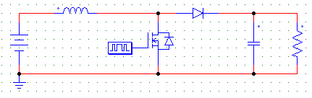
FIGURE 1. DC-DC boost converter circuits

The research method used by the author is based on an experimental approach to the design and development of a boost converter capacitor charger as a power supply for the solenoid in a wheeled soccer robot. To determine the specifications of the circuit used in the simulation, component parameter calculations are required. In this case, the calculation of the component parameters for the boost converter circuit is based is based on Equation 1 [10]:
$D=1-\frac{V_{o}}{V_{1}}$ (1)

The inductor used is a solenoid inductor made from copper wire wound around a ferrite core. The inductance can be calculated using Equation 2 [10]:
$L_{c}=\frac{{{D (1-D)}^{2}R}_{o}}{2.fs}$ (2)
The capacitor functions as a filter to limit the voltage ripple at the converter's output. The capacitor used in the design of this boost converter has a specific capacitance. The capacitance value can be calculated using Equation 3 [10]:
$C=\frac{D}{R_{o }.fs (\frac{{∆V}_{o }}{V_{o }})}$ (3)

Here’s a brief explanation of each component used in a boost converter:
- Buck Converter as Supply to PFM Generator: A buck converter reduces the input voltage to a lower, stable level to power the PFM generator, ensuring consistent control signals.
- PFM Generator and Control: The PFM generator adjusts the frequency of the switching signal to regulate the output voltage while maintaining high efficiency.
- Inductor: The inductor stores energy in a magnetic field when current flows through it, then releases this energy to boost the voltage when the switch is off.
- MOSFET: The MOSFET acts as a high-speed electronic switch that controls the flow of current through the inductor, enabling the voltage boost.
- Capacitor: The capacitor smooths out voltage fluctuations at the output by storing and releasing energy, reducing ripple in the output voltage.
- Diode: The diode directs current flow in one direction, preventing backflow and ensuring that energy stored in the inductor is transferred to the output when the MOSFET is off.

in FIGURE 2 is the schematic of the Boost Converter circuit that was created

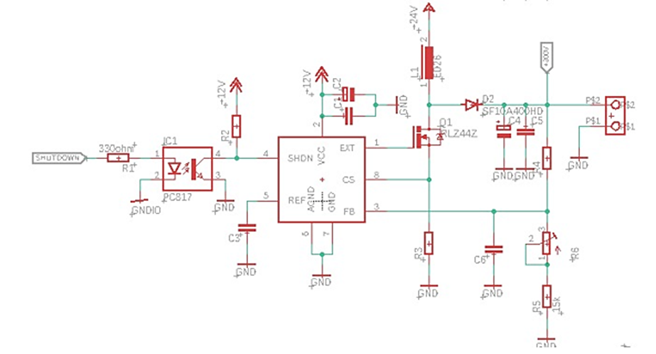
FIGURE 2. Schematic boost converter circuit design

RESULTS AND DISCUSSION
The boost converter is tested by providing an input power supply, by adjusting the variable resistor to determine the desired output voltage and then monitoring the voltage produced (output) by the boost converter. TABLE 1 is the test results of the boost converter:

TABLE 1. The results of dc-dc boost converter vin = 25v
Input Voltage (V) | Output Voltage (V) | Time (s)
25 | 250 | 0.2 s
25 | 300 | 0.15 s
25 | 350 | 0.1 s
25 | 400 | 0.05 s

The test results in TABLE 1. show the relationship between the input voltage 25V and the output voltage on a boost converter, along with the time required to reach the output voltage. The table shows that as the output voltage increases from 250V to 400V, the time required to reach that voltage decreases from 0.2 seconds to 0.05 seconds. This shows that the boost converter is able to increase the voltage very quickly when the target output voltage gets higher. This may occur because components in the circuit work more aggressively (for example, by shortening the switching period or increasing the switching frequency) to achieve a higher voltage target.
In FIGURE 3. is the result of testing the boost converter at an input voltage of 25V using an oscilloscope. So that the output voltage produced by the boost converter can be read by the oscilloscope, it is required to use a divider resistor. In testing, this is necessary because the oscilloscope can only handle peak voltages of up to 50 Vp, so a 1/10 divider resistor is needed so that it can be read.
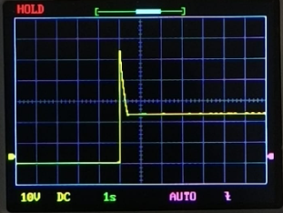
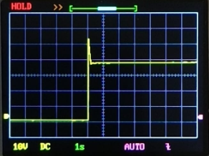
a b
FIGURE 3. Transient response; a) vout = 250v, b) vout =400v

Next, the boost converter was tested with an input voltage of 15V. The test results are shown in TABLE 2:

TABLE 2. The results of DC-DC Boost Converter Vin=15V
Input Voltage (V) | Output Voltage (V) | Time (s)
15 | 250 | 0.2 s
15 | 300 | 0.15 s
15 | 350 | 0.1 s
15 | 400 | 0.05 s

The test results in TABLE 2 show the relationship between the input voltage 15V and the output voltage on a boost converter, along with the time needed to reach the output voltage.
Test results of the boost converter using an oscilloscope when the voltage is 15V are shown in the FIGURE 4. The PFM signal is used to produce an output voltage of 250 Volts and 400 Volts with an input voltage of 15 Volts as in FIGURE 5.
a b
FIGURE 4. Transient response; a) vout = 250v, b) vout = 400v
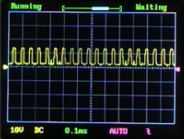
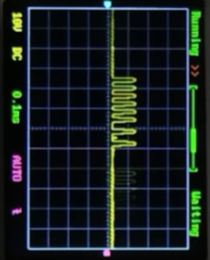
a b
FIGURE 5. PFM output signal; a) vout =250v, b) vout =400v

From the results of testing the PFM output signal, it can be seen that there is a change in the switching frequency used. In FIGURE 5.a when the output voltage is 250V and FIGURE 5.b when the output voltage is 400V, when the output voltage is greater, the switching frequency on the PFM is higher, so changes in the PFM switching frequency greatly affect the output.
From the test results on the boost converter in TABLE 1 and TABLE 2, it shows that the input voltage provided as a power supply to the boost converter does not affect the output voltage results. Data shows that the boost converter in this system is able to quickly adjust the output voltage according to needs. High efficiency, especially because the time to reach a higher output voltage is shorter. This indicates good converter performance in applications that may require fast response and high efficiency, such as in robotics or portable electronic devices.

CONCLUSIONS
This research successfully designed and developed a DC-DC boost converter using the Pulse Frequency Modulation (PFM) method optimized for wheeled soccer robots. The study shows that the use of Pulse Frequency Modulation (PFM) in the design of the DC-DC boost converter for wheeled soccer robots provides significant improvements in energy efficiency and response time. The experimental results indicate that the converter is capable of increasing the voltage from a low input level to a higher output level in a very short time. The increase in switching frequency at higher output voltages accelerates the voltage increase process, making this method ideal for applications requiring stability and power efficiency. The main conclusion of this research is that the use of the PFM method in DC-DC boost converters provides significant improvements in power efficiency and response speed, which is crucial in soccer robot applications. With higher switching frequency settings at larger output voltages, the converter can provide stable and efficient power to the robot components. The efficiency achieved allows for more optimal use of battery power, extending the robot's operating time during competitions, while ensuring component performance stability. Therefore, PFM-based boost converters have proven to be an effective solution for enhancing soccer robot performance in competitive environments, where speed and energy efficiency are highly demanded.

Acknowledgments
The author expresses his thanks to God Almighty. The author would like to thank Icon-TINE Call for Papers for organizing the 2024 Seminar, as well as thanking the University of Muhammadiyah Malang for supporting the UMM Robotics team and providing financial assistance for the development of DC - DC Boost Converter research used in soccer robots wheeled.

Reference
1. Watson, R., F.C. Lee, and G.C. Hua, Utilization of an Active-Clamp Circuit to Achieve Soft Switching in Flyback Converters. IEEE Transactions on Power Electronics, 1996. 11(1): p. 162-169.
2. Kwon, J.-M., et al., High-efficiency fuel cell power conditioning system with input current ripple reduction. IEEE Transactions on Industrial Electronics, 2008. 56(3): p. 826-834.
3. Zhao, Q. and F.C. Lee, High-Efficiency, High Step-Up DC-DC Converters. IEEE Transactions on Power Electronics, 2003. 18(1): p. 65-73.
4. Zhao, Y., et al. High Step-Up Boost Converter with Coupled Inductor and Switched Capacitor. in 5th IET International Conference on Power Electronics, Machines and Drives (PEMD). 2010. Brighton, UK: IET.
5. Muhammad, M., M. Armstrong, and M. Elgendy. Non-isolated DC-DC Converter for High-Step-Up Ratio Applications. in 17th European Conference on Power Electronics and Applications (EPE'15 ECCE-Europe). 2015. Geneva, Switzerland: IEEE.
6. Liu, X., et al. Analysis and design of a high efficiency boost DC-DC converter based on pulse-frequency modulation. 2007. IEEE.
7. Ahmed, K.Z., et al. Analysis of Efficiency Optimization for PFM Mode Switching DC-DC Boost Regulator. in International Conference on Electrical and Computer Engineering. 2008. Dhaka, Bangladesh: IEEE.
8. Syafaah, L., et al., Buck-Boost Converter Ssing GA-Based MPPT for Solar Energy Optimization. Kinetik: Game Technology, Information System, Computer Network, Computing, Electronics, and Control, 2023. 8(3): p. 607-614.
9. Mohamed, H.A., et al. Design, Control and Performance Analysis of DC-DC Boost Converter for Stand-Alone PV System. in Eighteenth International Middle East Power Systems Conference (MEPCON). 2016. Cairo, Egypt: IEEE.
10. Ponniran, A. and A.F.M. Said. DC-DC Boost Converter Design for Solar Electric System. in International Conference on Instrumentation, Control & Automation. 2009. Bandung, Indonesia.

