The Performance of Motor Drivers in Wheeled Soccer Robots Using a Three-Wheeled Omnidirectional Configuration
Salman Al-Farisi Ramadhani^{a)}, Nur Alif Mardiyah^{b)}, Khusnul Hidayat^{c)}, and Novendra Setyawan^{d)}
Department of Engineering, University of Muhammadiyah Malang, Malang, Indonesia

^{b)} Corresponding author: nuralif@umm.ac.id
^{a)} farissalman@webmail.umm.ac.id
^{c)} khusnulhidayat@umm.ac.id
^{d)} novendra@umm.ac.id
Abstract. This research investigates the performance of motor drivers in wheeled soccer robots utilizing a three-wheeled omnidirectional configuration. The study focuses on optimizing motor drivers to enhance the robot's speed and energy efficiency. The omnidirectional configuration enables dynamic movement in any direction without requiring the robot to reorient itself, providing a significant advantage in soccer match scenarios. The motor drivers are engineered to control the motors efficiently, ensuring rapid response to directional changes and maintaining high torque. Through a series of experiments using a prototype robot, the performance of the motor drivers was evaluated across various simulated match scenarios. The findings indicate that the three-wheeled omnidirectional configuration, combined with optimized motor drivers, significantly improves the overall performance of the robot, offering superior control, agility, and extended operational time. This research contributes to the advancement of robotics technology in sports, particularly in the development of more effective and efficient soccer robots.
Keywords: Motor Driver, three-wheeled omnidirectional configuration, energy efficiency, wheeled soccer robot

INTRODUCTION
Kontes Robot Sepak Bola Beroda Indonesia (KRSBIBeroda) is a national robotic soccer competition in Indonesia that adopts RoboCup Middle-Size League. The year of 2017 is the first time KRSBI-Beroda competition [1]. In an autonomous wheeled soccer robot, before selecting an action for movement, the robot’s position on the field coordinates, as well as the ball and goalpost positions, must be accurately determined [2], [3]. In the field of robotics, various researchers have developed methods to enhance the robot's capabilities. Soccer competition robots serve as a real-world testbed for control systems, path planning research, navigation sensors, and vision systems [4].
The determination of the robot's position is one of the main challenges in the development of autonomous robots. If the robot does not know its position, it becomes difficult to determine its subsequent actions [5]. Currently, DC motors are commonly used in many electrical applications. DC drive systems are often employed in various industrial applications, such as robotics, actuators, and manipulators [6].
The BTN motor drive system (Bridge Tied Load) is an attractive option because it provides excellent control over DC motors commonly used in wheeled robots. BTN technology enables more precise regulation of current and voltage, allowing the motor to operate with high energy efficiency and rapid response. In this study, we designed and implemented an optimized BTN motor driver system for wheeled soccer robots. The focus of this research is on the development of a motor driver that can enhance the robot's speed, precision, and energy efficiency. By utilizing Pulse Width Modulation (PWM), this system aims to regulate motor speed more accurately and allow for faster response to control commands.
Testing will be conducted on a soccer robot prototype equipped with the BTN motor drive system developed in this study. The results of this testing are expected to provide empirical evidence for improving the robot's performance and offer new insights into the development of motor control technology for robotic applications in sports. This research is anticipated not only to contribute to the advancement of soccer robot technology but also to provide broader benefits in the fields of motor control and energy efficiency. Therefore, this study is expected to be a significant step forward in enhancing the quality and performance of soccer robots, as well as serving as a reference for future research in the same field.

METHODS
In designing the BTN Motor Driver for a Wheeled Soccer Robot in the Indonesian Robot Contest Using a Three-Wheeled Omnidirectional Configuration, several references are required. These include books, journals, articles, and websites related to the use of C++ and C programming languages. Additionally, it is important to study literature on Hardware and Mechanical design. Subsequently, the system design needs to be created, including the system flow that will be used. At this stage, the adjustment of the method to be applied is crucial. FIGURE 1 represents the system-level data flow diagram. The system level involves breaking down the hardware and software systems into smaller, more detailed stages, referred to as levels, to better understand and manage the system.
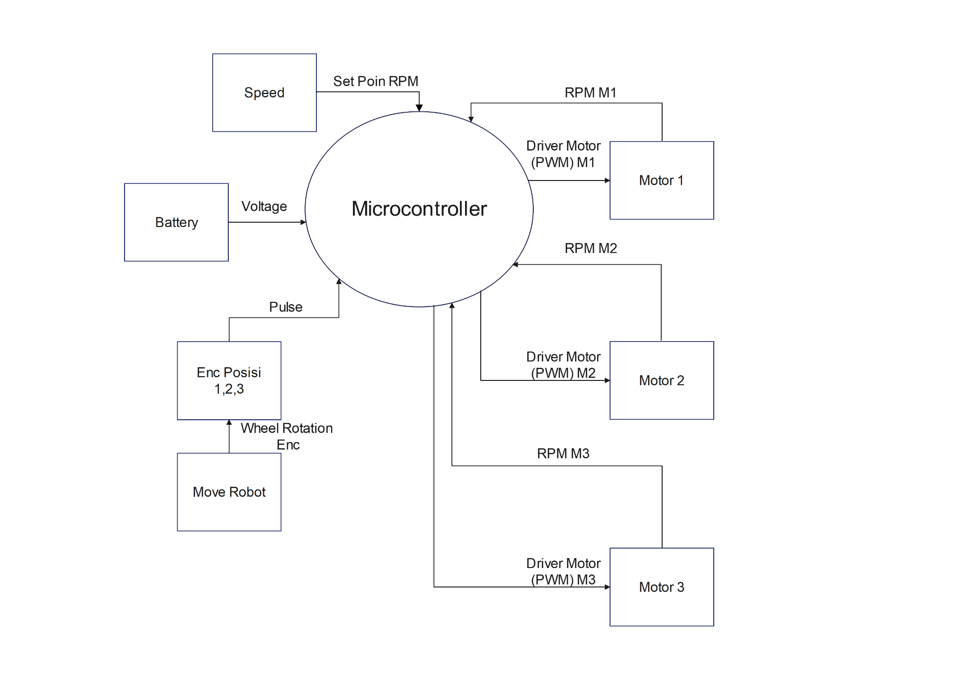
FIGURE 1. Data flow diagram system level

HARDWARE DESIGN
The overall hardware system consists of three main components:
- STM32F407VGT6 as the main microcontroller,
- PG45 DC Motor 1,2,3 as the actuator,
- Motor Driver BTN7970 is used to convert low-current control signals into higher current to drive the DC motor.

The motor driver for robot uses the BTN7970 IC, which acts as the motor controller. This driver can control both the speed and direction of the motor based on the outputs from the microcontroller. It can be supplied with voltages up to 45V and handle currents up to 44A. (see in FIGURE 2).
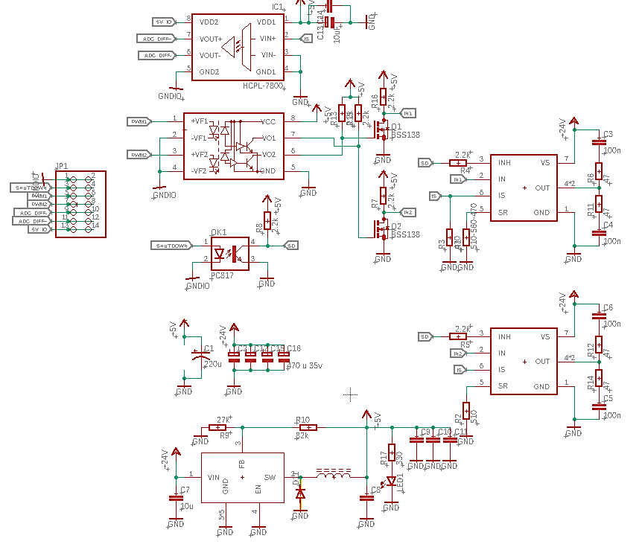
FIGURE 2. Driver motor btn7970

RESULTS AND DISCUSSION
The testing of the BTN motor driver system design for the wheeled soccer robot includes evaluating the output voltage generated at each PWM input provided by the microcontroller program. With different PWM settings applied to the motor driver, the output voltage varies accordingly. TABLE 1 presents the data from the motor driver testing for the DC motor PG45.
To collect data using a voltmeter, first ensure the device is properly calibrated. Then, connect the voltmeter probes to the measurement points. Record the voltage reading displayed on the voltmeter screen accurately.

TABLE 1. Output of driver motor
PWM (Duty Cycle) | Voltage (V)
0.1 | 2.3
0.2 | 4.75
0.3 | 7.19
0.4 | 9.65

During motor driver testing, when the PWM was set to 0.1, the resulting voltage was 2.34V. Similarly, when the PWM was set to 0.2, the measured voltage was 4.69V. When the PWM was adjusted to 0.3, the resulting voltage was 7.03V, and when the PWM was set to 0.4, the resulting voltage was 9.38V. This experiment indicates that as the PWM (Duty Cycle) value increases, the generated voltage also increases, demonstrating a direct proportionality between the PWM value and the resulting voltage.
To collect data using the STMStudio application, first ensure that the data values are correct. Then, connect the microcontroller to the ST-Link. Accurately record the data readings displayed on the application screen.

TABLE 2. Motor speed
PWM (Duty Cycle) | Pin Direction | Speed (rpm) | Rotation Direction
0.1 | HIGH | 37 | CW
0.2 | LOW | 74 | CCW
0.3 | HIGH | 122 | CW
0.4 | LOW | 149 | CCW

In TABLE 2, Output Motor, when the PWM (Duty Cycle) is set to 0.1 with the direction pin set to High, the motor produces 37 rpm (radian per minute), and the rotation direction is CW (clockwise). When the PWM is changed to 0.2 with the Direction Pin set to Low, the motor produces 74 rpm, and the rotation direction is CCW (counterclockwise). When the PWM is set to 0.3 with the Direction Pin set to Low, the motor produces 122 rpm with a CW rotation direction. Finally, when the PWM is set to 0.4 with the Direction Pin set to Low, the motor produces 149 rpm with a CCW rotation direction. This demonstrates that the higher the PWM value, the greater the rpm produced. Additionally, when the Direction Pin is set to HIGH, the motor rotates CW (clockwise), and when the Direction Pin is set to Low, the motor rotates CCW (counterclockwise).
To collect data using a power meter module, calibrate the device properly, connect it to the power source, select the appropriate measurement mode, power on the circuit, record the measurement results, and ensure to double-check the data before disconnecting.

TABLE 3. Efficiency Motor
PWM  (Duty Cycle) | Input Voltage  (V) | Input Current  (A) | Input  Power  (W) | Output  Voltage  (V) | Output  Ampere  (A) | Output  Power  (W) | Efficiency %
0.1 | 24.8 | 0.11 | 2.7 | 2.3 | 0.39 | 1.2 | 49.9
0.2 | 24.79 | 0.18 | 4.4 | 4.75 | 0.42 | 2 | 44.9
0.3 | 24.78 | 0.24 | 5.9 | 7.19 | 0.45 | 3.2 | 53.8
0.4 | 24.77 | 0.33 | 8.1 | 9.65 | 0.54 | 5.2 | 63.7

For each duty cycle, the efficiency of the system is calculated as the ratio of output power to input power, expressed as a percentage (TABLE 3). At a duty cycle of 0.1, the efficiency is approximately 43.9%, with an input power of 2.7W and an output power of 1.2W. At a duty cycle of 0.2, the efficiency rises to about 44.9%, with an input power of 4.46W and an output power of 2W. This trend continues at a duty cycle of 0.3, where the efficiency increases to approximately 53.8%, with an input power of 5.95W and an output power of 3.2W. Finally, at a duty cycle of 0.4, the efficiency reaches 63.7%, with an input power of 8.16W and an output power of 5.2W. The average efficiency across these duty cycles is approximately 51.6%, reflecting an overall improvement in the system's performance in converting input power to output power as the duty cycle increases., indicating that as PWM increases, the power efficiency also improves.

CONCLUSIONS
The conclusion of this research is that a Wheeled Soccer Robot for the Indonesian Robot Contest has been successfully developed using a Three-Wheeled Omnidirectional Configuration. Based on the conducted research, it can be concluded that the robot's construction was successfully achieved, and the motor's motion accurately reflected the applied PWM signals. Capable of operating at speeds ranging from 37 rpm to 149 rpm, rotating in both CW and CCW directions according to the provided value and direction pin input. The BTN motor driver used in the robot meets the robot's requirements, with average power efficiency from this data is about 51.6%. Additionally, no functional failures occurred during the configuration trials of the robot.

Acknowledgments
The author would like to thank God Almighty, the Icon-TINE Call for Papers committee for organizing the 2024 Seminar. The author would also like to thank the supervisors and lecturers who have contributed to the Muhammadiyah University of Malang campus environment.

References
1. Ardiyanto, I., et al. Development of Middle-Sized Mobile Robot FUKURO for Robot Soccer Competition. in The 6th Indonesian Symposium on Robotic Systems and Control (ISRSC). 2018. Yogyakarta, Indonesia: Universitas Muhammadiyah Yogyakarta.
2. Setyawan, N., et al., Navigasi Robot Sepak Bola Beroda Menggunakan Particle Filter Localization. Cyclotron, 2022. 5(1): p. 87-90.
3. Setyawan, N., N.A. Mardiyah, and K. Hidayat, Deteksi dan Prediksi Trajektori Objek Bergerak dengan Omni-Vision Menggunakan Pso-Nn dan Interpolasi Polynomial. Multitek Indonesia, 2019. 13(1): p. 66-80.
4. Setyawan, N., et al. Object Detection of Omnidirectional Vision Using PSO-Neural Network for Soccer Robot. in 5th International Conference on Electrical Engineering, Computer Science and Informatics (EECSI). 2018. Malang, Indonesia: IEEE.
5. Rachmawan, A., Penentuan posisi robot sepak bola beroda menggunakan rotary encoder dan kamera, in Electrical Engineering. 2017, Institut Teknologi Sepuluh Nopember.: Surabaya, Indonesia. p. 66.
6. Özer, T., S. Kıvrak, and Y. Oğuz, H Brıdge DC Motor Drıver Desıgn and Implementatıon with Usıng dsPIC30f4011. IJERSET, 2017. 6(10): p. 75-83.

