Meningioma Tumor Segmentation on MRI T1-weighted using Image Processing Algorithm
Hadi Purnomo^{a)}, M. Irfan^{b)}, and Novendra Setyawan^{c)}
Department of Electrical Engineering, Muhammadiyah University of Malang, Malang, Indonesia
^{b)} Corresponding author: irfan@umm.ac.id
^{a)} hasyashin75@gmail.com
^{c)} novendra@umm.ac.id
Abstract. Brain tumors pose a significant and multifaceted challenge in contemporary medicine, characterized by the abnormal and unregulated growth of cells within the brain or its surrounding structures. Among various types of brain tumors, meningiomas are the most encountered in clinical practice. The diagnosis of brain tumors primarily relies on advanced imaging techniques with magnetic resonance imaging (MRI). Despite the advancements in automated segmentation techniques, manual segmentation is often preferred due to its accuracy and the expert judgment involved. However, this method is labor-intensive, time-consuming, and subject to potential human error, which can affect the results. Therefore, there is an ongoing development of automated segmentation tools that can complement or even replace manual methods. This research proposes an approach aimed at enhancing the understanding of diagnostic processes and determining the presence of a tumor in the indicated area. The objective is to develop and validate computational algorithms for automatically segmenting tumors in brain magnetic resonance imaging (MRI). The methodology of this research is structured into two phases. The first stage is pre-processing, involving grayscale conversion, otsu thresholding, skull stripping, and binarization. The second stage is the segmentation process, involving morphological transformations and canny edge detection. Based on the proposed method, the segmentation achieved 87% accuracy based on the T1-weighted meningioma sample data. These results show a potential for automated segmentation.
Keywords: meningioma, segmentation, opencv, otsu, canny

INTRODUCTION
Brain tumors pose a significant and multifaceted challenge in contemporary medicine, characterized by the abnormal and unregulated growth of cells within the brain or its surrounding structures. These neoplasms are broadly classified into primary and secondary categories. Primary brain tumors originate within the brain itself, arising from various types of brain cells or its supporting tissues, while secondary brain tumors, also known as metastatic tumors, result from cancerous cells that have spread from other parts of the body to the brain [1]. The complexity of brain tumors is highlighted not only by their diverse origins but also by the wide range of histological types they encompass. Among these, gliomas and meningiomas are the most encountered in clinical practice. Meningiomas are originate from the meninges, the protective layers of tissue covering the brain and spinal cord. Although often benign, meningiomas can still cause significant clinical symptoms due to their size or location [2]. Overall incidence of malignant brain and other central nervous system (CNS) tumors are varied significantly by country region. Incidence was highest in Northern Europe, 6.59/100000 person, and lowest in Southeast Asia, 2.55/100000 person [3].
The diagnosis of brain tumors primarily relies on advanced imaging techniques, with magnetic resonance imaging (MRI) due to its ability to provide high-resolution images without the use of ionizing radiation [4]. Due to variations in size, location, and intensity, segmenting brain tumors in magnetic resonance imaging (MRI) presents a significant challenge [5]. In current clinical practice, manual delineation by radiologists or other trained operators remains a widely used method for tumor segmentation. Despite the advancements in automated segmentation techniques, manual segmentation is often preferred due to its accuracy and the expert judgment involved. However, this method is labor-intensive, time-consuming, and subject to potential human error, which can affect the consistency of the results. Therefore, there is an ongoing need for the development of automated segmentation tools that can complement or even replace manual methods, offering improved precision, efficiency, and reproducibility in the segmentation process.
Numerous studies have focused on brain tumor segmentation. In 2021, Sumir et al [6]. introduced a fully automated brain tumor segmentation method incorporating enhanced morphological and thresholding techniques. This method was employed to segment the abnormal proliferation of mass-containing tissues from brain tumor MRI images. Notably, this approach demonstrated higher accuracy and reduced computational time. Additionally, it effectively assisted in determining the tumor stage based on the quantified area. By applying the discrete wavelet transform (DWT) to MRI images, key features such as mean, correlation, contrast, skewness, energy, and homogeneity were extracted. In the same year, Anantharajan and Gunasekaran [7], proposed a segmentation method utilizing a weighted fuzzy factor approach grounded in kernel metrics. To enhance prediction accuracy, they combined a deep autoencoder (DAE) with a weighted fuzzy clustering algorithm, enabling precise segmentation of the lesion area from the rest of the MRI image. This proposed method demonstrated superior performance and accuracy compared to other existing techniques.
This study proposes an approach aimed at enhancing the understanding of diagnostic processes and determining the presence of a tumor in the indicated area. The objective is to develop and validate a set of computational algorithms for the automatic segmentation of tumors in brain magnetic resonance imaging (MRI). The methodology of this research is structured into two phases. In the first phase, pre-processing, which includes grayscale conversion, and otsu thresholding. In the second phase, segmentation involves closing, erosion & dilation, and canny edge detection. These steps collectively contribute to the effectiveness of the proposed approach.

METHODS
This research refers to digital image processing methods, which combined into proposed algorithm method. As MRI T1-weighted image will be used for input data, that will be processed into different steps afterwards, where the sources of data are combined MRI meningioma image from Figshare, SARTAJ, and Br35H. Hence, the process flow can be expressed as a flowchart in FIGURE 1.

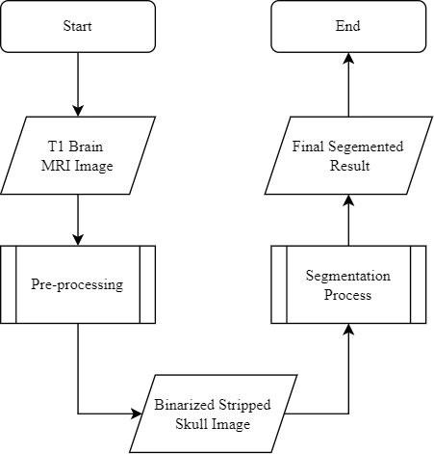

FIGURE 1. Main flowchart

In order to start algorithm process, brain MRI image need to be pre-processed first, which consist grayscale conversion, otsu thresholding, skull stripping, and image binarization, can be expressed as sub-process flowchart in FIGURE 2.
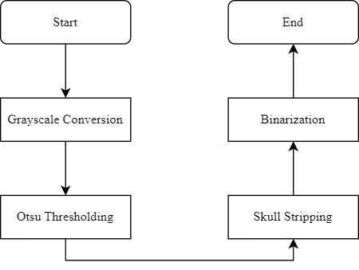
FIGURE 2. Pre-processing sub-process flowchart

The conversion of color images to grayscale is initial step in this research, as it reduces the complexity of the data while preserving crucial luminance information [8]. The process of converting color images to grayscale generally utilizes algorithms that consider the intensity of the red, green, and blue (RGB) channels. This approach involves computing a weighted average of these components, with the weights reflecting human perception of color brightness [9]. Otsu thresholding is a fundamental technique in this pre-processing, extensively utilized for the segmentation of images into distinct regions based on variations in pixel intensity values. This method operates on the principle of selecting an optimal threshold value that distinguishes the foreground, calculates the cumulative sums and the probabilities of each intensity level, enabling it to derive the mean values of the foreground and background classes. This results in a threshold that effectively separates the foreground from the background [10]. Skull stripping process itself are using color masking to highlight brain region to extract brain from original image, which is full image with cranium. Then, the stripped image processed into two binary images that will be used as a foundational step in further image processing tasks, such as morphology transformations and edge detection in the further process. FIGURE 3 is the result of each step of pre-processing as an image.

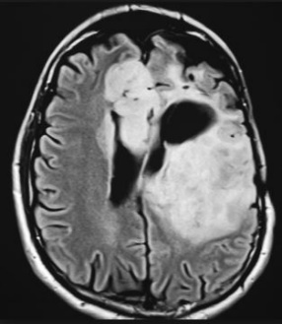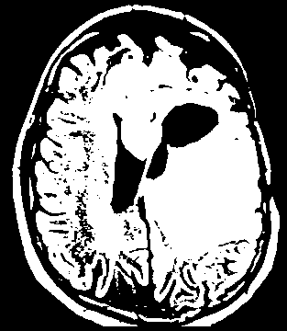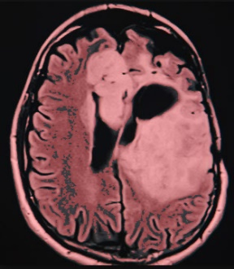
(a)
(c)
(b)

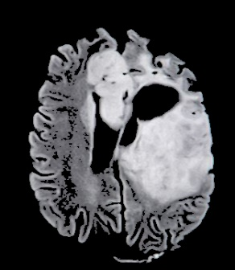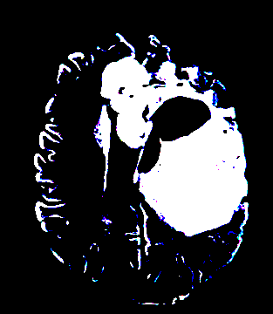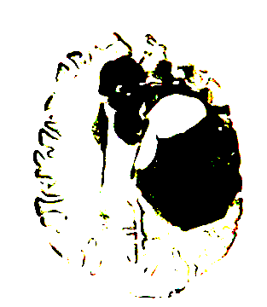
(f)
(e)
(d)

FIGURE 3. Steps of pre-processing: (a) grayscale, (b) otsu thresholding, (c) masking (d) skull stripping, (e) binarized image, and (f) inverted binarized image

The segmentation process is important to produce a final image result, which required the pre-processed image before to be processed later, involving closing, erosion & dilation, and canny edge detection. The sub-process flowchart in FIGURE 4.

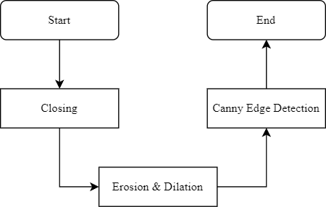

FIGURE 4. Segmentation sub-process flowchart

Image from pre-processing will be undergo different morphological operation such as closing and erosion & dilation, these operation are particularly effective in processing binary and grayscale images [11]. In the first stage, closing operation effectively smooths the contours of an object while closing small holes and gaps within it. This operation is particularly useful in applications where the preservation of the overall shape of the object is critical while simultaneously removing noise and small imperfections from the image. In the second stage, erosion involves reducing pixels in areas not fully surrounded by other pixels [12], leaving behind only the pixel regions indicating a meningioma tumor. This is followed by a dilation operation, which enlarges the object by adding pixels to its edges or filling gaps within the object to enhance its visibility in the image [13]. The object in this context refers to the pixel regions indicative of the meningioma tumor. In other words, morphological transformations are used to eliminate unnecessary pixels, leaving only the tumor-indicating pixels through erosion, which are then restored using dilation to make the detected object more complete and clearer. In the third stage, edge detection is performed using the canny edge detection process, which consists of several steps including noise reduction, gradient calculation to detect edges, and edge thinning [14]. The main advantage of canny edge detection is its superior sharpness in edge detection compared to other algorithms like Sobel and Prewitt [15]. This process works on the result of the previous morphological transformations, converting the remaining tumor-indicating pixel regions into edge lines surrounding the object. These edge lines are embedded in the final image as markers indicating the segmented of a meningioma tumor. FIGURE 5 is the results of each detection steps as images.

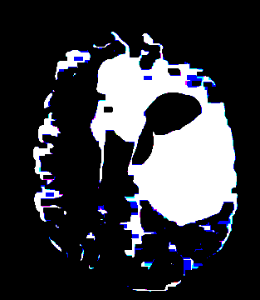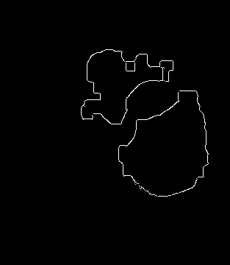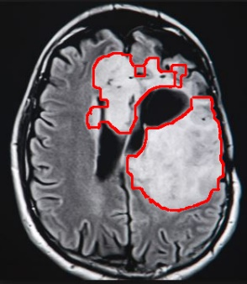
(d)
(c)
(b)
(a)

FIGURE 5. Steps of segmentation: (a) closing, (b) erosion & dilation, (c) canny edge detection, and (d) segmented result

RESULTS AND DISCUSSION
The total number of MRI T1-weighted used in this research is 247 images. The algorithm proposed in this research was able to detect meningioma tumors with an 87% accuracy, as calculated by the equation below (1), limited to T1-weighted images and using an image processing method based on Python programming language mainly using the OpenCV library.

$Accuracy \left(\%\right)= \frac{Total correct data}{Total data} ×100$ (1)

FIGURE 6. Samples of indicated meningioma area
Based on FIGURE 6, the image illustrates the outcomes of segmenting brain tumors in a series of MRI scans. The upper row (1st and 3rd row) displays a different sample of image pre-processing results, showcasing the diverse algorithms and filters used to separate the area of interest (tumor) from the surrounding tissue. These binary or semi-binary masks are utilized to outline the tumor boundaries. The lower row (2nd and 4th row) depicts the original MRI scans, with the tumor regions outlined in red to visually compare and confirm the accuracy of the segmentation. Each scan presents a unique cross-sectional view of the brain, and the red contour delineates the irregular shape and size of the tumor throughout the brain. This approach incorporates various methods to produce the final image. The pre-processing stage consists of grayscale conversion, otsu thresholding, skull stripping, and binarization, resulting series of binary below. The segmentation process consists of closing, erosion & dilation, and canny edge detection, resulting series of original images with red contours below.
This figure exemplifies the integration of medical imaging with segmentation techniques to aid in the identification, delineation, and quantification of brain tumors. The clear visualization of tumor boundaries against the background of normal brain structures provides a valuable tool for clinicians in both diagnostic and therapeutic processes. The highlighted areas on the MRI scans emphasize the spatial localization of tumors, assisting in diagnosis, treatment planning, or evaluation of tumor progression.

CONCLUSIONS
The proposed algorithm with image processing approaches, reaching 87% accuracy on T1-weighted meningioma images. As the sample image must be skull stripped first, in order to increase the accuracy of the indicated area of the tumor with grayscale conversion, otsu thresholding and masking before extracting the main brain area from the sample image. Morphological operations such as closing are needed to fill the desired area and eliminate the unnecessary pixels, leaving only the indicated tumor area with erosion, followed by dilation to increase visibility. With the result of the isolated indicated area of tumor in the binary image, the white area has more intensity than the rest of the image. Hence, this area is suspected as a meningioma tumor.

Acknowledgments
I would like to express my very great appreciation to my Lecturer Novendra Setyawan, S.T., M.T. and Lecturer Ir. Muhammad Irfan, M.T for valuable and constructive suggestions during the planning and development of this research work. His willingness to give his time so generously has been very much appreciated. I would also like to thank the Head of the Faculty, Head of the Department, Lecturers, and Staff of the Faculty of Engineering, especially the Electrical Engineering Department of the Muhammadiyah University of Malang, which has provided support for the publication of my paper.

References
- H. Yamashita et al., “A rare case of metastatic solitary fibrous tumor of the pancreas manifesting as a cystic neoplasm: a case report,” Surg. Case Reports, vol. 5, pp. 1–8, 2019.
- M. Wanner, S. Rohrmann, D. Korol, N. Shenglia, T. Gigineishvili, and D. Gigineishvili, “Geographical variation in malignant and benign/borderline brain and CNS tumor incidence: a comparison between a high-income and a middle-income country,” J. Neurooncol., vol. 149, no. 2, pp. 273–282, Sep. 2020, doi: 10.1007/S11060-020-03595-5/TABLES/4.
- R. Leece, J. Xu, Q. T. Ostrom, Y. Chen, C. Kruchko, and J. S. Barnholtz-Sloan, “Global incidence of malignant brain and other central nervous system tumors by histology, 2003–2007,” Neuro. Oncol., vol. 19, no. 11, pp. 1553–1564, Oct. 2017, doi: 10.1093/NEUONC/NOX091.
- S. Hussain et al., “Modern diagnostic imaging technique applications and risk factors in the medical field: a review,” Biomed Res. Int., vol. 2022, no. 1, p. 5164970, 2022.
- R. M. Young, A. Jamshidi, G. Davis, and J. H. Sherman, “Current trends in the surgical management and treatment of adult glioblastoma,” Ann. Transl. Med., vol. 3, no. 9, 2015.
- R. M. Sumir, S. Mishra, and N. Shastry, “Segmentation of brain tumor from MRI images using fast marching method,” in 2019 IEEE International Conference on Electrical, Computer and Communication Technologies (ICECCT), 2019, pp. 1–5.
- S. Anantharajan and S. Gunasekaran, “Automated brain tumor detection and classification using weighted fuzzy clustering algorithm, deep auto encoder with barnacle mating algorithm and random forest classifier techniques,” Int. J. Imaging Syst. Technol., vol. 31, no. 4, pp. 1970–1988, 2021.
- G. Dou, R. Chen, C. Han, Z. Liu, and J. Liu, “Research on water-level recognition method based on image processing and convolutional neural networks,” Water, vol. 14, no. 12, p. 1890, 2022.
- H. Mutahira, B. Ahmad, M. S. Muhammad, and D. R. Shin, “Focus Measurement in Color Space for Shape From Focus Systems,” IEEE Access, vol. 9, pp. 103291–103310, 2021, doi: 10.1109/ACCESS.2021.3098753.
- M. A. B. Siddique, R. B. Arif, and M. M. R. Khan, “Digital image segmentation in matlab: A brief study on otsu’s image thresholding,” in 2018 international conference on innovation in engineering and technology (ICIET), 2018, pp. 1–5.
- R. Sharma and B. S. D. Sagar, “MATHEMATICAL MORPHOLOGY BASED CHARACTERIZATION OF BINARY IMAGE,” Image Anal. Stereol., vol. 34, no. 2 SE-Original Research Paper, pp. 111–123, Jun. 2015, doi: 10.5566/ias.1291.
- A. Fadjeri, B. A. Saputra, D. K. Adri Ariyanto, and L. Kurniatin, “Karakteristik Morfologi Tanaman Selada Menggunakan Pengolahan Citra Digital,” J. Ilm. SINUS; Vol 20, No 2 Vol. 20 No. 2 Juli 2022DO - 10.30646/sinus.v20i2.601 , Jul. 2022, [Online]. Available: https://p3m.sinus.ac.id/jurnal/index.php/e-jurnal_SINUS/article/view/601.
- R. Devita, “Analisis Perbandingan Kernel Morfologi Citra Otak Ditinjau dari Nilai PSNR,” Indones. J. Comput. Sci., vol. 13, no. 3, 2024.
- Z. C. Ma and X. M. Ning, “A Novel Edge Detection Algorithm for Medical Image,” Appl. Mech. Mater., vol. 151, pp. 653–656, 2012.
- M. Kumar and R. Saxena, “Algorithm and technique on various edge detection: A survey,” Signal Image Process., vol. 4, no. 3, p. 65, 2013.

