Design and Development of Smart Feature Inverter and Automatic Transfer Switch (ATS) on Solar Panel Based on Internet of Things (IoT)
Adelia Rizkiana^{1, a)} Machmud Effendy^{1, b)}, Arienza Novetasari^{1, c)} Rio Saputra^{1, d)} Wilda Amalia Jamilah^{1, e)}M.Chasrun Hasani^{1, f)}
Author Affiliations
¹Electrical Engineering Department, Universitas Muhammadiyah Malang, Malang, Indonesia

Author Emails
^{a)} Corresponding author: machmud@umm.ac.id
^{b)} adeliarizkiana812@gmail.com
^{c)} arienzans@gmail.com
^{d)} riosaputra456@gmail.com
^{e)} wildaamalia115@gmail.com
^{f)} chasrun@umm.ac.id
Abstract. The demand for renewable energy continues to increase alongside the depletion of fossil resources and the growing awareness of the importance of using environmentally friendly energy. One potential solution to meet this demand is by utilizing solar panels as a source of electricity. This study aims to design and build a Smart Inverter and Automatic Transfer Switch (ATS) system based on the Internet of Things (IoT) to optimize the use of solar energy efficiently and automatically. The developed system uses an Arduino Mega microcontroller equipped with an ESP8266 module to support IoT connectivity, and utilizes PZEM-004T and ACS712 sensors for accurate monitoring of electrical parameters. Remote monitoring and control of the system are carried out through the Blynk platform, which is directly connected to the user's mobile device. The system can automatically detect the power supply condition from either the solar panels or the PLN grid, switch the power source automatically via the ATS module, and adjust the inverter output according to the current load requirements. The designed inverter is also equipped with intelligent features such as automatic energy conversion with plug and play capability, remote inverter control, real-time voltage monitoring, self-awareness ability to detect internal faults or damages, battery management combined with load reduction to maintain device durability, and adaptability that enables the inverter to work harmoniously with other devices in the system to overcome imbalances and maintain stable power distribution. Testing results show that the system operates stably and automatically, while providing ease of monitoring and remote control. Thus, the IoT-based Smart Inverter and ATS system developed in this study has great potential to increase the efficiency of solar energy utilization as well as strengthen the reliability of electricity supply, especially in areas prone to power outages.
Keywords: Smart Inverter, ATS, Solar Panel, IoT, Arduino Mega ESP8266, PZEM-004T sensor, CS712 sensor, Blynk, Renewable Energy.

INTRODUCTION
Electric energy in the modern era has developed rapidly since its discovery and has become not only a subject of research but also the main driving source for human activities such as heating, driving, lighting, and automation. The demand for electricity in Indonesia continues to grow by an average of 6.9% per year, while the availability of fossil fuels as the primary energy source continues to decline. To overcome this challenge, the Indonesian government has targeted 31% utilization of New and Renewable Energy (NRE) by 2050[1], [2]. At the same time, global issues such as climate change and greenhouse gas emissions from fossil fuel consumption further emphasize the urgency of developing Renewable Energy Sources (RES) including solar, wind, hydro, and biomass[3], [4], [5]. Among them, solar energy has great potential in Indonesia due to its tropical location, with an average solar irradiation of 4.8 kWh/m² per day, equivalent to a potential of 207,898 MW[6], [7].
Despite this high potential, the utilization of solar energy in Indonesia remains limited. Conventional solar panel systems still face several challenges, particularly in power management, real-time monitoring, and automated switching between power sources. These limitations reduce the overall efficiency and reliability of solar energy systems, especially in conditions of fluctuating irradiation or unexpected grid outages[8], [9]. In addition, existing inverters in conventional systems mainly function to convert DC to AC but do not provide intelligent features such as fault detection, automatic protection, or adaptive control. Similarly, Automatic Transfer Switch (ATS) systems often rely on manual or semi-automatic operation, which can cause delays in power recovery during outages[10], [11].
Several recent studies have demonstrated technological advances in integrating smart inverters and ATS with IoT. For example, an ATS system integrated with the Blynk IoT platform achieved fast switching delays of only 20–26 ms[12]. A Smart Home system with ATS and Automatic Battery Charging (ABC) also showed reliable performance with 2–4 s switching response and real-time monitoring via IoT[13]. Furthermore, Nagesh et al. (2025) introduced an automatic hybrid solar power inverter with IoT-based real-time monitoring through mobile applications[14]. Meanwhile, a comprehensive review highlighted challenges such as interoperability, cybersecurity, and regulatory issues that still hinder the full adoption of next-generation smart inverters[15]. These findings confirm the need for further research to develop systems that combine intelligent inverter functions, reliable ATS switching, and seamless IoT-based monitoring.
To address these challenges, this study proposes the design and development of a Smart Inverter integrated with an Automatic Transfer Switch (ATS) based on the Internet of Things (IoT). The smart inverter is designed to operate efficiently with features such as automatic plug-and-play energy conversion, real-time voltage and current monitoring, intelligent protection against overheating and low battery conditions, and adaptability to load variations. The ATS module is designed to switch automatically between solar panels, batteries, and the utility grid, ensuring uninterrupted power supply. Furthermore, IoT integration using the ESP8266 module and Blynk platform enables remote monitoring and control via mobile devices, allowing users to access system status anytime and anywhere. The main contributions of this paper are: (1) developing an IoT-based smart inverter system with advanced monitoring and protection features, (2) integrating ATS for reliable automatic power source switching, and (3) validating the system’s performance through testing under various load and supply conditions.

METHODS
System Design

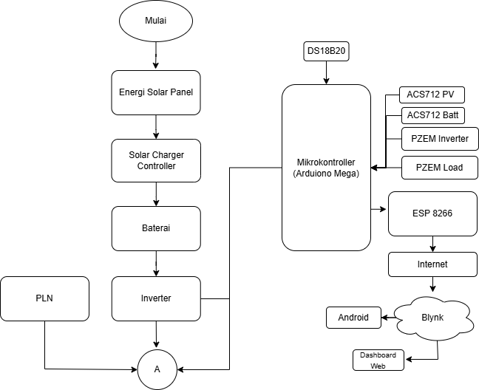
FIGURE 1.Comprehensive System Flowchart
This flowchart illustrates the workflow of the IoT-based Smart Inverter and ATS system, which starts with system activation. Electrical energy is generated by the solar panel and regulated by the solar charger controller to charge the battery, which then supplies power through the inverter along with backup power from the PLN to meet the load demand. The Arduino Mega microcontroller controls the entire system by reading data from the DS18B20 temperature sensor, ACS712 current sensors on the solar panel and battery, as well as PZEM modules to monitor electrical parameters on the inverter and load. Monitoring data is transmitted via the ESP8266 module to the internet, allowing users to access and control the system in real-time through the Blynk application on Android devices or a web dashboard. This system ensures an efficient, stable, and remotely monitored power supply.
Inverter Circuit Schematic
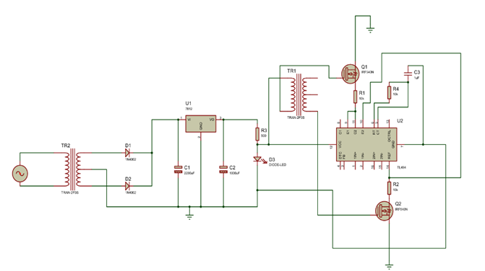
FIGURE 2.Inverter circuit schematic
The Smart inverters are generally as inverters which are charged through solar energy and which can perform solar tracking[16]. An inverter is an electronic device that works on the principle of converting a Direct Current (DC) power source into an Alternating Current (AC) power source. The inverter can be used by utilizing a DC power source from a battery[17]. An inverter is considered smart if it operates efficiently and automatically with minimal operator intervention. Its functions go beyond DC to AC conversion, including automatic plug-and-play energy conversion that allows the system to be used immediately without manual configuration, as well as real-time detection of current, voltage, and temperature. The inverter can be remotely controlled via the Blynk app or Web Dashboard. The system monitors battery voltage, disconnects the load if it drops below 10V, switches to the grid via ATS, and reactivates when stable. The self-awareness feature detects overheating and provides automatic protection with notifications. Its adaptability adjusts operation according to load and disturbances, along with intelligent relay control. The inverter must also cooperate with other devices to maintain system stability. The inverter is integrated with an ESP8266 microcontroller, which enables remote monitoring and control via a smartphone application. The Blynk platform is used to display real-time data such as voltage, current, power, frequency, and power factor[18].
SelfAwareness Components | Status | System Implementation
Condition Monitoring (CM) | Active | Temperature is monitored in real-time, and data is stored in the database.
Diagnostics | Available | Temperature and system behavior are recorded, enabling analysis of disturbance causes.
Diagnostics | Available | The system provides warning notifications before the temperature reaches a critical point to prevent damage.
TABLE 1.Overview of Self-Awareness Components in the System

Design Automatic Transfer Switch (ATS)
ATS stands for Automatic Transfer Switch. Based on the meaning of these words, ATS is a switch that operates automatically. Its automatic operation occurs when the power supply from the utility (PLN) is interrupted or experiences a blackout, at which point the switch transfers to another power source, such as an inverter[19]. The design of the Smart Automatic Transfer Switch (ATS) Electric Energy Monitoring System as an Energy Efficiency Effort Based on the Internet of Things (IoT) aims to improve the efficiency of electrical energy use by utilizing IoT technology. The system is designed to automatically switch electricity sources between the main provider, such as PLN, and backup sources, such as generators or solar power plants (PLTS), when there is a disruption in the main electricity supply[20]. The Automatic Transfer Switch (ATS) system will also be implemented using the NodeMCU ESP32 Microcontroller which hopes to be more effective because this Microcontroller has been designed as an IoT-based Microcontroller with a Wifi module that is already attached to the NodeMCU ESP8266[21].
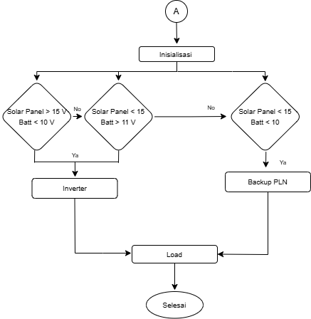
FIGURE 3. Flowchart ATS System
This system is designed to use solar panels as the primary power source, with batteries as backup, and the utility grid (PLN) as the last resort (backup). The energy source selection is performed automatically based on the voltage of the solar panels and the batteries, with the following conditions: (1) If the solar panel produces a voltage > 15 V and the battery is < 10 V, the load remains supplied by the inverter because the panel still has enough energy to charge the battery; (2) if the panel is < 15 V and the battery is > 11 V, the system continues to use the inverter because the battery is still capable of supplying the load; and (3) if the panel is < 15 V and the battery is < 10 V, the system automatically switches to the utility grid (PLN) as the final backup. If the battery voltage is in the range between 10 V and 11 V, the system will not switch the power source (it remains on the previous source) to avoid excessive switching due to voltage fluctuations. The 10 V / 11 V threshold means that if the battery voltage drops below 10 volts, the system will switch to the utility grid (PLN), and if the battery voltage rises above 11 volts, the system will switch back to the inverter.

TABLE 2. Test results of the ATS system
No | Test Condition | Solar Panel Voltage (V) | Battery Voltage (V) | Active Source | Output to Load | ATS Status | Remarks
1 | Condition A | 20 V | 12.7 V | Inverter | Load ON | Not switching | Panel and battery meet the requirements
2 | Condition B | 12.6 V | 11.9 V | Inverter | Load ON | Not switching | Weak panel, battery sufficient
3 | Condition C | 20 V | 10 V | Inverter | Load ON | Not switching | Panel meets requirements, battery weak
4 | Condition D | 5 V | 5 V | Utility grid (PLN) | Load ON | ATS switches to PLN | Panel and battery insufficient
The test results show that the ATS system is capable of automatically switching power sources quickly without disrupting load continuity. This response time is consistent with the study by Saputro et al.[21], which reported a switching delay of 20–26 ms using an IoT-based ATS, although the present research places greater emphasis on integrating the ATS with a smart inverter to ensure power supply reliability.

System Design Internet of Things (IoT)
The Internet of Things (IoT) is a concept that aims to extend the benefits of continuous internet connectivity. Basically, IoT (Internet of Things) refers to objects that can be uniquely identified as virtual representatives within an internet-based structure. The way IoT works is through automatic interaction between connected machines without user intervention, regardless of the distance between them.[22], [23]. The implementation of a smart inverter was proposed in [8] i.e a solar charged inverter that uses Wi-Fi technology to engage in a two way communication with the user, informing the user of both, the inverter as well as run time of the loads which the user chooses to run. Furthermore, wireless control of loads is implemented to increase human comfort [24]. Based on research that applies IoT technology using the ESP8266 Wifi module, so that it can send data to a computer device, but the distance that can be reached is only limited to the ability of the wifi module used (the computer must be connected to the wifi contained in the monitoring tool). Backup system / backup is absolutely necessary in electronic devices that require uninterrupted electrical energy. Reserves are used to replace PLN's main source[25].
Based on the description of the problems above, the research focuses on designing an IoT-based monitoring system that can send data to a database server, so that it can be monitored in real time by an Android smartphone anywhere and anytime without being constrained by distance. The PZEM-004T is a sensor that can be used to measure RMS voltage,RMS current, and active power, and it can be connected through Arduino or other open-source platforms. The physical dimensions of the PZEM-004T board are 3.1×7.4 cm[26].The monitoring system is connected via an ESP8266 WiFi connection, allowing data from the ACS712 sensor and the PZEM004T sensor to be displayed on the Arduino Mega 2560 serial monitor and simultaneo usly shown in real-time on the Blynk dashboard and smartphone for monitoring purposes.

Blynk is a platform for iOS and Android operating systems that serves as a controller for Arduino, Raspberry Pi, ESP8266, and other similar devices via the internet [27], [28]. The testing process involves several important stages to ensure that the system functions properly. These stages include testing the WiFi connection to confirm the device can successfully connect to Blynk through the ESP8266, verifying that the sensor parameter readings displayed on the Serial Monitor match those shown on the smartphone and web dashboard to guarantee the accuracy of the IoT system, and testing real-time updates to ensure that the values in the Blynk application are periodically refreshed[28].
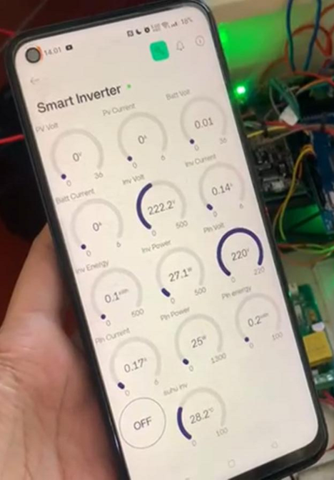
FIGURE 4.Smart inverter OFF condition
In OFF mode, the inverter is in standby condition and does not supply power to the load. This is indicated by the control button on the application showing the status as “OFF,” and the absence of current and power on the load side. The solar panel voltage (PV Volt) reads 0.0 V, and the panel power (PV Power) also shows 0.0 W, indicating that the panel is either not connected or not receiving sunlight. The load power is also 0 W, and the load current is nearly zero, confirming that no power is being consumed. The system temperature is at 28.2°C, indicating a cool state since the system has not yet started operating. In this mode, the system functions solely to monitor status without distributing any energy.
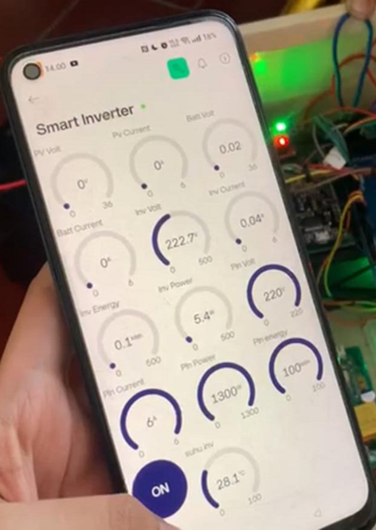
FIGURE 5.Smart inverter in ON condition
In the ON condition, the application button displays the status "ON", indicating that the inverter system has been activated. However, at this moment, the solar panel is either not connected or not generating power, as indicated by the PV Volt reading of 0.0 V and PV Power of 0.0 W. Despite this, the inverter continues to supply power to the load with an output voltage of 220V, inverter current of 5.4A, and a load power of 5.4W, which most likely comes from the battery as the backup source. The system temperature is recorded at 28.1°C, indicating that the inverter has just been turned on and the components are still cool. This demonstrates that the system is capable of supplying power even when the solar panel is inactive, supporting the smart inverter’s functionality with automatic alternative power sourcing.
The developed system is also capable of performing automatic protection when the temperature exceeds the threshold and when the battery voltage is low, and it can be monitored in real time through the Blynk application. These results are comparable to the study by Maghfiroh et al.[29], which implemented IoT-based monitoring in a Smart Home with ATS, but this research adds intelligent protection functions as well as adaptive control for load variations.

System Testing
System testing was conducted to ensure that the performance of the features aligns with the designed specifications. One of the main features tested was remote inverter control using the Blynk application and web dashboard. The test results showed that the system can activate and deactivate the inverter responsively via mobile devices without significant issues. The automatic temperature control feature was also tested by gradually heating the system. When the temperature exceeded the set threshold, the system successfully cut off the load to prevent overheating. After the temperature stabilized, the system automatically reactivated the inverter. This indicates that the temperature protection logic works well and effectively maintains system stability. The ACS712 sensor was used to monitor current in real-time.
Testing showed that the sensor could read load current steadily and send data to the NodeMCU for display on the dashboard. When a current surge beyond the normal limit occurred, the system detected the change and responded according to the programmed logic. Tests were also performed under low voltage conditions. The system successfully detected voltage drops and implemented protection by temporarily cutting the output, then reactivating once the voltage returned to normal. This demonstrates that the system can adapt to electrical disturbances. All important parameters such as temperature, current, and inverter status can be monitored through the web-based interface and Blynk application, allowing users to stay connected to the system remotely, even when out of town or abroad. Data logging via USB-serial was also successfully carried out for local monitoring purposes.
The overall system testing was conducted to evaluate the performance, reliability, and integration of all components, including the inverter, ATS, sensors, IoT connectivity, and protection features. This comprehensive test aimed to ensure that the system operates effectively under various scenarios and load conditions.
Key aspects of the testing included:
- Functional Testing: Verifying the ability of the system to switch power sources automatically based on voltage thresholds, and ensuring seamless transitions between solar, battery, and PLN power.
- Stability Testing: Running the system continuously under different load conditions to monitor temperature, voltage, and current stability using ACS712 and PZEM004T sensors.
- IoT Monitoring: Ensuring real-time data transmission to the Blynk dashboard via ESP8266, allowing remote monitoring and control through a smartphone.
- Protection Testing: Validating that safety components such as MCBs and relays respond effectively to overcurrent or overheating conditions.
- Control System Testing: Confirming that the Arduino Mega and switching relays function correctly in managing power flow and system logic.
The test results showed that the entire smart inverter system, including the ATS and IoT-based monitoring, functioned reliably and was able to respond dynamically to changes in power availability and load demands.
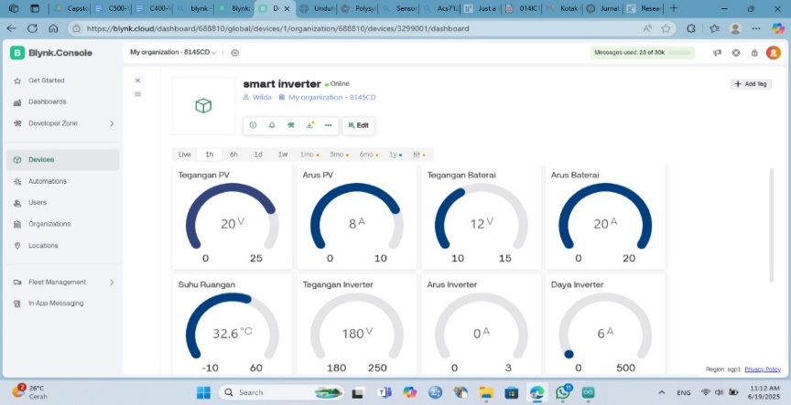
FIGURE 6.Blynk dashboard display on the website
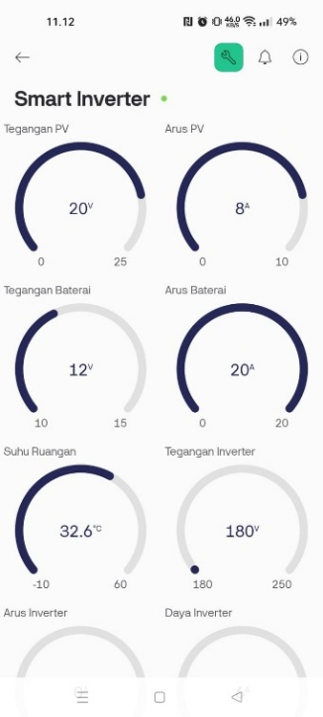
FIGURE 7.Blynk dashboard display on the Android application

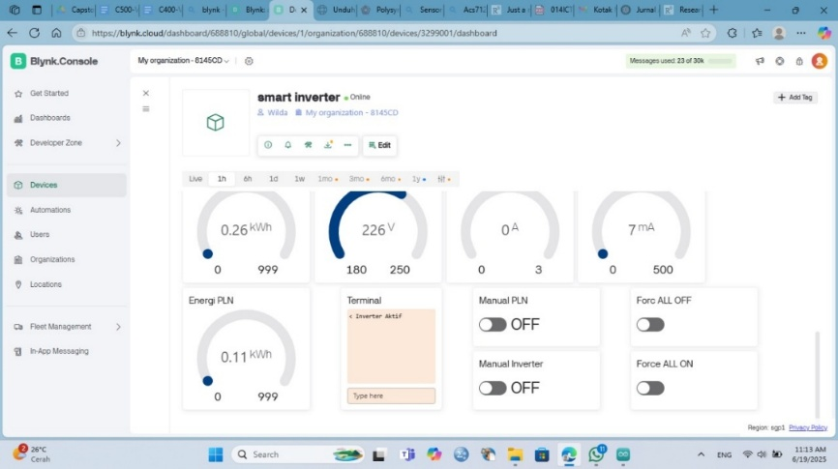
FIGURE 8.Blynk dashboard display on the website

TABLE 3.Results of System Continuity Testing
No | Test Time | Solar Panel Voltage (V) | Battery Voltage (V) | Inverter Temperature  (C) | Active Source | Load Output | ATS Status | Remarks
1 | 08:00 | 13.07V | 12.27V | 25.7 C | Inverter | Load Off (Lamp, Bulb 2) | Not Switched | Battery insufficient, system does not charge battery
2 | 09:00 | 14.20V | 11.44V | 25.2 C | Inverter | Load On (Lamp, Bulb 2) | Not Switched | Battery charging, system starts charging battery
3 | 10:00 | 17.33 V | 11.46 V | 30.6 C | Inverter | Load On (Aroma Diffuser and CCTV) | Not Switched | Battery charging, system continues charging battery
4 | 11:00 | 20.14 V | 11.61V | 32.1 C | Inverter | Load On (Lamp, Bulb 2) | Not Switched | Panel and battery sufficiently supplying load
5 | 12:00 | 20.11V | 11.71V | 30.6 C | Inverter | Load On (Aroma Diffuser and CCTV) | Not Switched | Panel and battery sufficiently supplying load
6 | 13:00 | 18.33V | 11.39V | 32.9 C | Inverter | Load On (Lamp, Bulb, and Laptop) | Not Switched | Panel and battery sufficiently supplying load
7 | 14:00 | 17.69 V | 11.95 V | 34.8 C | Inverter | Load On (Aroma Diffuser) | Not Switched | Panel and battery sufficiently supplying load
8 | 15:00 | 17.18 V | 11.53 V | 34.8 C | Inverter | Load Off (Lamp, Bulb 2) | Not Switched | Panel and battery sufficiently supplying load
9 | 16:00 | 14.76 V | 11.46 V | 33.0 C | Inverter | Load On (CCTV 1) | Not Switched | Battery charging
10 | 17:00 | 14.81 V | 10.80 V | 31.2 C | Utility Grid (PLN) | Load On (Lamp) | Switched | Panel and Battery do not meet the requirements

In addition, the test results prove that the smart inverter is able to maintain the efficiency of the power supply from solar panels, batteries, and the utility grid. These findings support the study by Nagesh et al.[30], who developed an IoT-based hybrid inverter; however, this research provides a further contribution through the full integration of the smart inverter, ATS, and IoT monitoring into a single centralized system. The findings of this study are also consistent with recent literature reviews[31], which emphasize the importance of next-generation smart inverters with protection features, real-time communication, and IoT integration. This research provides implementative evidence that such a concept can be realized on a small scale with stable performance.

CONCLUSION
This study successfully designed and developed a smart inverter integrated with an Automatic Transfer Switch (ATS) based on the Internet of Things (IoT) to optimize the utilization of solar energy. The system features real-time monitoring, automatic plug-and-play energy conversion, intelligent protection, and adaptive control, with seamless switching between solar panels, batteries, and the grid to ensure a stable power supply. Experimental results demonstrated that the system operates efficiently, reliably, and can be controlled remotely via the Blynk application, showing great potential to improve renewable energy utilization and enhance electricity reliability, particularly in areas prone to power outages.

Acknowledgments
All authors contributed significantly to this work. Adelia Rizkiana led the research, performed the system design, data collection, and prepared the manuscript. Machmud Effendy and M. Chasrun Hasani supervised the project, provided guidance in methodology, and contributed to manuscript revisions. Arienza Novetasari and Rio Saputra contributed to hardware development, circuit design, and implementation. Wilda Amalia Jamilah assisted in data analysis, system testing, and result interpretation. All authors reviewed and approved the final version of the manuscript.

References
[1] S. Anwar, T. Artono, and J. Teknik Elektro Politeknik Negeri Padang, “Pengukuran Energi Listrik Berbasis PZEM-004T,” Proceeding Seminar Nasional Politeknik Negeri Lhokseumawe, vol. 3, no. 1, 2019.
[2] L. N. Rahayu and J. Windarta, “Tinjauan Potensi dan Kebijakan Pengembangan PLTA dan PLTMH di Indonesia,” Jurnal Energi Baru dan Terbarukan, vol. 3, no. 2, pp. 88–98, Jun. 2022, doi: 10.14710/jebt.2022.13327.
[3] A. Alfouly, I. Hamdan, and M. Ismeil, “Voltage Profile of Hosting Capacity Enhancement Based on Smart Inverter Reactive Power Control for PV Grid Connected System,” SVU-International Journal of Engineering Sciences and Applications, vol. 4, no. 2, pp. 234–242, Dec. 2023, doi: 10.21608/svusrc.2023.194712.1106.
[4] H. Timotius, J. W. Simatupang, M. Andriani, P. Situmeang, I. Ramos Sm, and M. Fauzi, “ANALISIS POTENSI ENERGI MATAHARI MENJADI ENERGI LISTRIK DI INDONESIA: PROYEKSI DAN PERAMALAN KAPASITAS TERPASANG PLTS DENGAN METODE DOUBLE EXPONENTIAL SMOOTHING.”
[5] I. Wallimann-Helmer, “Justice in managing global climate change,” in Managing Global Warming: An Interface of Technology and Human Issues, Elsevier, 2018, pp. 751–768. doi: 10.1016/B978-0-12-814104-5.00026-0.
[6] S. Nadia, A. Ferels, L. Tambunan, A. Indraprastha, and Y. Setyo, “Parametric Optimization of Building-Integrated Photovoltaic 2 Insulated Glass for Multi-Story Offices in Hot-Humid Tropics 3 4 Dewi Larasati.” [Online]. Available: https://ssrn.com/abstract=5193872
[7] J. Jurasz, F. A. Canales, A. Kies, M. Guezgouz, and A. Beluco, “A review on the complementarity of renewable energy sources: concept, metrics, application and future research directions.”
[8] S. J. Dewan, E. Nasional, and D. Siswanto, BAURAN ENERGI NASIONAL 2020 PENANGGUNG JAWAB PEER REVIEWER.
[9] N. Amandha Adistia, R. Aditya Nurdiansyah, J. Fariko, and J. Welman Simatupang, “POTENSI ENERGI PANAS BUMI, ANGIN, DAN BIOMASSA MENJADI ENERGI LISTRIK DI INDONESIA.”
[10] J. E. Elektro, H. B. Nurjaman, and T. Purnama, “Pembangkit Listrik Tenaga Surya (PLTS) Sebagai Solusi Energi Terbarukan Rumah Tangga.” [Online]. Available: https://journal.uny.ac.id/index.php/jee
[11] P. Temperatur et al., “The Effect Of Temperature On Voltage Produced By Monocrystalline Solar Panel (Case Study : Baristand Industri Surabaya),” 2016.
[12] J. S. Saputro, H. Maghfiroh, F. Adriyanto, M. R. Darmawan, M. H. Ibrahim, and S. Pramono, “Energy Monitoring and Control of Automatic Transfer Switch between Grid and Solar Panel for Home System,” International Journal of Robotics and Control Systems, vol. 3, no. 1, pp. 59–73, 2023, doi: 10.31763/ijrcs.v3i1.843.
[13] H. Maghfiroh et al., “SMART HOME SYSTEM WITH BATTERY BACKUP AND INTERNET OF THINGS.”
[14] D. Nagesh et al., “Automatic Hybrid System for Solar Power Inverter with IOT,” 2025. [Online]. Available: www.ijnrd.org
[15] H. Awad and E. H. E. Bayoumi, “Next-Generation Smart Inverters: Bridging AI, Cybersecurity, and Policy Gaps for Sustainable Energy Transition,” Apr. 01, 2025, Multidisciplinary Digital Publishing Institute (MDPI). doi: 10.3390/technologies13040136.
[16] S. Anwar, T. Artono, and J. Teknik Elektro Politeknik Negeri Padang, “Pengukuran Energi Listrik Berbasis PZEM-004T,” Proceeding Seminar Nasional Politeknik Negeri Lhokseumawe, vol. 3, no. 1, 2019.
[17] “JURNAL 17”.
[18] B. Arbab-Zavar, E. J. Palacios-Garcia, J. C. Vasquez, and J. M. Guerrero, “Smart inverters for microgrid applications: A review,” Mar. 04, 2019, MDPI AG. doi: 10.3390/en12050840.
[19] N. Wayan, R. Jurusan, T. Elektro, N. Bali, B. Jimbaran, and T. Badung -Bali, “PANEL AUTOMATIC TRANSFER SWITCH (ATS)-AUTOMATIC MAIN FAILURE (AMF) DI PERUMAHAN DIREKSI BTDC,” 2013.
[20] W. Sukadana, I. Ayu, D. Giriantari, W. G. Ariastina, I. Bagus, and A. Swamardika, “Design Of Smart Automatic Transfer Switch (ATS) Electrical Energy Monitoring System As An Energy Efficiency Effort Based On The Internet Of Things (IOT).” [Online]. Available: https://theaspd.com/index.php
[21] T. Sulistyorini, N. Sofi, and E. Sova, “PEMANFAATAN NODEMCU ESP8266 BERBASIS ANDROID (BLYNK) SEBAGAI ALAT ALAT MEMATIKAN DAN MENGHIDUPKAN LAMPU,” JUIT, vol. 1, no. 3, 2022.
[22] C. K. Amuzuvi, E. A. Amuzuvi, and C. K. Addo, “A Microcontroller-Based Automatic Transfer Switching System for a Standby Electric Generator,” 2015.
[23] R. G. A and K. Perumal, “Iot Based Smart Controlled Inverter,” International Journal of Computer Trends and Technology, vol. 68, 2020, [Online]. Available: http://www.ijcttjournal.org
[24] N. Kurniawan, “Electrical Energy Monitoring System and Automatic Transfer Switch (ATS) Controller with the Internet of Things for Solar Power Plants.”
[25] A. L. Bustamante, M. A. Patricio, and J. M. Molina, “Thinger.io: An open source platform for deploying data fusion applications in IoT environments,” Sensors (Switzerland), vol. 19, no. 5, Mar. 2019, doi: 10.3390/s19051044.
[26] P. Harahap, F. I. Pasaribu, and M. Adam, “Prototype Measuring Device for Electric Load in Households Using the Pzem-004T Sensor”, doi: 10.33258/birex.v2i3.1074.
[27] “27.”.
[28] P. Temperatur et al., “The Effect Of Temperature On Voltage Produced By Monocrystalline Solar Panel (Case Study : Baristand Industri Surabaya),” 2016.
[29] H. Maghfiroh et al., “SMART HOME SYSTEM WITH BATTERY BACKUP AND INTERNET OF THINGS.”
[30] D. Nagesh et al., “Automatic Hybrid System for Solar Power Inverter with IOT,” 2025. [Online]. Available: www.ijnrd.org
[31] H. Awad and E. H. E. Bayoumi, “Next-Generation Smart Inverters: Bridging AI, Cybersecurity, and Policy Gaps for Sustainable Energy Transition,” Apr. 01, 2025, Multidisciplinary Digital Publishing Institute (MDPI). doi: 10.3390/technologies13040136.

