Improving Energy Efficiency with Data Monitoring: A Case Study on Energy Collection and Analysis Tools
Apri Syam Halim¹⁾ and Wahyu Sardjono²⁾
^{1,2} Information System Management Department
BINUS Graduate Program
Master of Information System Management
Bina Nusantara University
Jakarta, Indonesia 11480.
¹⁾ apri.halim@binus.ac.id
²⁾ wahyu.s@binus.ac.id
Abstract. In a new office setup, improving energy efficiency is essential not only for reducing operational costs but also for meeting sustainability goals. This case study explores the implementation of a data monitoring system specifically designed to track electrical and lighting power consumption, CO2 emissions, and air conditioning usage. The system integrates real-time data collection with analysis software, providing facility managers with detailed insights into energy usage trends and potential inefficiencies. Through continuous monitoring, the system identified areas where energy was being overused or wasted, allowing for timely adjustments to operational practices and equipment settings. Over the course of the project, noticeable improvements were achieved in managing lighting schedules, optimizing air conditioning performance, and reducing unnecessary power loads. These improvements contributed directly to lower energy bills and a measurable reduction in carbon emissions. The study also examines challenges encountered during deployment, including compatibility with existing infrastructure, initial setup complexity, and encouraging staff participation in energy-saving practices. Overall, the findings demonstrate that even in non-industrial environments like office spaces, targeted monitoring and analysis can lead to meaningful improvements in energy efficiency. This approach can serve as a practical model for other organizations seeking to create smarter, greener workplaces through data-driven solutions.
Keywords: Energy Efficiency; Data Monitoring; Industrial Energy Management; Energy Analysis Tools; Smart Energy.

INTRODUCTION
Energy consumption in buildings has become a critical concern due to its significant contribution to operational costs and environmental impact. advances technology in Internet of Things (IoT) is enabling intelligent approach to energy monitoring and management. Studies on integrating IoT systems into building infrastructures show energy consumption can be reduced by up to 30% while lowering operational costs by approximately 20% [1]. The concept of “green IoT” strengthened this potential by combining energy-efficient devices with sustainable building practices, leading to measurable improvements in energy conservation. Energy Management approaches are increasingly seen as fundamental to advancing net-zero strategies in commercial and office buildings when used alongside renewable systems and intelligent control function [2]. In the company’s previous office, power consumption was not monitored, making it difficult for the facility managers to compare the power billings with its actual usage, some of the cause might be lighting left on during off-hours or suboptimal air conditioning settings which went undetected and drove up costs. The transition to a new office offered a chance to embed an automated energy monitoring system from day one, integrating real-time tracking of lighting, AC, electrical usage, and CO₂ emissions.
Despite the well-known advantages of IoT for energy efficiency, many offices still face considerable hurdles in adopting such systems. Existing Building Management Systems (BMS) are often fragmented, making it difficult to integrate real-time monitoring, predictive analytics, and user-centric control into one cohesive platform. This fragmentation hampers energy-saving efforts and leaves facility managers without a clear view of building performance. Small and mid-sized offices are particularly affected, as they struggle with high implementation costs and a lack of scalable, interoperable solutions. Within the company, this translated into continued challenges with operational efficiency and energy management. Without access to detailed, real-time data, facility managers were unable to spot inefficiencies such as lighting left on after hours, poor air conditioning control, and underutilized equipment issues that drove up operational expenses and undermined the organization’s sustainability goals [3].
To address the identified challenges, this study proposes the implementation of an integrated energy monitoring system that unifies data on electrical power consumption, on air conditioning, lighting and CO₂ emissions into a centralized platform. Like the integration achieved in sales information systems where consolidated data improves decision making process faster and more effectively, the integration of energy-related information enables facility managers to obtain a single, coherent view of office energy performance [4].
The integrated platform collects real-time data from multiple sources and processes it into actionable data. This allows for immediate detection of inefficiencies, such as unnecessary power usage after working hours or underutilized equipment. By consolidating these data streams, managers can make faster and more effective operational decisions, reducing both energy costs and environmental impact [5].
In this way, the proposed solution mirrors the principles of sales information system integration: by bringing together fragmented information into one platform, organizations gain greater visibility, faster response capabilities, and improved overall performance.

LITERATURE REVIEW
This study uses theories from information systems and energy management to explain how energy monitoring tools can support efficiency in their newly established office. Provide context for understanding how real-time data, system integration, and user behavior all play a role in improving energy use. One of the methods is about Green Information Systems (Green IS) specifically designed to increase environmental sustainability that can support behavioral changes [6].
The integration of Information and Communication Technology (ICT) plays a central role in transforming urban environments to be more sustainable by enhancing energy efficiency, reducing costs, and improving user comfort. Smart city initiatives require coordination among multiple stakeholders and infrastructures, making the implementation complex. Using the Internet of Things (IoT) enables large-scale data collection and management to support these goals. A practical example of this is the #SmartMe Energy system, which was deployed at the University of Messina to help optimize electricity usage in office spaces, turning them into energy-efficient, comfortable "smart offices" [7].
Digital transformation in the building sector encompasses a range of socio-technical initiatives aimed at enhancing productivity, safety, sustainability, and collaboration within the framework of smart cities. Modern smart building systems now rely on integrated sensors, actuators, and communication networks to monitor environmental conditions and apply adaptive controls that balance comfort with energy efficiency. These developments reflect broader technological trends such as IoT and big data analytics, which are increasingly being explored for their role in optimizing smart building performance [8].
As energy systems evolve, the development of next-generation energy management systems (EMS) will be shaped by emerging regulatory frameworks, open access models, and demands for higher reliability, security, and flexibility. The control center, often considered the core of a power network's operation, must ensure system stability and efficient decision-making under increasingly complex conditions. Maximizing the potential of existing EMS infrastructure remains a key opportunity, especially by improving system convergence under stress, enhancing computational speed, and enabling timely remedial actions. Moreover, integrating advanced network analysis algorithms into EMS architecture will be crucial for addressing both supply- and demand-side challenges, aligning technological innovation with long-term energy management strategies [9].
Decision Support Systems (DSS) have long been a foundational area of research; however, traditional stand-alone DSS models are increasingly inadequate for addressing today's complex decision-making environments. In response, significant research has shifted toward the development of Integrated Decision Support Systems (IDSS), emphasizing the need for more cohesive, multi-perspective approaches supported by advanced integration technologies. A broad body of literature and software implementations has been analyzed to classify current progress and identify key trends. Findings suggest that greater system integration enhances decision-making quality and efficiency, positioning IDSS as a critical advancement in supporting more informed and effective decisions [10].
The literature shows that smart office systems are evolving through the use of AI, IoT, and data analytics to improve workplace efficiency, comfort, and productivity. Key features include occupancy sensors, smart lighting, climate control, and adaptive furniture, all supporting user-centered environments. Studies also highlight challenges such as integration with existing infrastructure and data privacy concerns. Future research focuses on improving human-machine interaction, energy efficiency, and system personalization [11].

SYSTEM IMPLEMENTATION
The implementation of the energy monitoring system was carried out in several stages to ensure accurate data collection and smooth integration with the office environment. The goal was to enable real-time visibility into electrical usage, lighting behavior, air conditioning patterns, and related CO₂ emissions.

Hardware Installation
The energy monitoring system was built using a combination of data collection hardware, including energy meters, environmental sensors, and a central data server. These components were installed at critical energy consumption points such as lighting circuits, air conditioning units, and main electrical panels. The server unit served as the main hub, gathering data from connected devices using standardized communication protocols. All hardware was chosen for its compatibility with the building’s electrical layout and its ability to record accurate, high-frequency usage data essential for real-time monitoring and analysis.

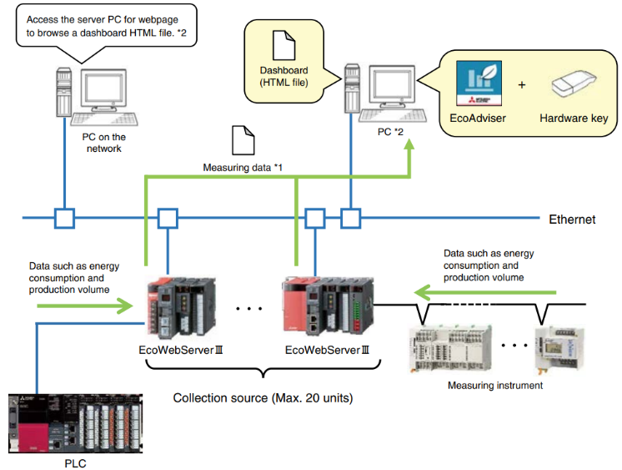

Figure 1. real-time energy data aggregation, connected to power meters and environmental sensors (temperature, humidity, CO₂)

Connecting and Communicating Data
All devices were connected to a central server over the office’s internal network. A standard communication protocol (Modbus TCP/IP) was used to allow the sensors to send data consistently. Backup features were included to avoid data loss in case of short-term network interruptions.

Monitoring System Software Setup
The software platform was configured to interpret, analyze, and present energy-related data through an intuitive dashboard. It provided real-time visualizations of electricity consumption, CO₂ emissions, and air conditioning system performance. Historical data analysis and trend tracking features supported the identification of inefficiencies and optimization opportunities.
Installed on a central server, the platform communicated with field devices—such as power meters, temperature sensors, humidity sensors, and CO₂ monitors—using standard industrial protocols (e.g., Modbus, BACnet). A hierarchical structure was used to organize monitoring points by area or function, improving navigation and report generation.

Collected data was stored in a central database and displayed through customizable dashboards. These included:
• Time-series graphs of energy usage (hourly, daily, monthly)
• Zone-based heatmaps for spatial insights
• CO₂ emission calculations derived from consumption data
• Performance indicators for HVAC and lighting systems

Users accessed the system through secure logins, with options to filter data, view historical trends, and receive alerts. Reports were auto generated or exported to support both day-to-day operations and strategic planning.

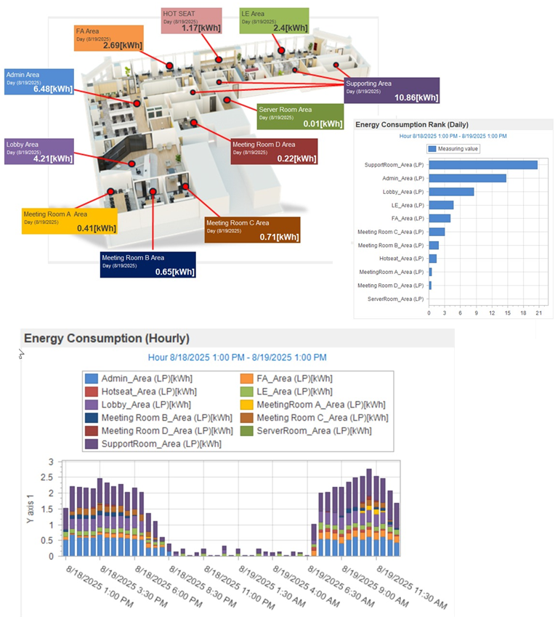

Figure 2. Examples of dashboard applications

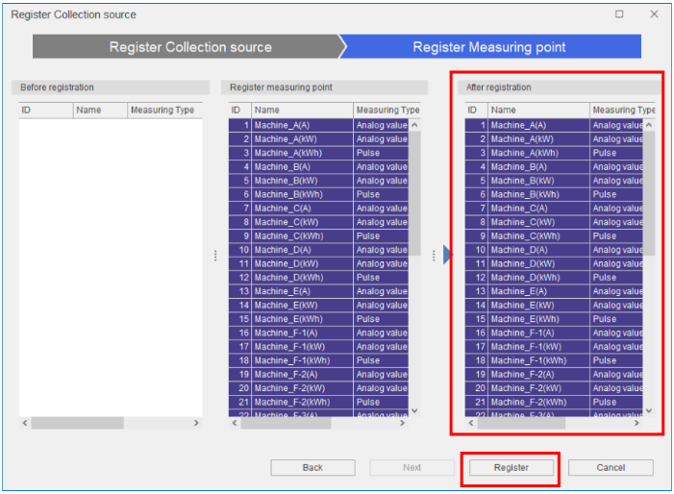

Figure 3. Energy Conservation Measurement

The energy-saving support software operates by collecting real-time data from various field devices such as power meters, temperature and humidity sensors, and CO₂ monitors, which are installed throughout the building. The software then processes this information and presents it through a customizable dashboard that visualizes energy consumption trends, emission estimates, and equipment performance indicators. Users can analyze this data through interactive graphs, heatmaps, and alerts, allowing them to identify inefficiencies, optimize operations, and support informed decision-making for energy-saving initiatives.

RESULTS AND DISCUSSION
The implementation of the smart office system was successfully carried out to enhance workplace efficiency through the integration of IoT-based automation and intelligent environmental control. After deployment, the system demonstrated stable functionality and achieved the intended design objectives, which included real-time occupancy detection, automated lighting and air conditioning adjustment, and centralized monitoring. The outcomes observed during and after deployment confirm that the system not only operated according to specifications but also provided actionable insights into energy usage. The smart office system was deployed in an L-shaped office covering approximately 900 m². To ensure a reliable setup, a comprehensive assessment of existing power and network infrastructure was conducted prior to installation. This step was essential for identifying optimal sensor locations, guaranteeing accurate measurement, and maintaining system scalability. Deployment was divided into four main phases:
- Infrastructure Preparation
Network communication and power lines were established to support continuous data transmission and synchronization across all devices.
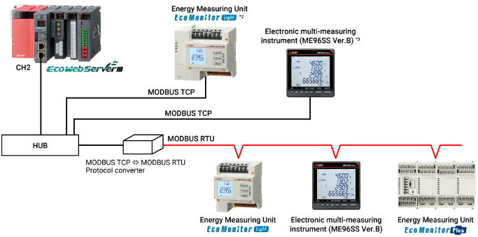

Figure 4. Energy Monitoring Infrastructure Setup and Communication Diagram

- Device Installation
A modular energy measuring unit was installed in each electrical panel to capture detailed, circuit-level data, including power usage, current, and voltage. Environmental and occupancy sensors were placed in meeting rooms, open-plan areas, corridors, and shared spaces. By networking all devices into the central monitoring platform, unified control and integrated diagnostics were achieved.

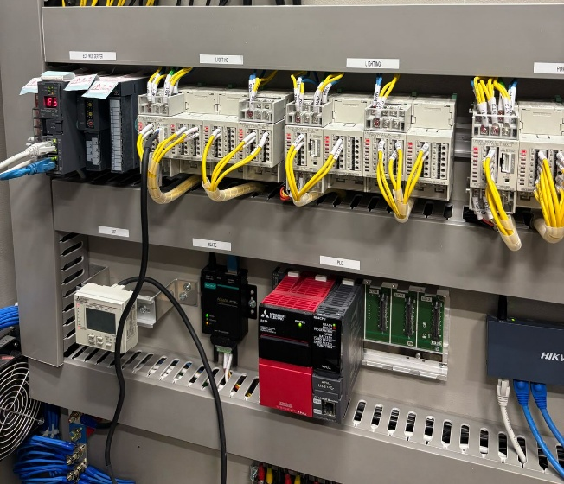

Figure 5. Modular Energy Measuring Unit Installation

- Configuration and Diagnostic Readiness
Following installation, the system underwent a configuration process to establish measurement points, assign circuit functions, and define operational thresholds. Automated diagnostic routines were enabled, which helped identify inefficiencies in real time, such as irregular consumption or overuse of air conditioning in unoccupied areas.

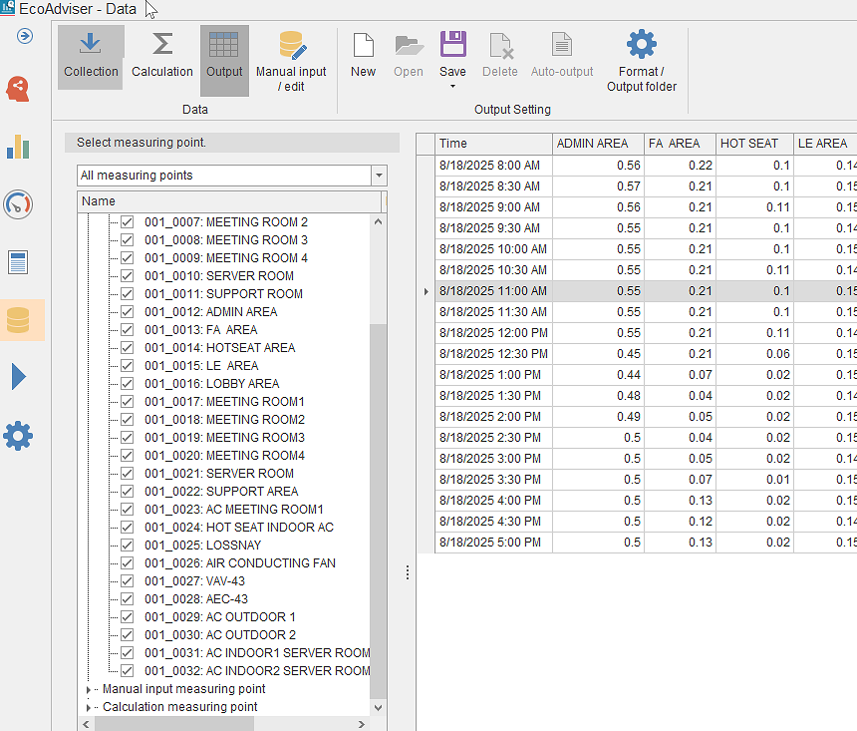

Figure 6. Data Point Measurement Setup

- System Dashboard Result
The monitoring platform visualized energy consumption through time-series graphs, Pareto charts, histograms, and scatter plots. These tools provided clear visibility into consumption trends, making it easier to detect anomalies and optimize energy use. Data transparency allowed facility managers to compare performance across circuits and identify specific sources of inefficiency.

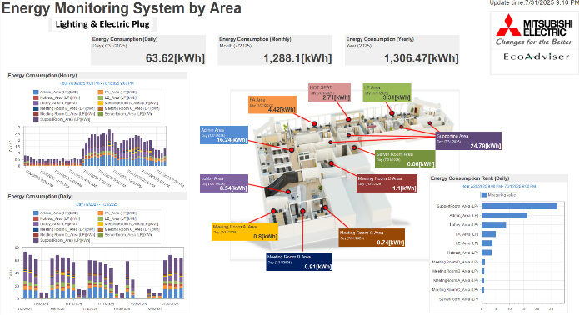

Figure 7. Energy Monitoring Dashboard for Lighting Power Consumption
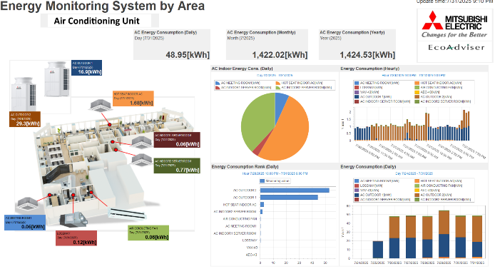

Figure 8. Energy Monitoring Dashboard for Air Conditioning Unit

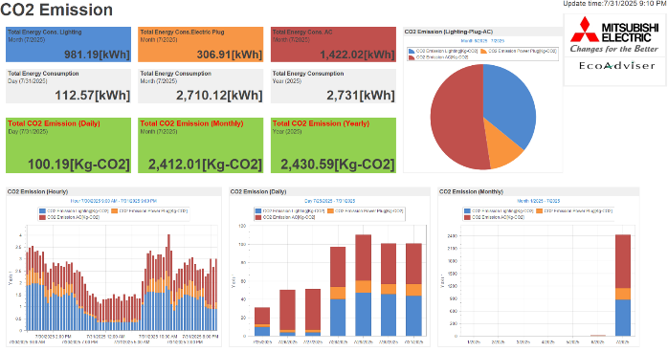

Figure 9. CO2 Emission Dashboard

The findings indicate that the integrated monitoring approach improved operational efficiency by reducing unnecessary energy use and strengthening sustainability efforts. The results also align with prior studies, which suggest that IoT-based energy monitoring systems improve visibility, enhance decision-making, and reduce costs in office environments [12].

CONCLUSION
The implementation of the smart office system provided facility managers with detailed insights into power usage, CO₂ emissions, and air conditioning performance data that had not been previously available due to the absence of measurement infrastructure in the earlier office setting. Although direct before-and-after comparisons could not be established, the system enabled the identification of inefficiencies such as prolonged lighting operation after working hours, inconsistent cooling across zones, and unnecessary standby power from idle equipment.
By transforming previously unavailable energy information into actionable insights, the system functions as a supporting Decision Support System (DSS) for facility managers. This capability allows for continuous performance evaluation, early detection of inefficiencies, and the formulation of targeted energy-saving strategies.

OPEN CONTRIBUTORSHIP
Apri Syam Halim, Responsible for the research methodology, implementation of the energy monitoring tools, formal analysis, investigation, and preparation of the initial draft.
Wahyu Sardjono, Supervision, critical review, and refinement of the manuscript, as well as providing guidance on the research framework and overall study.

OPEN DATA
Open data is available at https://drive.google.com/drive/folders/1tRskNcgk60aUXcZV4UP1k0YXhCVp9oeT

ACKNOWLEDGEMENT
This study received partial support from the Information System Management Department, BINUS Graduate Program – Master of Information System Management, Bina Nusantara University, Jakarta, Indonesia. The authors acknowledge the constructive feedback from the reviewers, which has significantly contributed to improving the quality and depth of this research.

References

[1] | M. M. B. R. N. S. M. &. A. Y. Poyyamozhi, "IoT—A Promising Solution to Energy Management in Smart Buildings," A Systematic Review, Applications, Barriers, and Future Scope. Buildings, 2024.
[2] | S. V. a. R. K. M. Pandiyan, "Advances in green IoT applications for smart grids and buildings," Sustainable Computing: Informatics and Systems 43, vol. 43, no. 100989, 2024.
[3] | J. D. M.-G. a. A. S.-L. E. Molina-Sánchez, "Is IoT monitoring key to improve building energy efficiency? Case study of a smart campus in Spain," Energy and Buildings 285, vol. 285, no. 112882, 2023.
[4] | C. F. a. S. Y. K. Zhou, "Big data driven smart energy management: From big data to big insights," Renewable and Sustainable Energy Reviews, vol. 56, p. 215–225, 2016.
[5] | T. X. a. R. H. N. O’Neill, "The role of data transparency in energy efficiency: Evidence from smart metering initiatives," Energy Policy, vol. 138, no. 111234, 2020.
[6] | T.-B. Lembcke, B. Herrenkind, I. Nastjuk and A. B. Brendel, "Promoting Business Trip Ridesharing with Green Information Systems: A Blended Environment Perspective," Transportation Research Part D: Transport and Environment Volume 94, May 2021, 102795, 2021.
[7] | M. P. G. S. M. Giacobbe, "An approach to implement the “Smart Office” idea: the #SmartMe Energy system," Journal of Ambient Intelligence and Humanized Computing, vol. 14, p. 1–19, 2023.
[8] | A. Daissaoui, A. Lbath, L. Karim and L. Karim, "IoT and Big Data Analytics for Smart Buildings: A Survey," Procedia Computer Science, vol. 170, pp. 161-168, 2020.
[9] | F. Maghsoodlou, R. Masiello and T. Ray, "Energy management systems," IEEE Power and Energy Magazine, vol. 2, pp. 49-57, 2004.
[10] | S. D. A. W. Liu, "Integration of decision support systems to improve decision support performance," Knowledge Information System, vol. 22, pp. 261-268, 2010.
[11] | A. H. Gatea, A. Al-Ibadi and M. A. Ali, "Smart office system: A review," 2024 17th International Conference on Development in eSystem Engineering (DeSE), vol. doi: 10.1109/DeSE63988.2024.10911973, pp. 25-30, 2024.
[12] | S. L. W. J. Q. Z. M. E. Y. S. L. Y. X. H. Xiu'e Yang, "Issues and challenges of implementing comprehensive renovation at aged communities," A case study of residents’ survey Energy and Buildings, vol. 249, no. 111231, ISSN 0378-7788, 2021.

