Maximum Power Point Tracking for Photovoltaic Water Pumping Systems Using the P&O Algorithm
Khusnul Hidayat^{1, a)}, Machmud Effendy^{1, b)}, and Nur Alif Mardiyah^{1, c)}
¹Department of Electrical Engineering, Universitas Muhammadiyah Malang, Indonesia
^{a)}Corresponding author: khusnulhidayat@umm.ac.id
^{b)}machmud@umm.ac.id
^{c)}nuralif@umm.ac.id
Abstract. This paper presents the modeling and performance analysis of a standalone photovoltaic (PV) water pumping system using a Perturb and Observe (P&O) maximum power point tracking (MPPT) algorithm. The system model, developed in MATLAB/Simulink, integrates a PV array based on the single-diode model, a DC–DC buck converter, a P&O-based MPPT controller, and a permanent magnet DC (PMDC) motor-driven submersible pump. The study compares the performance of two configurations: (i) PV-pump with MPPT-P&O and (ii) direct-coupled PV-pump without MPPT, under dynamically varying irradiance profiles (1000 W/m², 600 W/m², and 800 W/m²). Simulation results show that the MPPT-P&O configuration significantly outperforms the direct connection, achieving 2.6–4.5 times higher PV output power and 2.4–3.5 times greater water flow rate across all irradiance levels. Furthermore, the MPPT-P&O system exhibits better adaptability to rapid irradiance fluctuations, ensuring more stable and efficient water delivery. These findings highlight the importance of MPPT implementation in enhancing the efficiency and reliability of PV-powered water pumping systems, especially in regions with variable solar availability.
Keywords: buck converter, mppt, p&o, photovoltaic, water pump

INTRODUCTION
The increasing demand for clean water in rural and off-grid regions has driven the development of sustainable pumping solutions. Photovoltaic (PV)-powered water pumping systems (PVWPS) have emerged as an attractive alternative to conventional grid-powered or diesel-driven pumps due to their environmental benefits, low operating costs, and suitability for remote areas with abundant solar resources [1]. These systems directly convert solar energy into mechanical energy for water lifting, thereby eliminating the need for fossil fuels and reducing greenhouse gas emissions.
A typical PVWPS consists of a PV array, power electronic converters, an electric motor, and a pump. Depending on the configuration, the system may be designed as DC-driven or AC-driven, with either single-stage or multi-stage power conversion [1], [2]. However, the output of a PV array is inherently intermittent and non-linear due to variations in solar irradiance and temperature, making it necessary to employ maximum power point tracking (MPPT) techniques to maximize the utilization of the harvested solar energy [3].
Solar PV-powered water pumping systems have been widely investigated over the past decade due to their potential to provide reliable and sustainable water access in areas with limited infrastructure [1], [2], [3]. Early implementations relied on directly connected PV pumps without any power conditioning stages [4], which, although simple and low-cost, suffered from poor efficiency under variable weather conditions. To overcome this limitation, MPPT techniques have been introduced to ensure that the PV array operates at its maximum power point (MPP), thereby improving overall system performance [5], [6].
Among various MPPT algorithms, Perturb and Observe (P&O) remains the most widely used due to its simplicity, ease of implementation, and low computational requirements [3], [7]. However, conventional P&O suffers from oscillations around the MPP and reduced efficiency during rapidly changing environmental conditions [8], [9]. To address these drawbacks, researchers have proposed enhanced approaches, such as hybrid methods combining P&O with optimization algorithms like Particle Swarm Optimization (PSO) [8], [10], Grey Wolf Optimization (GWO) [7], [11], and fuzzy logic controllers [7], [9], which have demonstrated improved tracking speed and reduced oscillations. Artificial neural network (ANN)-based MPPT has also been proposed to predict optimal operating points with higher accuracy under dynamic irradiance [12].
Furthermore, the choice of motor and pump technology significantly influences system efficiency and reliability [6], [13], [14]. Permanent magnet DC (PMDC) motors are often used in small-scale systems due to their high torque-to-weight ratio [4], [15], while brushless DC (BLDC) and induction motors are commonly employed for larger-scale agricultural and industrial pumping applications [6], [14], [16]. Recent advancements also include the integration of multilevel inverters [16] and direct torque control (DTC) strategies [10] to enhance energy conversion efficiency and water output.
At the system level, intelligent MPPT integration with energy management strategies has enabled more stable water delivery even under fluctuating solar availability [13], [17]. Economic analyses have further confirmed the viability of PV water pumping systems, showing competitive payback periods compared to diesel-based alternatives [18].
While numerous studies have explored advanced MPPT techniques for PV water pumping systems, many of these approaches involve complex control algorithms or high computational overhead, which may not be practical for rural applications with limited technical support. Conventional P&O remains attractive due to its low cost and ease of implementation but still requires improvements to address its performance under rapid irradiance changes.
In this work, a P&O-based MPPT controller is designed and evaluated entirely through simulation using MATLAB/Simulink. The proposed approach focuses on improving the dynamic and steady-state performance of the P&O method while maintaining a simple structure suitable for low-cost deployment. The MATLAB/Simulink model incorporates realistic PV array characteristics, motor–pump dynamics, and environmental variations to assess the effectiveness of the control strategy.
The main contributions of this study are as follows: 1) development of a detailed MATLAB/Simulink model of a standalone PV-powered DC submersible pump system, 2) implementation of a P&O-based MPPT controller optimized for varying irradiance and temperature conditions, and 3) comprehensive simulation-based performance evaluation in terms of tracking efficiency, water output, and system response under dynamic solar conditions.

Methodology
The proposed solar water pumping system operates based on the direct conversion of solar energy into mechanical energy to lift groundwater for storage and distribution. As illustrated in Fig. 1(a) and Fig. 1(b), the system consists of five main components arranged sequentially: a PV array, a MPPT controller using the P&O algorithm, a DC submersible water pump, a water storage tank, and a distribution system.
In the configuration diagram shown in Fig. 1(a), solar irradiance is captured by the PV array and converted into electrical energy. However, due to the non-linear I–V characteristics of the PV module, the system requires a tracking mechanism to ensure that the PV array operates at its MPP under varying irradiance and temperature conditions. Therefore, an MPPT controller is employed using the widely used P&O algorithm, which adjusts the operating voltage of the PV array to maximize power extraction.
The regulated power output from the MPPT controller, as implemented in the physical system shown in Fig. 1(b), drives the DC submersible pump, which lifts water from the underground source to the elevated water tank. The stored water in the tank is then made available for usage through the distribution system, enabling gravity-fed supply to end users.
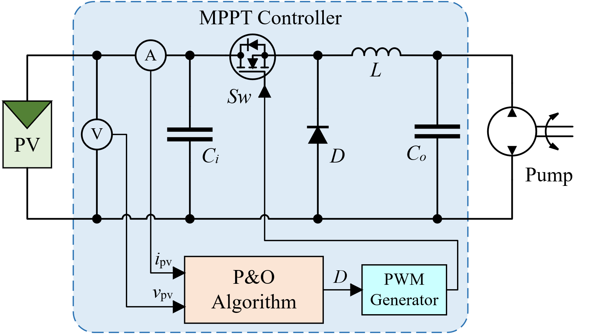 | 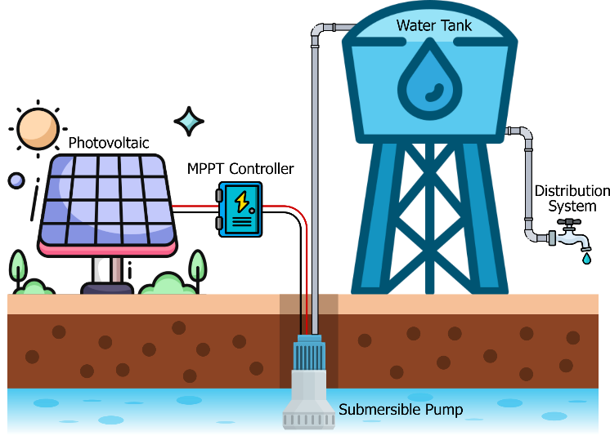
(a) | (b)
FIGURE 1. A solar-powered submersible DC water pump system: (a) configuration diagram; (b) physical implementation
This standalone system is particularly suitable for rural or off-grid areas with abundant solar resources, offering a sustainable solution for water access without reliance on fossil fuels or external electricity grids.

Photovoltaic Array Modeling
The PV array is modeled using the single-diode equivalent circuit model, as shown in Fig. 2, which represents the physical behavior of the solar cell with sufficient accuracy for system-level simulations. In this study, the shunt resistance R_{sh} is neglected due to its large value, making its effect on the overall model insignificant. The electrical parameters used in the simulation are listed in Table 1, which correspond to the Advance Power API-P250 module. These parameters are used to define the I–V and P–V characteristics in MATLAB/Simulink, allowing accurate representation of PV behavior under varying irradiance and temperature.
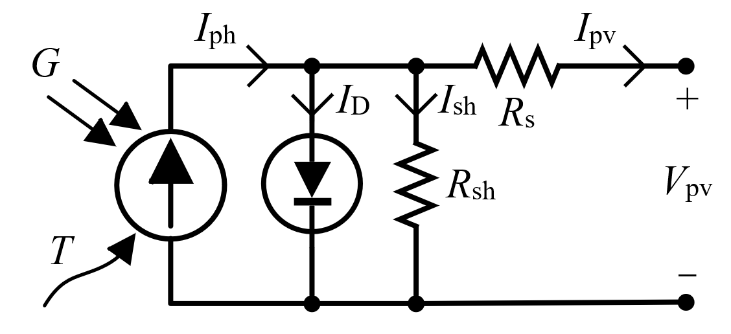
FIGURE 2. Single-diode equivalent circuit model of a PV cell
The output current of the PV array, I_{pv}, is described by the equation:
(1)
where, V_{pv} is the terminal voltage, I₀ is the diode reverse saturation current, R_{s} is the series resistance (internal losses), N_{s} is the number of PV cells connected in series, V_{t} is the thermal voltage.
The thermal voltage V_{t} is a function of the junction temperature and is calculated as:
(2)
where, n is the diode ideality factor (n = 1.2 for Monocrystalline silicon), k = 1.381 × 10-23 J/K is Boltzmann’s constant, q = 1.602 × 10-19 C is the electron charge, T_{k} is the PV cell temperature in Kelvin.
The PV model is implemented in MATLAB/Simulink with variable inputs for irradiance and temperature to reflect real-world conditions.

TABLE 1. Parameters of PV array (Advance Power API-P250 Module)
Symbol | Value and unit | Nomenclature
P_{max} | 250 W | Maximum Power
Ncell | 60 | Cells per module
Voc | 37.2 V | Open circuit voltage
Isc | 8.52 A | Short-circuit current
Vmp | 31.2 V | Voltage at maximum power
Imp | 8.03 A | Current at maximum power
Nms | 4 | Number of series-connected modules

MPPT Controller Using Perturb and Observe Algorithm
To maximize the power extracted from the PV array under varying environmental conditions, a MPPT controller is implemented using the P&O algorithm. This algorithm is favored due to its simplicity, ease of implementation, and low computational requirement.
The principle of the P&O algorithm is to periodically perturb the operating voltage of the PV module and observe the corresponding change in output power. If the power increases, the algorithm continues in the same direction; otherwise, it reverses the direction of perturbation. This logic allows the system to iteratively converge to the MPP.
Figure 3(a) illustrates the operating principle of the P&O algorithm on a typical PV power-voltage (P_{pv}-V_{pv}) curve. The five decision regions show how changes in power and voltage (ΔP_{pv}, ΔV_{pv}) determine whether to increase or decrease the duty cycle of the DC-DC converter. The MPP occurs when both ΔP_{pv} = 0 and ΔV_{pv} = 0.
The step-by-step logic of the algorithm is outlined in Fig. 3(b), which shows the control flowchart. The process begins by measuring the current voltage V(k) and current I(k) from the PV system, then calculating power as:
(3)
The changes in power and voltage from the previous step are calculated as:
(4)
(5)
Based on the sign of these values, the algorithm determines the next duty cycle adjustment D(k). After updating the duty cycle, the algorithm waits for a fixed interval (typically 100 ms) before repeating the process.
This technique enables the system to adapt dynamically to changes in irradiance and temperature, ensuring the PV array consistently operates near its maximum power point.
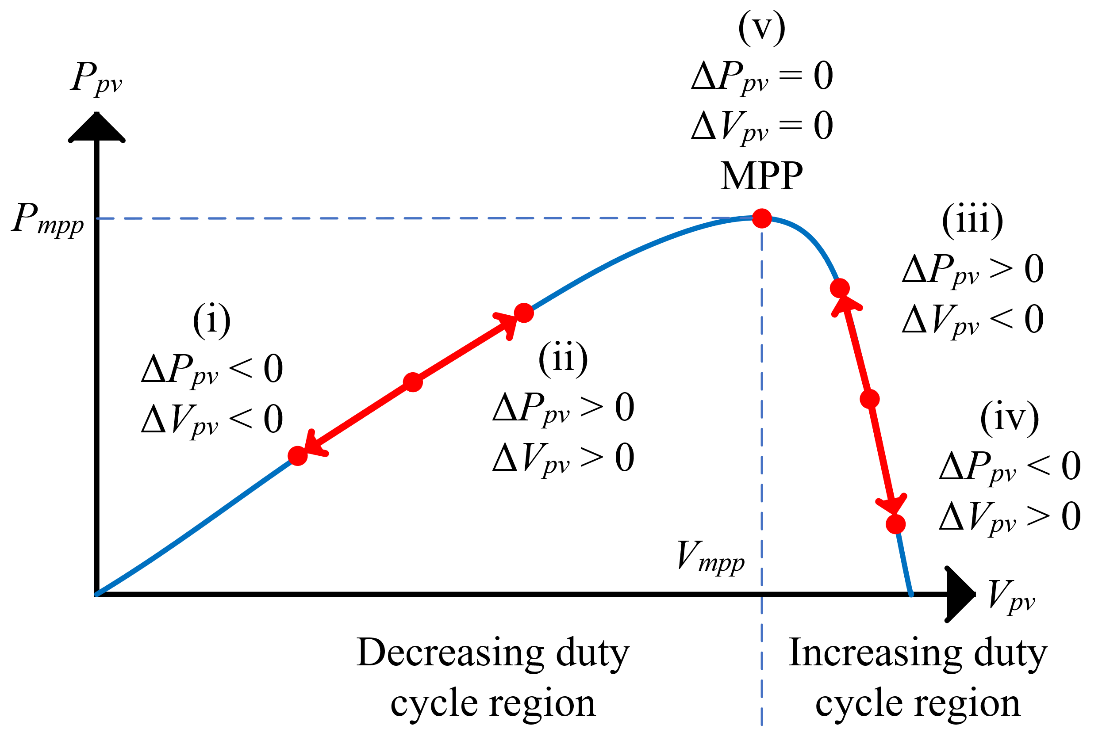 | 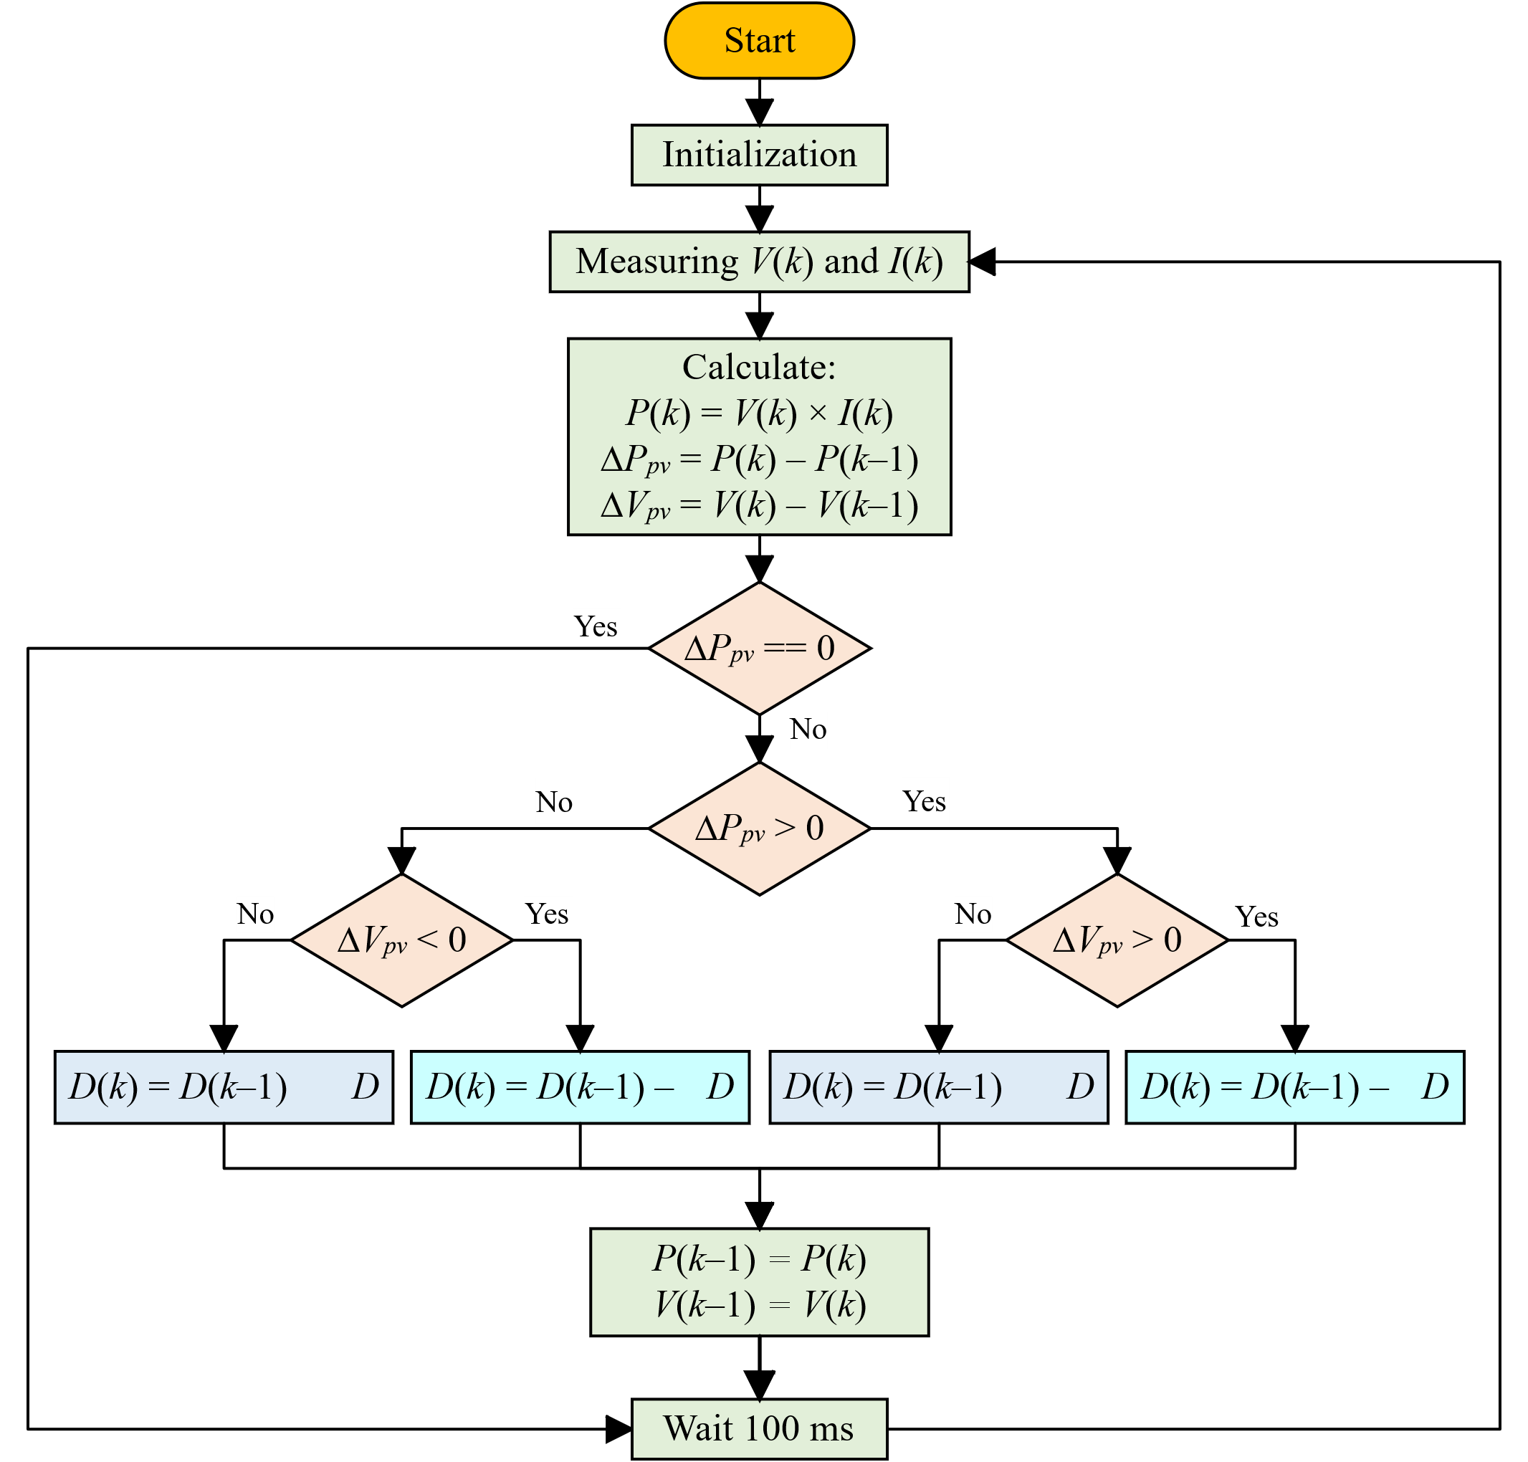
(a) | (b)
Figure 3. (a) Operating regions of the P&O algorithm on the P_{pv}-V_{pv} curve and (b) flowchart of the P&O algorithm

Buck Converter Design
The DC–DC buck converter is designed to regulate the PV voltage and deliver optimal power to the DC pump motor. The design parameters, including switching frequency, inductor, and capacitor values, are presented in Table 2. These values are selected to ensure low voltage ripple and stable operation of the MPPT controller. The converter steps down the PV voltage according to a controllable duty cycle D, defined as:
(6)
where V_{a} is the armature voltage of the DC pump motor (which is directly connected to the buck converter output) and V_{MPP} is the PV voltage at the MPP. Similar definitions have been adopted in PV-powered DC–DC converter design literature for MPPT systems [19].
In MPPT-controlled operation, the duty cycle varies continuously to track the PV maximum power point under changing irradiance and temperature conditions. However, for component sizing, the duty cycle at D_{MPP} is used, as this operating point demands the highest input current and therefore represents the most critical design case [19].
To maintain acceptable current and voltage ripple, the passive components—namely the inductor L, input capacitor C_{in}, and output capacitor C_{out}—are determined as follows.
The inductor value is chosen to limit the inductor current ripple ΔI_{L} to a desired percentage of the output current, according to:
(7)
where f_{sw} is the switching frequency. A lower ripple reduces output voltage fluctuations and eases the burden on the output capacitor, but requires a physically larger inductor [19].

The input capacitor is sized to attenuate the voltage ripple at the PV terminals ΔV_{pv}, which helps prevent rapid PV voltage variations that can disturb the MPPT algorithm. The required minimum value is given by:
(8)
where I_{MPP} is the PV current at MPP. In practice, ΔV_{pv} is often set to 1–2% of V_{MPP} to ensure stable MPPT operation [19], [20].
The output capacitor is selected to limit the output voltage ripple ΔV_{out} within acceptable limits for the load:
(9)
A smaller ripple ΔV_{a} percentage may be chosen for sensitive loads, while higher ripple may be tolerated for more robust applications such as pump motors [19].
It should be noted that these equations provide initial sizing values for ideal components. In practical implementation, additional factors such as capacitor ESR, temperature characteristics, and voltage derating must be taken into account. Typically, C_{in} is implemented as a combination of a bulk electrolytic capacitor for low-frequency energy buffering and multiple low-ESR ceramic capacitors to suppress high-frequency switching noise [20]. Likewise, C_{out} is often paralleled with ceramics to improve transient performance.
TABLE 2. Parameters of buck converter
Symbol | Value and unit | Nomenclature
f_{sw} | 5 kHz | Switching frequency
L | 1 mH | Inductor
C_{out} | 330 uF | Output capacitor
C_{in} | 4700 uF | Input capacitor

Modeling of PMDC Motor–Driven Submersible Pump
A permanent magnet direct current (PMDC) motor is selected due to its simple construction, high efficiency, and ease of control for solar-powered water pumping applications. The equivalent circuit of the PMDC motor is shown in Fig. 3, where the motor drives a submersible pump as the hydraulic load.
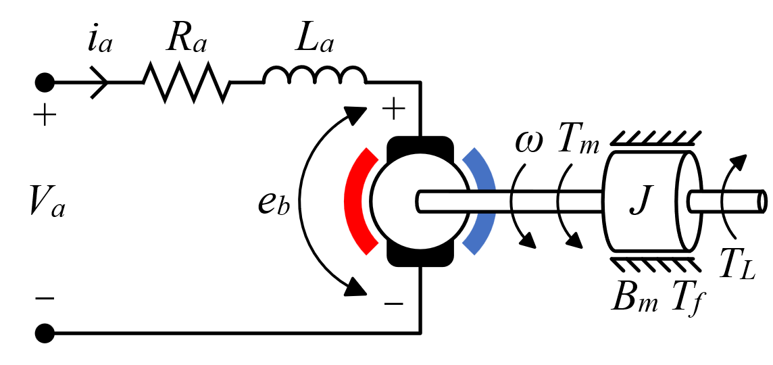
FIGURE 3. Equivalent circuit of PMDC motor

The electrical dynamics of the PMDC motor are expressed as [21], [22], [23]:
(10)
where V_{a}(t) is the armature voltage (V), i_{a}(t) is the armature current (A), R_{a} is the armature resistance (Ω), L_{a} is the armature inductance (H), and e_{b}(t) is the back-electromotive force (V), which is given by:
(11)
with K_{e} being the back-emf constant (V·s/rad) and ω(t) the rotor angular speed (rad/s).

The mechanical dynamics of the motor, considering the load torque from the centrifugal pump and rotational losses, can be modeled as [23]:
(12)
where J is the moment of inertia (kg·m²), T_{m}(t) = K_{t}⋅i_{a}(t) is the motor-generated torque (N·m), T_{L}(t) is the load torque from the pump (N·m), B_{m} is the viscous friction coefficient (N·m·s/rad), and T_{f} is the Coulomb friction torque (N·m).

Hydraulic Load Torque from a Centrifugal Pump
At any operating point, the hydraulic power delivered by the pump is
(13)
and the mechanical load torque applied to the motor shaft is
(14)
where ρ is fluid density, g gravity, Q volumetric flow rate, H_{pump} total dynamic head generated by the pump, η_{pump} pump hydraulic-to-shaft efficiency (used for calibration), ω shaft speed, and ε≪1 avoids division by zero near startup. Eq. (14) supplies the Mechanical load torque input of the PMDC block; viscous B_{m}ω and Coulomb T_{f} losses remain in the motor model (12).

Pump Characteristic at Rated Speed and Speed Scaling
From the rated curve data {(Q_{i}, H_{i})} supplied by the manufacturer, we build a smooth algebraic approximation at the rated speed ω₀ via least-squares polynomial fitting (quadratic is typically sufficient over the admissible flow range):
, Q in m³/s (15)
Coefficients (a₀, a₁, a₂) are obtained with MATLAB’s polyfit – Polynomial curve fitting.
To account for off-rated speed, affinity laws give the speed dependence (for geometrically similar operation):
, , , (16)
Combining (15)-(16), the head developed at speed ω can be written directly as
(17)

The classical affinity relations and their use in variable-speed performance prediction are well established and remain standard practice.

System Head Curve (Static + Losses)
The installation dictates the system curve as the sum of static and frictional heads:
(18)
Using Darcy–Weisbach for fully developed pipe flow and lumped minor-loss coefficients for fittings/valves, each of the lossy terms scales with Q². Expressing everything in terms of Q yields
, (19)
where f is the Darcy friction factor (function of Reynolds number and relative roughness), L pipe length, D diameter, and K_{tot} the sum of minor-loss coefficients. When needed, f can be computed explicitly via modern Colebrook surrogates such as the Swamee–Jain relation.
Cavitation constraint. The operating point must satisfy NPSH_{A}≥NPSH_{R} to avoid cavitation; this can be checked from suction conditions and catalog data and, if violated, enforced by limiting Q.

Operating Point Solution (Flow Rate)
At each simulation step, the quasi-steady pump operating condition is the intersection of (17) and (19):
(20)
With (17)–(19), this is a scalar quadratic in Q,
(21)
whose nonnegative real root gives Q(ω). If both roots are nonphysical (negative or complex), we clamp Q = 0 (shut-off). A Newton step seeded by the previous Q further improves robustness when the head curve is highly nonquadratic. The “pump curve ∩ system curve = operating point” construction is standard in pump engineering practice.
The PMDC motor and submersible pump parameters used in the simulation are summarized in Table 3. These include electrical constants, mechanical properties, and hydraulic characteristics, which are essential for accurately simulating the electromechanical and hydraulic performance of the water pumping system.
TABLE 3. Parameters of PMDC motor–driven submersible pump
Symbol | Value and unit | Nomenclature
V_{a} | 60 V | Armature voltage (rated)
I_{a}, i_{a} | 16.5 A | Armature current (rated)
ω | 272.3 rad/s | Shaft speed (rated)
R_{a} | 0.8 Ω | Armature resistance
L_{a} | 0.02 H | Armature self inductance
K_{e} | 0.01833 V/rpm | Back-emf constant
J | 0.024 kg·m² | Moment of inertia
T_{f} | 0.08 N·m | Coulomb friction torque
B_{m} | 0.001 N·m·s | Viscous friction coefficient
H_{s} | 10 m | Static head
D | 0.0254 m | Pipe inner diameter
L | 15 m | Pipe length
f | 0.02 | Darcy friction factor (Smooth PVC)
η_{p} | 0.7 | Pump efficiency
H_{0r} | 50 m | Pump shut-off head @ ω_{r}
Q_{r} | 0.000957 m³/s | Reference flow
ρ | 1000 kg/m³ | Water density
g | 9.81 m/s² | Gravity
a₀ | 79.0741 m | Pump curve coefficients
a₁ | -5.2889×10⁴ m/(m³/s) | Pump curve coefficients
a₂ | 9.93×10⁻⁸ m/(m³/s)² | Pump curve coefficients

RESULTS AND DISCUSSION
The performance evaluation of the proposed PV water pumping system was carried out entirely through simulation using MATLAB/Simulink. The developed model incorporates a PV array based on the single-diode equivalent circuit, a DC–DC buck converter, a P&O-based MPPT controller, and a PMDC motor-driven submersible pump. Environmental variations were emulated by dynamically changing the solar irradiance profile during the simulation to assess the system’s response under realistic operating conditions. Two configurations were compared: (i) a PV-pump system equipped with MPPT using the P&O algorithm, and (ii) a direct-coupled PV-pump system without MPPT. The comparison focuses on the PV output power and the resulting water flow rate, aiming to highlight the impact of MPPT on system performance under varying irradiance levels.
Figure 4(a) shows the solar irradiance profile applied during the simulation. Initially (0–15 s), the irradiance is maintained at 1000 W/m². At 15 s, the irradiance drops rapidly to 600 W/m² at 16 s and remains constant until 30 s. Subsequently, it increases to 800 W/m² at 31 s and is held constant until the end of the simulation. This profile simulates typical environmental variations such as passing cloud cover.
Figure 4(b) presents the PV output power for both configurations. At 1000 W/m², the MPPT-P&O system achieves an average PV power of 991.7 W, while the direct-coupled system produces only 301.3 W. When the irradiance drops to 600 W/m², the MPPT system maintains an average of 587.4 W compared to only 131.4 W for the direct-coupled system. At 800 W/m², the MPPT configuration outputs 792.1 W, significantly higher than the 205.7 W achieved by the direct connection. These results clearly indicate that the MPPT controller enables the PV array to operate much closer to its maximum power point under all irradiance levels.
Figure 4(c) shows the water flow rate for both configurations. At the highest irradiance (1000 W/m²), the MPPT system delivers 4309 L/h, more than double the 1946 L/h of the direct system. When the irradiance decreases to 600 W/m², the MPPT configuration sustains 3142 L/h, compared to just 909.5 L/h for the direct connection. At 800 W/m², the MPPT system achieves 3790 L/h, again well above the 1402 L/h of the non-MPPT system.
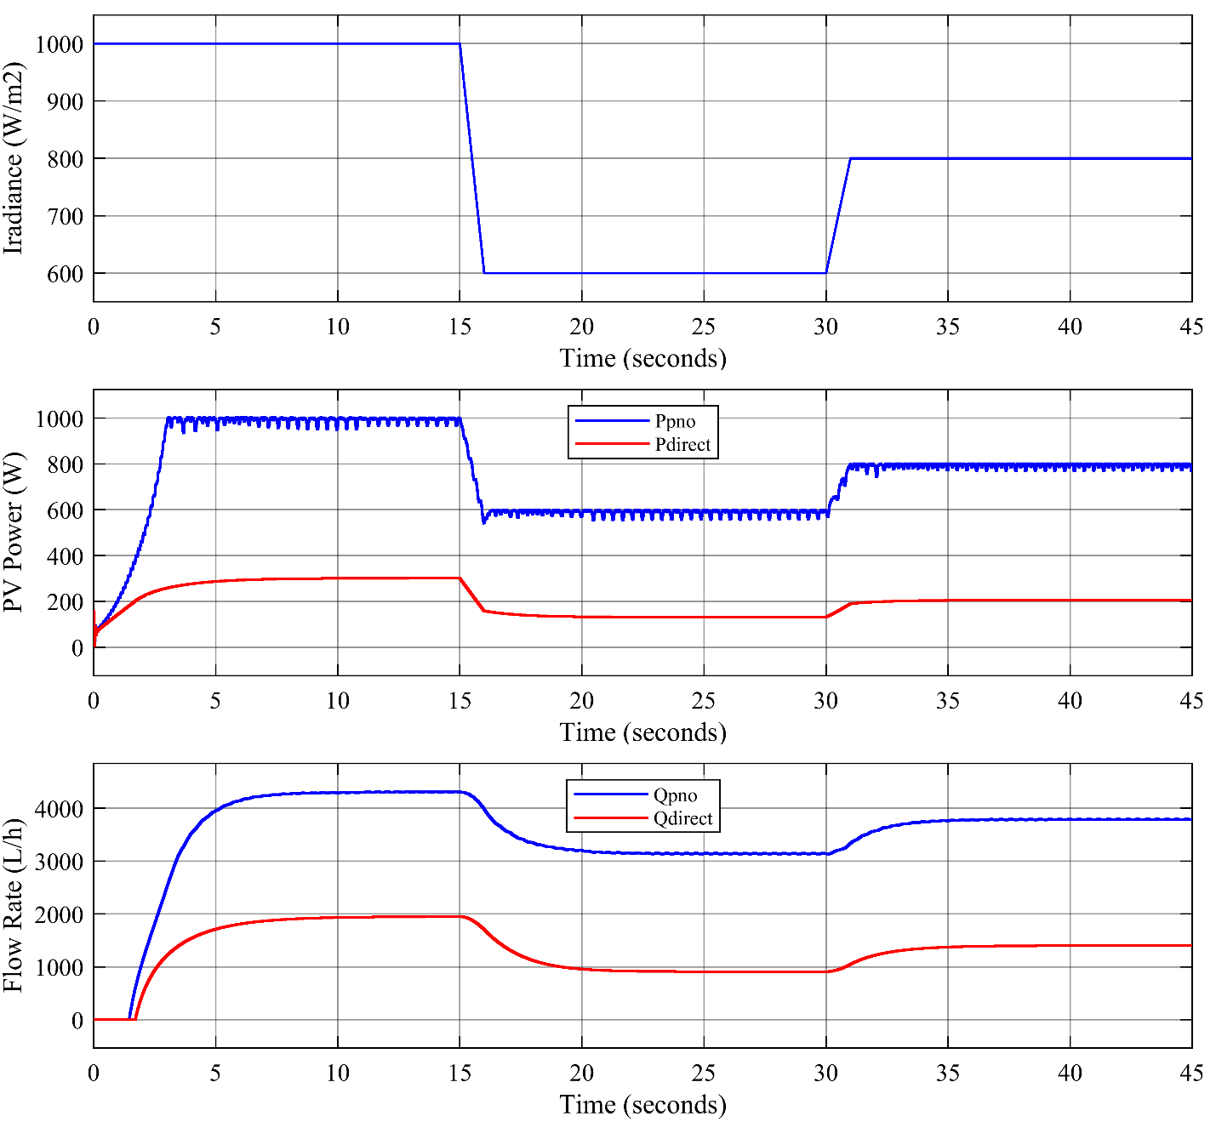
FIGURE 4. PV-pump performance with and without MPPT-P&O under varying irradiance
The summary of these results is provided in Table 4, which highlights the significant performance gap between the two configurations across all irradiance conditions. Overall, the P&O-based MPPT increases PV power output by approximately 2.6–4.5 times and water flow rate by about 2.4–3.5 times compared to the direct-coupled system. Furthermore, the MPPT system demonstrates strong adaptability to rapid irradiance fluctuations, ensuring stable and efficient water delivery under variable weather conditions.

TABLE 4. Average PV power and flow rate under different irradiance levels
Time (s) | Iradiance (W/m²) | Configuration | PV Power (W) | Flow Rate (L/h)
0-15 | 1000 | Direct | 301.3 | 1946
0-15 | 1000 | MPPT-P&O | 991.7 | 4309
16-30 | 600 | Direct | 131.4 | 909.5
16-30 | 600 | MPPT-P&O | 587.4 | 3142
31-45 | 800 | Direct | 205.7 | 1402
31-45 | 800 | MPPT-P&O | 792.1 | 3790

CONCLUSION
This study has presented the modeling and performance evaluation of a photovoltaic (PV) water pumping system equipped with a Perturb and Observe (P&O) maximum power point tracking (MPPT) algorithm, compared to a direct-coupled PV-pump configuration without MPPT. The simulation, conducted in MATLAB/Simulink under varying irradiance conditions, demonstrates that the MPPT-P&O system consistently delivers significantly higher PV output power and water flow rate than the direct connection.
The MPPT-P&O configuration increased PV power output by approximately 2.6–4.5 times and water flow rate by about 2.4–3.5 times compared to the non-MPPT system across all irradiance levels tested. Furthermore, the MPPT system exhibited strong adaptability to rapid irradiance fluctuations, ensuring more stable water delivery under dynamic weather conditions. These results confirm that implementing MPPT is essential for improving the efficiency and reliability of standalone PV water pumping systems, particularly in environments with frequent solar variability.
Future work may focus on experimental validation of the proposed system and exploring hybrid MPPT strategies to further enhance performance under partial shading or highly intermittent solar conditions.

References
1. L. Gevorkov, J. L. Domínguez-García, and L. T. Romero, “Review on solar photovoltaic-powered pumping systems,” Energies (Basel), vol. 16, no. 1, p. 94, 2023.
2. K. Muralidhar and N. Rajasekar, “A review of various components of solar water-pumping system: Configuration, characteristics, and performance,” International Transactions on Electrical Energy Systems, vol. 31, no. 9, p. e13002, 2021.
3. A. Hilali, Y. Mardoude, Y. Ben Akka, H. El Alami, and A. Rahali, “Design, modeling and simulation of perturb and observe maximum power point tracking for a photovoltaic water pumping system,” International Journal of Electrical and Computer Engineering, vol. 12, no. 4, pp. 3430–3439, 2022.
4. P. S. Sikder and N. Pal, “A comparison between directly connected and MPPT connected solar powered water pumping system using PMDC motor,” Journal of Power Technologies, vol. 98, no. 1, pp. 80–88, 2018.
5. A. Hilali, Y. Mardoude, A. Essahlaoui, A. Rahali, and N. El Ouanjli, “Migration to solar water pump system: Environmental and economic benefits and their optimization using genetic algorithm based MPPT,” Energy Reports, vol. 8, pp. 10144–10153, 2022.
6. F. Belgacem, M. Mostefai, M. Yahia, and A. Belgacem, “Optimization of photovoltaic water pumping system based on BLDC motor for agricultural irrigation with different MPPT methods,” Periodica Polytechnica Electrical Engineering and Computer Science, vol. 66, no. 4, pp. 315–324, 2022.
7. N. Priyadarshi and others, “A novel hybrid grey wolf optimized fuzzy logic control based photovoltaic water pumping system,” IET Renewable Power Generation, 2022.
8. S. Sumathi and T. Monika, “Water pumping system using PSO-MPPT algorithm based on solar photovoltaic,” in Proc. IEEE ICAAIC, 2022.
9. S. Assahout, H. Elaissaoui, A. El Ougli, B. Tidhaf, and H. Zrouri, “A neural network and fuzzy logic based MPPT algorithm for photovoltaic pumping system,” International Journal of Power Electronics and Drive Systems, vol. 9, no. 4, pp. 1823–1833, 2018.
10. A. Hilali and others, “Towards sustainable water pumping systems: Integration of particle swarm optimization and direct torque control PSO-DTC,” e-Prime - Advances in Electrical Engineering, Electronics and Energy, vol. 7, p. 100480, 2024.
11. D. Shetty and J. N. Sabhahit, “Grey wolf optimization and incremental conductance based hybrid MPPT technique for solar powered induction motor driven water pump,” International Journal of Renewable Energy Development, vol. 13, no. 1, pp. 52–61, 2024.
12. H. A. Attia, “High performance PV system based on artificial neural network MPPT with PI controller for direct current water pump applications,” International Journal of Power Electronics and Drive Systems, vol. 10, no. 3, pp. 1329–1338, 2019.
13. A. Loubna, R. Toufouti, and S. Meziane, “Standalone photovoltaic array fed induction motor driven water pumping system,” International Journal of Electrical and Computer Engineering, vol. 10, no. 5, pp. 4534–4542, 2020.
14. A. S. Kumar, T. P. V Raj, A. Tharagesh, and V. Prasanna, “Design and analysis of a permanent magnet DC motor,” in Advances in Systems, Control and Automation, Singapore: Springer, 2018, pp. 237–249.
15. C. A. Perez-Gomez, J. U. Liceaga-Castro, and I. I. Siller-Alcala, “Hard dead zone and friction modeling and identification of a permanent magnet DC motor non-linear model,” WSEAS Transactions on Systems and Control, vol. 15, pp. 527–538, 2020.
16. I. Saady and others, “Optimization and control of photovoltaic water pumping system using Kalman filter based MPPT and multilevel inverter fed DTC-IM,” Results in Engineering, vol. 17, p. 100829, 2023.
17. S. Jain, S. V. S. P. K. Ch, A. Keskar, J. X. Johnson, and S. Ghosh, “A hybrid MPPT algorithm for solar PV water pumping systems,” in Proc. IEEE STPEC, 2021.
18. A. Allouhi and others, “PV water pumping systems for domestic uses in remote areas: Sizing process, simulation and economic evaluation,” Renew Energy, vol. 132, pp. 1209–1221, 2019.
19. R. Ayop and C. W. Tan, “Optimum sizing of components for photovoltaic maximum power point tracking buck converter,” Solar Energy, vol. 160, pp. 322–335, Jan. 2018, doi: 10.1016/j.solener.2017.12.047.
20. Texas Instruments, “How to select input capacitors for a buck converter,” Analog Applications Journal, vol. 13, no. 1, pp. 24–29, 2016.
21. S. A. Khan, M. A. Khan, and M. A. Abido, “A review on solar-powered pump system for irrigation,” Renewable and Sustainable Energy Reviews, vol. 152, p. 111661, Jul. 2021, doi: 10.1016/j.rser.2021.111661.
22. N. M. Kumar, M. Sundareswaran, and S. P. Simon, “A review of maximum power point tracking algorithms for photovoltaic systems under uniform and non-uniform irradiance conditions,” Energy Procedia, vol. 54, pp. 71–80, 2020, doi: 10.1016/j.egypro.2020.01.012.
23. R. Krishnan, Electric Motor Drives: Modeling, Analysis, and Control, 2nd ed. Hoboken, NJ, USA: Wiley-IEEE Press, 2017.
24. Y. A. Çengel and J. M. Cimbala, Fluid Mechanics: Fundamentals and Applications, 4th ed. New York, NY, USA: McGraw-Hill, 2018.
25. S. Karassik, J. P. Messina, P. Cooper, and C. Heald, Pump Handbook, 5th ed. New York, NY, USA: McGraw-Hill, 2017.
26. A. B. S. Sidhu, S. S. Chandel, and A. K. Sharma, “Performance analysis of a solar photovoltaic water pumping system,” Energy Reports, vol. 5, pp. 1374–1387, Nov. 2019, doi: 10.1016/j.egyr.2019.09.028.
27. M. S. Ismail, M. Moghavvemi, and T. M. I. Mahlia, “Design of a PV/diesel standalone hybrid system for a remote community in Palestine,” Energy, vol. 111, pp. 1–13, Sep. 2016, doi: 10.1016/j.energy.2016.05.036.

