Warehouse Order Picking Simulation Model: Considering Storage Layout and Picker Routes
Muhammad Faisal Ibrahim^{a)}, Fahd Han Bey Ardafan^{b)}, Prita Meilanitasari^{c)}, and Maulin Masyito Putri^{d)}
Department of Logistics Engineering, Universitas Internasional Semen Indonesia, Gresik, Indonesia
^{a)} Corresponding author: muhammad.ibrahim@uisi.ac.id
^{b)} fahd.ardafan20@student.uisi.ac.id
^{c)} prita.meilanitasari@uisi.ac.id
^{d)} maulin.putri@uisi.ac.id
Abstract. Order picking accounts for 50–70% of warehouse costs and directly impacts customer satisfaction. To optimize this process, this study examines warehouse layouts and picker routes using simulation methods. Two layouts, chevron and leaf, are considered, as prior research suggests they can reduce order picking time by 10%–20%. The study also evaluates s-shape and return picker routes, chosen for their ease of implementation despite being less optimal. Additionally, ABC classification is incorporated, as it has been shown to reduce order picking time significantly. Results indicate the leaf layout offers the shortest picking time, reducing it by 3%–49% compared to existing and chevron layouts. ABC classification further decreases picking time by 28%–36%. For picker routes, the s-shape route reduces travel distance by 19%–45% compared to the return route. These findings demonstrate that optimizing layouts and routes can reduce picking time, improve order fulfillment speed, and enhance customer satisfaction, providing valuable insights for logistics optimization through simulation. This study contributes to the field of logistics by providing empirical evidence supporting the use of simulation methods to optimize warehouse layouts and picker routes.
Keywords: Order Picking, Picker Route, Storage Layout, Discrete Simulation, Warehouse.

INTRODUCTION
The intense business competition and high customer demand in today's market compel companies to enhance warehouse operations to shorten business process times [1, 2]. The wide variety and quantity of products stored in warehouses present a significant challenge that must be addressed in warehouse operations [3, 4]. Coupled with technological advancements, the trend of increasing consumer demand for higher quantities, shorter delivery times, and consistently high-quality service poses a challenge for companies or organizations. To meet these demands, warehouses must efficiently perform all operational activities such as receiving, putaway, cross-docking, order picking, and more, ensuring a smooth supply chain with minimal operational costs and high customer service levels [3, 5-8]. This study focuses on order picking activities because, according to several studies, order picking is the most crucial activity in terms of labor, time, and cost, accounting for 50–70% of total warehouse expenses [6, 9, 10]. According to Winkelhaus and Grosse [6] and Loske, Klumpp [11], the majority of companies still conduct the order picking process traditionally, with human labor, either manually or with the assistance of technology. Traditionally, the order picking process is carried out by operators who retrieve items from storage racks within the warehouse by walking along the aisles to locate and pick the required items, a method commonly referred to as the person-to-goods system [9, 12, 13].
According to De Koster, Le-Duc [9], the walking process in order picking accounts for 50% of the total order picking time. Several factors can influence the order picking process, including order picking methods, the size and layout of the storage system, material handling systems, product characteristics, demand trends, turnover rates, and space requirements [14]. The layout of the storage system, or warehouse layout, has a significant impact on order picking, accounting for up to 60% of the total influence of several factors, particularly concerning the distance required to retrieve items from storage locations [15]. In response to this, several warehouse layout innovations have been introduced, including the Flying-V layout, Fishbone layout, and Chevron layout [16, 17]. Additionally, there are the Inverted V layout [18], Leaf layout and Butterfly layout [19]. According to several studies, these warehouse layouts can reduce travel time by 10–20% in the order picking process [20]. Another factor that significantly influences order picking time is the type of route and the rules for product placement in storage locations [20]. Another factor that significantly impacts order picking time is the type of route and the rules for product placement in storage locations. Commonly used route types include s-shape, midpoint, largest gap, and return [20]. In practice, determining the picking routes in a warehouse is usually accomplished using heuristic methods [21]. This is due to several limitations in applying optimal routing in warehouse operations, such as frequently changing warehouse layouts [21, 22]. Meanwhile, a commonly used product placement rule is ABC classification, which, according to [20, 23] has a significant impact on the efficiency of order picking time.
This study will employ discrete-event simulation to test various layouts and picker routes concerning order picking time. According to several researchers, approximately 51% of simulations are widely used in order picking optimization cases [21, 24]. In this study, an order picking simulation model will be developed considering both the Chevron and Leaf layouts, with and without ABC classification, as well as applying s-shape and return picker routes. The simulation will aim to identify the configuration with the lowest average order picking time based on these considerations. In the past decade, there has been research on nontraditional warehouse layouts to minimize order picking time, including a study by [18] which analyzed order picking performance in Flying V and Inverted V layouts with optimal routing strategies using nonlinear programming models. The study found that with the same number of depots or destinations, the Flying V and Inverted V layouts exhibited 3-6% better order picking performance compared to traditional warehouse layouts. The study by Zhou, Liu [20], tested order picking performance on the Leaf layout using s-shape, return, and composite routing strategies with a Cuckoo algorithm. The findings indicated that the composite picker route strategy performed 40% better than both s-shape and return strategies. Among the strategies, return performed better than s-shape with fewer than 7 destinations, but as the number of destinations increased, the s-shape strategy outperformed the return strategy.
Additionally, the study by Öztürkoğlu, Gue [19] analyzed and tested the Chevron, Leaf, Fishbone, and Butterfly layouts regarding order picking travel distance using integral mathematical models. The study found that the Chevron and Fishbone layouts could reduce order picking travel distance by 19.53%. The Leaf layout reduced travel distance by 21.75%, while the Butterfly layout achieved a reduction of 22.52%. The study by Zhou, Zhao [23], analyzed return and s-shape routing strategies on the Fishbone layout, considering ABC classification using a stochastic model. The research found that the return strategy resulted in shorter travel distances compared to the s-shape strategy. Bortolini, Faccio [25], focused on the development of a V-shape layout design, incorporating ABC classification to shorten order picking travel time using a Sequential Quadratic Programming model. The study found that varying the degrees of rack inclination in the V-shape layout could reduce picking travel distance by 13–16%. The study by Yang, Liu [26] focused on optimizing workstation locations in a robotic mobile fulfillment system to shorten order picking travel distances in a warehouse with a Flying-V layout, using an integer programming model. The research found that the Flying-V layout could reduce total travel distance by 8–26% compared to a traditional warehouse layout. Masae, Glock [27] focused on optimizing order picking in a Chevron layout, considering picker routes such as s-shape, midpoint, largest gap, and optimal routes, as well as ABC classification and random storage assignment, using dynamic programming. The research demonstrated that using the optimal route algorithm reduced travel distance by 10.29–39.08% compared to the s-shape, largest gap, and midpoint routes.
Furthermore, research by Masae, Glock [1], on the efficiency of order picking routes on Leaf layout using s-shape, midpoint, return, and largest gap routes by considering random and class based storage assignment. Then some of these picker routes are compared with the exact algorithm using a dynamic programming model. The study found that the s-shape, midpoint, return, and largest gap routes resulted in travel distances that were 3.96%–43.68% longer compared to the optimal routes determined by the exact algorithm. Following the research by Altarazi and Ammouri [28] regarding the performance analysis of warehouse activities including receiving, unloading, putaway, storing, order preparation, and picking shipping on the fishbone layout by considering throughput, size, layout, manpower, and operational policies using the Arena simulation model. This study found that the horizontal warehouse layout has better performance than other warehouse layouts in the study. Later, research by Ibrahim, Meilanitasari [21] on analyzing order picking performance by considering s-shape, return, and midpoint routes and considering pick by paper and by voice using a discrete simulation model. This study shows that the best order picking scenario is using pick by voice, midpoint route, and with 2 pickers in the traditional warehouse layout.
The previous research studies mentioned above will serve as references for this study. Unlike those prior studies, this research uses an order picking simulation model aimed at reducing the order picking process time by considering the chevron layout and leaf layout. Additionally, the picker routes considered are the s-shape and return routes. Furthermore, the researcher also considers ABC classification to determine the placement of items based on their frequency of being picked.

METHODS
The methodology of this study is illustrated in FIGURE 1. The first stage involves a literature review on non-traditional warehouse layouts, picker routing methods, and ABC classification. These references were used as guidelines for developing the picker routes and designing the chevron and leaf layouts in the warehouse where the study was conducted. The next stage involves observation and data collection at the research site, a fulfillment warehouse located in Surabaya, Indonesia. The data collected includes warehouse size, the dimensions of storage areas, SOP for order picking, outbound goods data, picklist data, and order picking process times. These data will be used as inputs for the order picking simulation model in Arena Software. Subsequently, ABC classification calculations for the storage areas will be performed using the frequency of outbound goods within a given period. The ABC classification will yield storage category data that can be used for layout planning. The next stage involves modifying the existing warehouse layout to the chevron and leaf layouts, utilizing both ABC classification and the existing classification. The following step is the development of the simulation model in Arena Software, with several modules utilized as described in the Model Development section. The simulation model will be verified to ensure there are no errors in the program and validated to ensure that the simulation results, including the average order picking time per picklist and the number of completed picklists per day, do not significantly differ from the observed data in the warehouse.

FIGURE 1. Research Method

Once the model has been verified and validated, experiments with various scenarios can be conducted using the simulation model, with the details of the scenarios provided in TABLE 1. The simulation results, including the average daily order picking time, average picker utilization, and total picker travel distance, will be analyzed to assess the impact of the changes made and to identify the scenario that yields the lowest average order picking time.

PROBLEM DESCRIPTION
The warehouse studied in this research is used to store a variety of products from different manufacturers, which will later be distributed to end customers. The warehouse team must respond to manufacturers' requests by arranging the shipment of these products to the end customers. Through observations and interviews with the warehouse supervisor, it was found that the current warehouse employs a person-to-goods system with an inconsistent number of pickers, uses an s-shape picker route, and lacks a classification system for storage locations. FIGURE 2. illustrates the general order picking process. This process begins with the arrival of an order list, followed by the assignment of pickers. The pickers carry devices, such as smartphones, containing the list of items to be retrieved from the storage locations. These devices are also connected to barcode scanners for scanning the items to be picked. The pickers navigate the warehouse using an s-shape route. Once all items have been collected, the pickers proceed to the temporary storage area to place the items. After completing the order picking process, pickers may be assigned another pick list. This study aims to evaluate and optimize the order picking process in this fulfillment warehouse, with the goal of improving operational efficiency and reducing order picking time.
TABLE 1. Table information
Scenario | Layout | Picker Route | Item Classification | Picker Number | Scenario | Layout | Picker Route | Item Classification | Picker Number
1 | Existing Layout | s-shape | Existing | 6 | 19 | Chevron Layout | s-shape | ABC | 6
2 | Existing Layout | s-shape | Existing | 7 | 20 | Chevron Layout | s-shape | ABC | 7
3 | Existing Layout | s-shape | Existing | 8 | 21 | Chevron Layout | s-shape | ABC | 8
4 | Existing Layout | return | Existing | 6 | 22 | Chevron Layout | return | ABC | 6
5 | Existing Layout | return | Existing | 7 | 23 | Chevron Layout | return | ABC | 7
6 | Existing Layout | return | Existing | 8 | 24 | Chevron Layout | return | ABC | 8
7 | Existing Layout | s-shape | ABC | 6 | 25 | Leaf  Layout | s-shape | Existing | 6
8 | Existing Layout | s-shape | ABC | 7 | 26 | Leaf  Layout | s-shape | Existing | 7
9 | Existing Layout | s-shape | ABC | 8 | 27 | Leaf  Layout | s-shape | Existing | 8
10 | Existing Layout | return | ABC | 6 | 28 | Leaf  Layout | return | Existing | 6
11 | Existing Layout | return | ABC | 7 | 29 | Leaf  Layout | return | Existing | 7
12 | Existing Layout | return | ABC | 8 | 30 | Leaf  Layout | return | Existing | 8
13 | Chevron Layout | s-shape | Existing | 6 | 31 | Leaf  Layout | s-shape | ABC | 6
14 | Chevron Layout | s-shape | Existing | 7 | 32 | Leaf  Layout | s-shape | ABC | 7
15 | Chevron Layout | s-shape | Existing | 8 | 33 | Leaf  Layout | s-shape | ABC | 8
16 | Chevron Layout | return | Existing | 6 | 34 | Leaf  Layout | return | ABC | 6
17 | Chevron Layout | return | Existing | 7 | 35 | Leaf  Layout | return | ABC | 7
18 | Chevron Layout | return | Existing | 8 | 36 | Leaf  Layout | return | ABC | 8
FIGURE 2. Order Picking Process

MODEL DEVELOPMENT
The simulation was conducted using Arena software and ran for a duration of 24 days. At the initial stage of the study, observations were made to understand the existing warehouse layout. The warehouse layout is divided into two main sections: the rack storage area and the pallet storage area, as shown in FIGURE 4. Each picking location (station) is identified with the code "R" for rack picking and "F" for pallet picking, followed by a number to identify the specific station. Regarding the routes used, the s-shape and return routes were chosen. Since multiple route options could arise in the warehouse, it was necessary to determine the shortest routes for both the s-shape and return paths. The shortest routes in the existing layout will be applied to the chevron layout and leaf layout (detailed route calculations are provided in the Supporting File). The next step involves calculating ABC classification based on the frequency of items leaving each storage location (detailed calculations are also available in the Supporting File). Due to the presence of ABC classification, each layout type will have a version that either uses the existing classification and a version that applies ABC classification. The simulation model in Arena software utilizes several modules, including create, assign, decide, process, and dispose. Additionally, advanced process modules such as seize and release, as well as advanced transfer modules like station and route, were used. Overall, the simulation model in Arena software can be seen in FIGURE 3.

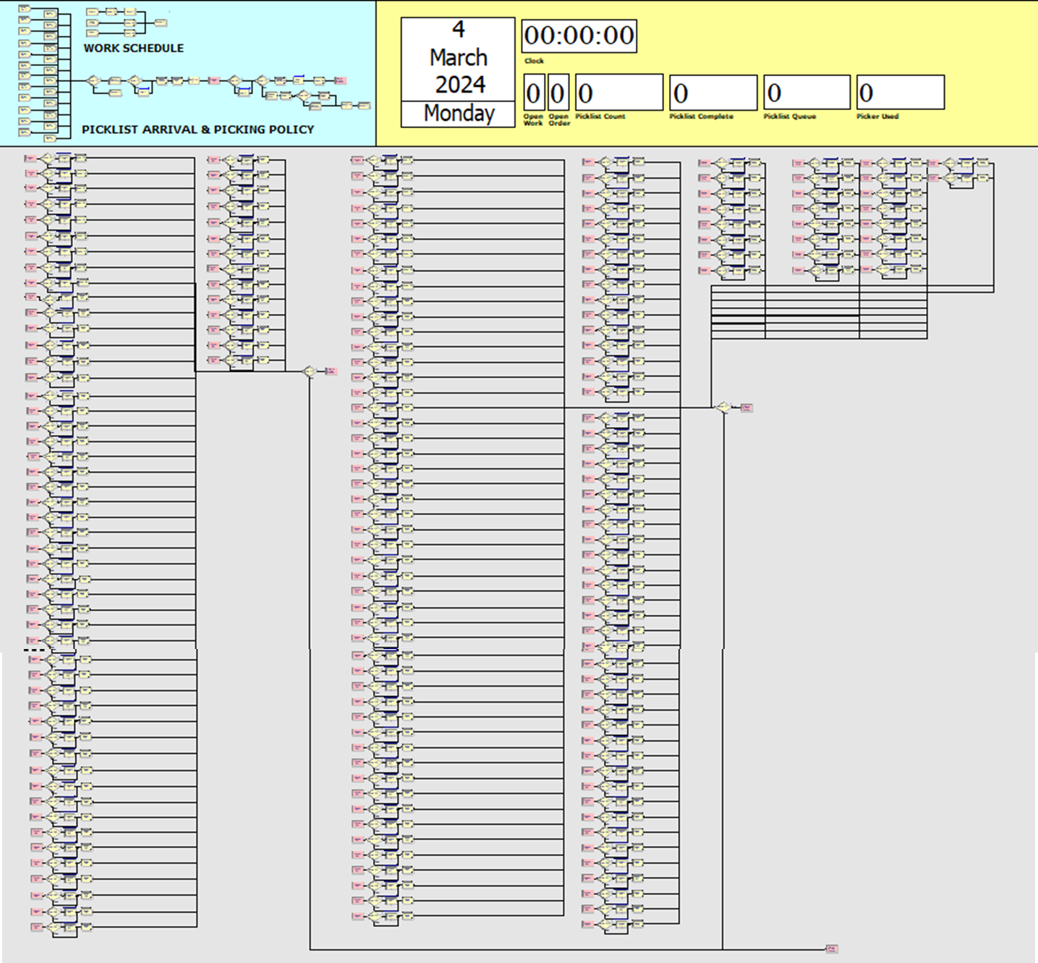
FIGURE 3. Supplementary Material 1. Simulation Model by Arena Software

Several assumptions were made in the development of the simulation model in Arena Software, including (1) Stock is always available whenever the order picking process is carried out; (2) The number of levels on the racks is considered uniform; (3) The picker is capable of retrieving all items in a single picklist; (4) The picker's average walking speed is 81 meters per minute; (5) A single station location can encompass four pallet storage areas and two rack locations, as the picker can easily reach items within one station.
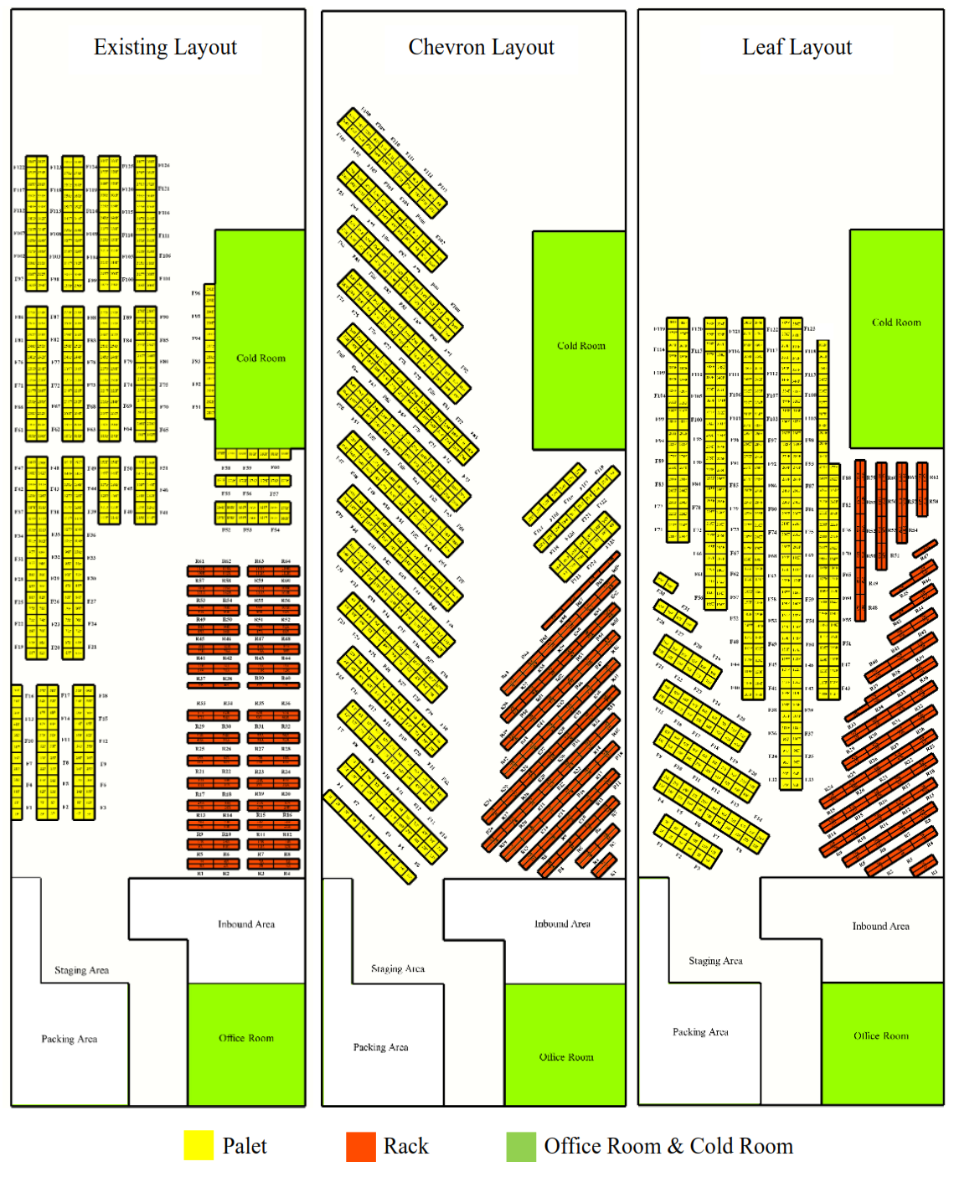
FIGURE 4. Warehouse Layout

MODEL ELEMENTS
Arena Software includes various modules that can be used to identify specific processes or calculations within a system. The modules utilized in the order picking simulation model are as follows:

Create Modules
The create module is used to generate entities within the system. In this simulation model, the entities are represented by picklists. The picklists arrive during warehouse working hours and appear according to the number of picklists for that particular day. An example of the create module is shown in FIGURE 5. A total of 24 create modules are used in the simulation since it runs over a span of 24 days.

Process Modules
The process module is used to identify the duration of a particular process. In the order picking simulation, this module is applied to the picking process at each station. Since the picking times vary between stations using pallets and those using racks, specific expressions are required to represent the picking times. For rack stations, the expression used is 4.5 + 69 * BETA(0.577, 0.691) , while for pallet stations, the expression is 4.5 + WEIB(8.96, 1.51). An example of the process module is shown in FIGURE 6.

Assign Modules
The assign module is used to provide attributes to entities. In the order picking simulation, attributes determine the number of items to be picked at the designated station, the likelihood of that station being visited within a single picklist, the route to be used, and the number of pickers assigned. An example of the use of the assign module, particularly for determining the station to be visited (Assign Station) and the number of items to be picked at that station (Assign Unit), can be seen in FIGURE 7. The attributes used in Assign Station and Assign Unit are expressed as expressions based on the picklist data.

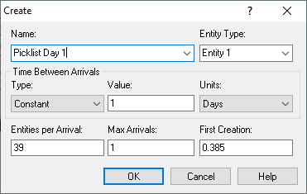 | 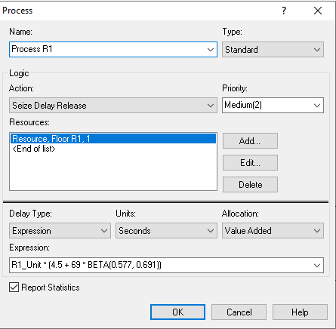 | 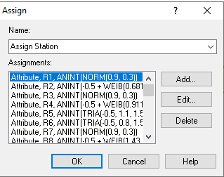  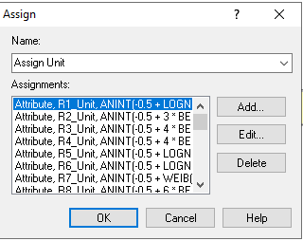
FIGURE 5. Create Module | FIGURE 6. Process Module | FIGURE 7. Assign Module

Seize and Release Modules
The seize module is used to assign a picker to retrieve items according to the attributes specified in the picklist. When the picker is engaged in order picking, their status is marked as busy. Once the picker has collected the items from the station, they will place them in the staging area. If all items have been picked, the entity will be released from the picker, who will then become idle and wait for the next picklist to arrive before starting the order picking process again. This process is detailed in FIGURE 8.

Station and Route Modules
The station module is used to identify the location of stations within the warehouse. Each station in the warehouse is assigned an identity through this module, allowing the picker to navigate to the appropriate station after passing through the seize module. The route module, on the other hand, is used to define the path the picker will take to retrieve items according to the picklist. This module needs the travel distances from the starting point to each warehouse station, as illustrated in FIGURE 9.

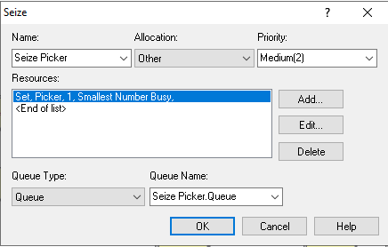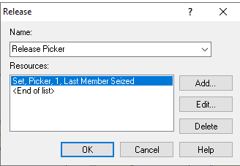 | 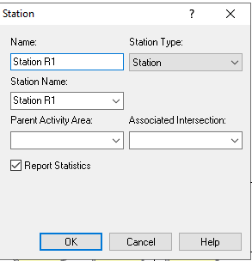  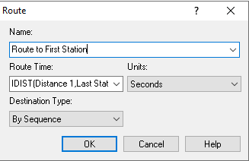
FIGURE 8. Seize & Release Module | FIGURE 9. Station & Route Module

RESULTS AND DISCUSSION
The order picking simulation model has been verified and validated. The simulation results for various scenarios are detailed in TABLE 1. and illustrated in FIGURE 10. The existing condition, represented by Scenario 1, shows an average order picking time of 3.4998 hours per day. In contrast, Scenario 33, which uses a leaf layout with ABC classification, an s-shape route, and 8 pickers, achieves the lowest average order picking time of 1.9961 hours per day. This demonstrates a significant reduction compared to Scenario 1, with a time difference of 1.4537 hours. Conversely, Scenario 16, using a chevron layout without ABC classification, an s-shape route, and 6 pickers, shows the highest average order picking time of 3.9167 hours per day. The chevron layout consistently results in higher average order picking times across all considered aspects compared to the existing layout. In contrast, the leaf layout generally yields the lowest average order picking times compared to both the existing and chevron layouts. Furthermore, implementing ABC classification in any layout has proven to reduce the average order picking time compared to layouts without ABC classification, as seen in Scenario 1 and Scenario 7. Both scenarios use the existing layout, 6 pickers, and an s-shape route, but Scenario 1 does not apply ABC classification while Scenario 7 does, showing a time difference of 0.9979 hours with Scenario 7 achieving the lower time.
The number of pickers also affects the order picking time. In every layout, having 8 pickers results in a lower average order picking time compared to having 6 pickers. For instance, Scenario 1 and Scenario 4 use the existing layout without ABC classification and an s-shape route, with Scenario 1 having 6 pickers and Scenario 4 having 8 pickers, showing a time difference of 0.5863 hours. Additionally, the s-shape route consistently results in lower average order picking times compared to the return route. The total travel distance for the s-shape route is shorter than that for the return route in all tested layouts. For example, in the leaf layout, the s-shape route has a total distance 364.9 meters shorter than the return route. The picker utilization aspect also shows a correlation with the order picking time. As the average order picking time decreases, the average picker utilization also decreases. Similarly, increasing the number of pickers reduces the average picker utilization. The leaf layout tends to show the lowest picker utilization compared to the existing and chevron layouts. Based on the simulation results, it can be concluded that non-traditional warehouse layouts, particularly the leaf layout, significantly reduce order picking times. The picker route also impacts the order picking time, with the s-shape route performing better than the return route. However, it is essential to note that the tested warehouse layouts are compatible with the s-shape route.

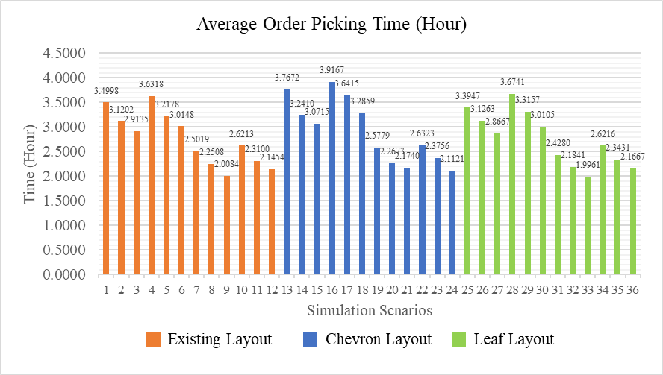
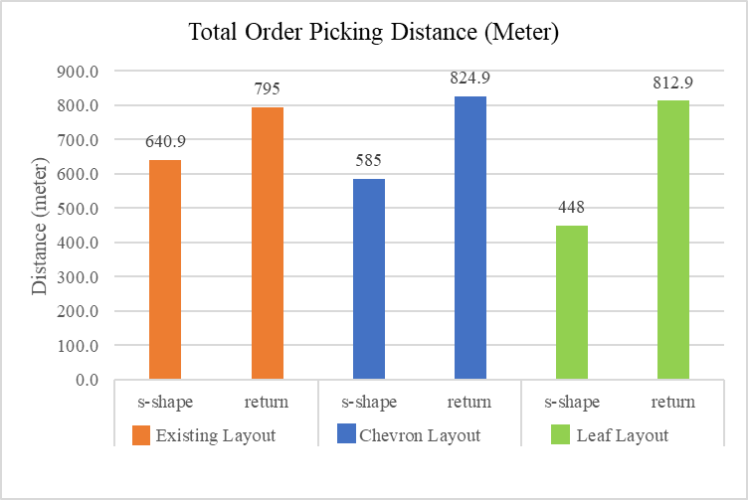
FIGURE 10. Simulation Result

CONCLUSIONS
This study focuses on the implementation of chevron layout, leaf layout, s-shape picker route, and return picker route using a discrete event simulation model in Arena Software to minimize order picking time in warehouse. Additionally, ABC classification and varying numbers of pickers are also considered in this research, resulting in 36 simulation scenarios. Among these scenarios, Scenario 33 achieves the lowest average order picking time of 1.9961 hours per day. Based on the simulation results, it can be concluded that the leaf layout provides the lowest order picking time, with a reduction of 3% – 49% compared to the existing and chevron layouts. The implementation of ABC classification also proves to reduce the average order picking time by 28% – 36% across all layouts. For the picker routes, the s-shape route shows the shortest travel distance, with a reduction of 19% – 45% compared to the return route across each layout. However, the study's limitations such as human error, various warehouse size and various order picking policy, and its focus on specific layouts and picker routes, potentially overlooking other effective strategies. Future research could address these gaps by exploring additional non-traditional warehouse layouts, consider scenarios such as single pickup or out-of-stock products, and also considering special treatment to specific product such as dangerous goods or perishable goods. Examining these factors can provide further insights into optimizing order picking efficiency and adapting strategies to various operational challenges.

Acknowledgments
This study is supported and financed by Universitas Internasional Semen Indonesia under the HRKK Grant Program. Acknowledgments extend to prior researchers whose findings contributed to this paper.

References
1. Masae, M., C.H. Glock, and P. Vichitkunakorn, A method for efficiently routing order pickers in the leaf warehouse. International Journal of Production Economics, 2021. 234: p. 108069.
2. Zhang, M., E.H. Grosse, and C.H. Glock, Ergonomic and economic evaluation of a collaborative hybrid order picking system. International Journal of Production Economics, 2023. 258: p. 108774.
3. Boysen, N., R. De Koster, and F.J.E.J.o.O.R. Weidinger, Warehousing in the e-commerce era: A survey. 2019. 277(2): p. 396-411.
4. Engels, T., et al., Exact results for the order picking time distribution under return routing. Operations Research Letters, 2023. 51(2): p. 179-186.
5. Shetty, N., B. Sah, and S.H. Chung, Route optimization for warehouse order picking operations via vehicle routing and simulation. SN Applied Sciences, 2020. 2(2): p. 311.
6. Winkelhaus, S. and E.H. Grosse, Logistics 4.0: a systematic review towards a new logistics system. International Journal of Production Research, 2020. 58(1): p. 18-43.
7. Giannikas, V., et al., An interventionist strategy for warehouse order picking: Evidence from two case studies. International Journal of Production Economics, 2017. 189: p. 63-76.
8. Tongliang, Z., et al., Upgrading of intelligent warehouse management system based on RFID technology-taking company as an example. 2019. 4(3): p. 840-844.
9. De Koster, R., T. Le-Duc, and K.J.J.E.j.o.o.r. Roodbergen, Design and control of warehouse order picking: A literature review. 2007. 182(2): p. 481-501.
10. Boysen, N., R. de Koster, and D. Füßler, The forgotten sons: Warehousing systems for brick-and-mortar retail chains. European Journal of Operational Research, 2021. 288(2): p. 361-381.
11. Loske, D., et al., Storage systems’ impact on order picking time: An empirical economic analysis of flow-rack storage systems. International Journal of Production Economics, 2023. 261: p. 108887.
12. Grosse, E.H., C.H. Glock, and W.P.J.I.j.o.p.r. Neumann, Human factors in order picking: a content analysis of the literature. 2017. 55(5): p. 1260-1276.
13. Öztürkoğlu, Ö. and D. Hoser, A discrete cross aisle design model for order-picking warehouses. European Journal of Operational Research, 2019. 275(2): p. 411-430.
14. Chan, F.T. and H.K.J.E.s.w.a. Chan, Improving the productivity of order picking of a manual-pick and multi-level rack distribution warehouse through the implementation of class-based storage. 2011. 38(3): p. 2686-2700.
15. Caron, F., G. Marchet, and A. Perego, Optimal layout in low-level picker-to-part systems. International Journal of Production Research, 2000. 38(1): p. 101-117.
16. Meller, R.D. and K.R. Gue. The application of new aisle designs for unit-load warehouses. in NSF Engineering Research and Innovation Conference. 2009. Citeseer.
17. Pohl, L.M., R.D. Meller, and K.R. Gue. A new aisle design for dual-command travel. in IIE Annual Conference. Proceedings. 2010. Institute of Industrial and Systems Engineers (IISE).
18. Gue, K.R., G. Ivanović, and R.D. Meller, A unit-load warehouse with multiple pickup and deposit points and non-traditional aisles. Transportation Research Part E: Logistics and Transportation Review, 2012. 48(4): p. 795-806.
19. Öztürkoğlu, Ö., K.R. Gue, and R.D. Meller, Optimal unit-load warehouse designs for single-command operations. IIE Transactions, 2012. 44(6): p. 459-475.
20. Zhou, L., et al. Performance Analysis of Picking Routing Strategies in the Leaf Layout Warehouse. Mathematics, 2022. 10, DOI: 10.3390/math10173149.
21. Ibrahim, M.F., et al. Order Picking System Simulation Model Considering Picking Method and Picker Route to Improve Warehouse Performance. in 2023 IEEE 8th International Conference on Recent Advances and Innovations in Engineering (ICRAIE). 2023.
22. Roodbergen, K.J. and R. Koster, Routing methods for warehouses with multiple cross aisles. International Journal of Production Research, 2001. 39(9): p. 1865-1883.
23. Zhou, L., et al., Stochastic models of routing strategies under the class-based storage policy in fishbone layout warehouses. 2022. 12(1): p. 12876.
24. Van Gils, T., et al., Designing efficient order picking systems by combining planning problems: State-of-the-art classification and review. 2018. 267(1): p. 1-15.
25. Bortolini, M., et al., Design of diagonal cross-aisle warehouses with class-based storage assignment strategy. The International Journal of Advanced Manufacturing Technology, 2019. 100(9): p. 2521-2536.
26. Yang, X., et al. Non-Traditional Layout Design for Robotic Mobile Fulfillment System with Multiple Workstations. Algorithms, 2021. 14, DOI: 10.3390/a14070203.
27. Masae, M., C.H. Glock, and P. Vichitkunakorn, Optimal order picker routing in the chevron warehouse. IISE Transactions, 2020. 52(6): p. 665-687.
28. Altarazi, S.A. and M.M. Ammouri, Concurrent manual-order-picking warehouse design: a simulation-based design of experiments approach. International Journal of Production Research, 2018. 56(23): p. 7103-7121.

