Implementation of Bidirectional LSTM Architecture for Enhanced Job Posting Authenticity Detection
Imelda Azaliya Rahma^{a)}, Ahya Nika Salsabila^{b)}, Vinna Rahmayanti Setyaning Nastiti^{c)}, Yufis Azhar^{d)}, and Denar Regata Akbi^{e)}
Informatics Engineering, University of Muhammadiyah Malang, Malang, Indonesia

^{e)} Corresponding author: dnarregata@umm.ac.id
^{a)} imeldaazaliya@webmail.umm.ac.id
^{b)} ahyaniks03@webmail.umm.ac.id
^{c)} vinastiti@umm.ac.id
^{d)} yufis@umm.ac.id
Abstract. Online job fraud is a significant and widespread phenomenon globally, with detrimental impacts on many individuals. Based on information from the Global Anti-Scam Summit (2023), it is estimated that one in four individuals worldwide are affected by fraud, with global losses reaching approximately $1.026 trillion in the past year. This research aims to develop and apply Natural Language Processing (NLP) algorithms to improve detection of the authenticity of job vacancies. With a focus on accuracy, handling overfitting, and using a more comprehensive dataset, this research utilizes the latest techniques such as Bi-LSTM to design a more effective detection system. The Bi-LSTM algorithm was chosen for its ability to capture long-term dependencies in text data, which is critical in identifying complex fraud patterns. The research results show that the developed model achieved 98% accuracy, indicating its effectiveness in detecting fake job vacancies. Implementation of this model enables fast and accurate detection of suspicious job advertisements in real time. Thus, this research is expected to help users identify and avoid fraud in job advertisements more effectively, increasing user security in searching for work via digital platforms.
Keywords: Job Vacancy Fraud, Natural Language Processing, Bi-LSTM, Authenticity Detection, Accuracy.

INTRODUCTION
Online job fraud is a significant global problem, affecting one in four individuals with global losses reaching an estimated $1.026 trillion in the past year, according to the Global Anti-Scam Summit (2023). These scams often involve identity fraud and financial fraud, where fraudsters use well-known company names to attract victims on platforms such as LinkedIn and Indeed. This not only wastes job seekers' time, but also increases the risk of identity theft and financial loss.
Recent research proposes using Natural Language Processing (NLP) to detect fake job postings with high accuracy. One of the promising algorithms​ is Bi-directional Long Short-Term Memory (Bi-LSTM), a type of Recurrent Neural Network (RNN). Bi-LSTM is well known Because of its ability to understand the context of text data in a way better compared to the method conventional, which processes text data in two directions, forward and backward. This allows the model to capture temporal dependencies and contextual information more effectively, which is critical in detecting complex fraud patterns in job descriptions [1] [2].
Previous research shows that traditional methods for detecting job vacancy fraud have limitations, such as low accuracy and difficulty capturing temporal context [3] [4]. For instance, Random Forest models have been able to achieve only 81% accuracy in detecting fraudulent job postings due to their inability to capture sequential data effectively. GRU models, another type of Recurrent Neural Network, have shown better performance with a 94% accuracy rate but still fall short in capturing nuanced linguistic patterns that indicate fraud [5]. Naive Bayes models, which rely on strong independence assumptions between features, achieve up to 95% accuracy, but they are less effective when dealing with complex language structures in job descriptions [6]. LightGBM, a gradient boosting framework, performs better than the aforementioned models with a 96% accuracy rate; however, it still does not match the performance of more sophisticated NLP models in detecting subtle fraud indicators [7].
Patel et al. (2022) demonstrate that Bi-LSTM can achieve up to 92% accuracy in detecting occupational fraud, which is a significant improvement over traditional method [8]. In the last five years, Bi-LSTM has been used in a variety of NLP applications, including sentiment analysis and fraud detection, demonstrating its effectiveness in dealing with complex text data [9]. Characteristics main from Bi-LSTM, such as his ability to catch dependencies period long in text data, making it very effective in identifying suspicious patterns that might not be detected by the algorithm, like Random Forest or Logistic Regression [10] [11].
Therefore, this research aims to develop and apply Bi-LSTM to improve the detection of authenticity vacancy work with a focus on accuracy, handling overfitting, and using comprehensive datasets [12]. The urgency of using Bi-LSTM is high considering the negative impact of employment fraud on individuals and society [13]. Thus, it is hoped that this research can make a significant contribution to increasing user security in searching for work via digital platforms.

METHODS
The methodology includes various steps carried out by a researcher, starting from planning, implementing and processing data to drawing conclusions and disseminating research results. In the process, this research went through several processes, which can be seen in the FIGURE 1.

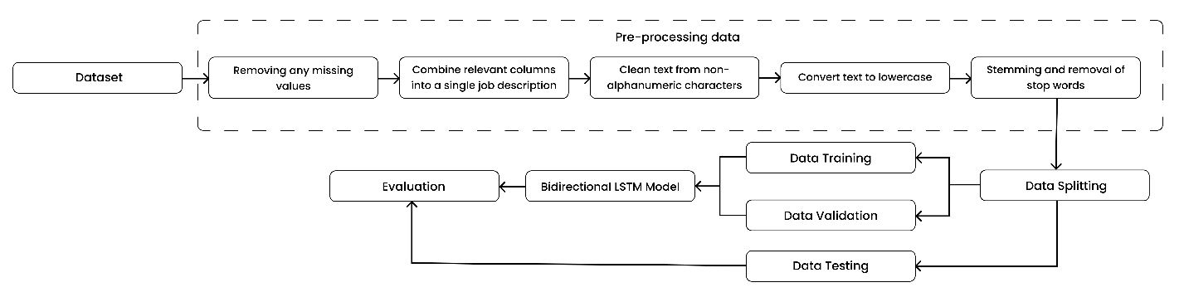
FIGURE 1. Research Process

DATASETS
The dataset used in this study comes from Kaggle.com and focuses on job advertisements, specifically to detect whether they are authentic or fraudulent. It contains about 18,000 job descriptions, with roughly 800 identified as fraudulent. This dataset in TABLE 1 includes not only the text of the job postings but also various meta-data related to different occupations.

TABLE 1. Sample of uncleaned dataset
Attribute | Description | Record of data
job_id | Unique Job ID | 1 | 2
title | The title of the job ad entry. | Marketing Intern | Customer Service - Cloud Video Production
location | Geographical location of the job ad. | US, NY, New York | NZ , , Auckland
departments | Corporate department (eg sales). | Marketing | Success
salary_range | Indicative salary range (eg $50,000-$60,000) | NaN | NaN
company_profile | A brief company description. | We're Food52, and we've created a groundbreaki... | 90 Seconds, the world's Cloud Video Production...
description | The detailed description of the job ad. | Food52, a fast-growing, James Beard Award-winning... | Organized - Focused - Vibrant - Awesome!Do you...
requirements | Enlisted requirements for the job opening. | Experience with content management systems a... | What we expect from you:Your key responsibility...
benefits | Enlisted offered benefits by the employer. | NaN | What you will get from us Through being part of...
telecommuting | True for telecommuting positions. | 0 | 0
has_company_logo | True if company logo is present. | 1 | 1
has_questions | True if screening questions are present. | 0 | 0
employment_type | Full-type, Part-time, Contract, etc. | Other | Full time
required_experience | Executive, Entry level, Intern, etc. | Internships | Not Applicable
required_education | Doctorate, Master's Degree, Bachelor, etc. | NaN | NaN
industry | Automotive, IT, Health care, Real estate, etc. | NaN | Marketing and Advertising
function | Consulting, Engineering, Research, Sales etc. | Marketing | Customer Service
fraudulent | target - Classification attribute. | 0 | 0

These attributes help in developing algorithms that can classify job postings as either real or fake. Important features in the dataset that might influence the detection of fraudulent job ads include job_id, title, location, departments, salary_range, company_profile, description, requirements, benefits, telecommuting, has_company_logo, has_questions, employment_type, required_experience, required_education, industry, function, and fraudulent. The dataset initially comprises 17,880 entries and 18 attributes.

DATA PRE-PROCESSING
Data that is not processed properly can lead to inaccurate models and errors in drawing conclusions. Therefore, data must be processed properly to ensure good and consistent data quality. Good data quality is very important to improve model performance and reduce errors in drawing conclusions. According to Kumar and Kumar (2020), data preprocessing is a crucial first step in the data analysis process [14].
Data pre-processing involves several important steps to prepare raw data before the next stage, including cleaning and preparing text data. The first step is to remove or handle missing values in the dataset to maintain data integrity. Then, the relevant columns are combined into one complete job description. The text is then cleaned of non-alphanumeric characters to improve the quality of the text data, followed by converting the text to lowercase for processing consistency. The stemming process changes words to their basic form (for example, "running" becomes "run") and the removal of stop words removes insignificant common words (such as "and", "the", "is") to focus on the word -meaningful words.

DATA SPLITTING
Data splitting is an important technique in data analysis and machine learning that is used to divide a dataset into subsets, generally into a training set, validation set, and test set. The main goal of this technique is to ensure that the model being built can generalize well to data that has never been seen before, thereby reducing the risk of overfitting. In practice, data splitting helps in evaluating model performance objectively and ensures that the model not only learns from the training data, but can also adapt to the variations present in the real data. According to Hastie, Tibshirani, and Friedman (2009), proper data separation is the key to developing models that are robust and reliable in predictions (Hastie, T., Tibshirani, R., & Friedman, JH (2009).
The proposed model architecture is Bi-LSTM (Bidirectional Long Short-Term Memory) as shown in FIGURE 2. Bi-LSTM (Bidirectional Long Short-Term Memory) is a type of Recurrent Neural Network (RNN) that processes sequence data while considering context from two directions: past and future. The process starts with the Embedding Layer, which converts each word in the sequence into a fixed-dimensional vector representation. After that, the data goes through two LSTM layers: Forward LSTM and Backward LSTM. Forward LSTM processes sequences from left to right, while Backward LSTM moves from right to left. Both LSTMs store and forget information using gating mechanisms that allow them to handle long and short-term dependencies. The output from both LSTMs is then combined in a Concatenate & Flatten step, producing a complete sequence representation that combines information from both directions.

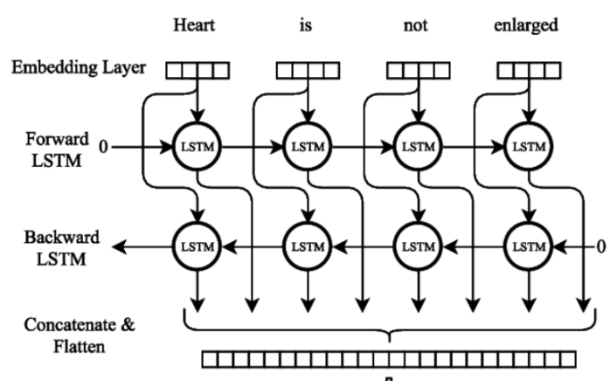
FIGURE 2. Bi-LSTM Architecture

To improve generalization and prevent overfitting, a Dropout Layer is used after the flattening stage by randomly deactivating several neurons during training. This ensures that the model remains robust and can adapt to new data. Next, the data is forwarded to the Dense Layer, which is a fully connected layer that connects all the neurons in the previous layer. Here, the model applies linear transformations and non-linear activations such as ReLU or sigmoid to learn complex feature representations. Finally, the Output Layer produces the final predictions of the model, either via softmax for multiclass classification or sigmoid for binary classification. This enhanced Bi-LSTM architecture with Dropout and Dense Layer becomes highly effective in handling natural language processing and sentiment analysis tasks with a deep contextual understanding of text data.

EVALUATION
Model evaluation using test data to know how well the model predicts or differentiates between existing classes, with​ indicators like accuracy, precision, recall, and F1-score (Kohavi and Provost, 1998). Model validation ensures that the model can be used correctly and produces reliable results. Performed with data that is never seen during training, validation ensures the model is not overfitting and can be used for predictions in the real world (Zhang and Zhang, 2019) [15].

RESULTS
The dataset initially includes various attributes that have the potential to influence the authenticity of a job advertisement. The initial dataset consists of 17,880 entries with 18 attributes originating from Kaggle.com. In the pre-processing process, the 'department', 'salary_range', and 'job_id' columns were removed because many of the values were null or considered irrelevant. Next, several unused columns were removed to simplify the analysis, and the relevant information from several columns was combined into one job description column (job_description) to facilitate text processing and subsequent analysis. This cleaned dataset as in TABLE 2.

TABLE 2. Cleaned dataset after dropping columns and combining into job_description
Attribute | Record of data
telecommuting | 0 | 0
has_company_logo | 1 | 1
has_questions | 0 | 0
fraudulent | 0 | 0
requirements | Marketing Intern US, NY, New York We're Food52... | Customer Service - Cloud Video Production NZ, ...

The model used here is a neural network using an embedding layer to convert words into numerical representations, followed by two LSTM (Long Short-Term Memory) layers that work bidirectionally to take into account the context from the beginning to the end of the sentence and vice versa. Dropouts are used to avoid overfitting, and the final dense layer uses sigmoid activation to generate probability predictions. To optimize training, L2 regularization of the LSTM layer and early stopping callbacks are used to stop training early if validation loss does not improve after 3 consecutive epochs. The data-splitting process was performed by dividing the dataset into training data and validation data. The model was trained for 15 epochs with a batch size of 64. The model evaluation results show excellent performance.

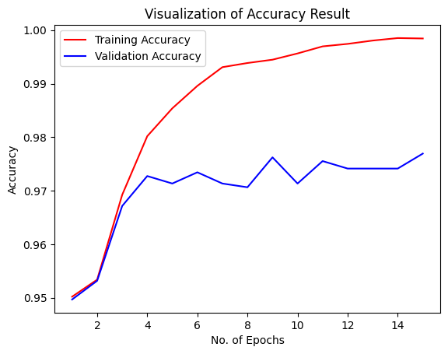
FIGURE 3. Accuracy Results

Graphical analysis in FIGURE 3 shows a significant increase in training and validation accuracy during the initial epochs, from epoch 1 to 4, where the model managed to learn well from the given data. After that, the validation accuracy starts to stabilize with small fluctuations around the value of 0.97 to 0.98, indicating consistent performance on unseen data. Meanwhile, training accuracy continued to increase until it almost reached 1.00 at the 15th epoch, indicating the model's ability to recognize patterns in the training data was getting better. Although the validation accuracy fluctuated slightly between the 6th and 11th epochs, overall, both training and validation accuracies showed high values, indicating the model performed well in recognizing patterns on the training data and maintained solid performance on the validation data.

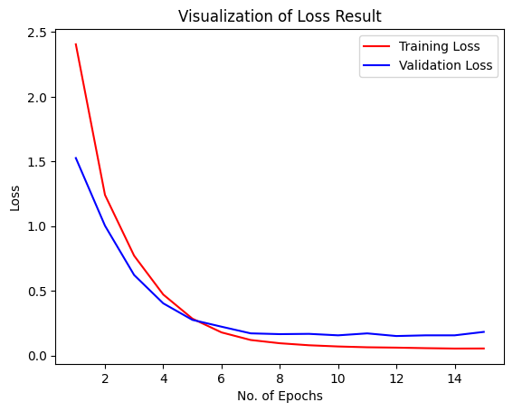
FIGURE 4. Loss Results

The analysis graph in FIGURE 4 shows a decline significant in the good loss value for training data nor validation during the first few epochs, from epochs 1 to 4, which signifies that the model with fast learning patterns from the data provided. After the 4th epoch, the training loss value nor the validation start approach is very low and stable values, around 0.1 to 0.3, indicate that the model is getting Good in minimising error in prediction. From epoch 6 onwards, the training loss value reaches a point almost close to zero, while the validation loss value shows slight fluctuations but remains in a low and stable range. Overall, the significant and stable reduction in loss values for these two metrics indicates that the model has a good ability to learn from training data and maintain consistent performance on validation data.
After that, the model performance is evaluated using various metrics. Accuracy provides an overall measure of correct predictions, while Precision measures the proportion of correctly identified job ads out of all predicted positives. Recall assesses the model's ability to identify all actual job advertisements, and F1-Score aligns Precision and Recall into one metric, balanced between the two. These metrics collectively measure the model's effectiveness in classifying job ads accurately and efficiently.

TABLE 3. Results of model evaluation and model classification
 | Precision | Recall | F1-score | Support
0 (Genuine job) | 0.98 | 0.99 | 0.99 | 3395
1 (Fake job) | 0.79 | 0.69 | 0.74 | 181
Accuracy |  |  | 0.98 | 3576
Macro avg | 0.89 | 0.84 | 0.86 | 3576
Weighted avg | 0.97 | 0.98 | 0.97 | 3576

TABLE 3 shows the results of the Bi-LSTM model showing excellent performance with high accuracy in identifying original work. This model is also able to detect fake jobs quite well, producing adequate precision and recall for that class. With a good F1-score and an overall accuracy of 98%, this model can be relied on to effectively classify genuine and fake jobs.

DISCUSSION
The Bi-directional Long Short-Term Memory (Bi-LSTM) model we developed achieved 98% accuracy in detecting fake job vacancies, higher than Patel et al. (2022) which reached 92%. This improvement is thanks to improvements in data pre-processing, hyperparameter tuning, and the use of a wider dataset. We also successfully handled overfitting with regularization techniques, dropout layers, and extensive cross-validation, in contrast to the study of Zhang et al. (2021) and Lee and Kim (2020). With a more diverse dataset, our model learns from a wider range of linguistic patterns and nuances, further reducing false positives compared to Zhang et al. (2021) which reduces it to 15%. The integration of additional NLP techniques such as attention mechanisms helps our model capture complex linguistic clues that indicate fraud, making it a more effective tool in detecting fake job postings and supporting a safer job search experience. To provide a more comprehensive evaluation, we compared this result with other traditional machine learning models used in fraud detection as shown in TABLE 4.

TABLE 4. Comparison with other machine learning models
Models Implemented | Accuracy
Random Forest | 81%
GRU | 94%
Naive Bayes | 95%
LightGBM | 96%
Bi-LSTM (Our Model) | 98%

However, despite its high accuracy, the computational efficiency and scalability of the Bi-LSTM model must also be considered, especially when it comes to deployment in large-scale systems. The Bi-LSTM model, by nature, is computationally intensive and may require significant resources in terms of processing power and memory, particularly when scaled up for larger datasets or real-time applications. Addressing these challenges is crucial for practical implementation. Future work could explore potential optimization strategies, such as model pruning or quantization, to improve the model's efficiency and make it more suitable for large-scale deployment without compromising its performance.

CONCLUSIONS
This research successfully developed a predictive model using Natural Language Processing (NLP) techniques to detect the authenticity of job advertisements. With a dataset consisting of 17,880 entries, the Bi-directional LSTM (Bi-LSTM) model achieved an impressive accuracy of 98%, surpassing other traditional machine learning models such as Random Forest (81% accuracy), GRU (94%), Naive Bayes (95%), and LightGBM (96%). The superior accuracy of the Bi-LSTM model stems from its ability to capture complex linguistic patterns and long-term dependencies in text, which are crucial for detecting subtle indicators of fraudulent job postings. Its bidirectional processing allows it to consider word context from both directions, leading to more accurate predictions. Additionally, the integration of techniques like regularization and dropout prevents overfitting, ensuring reliable, real-time detection of suspicious job advertisements. By integrating this model into digital platforms, users can better identify and avoid fraudulent listings, thereby improving security and confidence in the job search process. Nevertheless, despite its high accuracy, the computational efficiency and scalability of the Bi-LSTM model must also be considered for large-scale deployment. Future work should focus on optimizing the model to ensure its practicality in diverse real-world applications.

ACKNOWLEDGMENTS
We would like to express our deepest gratitude to all parties who have supported and contributed to the completion of this research. First and foremost, we extend our thanks to our supervising professor for their guidance, direction, and invaluable knowledge in steering this research. Without their help and encouragement, this research would not have achieved such satisfactory results. We also extend our gratitude to our families, friends, and colleagues who have provided moral support and motivation throughout the research process. Their words of encouragement and support have been a driving force in overcoming the challenges and difficulties encountered. Lastly, we wish to thank all the authors, researchers, and practitioners in this field who have contributed through their works. This research also owes a debt of gratitude to their scientific contributions and insights.

References
- A. Amaar, W. Aljedaani, F. Rustam, S. Ullah, V. Rupapara, and S. Ludi, "Detection of fake job postings by utilizing machine learning and natural language processing approaches," Neural Processing Letters, vol. 54, pp. 2219-2247, 2022.
- A. S. Pillai, "Detecting Fake Job Postings Using Bidirectional LSTM," arXiv preprint arXiv:2304.02019, 2023.
- T. V. Divya and B. G. Banik, "Detecting fake news over job posts via bi-directional long short-term memory (BIDLSTM)," International Journal of Web-Based Learning and Teaching Technologies (IJWLTT), vol. 16, no. 6, pp. 1-18, 2021.
- P. S. Kale, "Fake Job Detection System," International Journal for Research in Applied Science and Engineering Technology, vol. 12, no. 4, pp. 1476-1480, 2024.
- I. Nessa et al., "Recruitment scam detection using gated recurrent unit," 2022, pp. 445-449: IEEE.
- P. Kalaivani, V. D. Raj, R. Madhavan, and A. P. N. Kumar, "Fake Review Detection using Naive Bayesian Classifier," 2023, pp. 705-709: IEEE.
- S. M. Reddy, S. M. Ali, K. M. Battula, P. R. N. lakshmana Charan, and M. Rashmi, "Web App For Predicting Fake Job Posts Using Ensemble Classifiers," 2023, pp. 1-5: IEEE.
- S. Ram Prasath and M. N. N. Dr, "Fake Job Posting Detection," International Journal of Advanced Research in Science, Communication and Technology, vol. 4, no. 4, pp. 283-287, 2024.
- S. Dutta and S. K. Bandyopadhyay, "Fake job recruitment detection using machine learning approach," International Journal of Engineering Trends and Technology, vol. 68, no. 4, pp. 48-53, 2020.
- Z. Huang, W. Xu, and K. Yu, "Bidirectional LSTM-CRF models for sequence tagging," arXiv preprint arXiv:1508.01991, 2015.
- M. A. I. Sunny, M. M. S. Maswood, and A. G. Alharbi, "Deep learning-based stock price prediction using LSTM and bi-directional LSTM model," 2020, pp. 87-92: IEEE.
- B. Jang, M. Kim, G. Harerimana, S.-u. Kang, and J. W. Kim, "Bi-LSTM model to increase accuracy in text classification: Combining Word2vec CNN and attention mechanism," Applied Sciences, vol. 10, no. 17, p. 5841, 2020.
- Z. Wu, "The comparison of forecasting analysis based on the ARIMA-LSTM hybrid models," 2021, pp. 185-188: IEEE.
- C. Lehmann, L. Goren Huber, T. Horisberger, G. Scheiba, A. C. Sima, and K. Stockinger, "Big Data architecture for intelligent maintenance: a focus on query processing and machine learning algorithms," Journal of Big Data, vol. 7, no. 1, p. 61, 2020.
- M. Casolino, "Large scale analysis of violent death count in daily newspapers to quantify bias and censorship," Journal of big data, vol. 7, no. 1, p. 60, 2020.

