TOPSIS Method as a Recommendation for Selection of Entrepreneurship Skills for Double Track Senior High School
Maula Izza Azizi^{a)}, Fajar Baskoro^{b)}, and Dwi Sunaryono^{c)}
Department of Informatics Engineering, Sepuluh Nopember Institute of Technology, Surabaya, Indonesia

^{a)} Corresponding author: 5025201104@student.its.ac.id
^{b)} fajar@its.ac.id
^{c)} dwi@its.ac.id
Abstract. This research investigates using the Technique for Order Preference by Similarity to Ideal Solution (TOPSIS) method to recommend entrepreneurial skill areas in Double Track Senior High Schools. TOPSIS ranks alternatives based on their proximity to an ideal solution, considering criteria that influence the results. The alternatives include Multimedia, Electrical Engineering, Electronics Engineering, Culinary Arts, Fashion Design, Beauty, and Light Vehicle/Motorcycle Engineering. The criteria affecting the rankings are students' interest, school facilities, job opportunities, entrepreneurial opportunities, and salary, with average weighting percentages of 37.38%, 28.36%, 17.72%, 4.74%, and 11.80%, respectively, based on a sample of 70 students from SMA Dharma Wanita Surabaya. The weights are calculated using a combinative method that integrates subjective assessments from the Analytic Hierarchy Process (AHP) and objective assessments from the entropy weighting method. The results show that TOPSIS with entropy weighting achieves an average accuracy of 85.54%, significantly higher than the 78.45% average accuracy of the AHP method alone.
Keywords: TOPSIS, Combinative, Double Track.

INTRODUCTION
According to the East Java Provincial Education Office in 2018, there were 172,063 high school graduates with a percentage of 32.16%, namely 55,341 students can continue their education to the college level. While 67.84%, namely as many as 116,772 people did not continue to college. In an effort to improve the skills of SMA/MA graduates, the East Java Provincial Government has initiated a double track programme to provide skills to SMA/MA students. The double track programme became a flagship programme in the education sector of East Java Province by involving the integration of learning and provision of skills relevant to local values and wisdom. This programme focuses on providing education that combines skills learning in parallel with the applicable curriculum. This programme is targeted at SMA and MA that have more than 50% of graduates or students who do not continue to higher education [1]. Unemployment is caused by an increase in the labour force that is not in line with the availability of adequate jobs. As a result, there is a significant unemployment gap. In 2017, the majority of Indonesia's population was dominated by the millennial generation with a percentage of around 33.75%. This millennial generation includes individuals born between 1980 and 2000. However, the percentage of millennials who choose to become entrepreneurs is still relatively small. This is due to the lack of experience and the fear of risk and the possibility of failure that may occur when entrepreneurship. This has resulted in economic decline, social poverty, educational decline, and poor health conditions [6]. One of the steps that can be taken to reduce unemployment is through education, training, courses, and certification programmes in order to improve the competence of the workforce in accordance with employment needs [6].
Life skills education is a form of education that provides the basics of skills involving values in everyday life so that students can have the ability, readiness, and skills to face their lives, and be able to maintain survival and personal development. Life Skills has a concept and structure that consists of 5 main dimensions, namely: self-awareness of personal abilities, personal ability to think logically, social skills, academic skills, and vocational skills [7]. A skills training recommendation system is needed to help SMA/MA students choose the appropriate skill fields, based on their interests and talents. The system aims to alleviate the confusion experienced by students when deciding on the right field of skills training. It follows a standard procedure involving the formation of a weight-normalised decision matrix, as well as the identification of positive ideal solutions and negative ideal solutions. The TOPSIS method is then used to determine the relative closeness of an alternative to the optimal ideal solution in multicriteria decision making. The main goal of selecting skills training is to gain a deeper understanding of students' interests and talents. By providing tailored recommendations, the system seeks to offer solutions to the challenges faced by students in choosing the most suitable skills training field [15]. Therefore, this final project requires alternatives on each criterion that have been normalised. The TOPSIS method is a multicriteria decision-making method used to select alternatives. The alternative referred to in the research is the field of entrepreneurial skills in the double track programme. This is suitable for use in final project research because it has a calculation of the weight of the criteria that must be taken into account including interest, facilities, number of jobs, entrepreneurial opportunities and salaries which are considered by the TOPSIS method to determine the order of the recommendation fields. In addition, it can handle criteria that do not have the same scale by normalising data and being able to handle positive and negative criteria by determining positive ideal solutions and negative ideal solutions. The TOPSIS method does not include the calculation of criterion weights [14]. However, TOPSIS method can use combinative weighting method. The combinative method can reduce the bias that may occur in the weighting process by combining the subjective weighting method and the objective weighting method [11]. AHP weighting method can be used in the calculation of subjective weighting methods because it uses a subjective quality-based assessment method in determining the weight of criteria by comparing one criterion with other criteria according to the preferences of each individual or group [12][13]. Entropy method weighting in the calculation of objective methods to determine criteria based on the quantity of data assessment and there are facts that can be measured and verified [13]. The encroachment entropy method is commonly used to measure the level of diversity or variability in the data in determining the weights [12].

METHODS

TOPSIS METHOD
The Technique for Order Preference by Similarity to Ideal Solution (TOPSIS) method involves the formation of a matrix that has normalised the weight of each criterion against all alternatives. The TOPSIS method involves the construction of an ideal solution. In its application, alternatives can be sorted based on closeness to the positive ideal solution and distance from the negative ideal solution. The TOPSIS method is used to determine the relative closeness of an alternative to the optimal ideal solution in multicriteria decision making [15][2].
- Decision Matrix
The decision matrix consists of criteria values for each alternative variable. There are n criteria and m alternatives. Thus, it can be represented into a matrix equation.
$D= \left[\begin{matrix}x_{11} & … & x_{1n} \\ … & ⋱ & … \\ x_{1m} & … & x_{mn}\end{matrix}\right]$ $\left(1\right)$
- Matrix Normalisation
$r_{ij}= \frac{x_{ij}}{\sqrt{\sum_{i=1}^{m}{{x^{2}}_{ij}}}}$ $\left(2\right)$
In equation (2) there is a decision matrix $R={[r_{ij}]}_{mxn}$with $i=1, …, m, and j=1,…, n.$
- Weight Normalisasion
$p_{ij}= w_{i} × r_{ij}$ $\left(3\right)$
Where $w_{i}$ represents the weight of each criterion at index $i$ and $r_{ij}$represents the normalisation matrix elements of index $i$ and $j$ to determine the normalised decision matrix P = ${[p_{ij}]}_{mn}$with $i=1, …, m$dan $j=1, …, n$.
- Positive and Negative Ideal Solusion
$A^{+}=(p_{1}^{+}, p_{2}^{+},p_{3}^{+}, …, p_{m}^{+})$ (4)
$A^{-}=(p_{1}^{-}, p_{2}^{-},p_{3}^{-}, …, p_{m}^{-})$ (5)
Where
$p_{j}^{+}\left\{\left(max{ p}_{ij}\right| j ∈J\right), \left(min{ p}_{ij}\right| j ∈ J^{'}), i=1, …, m\}$
$p_{j}^{-}\left\{\left(min{ p}_{ij}\right| j ∈J\right), \left(max p_{ij}\right| j ∈ J^{'}), i=1, …, m\}$
$J$: the set of benefit criteria (Benefit Criteria)
$J^{'}$: set of cost criteria (Cost Criteria)
$p_{ij}$: weighted normalised matrix element $p$
$p_{j}^{+}\max_{i} \{p_{ij}\}$; : if $J$ is a benefit attribute
$p_{j}^{+}\min_{i} \{p_{ij}\}$; : if $J$ is a cost attribute
$p_{j}^{-}\min_{i} \{p_{ij}\}$; : if $J$ is a profit attribute
$p_{j}^{-}\max_{i} \{p_{ij}\}$; : if $J$ is a cost attribute
- Ideal Solution Distance
- Calculate the Euclidean distance of the positive ideal solution $A^{+}$(benefit) and negative ideal solution $A^{-}$ from each alternative variable element $A_{i}$.
$d_{i}^{+}= \sqrt{\sum_{j=1}^{n}{{(d_{ij}^{+})}^{2}}}$ (6)
$d_{i}^{-}= \sqrt{\sum_{j=1}^{n}{{(d_{ij}^{-})}^{2}}}$ (7)
Where :
$d_{ij}^{+}= p_{j}^{+}- p_{ij}, with i=1, …, m$
$d_{ij}^{-}= p_{j}^{-}- p_{ij}, with i=1, …, m$
- Alternative Preference
$ξ_{i}= \frac{d_{i}^{-}}{d_{i}^{+}+ d_{i}^{-}}$ (8)
The recommendation order of alternative variables is based on relative closeness where the best alternative is the one with the higher $ξ_{i}$ value. Therefore, it should be selected based on the closeness to the positive ideal solution.

SUBJECTIVE WEIGHTING METHOD
Weighting in the Analytical Hierarchy Process (AHP) method is identical to the comparison of each criterion to get weighting. Weighting in the AHP method is said to be a subjective weighting method because this method uses an assessment by comparing each criterion subjectively by each individual or group in determining the weighting of criteria. In analysing the problem, it can be initiated by creating an eigen vector that represents the priority scale ratio for each element in a hierarchy. With the value of the eigen vector, it can be used to determine the results of the evaluation of the matrix consistency score. If the consistency requirements are met, then the priority order represented by the eigen vector will be used as the basis for determining decision making [8]. There are steps in determining subjective weighting in the AHP method [9].
- Build a hierarchical structure
Determine the matrix arrangement based on the criteria, sub-criteria, and alternatives needed. It can be seen in FIGURE 1 that there are levels consisting of targets, criteria, sub-criteria, and solutions.

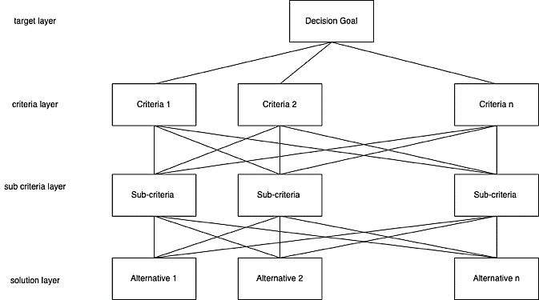
FIGURE 1. Hierarchical structure of the AHP method

- Decision matrix comparison
Making a decision matrix is done by making a comparison scale which can be seen in TABLE 1.
TABLE 1. AHP comparison scale
Scale Value | Mean
1 | Equal importance
3 | Moderate importance
5 | Strong importance
7 | Very strong importance
9 | Extreme importance
1/3, 1/5, 1/7, 1/9 | Inverse comparison importance

- Matrix Normalization
By involving the comparison results of each criterion in the matrix. Each element in the matrix can be divided by the sum of each column that indicates each criterion.
${norm_kriteria}_{ij}= \frac{{kriteria}_{ij}}{\sum_{k=1}^{n}{{kriteria}_{kj}}}$ $\left(9\right)$
Where :
$i$ and $j$ : row index and column index
${criteria}_{ij}$: pairwise comparison matrix of $i$th row and $j$th column
- AHP method weighting
In determining the weighting in the AHP method. Each criterion can be calculated by averaging the normalised matrix along the rows in the normalised matrix.
${bobot_kriteria }_{i}= \frac{\sum_{j=1}^{n}{{norm_kriteria}_{ij} }}{n}$ $\left(10\right)$
Where:
$i$: row index
${norm_criteria}_{ij}$: normalized criteria
$n$: total number of criteria

OBJECTIVE WEIGHTING METHOD
The entropy weighting method can be categorised as an objective weighting method because the data obtained is based on data and facts in the field that can be measured or verified [8][13].
- Matrix Normalization
$a_{ij}= \frac{k_{ij}}{\sum_{i=1}^{m}{\sum_{j=1}^{n}{k_{ij}}}}$ $\left(11\right)$
$a_{ij}$ : the result of calculating the criteria
$k_{ij}$ : value of each criteria
$i$ : respondent to 1, 2, ..., $m$
$j$ : criteria to 1, 2, ..., $n$
$m$ : number of decision making
$n$ : number of criteria
- Entropy Calculation
$E_{j}= \left[\frac{-1}{\ln{m}}\right]\sum_{i=1}^{n}{\left[a_{ij} ln⁡(a_{ij})\right]}$ $\left(12\right)$
$E_{ij}$: Entropy weight value
- Dispersion of each criteria
$D_{j}=1- E_{j}$ $\left(13\right)$
$D_{j}$: Dispersion value
- Dispersion Normalized
$W_{j}= \frac{D_{j}}{\sum{D_{j}}}$ $\left(14\right)$
$W_{j}$: dispersion normalisation value (criteria priority weight)

COMBINATIVE WEIGHTING METHOD
In the outcome evaluation of multi-criteria decision methods, the weighting value for each criterion has the ability to influence the evaluation results and plays an important role in prioritizing the alternatives. A combinative weighting method considers the results of subjective weighting and objective weighting of evaluation standards comprehensively. Therefore, the combinative weighting method can reduce the possibility of bias from subjective weighting results and objective weighting results in the selection of ranking results [8]. There are n criteria from the results of AHP weighting method $W_{h}=(W_{h1 },W_{h2},…, W_{hn})$ and entropy weighting method $W_{e}=\left(W_{e1 },W_{e2},…, W_{en}\right)$ can determine the combinative weighting by integrating into equation [13]:
$W_{cj}= \frac{W_{ej} × W_{hj}}{\sum_{j=1}^{n}{W_{ej}× W_{hj}} }, j=1, 2, …, n.$ $\left(15\right)$

Methodology

CONCEPTUALISED SYSTEM DESIGN
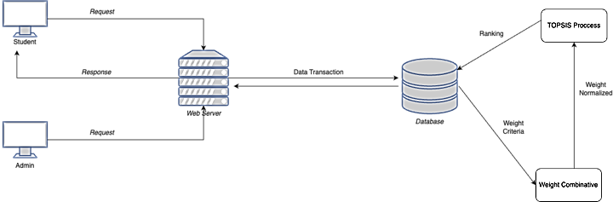
FIGURE 2. General system design

FIGURE 2 shows the overall system design. There is a web server that acts as an intermediary between the client and the database built in a web-based application in the research system design. The client interacts with the web server through sending (request) in the form of hypertext transfer protocol (HTTP) and receives a response (response) according to the request submitted. The connection between the client and the web server allows access to database management by storing and changing data. There are two types of clients connected to the web server, namely students and admins. Student clients can fill out questionnaires to determine preferences for entrepreneurial skill areas. In addition, student clients can sort the order of skill area expectations which will be useful for determining the suitability of the accuracy level in the TOPSIS method. Meanwhile, the school admin client uses the application to configure supporting data and criteria in the selection using the TOPSIS method and is in charge of entering data on students who take part in the double track programmed into the system, and entering the skill fields and criteria to be filled in by each student.

RESEARCH FRAMEWORK
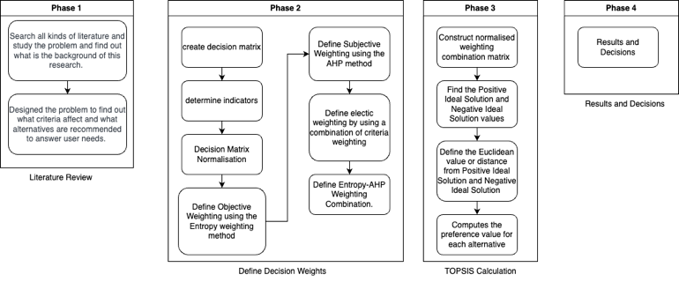
FIGURE 3. Research Framework

In FIGURE 3 there is a research framework which is divided into four phases:
- Recognise the background of the research so that it requires a literacy study related to the problem in determining the criteria aspects and the order of alternatives that will be used in solving the problem.
- Modeling the flow of TOPSIS method using combinative weighting method by combining subjective weighting method with objective weighting method. The subjective weighting method in the research uses weighting in the AHP method because it uses judgement by comparing from individuals or groups in determining the weight of multicriteria. The objective weighting method uses the entropy weighting method because in determining the weight of the criteria using data and facts that can be measured or verified.
- Compute an alternative evaluation method using the TOPSIS method with combinative weighting.
- Result and Decision

IMPLEMENTATION
There are some algorithms in the implementation of the methods that have been designed including:
- Entropy-Weighting Algorithm
There are several steps in the entropy weighting algorithm, as shown in FIGURE 4-6:
- Entropy Normalisation
Pseudocode 3.1 performs the entropy normalisation process.
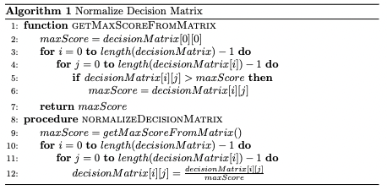
FIGURE 4. Pseudocode 3.1 Entropy Normalisation
- Entropy Value
Computes the entropy value to help get the weight on each criterion feature. For more details, see pseudocode 3.2 below.

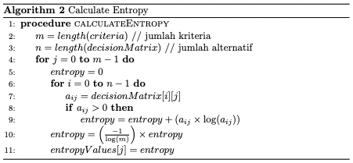
FIGURE 5. Pseudocode 3.2 Entropy

- Determine the Weighting of Each Criterion
However, by determining the total score that has been obtained, it is then entered into the weighting formula. For more details can be seen in pseudocode 3.3 entropy weighting.
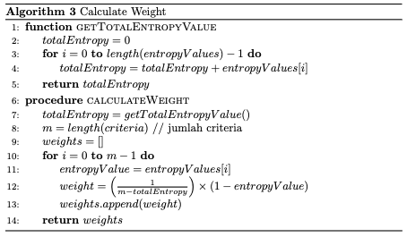
FIGURE 6. Pseudocode 3.3 entropy weighting

- AHP Weighting Algorithm
- Determine Matrix Comparison
Sum up all the values of each column in the Matrix Pairwise Comparison (MPC) or pairwise comparison matrix. For more details can be seen in pseudocode 3.4 (FIGURE 7) below:
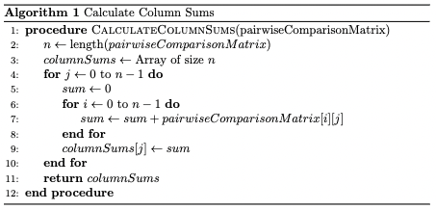
FIGURE 7. Pseudocode 3.4 Matrix Pairwise Comparison

- Normalization of Pairwise Comparison Matrix
Normalise the pairwise comparison matrix by dividing the value of each element by the sum of each column in the previous matrix. For more details can be seen in the following pseudocode 3.5 (FIGURE 8):
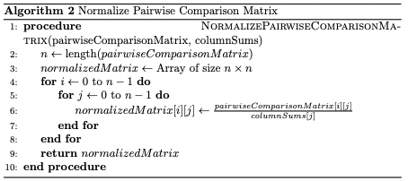
FIGURE 8. Pseudocode 3.5 Matrix Pairwised Comparison Normalized

- Weight of Criteria with AHP Weighting Method
Calculate the weight of each criterion by determining the average of the values in each matrix row element that represents each criterion. For more details can be seen in pseudocode 3.6 (FIGURE 9) below:
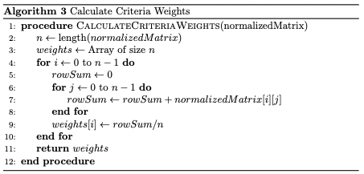
FIGURE 9 Pseudocode 3.6 AHP Weight Method

- Combinative Weighting Algorithm
We present below the pseudocode to determine the combinative weighting method that combines the subjective weighting method with the objective weighting method, as seen in FIGURE 10.
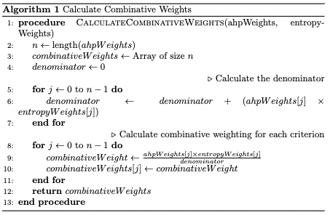
FIGURE 10. Pseudocode 3.7 Combinative Weight Method

- TOPSIS Algorithm
Research to create a system to determine the ranking of recommendation fields using the TOPSIS method has several stages including:
- Matrix Normalisation
The normalisation of each value by dividing the root of the sum of each element. For more details can be seen in pseudocode 3.8 (FIGURE 11) below
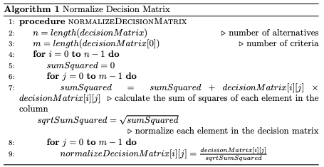
FIGURE 11. Pseudocode 3.8 TOPSIS Matrix Normalisation

- Weight Normalisation
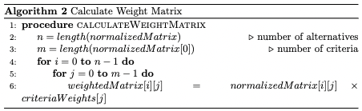
Weight normalisation can be done by multiplying each element with the weighting results of each criterion from the combinative weighting method. For more details, it can be seen in the following FIGURE 12 or pseudocode 3.9:
FIGURE 12. Pseudocode 3.9 Weight Normalisation

- Positive Ideal Solution and Negative Ideal Solution
Refer to pseudocode 3.10 (FIGURE 13) to calculate the positive ideal solution and negative ideal solution.
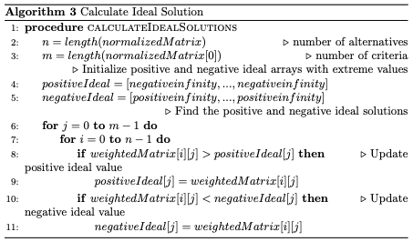
FIGURE 13. Pseudocode 3.10 Ideal Solution

- Distance of Both Ideal Solutions
Calculate the distance of each positive ideal solution and negative ideal solution. This aims to determine the best alternative chosen based on proximity to the positive ideal solution for more details can be seen in pseudocode 3.11 (FIGURE 14) below:
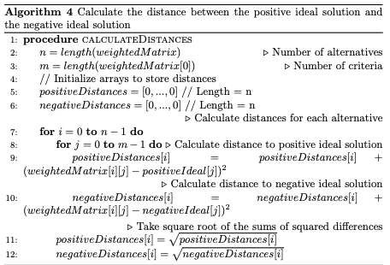
FIGURE 14. Pseudocode 3.11 Ideal Solution Distance

- Preference value
Computation of preference values for each skill area as an alternative variable. In this case, the ranking is sorted based on the score of the highest final result which will be the top priority. For more details can be seen in the following FIGURE 15 pseudocode 3.12
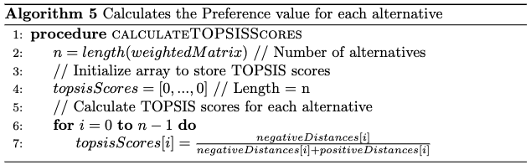
FIGURE 15. Pseudocode 3.12 Preference Value

RESULTS AND DISCUSSION

EXPERIMENTAL RESULT
This research involves testing students and teachers of SMA Dharma Wanita Surabaya. In the research, a teacher is needed as the object of research by providing an assessment of the criteria for the number of jobs, salaries, and entrepreneurial opportunities. The results of the assessment of the accompanying teacher can be seen in TABLE 1.
TABLE 1. Criteria score of mentor teachers
Skills | Number of Jobs | Salary | Entrepreneurship Opportunities
Multimedia | 4 | 2 | 3
Electrical Engineering | 3 | 3 | 3
Electronics Engineering | 2 | 2 | 3
Fashion | 3 | 2 | 3
Culinary | 4 | 2 | 4
Beauty Style | 4 | 3 | 4
Light Vehicle/Motorbike Engineering | 4 | 3 | 4

The likert scale weighting related to interest criteria as a measure of student interest in a skill area can be seen in TABLE 2. assessment can be determined by the student
TABLE 2. Weight on Interest criteria
Weights | Student Specialisation
1 | Very Disinterested
2 | Not Interested
3 | Interested
4 | Very Interested

TABLE 3 shows the weighting benchmarks of the Likert scale which contains facility criteria that can be determined by students. Students can determine the assessment of the facilities and support provided by the school for the double track programme as a skill development.
TABLE 3. Weights on facility criteria
Weights | Facility
1 | Very unfavourable
2 | Not in favour
3 | Support
4 | Very Supportive

The results of the combinative weighting method calculation can affect the results of the TOPSIS method calculation. In the study there were 93 students of Dharma Wanita High School Surabaya City who participated in the double track programme. 70 of them became the object of research. The research discusses the results of the calculation of the order of the field of entrepreneurship using the TOPSIS method. The calculation results that have been obtained will be compared with the order of entrepreneurship field expectations as a benchmark in measuring the accuracy of the suitability of TOPSIS calculations.
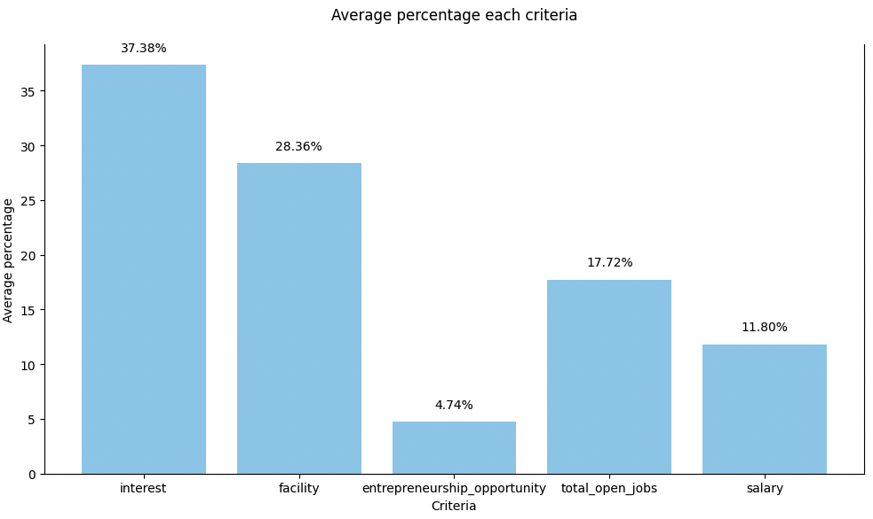
FIGURE 16. Average percentage each criteria

FIGURE 16 shows the experimental results on the combinative weighting method, which is a weighting method that combines the results of subjective weighting with objective weighting methods. The subjective weighting method uses the AHP method weighting calculation while the objective weighting method uses the entropy weighting method calculation. It can be seen that the results of the calculation of the average weighting of the criteria have the largest to smallest tendency of influence, namely the specialization criteria have a percentage of 37.38%, the criteria for facilities and school support have a percentage of 28.36%, the criteria for the number of jobs have a percentage of 17.72%, the salary criteria have a percentage of 11.80%, and entrepreneurial opportunities have a percentage of 4.74%.
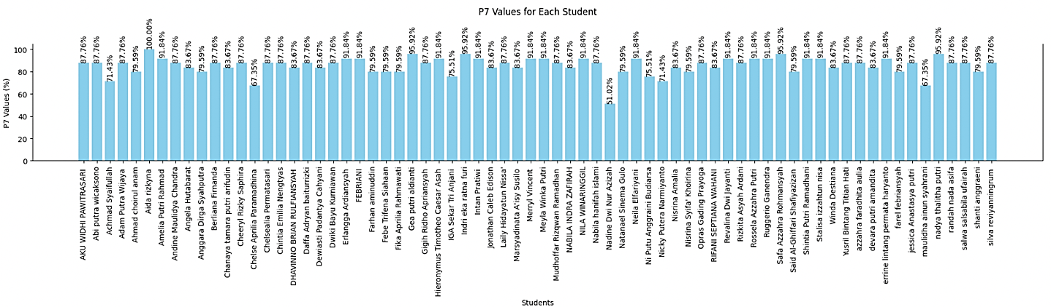
FIGURE 17. Diagram of percentage evaluation of suitability accuracy of TOPSIS method

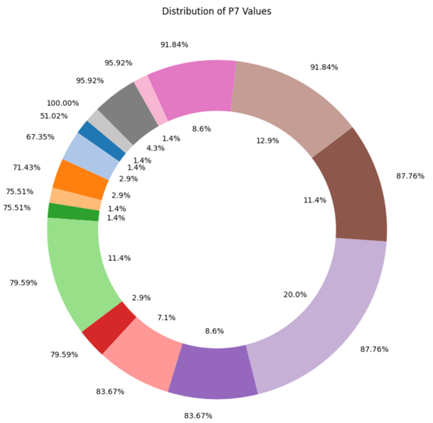
Figure 17 shows the average accuracy of the evaluation calculation results for each student of Dharma Wanita Surabaya City High School. The highest accuracy for seven skill areas is 100.00% for 1 student. While the lowest accuracy is 51.02% for 1 student.
FIGURE 18. Distribution chart of the seven skill areas evaluation

FIGURE 18 shows a diagram that represents the evaluation of the accuracy of the TOPSIS method for each student. There is 1 student who has the greatest accuracy of 100.00%, 22 students have an accuracy of 87.76%, 2 students have an accuracy of 71.43%, 10 students have an accuracy of 79.59%, 15 students have an accuracy of 91.84%, 11 students have an accuracy of 83.67%, 2 students have an accuracy of 67.35%, 4 students have an accuracy of 95.92%, 2 students have an accuracy of 75.51, and 1 student has an accuracy of 51.02%. so that in percentage form it will be seen in the figure.

DISCUSSION
In the research results will be discussed regarding an in-depth discussion of the evaluation of the TOPSIS method calculation. The evaluation of the TOPSIS method aims to find out more about the selection of the order of skill field recommendations. TABLE 4 shows the results of the calculation of the TOPSIS method from a Dharma Wanita Surabaya City High School student named Nadya Thalitha Putri.
TABLE 4. TOPSIS calculation results
Ranking | Skills Area | Score
1 | Culinary | 0,895
2 | Beauty Style | 0,697
3 | Multimedia | 0,421
4 | Fashion | 0,351
5 | Light Vehicle/Motorbike Engineering | 0,278
6 | Electrical | 0,178
7 | Electricity | 0

Table 4 shows that in each skill field order the results of the TOPSIS method calculation will be compared with the expected ranking order that has been filled in by each student.
$$∆_{rank}= {rank}_{exp}- {rank}_{topsis}$$
Description:
$∆_{rank}$ :Ranking difference
${rank}_{exp}$ :Expectation Rank
${rank}_{topsis}$ :TOPSIS Rangking
TABLE 5. Difference between topsis method and expectation
Skills Area | Expectations | Difference
Culinary | 1 | 0
Beauty Style | 2 | 0
Fashion | 3 | -1
Multimedia | 4 | 1
Light Vehicle/Motorbike Engineering | 5 | 0
Electrical | 6 | 0
Electricity | 7 | 0

TABLE 5 shows that the results of the difference in recommendations can be calculated for accuracy in each skill area.
$${accur}_{percentage}= \frac{7- ∆_{rank}}{7} × 100\%$$
Description:
${accur}_{percentage}$ : Persentase Akurasi (%)
TABLE 6. Accuracy of topsis method
Skills Area | Difference | Accuracy(%)
Culinary | 0 | 100
Beauty Style | 0 | 100
Fashion | -1 | 85.714
Multimedia | 1 | 85.714
Light Vehicle/Motorbike Engineering | 0 | 100
Electrical | 0 | 100
Electricity | 0 | 100

The accuracy result for the average order in the top 3 skill areas is 95.238%, as seen in TABLE 6. On the results of the order of the top 5 skill areas have an average accuracy of 94.285%. so that the average result on the order of the skill areas as a whole of the seven skill areas has an accuracy of 95.918%. Thus in both skill areas namely fashion and multimedia have recommendation results that are different from expectations.
In the overall research on 70 Dharma wanita High School students, there are three parts, namely P3, P5, and P7 as the accuracy of the skill field sequence. FIGURE 7 shows the calculation results with a discussion of the research results of average accuracy, maximum accuracy, and minimum accuracy.

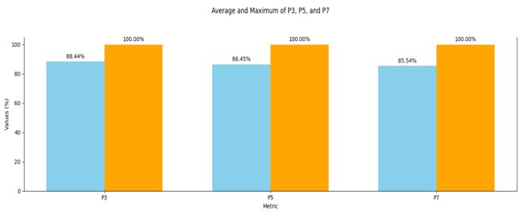
FIGURE 7. Evaluation Chart
Description:
- P3 is the ranking accuracy of the top three skill area sequences
- P5 is the ranking accuracy of the top five skill area sequences
- P7 is the ranking accuracy on all top skill area sequences
It can be seen in Figure 7 that the top three skill areas have an overall average of 88.44% with a maximum accuracy of 100.00%. On the other hand, the top five skill areas have an average of 86.45% overall students with a maximum accuracy of 100.00%. Therefore, for the overall average skill area of 85.54%, the maximum accuracy is 100.00% overall for 70 students of Dharma Wanita Surabaya City High School

CONCLUSIONS
The research concludes that the Technique for Order Preference by Similarity to Ideal Solution (TOPSIS) method effectively assists high school students in selecting entrepreneurial skill areas within the double track program. The alignment of skill area rankings obtained through TOPSIS with the expectations of 70 students participating in the double track program at SMA Dharma Wanita, Surabaya, achieves an accuracy of 85.539%. This is significantly better than the overall AHP method, which has an accuracy of approximately 78.45%.
By using a combinative weighting approach, integrating both subjective and objective weighting methods, the research provides a comprehensive assessment of criteria such as interest, school facilities, support for the double track program, job opportunities, entrepreneurial opportunities, and salary. The alternatives considered in this study include Multimedia, Electrical Engineering, Electronics Engineering, Culinary Arts, Fashion Design, Beauty, and Light Vehicle/Motorcycle Engineering. The criteria influencing the weighting results encompass students' interest in a field, school facilities and support, the number of job opportunities, entrepreneurial opportunities, and salary, with average weighting percentages of 37.38%, 28.36%, 17.72%, 4.74%, and 11.80%, respectively. The AHP method is used for subjective weighting due to its ability to compare each criterion qualitatively. In contrast, the entropy weighting method is used for objective weighting, offering quantitative evaluations based on measurable and verifiable facts, thus providing preferences for each individual. This combinative weighting aids in normalizing the weights during the TOPSIS calculation, resulting in preference values based on closeness to the ideal positive solution.
The skill area rankings derived from the TOPSIS method are compared with students' expected rankings for each skill area. The difference in rankings is used to calculate the accuracy percentage for each skill area. The average accuracy for the top three skill areas is 88.435%, for the top five skill areas is 86.448%, and for all skill areas is 85.539%, with a maximum possible accuracy of 100.0% in each case.

References
- R. D. Cahyono and H. Subiyantoro, “Pengaruh Program Double Track dan Efikasi Diri terhadap Minat Berwirausaha Siswa SMAN 1 Rejotangan,” ECONOMINA, vol. 1, no. 2, pp. 123-136, Oct. 2022.
- R. A. Krohling and A. G. C. Pacheco, “A-TOPSIS – An Approach Based on TOPSIS for Ranking Evolutionary Algorithms,” Procedia Computer Science, vol. 55, pp. 123-136, 2015.
- K. D. Maisari, D. Andreswari, and R. Efendi, “Implementasi Metode TOPSIS dengan Pembobotan Entropy untuk Penentuan Calon Penerima Bantuan Siswa Miskin (BSM) APBD Kota Bengkulu (Studi Kasus: SMAN 8 Kota Bengkulu),” Rekursif: Jurnal Informatika, vol. 5, no. 2, pp. 123-136, Jul. 2017.
- N. Alfiyah, A. I. Siska, and N. Kareja, “Pelaksanaan Pendidikan Kewirausahaan dalam Program Double Track pada Sekolah Menengah Atas di Kabupaten Banyuwangi,” Jurnal Pendidikan Ekonomi Undiksha, vol. 14, no. 2, pp. 123-136, 2022.
- M. Mesran, E. P. Sumantri, S. Supriyanto, S. H. Sahir, and N. K. Daulay, “Implementation of Technique for Order Preference by Similarity to Ideal Solution (TOPSIS) in Recommendations for New Position in Companies,” International Journal of Information System & Technology, vol. 4, no. 2, pp. 661-669, 2021
- P. Haliawan, “Peningkatan Ketrampilan Kewirausahaan pada Generasi Milenial SMU Mandiri Kota Bekasi,” STIE Tri Bhakti, vol. 14, no. 2, pp. 661-669, 2021.
- Zainul Asrori, M., Baskoro, F., & Yudhi Wijaya, A. “Peningkatan Life Skill Siswa SLTA Melalui Program SMA Double Track Sebagai Upaya Mengurangi Potensi Pengangguran di Jawa Timur,” Darmabakti: Jurnal Pengabdian dan Pemberdayaan Masyarakat, vol. 3, no. 1, pp. 1-11, 2022.
- C.-H. Chen, “A Novel Multi-Criteria Decision-Making Model for Building Material Supplier Selection Based on Entropy-AHP Weighted TOPSIS,” Entropy, vol. 22, no. 2, pp. 259, 2020.
- T. L. Saaty, “Decision Making with the Analytic Hierarchy Process,” Entropy, vol. 22, no. 2, pp. 259, 2020.
- A. C. Febryanti, “Pembobotan Kriteria Sistem Pendukung Keputusan Pemilihan Bidang Peminatan Menggunakan Metode Analytic Hierarchy Process (Studi Kasus: Program Studi Sistem Informasi Universitas Telkom),” Jurnal Rekayasa Sistem & Industri (JRSI), vol. 3, no. 4, pp. 272, 2020.
- B. Ayan, S. Abacıoğlu, and M. P. Basilio, “A Comprehensive Review of the Novel Weighting Methods for Multi-Criteria Decision-Making,” IEEE Transactions on Systems, Man, and Cybernetics: Systems, vol. 14, no. 5, pp. 285-296, May 2023.
- M. Şahin, “A Comprehensive Analysis of Weighting and Multicriteria Methods in the Context of Sustainable Energy,” IEEE Transactions on Sustainable Energy, vol. 18, no. 9, pp. 1591-1616, September 2020.
- R. Al-Aomar, “A Combined AHP-Entropy Method for Deriving Subjective and Objective Criteria Weights,” IEEE Transactions on Industrial Informatics, vol. 17, no. 1, pp. 330-337, March 2022.
- H.-S. Shih and D. L. Olson, TOPSIS and its Extensions: A Distance-Based MCDM Approach, Studies in Systems, Decision and Control, vol. 447, 2022.
- Yoon, K., & Hwang, C. L. (1987). TOPSIS: Technique for Order Preference by Similarity to Ideal Solution. Studies in Systems, Decision and Control, 336, 83–91¹²

