Requirements Analysis on PT XYZ Livestock Management System
Evi Dwi Wahyuni^{a)}, Firdatul Nurul Ramadha^{b)}, and Briansyah Setio Wiyono^{c)}

Department of Informatics, Universitas Muhammadiyah Malang, Malang, Indonesia

^{a)} Corresponding author: evidwi@umm.ac.id
^{b)} firdatulnr@webmail.umm.ac.id
^{c)} brian@umm.ac.id

Abstract. This study aims to align system development with client needs through a structured requirements development process at PT XYZ, a poultry farming company facing challenges in managing egg production, from the coop to administrative data recording. The process involves four key stages: requirements elicitation, analysis, specification, and validation. During the elicitation phase, various techniques were employed to gather stakeholder input, capturing both functional and non-functional requirements. However, challenges emerged, including conflicting stakeholder perspectives and difficulties in achieving a shared understanding of system needs. The analysis phase utilized modeling techniques such as Unified Modeling Language (UML) to refine these requirements, though resolving ambiguities and inconsistencies required considerable effort. (Rev1. Determine the challenges during requirement gathering and analysis process) (Rev3. Describing methodologies or tools during requirement gathering, and analysis phases) Despite these challenges, prioritization and clarification were achieved, resulting in a Software Requirements Specification (SRS) document that outlined system requirements. A use case diagram was developed to visually represent system functionalities, while detailed use case descriptions covered interactions, actors, preconditions, and event flows. In the validation phase, stakeholders reviewed the requirements to confirm their accuracy and alignment with business objectives, which minimized the risk of misunderstandings. The validated SRS document laid a strong foundation for subsequent stages of system development, such as design, implementation, and testing, providing long-term benefits by minimizing the risk of misunderstandings and future adjustments.
Keywords: elicitation, usecase, requirement_development, requirement_analysis, animal husbandry

INTRODUCTION
Rapid technological advancements, such as those brought by the Industrial Revolution 4.0 with the emergence of smart robots and cloud computing, have transformed many aspects of life, including the livestock industry [1]. PT XYZ is a company involved in animal husbandry and the data management of starter and layer chickens. Starter chickens are those aged 0-18 weeks, while layer chickens, aged 18-80 weeks, are ready to lay eggs [2]. Currently, the management processes at PT XYZ are still performed manually. Each cage staff must report the conditions of their respective cages using paper records, which are then submitted to the company administrator for input into Excel. Additionally, the process of identifying chicken health through egg production data is also done manually, resulting in delays in making decisions about appropriate healthcare. A centralized monitoring system could offer a solution to these challenges. In system development, the initial stage of requirement gathering is critical. This step is essential because a through understanding of user needs and system objectives forms the foundation of the entire development process. Requirements analysis is conducted to clearly identify and detail what is needed from the system, thereby preventing potential shortcomings or errors during implementation. Without a comprehensive needs analysis, the developed system risks failing to meet user expectations or demands, which could ultimately jeopardize the project's success [3].
In system development, the early stage of requirements elicitation is crucial. This step is essential because a deep understanding of user needs and system goals forms the foundation for the entire development process [4]. Requirements analysis helps to clearly identify and specify what the system must achieve, thereby avoiding potential shortcomings or errors during implementation. One of the effective modeling techniques for analyzing requirements is the Unified Modeling Language (UML), which enables clear and structured modeling of various aspects of the system, facilitating communication between stakeholders and the development team. Without comprehensive requirements analysis, the system risks failing to meet user expectations, potentially jeopardizing the project's success [5].
This research focuses solely on the requirement development process, which encompasses all activities related to discovering, recording, documenting, and validating project requirements. Requirement development involves the collection, analysis, and definition of requirements, ensuring that the final outcome aligns with user needs and avoiding misunderstandings between developers and users. The goal of this process is to obtain valid requirements from users, enabling developers to understand the necessary requirements fully. UML provides a visual representation of these requirements, allowing stakeholders to understand and evaluate them iteratively.

METHODS
According to Moleong (2017: 6), qualitative research is conducted to gain a comprehensive understanding of phenomena experienced by research subjects, such as behaviors, perceptions, motivations, actions, and more. This understanding is conveyed through descriptive narratives in the form of words and language within a specific natural context, using various naturalistic methods. The stages of the research method are illustrated in FIGURE 1.

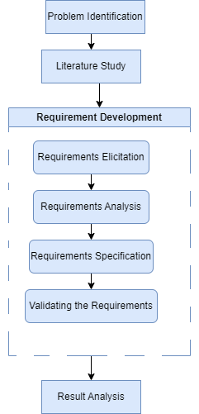
FIGURE 1. Research Stages

Problem Identification
At this stage, observations and interviews were conducted with PT XYZ to identify the problems encountered at the case study location. The interviews revealed that PT XYZ requires a system to help manage layer chicken data, from collecting egg production in the cages to managing product data in the administration department. One of the main obstacles to system development is the difficulty stakeholders face in determining system requirements and developing a comprehensive design. Therefore, it is essential to carry out the requirement development stage by involving stakeholders to ensure that the resulting system meets user needs and minimizes the need for changes.

Literature Study
At this stage, researchers read, study, and analyze various sources of scientific information from experts relevant to the current research. These references support the research and provide insights from other studies, helping researchers avoid making incorrect decisions while conducting this study.

Requirement development
Requirement development is a process that involves the identification, analysis, specification, and validation of needs or stakeholder requirements for a system or product. This process is a crucial first step in project development because it determines what the system or product must do to meet user needs and business goals [6]. The following are the main stages in requirement development:
- Elicitation
This stage involves gathering information from stakeholders to understand what they need from the system or product. Techniques used can include interviews, surveys, observations, and workshops. [6].
- Analysis (Needs Analysis)
After collecting the data, the needs are analyzed to ensure that they are complete, clear, and free from ambiguity. This analysis also aims to identify and address conflicts between stakeholder needs. [6].
- Specification
The needs that have been analyzed are then documented in a structured manner. This specification is usually presented in the form of a detailed and clear requirement specification document for use by the development team [7].
- Validation
At this stage, the requirements that have been specified are validated with stakeholders to ensure that the requirements actually reflect what the stakeholders' needs are [6].
An effective requirements development process helps reduce the risk of misunderstandings and ensures that the final product matches user expectations and business goals.

Results Analysis
This stage is carried out to review and analyze the results of the requirements development process to ensure that the requirements have met the quality criteria and are ready to proceed to the design and implementation stages.

RESULTS AND DISCUSSION

The purpose of the requirement development stage is to ensure that the system or product being developed aligns with the requirements and expectations of stakeholders.

Elicitation
Requirements elicitation is the initial stage of the requirements development process. This stage involves gathering information from stakeholders to understand their needs for the system or product. During this phase, interviews were conducted with stakeholders which include Cage Admin, Cage PIC, Location Coordinator, Supervisor / Animal Welfare, Office Admin, Farm Manager, and Director. It also examines these information and objectives of requirements for the system to be developed.
From the results were compiled into a list of user requirements as in TABLE 1 are obtained below:

TABLE 1. List of User Requirements
Requirement Code | Stakeholders |  | Description
RC-001 | Cage Admin |  | Upload or input egg production data
RC-002 |  |  | Fill in captions
RC-003 |  |  | View decisions given by farm managers  and directors
RC-004 | Cage PIC |  | View and download egg production data
RC-005 |  |  | Approve reports that have been inputted  by the cage admin
RC-006 |  |  | Can give decision
RC-007 | Location  Coordinator |  | View and download egg production data
RC-008 |  |  | Approve reports that have been inputted
 |  | by the cage admin
RC-009 |  | Give decision
RC-010 |  | View graphs
RC-011 | Supervisor / Animal Welfare | View egg production reports
RC-012 | Supervisor / Animal Welfare | Provide decision
RC-013 | Office  Admin | View egg production reports
RC-014 | Office  Admin | Provide decision
RC-015 | Office  Admin | Perform cage management
RC-016 | Office  Admin | Manage employees
RC-017 | Office  Admin | Manage chicken status
RC-018 | Farm  Manager | View egg production reports
RC-019 | Farm  Manager | Give decision
RC-020 | Farm  Manager | View graphs
RC-021 | Farm  Manager | View activity logs
RC-022 | Farm  Manager | Define access rights
RC-023 | Farm  Manager | Determine the status of the cage
RC-024 | Director | View egg production reports
RC-025 | Director | Give decision
RC-026 | Director | Manage control data
RC-027 | Director | View graphs

Analysis
At this stage, the requirements are analyzed to ensure they are complete, clear, and free from ambiguity. This analysis also aims to identify and resolve any conflicts between stakeholder needs. During the requirements analysis process, researchers categorize user needs into functional requirements with high, medium, or low priority.
a. Prioritization
The results from the requirements elicitation process are compiled into a list of user needs, as described in the following TABLE 2:

TABLE 2. Prioritizazion Analysis
No. | Stakeholders | Requirement | HML Analysis
No. | Stakeholders | Requirement | H | M | L
1. | Cage Admin | Upload or input egg production data | 🗸
1. | Cage Admin | Fill in the description | 🗸
 |  | Looking at the decisions given by farm  managers and directors | 🗸
2. | Cage PIC | View and download egg production data | 🗸
2. | Cage PIC | Approve reports that have been inputted  by the cage admin. | 🗸
2. | Cage PIC | Giving decision | 🗸
3. | Site Coordinator | View and download egg production data | 🗸
3. | Site Coordinator | Approve reports that have been inputted  by the cage admin. | 🗸
3. | Site Coordinator | Giving decision | 🗸
3. | Site Coordinator | View graphs | 🗸
4. | Supervisor / Animal Welfare | View egg production report | 🗸
4. | Supervisor / Animal Welfare | Providing decision | 🗸
5. | Office Admin | View egg production report | 🗸
5. | Office Admin | Providing decision | 🗸
5. | Office Admin | Manage the cage | 🗸
5. | Office Admin | Manage employees | 🗸
5. | Office Admin | Manage chicken status | 🗸
6. | Farm Manager | View egg production report | 🗸
6. | Farm Manager | Giving decision | 🗸
6. | Farm Manager | View graphs | 🗸
6. | Farm Manager | View activity logs | 🗸
6. | Farm Manager | Specify access rights | 🗸
6. | Farm Manager | Determine the status of the cage | 🗸
7. | Director | View egg production report | 🗸
7. | Director | Giving decision | 🗸
7. | Director | Manage control data | 🗸
7. | Director | View graphs | 🗸

b. Functional Requirement Analysis
Functional requirements analysis is conducted to determine the actions and features the system or product must provide to fulfill user needs and achieve business objectives. The stages of functional requirement analysis can be seen in TABLE 3.

TABLE 3. List of Functional Requirements

Functional Requirement Code | Description
FR-001 | User can manage egg production data
FR-002 | User is able to manage decision
FR-003 | User is able to do approval
FR-004 | User is able to manage control data
FR-005 | User is able to view graphs
FR-006 | User is able to manage employee data
FR-007 | User can manage egg production report
FR-008 | User is able to manage cage data
FR-009 | User can manage chicken status
FR-010 | User is able to view activity log
FR-011 | User is able to determine access rights
FR-012 | User is able to manage cage status

3. Specification
The analyzed requirements are then documented in a structured format. Specifications are presented as a detailed and clear requirement specification document for use by the development team. At this stage, researchers create requirements specifications using Use Case Diagrams and Use Case Descriptions. These tools help visualize interactions between actors and the system, identify functional requirements, establish system boundaries, and facilitate communication with stakeholders. The Use Case Diagram and Use Case Description are shown in the following FIGURE 2 and TABLE 4.

4. Validation
Validation is conducted through an iterative inspection process. Before validating with the client, a mapping is performed to align user requirements, functional requirements, and use cases, ensuring that all functional requirements meet user needs. Following this, the inspection process is carried out with the client. During the initial online inspection between the client and the developer, several evaluations were obtained. Feedback from the client led to the addition of requirements from one stakeholder, resulting in updated use cases and use case descriptions. In the second validation inspection, further additions to stakeholders and requirements were made. The third inspection involved a site visit by the development team to the client's location, which led to the inclusion of additional stakeholders and clarification of some requirements. These updates were incorporated into the Software Requirements Specification (SRS) and subsequently submitted to the client for approval. Table 5 shows mapping table that contain functional requirement code (FR), Usecase Code (UC), and Requirement Code (RC).

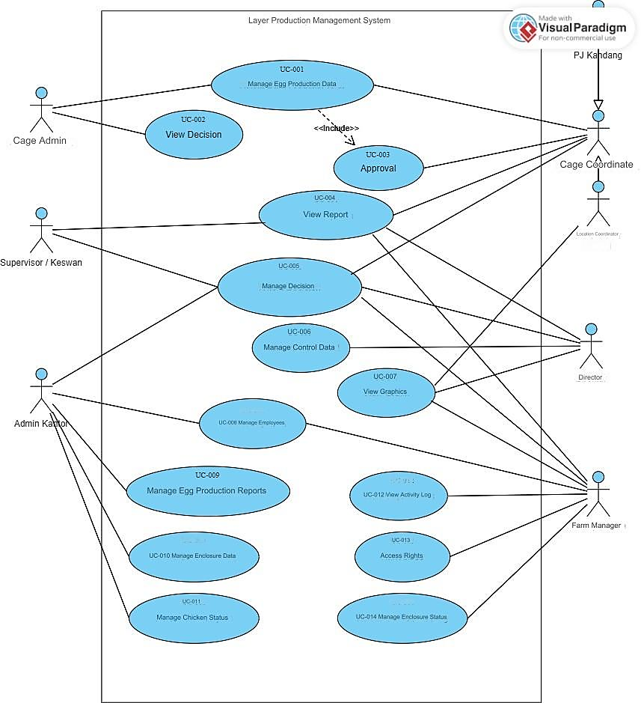
FIGURE 2. Usecase Diagram

TABLE 4. Usecase Description Manage Egg Production Data
Usecase Name: Manage Egg Production Data |  |  |  | ID : Cage-Admin_01
Primary Actor: Cage Admin
Brief Description:
This usecase describes when Admin Cage:
- Uploading data
- View data
- Downloading data
- Manage captions
- Edit data
- The cage admin can view the total feed, total eggs, number of dead chickens
Relationship:
- Association: Cage Admin and Cage PIC
- Included use case : Approval
Precondition: The Cage Admin has successfully authenticated.
The cage admin can only upload egg production data, if the cage admin has obtained the data from the cage mother.
Normal Flow of Events:
Actor |  | System
1. | Cage Admin click the cage menu → manage cages | 2. | Display daily production reports per flock and per cage.
3. | Admin Cage clicks the detail button. | 4. | Display a list of reports.
5. | To download, Admin Cage clicks the download button
6. | Admin Cage click the add button Report. | 7. | Display module (file upload / input)
8. | Admin Cage clicks the submit button | 9. | Report saved
Notes:
- The Cage Admin can view reports and download data that has been uploaded.
- Admin Cage can upload excel file
- Cage Admin can edit egg production data as long as Cage PIC has not approved it.
- Cage Admin can download report templates
- Cage Admin can download reports
Alternate Flows:
- When the uploaded file name is the same as an existing file then an alert will appear.
- When egg production data does not match the criteria, the Admin Office can add a description to the data.

TABLE 5. Mapping Table
Functional  Requirement Code | Usecase  Code | Requirement  Code
FR-001 | UC-001 | RC-001
FR-001 | UC-001 | RC-002
FR-001 | UC-001 | RC-004
FR-001 | UC-001 | RC-007
FR-002 | UC-002 | RC-003
FR-002 | UC-005 | RC-006
FR-002 | UC-005 | RC-009
FR-002 | UC-005 | RC-012
FR-002 | UC-005 | RC-014
FR-002 | UC-005 | RC-019
FR-002 | UC-005 | RC-025
FR-003 | UC-003 | RC-005
FR-003 | UC-003 | RC-008
FR-004 | UC-006 | RC-026
FR-005 | UC-007 | RC-010
FR-005 | UC-007 | RC-020
FR-005 | UC-007 | RC-027
FR-006 | UC-008 | RC-016
FR-007 | UC-009 | RC-011
FR-007 | UC-004 | RC-013
FR-007 | UC-004 | RC-018
FR-007 | UC-004 | RC-024
FR-008 | UC-010 | RC-015
FR-009 | UC-011 | RC-017
FR-010 | UC-012 | RC-021
FR-011 | UC-013 | RC-022
FR-012 | UC-014 | RC-023

CONCLUSIONS

The need for an effective system to streamline data processing at PT XYZ has been clearly identified. Stakeholders often lack a deep understanding of system development processes and the necessary preparations for system creation. Therefore, a through requirement development process is crucial to ensure that the final system meets stakeholder needs and to avoid misunderstandings between developers and stakeholders. In the software requirements analysis for PT XYZ’s poultry management system, a total of twenty-three user requirements, twelve functional requirements, and fourteen use cases were identified and detailed with use case descriptions from six stakeholders. The requirements validation was conducted through an inspection process carried out three times, resulting in a validated Software Requirements Specification (SRS) document. The successful implementation of the requirement development process for PT XYZ’s poultry management system is evident from the final SRS document. This document lays a critical foundation for the system development process, though its influence on subsequent stages, such as design, implementation, and testing. Nevertheless, the document affirms that the requirement development process effectively captured stakeholder needs and mitigated potential misunderstandings, ensuring that the final system aligns with user expectations and supports overarching business objectives.
This document confirms that the requirement development process effectively addressed stakeholder needs and minimized potential misunderstandings, thereby ensuring the development of a system that aligns with user expectations and business goals.

ACKNOWLEDGMENTS

We would like to thank PT XYZ and University of Muhammadiyah Malang for the opportunity, support, and data provided during the needs gathering process until validation. The support and good cooperation from both parties greatly contributed to the success of this project.

REFERENCES

- W. Suryn, Software Quality Engineering: A Practitioner’s Approach, vol. 9781118592. 2014.
- Hy-Line, “Panduan manajemen,” p. 30, 2019.
- A. Perwitasari and M. A. Irwansyah, “Model Prototipe dan Analisis Use Case pada Rekayasa Kebutuhan Perangkat Lunak Pengajuan Dokumen Kependudukan,” J. Edukasi dan Penelit. Inform., vol. 7, no. 2, p. 175, 2021, doi: 10.26418/jp.v7i2.47976.
- F.- Sonata, “Pemanfaatan UML (Unified Modeling Language) Dalam Perancangan Sistem Informasi E-Commerce Jenis Customer-To-Customer,” J. Komunika J. Komunikasi, Media dan Inform., vol. 8, no. 1, p. 22, 2019, doi: 10.31504/komunika.v8i1.1832.
- N. Putri, N. Agung Prabowo, and R. A. Widyanto, “Implementasi Metode Prototyping pada Perancangan Aplikasi Electronic Ticket (E-Ticket) berbasis Android,” J. Komtika (Komputasi dan Inform., vol. 3, no. 2, pp. 62–68, 2020, doi: 10.31603/komtika.v3i2.3474.
- S. L. Only, Praise for This Book. 2001.
- G. Karnawan, “Implementasi User Experience Menggunakan Metode Design Thinking Pada Prototype Aplikasi Cleanstic,” J. Teknoinfo, vol. 15, no. 1, p. 61, 2021, doi: 10.33365/jti.v15i1.540.

