Enhancing Time Series Predicting: An Analytical Comparison of LSTM, Random Forest, and Hybrid Models for Predicting BRI Stock Prices
Brina Miftahurrohmah^{1,a)}, Taufiqotul Bariyah^{2,b)}, Catur Wulandari^{1,c)}, Grandys Frieska Prassida^{1,d)}, and Ardhi Dwi Firmansyah^{1,e)}
¹Department of Information System, Universitas Internasional Semen Indonesia, Gresik, Indonesia
²Department of Informatics, Universitas Internasional Semen Indonesia, Gresik, Indonesia

^{a)} Corresponding author: brina.miftahurrohmah@uisi.ac.id
^{b)} taufiqotul.bariyah@uisi.ac.id
^{c)} catur.wulandari@uisi.ac.id
^{d)} grandys.prassida@uisi.ac.id
^{e)} ardhi.firmansyah@uisi.ac.id
Abstract. Accurately predicting stock price fluctuations is crucial for understanding BRI (BBRI) stock trends from January 2020 to July 2024. This study evaluates the effectiveness of Long Short-Term Memory (LSTM) and Random Forest models, as well as hybrid approaches. The analysis involves developing LSTM models with one and two hidden layers alongside Random Forest and hybrid models. The results indicate that the LSTM model with two hidden layers and Adam's optimization method (learning rate 0.01, epoch 200, batch size 64) delivers the highest accuracy, achieving an RMSE of 97.84, MAPE of 1.45%, and MAD of 76.12. In contrast, Random Forest and hybrid models show lower performance and less accuracy in predicting stock prices.
Keywords: LSTM, Random Forest, Hybrid

INTRODUCTION
As one of the most active and complicated elements in the global financial system, the stock market is characterized by high volatility, large transaction volumes, and complexity of information to be analyzed [1] [2] [3]. High volatility, caused by a variety of factors, including economic and political uncertainty, contributes to substantial risk for investors [4] [5] [6] [7]. Large transaction volumes reflect a high level of market activity [8] [9], while information complexity includes different types of data to consider, such as company financial reports, economic news, and market analysis [10] [11] [12]. Sharp price fluctuations are influenced by external factors, such as monetary policy and interest rate changes, as well as by the diversity of products traded, including stocks, bonds, and derivative instruments [13] [14] [15]. All these factors interact to create a highly dynamic and complex market. The characteristics of fast and volatile stock price movements demand accurate and reliable forecasting methods to assist investors and analysts in making informed investment decisions [16] [17] [18] [19]. The stock analysis of PT Bank Rakyat Indonesia (Persero) Tbk (BBRI) is particularly important due to significant global and regional recognition, such as a 110-world ranking and awards from Forbes and Fortune. Despite a declining share price, BBRI continues demonstrating profit growth and financial stability, making it crucial for investment analysis and future performance assessment. Effective forecasting helps investors determine the right time to buy or sell BBRI shares and supports market stability by providing better insight into potential future price movements.

In recent years, advanced analysis methods such as Long Short-Term Memory (LSTM) and Random Forest have shown great potential in predicting complex time series data, including stock prices. LSTM, an artificial neural network, is specifically designed to handle long-term dependencies in sequential data, making it highly effective in analyzing complex and non-linear temporal patterns in stock price data [20] [21] [22]. The advantage of LSTM lies in its ability to process long-term preserved information through sophisticated gating mechanisms, thus capturing undetectable patterns by other methods. On the other hand, as an ensemble learning method, Random Forest operates by building various decision trees that combine their results to provide more stable and accurate predictions. By reducing the risk of overfitting and improving prediction accuracy, Random Forest has been proven effective in various data analysis applications [23] [24] [25] [26] [27]. Combining these two methods in a hybrid model offers significant potential for improving stock price prediction accuracy. Hybrid models that combine LSTM with random forest capitalize on each method's strengths: LSTM handles long-term temporal data, and random forest reduces variability and improves prediction accuracy. By integrating the ability of LSTM to identify complex patterns and Random Forest to mitigate model variability, this approach can provide more accurate and reliable results in predicting stock prices. Recent research shows that this hybrid model not only overcomes the weaknesses of a single model but also offers a more robust solution in stock data analysis [28] [29] [30] [31] [32].
Given the advantages offered by both methods, this research aims to explore the application of the hybrid LSTM and Random Forest models in the context of BRI (BBRI) stock price prediction. This research will compare the effectiveness of both methods separately and evaluate how their combination can create synergies that improve prediction accuracy. By focusing on combining the strength of LSTM in capturing deep temporal patterns and Random Forest's ability to minimize model uncertainty, this study aims to find the most effective approach for the Indonesian stock market. Hopefully, the findings from this study will provide valuable insights that can be used to formulate more informed and strategic investment strategies and improve understanding of how best to utilize analytics technology in the context of the stock market.

METHODS
This study evaluated the effectiveness of various models in predicting BRI's stock price through a comprehensive methodology. The process involved collecting and pre-processing data, developing LSTM models with one and two hidden layers, testing Random Forest models, and exploring hybrid approaches (RF-LSTM and LSTM-RF). Model performance was assessed using RMSE, MAPE, and MAD metrics to compare the strengths and weaknesses of each approach. Below are the steps for this research:

Data Collection
The dataset comprises the daily closing prices of BRI (BBRI) shares, sourced from the website https://finance.yahoo.com/quote/BBRI.JK/. The data period used is from January 2, 2020, when the COVID-19 issue began to emerge, to July 31, 2024. The collection process involves examining the data to identify and remove outliers and correct any errors.

Data Pre-processing
Normalization is performed using the Min-Max Scaling technique to standardize variable scales. The dataset is subsequently divided into a training set and a testing set, where the training set is utilized for model development, and the testing set is employed for evaluating model performance. A time series technique with lag generation is applied to prepare the data in a format suitable for the LSTM model. This study uses a lag of 10-time steps of historical data, meaning that ten independent variables are formed. The choice of 10-time steps was based on preliminary experiments that showed that using more than ten lags did not significantly improve the model's prediction accuracy. Using more lags slowed down the training process. Therefore, a 10-time step is considered optimal to balance model performance and the efficiency of the training process.

LSTM and Random Forest Model Development
LSTM models were developed with one and two-hidden layer configurations to capture the temporal dependency of stock prices. Hyperparameter settings, including number of epochs, batch size, learning rate, and optimizer type (Adam, SGD, Adamax, Adagrad, and RMSprop), were performed to determine the optimal configuration. The model implementation uses deep learning libraries such as TensorFlow or PyTorch in Python, with evaluation based on its ability to reflect actual stock price fluctuations. In the LSTM model with two hidden layers, each layer uses 50 neurons. The alternative hyperparameters used in this modelling are shown in TABLE 1.

TABLE 1. Alternative Hyperparameters for LSTM
Hyperparameter | Alernatives
Neurons | 50
Droupout rate | 0.2
Learning rate | 0.001, 0.01, 0.1
Batch size | 32, 64
Epochs | 50, 100, 150, 200

The Random Forest model was developed to compare its performance with the LSTM model. Parameters such as tree depth, number of trees (n estimators), and splitting criteria were optimized to improve prediction accuracy. The model was implemented using the scikit-learn library in Python, focusing on its ability to capture sharp and significant stock price trends.

Hybrid Model Implementation
The hybrid approaches tested include RF-LSTM and LSTM-RF, which aim to explore the potential for improving prediction accuracy. In the RF-LSTM approach, the prediction results from Random Forest are used as input features for the LSTM model, while in the LSTM-RF approach, the prediction results from LSTM are used as input for the Random Forest model. The purpose of this approach is to utilize both models' power to capture various aspects of stock price movements.

Model Evaluation
Evaluation is done using key metrics: Root Mean Square Error (RMSE), Mean Absolute Percentage Error (MAPE), and Mean Absolute Deviation (MAD). These metrics were chosen to provide a comprehensive picture of the accuracy and precision of the model's predictions. The evaluation is performed on both the training and test sets to assess the model's ability to generalize the predicted results.

RESULTS AND DISCUSSION
LSTM modelling is applied using one and two hidden layers. The analysis shows that for the LSTM model with one hidden layer, the best optimization method for prediction is Adam, with a learning rate parameter of 0.01, number of epochs of 200, and batch size of 32, as shown in FIGURE 1(a). The LSTM model with this configuration shows that the fluctuations in prediction results tend to follow the actual data pattern more every day than other estimation models. The models are reinforced by the smallest RMSE, MAPE, and MAD values of Adam's method compared to other optimization methods, which are 100.46, 1.48%, and 78.26, respectively, as shown in TABLE 2. In contrast, the SGD optimization method shows the worst performance, with RMSE, MAPE, and MAD values of 140.52, 2.12%, and 110.19, respectively, indicating that the fluctuations of the prediction results from this method are significantly different from the actual data, especially in patterns that have a drastic increase or decrease.
In the LSTM model with two hidden layers, the best optimization method is Adam, and the worst is SGD. The model with Adam's optimization uses a learning rate of 0.01, several epochs of 200, and a batch size of 64, while SGD uses a learning rate of 0.1, number of epochs of 150 and a batch size of 32. For the LSTM model with one hidden layer, SGD optimization uses a learning rate of 0.1, some epochs of 200, and a batch size 32. These results are reinforced by the RMSE, MAPE, and MAD values of Adam's method, which remain the smallest, indicating that adding hidden layers to LSTM with the right optimization method can improve the model's accuracy. In contrast, other optimization methods show a decrease in performance by adding hidden layers, as shown by the increase in error values in TABLE 2.

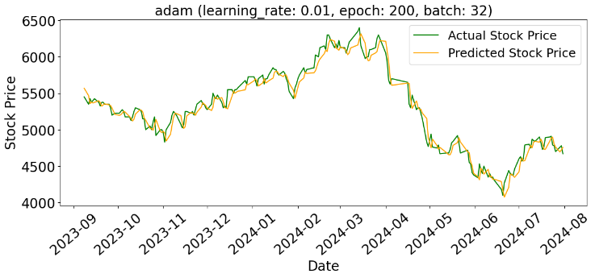 | 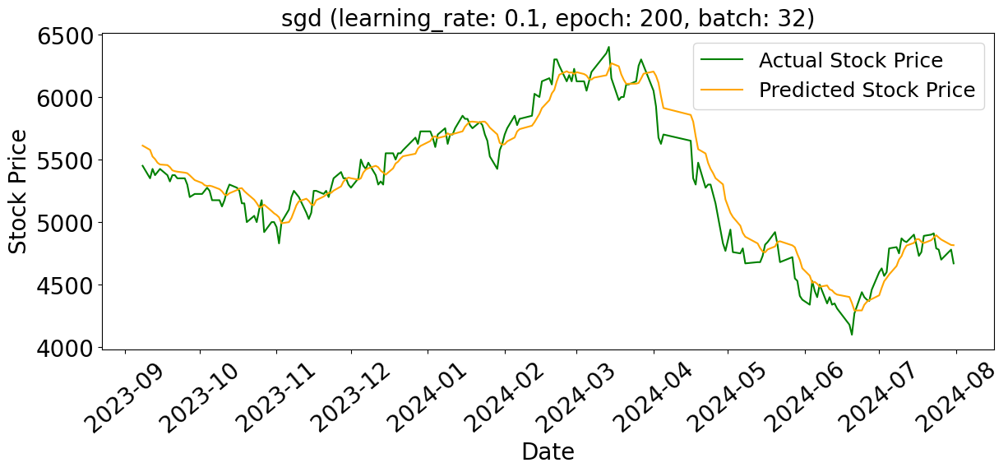
(a) | (b)
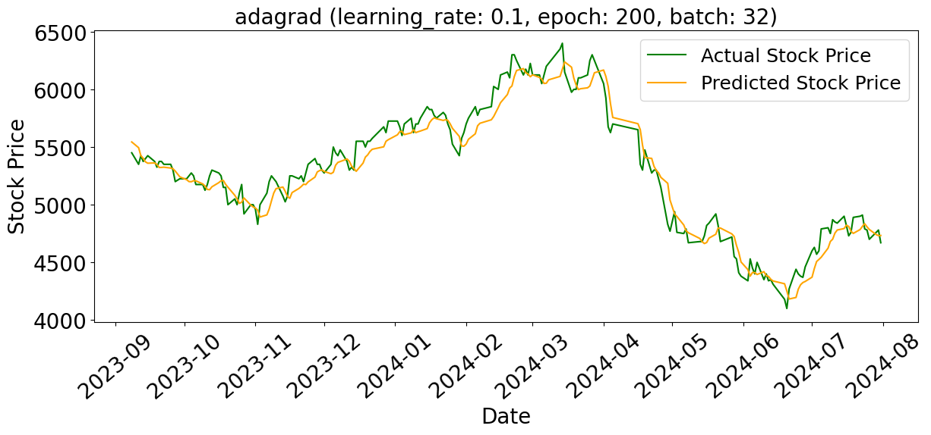 | 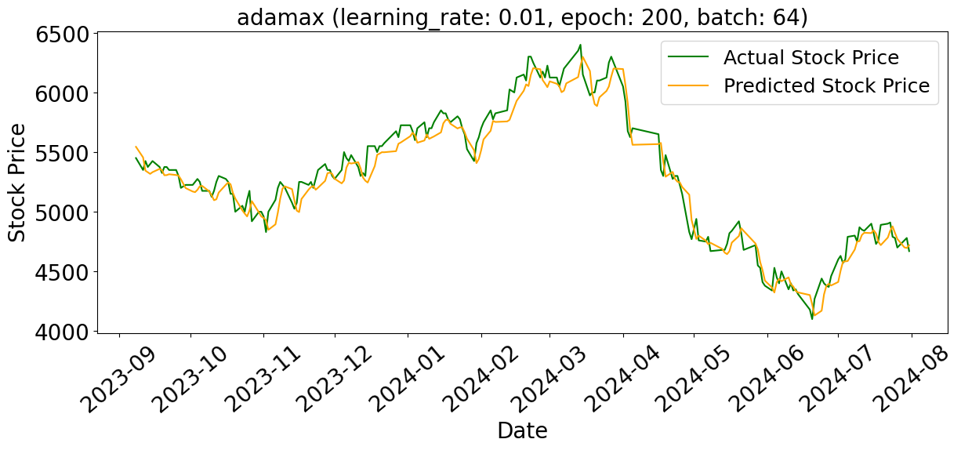
(c) | (d)
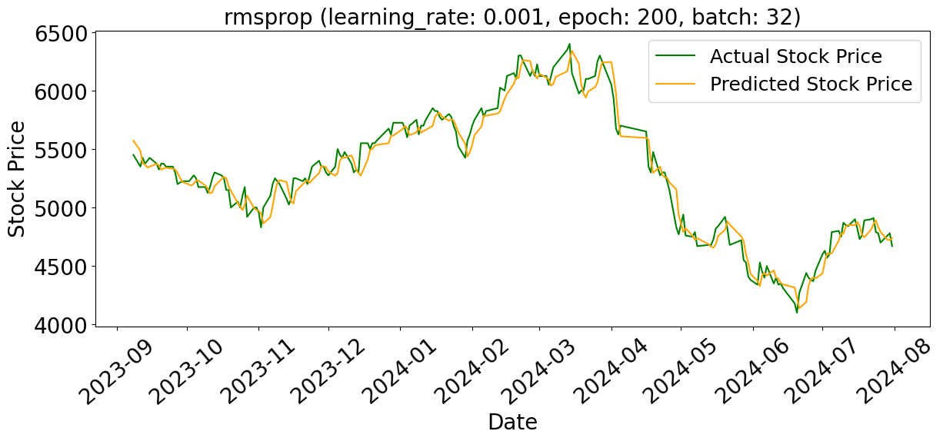 | 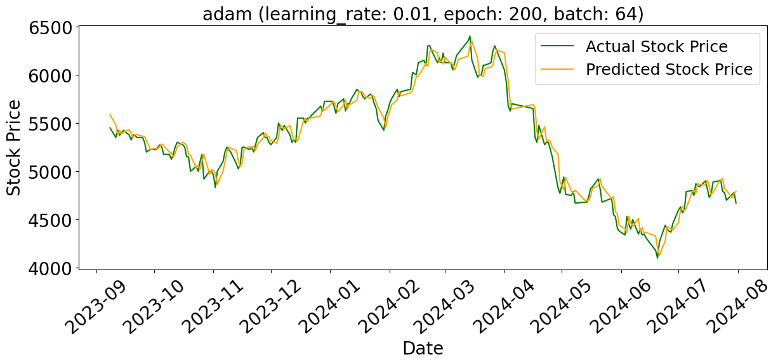
(e) | (f)
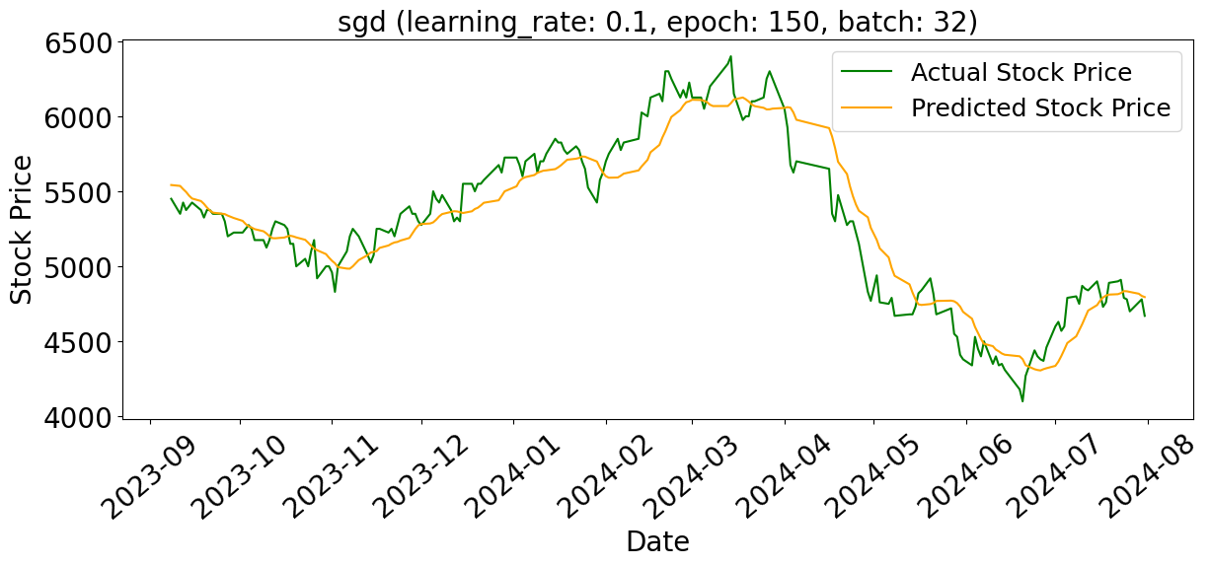 | 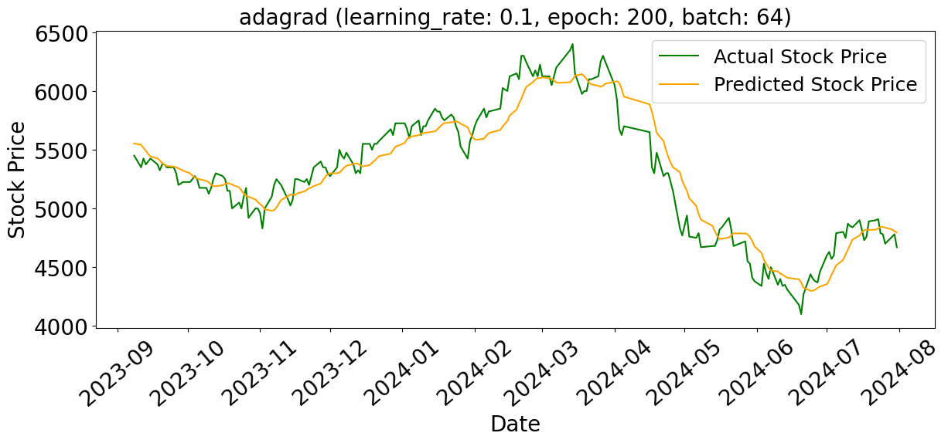
(g) | (h)
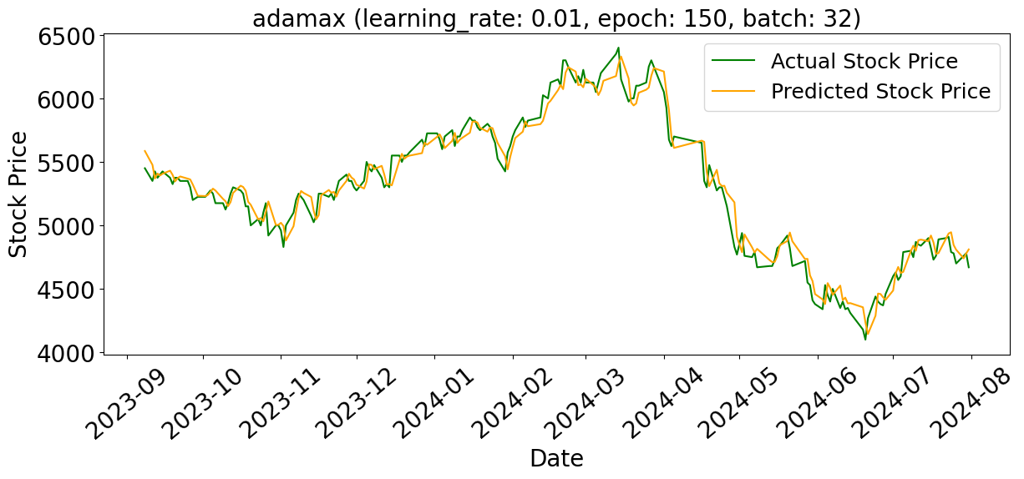 | 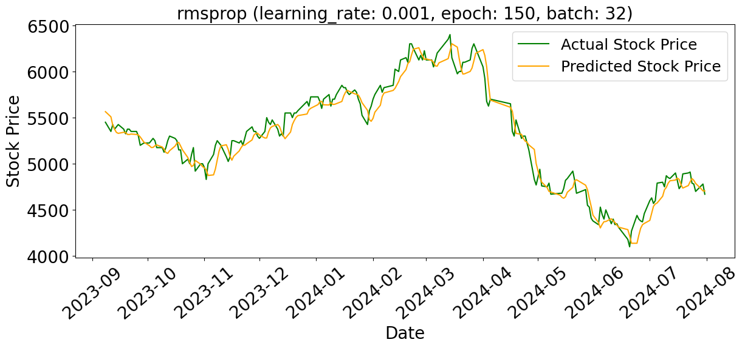
(i) | (j)
FIGURE 1. Comparison of daily stock price predictions for BRI using LSTM: (a-e) show predictions with 1 hidden layer, while (f-j) illustrate predictions with 2 hidden layers, compared to the actual stock prices.
Furthermore, for models with two hidden layers, the Adam and Adamax optimization methods show that adding one hidden layer improves the performance of the LSTM model, or in other words, it can predict more accurately. The fluctuation graph of the prediction results in FIGURE 1(f) for Adam with hidden layers shows the accuracy, which is more accurate than FIGURE 1(a) for Adam with one hidden layer. The Adam optimization results are the same as the comparison of Adamax, with one hidden layer in FIGURE 1(d) and two hidden layers in FIGURE 1(i). However, the combination of parameters used to achieve the optimal condition differs, especially in the number of batches used. For other optimization methods, increasing the number of hidden layers decreases the performance of the LSTM model, where the fluctuations in prediction results in FIGURE 1(b), (c), and (e) are better than those in FIGURE 1(g), (h), and (j). Overall, the best LSTM model that can be used to predict BRI shares in the future is the LSTM model with the Adam optimization method, learning rate of 0.01, number of epochs of 200, and batch size of 64. In addition to choosing the right optimization method, the suitability of other parameter combinations also needs to be considered, and it is necessary to increase the range of values for each parameter to achieve optimal results.

TABLE 2. Evaluation of LSTM models based on MSE, MAPE, and MAD for different configurations of hidden layers: 1 hidden layer and 2 hidden layers
Number of Hidden Layer | Optimizer Algorithm | Evaluation Criteria
Number of Hidden Layer | Optimizer Algorithm | RMSE | MAPE | MAD
1 | Adam | 100.46 | 1.48 | 78.26
1 | SGD | 140.52 | 2.12 | 110.19
1 | Adagrad | 123.17 | 1.87 | 98.87
1 | Adamax | 112.93 | 1.69 | 90.43
1 | RMSprop | 104.06 | 1.54 | 81.68
2 | Adam | 95.82 | 1.42 | 74.22
2 | SGD | 175.96 | 2.68 | 140.55
2 | Adagrad | 164.01 | 2.51 | 131.60
2 | Adamax | 99.12 | 1.50 | 78.19
2 | RMSprop | 119.64 | 1.79 | 94.51

Besides LSTM, another method used to predict time series is Random Forest. Modelling results using Random Forest show that the resulting predictions are less accurate than LSTM. The Random Forest model can only capture data patterns that experience a sharp increase that exceeds the initial prediction value of around 5500. This pattern is consistently seen in all simulations of the depth parameter used. The fluctuation of the prediction results can be seen in FIGURE 2(a-d), which shows that the Random Forest model is less able to follow the actual data fluctuation pattern well. Based on TABLE 3, it can be seen that the best Random Forest model is the model with a depth of 15, with RMSE, MAPE, and MAD values of 227.22, 2.84, and 157.90, respectively. However, it performed no better than the best LSTM model and even worse than the worst LSTM model. The results indicate the limitations of Random Forest in modelling more complex and diverse stock price fluctuations, especially in the case of time series data that requires more dynamic and adaptive pattern detection capabilities such as those possessed by the LSTM model.
For the hybrid model, the analysis results in TABLE 4 show that the Hybrid RF-LSTM model has RMSE, MAPE, and MAD values of 518.89, 7.12, and 402.92, respectively, indicating that the resulting predictions are less accurate than the individual LSTM or Random Forest models. In contrast, the Hybrid LSTM-RF model has RMSE, MAPE, and MAD values of 218.39, 2.54, and 143.25, indicating better performance than the Random Forest model, but still not as good as the LSTM model. FIGURE 2(e-f) also shows that the Hybrid LSTM-RF model is better than the Hybrid RF-LSTM model, where the stock fluctuation of the LSTM-RF model is closer to the actual but not better than the LSTM model. From these results, LSTM has a more significant influence in improving the accuracy of the hybrid model. Hybrid LSTM-RF models that use LSTM as the first stage show better performance because LSTM can more effectively capture complex and non-linear data patterns. In contrast, the Hybrid RF-LSTM model that uses Random Forest as the first stage does not make the same contribution, leading to poorer overall prediction performance. Thus, the order in which the models are used in the hybrid plays an important role, and LSTM is more effective as the first stage to improve prediction accuracy in time series data such as stock prices.

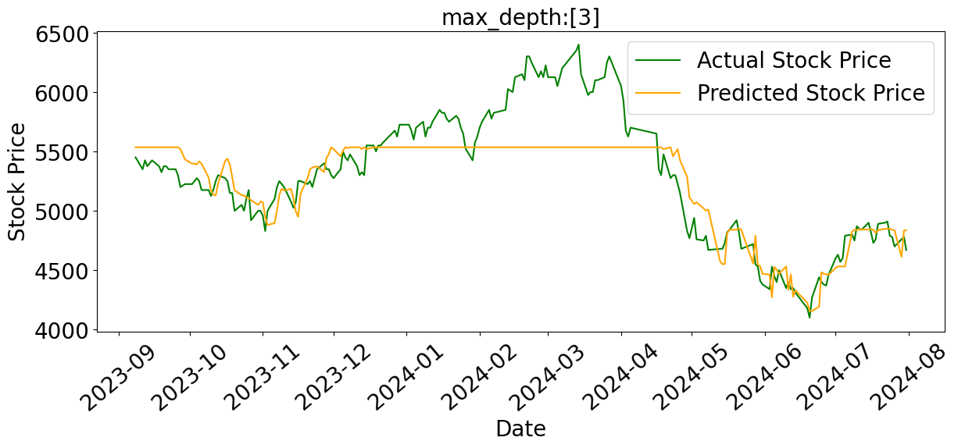 | 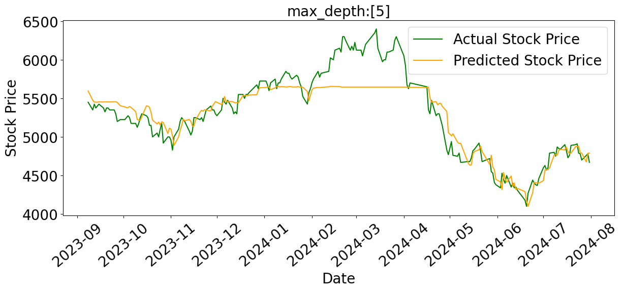
(a) | (b)
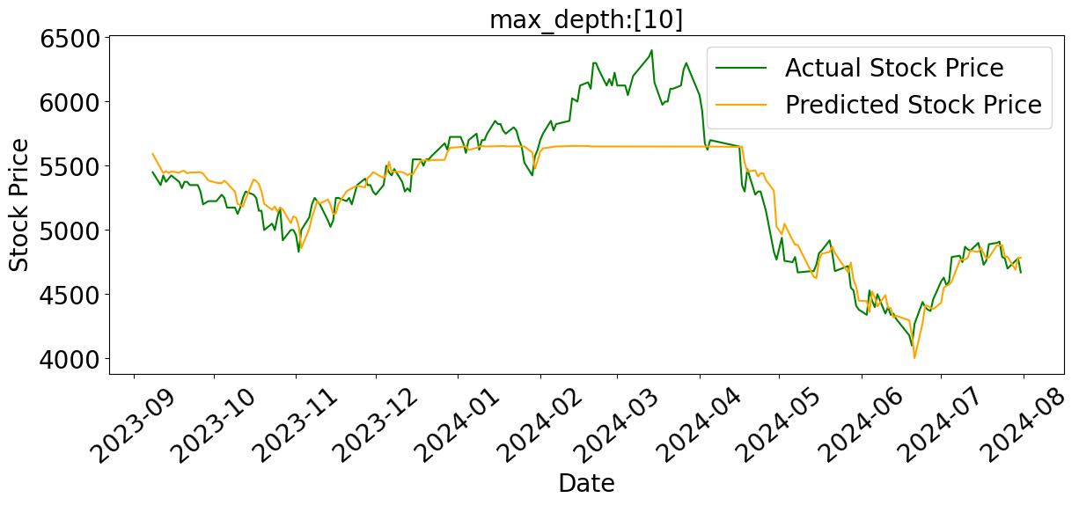 | 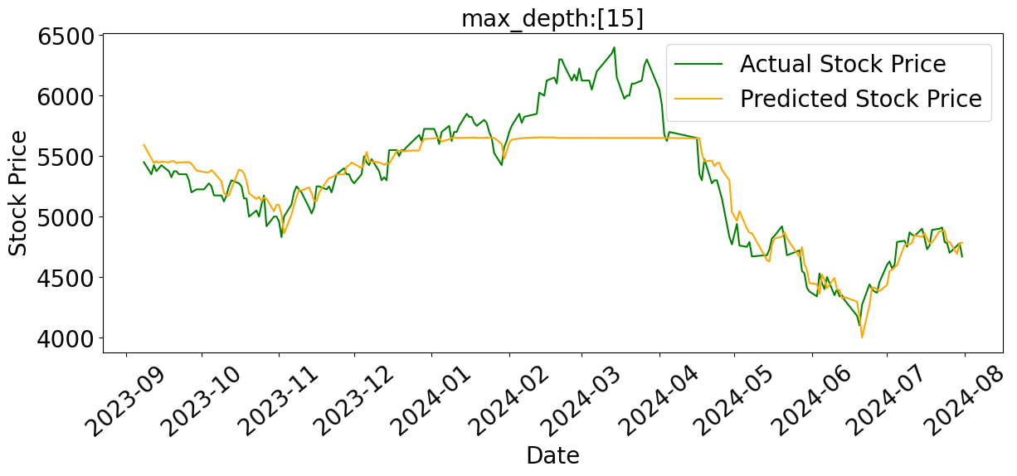
(c) | (d)
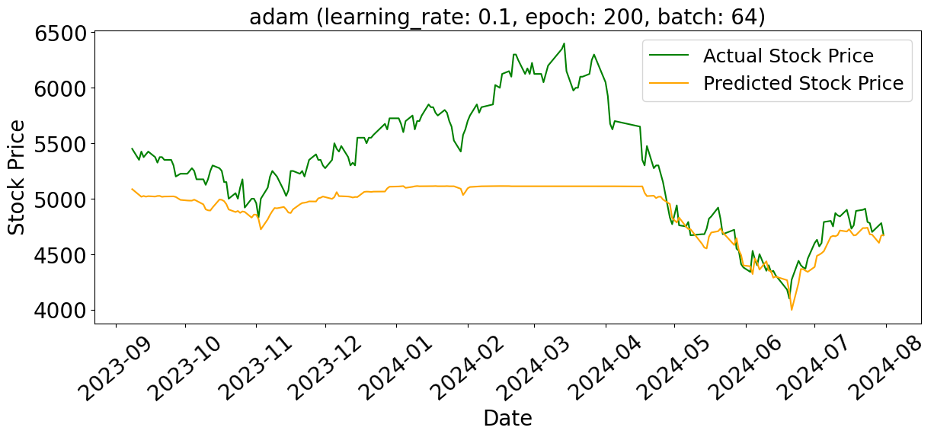 | 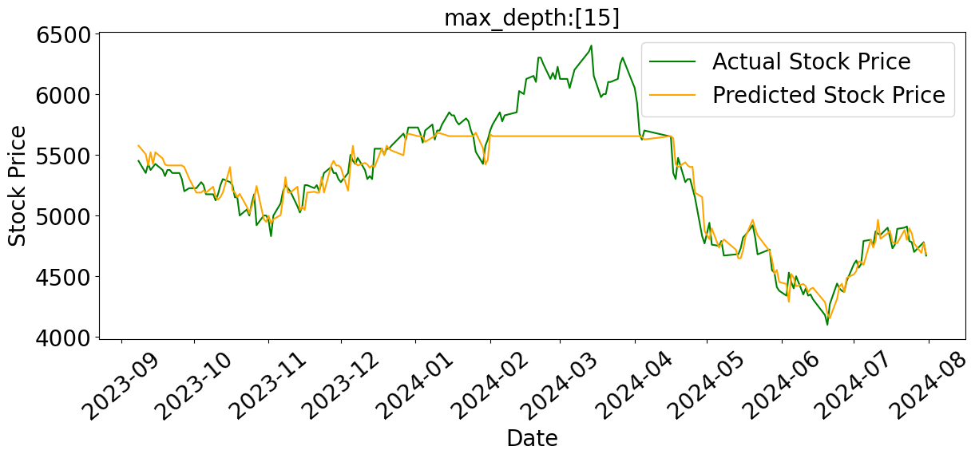
(e) Hybrid RF-LSTM | (f) Hybrid LSTM-RF
FIGURE 2. Comparison of daily stock price prediction for BRI using Random Forest versus actual stock price (a-d) and Hybrid model versus actual stock price (e-f)

TABLE 3. Evaluation metrics for Random Forest model with four different parameter depth scenarios, including MSE, MAPE, and MAD
Depth | Evaluation Criteria
Depth | RMSE | MAPE | MAD
3 | 284.42 | 3.73 | 207.93
5 | 230.97 | 2.93 | 162.41
10 | 227.85 | 2.86 | 158.82
15 | 227.22 | 2.84 | 157.90

Overall, hybrid models cannot always perform better time series prediction than non-hybrid models, especially LSTMs with two hidden layers, Adam optimization method, learning rate of 0.01, number of epochs of 200, and batch size of 64. Although the hybrid model tries to combine the strengths of two different models, the results show that, in this case, the LSTM with the right configuration still excels in capturing complex stock price fluctuation patterns. The results emphasize the importance of choosing the right optimization method, ensuring the suitability of other parameter combinations, and increasing the range of values for each parameter to achieve optimal results. The LSTM model with the right parameters proved more effective in predicting BRI stock data or stock data with similar patterns.

TABLE 4. Evaluation metrics for Hybrid models: RF-LSTM and LSTM-RF, including MSE, MAPE, and MAD
Model | Evaluation Criteria
Model | RMSE | MAPE | MAD
Hybrid RF-LSTM | 518.89 | 7.12 | 402.92
Hybrid LSTM-RF | 218.39 | 2.54 | 143.25

CONCLUSIONS
The analysis shows that the Long Short-Term Memory (LSTM) model with two hidden layers and Adam's optimization method, using a learning rate of 0.01, number of epochs of 200, and batch size of 64, is the best configuration for predicting BRI stock prices. This model outperformed the other methods with Root Mean Square Error (RMSE), Mean Absolute Percentage Error (MAPE), and Mean Absolute Deviation (MAD) values of 100.46, 1.48, and 78.26, respectively, indicating superior prediction accuracy. In contrast, the Random Forest model and RF-LSTM hybrid model showed inferior performance, with the Random Forest having RMSE, MAPE, and MAD values of 227.22, 2.84, and 157.90, and the RF-LSTM hybrid model with RMSE values of 518.89, MAPE 7.12, and MAD 402.92, indicating the inability of these models to capture stock price fluctuations accurately. Although hybrid models can combine the strengths of several methods, the LSTM model with properly optimized parameters proved to be more effective for time series prediction, especially for BRI stock prices or stock data with similar patterns. This finding emphasizes the importance of choosing the right optimization method and adjusting the optimal combination of parameters to achieve the best prediction accuracy. A properly tuned LSTM model remains the top choice in complex stock price prediction.

Acknowledgments
We extend our sincere gratitude to Universitas Internasional Semen Indonesia for their invaluable support in funding the publication of this article and enabling our participation in the 4th International Conference on Technology, Informatics, and Engineering (Icon-TINE 2024). Their assistance has been crucial in advancing this research and facilitating our engagement in this prominent scientific forum.

References
- M. Raddant and D. Y. Kenett, "Interconnectedness in the global financial market," Journal of International Money and Finance, vol. 110, p. 102280, 2021.
- D. Han, "Network analysis of the Chinese stock market during the turbulence of 2015–2016 using log-returns, volumes and mutual information," Physica A: Statistical Mechanics and its Applications, vol. 523, pp. 1091-1109, 2019.
- H. Han, J. Y.-L. Forrest, J. Wang, S. Yuan, F. Han, and D. Li, "Explainable machine learning for high frequency trading dynamics discovery," Information Sciences, vol. 684, p. 121286, 2024.
- Y. Shi and L. Wang, "Comparing the impact of Chinese and US economic policy uncertainty on the volatility of major global stock markets," Global Finance Journal, vol. 57, p. 100860, 2023.
- R. Li, G. Tang, C. Hong, S. Li, B. Li, and S. Xiang, "A study on economic policy uncertainty, geopolitical risk and stock market spillovers in BRICS countries," The North American Journal of Economics and Finance, vol. 73, p. 102189, 2024.
- Z. Hu and S. Borjigin, "The amplifying role of geopolitical Risks, economic policy Uncertainty, and climate risks on Energy-Stock market volatility spillover across economic cycles," The North American Journal of Economics and Finance, vol. 71, p. 102114, 2024.
- Z. Wang, X. Wang, Q. Cheng, and S. Shi, "Heterogeneous impact of economic and political uncertainty on green bond volatility: Evidence from the MRS-GARCH-MIDAS-Skewed T model," International Review of Financial Analysis, vol. 95, p. 103461, 2024.
- A. M. Christiana, E. Setiana, and M. Mamduch, "The empirical relationship between stock return and trading volume based on stock market cycles," The Indonesian Capital Market Review, vol. 8, no. 1, p. 5, 2016.
- Y. Koubaa and S. Slim, "The relationship between trading activity and stock market volatility: Does the volume threshold matter?," Economic Modelling, vol. 82, pp. 168-184, 2019.
- A. G. Mayapada, P. K. Biswas, and H. Roberts, "Financial reporting timeliness and its determinants in UK charities," Advances in accounting, vol. 65, p. 100733, 2024.
- R. Wang, W. F. Chua, R. Simnett, and S. Zhou, "Is greater connectivity of financial and non-financial information in annual reports valued by market participants?," The British Accounting Review, vol. 56, no. 6, p. 101407, 2024.
- M. N. Ashtiani and B. Raahemi, "News-based intelligent prediction of financial markets using text mining and machine learning: A systematic literature review," Expert Systems with Applications, vol. 217, p. 119509, 2023.
- J. Schrank, "The impact of a crisis on monetary policy’s influence on financial markets: Evidence from the COVID-19 pandemic," Cogent Economics & Finance, vol. 12, no. 1, p. 2322874, 2024.
- S. Ashraf, A. M. M. de Almeida, I. Naz, and R. Latief, "Diversification of the Islamic stock market, Bitcoin, and Bullions in response to the Russia-Ukraine conflict and the COVID-19 outbreak," Heliyon, vol. 9, no. 8, p. e19023, 2023.
- X. Lyu and H. Hu, "The dynamic impact of monetary policy on stock market liquidity," Economic Analysis and Policy, vol. 81, pp. 388-405, 2024.
- C. Zhao et al., "Progress and prospects of data-driven stock price forecasting research," International Journal of Cognitive Computing in Engineering, vol. 4, pp. 100-108, 2023.
- A. Pagliaro, "Forecasting significant stock market price changes using machine learning: extra trees classifier leads," Electronics, vol. 12, no. 21, p. 4551, 2023.
- D. P. Gandhmal and K. Kumar, "Systematic analysis and review of stock market prediction techniques," Computer Science Review, vol. 34, p. 100190, 2019.
- G. Sonkavde, D. S. Dharrao, A. M. Bongale, S. T. Deokate, D. Doreswamy, and S. K. Bhat, "Forecasting stock market prices using machine learning and deep learning models: A systematic review, performance analysis and discussion of implications," International Journal of Financial Studies, vol. 11, no. 3, p. 94, 2023.
- B. Gülmez, "Stock price prediction with optimized deep LSTM network with artificial rabbits optimization algorithm," Expert Systems with Applications, vol. 227, p. 120346, 2023.
- A. K. Yadav and V. P. Vishwakarma, "An Integrated Blockchain Based Real Time Stock Price Prediction Model by CNN, Bi LSTM and AM," Procedia Computer Science, vol. 235, pp. 2630-2640, 2024.
- M. Salim and A. Djunaidy, "Development of a CNN-LSTM Approach with Images as Time-Series Data Representation for Predicting Gold Prices," Procedia Computer Science, vol. 234, pp. 333-340, 2024.
- I. Simonetti, C. Lubello, and L. Cappietti, "On the use of hydrodynamic modelling and random forest classifiers for the prediction of hypoxia in coastal lagoons," Science of The Total Environment, vol. 951, p. 175424, 2024.
- A. Shebl, D. Abriha, M. Dawoud, M. A. H. Ali, and Á. Csámer, "PRISMA vs. Landsat 9 in lithological mapping− a K-fold Cross-Validation implementation with Random Forest," The Egyptian Journal of Remote Sensing and Space Sciences, vol. 27, no. 3, pp. 577-596, 2024.
- V. J. Pasquarella, L. L. Morreale, C. F. Brown, J. B. Kilbride, and J. R. Thompson, "Not-so-random forests: Comparing voting and decision tree ensembles for characterizing partial harvest events," International Journal of Applied Earth Observation and Geoinformation, vol. 125, p. 103561, 2023.
- M. Haydar, H. Sadia, and M. T. Hossain, "Data driven forest fire susceptibility mapping in Bangladesh," Ecological Indicators, vol. 166, p. 112264, 2024.
- J. V. Silva, J. van Heerwaarden, P. Reidsma, A. G. Laborte, K. Tesfaye, and M. K. van Ittersum, "Big data, small explanatory and predictive power: Lessons from random forest modeling of on-farm yield variability and implications for data-driven agronomy," Field Crops Research, vol. 302, p. 109063, 2023.
- A. F. Kamara, E. Chen, and Z. Pan, "An ensemble of a boosted hybrid of deep learning models and technical analysis for forecasting stock prices," Information Sciences, vol. 594, pp. 1-19, 2022.
- R. J. Kuo and T.-H. Chiu, "Hybrid of jellyfish and particle swarm optimization algorithm-based support vector machine for stock market trend prediction," Applied Soft Computing, vol. 154, p. 111394, 2024.
- R. Pietukhov, M. Ahtamad, M. Faraji-Niri, and T. El-Said, "A hybrid forecasting model with logistic regression and neural networks for improving key performance indicators in supply chains," Supply Chain Analytics, vol. 4, p. 100041, 2023.
- W. Chen, W. Hussain, F. Cauteruccio, and X. Zhang, "Deep Learning for Financial Time Series Prediction: A State-of-the-Art Review of Standalone and Hybrid Models," CMES-Computer Modeling in Engineering and Sciences, vol. 139, no. 1, pp. 187-224, 2023.
- A. Labib, "Towards a new approach for managing pandemics: Hybrid resilience and bowtie modelling," Safety Science, vol. 139, p. 105274, 2021.

