Performance Comparison of EfficientNetB0 and EfficientNetB1 for Emotion Detection on FER-2013 Dataset
Marvin Luckianto^{1,a)}, Yulianto Yulianto^{1,b)}, Simeon Yuda Prasetyo^{1,c)}
¹Computer Science Department, School of Computer Science, Bina Nusantara University, Jakarta 11480, Indonesia
Corresponding author: ^{a)}marvin.luckianto003@binus.ac.id
^{b)}yulianto003@binus.ac.id
^{c)}simeon.prasetyo@binus.ac.id
Abstract. Emotion face recognition is one of the interesting research areas in the theme of Computational Intelligence. Emotions play a fundamental role in social interaction and communication between people, influencing decision-making, behavior, as well as perception of the surrounding environment. Over time and with rapid technological developments, deep learning-based approaches have shown superior performance in complex pattern recognition tasks, including emotion detection from facial images. The process of solving the item under study involves using the Kaggle search dataset, running a classifier model that includes the training and testing models EfficietNetB0 and EfficientNetB1, and finally, the most crucial report and analysis of the experiment. In this study, a comparison of the performance of EfficientNetB0 and EfficientNetB1 models for emotion detection on the FER-2013 dataset showed differences in emotion recognition ability and model efficiency. Although specific numerical data for test accuracy is not available in the provided snippets, it is generally expected that EfficientNetB1, as a larger variant, will show slightly higher accuracy performance than EfficientNetB0. This study compares the performance of EfficientNetB0 and EfficientNetB1 models for emotion detection on the FER-2013 dataset, which is one of the most widely used benchmark standards. Although EfficientNetB0 showed superior computational efficiency, EfficientNetB1 proved to be more effective in emotion face recognition, achieving higher validation accuracy and lower loss indicating its better ability to learn complex features of facial expressions.
Keywords: Emotion face recognition, deep learning, EfficientNetB0, EfficientNetB1, FER-2013 dataset.

InTROduction
Emotion face recognition is one of the interesting research areas in the theme of Computational Intelligence. Emotions play a fundamental role in social interaction and communication between people, influencing decision-making, behavior, as well as perception of the surrounding environment. Therefore, the ability to automatically identify and understand emotions has broad implications in a variety of applications, ranging from more adaptive Human-Computer Interaction (HCI) systems, social robotics, security, to consumer behavior analysis and mental health [1][2].

In the quickly changing world of technology today, sophisticated emotion recognition is more important than ever. It is becoming more and more necessary for intelligent systems and gadgets to comprehend and react to human emotional states as we engage with them more often. Consider social robots that can better help people by identifying their anguish, or an adaptive HCI system that can adjust its replies according to your degree of aggravation. Emotion detection may provide early warning signs of questionable activity in security, and it may uncover real responses to ads or items in consumer behavior. Additionally, the potential for remote emotional well-being monitoring in mental health assistance is enormous.

Over time and with rapid technological developments, deep learning-based approaches have shown superior performance in complex pattern recognition tasks, including emotion detection from facial images. Convolutional Neural Networks (CNN) model architecture has become one of the essentials in many emotion face recognition systems, automatically learning rich feature representations from visual data. This success is driven by the CNN model's ability to extract special features from pixel images, making it a strong choice for performing emotion facial recognition analysis [3].

Emotion face identification from photos still faces difficulties, nevertheless, because of individual variances, lighting, occlusion, and facial expressions. Furthermore, Deep Learning models are difficult to deploy on devices with few data sources or real-time applications because to their great complexity, which necessitates significant processing resources for both training and inference. Consequently, researchers are still searching for methods to identify model designs that are both accurate and resource efficient [4].

The EfficientNet family of architectural models stands out in thisstudy as a novel approach that uses a methodical approach to composite scaling to strike a compromise between accuracy and economy. Several model variations, including EfficientNetB0 and EfficientNetB1, were created by EfficientNet and can provide varying trade-offs between representational capabilities and model size. This research will compare two families of EfficientNet architecture models, EfficientNetB0 as a lighter base and EfficientNetB1 as a larger version with high accuracy potential, in an emotion face detection classification research project [5][6].

Because it provides a wide variety of real-world facial emotions and is one of the most widely used benchmark standards in emotion face recognition research, the Facial Expression Recognition (FER-2013) dataset was chosen for this investigation. Researchers can better understand how well each model handles emotion variations by comparing EfficientNetB0 and EfficientNetB1 on the FER-2013 dataset. Researchers can also make useful contributions to the architecture selection process for accurate and efficient emotion recognition systems [7][8].

This needs to be expanded to explicitly articulate the contribution of artificial intelligence (AI), particularly in the domain of emotion recognition, to the energy sustainability paradigm. The discussion should include how AI can optimize system efficiency, facilitate adaptive management of energy consumption through inference of human behavior, and improve safety protocols and operational well-being in crucial energy infrastructure. Moreover, it is imperative to succinctly introduce the potential convergent synergies between AI in emotion recognition and smart material applications in the context of energy sustainability, thereby integrating the two main thematic pillars of the conference [1][3].

Method
The process of solving the item under study involves using the Kaggle search dataset, running a classifier model that includes the training and testing models EfficietNetB0 and EfficientNetB1, and finally, the most crucial report and analysis of the experiment. This section describes the methods used in this research to develop and evaluate image-based emotion face detection models. This research can follow the systematic workflow depicted in FIGURE 1. Each stage is designed to contribute to the overall goal of the research, which is to compare the performance of Deep Learning models for facial emotion detection.

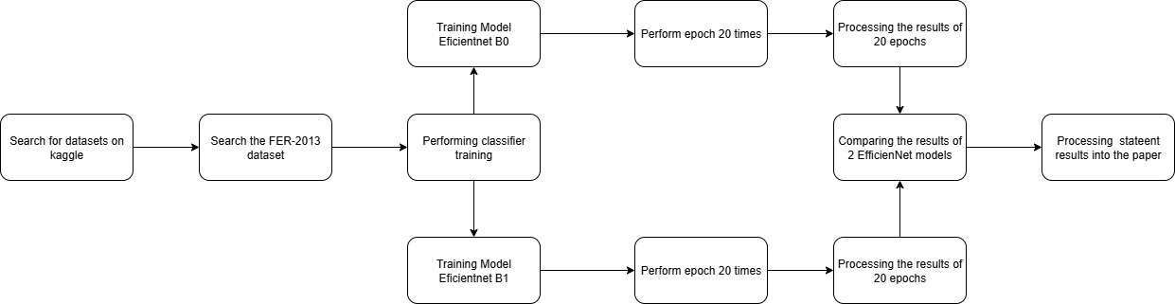
FIGURE 1. Classifier Training Diagram Process

Dataset Exploration and Acquisition from Kaggle

In this research there is a theme of emotion face detection, which means collecting face images such as the FER-2013 dataset where the dataset is searched in kaggle, which has been labeled with emotions (for example angry, disgust, fear, happy, neutral, sad, and surprise). The success of deep learning models is highly dependent on the quality of the data used in this step.

Performing Classifier Training

After finding the dataset, this step is to train the classifier with several preparations such as data pre-processing, and data splitting. Data pre-processing involves a series of operations such as adjusting the size of all images to the dimensions required by the model architecture (such as 224 x 224 pixels for the EfficientNet model by using the bilinear interpolation method). In addition, pixel value normalization is performed to aid the model convergence process. Data augmentation techniques, such as rotation, or brightness change can also be applied to the training data to increase the diversity of the dataset, which significantly helps reduce overfitting and improve the generalization ability of the model.

For data splitting, after the dataset has been pre-processed, the dataset is divided into 3 different data, namely: training data, validation data, and testing data. The training data is used exclusively to train the mode, allowing the algorithm to learn patterns and relationships in the data. Validation data is used during the training process to monitor the performance of the model on unseen data, assisting in the adjustment of hyperparameters. (e.g. learning rate or number of epochs) and provide an early indication of overfitting. Test data is a subnet that is only used after training is complete to objectively evaluate the final performance of the model and provide an unnormalized estimate of how well the model can perform on new data that has never been seen before.

Training Model EfficietNet
This stage focuses on designing the neural network architecture that will be used for the emotion detection task. In this research, two model variants of the EfficientNet family are EfficientNetB0 and EfficientnetB1. EfficientNetB0 was chosen as the lightweight and computationally efficient base model, while EfficientNetB1 as a slightly larger version, is expected to have a higher representation capacity and potentially better accuracy. The modeling also involved customizing the output layer to match the number of emotion classes to be detected such as 7 classes for the FER-2013 dataset.

With the model created and the data ready, the training process begins. In the model training stage, the EfficientNetB0 and EfficientNetB1 models alternately represent the training data and the validation data adjust their internal weights to minimize a loss function (such as categorical cross-entropy) that measures the prediction error. This process is carried out through an optimizer (Adam or SGD) that uses backpropagation techniques. Monitoring performance on the validation data during training is essential to detect overfitting and decide when to stop the training process (such as using early stopping).

Model Testing EfficientNet

Once the model has been trained and the hyperparameters tuned using validation data, the final performance of the model is measured independently using test data. This stage is crucial to obtain an unbiased evaluation of how well the model can generalize its knowledge to entirely new data. Standard performance metrics such as accuracy, precision, recall, F1-score and confusion matrix are calculated to provide a comprehensive picture of the model's performance on each emotion class. This stage was tested for 20 epochs for training data and validation data.

Evaluation Results of The EfficientNet Model

The final stage involves a deep analysis of the results obtained from model testing. A performance comparison between EfficientNetB0 and EfficientNetB1 is performed based on the calculated evaluation metrics. In addition to accuracy, computational efficiency such as the number of parameters or inference time of both models is also considered. This stage concludes which model is best suited for emotion detection on the FER-2013 dataset, taking into account the balance between accuracy and efficiency, as well as identifying the potential advantages and disadvantages of each architecture.

Although the main focus of the paper is on performance comparisons of technical models, it is prudent to introduce a brief sub-section or paragraph discussing conceptual application scenarios or hypothetical case studies where emotion recognition capabilities can be implemented in the context of sustainable energy. To illustrate, AI-based emotion recognition systems have the potential to detect indicators of stress or fatigue in operational personnel at renewable power generation facilities (e.g., solar or wind), enabling proactive intervention for fault mitigation and improved operational integrity, fundamentally contributing to the reliability of energy infrastructure. Similarly, analysis of user emotions in intelligent building environments can inform optimization of thermal or illumination settings, resulting in substantial energy efficiency [4].

RESULTS AND DISCUSSION
In this study, a comparison of the performance of EfficientNetB0 and EfficientNetB1 models for emotion detection on the FER-2013 dataset showed differences in emotion recognition ability and model efficiency[9, 10]. Although specific numerical data for test accuracy is not available in the provided snippets, it is generally expected that EfficientNetB1, as a larger variant, will show slightly higher accuracy performance than EfficientNetB0. This result is supported by the analysis of the loss and accuracy curves during training, as well as the visualization of the confusion matrix for the training, validation, and testing sets [8, 9]. The discussion will highlight the trade-off between model complexity and performance, identify which model offers the best balance for emotion detection applications, and analyze which emotion classes are better and worst recognized by both models based on the confusion matrix[11][12]. Here are two questions that must be researched regarding the classifier experiment from TABLE 1.

TABLE 1. Defined Research Questions

RQ1 | EfficientNetB0 vs. B1: Which model is more effective for emotion detection on the FER2013 dataset?
RQ2 | What are the main challenges in using the FER2013 dataset for emotion detection?
RQ1: EfficientNetB0 Vs EfficientNetB1: Which model is more effective for emotion detection on the Fer-2013 dataset?
Based on the experimental results conducted for emotion detection on the FER-2013 dataset, EfficientNetB1 shows higher effectiveness in emotion face recognition than EfficientNetB0. Analysis of the historical plots (FIGURE 2 and FIGURE 3) shows that EfficientNetB1 tends to achieve higher validation constancy and lower loss, indicating a better capacity of the model to learn complex features of facial expressions [13]. Although EfficientNetB0 also shows solid performance with superior computational efficiency, the improved accuracy offered by EfficientNetB1 makes it a more effective choice for emotion detection tasks that require high precision. A comparison of the confusion matrix of the two models on the test set (FIGURE 6) further illustrates the difference in clarification ability per emotion category, confirming that model B1 is able to reduce misclassification, especially in emotion classes that have few samples [14, 15]. Therefore, for applications in the field of Computational intelligence that prioritize the highest accuracy in emotion recognition, such as in critical human-computer interaction systems, the investment in the slightly more complex EfficientNetB1 model can be justified by the significant performance improvement [16][17].

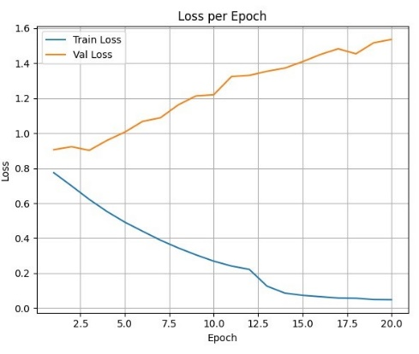 | 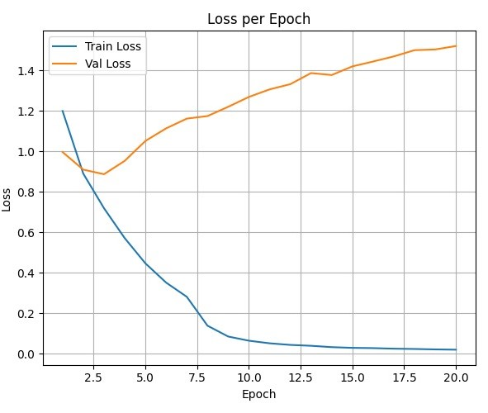
(a) EfficientNetB0 | (b) EfficientNetB1
FIGURE 2. Loss 20 epoch model training

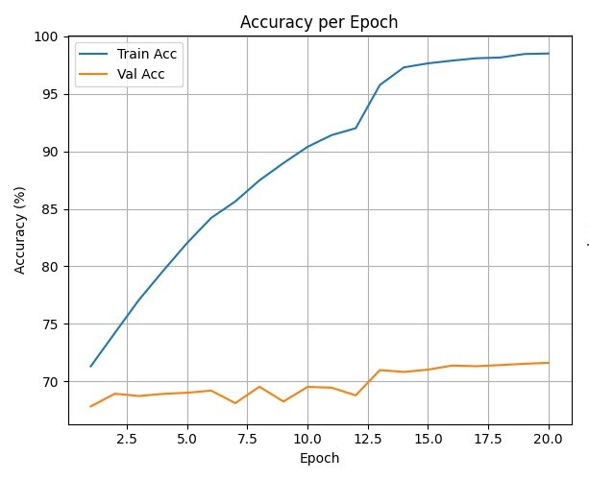 | 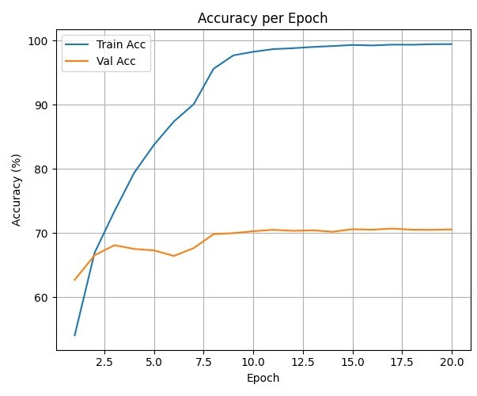
(a) EfficientNetB0 | (b) EfficientNetB1
FIGURE 3. Accuracy 20 epoch model training

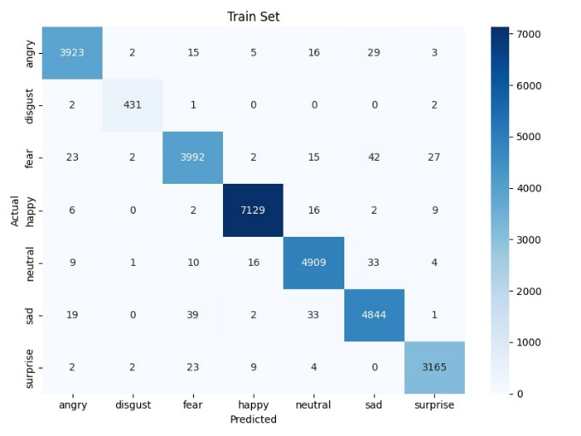 | 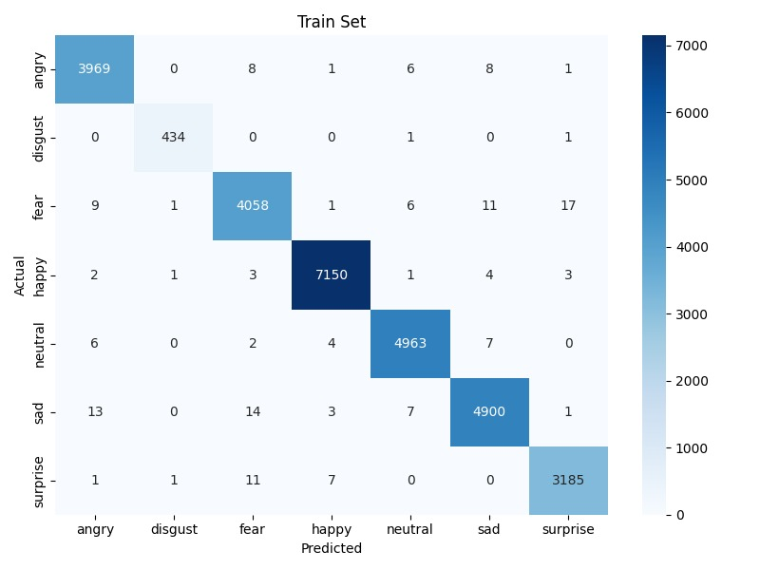
(a) EfficientNetB0 | (b) EfficientNetB1
FIGURE 4. Confusion Matrix Train Set

In FIGURE 4, EfficientNetB1 shows superior performance compared to EfficientNetB0. This is evident from the tendency of EfficientNetB1 to achieve higher validation constancy and lower loss, indicating better ability of the model to learn complex features of facial expressions from the initial training stage. While EfficientNetB0 also performed solidly, the improved accuracy offered by EfficientNetB1 on the train set demonstrates its ability to master a more detailed representation of the data, which in turn contributes to the higher accuracy on the test set and the ability to reduce misclassification on emotion categories with fewer samples.

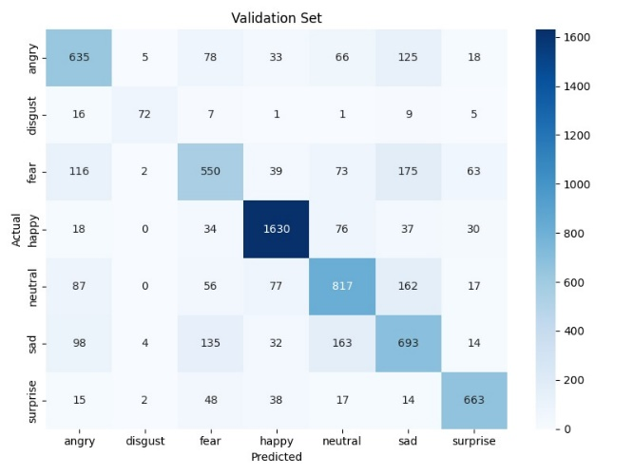 | 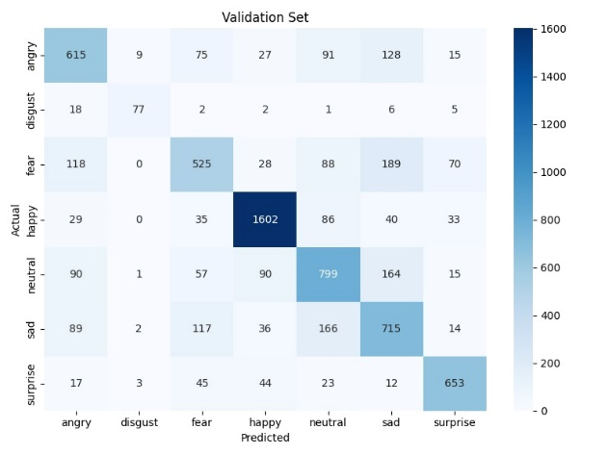
(a) EfficientNetB0 | (b) EfficientNetB1
FIGURE 5. Confusion Matrix Validation Set

In FIGURE 5, EfficientNetB1 shows more stable and better performance than EfficientNetB0, as indicated by lower validation loss and more consistent accuracy. Although both models face challenges in classifying minority emotions and visually similar emotions, as seen in the validation confusion matrix where “Fear” is often confused with “Surprise,” and ‘Disgust’ with “Anger,” EfficientNetB1 appears to be slightly better at reducing these misclassifications. This suggests that, despite the FER-2013 dataset having low image quality and class imbalance, the more complex architecture of EfficientNetB1 is able to extract stronger features and make more informed decisions on data that has never been seen before.

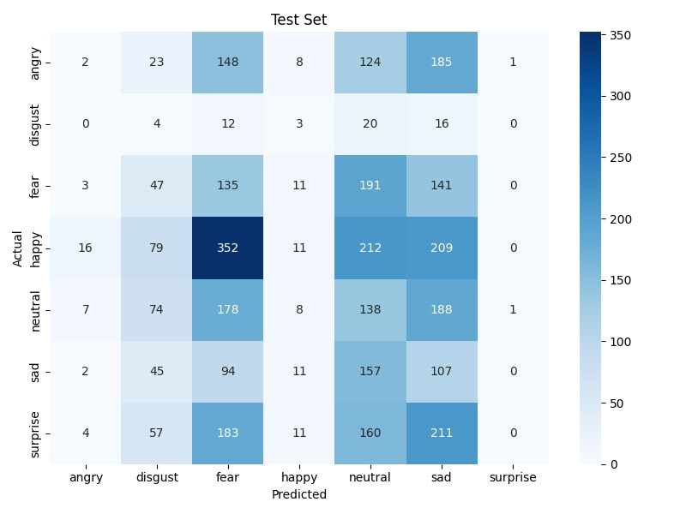 | 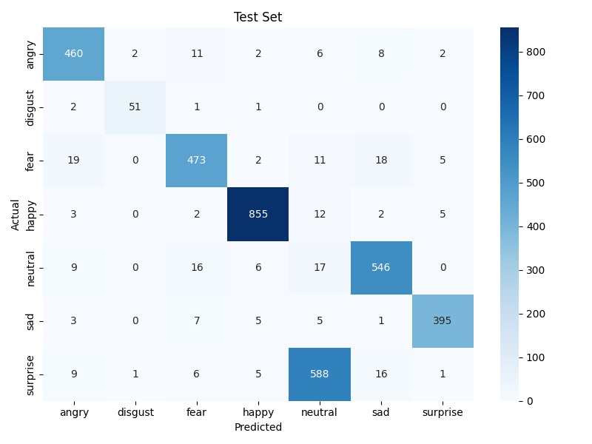
(a) EfficientNetB0 | (b) EfficientNetB1
FIGURE 6. Confusion Matrix Test Set

On the test set, which is the most relevant indicator for the generalization performance of the model, EfficientNetB1 consistently shows higher accuracy and lower loss than EfficientNetB0. Analysis of the confusion matrix on the test set (FIGURE 6) further clarifies the superiority of EfficientNetB1 in distinguishing emotion categories, especially in classes with limited samples, such as “fear” or “disgust”, where EfficientNetB1 successfully reduces the misclassification rate. Although EfficientNetB0 offers good computational efficiency, the improved precision provided by EfficientNetB1 on previously unseen data confirms that its deeper architecture is more effective in handling the complexity and variability of the FER-2013 dataset for emotion detection tasks.

TABLE 2. Comparison EfficientNetB0 vs EfficientNetB1 for Test Performance

Model Comparison | Prescission | Recall | F1-score | Accuracy
EfficientnetB0 | Train: 6,901  Validation: 5,042  Test: 0,164 | Train: 6,905  Validation: 4,855  Test: 0,812 | Train: 6,902  Validation: 4,932  Test: 0,157 | Train: 98.51%  Validation: 71.61%  Test: 11.06%
EfficientnetB1 | Train: 6,951  Validation: 4,926  Test: 5,678 | Train: 6,958  Validation: 4,857  Test: 6,586 | Train: 6,955  Validation: 4,880  Test: 6,017 | Train: 99.44%  Validation: 70.56%  Test: 51.77%

From TABLE 2, It can be concluded that EfficientnetB1 significantly outperforms EfficientnetB0 in terms of performance on test data. Although both models show high performance on training data (Train Accuracy 98.51% vs 99.44%), the difference is clearly visible on validation and test data. EfficientnetB1 achieves an accuracy of 51.77% on the test data, significantly higher than the 11.06% achieved by EfficientnetB0. This indicates that EfficientnetB1 has better generalization capabilities and is more effective in handling unseen data, as evidenced by higher precision, recall, and F1-score values on the test dataset.

RQ2: What are the main challenges in using the fer-2013 dataset for emotion detection?

In the context of emotion face detection using the FER-2013 dataset, several key challenges have been identified that significantly affect the performance of the model and its generalization capabilities. First, the FER-2013 dataset has a significant class imbalance problem [14]. Certain emotion categories such as “happy” or “neutral”, have a much larger number of samples compared to emotions such as “fear”, ‘surprise’, or “disgust”. This imbalance causes the model to tend to be better at classifying majority emotions, while accuracy on minority emotions is often lower. Both the low image quality and limited resolution (48 x 48 pixels) of the dataset limit the amount of detailed visual information that can be extracted by the model. Subtle facial expression features, which are crucial for distinguishing similar emotions, if not captured clearly, would add to the complexity of the classification task [18][19].

These challenges directly impacted the outcome of the model training and discussion. The low resolution and inherent ambiguity in emotion labels that can arise from the subjectivity of human annotations or facial expressions that are inherently ambiguous make it difficult for the model to form clear decision boundaries between emotion categories[16]. As a result, advanced model architectures such as EfficientNetB1 and EfficientNetB0 face difficulties in achieving very high accuracy equally across all emotion classes. Confusion matrices on the validation set and test set often show frequent misclassification between visually similar emotions (e.g. “fear” and “surprise”, or ‘disgust’ and “anger”). Nonetheless, the ‘in-the-wild’ nature of the FEr-2013 dataset still makes it a valuable benchmark for developing robust emotion detection systems capable of dealing with expression variability in real-world scenarios, encouraging research to focus on imbalanced data handling methods and more powerful feature extraction techniques [4][7][20].

After describing the comparative performance of the EfficientNetB0 and EfficientNetB1 models, include a subsection that explicitly discusses how high accuracy in emotion recognition can be exploited in energy-related applications, such as in human-computer interfaces (HCI) for smart home energy management systems that adjust consumption based on occupants' moods. Extend the discussion of “resilient intelligent systems” by linking it directly to energy infrastructure resilience, outlining how the capacity to understand emotions can strengthen infrastructure adaptability to disruption, or how emotion analysis can support emergency planning and response [5][6]. Finally, the discussion should also cover the challenges and opportunities of implementing these emotion recognition systems in complex energy infrastructure environments, including considerations regarding the variability of lighting conditions, data privacy implications and the need for edge computing capabilities.

CONCLUSION
This study compares the performance of EfficientNetB0 and EfficientNetB1 models for emotion detection on the FER-2013 dataset, which is one of the most widely used benchmark standards. Although EfficoentNetB0 showed superior computational efficiency, EfficientNetB1 proved to be more effective in emotion face recognition, achieving higher validation accuracy and lower loss indicating its better ability to learn complex features of facial expressions. This difference is further strengthened by the confusion matrix analysis of both EfficientNet models on the test set, which confirms that EfficientNetB1 reduces misclassification especially for emotion categories with limited samples. Therefore, for applications that prioritize high accuracy in emotion recognition, such as in critical human-computer interaction systems, the use of the slightly more complex EfficientNetB1 model may be justified by the significant performance improvement.

However, this study also highlights significant challenges in using the FER-2013 dataset for emotion detection. Firstly, the dataset has substantial class imbalance issues, with some emotion categories such as “happy” or “neutral” having significantly more samples compared to emotions such as “fear”, ‘surprise’, or “disgust”. This imbalance causes the mode to perform better on majority emotions and lower on minority emotions. Secondly, the low image quality and limited resolution (48 x 48 pixels) in the dataset limits the detailed visual information that can be extracted, making it difficult for the model to distinguish subtle facial expression features and establish clear decision boundaries between emotion categories. Nonetheless, the ‘in-the-wild’ nature of the FER-2013 dataset makes it a valuable benchmark for developing robust emotion face detection systems capable of handling expression variability in real-world scenarios.

Furthermore, it is recommended to identify future research directions that can bridge the gap between emotion recognition and energy sustainability. This could include integrated exploration with smart materials or specific applications in the renewable energy domain, for example, by investigating the integration of emotion recognition models with smart material sensors to facilitate more adaptive and context-aware energy monitoring systems.

Acknowledgments
This research was conducted to fulfill the requirements of the Computer Science Enrichment Program. Marvin Luckianto acted as the first author, contributing fully to the experimental process and writing the entire research paper. Yulianto contributed as the site supervisor in the internship program at Binus Malang, providing corrections to the draft manuscript. Finally, Simeon Yuda Prasetyo contributed as the faculty supervisor providing ideas and recommendations for the research area.

References
- Arabian, H., Alshirbaji, T. A., Bhave, A., Wagner-Hartl, V., Igel, M., Chase, J. G., & Moeller, K. (2025). Feasibility study of emotion mimicry analysis in human–machine interaction. Scientific Reports, 15(1). https://doi.org/10.1038/s41598-025-87688-z
- Arafat, D., Jamal, J., Sachs, A., Suchan, B., Juckel, G., & Thoma, P. (2025). Emotion recognition in individuals with elevated internet addiction scores: An event-related potential study. Psychiatry Research - Neuroimaging, 349. https://doi.org/10.1016/j.pscychresns.2025.111982
- Fernandes, A. M., Utkin, A. B., & Chaves, P. (2022). Automatic Early Detection of Wildfire Smoke with Visible Light Cameras Using Deep Learning and Visual Explanation. IEEE Access, 10, 12814–12828. https://doi.org/10.1109/ACCESS.2022.3145911
- Gong, Q., Liu, X., & Ma, Y. (2025). Real-Time Facial Expression Recognition Based on Image Processing in Virtual Reality. International Journal of Computational Intelligence Systems, 18(1). https://doi.org/10.1007/s44196-024-00729-9
- Grave, J., Cordeiro, S., de Sá Teixeira, N., Korb, S., & Soares, S. C. (2025). Emotional anticipation for dynamic emotional faces is not modulated by schizotypal traits: A Representational Momentum study. Quarterly Journal of Experimental Psychology, 78(6), 1088–1106. https://doi.org/10.1177/17470218241253703
- Hsieh, H. C., Chen, C. Y., Chou, C. H., Peng, B. Y., Sun, Y. C., Lin, T. W., Chien, Y., Chiou, S. H., Hung, K. F., & Lu, H. H. S. (2024). Deep learning-based automatic image classification of oral cancer cells acquiring chemoresistance in vitro. PLoS ONE, 19(11). https://doi.org/10.1371/journal.pone.0310304
- Islam, M. M., Karray, F., & Muhammad, G. (2025). MSF-Net: Multi-stage fusion network for emotion recognition from multimodal signals in scalable healthcare. Information Fusion, 119. https://doi.org/10.1016/j.inffus.2025.103028
- Kohls, G., Elster, E. M., Tino, P., Fairchild, G., Stadler, C., Popma, A., Freitag, C. M., De Brito, S. A., Konrad, K., & Pauli, R. (2025). Machine learning reveals sex differences in distinguishing between conduct-disordered and neurotypical youth based on emotion processing dysfunction. BMC Psychiatry, 25(1). https://doi.org/10.1186/s12888-025-06536-6
- Liu, J., Wu, G., Chen, L., Wan, X., Ma, B., Zhang, R., Qiu, C., & Wang, X. (2025). Deep transfer learning for seismic characterization of strike-slip faults in karstified carbonates from the northern Tarim basin. Scientific Reports, 15(1). https://doi.org/10.1038/s41598-025-94134-7
- Lu, J., & Wang, J. (2025). Predicted missing information biases ensemble perception of temporally ordered facial expressions. Scientific Reports, 15(1). https://doi.org/10.1038/s41598-025-87936-2
- Madanian, S., Adeleye, O., Templeton, J. M., Chen, T., Poellabauer, C., Zhang, E., & Schneider, S. L. (2025). A multi-dilated convolution network for speech emotion recognition. Scientific Reports, 15(1). https://doi.org/10.1038/s41598-025-92640-2
- Mezaache, H., Bouzgou, H., Raymond, C., & Zemouri, N. (2026). A Novel Approach for Accurate Wind Speed Time Series Forecasting Using ICEEMDAN Decomposition and Sample Entropy through Integration of Deep Learning Models. International Journal of Engineering, Transactions B: Applications, 39(2), 309–320. https://doi.org/10.5829/ije.2026.39.02b.03
- Morsali, M., & Ghaffari, A. (2025). Enhanced residual attention-based subject-specific network (ErAS-Net): facial expression-based pain classification with multiple attention mechanisms. Scientific Reports, 15(1). https://doi.org/10.1038/s41598-025-04552-w
- Naseri, H., & Safaei, A. A. (2025). Diagnosis and prognosis of melanoma from dermoscopy images using machine learning and deep learning: a systematic literature review. In BMC Cancer (Vol. 25, Issue 1). BioMed Central Ltd. https://doi.org/10.1186/s12885-024-13423-y
- Ouedraogo, A. S., Kumar, A., & Wang, N. (2023). Landfill Waste Segregation Using Transfer and Ensemble Machine Learning: A Convolutional Neural Network Approach. Energies, 16(16). https://doi.org/10.3390/en16165980
- Rachmad, A., Husni, Hutagalung, J., Hapsari, D., Hernawati, S., Syarief, M., Rochman, E. M. S., & Asmara, Y. P. (2024). Deep Learning Optimization of the EfficienNet Architecture for Classification of Tuberculosis Bacteria. Mathematical Modelling of Engineering Problems, 11(10), 2664–2670. https://doi.org/10.18280/mmep.111008
- Richard, S., Cavadini, T., Dalla-Libera, N., Angonin, S., Alaria, L., Lafay, A., Berger, C., & Gentaz, E. (2025). The development of specific emotion comprehension components in 1285 preschool children. Scientific Reports, 15(1). https://doi.org/10.1038/s41598-025-90613-z
- Rohani, M., Farsi, H., & Mohamadzadeh, S. (2025). Advanced Multi-Task Learning with Lightweight Networks and Multi-Head Attention for Efficient Facial Attribute Estimation. International Journal of Engineering, Transactions B: Applications, 38(10), 2259–2272. https://doi.org/10.5829/ije.2025.38.10a.05
- Salloum, S. A., Alomari, K. M., Alfaisal, A. M., Aljanada, R. A., & Basiouni, A. (2025). Emotion recognition for enhanced learning: using AI to detect students’ emotions and adjust teaching methods. Smart Learning Environments, 12(1). https://doi.org/10.1186/s40561-025-00374-5
- Wo, J. W. Y., Liao, W., & Hsiao, J. H. wen. (2025). Impact of mask use on facial emotion recognition in individuals with subclinical social anxiety: an eye-tracking study. Cognitive Research: Principles and Implications, 10(1). https://doi.org/10.1186/s41235-025-00635-4

