Temporal Analysis and Platform Specific Sentiment in Social Media: A Study of Data Mining on Twitter, Facebook, and Instagram
Didih Rizki Chandranegara ^{a)}, Muhammad Sulaiman Rafiq ^{b)}, Amalia Sanyoto ^{c)}, Ani Seila Nanda Putri ^{d)}, Farid Al Farizi ^{e)}, Sofyan Arifianto ^{f)}, and Hardianto Wibowo ^{g)}
Departmen of Informatics, Faculty of Engineering, Universitas of Muhammadiyah Malang, Malang, Indonesia

^{a)} Corresponding author: didihrizki@umm.ac.id
^{b)} sulaimanrafiq@webmail.umm.ac.id
^{c)} amaliasanyoto@webmail.umm.ac.id
^{d)} aniseilanandaputri@webmail.umm.ac.id
^{e)} faridalfarizi017@webmail.umm.ac.id
^{f)} sofyan_arifianto@umm.ac.id
^{g)} ardi@umm.ac.id

Abstract. The development of social media has made it a major channel for real-time and multi-platform public opinion. This study aims to analyze the distribution and dynamics of public sentiment on three social media platforms Twitter, Facebook, and Instagram with a data mining-based approach. Three main methods were applied: sentiment classification using the Random Forest algorithm, temporal analysis based on the time of publication, and comparative analysis between platforms. The classification results showed that the Random Forest model was able to achieve 99% accuracy with a very high f1-score value on all sentiment classes. Temporal analysis revealed that public opinion tended to increase from 14:00 to 18:00, while platform analysis showed that neutral sentiment dominated greater than 65%, followed by positive approximately 26% and negative less than 7% sentiment. These findings confirm that opinions on social media are dynamic, time-sensitive, and influenced by the characteristics of each platform. This research makes a significant contribution to the development of a contextual, reliable, and applicable public opinion analysis system for digital policy, strategic communication, and social issue monitoring.

Introduction
Social media is a collection of internet-based digital platforms designed to allow users to create, distribute, and interact with content in public and private. In addition, social media also plays a role in forming online communities based on certain interests, activities, or social relationships [4]. In its development, social media has evolved into a dynamic center of digital interaction, producing data with big data characteristics, namely in large volumes (volume), high speed (velocity), and diverse formats (variety). Platforms such as Twitter, Facebook, and Instagram are widely used by individuals and groups to express opinions, emotions, and attitudes on a variety of issues, ranging from social, political, to economic, [7]. This phenomenon creates strategic opportunities in the realm of data-driven research, especially through the sentiment analysis approach. This approach allows for systematic, quantitative, and real-time mapping of public opinion, thus becoming a relevant tool in understanding the collective perception of the public towards actual issues [5], [11].
To derive valuable insights from unstructured textual data, sentiment analysis often referred to as opinion mining has emerged as a pivotal subfield within Natural Language Processing (NLP) [2]. This area of study focuses on extracting emotional or attitudinal content from diverse textual sources, such as social media updates, user generated comments, and public product or service reviews. The practical utility of sentiment analysis has been validated across multiple sectors, including brand reputation monitoring, financial market forecasting, evaluation of public health initiatives like vaccination programs, and the early detection of public safety or crisis events [13], [10], [12], [9].
Due to its capacity to process large volumes of data in real time and reflect aggregated public sentiment, sentiment analysis serves as a strategic tool for data informed policy and business decisions. Nevertheless, when applied to social media contexts, the methodology encounters several complexities. These include platform specific linguistic styles, highly dynamic temporal patterns, and multilingual content variations that challenge generalizability and consistency [15]. Prior investigations have often limited their scope to single-platform analyses most notably Twitter using either lexicon based models or machine learning techniques [11], [15].
However, there remains a notable research gap concerning the integration of temporal analysis with a platform-comparative perspective. In reality, public sentiment is fluid, reactive to contemporaneous events, and often spreads concurrently across multiple digital ecosystems [6]. Addressing this gap is essential for developing a more nuanced and comprehensive understanding of public discourse in the digital era.
To address the gaps in previous research, this study proposes an integrated three-dimensional approach, namely: (1) Machine Learning Classification using the Random Forest algorithm for automatic classification of sentiments; (2) Temporal Data Analysis to identify temporal dynamics in sentiment fluctuations; and (3) Platform-Based Comparative Analysis to explore differences in sentiment expression patterns on three main platforms, namely Twitter, Facebook, and Instagram. The integration of these three approaches aims to produce a more comprehensive understanding of how public opinion is formed and developed in the social media ecosystem.
The contributions of this research are:
- Provision of cross-platform public sentiment mapping in a systematic and time-based manner.
- Evaluate the effectiveness of the Random Forest algorithm in the classification of sentiment in a multi-platform context.
- Presenting an empirical foundation that can be used in social, political, and public policy decision-making based on social media analytics.
With this approach, this research is expected to enrich the literature on social media sentiment analysis and support the implementation of digital strategies that are more contextual, adaptive, and data-based.

Related Works
Research related to sentiment analysis on social media has grown rapidly in recent years. The study not only covers aspects of sentiment classification, but also includes temporal analysis and cross-platform comparisons. The focus of the previous literature has been largely directed at the exploration of machine learning algorithms, hybrid approaches, and applications to social issues such as pandemics and brand management.

Classification of Sentiment with Machine Learning
The application of sentiment classification techniques on social media platforms has significantly expanded in tandem with the increasing integration of machine learning (ML) methodologies. As a pivotal branch within the field of Artificial Intelligence (AI), machine learning is oriented toward constructing algorithms and statistical models that enable systems to identify patterns and make informed decisions based on data, without the need for explicitly programmed rules [3]. Within the domain of sentiment analysis, numerous empirical studies have investigated the comparative performance between traditional lexical-based methods and several machine learning algorithms such as Random Forest, Naïve Bayes, and Support Vector Classification.
A study conducted by [15] reported that Random Forest demonstrates superior stability and predictive consistency, particularly when paired with advanced feature representation techniques like Term Frequency-Inverse Document Frequency (TF-IDF) and Word2Vec. Conceptually, Random Forest is an ensemble based learning strategy that constructs multiple decision trees concurrently and aggregates their outcomes via majority voting (for classification tasks) or averaging (for regression scenarios). This strategy aims to enhance generalization capabilities and mitigate the overfitting tendencies associated with individual tree models [14].
The robustness of Random Forest in sentiment analysis contexts is further validated by subsequent studies which affirm that integrating ensemble algorithms with well-structured feature engineering yields improved classification accuracy across a wide range of textual datasets spanning from consumer product evaluations to user-generated content on digital social platforms [5].
This is reinforced by studies that confirm that a combination of feature engineering and ensemble algorithms such as Random Forest is able to provide high accuracy in the classification of sentiment polarity across a wide range of domains, including consumer reviews and social media comments [5].

Temporal Analysis on Social Media
Temporal analysis is an approach that focuses on the time aspect in data processing, with the main goal of identifying patterns of change, trends, and dynamics of a phenomenon within a certain period of time. This approach allows researchers to capture data variability and evolution that cannot be revealed through static analysis. In the context of environmental research, for example, temporal analysis has been used to evaluate changes in the effects of Urban Heat Island (UHI) in Tiruchirappalli City over a two-decade period, from 2000 to 2020 [1]. In the study of sentiment analysis, the temporal approach aims to observe the dynamics of public opinion that evolves over time, particularly in response to certain social or political events. This analysis allows for temporal mapping of sentiment dynamics that can provide valuable insights regarding the direction of changing people's collective emotions in real-time. One of the approaches used is the development of temporal sentiment signals, which are representations of sentiment values along a timeline that are analyzed to measure the fluctuations and intensity of public opinion on a particular issue [11].
In the same study, the causality aspect was also highlighted as an important part in analyzing whether changes in public opinion could be predicted from previous time trends. Techniques such as Granger Causality are beginning to be adopted in follow-up studies to analyze the cause-and-effect relationship between sentiment and external variables such as market prices or national events [11]. This approach allows researchers to identify directional influences and improve the accuracy of predictive models in various socio-economic contexts.

Cross-Platform Comparative Analysis
Comparative analysis is a systematic approach used to compare two or more methods, techniques, or systems with the aim of evaluating the advantages, limitations, and relative performance of each entity under review. In this study, the approach was used to assess the effectiveness of various machine learning algorithms in classifying sentiment from data taken from social media [8]. The results of this comparison provide valuable insights into which algorithms offer the best balance between accuracy, computational efficiency, and adaptability to different data conditions.
While a large number of previous studies have focused on one specific platform, such as Twitter, recent literature is beginning to highlight the importance of cross-platform analysis to gain a more holistic understanding of the dynamics of public sentiment. The study by [11] shows that there are significant differences in sentiment expression patterns between Twitter, Facebook, and Instagram, which are influenced by the characteristics of their respective platforms, such as the structure of user interaction, text length limits, and communication norms that develop within these online communities. In addition, in a study themed on brand management, it was found that platform differences significantly affect engagement and sentiment polarity. Data from Facebook tend to have a stronger intensity of opinion, while Instagram is more dominated by positive sentiment, especially in visual and aesthetic contexts [13].

Methodology
This research uses a quantitative approach based on data mining and natural language processing (NLP). There are three main phases in this methodology: data collection, data processing, and analysis.

Data Collection
Data was collected from three platforms:
- Twitter: uses the Twitter API v2 with popular keywords and national trending topics.
- Facebook: public comment and status data is collected through the Facebook Graph API.
- Instagram: collected through the crawling technique (scraping) on captions and comments of public posts with specific hashtags.
The data used in this study was obtained from the Kaggle platform, which is an open data repository that is widely used in the data science community for the purposes of exploration, model training, and algorithm testing. The dataset was chosen because it has a structure that is relevant to the research objectives and has gone through an adequate initial curation process, so as to meet the eligibility criteria in machine learning-based sentiment analysis.

Data Preprocessing
The data obtained went through the cleaning and normalization stages:
- Tokenization
- Case folding
- Stopword removal (with Indonesian and English listing)
- Stemming dan Lemmatization
- Noise filtering (remove URLs, mentions, emojis, etc.)

Sentiment Classification with Machine Learning
The study utilizes the Random Forest classification model, selected due to its robustness in processing high dimensional feature spaces and its inherent capability to mitigate overfitting issues. The classification process is divided into:
a. Text representation: using TF-IDF Vectorizer
b. Labeling: based on remote supervision datasets (e.g. emoticons, hashtags, or manual annotations)
c. Model evaluation: with 80:20 data split (train:test), as well as accuracy, precision, recall, and F1-score measurements

Temporal Data Analysis
After the data is classified, temporal analysis is carried out by grouping the results based on:
a. Daily and weekly time range
b. Major national events (event-driven grouping)
These results are visualized in the form of a time-series chart to observe the dynamics of fluctuations in public opinion.

Platform-Based Comparative Analysis
Comparisons were made against:
a. Distribution of sentiment between platforms
b. Temporal response of each platform
c. Dominant topics and popular keywords per platform
Comparative statistics are calculated to find out the characteristics of user opinions on each platform.

Results and Discussion

Random Forest Model Evaluation
This research employs the Random Forest algorithm as the primary model for sentiment classification. Performance assessment indicates highly promising outcomes, as reflected in the evaluation metrics. As shown in the results table, the model achieved an overall accuracy of 99%, while the precision, recall, and F1-score across all sentiment categories namely Negative, Neutral, and Positive ranged between 0.94 and 1.00, indicating a high level of consistency and reliability in classification performance.

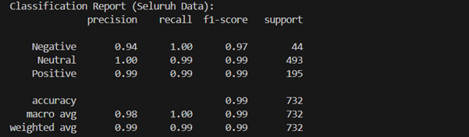
FIGURE 1. Classification Report results from testing the model on the entire dataset, showing precision, recall, and f1-score metrics for each sentiment class.

The dataset used consisted of 732 social media posts that had been labeled sentiment by an automatic classification model. Sentiment is divided into three categories: positive, negative, and neutral. Based on the results of the initial analysis:
a. Positive Sentiment: 195 data
b. Neutral Sentiment: 493 dates
c. Negative Sentiment: 44 data
This distribution shows that the majority of public responses tend to be neutral or informational, followed by quite significant positive sentiment. Only a small fraction of the data showed negative sentiment, indicating that the topic or service being discussed was likely to be well received by the public. These results show that Random Forest is able to perform very precise classification and generalization on the social media data used. This reliability reinforces the choice of ensemble learning-based classification methods for unstructured data such as social media texts.

Sentimen Temporal Analysis
The hourly distribution of sentiment shows an interesting temporal pattern. Neutral sentiment dominated throughout the day, with a significant spike at 14:00. Positive sentiment has gradually increased since 08.00 and reaches its peak between 15.00–18.00. On the other hand, negative sentiment tends to be stable and low throughout the day.

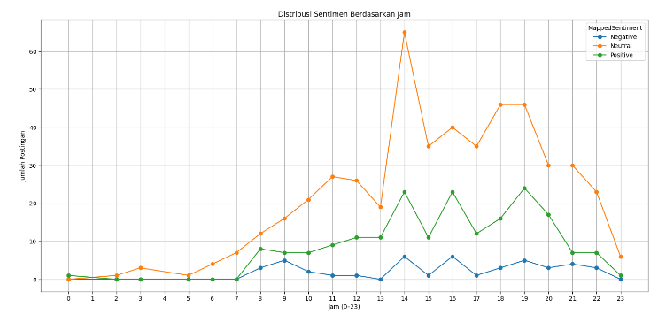
FIGURE 2. Graph showing the distribution of posts for Negative, Neutral, and Positive sentiments based on the time of day (0-23).
Key findings:
- Neutral sentiment dominated on almost the entire time frame, with the highest spike around 14:00–15:00, reaching more than 60 uploads.
- Positive Sentiment shows a consistent pattern from 08:00 to 21:00, with the highest peak around 19:00–20:00.
- Negative sentiment is relatively lower overall, but it starts to increase slowly from 8:00 a.m. to 8:00 p.m., with small peaks at 3:00 p.m. and 6:00 p.m.
High neutral activity during the day, especially around 14:00, can be associated with work or school breaks. During this period, users tend to open social media to share uploads that are informative or neutral. Meanwhile, positive sentiment is more predominantly present at night, most likely due to the consumption of appreciative or entertainment content after completing daily activities. On the other hand, although the volume of negative sentiment is relatively small, its appearance is quite significant in the late afternoon to evening. This can be attributed to a state of exhaustion, dissatisfaction with service, or a response to issues that peaks in the afternoon to evening. This interpretation is in line with studies that emphasize the importance of temporal dynamics in capturing collective emotional reactions to public information [11].

Comparative Analysis Between Platforms
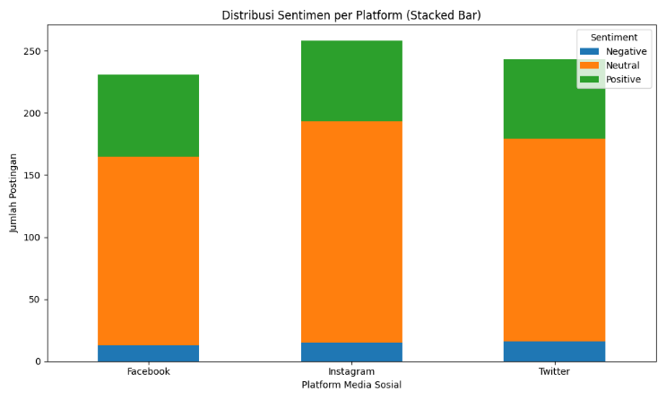
FIGURE 3. Comparison chart of sentiment distribution (Negative, Neutral, and Positive) on social media platforms Facebook, Instagram, and Twitter.

The distribution of sentiment between platforms shows that:
a. All platforms are dominated by neutral sentiment.
b. Instagram has the highest total number of posts, followed by Twitter and Facebook.
c. Facebook showed the highest proportion of positive sentiment (28.6%), followed by Instagram (25.2%) and Twitter (26.3%).
d. Negative sentiment is relatively small (<7%) across platforms.

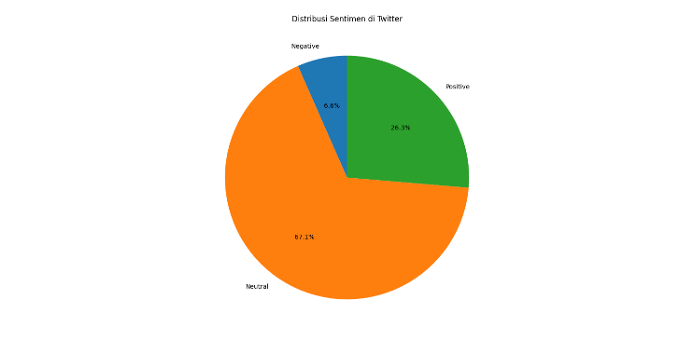
FIGURE 4. Persentase distribusi sentimen di Twitter, yang terdiri dari 67.1% Netral, 26.3% Positif, dan 6.6% Negatif.

Neutral sentiment dominated the discourse with a proportion of 67.1%, followed by positive sentiment at 26.3%, and negative sentiment at only 6.6%. This shows that the majority of Twitter users convey more information or opinions that are objective and do not contain extreme emotional expressions.
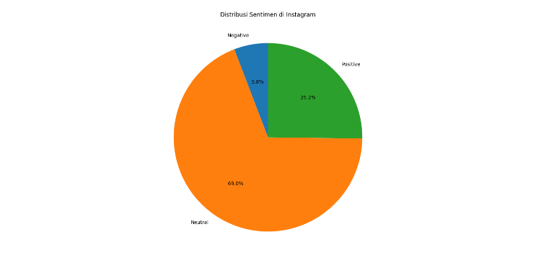
FIGURE 5. Persentase distribusi sentimen di Instagram, yang terdiri dari 69.0% Netral, 25.2% Positif, dan 5.8% Negatif.

The platform shows a neutral sentiment composition of 69.0%, slightly higher than Twitter. Positive sentiment contributed 25.2%, while negative sentiment reached 5.8%. The dominance of neutral and positive content reflects the characteristics of Instagram as a visual and lifestyle-based media, which is generally used to share moments or appreciation of content.
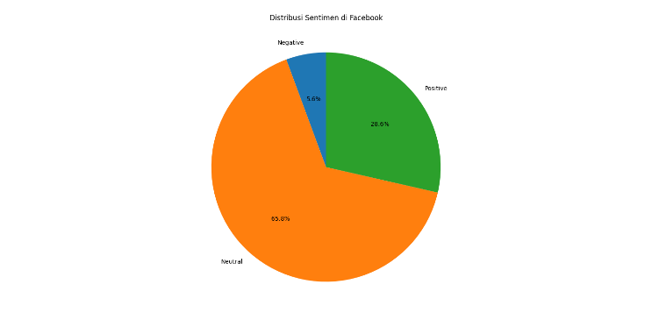
FIGURE 6. Persentase distribusi sentimen di Facebook, yang terdiri dari 65.8% Netral, 28.6% Positif, dan 5.6% Negatif.

Distribution on Facebook is relatively balanced with Twitter and Instagram. Neutral sentiment was at 65.8%, positive 28.6%, and negative 5.6%. Higher positive sentiment rates than the other two platforms can be associated with Facebook users who are more engaged in supportive or appreciative social and community discussions.
From the overall results, it can be seen that neutral sentiment consistently dominates across all three platforms, indicating that the majority of public conversations are informative, objective, or do not show certain emotional tendencies. This can be attributed to the behavior of social media users who prefer to express opinions politely and professionally, or avoid open conflicts in digital public spaces.
Positive sentiment also occupies a significant portion (around 25–29%), reflecting a trend of appreciation for entertainment content, motivation, and personal achievements. This condition is in accordance with the characteristics of social media algorithms that encourage the spread of positive and viral content. Meanwhile, negative sentiment is at a very small portion (<7%), but it is still important to note. Despite being in the minority, the emergence of negative sentiments is often intense and has the potential to trigger a digital crisis, especially when it comes to sensitive issues or public services.

Implications of the Findings
The findings of the three classification, temporal, and comparative methods result in an in-depth understanding:
a. Random Forest is perfect for social media opinion data, particularly in multi-class contexts.
b. Public sentiment tends to be neutral and positive, showing a relatively stable and non-extreme attitude.
c. Publication time affects the dominant type of sentiment, relevant to timing strategies in digital marketing.
d. The differences between platforms are significant, so a tailored approach is needed for each social channel.

Conclusion
This study systematically examines the patterns and distribution of public sentiment on social media using a multi-methodology approach: machine learning-based classification, temporal analysis, and cross-platform comparison. Using the Random Forest algorithm, the study successfully classified 732 social media entries into three main categories of positive, neutral, and negative sentiments with a very high accuracy rate of 99%, as well as an average f1-score value of 0.99. This confirms that Random Forest is a reliable, stable, and efficient model in handling unstructured opinion data from various digital social platforms.
The combination of cross-platform sentiment classification, temporal and comparative analysis provides a holistic perspective on the dynamics of public opinion. The Random Forest model is proven to be able to recognize sentiment patterns with high precision, even at unbalanced data distributions. Temporal analysis revealed a significant spike in opinion at certain hours, suggesting that time had a strong correlation with the intensity and direction of sentiment. Meanwhile, significant differences in the distribution of sentiment between platforms indicate that the structure and ecosystem of users of each platform influence the way the public expresses their emotions and views.
The results of the analysis show that neutral sentiment dominates discourse across social media platforms, with an average proportion exceeding 65%. These findings indicate that the majority of users tend to convey opinions in an informative and descriptive manner without strong emotional expressions. On the other hand, positive sentiment has a significant volume, which is around 26% of the total posts, which reflects the tendency of users to show an appreciative and optimistic attitude in their digital interactions. Meanwhile, negative sentiment only appears in a small portion of less than 7%, but it is still important to note because of its potential in reflecting sensitive issues, dissatisfaction, or even symptoms of a reputation crisis. Temporally, public opinion tends to be most active in the time range from 14:00 to 18:00, making this period a strategic moment for launching digital campaigns, disseminating information, or mitigating emerging issues.

REFERENCES
- A. Badugu, K. S. Arunab, A. Mathew, and P. Sarwesh, Geod. Geodyn. 14, 69-80 (2023).
- B. Liu, Sentiment Analysis and Opinion Mining (Cambridge University Press, Cambridge, 2012).
- D. Kreuzberger, N. Kühl, and S. Hirschl, IEEE Access 11, 31866-31879 (2023).
- F. Li, J. Larimo, and L. C. Leonidou, J. Acad. Mark. Sci. 49, 51-70 (2021).
- G. Kaur and A. Sharma, J. Big Data 10, 5 (2023).
- K. Aalijah, Int. J. Res. Publ. Rev. 6, 5540-5548 (2025).
- K. L. Tan, C. P. Lee, K. S. M. Anbananthen, and K. M. Lim, IEEE Access 10, 21517-21525 (2022).
- K. S. Yogi, D. C. Gowda, G. Poornima, G. C. Nagaraj, R. N. Nagashree, and B. K. Chethana, “Comparative analysis of machine learning techniques for detecting sentiments in social media,” in Proceedings of the 3rd International Conference on Artificial Intelligence and Internet of Things (AIIoT) (Vellore, India, 2024).
- M. M. Rahman, A. I. Shiplu, Y. Watanobe, and M. A. Alam, IEEE Trans. Emerg. Top. Comput. Intell. (2024).
- M. Qorib, T. Oladunni, M. Denis, E. Ososanya, and P. Cotae, Expert Syst. Appl. 212, 118715 (2023).
- M. Rodríguez-Ibánez, A. Casánez-Ventura, F. Castejón-Mateos, and P. M. Cuenca-Jiménez, Expert Syst. Appl. 223, 119862 (2023).
- M. S. M. Suhaimin, M. H. A. Hijazi, E. G. Moung, et al., J. King Saud Univ.–Comput. Inf. Sci. 35, 101776 (2023).
- R. H. Chowdhury, World J. Adv. Res. Rev. 23, 287-296 (2024).
- V. S. Anoop, C. S. Krishna, and U. H. Govindarajan, Int. J. Inf. Manag. Data Insights 4, 100221 (2024).
- Y. Qi and Z. Shabrina, Soc. Netw. Anal. Min. 13, 31 (2023).

