Fluid-Structure Interaction Modeling for Horizontal-Axis Wind Turbine Blades
Alvian Iqbal Hanif Nasrullah^{a)}, Daryono^{b)}, Alvin Evandiaz Audhia^{c)}, and Ahad Muzakki^{d)}
Mechanical Engineering Department, University of Muhammadiyah Malang, Malang, Indonesia

^{b)} Corresponding author: daryono@umm.ac.id
^{a)} alvianiq@umm.ac.id
^{c)} evan56diaz@gmail.com
^{d)} muzakki614@gmail.com
Abstract. Wind turbines are critical components of renewable energy infrastructure, subjected to significant aerodynamic loads. This research employed Fluid-Structure Interaction (FSI) analysis, integrating Computational Fluid Dynamics (CFD) and Finite Element Analysis (FEA), to assess the structural integrity of a wind turbine blade made from 6061 T6 aluminum alloy. The numerical simulation accurately captured the complex interplay between wind forces and blade deformation under various operating conditions. Boundary conditions included wind speeds up to 70 m/s, and the pressure data transfer between CFD and FEA domains was carefully managed to ensure accurate stress distribution analysis. Results indicate that the blade can withstand extreme wind speeds without structural failure; however, a critical stress region was identified at the blade-hub interface where the safety factor marginally exceeded the acceptable limit. This finding underscores the importance of optimizing blade design and material selection to enhance structural reliability and extend turbine lifespan. Future research should explore potential design modifications to improve the safety factor and overall performance of wind turbine blades.
Keywords: Wind turbine, Fluid Structure Interaction, Computational Fluid Dynamics, Finite Element Analysis

INTRODUCTION
Humanity is confronted with a critical juncture characterized by escalating greenhouse gas emissions and subsequent climate change. Fossil fuels continue to dominate the energy landscape, accounting for 61.3% of global electricity generation in 2020 [1]. To address this, there is a pressing need to transition to alternative energy sources.
The global demand for electricity is concurrently on the rise, with estimates indicating a combined growth of 286 terawatt-hours (TWh) in 2016 alone, and projections of approximately 321 TWh by 2030 [2]. While fossil fuels represented 83% of the overall energy mix in 2020, renewable energy sources contributed a modest 12.6%, with nuclear energy comprising the remaining 6.3% [3]. Notably, renewable energy has demonstrated its potential to mitigate greenhouse gas emissions, supplying 6-7% of the world's electricity [4]. While micro-hydro power plants, such as the one in Taji Village, Malang Regency, offer localized solutions [5].
Among the diverse renewable energy options, wind energy has emerged as a particularly promising solution. Offshore wind farms have shown significant growth potential, contributing 21.1 GW in 2001 and with projections of 6044 GW by 2050 [6]. Moreover, the installed capacity of wind turbines has expanded rapidly, increasing by more than 20% annually from 2000 to 2019, and this trend is expected to continue, with a projected 50% increase by the end of 2023 [7]. These developments underscore the increasing significance of wind turbines as a cornerstone of renewable energy infrastructure.
Wind turbines are primarily classified into two configurations: horizontal-axis and vertical-axis. The former, characterized by a horizontal rotor axis, is the predominant design, comprising essential components such as the foundation, tower, nacelle, generator, and rotor blades [8]. To ensure the structural integrity and performance of wind turbines, a combination of testing methodologies is employed. These include traditional methods like visual inspection and non-destructive testing (NDT), as well as advanced computational techniques. Computer-aided manufacturing (CAM) tools, encompassing computational fluid dynamics (CFD), finite element analysis (FEA), and fluid-structure interaction (FSI) simulations, play a crucial role in optimizing turbine design and material selection [9].
The design of wind turbine blades necessitates a meticulous approach to structural engineering and material selection, with a focus on strength, lightness, and the capacity to withstand aerodynamic loads [10]. A study conducted by Shiv Narayan Prajapati and Manish Kumar investigated wind turbine blades incorporating NACA 4420 airfoils and constructed from 6061 T6 aluminum alloy. Their research, employing modal and finite element method (FEM) analyses, concluded that these blades exhibit satisfactory performance without experiencing resonance, thereby validating their structural integrity [11].
Simulation has emerged as a valuable tool for predicting system behavior without incurring the substantial costs associated with physical prototyping. A wide range of industries, including engineering and design, have leveraged simulation methodologies such as Computational Fluid Dynamics (CFD), Finite Element Analysis (FEA), Thermal Analysis, and Fluid-Structure Interaction (FSI), often utilizing software platforms like Ansys. The efficacy of these simulation techniques is exemplified by research conducted by Xueping Chen and colleagues, who employed FSI to investigate the intricate interaction between arteries and blood flow. Their findings underscored the role of arterial wall elasticity in mitigating flow complexities within the coronary bifurcation system [12] [13].
This research employs the Fluid-Structure Interaction (FSI) method to investigate the structural response of wind turbine blades under dynamic aerodynamic loading. FSI integrates Computational Fluid Dynamics (CFD) and Finite Element Analysis (FEA) to accurately capture the complex interplay between fluid flow and solid mechanics.

METHODS

BLADE MATERIALS
The research investigates the structural response of wind turbine blades subjected to aerodynamic loads using the Fluid-Structure Interaction (FSI) approach, which integrates Computational Fluid Dynamics (CFD) and Finite Element Analysis (FEA). The blade is constructed from 15 mm thick Al 6061 T6 aluminum alloy, known for its high strength-to-weight ratio, good corrosion resistance, and excellent machinability. TABLE 1 details the material properties, including density, Young's modulus, Poisson's ratio, tensile yield strength, and ultimate tensile strength, which are essential for evaluating the blade’s performance under aerodynamic loads [11].

TABLE 1. Material Properties of the blade
Material Property | Aluminium 6061 T6
Density | 2.77 g/cm³
Young Modulus | 71000 MPa
Poisson Ratio | 0.33
Bulk Modulus | 69608 MPa
Shear Modulus | 26692 MPa
Tensile Yield Strength | 280 MPa
Compressive Yield Strength | 280 MPa
Tensile Ultimate Strength | 310 MPa

The choice of Al 6061 T6 aluminum alloy is driven by its mechanical properties, which provide the necessary balance of strength and lightness required for wind turbine blades. With a tensile yield strength of 280 MPa and an ultimate tensile strength of 310 MPa, the material is well-suited to withstand the significant stresses imposed by high wind speeds. These properties, along with a relatively low density of 2.77 g/cm³, help ensure that the blades can maintain structural integrity while minimizing weight, which is critical for optimizing turbine performance and efficiency.

GEOMETRY AND SIMULATION SETUP
The simulation utilized a realistic wind turbine blade geometry, commonly used in horizontal-axis wind turbines, as illustrated in FIGURE 1(A). To facilitate CFD analysis, a tubular geometry was added around the blade, representing the fluid domain necessary for simulating wind flow interactions. This setup enabled the FSI method to capture the detailed interaction between the fluid (airflow) and the structure (blade), accurately reflecting real-world conditions. The blade was modeled as a solid wall subjected to aerodynamic forces, while the surrounding tube simulated the atmospheric environment, as depicted in FIGURE 1(B).
Meshing was conducted with element sizes of 500 mm for the FEA domain and 2500 mm for the CFD domain to balance computational efficiency with the resolution required to capture critical stress areas. The finer mesh in the FEA domain allowed for a detailed analysis of stress distribution within the blade, particularly near the tip and blade-hub interface, which are prone to high stress concentrations. The integration of CFD and FEA through the FSI method provided a comprehensive understanding of how aerodynamic forces impact the blade's structural integrity, highlighting key regions susceptible to failure.

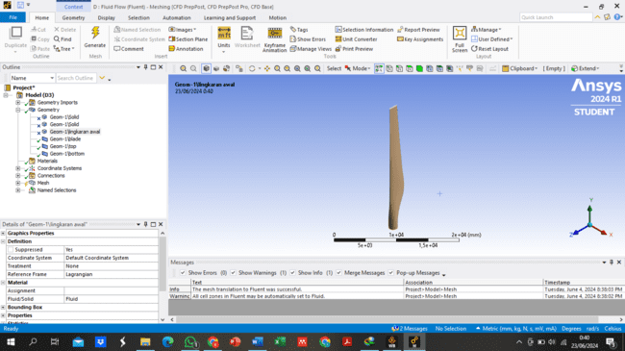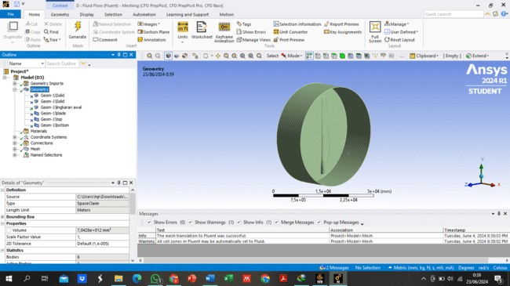
(A)
(B)
FIGURE 1. (A) Wind Turbine Blade Geometry (B) CFD Geometry

BOUNDARY CONDITIONS AND PRESSURE DATA TRANSFER
Boundary conditions were defined to simulate extreme loading scenarios, with CFD simulations conducted using a wind speed of 70 m/s as the inlet boundary condition, representing a severe storm scenario. The fluid domain was enclosed within a virtual tube to simulate the atmospheric environment around the blade. Fixed support conditions were applied at the blade root to replicate the attachment points to the turbine hub, ensuring a realistic representation of operational conditions.
Pressure data from the CFD analysis was transferred to the FEA domain through a mapped data transfer process, ensuring accurate application of aerodynamic loads across the blade surface. The data transfer involved interpolating pressure values from the CFD mesh onto the FEA mesh, maintaining consistency in boundary conditions across simulations. This method allowed for the precise application of distributed aerodynamic loads in the FEA model, which is critical for predicting stress distribution accurately and identifying potential failure points in the blade structure.

FINITE ELEMENT ANALYSIS
FEA simulations focused on capturing the structural response of the blade under aerodynamic loading, with a detailed mesh size of 500 mm used to model the structural domain. The FEA setup aimed to identify areas of maximum stress and deformation, particularly near critical regions such as the blade-hub interface. The analysis considered various load conditions, including gravity and aerodynamic pressures derived from the CFD simulations.
The calculation of the safety factor was based on the stress values obtained from the FEA results. A critical safety factor was determined at the most stressed regions, providing insights into the blade's structural limits under extreme conditions. The safety factor assessment highlighted areas where design modifications might be necessary to enhance the blade's structural integrity and reliability, particularly in scenarios involving extreme wind loads.

RESULTS AND DISCUSSION

STRUCTURAL RESPONSE AND PRESSURE DISTRIBUTION
The CFD analysis revealed significant pressure variations across the wind turbine blade, with the highest pressure concentrations observed on the leading edge, directly exposed to the oncoming wind. As shown in FIGURE 2, the maximum pressure on the blade surface reached 0.00064547 MPa under extreme wind conditions of 70 m/s. This pressure distribution is critical in understanding how aerodynamic forces contribute to the overall stress experienced by the blade. The concentration of pressure along the leading edge suggests that these regions are primary candidates for structural reinforcement to prevent failure under severe loading conditions.

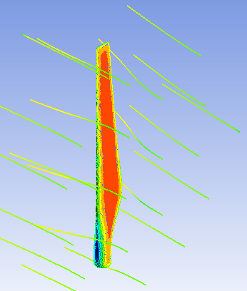
FIGURE 2. Fluid Flow (Wind) Interacting with Wind Turbine Blade Structure

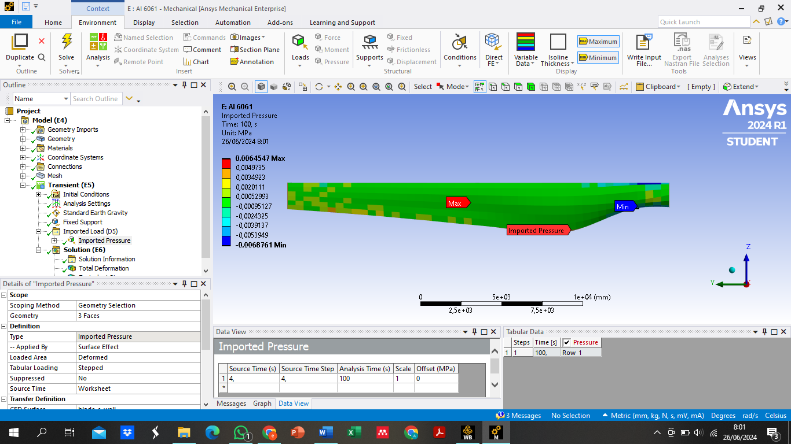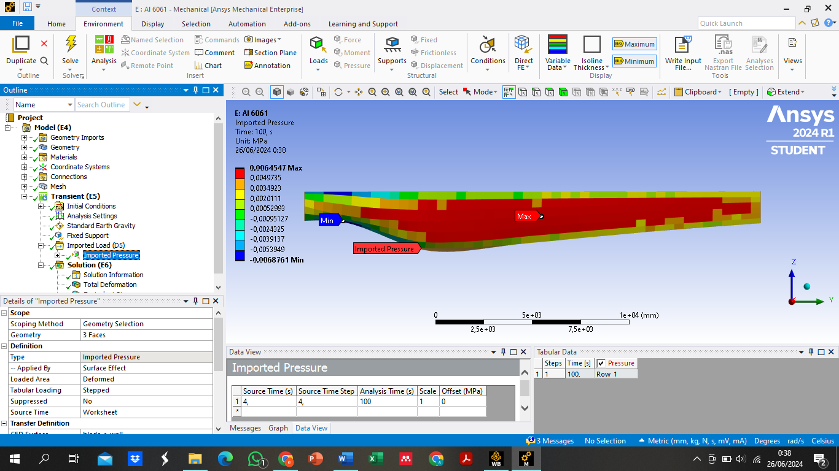
(A)
(B)

FIGURE 3. Wind pressure on wind turbine blade (A) front view, (B) back view

The FSI analysis effectively captured the complex interaction between fluid dynamics and structural mechanics, highlighting the areas most susceptible to high stress. FIGURE 3(A) and FIGURE 3(B) illustrate the front and back views of the wind pressure distribution on the blade, respectively. These figures demonstrate that while the leading edge faces the highest pressure loads, there are also notable stress regions near the blade tip and trailing edge. This distribution necessitates a detailed evaluation of the blade's design, focusing on enhancing these critical areas to improve overall structural resilience.

STRESS ANALYSIS AND SAFETY FACTOR EVALUATION
The FEA results showed that the blade experiences maximum deformation at the tip, reaching a value of 1.02 m under extreme aerodynamic loading. This is depicted in FIGURE 4, which highlights the deformation profile across the blade, indicating significant bending towards the tip. Such deformations are indicative of the dynamic responses of the blade under high wind speeds and must be managed to maintain aerodynamic efficiency and structural integrity. The deformation analysis underscores the importance of optimizing blade geometry and material properties to reduce excessive bending and associated stresses.

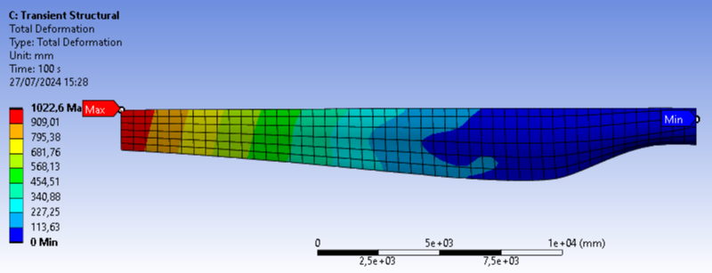
FIGURE 4. Total Deformation

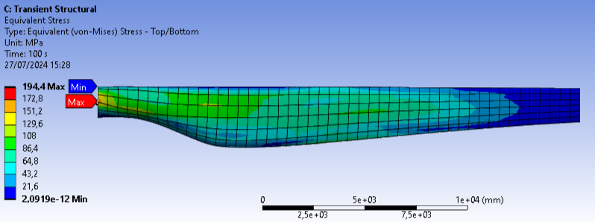
FIGURE 5. Equivalent Stress

A critical stress concentration was identified near the blade-hub interface, where the equivalent stress reached a maximum value of 194.4 MPa. As shown in FIGURE 5, this region is a focal point for potential failure, as the calculated safety factor at the blade-hub interface is 1.42, which is marginally above the acceptable limit. The safety factor assessment suggests that while the blade is designed to withstand the applied loads, the margin of safety is narrow, highlighting the need for further design improvements. To enhance the safety factor, potential design modifications could include increasing the thickness of the blade at critical points, using materials with higher yield strength, or altering the blade's structural configuration to better distribute stress.

CONCLUSIONS
The analysis demonstrated that a 15 mm thick Al 6061 T6 aluminum alloy wind turbine blade can withstand extreme wind pressures of up to 70 m/s, simulating conditions equivalent to a Category 5 hurricane. The CFD and FEA simulations effectively captured the complex interaction between aerodynamic forces and the blade’s structural response. The results identified critical stress concentrations, particularly at the blade-hub interface, where the safety factor was calculated to be 1.42, indicating a narrow margin of safety. This finding suggests that while the current blade design is sufficient under extreme conditions, there is limited room for unexpected loading scenarios or material fatigue over time.
To enhance the structural reliability and extend the lifespan of wind turbine blades, potential design improvements are necessary. Recommendations include exploring alternative materials with higher yield strength, optimizing the blade geometry to better distribute stress, and reinforcing critical areas such as the blade-hub interface. Further research should focus on evaluating these modifications to ensure a broader safety margin, ultimately improving the performance and durability of wind turbine blades in extreme operational environments.

References
1. Kabeyi, M.J.B. and O.A. Olanrewaju, Sustainable energy transition for renewable and low carbon grid electricity generation and supply. Frontiers in Energy research, 2022. 9: p. 743114.
2. Koot, M. and F. Wijnhoven, Usage impact on data center electricity needs: A system dynamic forecasting model. Applied Energy, 2021. 291: p. 116798.
3. Holechek, J.L., et al. A Global Assessment: Can Renewable Energy Replace Fossil Fuels by 2050? Sustainability, 2022. 14, DOI: 10.3390/su14084792.
4. Barthelmie, R.J. and S.C. Pryor Climate Change Mitigation Potential of Wind Energy. Climate, 2021. 9, DOI: 10.3390/cli9090136.
5. Sudarman, S., et al., A Feasibility Study on a Micro Hydro Power Plant at Coban Jahe Waterfall, Jabung, Malang Regency. Journal of Energy, Mechanical, Material, and Manufacturing Engineering, 2021. 6(1): p. 41-52.
6. Bošnjaković, M., et al. Wind Turbine Technology Trends. Applied Sciences, 2022. 12, DOI: 10.3390/app12178653.
7. Pryor, S.C., et al., Climate change impacts on wind power generation. Nature Reviews Earth & Environment, 2020. 1(12): p. 627-643.
8. Niebsch, J. and R. Ramlau, Simultaneous estimation of mass and aerodynamic rotor imbalances for wind turbines. Journal of Mathematics in Industry, 2014. 4(1): p. 12.
9. Wijesooriya, K., et al., Comparison between an uncoupled one-way and two-way fluid structure interaction simulation on a super-tall slender structure. Engineering Structures, 2021. 229: p. 111636.
10. Ikramullah, I., H.N. Firmansyah, and D.W. Santoso, Analisis Tegangan Bilah Turbin Angin Komposit Berpenguat Spar Ganda. Jurnal Serambi Engineering, 2023. 8(2).
11. Prajapati, S.N. and M. Kumar, A finite element structural analysis of wind turbine blade. Int. J. for Res. Trends and Innov, 2017.
12. Karmankar, R.G., Analysis of Von-Mises-Stress for interference fit and pull-out states by using finite element method. Int. Res. J. Eng. Technol, 2017. 4(11): p. 1367-1374.
13. Chen, X., et al., Fluid–structure interactions (FSI) based study of low-density lipoproteins (LDL) uptake in the left coronary artery. Scientific Reports, 2021. 11(1): p. 4803.

