The Effect of Electrode Distance and KOH Solution Concentration on Hydrogen Production from Alkaline Electrolysis
Yepy Komaril Sofii^{1,a)}, Taufik Hidayat^{1,b)}, Sudarman^{1,c)}, Achmad Fauzan Hery Soegiharto^{1,d)}, Mulyono^{1,e)}, Aden Akbar Runindya^{1,f)}, and Willy Satrio Nugroho^{2,g)}
¹Department of Mechanical Engineering, University of Muhammadiyah Malang, Malang, Indonesia
²Department of Mechanical Engineering, University of Brawijaya, Malang, Indonesia

^{a)} Corresponding author: yepykomarils@umm.ac.id
^{b)} taufik02000@webmail.umm.ac.id
^{c)} sudarman@umm.ac.id
^{d)} achmadfauzan@umm.ac.id
^{e)} mulyono@umm.ac.id
^{f)} adenakbar49@gmail.com
^{g)} willysatrio@ub.ac.id
Abstract. Alkaline electrolysis is a well-established and energy-efficient method for hydrogen production. This study investigates the impact of electrode distance and electrolyte concentration on hydrogen yield in alkaline electrolysis using a KOH solution. The experimental results demonstrate that a 40% KOH concentration at an electrode distance of 3 cm produces the highest hydrogen output, with measured values of 149, 150, and 156 ppm, averaging 155.67 ppm. In comparison, a 50% concentration under the same electrode spacing yielded hydrogen levels of 120, 130, and 134 ppm, with an average of 128 ppm. At a greater electrode distance of 7 cm, the hydrogen production decreased further, with a 60% concentration resulting in values of 87, 90, and 95 ppm, averaging 90.67 ppm. The superior performance observed with the 40% concentration is attributed to the optimal balance between ionic mobility and electrical resistance within the electrolyte, which facilitates efficient electrochemical reactions. These findings underscore the importance of optimizing both electrolyte concentration and electrode spacing to enhance hydrogen production efficiency in alkaline electrolysis.
Keywords: Electrolysis, Alkaline Electrolysis, Hydrogen Production

INTRODUCTION
The global demand for hydrogen continues to grow, driven by its critical role as an energy carrier in both industrial and healthcare sectors [1]. Hydrogen (H), the lightest and most abundant element in the universe, is a colorless, odorless, and highly flammable gas, widely recognized for its potential in sustainable energy storage and distribution [2-3]. Its versatility extends to numerous applications, including ammonia and methanol production, as well as petroleum refining [4-5].
To meet the increasing demand for hydrogen, various production methods have been developed, each with distinct advantages and challenges. These include biological fermentation, photolysis, hydrocarbon reforming, hydrogen extraction from natural gas, and electrolysis [6-10]. Among these, electrolysis stands out due to its ability to produce clean, pollutant-free hydrogen without the need for extensive infrastructure, making it a preferred choice for sustainable hydrogen production [11].
Electrolysis, the process of splitting water (H₂O) into hydrogen (H₂) and oxygen (O₂) using an electric current, can be classified into high-temperature steam electrolysis (HTSE) and conventional electrolysis [12]. While HTSE operates at elevated temperatures of 800-1000°C, conventional electrolysis, particularly membrane-free methods such as Alkaline Electrolysis (AEL), offers a more cost-effective and manageable approach [13]. AEL, which uses a simple setup with carbon electrodes and an alkaline solution, provides better control over the electrical voltage, enhancing the efficiency of hydrogen production [14-15].
Previous research has extensively explored various electrolysis methods, particularly focusing on factors that influence hydrogen yield. Studies have shown that electrode distance and solution concentration are critical variables. For instance, research utilizing AEM and BPM with carbon steel electrodes in a NaOH solution demonstrated that variations in these parameters significantly affect hydrogen production efficiency, yielding up to 4.66 L/d [16]. Another study using AEL with graphite and stainless steel electrodes in a KOH solution produced 3.7 L/d of hydrogen, emphasizing the importance of optimizing these variables [17]. Additionally, studies using Microbial Electrolysis Cells (MEC) and other configurations have shown varying hydrogen yields depending on the electrode distance and solution concentration [18-24].
Despite these advances, challenges remain, particularly in optimizing electrode distance and solution concentration to maximize hydrogen production efficiency. Excessive electrode spacing can reduce production efficiency, while overly concentrated solutions may lead to rapid contamination, further impacting yield. This study aims to address these challenges by optimizing these critical parameters in a membrane-free AEL system using carbon electrodes and a KOH solution. The objective is to enhance hydrogen production efficiency at a minimal cost, contributing to the development of environmentally friendly alternative fuels and reducing greenhouse gas emissions.

METHODS
The experimental study was designed to evaluate the effects of electrode distance and KOH solution concentration on hydrogen production in an alkaline electrolysis system. The system setup, data acquisition, and analysis methods are detailed as follows:
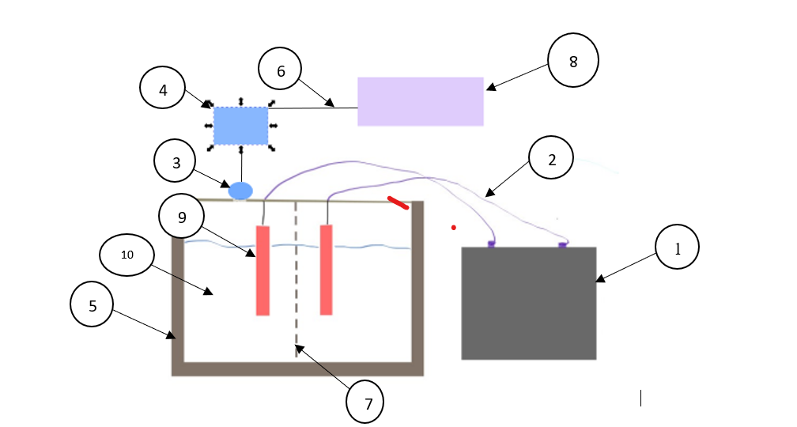
FIGURE 1. Experimental Apparatus

The scheme for producing hydrogen from the FIGURE 1. Energy from the battery (1) with 12 Volt power flows to the battery jumper cable (2) with a cable voltage of 12 Volts, and the energy received from the battery flows to the carbon electrode (9) and reacts with the KO₂+O₂ solution (10) which produces a reaction at the cathode (-) the reaction 2KO₂+2e = K₂+O₂ occurs which produces H₂ gas, and at the anode (+) the reaction 2H₂O→O₂+4H+4O occurs which produces O2 gas, with the gas overflowing to the top it will be detected by the MQ8 sensor (3) and connected by the Arduino Uno (4) to the laptop (8) which displays the amount of H₂ produced.
Experimental Setup:
Electrolysis System: The electrolysis system was constructed using a 12V DC power supply, carbon electrodes, and a KOH electrolyte solution. The choice of a 12V battery was based on its ability to provide a stable and consistent voltage, which is critical for maintaining controlled electrolysis conditions. Carbon electrodes were selected for their chemical stability and cost-effectiveness, making them suitable for prolonged electrolysis operations without significant degradation. The KOH solution, known for its high conductivity and effectiveness in promoting hydrogen production, was used as the electrolyte.
Electrode Configuration: The electrodes were arranged within the electrolysis cell at varying distances of 3 cm, 5 cm, and 7 cm to investigate the influence of electrode spacing on hydrogen production. The distance between electrodes was measured precisely using a digital caliper to ensure accuracy.
Solution Concentration: The concentration of the KOH solution was varied among 40%, 50%, and 60% to assess its impact on hydrogen yield. The solutions were prepared using analytical-grade KOH and deionized water, ensuring consistent concentration levels across experiments.
Data Collection:
Hydrogen Measurement: Hydrogen production was monitored in real time using an MQ-8 gas sensor, which is sensitive to hydrogen concentrations. The sensor was calibrated before each experiment using a standard hydrogen gas mixture to ensure accurate readings. The sensor was interfaced with an Arduino Uno microcontroller, which processed the sensor signals and transmitted the data to a laptop for recording.
Data Acquisition System: The Arduino Uno was programmed to collect hydrogen concentration data at regular intervals. The collected data were logged using a custom software application on the laptop, which allowed for real-time visualization and storage of the results.
Experimental Conditions:
Control of Environmental Variables: The experiments were conducted under controlled laboratory conditions to minimize the impact of external factors. The ambient temperature was maintained at 25 ± 2°C using a thermostatically controlled environment, and the atmospheric pressure was recorded during each experiment to ensure consistency. The electrolysis cell was sealed to prevent contamination from atmospheric gases.
Repetition and Replication: Each experimental condition, defined by a specific electrode distance and KOH concentration, was tested in triplicate to ensure the reliability and reproducibility of the results. This approach allowed for statistical analysis of the data to assess the significance of the observed effects.
The experimental approach involved setting up an alkaline electrolysis system with carbon electrodes and a KOH solution. The electrode distance and solution concentration were varied to measure their impact on hydrogen production. The system was assembled with a power source, sensors, and data acquisition devices to monitor hydrogen output.

RESULTS AND DISCUSSION
The study investigates the production of hydrogen through alkaline electrolysis under varying concentrations of solution and different distances between electrodes. The results are analyzed using statistical tests to determine the significance of differences in hydrogen output across different experimental conditions.

EFFECT OF ELECTRODE DISTANCE AND SOLUTION CONCENTRATION ON HYDROGEN PRODUCTION
This experiment was conducted to assess the amount of hydrogen produced with a distance of 3 cm, 5cm, and 7 cm between the electrodes and solution concentrations of 40%, 50%, and 60% (see TABLE 1). The goal was to understand the influence of these variables on hydrogen production to optimize the electrolysis process.

TABLE 1. Effect of Electrode Distance and Solution Concentration on Hydrogen Production
Distance (cm) | Concentration
Distance (cm) | 40% | 50% | 60%
3 | 506 ppm | 488 ppm | 452 ppm
5 | 504 ppm | 478 ppm | 456 ppm
7 | 503 ppm | 469 ppm | 468 ppm
 | Hydrogen Production

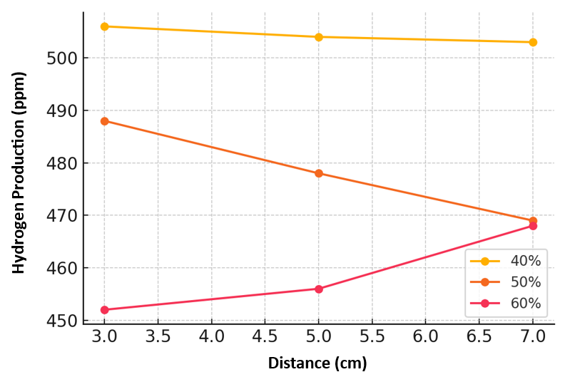

FIGURE 2. Effect of Electrode Distance and Solution Concentration on Hydrogen Production

The amount of hydrogen produced decreases as the concentration increases. The data show in FIGURE 2 that as the concentration of the solution increases, the amount of hydrogen produced decreases. This trend suggests that higher concentrations may hinder the electrochemical reaction, possibly due to increased resistance or reduced mobility of ions. However, the overall yield is higher due to the longer reaction time. This further supports the observation that while higher concentrations might reduce efficiency, extended reaction times can compensate for this to some extent. The results showed significant variations in hydrogen production based on electrode distance and solution concentration. At a 3 cm distance, a 40% concentration produced the highest hydrogen output (average 155.67 ppm), followed by 50% (128 ppm) and 60% (90.67 ppm). Increasing the distance to 7 cm reduced the hydrogen output for all concentrations.

Experiment 2: EFFECT OF SOLUTION CONCENTRATION AT THE same DISTANCE ON HYDROGEN PRODUCTION

The second experiment was conducted at the same distance (3 cm) with 40%, 50%, and 60% for 15 minutes to observe the effect of the concentration variations on hydrogen production (see TABLE 2)

TABLE 2. Effect of solution concentration at the same distance on hydrogen production
Concentration (%) | Hydrogen Production (ppm)
Concentration (%) | Trial 1 | Trial 2 | Trial 3
40 | 476 | 500 | 499
50 | 457 | 488 | 454
60 | 441 | 438 | 438

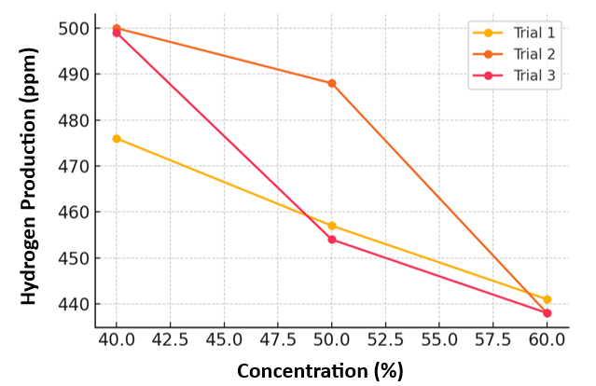
FIGURE 3. Hydrogen production at different concentrations

FIGURE 3 indicates that higher concentrations result in a decreased production of hydrogen. This reduction occurs because, as the solution becomes more concentrated, the ionic mobility within the electrolyte decreases, which impedes the flow of electrical current between the anode and cathode. A more concentrated solution increases the resistance within the electrolyte, leading to less efficient energy transfer and, consequently, lower hydrogen output. Additionally, higher viscosity in more concentrated solutions can further hinder ion movement, exacerbating the reduction in hydrogen production. Therefore, optimizing the concentration of the solution is crucial to maximizing the efficiency of hydrogen generation in electrolysis processes.

TABLE 3. Previous Research
Anode | Cathode | Solution | Method | Distance | Hydrogen Production (L/d) | Ref
Carbon Cloth | Carbon Cloth | Glucose | Microba Electrolysis Cell | - | 5.04 | [24]
Graphite Felt | Stainless Steel 304 Mesh sheet + Graphite Felt | Acetic Acid | Microba Electrolysis Cell | 1 | 1.52 | [25]
Graphite Felt | Stainless Steel 316 Mesh sheet | Acetic Acid | Microba Electrolysis Cell | 1 | 0.90 | [26]
Carbon Felt | Stainless Steel Wire Wool | Phosphate Buffer | Microba Electrolysis Cell | - | 2.25 | [23]
Graphite Brush | Stainless Steel 304 Mesh sheet | Buffer | Microba Electrolysis Cell | 1 | 2.60 | [27]
Carbon Felt | Alga+ Graphite | NaOH | Hybrid Water Electrolysis | 5 | 3.20 | [28]
Carbon Steel | Carbon Steel | NaOH | Anion Excange Membrane | 3 | 3.36 | [20]
Graphite | Stainless steel | KOH | Alkaline Electrolysis | - | 1.70 | [21]
Graphite | Graphite | NaOH | Alkaline Electrolysis | - | 1.13 | [22]
Carbon | Carbon | KOH | Alkaline Electrolysis | 3 | 1.24 | Recent study
 |  |  |  | 5 | 1.05 | Recent study
 |  |  |  | 7 | 0.75 | Recent study

The results of this study demonstrate that both electrode distance and KOH solution concentration significantly influence hydrogen production in alkaline electrolysis. A comparative analysis with previous research highlights important distinctions and similarities, offering insights into the efficiency of different electrolysis methods and their potential applications.
In the current study as shown in TABLE 3, the Alkaline Electrolysis (AEL) method using carbon electrodes with a KOH solution produced hydrogen within the range of 0.582-1.247 L/d. This performance can be contextualized by comparing it to other electrolysis methods. For instance, the Microbial Electrolysis Cell (MEC) method, which typically employs graphite and stainless steel electrodes with solutions such as glucose, acetic acid, and phosphate buffer, has demonstrated hydrogen production ranging from 0.9 to 5.041 L/d. The higher yield observed in MEC methods can be attributed to the bio-catalytic processes involved, which enhance the electrochemical reactions. However, MEC systems are often more complex and cost-intensive compared to the relatively straightforward and scalable AEL process.
Furthermore, the Anion Exchange Membrane (AEM) method, which utilizes carbon steel electrodes with a NaOH solution, reported hydrogen production of approximately 3.36 L/d. While the AEM method shows superior hydrogen yields, it is important to note that the initial costs associated with membrane technology and the ongoing maintenance required may limit its practicality for large-scale applications. In contrast, the AEL method, despite its lower hydrogen production, offers a more cost-effective and easier-to-maintain alternative, especially when carbon electrodes and simple electrolyte solutions like KOH are used.
The comparison with the Hybrid Water Electrolysis method, which integrates algae with graphite and carbon felt electrodes in a NaOH solution, indicates a hydrogen production of around 1.02 L/d. This method combines biological and electrochemical processes to enhance efficiency, but it also involves more complex operational requirements. The AEL method’s simplicity, along with its ability to achieve comparable hydrogen production rates, suggests that it remains a viable option for applications where ease of operation and lower costs are prioritized.
When examining the use of graphite and stainless steel electrodes in conventional alkaline electrolysis systems with NaOH or KOH solutions, previous studies have reported hydrogen production ranging from 1.13 to 1.7 L/d. The slightly higher yields in these studies compared to the present findings may be due to the use of more conductive electrode materials, which enhance the efficiency of the electrochemical reactions. However, the carbon electrodes used in this study offer a balance between cost and performance, making them an attractive option for scaling up the AEL process.
The findings from this study have significant implications for the practical application of alkaline electrolysis in industrial hydrogen production. The optimization of electrode distance and electrolyte concentration can lead to more efficient hydrogen generation, which is crucial for reducing operational costs and improving the overall feasibility of hydrogen as a clean energy source. Specifically, the results suggest that a 40% KOH solution with a 3 cm electrode distance is optimal for maximizing hydrogen yield while maintaining a cost-effective setup.
In an industrial context, the ability to produce hydrogen efficiently with relatively inexpensive materials, such as carbon electrodes, and without the need for complex membrane systems, positions AEL as a competitive technology. The scalability of this method, combined with its lower initial and maintenance costs, makes it particularly suitable for decentralized hydrogen production systems or applications where budget constraints are a concern.
Overall, while other methods may offer higher hydrogen yields, the balance of efficiency, cost, and simplicity provided by the AEL method using carbon electrodes and a KOH solution presents a compelling case for its use in various industrial applications, particularly in scenarios where cost-effectiveness and ease of operation are prioritized over maximum yield.

CONCLUSIONS

In conclusion, this study demonstrates that both the distance between electrodes and the concentration of the electrolyte significantly influence hydrogen production in electrolysis. Shorter electrode distances result in higher hydrogen yields, with the 3 cm distance consistently outperforming longer distances across all concentration levels. Among the concentrations tested, 40% proved to be the most effective, producing the highest hydrogen output compared to 50% and 60% concentrations, making it the optimal choice for maximizing efficiency in electrolysis processes. Additionally, the duration of the electrolysis process plays a crucial role in hydrogen production, with longer durations leading to substantially increased yields. These findings suggest that optimizing electrode distance, electrolyte concentration, and electrolysis duration are key factors in enhancing hydrogen generation efficiency.

Acknowledgments
The authors gratefully acknowledge the University of Muhammadiyah Malang for the financial support of this research (No. 1/P2M-HDL/F1-IMM/VI/2024).

References
- A. Pareek, R. Dom, J. Gupta, J. Chandran, V. Adepu, and P. H. Borse, “Insights into renewable hydrogen energy: Recent advances and prospects,” Mater. Sci. Energy Technol., vol. 3, pp. 319–327, 2020, doi: 10.1016/j.mset.2019.12.002.
- M. H. McCay and S. Shafiee, “Hydrogen: An energy carrier,” Futur. Energy Improv. Sustain. Clean Options Our Planet, pp. 475–493, 2020, doi: 10.1016/B978-0-08-102886-5.00022-0.
- A. Keçebaş and M. Kayfeci, “Hydrogen properties,” Sol. Hydrog. Prod. Process. Syst. Technol., pp. 3–29, 2019, doi: 10.1016/B978-0-12-814853-2.00001-1.
- A. Blasi, G. Fiorenza, and A. Verardi, Hydrogen from biomass. Elsevier Inc., 2020.
- D. Xu, L. Dong, and J. Ren, “Introduction of Hydrogen Routines,” Hydrog. Econ. Supply Chain. Life Cycle Anal. Energy Transit. Sustain., pp. 35–54, 2017, doi: 10.1016/B978-0-12-811132-1.00002-X.
- B. Sundén, “Hydrogen 3 3.1,” pp. 37–55, 2019, doi: 10.1016/B978-0-12-816950-6.00003-8.
- G. Balachandar, J. L. Varanasi, V. Singh, H. Singh, and D. Das, “Biological hydrogen production via dark fermentation: A holistic approach from lab-scale to pilot-scale,” Int. J. Hydrogen Energy, vol. 45, no. 8, pp. 5202–5215, 2020, doi: 10.1016/j.ijhydene.2019.09.006.
- M. A. Soliman and M. Zakaria, “Kinetics of photolysis and photocatalytic oxidation of ammonium sulfite for hydrogen production,” J. King Saud Univ. - Eng. Sci., no. xxxx, 2021, doi: 10.1016/j.jksues.2021.11.006.
- M. Dewa, W. Yu, N. Dale, A. M. Hussain, M. G. Norton, and S. Ha, “Recent progress in integration of reforming catalyst on metal-supported SOFC for hydrocarbon and logistic fuels,” Int. J. Hydrogen Energy, vol. 46, no. 67, pp. 33523–33540, 2021, doi: 10.1016/j.ijhydene.2021.07.177.
- M. Kayfeci, A. Keçebaş, and M. Bayat, Hydrogen production. 2019.
- S. Krishnan, M. Fairlie, P. Andres, T. De Groot, and G. J. Kramer, Power to gas (H2): Alkaline electrolysis. Elsevier Inc., 2019.
- W. Zhao and S. Ci, Nanomaterials As Electrode Materials of Microbial Electrolysis Cells for Hydrogen Generation. Elsevier Inc., 2018.
- D. Bessarabov and P. Millet, “Brief Historical Background of Water Electrolysis,” PEM Water Electrolysis, no. 1981, pp. 17–42, 2018, doi: 10.1016/b978-0-12-811145-1.00002-2.
- D. Catalán-Martínez et al., “Thermo-fluid dynamics modelling of steam electrolysis in fully-assembled tubular high-temperature proton-conducting cells,” Int. J. Hydrogen Energy, vol. 47, no. 65, pp. 27787–27799, 2022, doi: 10.1016/j.ijhydene.2022.06.112.
- I. Vincent and D. Bessarabov, “Low cost hydrogen production by anion exchange membrane electrolysis: A review,” Renew. Sustain. Energy Rev., vol. 81, no. May, pp. 1690–1704, 2018, doi: 10.1016/j.rser.2017.05.258.
- G. Chisholm, L. Cronin, and M. D. Symes, “Decoupled electrolysis using a silicotungstic acid electron-coupled-proton buffer in a proton exchange membrane cell,” Electrochim. Acta, vol. 331, p. 135255, 2020, doi: 10.1016/j.electacta.2019.135255.
- H. Lange, A. Klose, W. Lippmann, and L. Urbas, “Technical evaluation of the flexibility of water electrolysis systems to increase energy flexibility: A review,” Int. J. Hydrogen Energy, no. xxxx, 2023, doi: 10.1016/j.ijhydene.2023.01.044.
- S. Shiva Kumar and H. Lim, “An overview of water electrolysis technologies for green hydrogen production,” Energy Reports, vol. 8, pp. 13793–13813, 2022, doi: 10.1016/j.egyr.2022.10.127.
- D. Kurniawati, “Effect of Alkaline Metal Catalyst to Transesterification of Jatropha Curcas oil,” J. Energy, Mech. Mater. Manuf. Eng., vol. 3, no. 1, p. 31, 2018, doi: 10.22219/jemmme.v3i1.5880.
- B. Yuzer, H. Selcuk, G. Chehade, M. E. Demir, and I. Dincer, “Evaluation of hydrogen production via electrolysis with ion exchange membranes,” Energy, vol. 190, p. 116420, 2020, doi: 10.1016/j.energy.2019.116420.
- M. F. Kaya, N. Demir, M. S. Albawabiji, and M. Taş, “Investigation of alkaline water electrolysis performance for different cost effective electrodes under magnetic field,” Int. J. Hydrogen Energy, vol. 42, no. 28, pp. 17583–17592, 2017, doi: 10.1016/j.ijhydene.2017.02.039.
- N. Bidin et al., “The effect of magnetic and optic field in water electrolysis,” Int. J. Hydrogen Energy, vol. 42, no. 26, pp. 16325–16332, 2017, doi: 10.1016/j.ijhydene.2017.05.169.
- D. D. Leicester, J. M. Amezaga, A. Moore, and E. S. Heidrich, “Optimising the Hydraulic Retention Time in a High Volumetric Treatment Rates Using Concentrated Domestic Wastewater,” Molecules, vol. 25, no. 2945, pp. 1–20, 2020.
- L. Wang, F. Long, D. Liang, X. Xiao, and H. Liu, “Hydrogen production from lignocellulosic hydrolysate in an up-scaled microbial electrolysis cell with stacked bio-electrodes,” Bioresour. Technol., vol. 320, no. PA, p. 124314, 2021, doi: 10.1016/j.biortech.2020.124314.
- L. Huang, F. Tian, Y. Pan, L. Shan, Y. Shi, and B. E. Logan, “Mutual benefits of acetate and mixed tungsten and molybdenum for their efficient removal in 40 L microbial electrolysis cells,” Water Res., vol. 162, pp. 358–368, 2019, doi: 10.1016/j.watres.2019.07.003.
- S. E. Cotterill, J. Dolfing, C. Jones, T. P. Curtis, and E. S. Heidrich, “Low Temperature Domestic Wastewater Treatment in a Microbial Electrolysis Cell with 1 m2 Anodes: Towards System Scale-Up,” Fuel Cells, vol. 17, no. 5, pp. 584–592, 2017, doi: 10.1002/fuce.201700034.
- G. K. Rader and B. E. Logan, “Multi-electrode continuous flow microbial electrolysis cell for biogas production from acetate,” Int. J. Hydrogen Energy, vol. 35, no. 17, pp. 8848–8854, 2010, doi: 10.1016/j.ijhydene.2010.06.033.
- S. E. Cotterill, J. Dolfing, T. P. Curtis, and E. S. Heidrich, “Community assembly in wastewater-fed pilot-scale microbial electrolysis cells,” Front. Energy Res., vol. 6, no. September, pp. 1–12, 2018, doi: 10.3389/fenrg.2018.00098.

