Conceptual Design of Refrigerant Utilization for Organic Rankine Cycle System in Hot Springs
Andinusa Rahmandhika^{a)}, Dwi Kristian^{b)}, Achmad Fauzan Hery Soegiharto^{c)}, Ali Mokhtar^{d)}, and Muhammad Iqbal Maulana Kusuma Wibawa^{e)}
Department of Mechanical Engineering, Universitas Muhammadiyah Malang, Malang, Indonesia
^{a)} Corresponding author: andinusa@umm.ac.id
^{b)} dwikristian@webmail.umm.ac.id
^{c)} achmadfauzan@umm.ac.id
^{d)} mokhtar@umm.ac.id
^{e)} miqbalmaulanakwpmb@gmail.com
Abstract. Utilization of low enthalpy heat is an alternative solution to energy scarcity. One of the geothermal sources produces a hot water reservoir that has not been optimally exploited. This study aims to obtain a comparative power value from the conceptual design made in the Organic Rankine Cycle utilizing hot water sources. This study is a simulation method using Cyclepad software. Refrigerants used as working fluids are R134a and R22. The input of a hot water reservoir of 60 degrees Celsius is used to heat the refrigerant to a temperature of 55 degrees Celsius at a pressure of up to 1400 kPa. The mass flow rate of the working fluid used is 1 kg / s. Based on the results of the study, R134a can produce a turbine power of 20.69 kW. While refrigerant R22 can produce a turbine power of 17.68 kW. The study's results indicate that the influence of the refrigerant boiling point parameter affects the temperature and pressure range of the ORC cycle operation. A boiling point that does not match the reservoir will limit the production of turbine power in a large range.
Keywords: refrigerant, hot water reservoir, organic rankine cycle, cyclepad, power

INTRODUCTION
The utilization of renewable energy sources is increasingly becoming a major focus in efforts to reduce dependence on fossil fuels, which aims to improve global energy sustainability [1]. One promising technology is the steam turbine, which uses hot water sources as primary energy [2]. This study has a clear objective, namely to conduct an in-depth analysis of the power generated by the steam turbine using the CyclePad application, a very effective tool in modeling and optimizing the thermal cycle in the steam turbine system. Thus, the application can improve the efficiency and overall performance of the system [3].
In this chapter, the theoretical basis will be discussed, including the working principle of the steam turbine, the applied thermal cycle, and the analysis method using the CyclePad application [4]. Particular emphasis is placed on the utilization of hot water sources as the main input in the thermal cycle, which directly affects the final power generated by the steam turbine [5]. The purpose of the analysis carried out is to provide a deeper understanding of the factors that influence the efficiency and performance of the steam turbine in the context of renewable energy utilization [6].
Through an integrated analytical and computational approach, this study is expected to make a significant contribution to the development of renewable energy technology [7]. The main focus is to improve the efficiency of hot water resource utilization to generate electricity through steam turbines [8]. This study aims to investigate the potential of utilizing hot water resources as a renewable energy source, using CyclePad simulation as the main analysis tool [9]. This simulation allows detailed modeling of the thermal cycle in a steam turbine, which in turn facilitates the evaluation of the efficiency and performance of the system as a whole [10].
By using this approach, it is expected to identify key parameters that affect the power production of a steam turbine based on hot water resources [11] as well as optimal strategies to improve the efficiency of using available heat energy [12]. This study focuses on the potential of utilizing hot water resources in Cangar, Batu, East Java as one of the significant renewable energy potentials to generate electricity through steam turbines [13]. This location is known for its large geothermal potential, which can be exploited to meet local energy needs [14].
The hot water resources in Cangar, Batu, East Java are formed through a series of complex geological processes, which generally occur in areas with high geothermal activity [15]. The renewable energy potential in Cangar, Batu, East Java includes significant geothermal resources, which can be exploited to generate electricity through technologies such as steam turbines [16]. This location offers great potential in utilizing hot water sources as primary energy to support energy sustainability at the local level and contribute to national efforts in expanding Indonesia's renewable energy portfolio [17].
Through an analytical and computational approach using the CyclePad application. this study aims to identify the thermal characteristics of hot water sources in Cangar and optimize the thermal cycle in a steam turbine system [18]. It is hoped that effective strategies can be developed to maximize the potential of geothermal energy in this area [19] which can ultimately make a significant contribution to the transition towards sustainable renewable energy in Indonesia [10].

METHODS
The research method used is simulation using the Cyclepad application. Organic Rankine Cycle (ORC) is used as the working fluid. The choice of organic working fluid is intended so that the Rankine cycle continues to run even though it operates at low enthalpy. When collecting hot spring reservoir data, the temperature obtained was only 60 degrees Celsius, which cannot evaporate water at atmospheric pressure. Certain working fluids can evaporate at temperatures lower than that. There are 2 variations of working fluid, namely using refrigerant R134a and R22. These variations are used to find out the right type of working fluid to get maximum power. The research flow is shown in FIGURE 1.

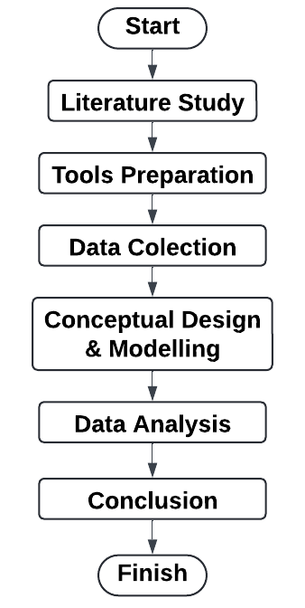
FIGURE 1. Research flow diagram

FIGURE 2 shows the design of the ORC scheme using CyclePad. There are 4 main components in the cycle, including a pump, 2 heat exchangers, and a turbine. Organic working fluid is flowed through the four components to produce optimal power in the turbine. The mechanical power in the turbine is used to rotate the generator to produce electrical power.
In this cycle, the refrigerant is pumped to produce high pressure. The refrigerant is then heated in the heat exchanger so that it changes phase to vapor. The hot fluid used to heat the refrigerant is a hot spring with a temperature of around 60 degrees Celsius. The enthalpy obtained after passing through the heat exchanger allows the refrigerant to rotate the turbine. The refrigerant output from the turbine is then changed phase to liquid form. The refrigerant is flowed to the second heat exchanger (condenser) to extract its heat. The refrigerant is then flowed back to the pump to repeat the same cycle.
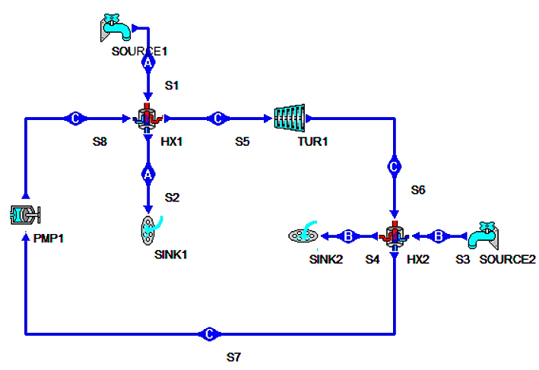
FIGURE 2. ORC design using Cyclepad

FIGURE 3 and FIGURE 4 show the specifications of Refrigerant variations, namely R134a and R22. Each refrigerant has a different boiling point, so that the heat transfer process in the heat exchanger is not in the same condition, especially the input and output temperatures. R134a has a boiling point of -26.2 degrees Celsius at atmospheric pressure. While R22 has a boiling point of -40.8 degrees Celsius at the same pressure. Thus, it is possible that the output temperature of the heat exchanger for R134a is higher. Another option that can be done in the simulation is to set the same refrigerant output temperature, but a different mass flow rate. R22 will be flowed with a smaller mass flow rate to obtain a larger temperature change range.
Meanwhile, the design specifications of the heat exchanger to be used are the shell and tube type with the assumption of the same diameter and length, so that the input variations in the design are at temperature, pressure, and mass flow rate, with the assumption of a constant geometry.

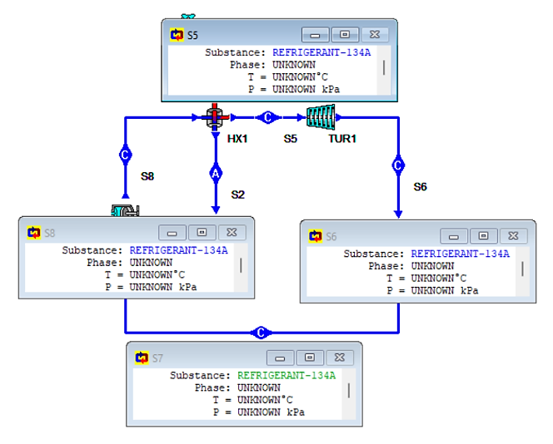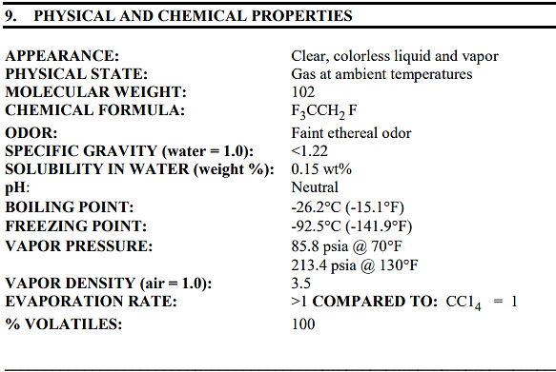
FIGURE 3. R134a refrigerant properties

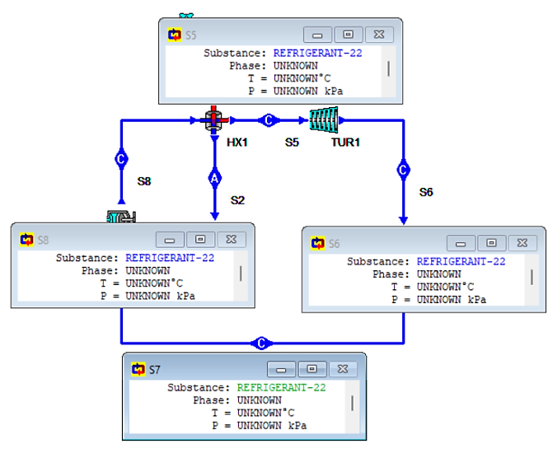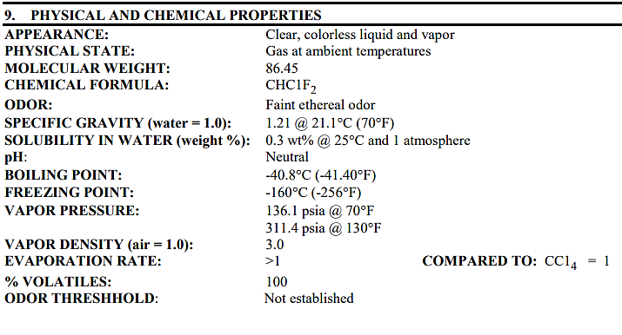
FIGURE 4. R22 refrigerant properties

RESULTS AND DISCUSSION
Cyclepad software runs the design with the input parameters. The hot and cold water reservoirs are in an open space, so the pressure setting is atmospheric pressure (100 kPa). The inlet temperature of the hot water is 60 degrees Celsius, while the cold water is 8 degrees Celsius. This temperature is obtained in cold mountainous areas, so it is lower than 27 degrees Celsius. Meanwhile, the parameters entered are not the same between R134a and R22, adjusting the boiling point of each refrigerant.

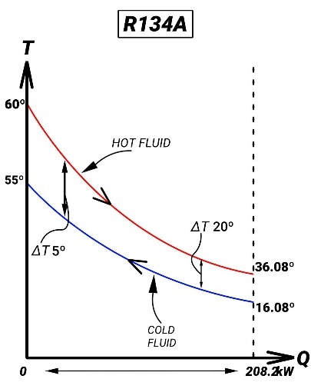 | 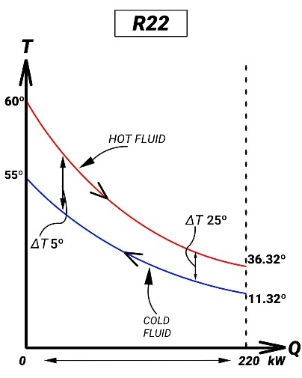
a) | b)
FIGURE 5. Q-T Diagram for a) R134a refrigerant and b) R22 refrigerant

Refrigerant R134a uses an operating pressure before entering the pump of 500 kPa and 1350 kPa after passing through the pump. While R22 uses an operating pressure of 700 kPa before entering the pump and 1400 kPa after leaving the pump. This is adjusted to the operating pressure that allows for the rankine cycle of each refrigerant. In addition, the operating temperature used at this pressure is set so that it is not higher than the heating fluid and not lower than the cooling fluid. However, the range of high and low pressure differences between the two refrigerants is not much different, which is 850 kPa for R134a and 700 kPa for R22.
At this low pressure, the temperature of R134a before entering the heat exchanger is 16.08 degrees Celsius and has an output temperature of 55 degrees Celsius. This value is the same as the output temperature for refrigerant R22, although it has a different input temperature for R22, which is 11.32 degrees Celsius. The mass flow rate of the refrigerant in both ORC systems is made the same, which is 1 kg/s. The mass flow rate for the heating fluid is also almost the same, which is 2.1 kg/s for R134a and 2.2 kg/s for R22. In general, the heat transfer process involving both ORC systems in the heat exchanger have almost the same value, which is 208 kW and 220 kW. This value is Qin, which is the input enthalpy for the ORC system. FIGURE 5 shows the Q-T diagram for refrigerant R134a (a) and R22 (b). The diagram shows the heat transfer process in a heat exchanger with a hot water reservoir.

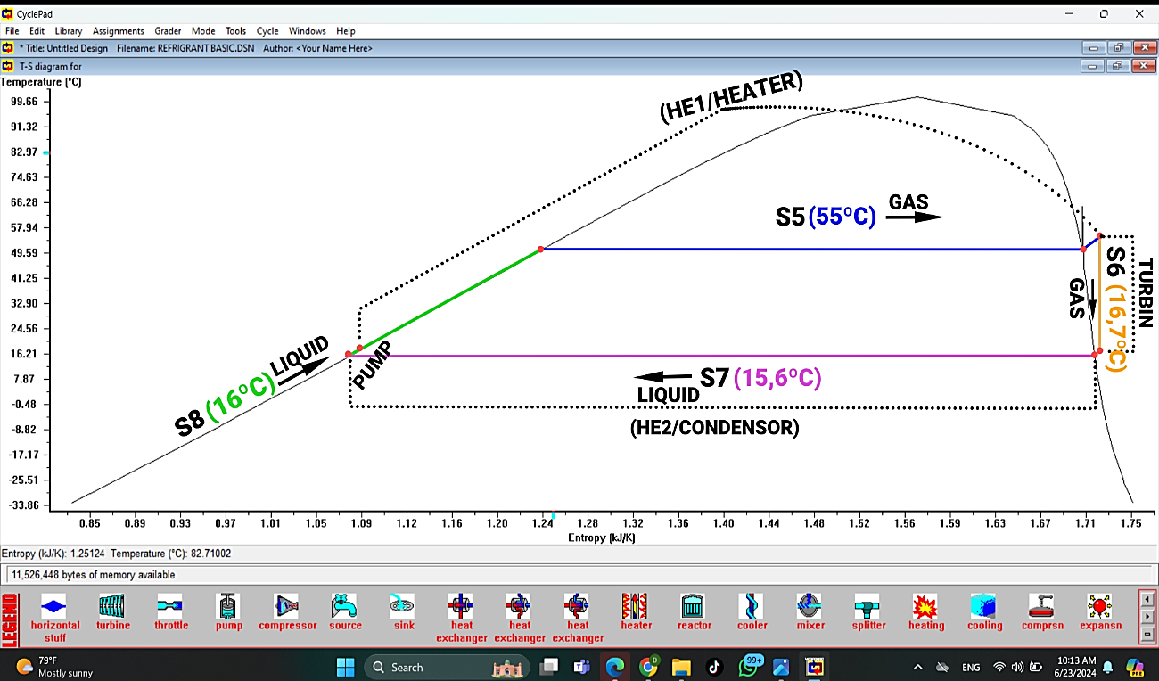
FIGURE 6. T-S Diagram for R134a refrigerant

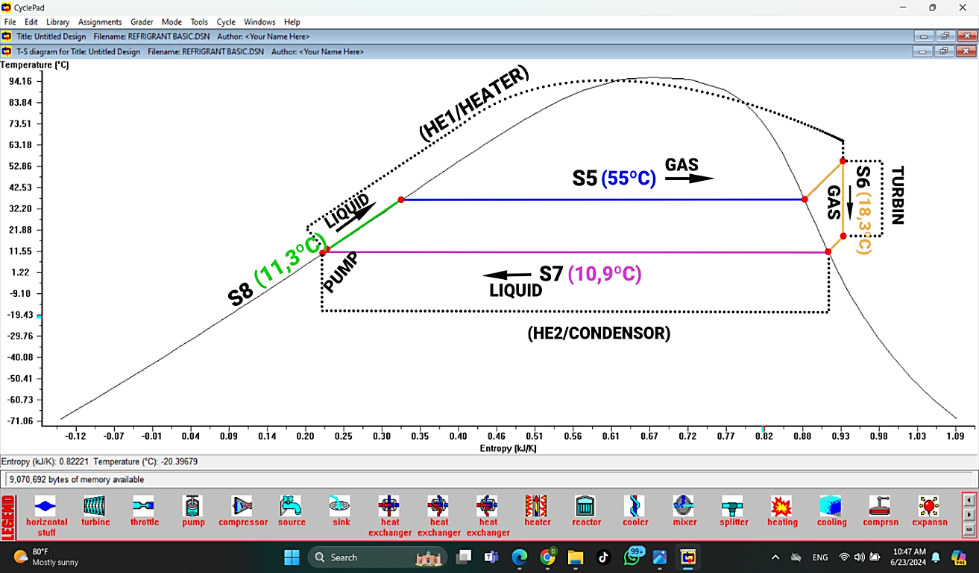 FIGURE 7. T-S Diagram for R22 refrigerant

FIGURE 6 and FIGURE 7 represent the T-s diagram for the ORC system using R134a and R22 refrigerants respectively. In the diagram, the difference in refrigerant temperature in the evaporator and condenser is visible. The temperature value is set so that the refrigerant is truly in the subcooled phase when entering the pump. This is intended to prevent cavitation in the pump. The cavitation effect allows the pump not to work optimally because there are 2 phases of working fluid being pumped. As a result, the pump component work is not continuous. In addition, the turbine outlet temperature value must also be ensured to be in the superheated phase. The loss that occurs if the fluid passes the saturated line is the appearance of water droplets that will damage the turbine in the long term. This is due to the corrosion effect caused by the turbine components. This can be anticipated in R134a and R22, because both are dry fluids and isentropic fluids. Moreover, FIGURE 7 shows the fluid line through the turbine far from the steam saturation line, thus minimizing the corrosion effects that occur.

FIGURE 8. Comparison of shaft power turbines for R134a and R22 refrigerants

Based on FIGURE 8, refrigerant R134a and R22 produce different turbine power. With the same pressure and temperature as R22, R134a is able to produce turbine power of 20.69 kW. While R22 produces 17.68 kW of power. This is because the temperature and pressure of the turbine output on R22 are still high, namely 18.3 degrees Celsius and 700 kPa. However, further adjustments so that the temperature and pressure values ​​are similar to R134a cannot be done. The limitation lies in R22 which does not allow it to operate at lower temperatures at reduced pressure. Thus, the use of R134a is more effective because the boiling point range is more suitable for the required operating temperature. This is inseparable from the operating temperature of the available hot and cold reservoirs.

CONCLUSIONS
Based on the results and discussion, each refrigerant has different specifications from each other, so it has many operating range limitations. One of the parameters that need to be considered for the Organic Rankine Cycle is the suitability of the pressure and boiling point of the refrigerant to the cycle feed temperature. R134a has operating conditions that are more likely to obtain higher turbine power than R22 at the input parameter of hot water temperature (60 degrees Celsius). R134a has a turbine output power of 20.69 kW. This value is 3 kW greater than R22, which is 17.68 kW.

References
- M. Mosbahi, A. Ayadi, Y. Chouaibi, Z. Driss, and T. Tucciarelli, “Performance improvement of a novel combined water turbine,” Energy Convers. Manag., vol. 205, no. January, p. 112473, 2020, doi: 10.1016/j.enconman.2020.112473.
- S. Hoseinzadeh and P. S. Heyns, “Thermo-structural fatigue and lifetime analysis of a heat exchanger as a feedwater heater in power plant,” Eng. Fail. Anal., vol. 113, no. February, p. 104548, 2020, doi: 10.1016/j.engfailanal.2020.104548.
- Y. Wang et al., “Proposal and comprehensive thermodynamic performance analysis of a new geothermal combined cooling, heating and power system,” Cogent Eng., vol. 9, no. 1, 2022, doi: 10.1080/23311916.2022.2075131.
- C. Ballzus, H. Frimannson, G. I. Gunnarsson, and I. Hrolfsson, “The Geothermal Power Plant AT Nesjavellir, Iceland.”
- G. Feng, X. Wang, M. Wang, and Y. Kang, “Experimental investigation of thermal cycling effect on fracture characteristics of granite in a geothermal-energy reservoir,” Eng. Fract. Mech., vol. 235, p. 107180, 2020, doi: 10.1016/j.engfracmech.2020.107180.
- L. Lipan and S. Dimitriu, “Possibilities To Use The Energy Of Geothermal Water In A Centralized Heating System,” U.P.B. Sci. Bull., Ser. C, vol. 82, p. 2020.
- C. I. Igwe, “Geothermal Energy: A Review.” [Online]. Available: www.ijert.org
- J. C. Jiménez-García, A. Ruiz, A. Pacheco-Reyes, and W. Rivera, “A Comprehensive Review of Organic Rankine Cycles,” Processes, vol. 11, no. 7, 2023, doi: 10.3390/pr11071982.
- S. Rane, L. He, Z. Yu, and G. Yu, “Design and Analysis of Two-Phase Geothermal Energy Turbine in Project Combi-Gen.”
- B. Xu et al., “A review of dynamic models and stability analysis for a hydro-turbine governing system,” Renew. Sustain. Energy Rev., vol. 144, no. April 2020, 2021, doi: 10.1016/j.rser.2021.110880.
- S. O. Oyedepo et al., “Thermodynamics analysis and performance optimization of a reheat – Regenerative steam turbine power plant with feed water heaters,” Fuel, vol. 280, Nov. 2020, doi: 10.1016/j.fuel.2020.118577.
- S. Wang et al., “Performance analysis on parallel condensing air-source heat pump water heater system,” Energy Reports, vol. 8, pp. 398–414, Jul. 2022, doi: 10.1016/j.egyr.2022.01.212.
- Muhammad Rifqi Dwi Septian, “The Optimization Of Shell And Tube Cycle Recuperator Design In Organic Rankine Geothermal Power Plant,” J. Energy, Mech. Mater. Manuf. Eng., vol. 8, no. 2 SE-Articles, Dec. 2023, [Online]. Available: https://ejournal.umm.ac.id/index.php/JEMMME/article/view/27082
- C. Sihombing and C. Politeknik Energi dan Mineral Akamigas, “Analisa Efisiensi Termal Turbin, Kondensor dan Menara Pendingin pada Pembangkit Listrik Tenaga Panas Bumi”.
- Y. qiang Feng et al., “Experimental comparison of the performance of basic and regenerative organic Rankine cycles,” Energy Convers. Manag., vol. 223, no. October, p. 113459, 2020, doi: 10.1016/j.enconman.2020.113459.
- A. Nemati, H. Nami, F. Ranjbar, and M. Yari, “A comparative thermodynamic analysis of ORC and Kalina cycles for waste heat recovery: A case study for CGAM cogeneration system,” Case Stud. Therm. Eng., vol. 9, no. September 2016, pp. 1–13, 2017, doi: 10.1016/j.csite.2016.11.003.
- J. Wang, J. Wang, Y. Dai, and P. Zhao, “Thermodynamic analysis and optimization of a flash-binary geothermal power generation system,” Geothermics, vol. 55, pp. 69–77, May 2015, doi: 10.1016/j.geothermics.2015.01.012.
- E. Allymehr, Á. Á. Pardiñas, T. M. Eikevik, and A. Hafner, “Characteristics of evaporation of propane (R290) in compact smooth and microfinned tubes,” Appl. Therm. Eng., vol. 181, no. September, p. 115880, 2020, doi: 10.1016/j.applthermaleng.2020.115880.
- P. Nikhil Babu et al., “Energy efficient refrigeration system with simultaneous heating and cooling,” Mater. Today Proc., vol. 45, pp. 8188–8194, 2021, doi: 10.1016/j.matpr.2021.03.072.

